Supplementary Materials

Appendix 1. MRI Parameters
Participants underwent conventional and DCE-MRI imaging using a 3T MR system (Magnetom Verio, Siemens Medical Solutions, Erlangen, Germany) with a 64-channel head-neck coil. The parameters of the conventional MRI were as follows: transversal T2WI [repetition time (TR), 4200 ms; echo time (TE), 109 ms; field of view (FOV), 243 mm × 194 mm; slice thickness, 6 mm; voxel resolution, 0.6 mm × 0.6 mm× 6.0 mm) and transversal T1WI (TR, 2000 ms; TE, 17 ms; FOV, 230 mm × 187 mm; slice thickness, 6.0 mm; voxel resolution, 0.7 mm × 0.7 mm × 6.0 mm) were obtained. For, DCE-MRI, T1-VIBE was applied at two different flip angles (2◦ and 15◦) to calculate the T1 maps, and it had the following parameters: TR, 3.83 ms; TE, 1.37 ms; slice thickness, 3.5 mm; FOV, 220 mm × 220 mm; voxel resolution, 1.4 mm × 1.4 mm × 3.5 mm. DCE-MRI was acquired with time-resolved angiography using stochastic trajectories (TWIST) sequence; the parameters were the following: TR, 4.89 ms; TE, 1.88 ms; flip angle, 12◦; slice thickness, 3.5 mm; for each measurement, 4.77 s; FOV, 220 mm × 220 mm; 75 measurements, total scan time of 358 s; voxel resolution, 1.4 mm × 1.4 mm × 3.5 mm; contrast media (0.2 mmol/kg body weight of Gd DTPA, Magnevist, Schering, Berlin, Germany); contrast median injection rate, 4 mL/s, followed by 20 mL of 0.9% saline flush using the same injection speed. The infusion was started from the fifth measurement. Postcontrast 3D T1mprage sagittal T1-weighted images (TR, 2300 ms; TE, 2.43 ms; section thickness, 0.75 mm; FOV, 240 mm × 225 mm; voxel resolution, 0.8 mm × 0.8 mm × 0.8 mm) were obtained after DCE-MRI.

Appendix 2. Supplementary Image Processing Methods

The analysis of DCE-MRI data was performed using a commercial software tool (TISSUE 4D; Siemens Healthcare, Erlangen, Germany). The value for the arterial input function was automatically calculated using the software. TISSUE 4D was based on the two-compartment model.

Appendix 3. Detailed statistical methods
Distribution of data was assessed on histograms and with Shapiro–Wilk tests. Categorical variables were appropriately compared using Pearson chi-squared tests, chi-squared tests with continuity correction, or Fisher’s exact tests. Cochran-Armitage tests were used to evaluate the trends of glioma grades. Receiver Operating Characteristics (ROC) curves were used to evaluate diagnostic efficacy. For continuous dependent variables, Cohen’s d was used as a measure of effect size (small effect=0.2, medium effect=0.5, large effect=0.8). For categorical variables, Phi or Cramer’s V coefficients were used as effect size indicators (small effect=0.1, medium effect=0.3, large effect=0.5). Simple kappa was calculated to assess the consistency of different diagnoses and interobserver agreement. Kappa values were interpreted using the following criteria: <0.20=poor agreement; 0.21–0.40=general agreement; 0.41–0.60=moderate agreement; 0.61–0.80=strong agreement; and 0.81–1.00=excellent agreement. Survival data was analyzed by Kaplan–Meier survival analysis using the R “survival” and “survminer” packages, and differences in survival were evaluated with the log-rank tests. Multivariable analyses with the Cox proportional-hazards model were used to estimate the simultaneous effects of prognostic factors on survival using stepwise forward likelihood-ratio testing. Hazard ratios (HR) were estimated according to the Cox proportional hazard method. For multiple comparisons, the p-value was set at the Bonferroni-corrected significance level.

Appendix 4. Extra detailed Patients’ Demographic and Clinical Findings

One hunderd and thirteen people were finally included who demonstrated to be with both imaging and pathological necrosis. Ninety-nine patients were included in the final survival analysis of groups with or without pathological necrosis. Among the 102 (68%) patients who underwent DCE-MRI, there were 24 cases without pathological necrosis, 50 with pathological necrosis, 37 without imaging necrosis, and 65 with imaging necrosis. For the follow-up, 20 (13.33%) patients were lost-to-follow-up, 66 (44%) patients had died, and 64 (42.67%) patients were alive.

Appendix 5. Tables

Sup. Table 1. The final diagnoses assigned to the included patients

Integrated diagnoses | WHO grade |  |  | sum
Integrated diagnoses | WHO grade 2 | WHO grade 3 | WHO grade 4 | sum
Astrocytomas,  IDH-mutant | 14 | 5 | 8 | 27
Oligodendrogliomas, IDH-mutant and 1p/19q-deleted | 16 | 8 | 0 | 24
Glioblastomas,  IDH-wildtype | 0 | 0 | 65 | 65
IDH-mutation, NOS | - | - | - | 7
IDH-wildtype, NOS | - | - | - | 21
not diagnosed | - | - | 3 | 6
Note. “-” respresents the numbers are uncertain. “not diagnosed” means that cases were not reclassified because of unknown IDH status, including 3 ones of WHO grade 4 with 1p19q non-codeletion and pathological necrosis

Sup. Table 2. Chi-square analysis results between imaging and pathological necrosis
Parameter | type | imaging necrosis |  | sum | χ² | p | Phi
Parameter | type | negative  (%) | positive  (%)
pathological necrosis | negative | 28  (87.50) | 7 (8.64) | 35  (30.97) | 66.718 | 0.000***^{b} | 0.768
pathological necrosis | positive | 4  (12.50) | 74 (91.36) | 75  (69.03) | 66.718 | 0.000***^{b} | 0.768
sum |  | 32 | 81 | 113 | 66.718 | 0.000***^{b} | 0.768
*** represents p<0.001.
Note. Superscripts b represents using the chi-square test with continuity correction

Appendix 6. Figures
Sup.fig. 1 Description of the inclusion and exclusion criteria (T1WI-CE, contrast-enhanced T1-weighted image).

Sup.fig. 2 The respresentative MR images with (A-E) or without (F-H) imaging necrosis. Shown from left to right by the order are T1WI, T2WI, and T1WI-CE. (A) a 40-year-old man with a WHO grade 2 IDH-mutant astrocytoma; (B) a 26-year-old woman with a WHO grade 3 IDH-mutant astrocytoma; (C) a 51-year-old man with a WHO grade 2 IDH-mutant and 1p/19q-deleted oligodendroglioma; (D) a 36-year-old man with a WHO grade 3 IDH-mutant and 1p/19q-deleted oligodendroglioma; (E) a 63-year-old woman with a WHO grade 4 IDH-mutant astrocytoma; (F) a 31-year-old woman with a WHO grade 2 IDH-mutant astrocytoma; (G) a 29-year-old woman with a WHO grade 2 IDH-mutant and 1p/19q-deleted oligodendroglioma.

Sup.fig. 3 Diagnostic algorithm for the integrated classification of adult-type diffuse glioma according to the latest WHO classification edition. *: not certain in this study. ‘n’ indicates the final number of cases included in the study.

Sup.fig. 4 Some resprentative MRI images without imaging necrosis, even if there were spot-like, dotted, long-strip, long tubular and fissural enhancements, which was exactly confused in diagnosing imaging necrosis. Shown from left to right by the order are T1WI, T2WI, and T1WI-CE. (A) a 29-year-old man with a WHO grade 2 IDH-mutant astrocytoma; (B) a 24-year-old woman with a WHO grade 2 IDH-mutant and 1p/19q-deleted oligodendroglioma; (C) a 32-year-old woman with a WHO grade 2 IDH-mutant astrocytoma; (D) a 39-year-old man with a WHO grade 2 IDH-mutant and 1p/19q-deleted oligodendroglioma; (E) a 31-year-old man with a WHO grade 3 IDH-mutant astrocytoma; (F) a 55-year-old woman with a WHO grade 2 IDH-mutant and 1p/19q-deleted oligodendroglioma; (G) a 45-year-old man with a WHO grade 2 IDH-mutant astrocytoma; (H) a 38-year-old man with a WHO grade 2 IDH-mutant aastrocytoma; (H) a 34-year-old man with a WHO grade 3 IDH-mutant and 1p/19q-deleted oligodendroglioma.

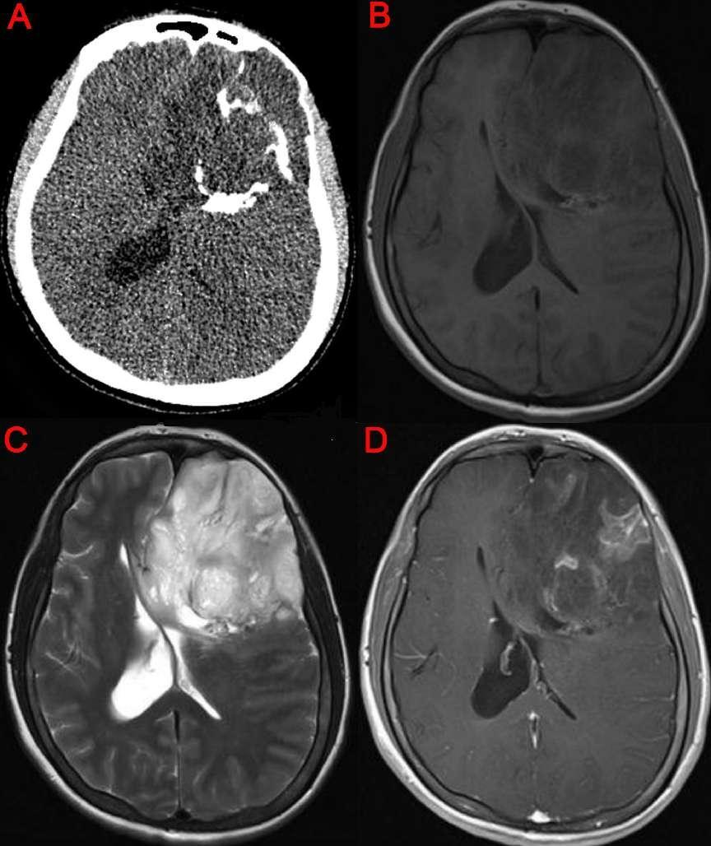
Sup.fig. 5 This case was a 36-year-old woman with a WHO grade 2 IDH-mutant and 1p/19q-deleted oligodendroglioma. Though on the T1WI-CE image (D), it showed multiple long tubular and filiform enhancement and there were some tumor areas with remarked decrease of reinforcement. But these areas are hyperintense, not hypointense, on the T1-weighted image. Comparing with CT images, calcification on there areas were just observed. So there was no imaging necrosis in this condition. Waqar et al. also reported this kind of reinforcement as a “chicken wire” appearance with the explanation that oligodendroglioma vasculature often was described as a network of regular fine branching capillaries [1, 2].

1. Waqar M, Lewis D, Agushi E, Gittins M, Jackson A, Coope D (2021) Cerebral and tumoral blood flow in adult gliomas: a systematic review of results from magnetic resonance imaging. Br J Radiol 94(1125): 20201450. doi: 10.1259/bjr.20201450.
2. Cha S, Tihan T, Crawford F, Fischbein NJ, Chang S, Bollen A, et al (2005) Differentiation of low-grade oligodendrogliomas from low-grade astrocytomas by using quantitative blood-volume measurements derived from dynamic susceptibility contrast-enhanced MR imaging. AJNR Am J Neuroradiol 26: 266–73.

