A novel higher performance nomogram based on explainable machine learning for predicting mortality risk in stroke patients within 30 days based on clinical features on the first day ICU admission
Haoran Chen ^{1, 2}, Fengchun Yang ^{1, 2}, Yifan Duan¹, Lin Yang^{1, 2}and Jiao Li ^{1,2}*
¹ Institute of Medical Information/Library, Chinese Academy of Medical Sciences & Peking Union Medical College, Beijing 100020, China
² Key Laboratory of Medical Information Intelligent Technology, Chinese Academy of Medical Sciences, Beijing 100020, China
* Correspondence: li.jiao@imicams.ac.cn; Tel: +(86)10-52328740

Figure S1: The stroke patient selection processes for data selection from the MIMIC-IV database;
Figure S2: Spearman correlation matrix of ten selected variables.
Figure S3: The performance of the optimized LightGBM.
Figure S4: Association between selected variables and death risk of stroke patients by Cox proportional hazards models and Kaplan-Meier (KM) survival curves using high risk subgroup as the reference.
Table S1: All variables extracted from the MIMIC-IV and their explanations in our study.
Table S2: Comparison of all variables between survived and dead patients.
Table S3: Covariance diagnosis for 10 variables selected.
Table S4: Comparison of 10 selected categorical variables between survived and dead patients.

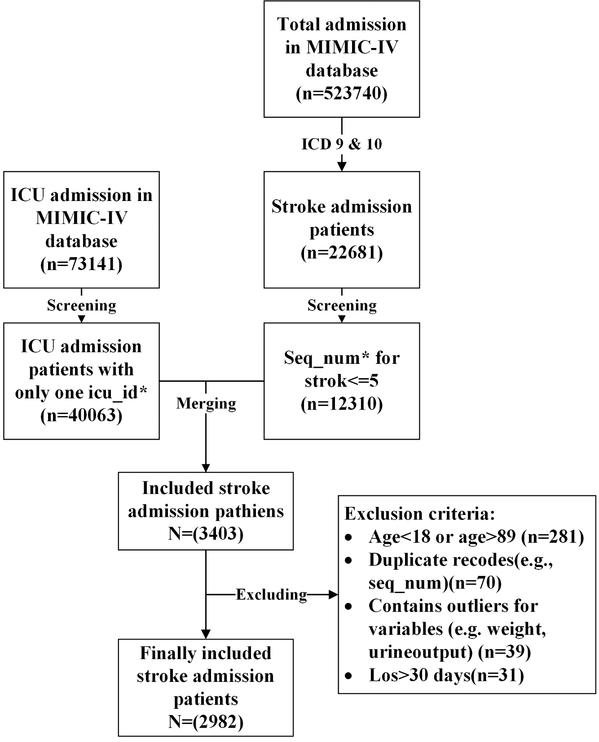
Figure S1 The stroke patient selection processes for data selection from the MIMIC-IV database.

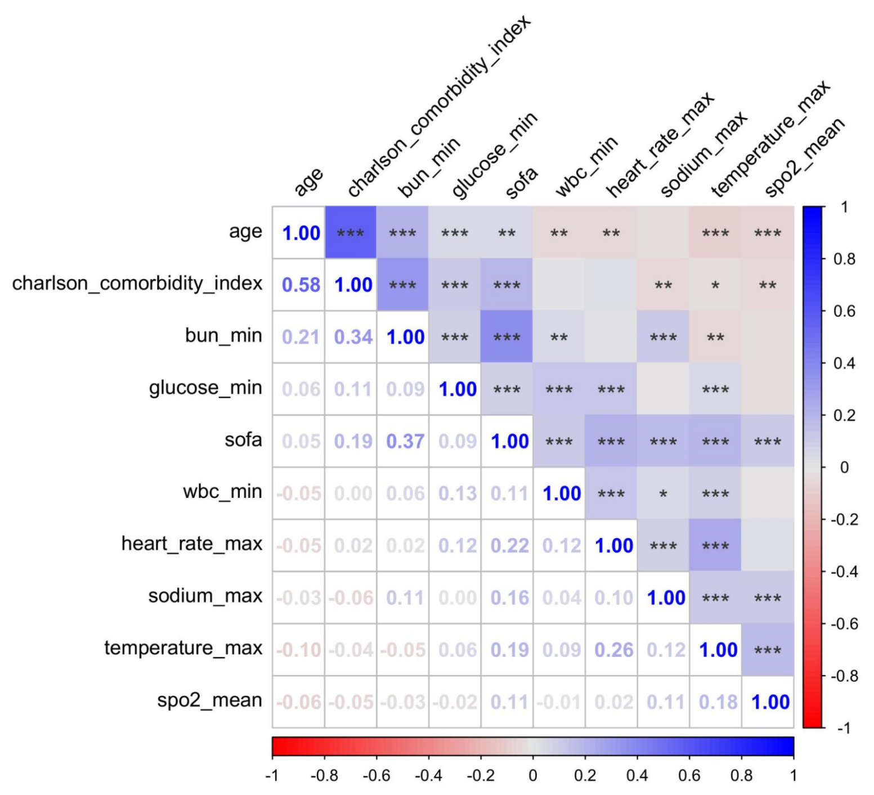
Figure S2 Spearman correlation matrix of ten selected variables.

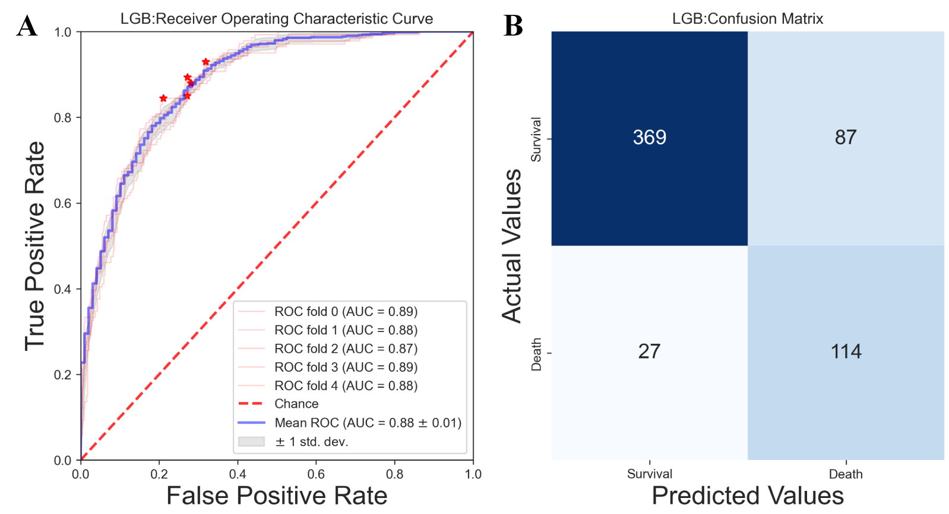
Figure S3. The performance of the optimized LightGBM in the test datasets. A: the operating characteristics curve of 5-fold cross-validation of LightGBM in the datasets. B: the confusion matrix of the LightGBM in the fifth fold datasets. Sensitivity=0.809(114/(27+114)), Specificity=0.809(369/(87+369)). AUC: area under the curve.

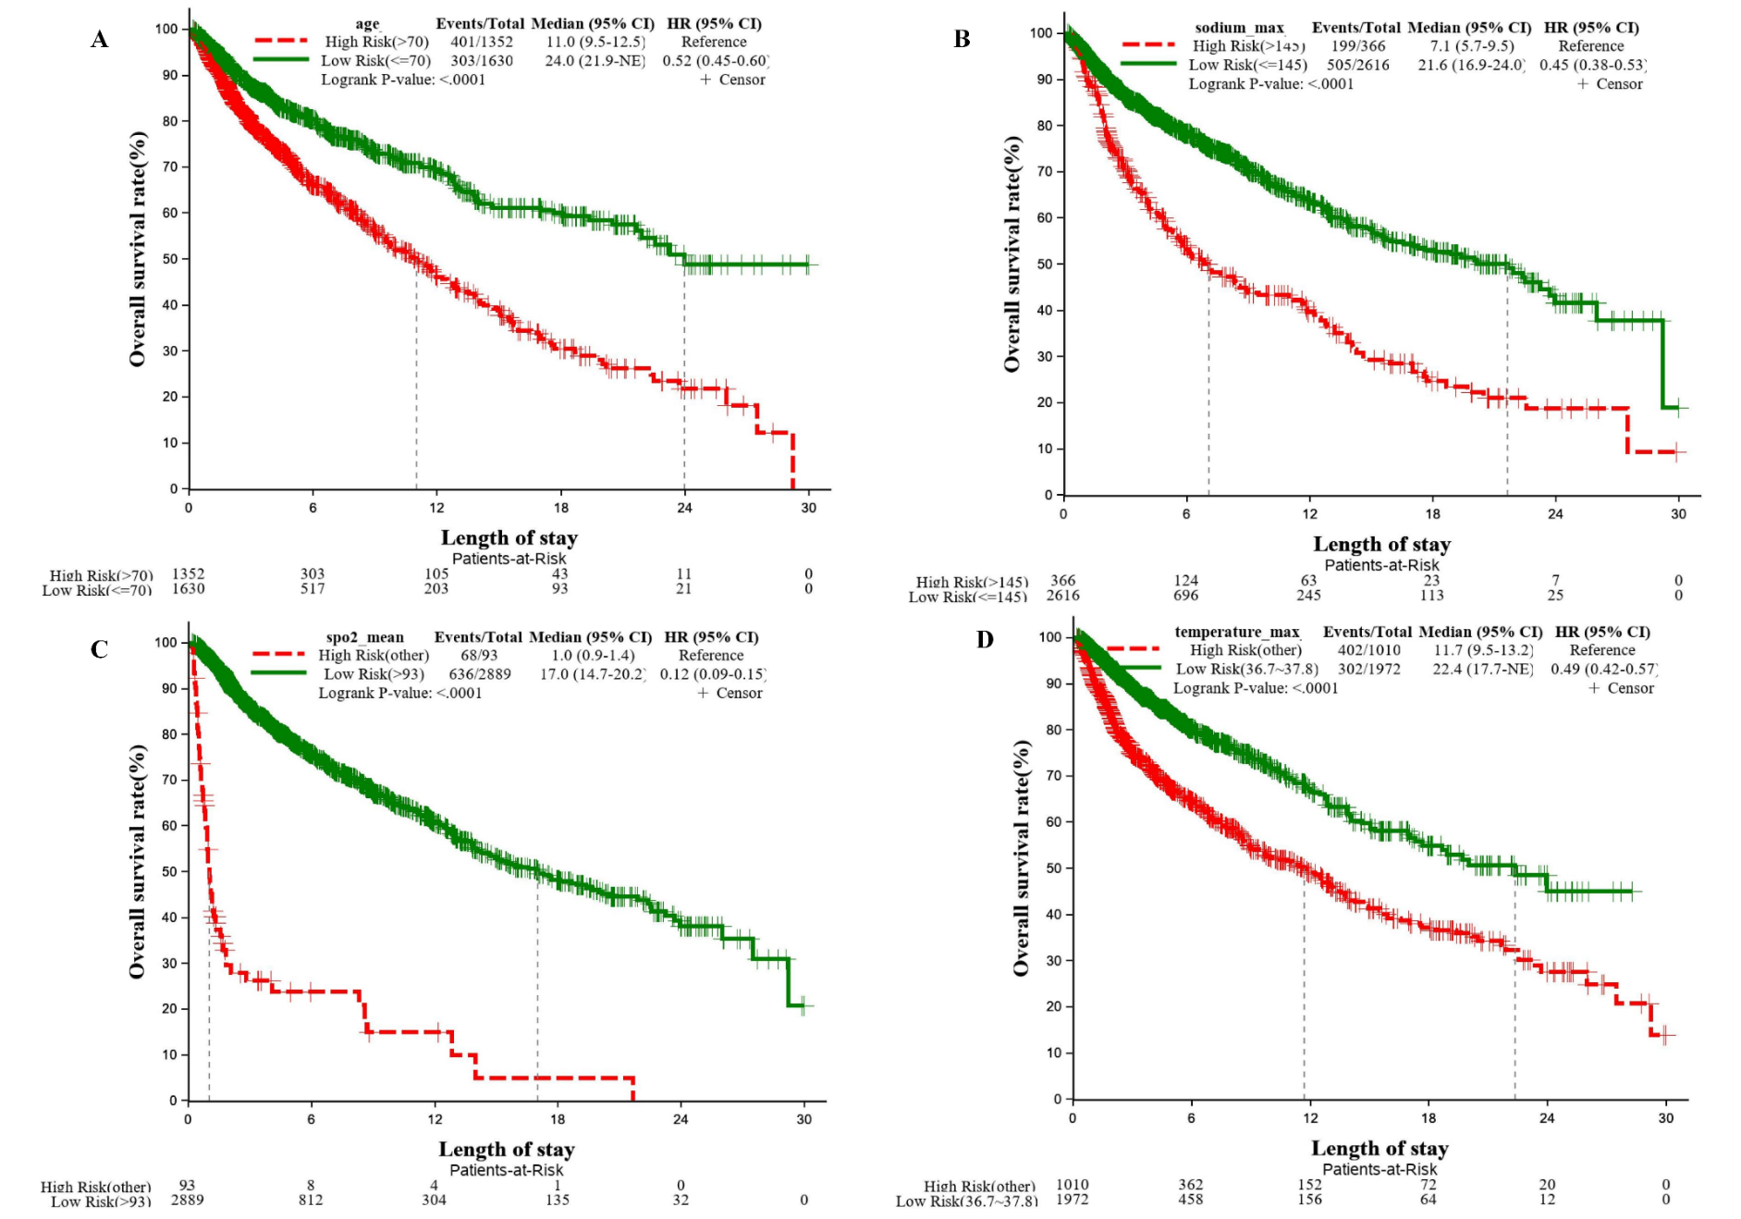
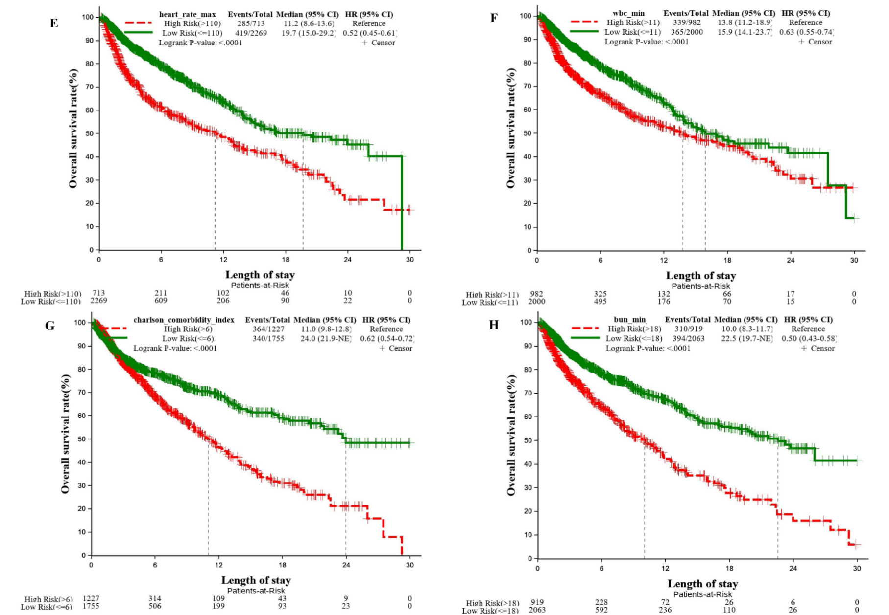
Figure S4. Association between selected variables and death risk of stroke patients by Cox proportional hazards models and Kaplan-Meier (KM) survival curves using high risk subgroup as the reference. A: sge; B: sodium_max; C: spo2_mean; D: temperature_max; E: heart_rate_max; F: wbc_min; G: charlson_comorbidity_index; H: bun_min. NE: missing values.

Table S1. All variables extracted from the MIMIC-IV and their explanations in our study.
variable | interpretation | variable | interpretation | variable | interpretation
insurance | type of medical insurance | weight | - | dbp min | minimum diastolic blood pressure within 24 hours of icu admission
ethnicity | - | heart rate min | minimum heart rate values within 24 hours of icu admission | dbp max | maximum diastolic blood pressure within 24 hours of icu admission
marital status | - | heart rate max | maximum heart rate within 24 hours of icu admission | dbp mean | mean diastolic blood pressure within 24 hours of icu admission
gender | - | heart rate mean | mean heart rate values within 24 hours of icu admission | mbp min | minimum mean arterial pressure  within 24 hours of icu admission
diagnosis type | types of stroke diagnosis | sbp min | minimum systolic blood pressure within 24 hours of icu admission | mbp max | maximum mean arterial pressure  within 24 hours of icu admission
los | length of icu stay | sbp max | maximum systolic blood pressure within 24 hours of icu admission | mbp mean | mean mean arterial pressure  within 24 hours of icu admission
age | - | sbp mean | mean systolic blood pressure within 24 hours of icu admission | bun min | minimum blood urea nitrogen values within 24 hours of icu admission
resp rate min | minimum respiratory rate within 24 hours of icu admission | glucose min | minimum blood glucose within 24 hours of icu admission | bun max | maximum blood urea nitrogen values within 24 hours of icu admission
resp rate max | maximum respiratory rate within 24 hours of icu admission | glucose max | maximum blood glucose within 24 hours of icu admission | hematocrit min | minimum hematocrit values within 24 hours of icu admission
resp rate mean | mean respiratory rate within 24 hours of icu admission | glucose mean | mean blood glucose within 24 hours of icu admission | hematocrit max | maximum hematocrit values within 24 hours of icu admission
temperature min | minimum body temperature within 24 hours of icu admission | charlson comorbidity index | a more widely used comorbidity scoring system | hemoglobin min | minimum hemoglobin values within 24 hours of icu admission
temperature max | maximum body temperature within 24 hours of icu admission | sofa | sepsis-related organ failure assessment: a scoring system to assess the extent and prognosis of organ failure in intensive care patients | hemoglobin max | maximum hemoglobin values within 24 hours of icu admission
temperature mean | mean body temperature within 24 hours of icu admission | aniongap min | minimum anion gap value within 24 hours of icu admission | platelets min | minimum platelets values within 24 hours of icu admission
spo2 min | minimum blood oxygen saturation within 24 hours of icu admission | aniongap max | maximum anion gap value within 24 hours of icu admission | platelets max | maximum platelets values within 24 hours of icu admission
spo2 max | maximum blood oxygen saturation within 24 hours of icu admission | creatinine min | minimum creatinine value within 24 hours of icu admission | wbc min | minimum white blood cell values within 24 hours of icu admission
spo2 mean | mean blood oxygen saturation within 24 hours of icu admission | creatinine max | maximum creatinine value within 24 hours of icu admission | wbc max | maximum white blood cell values within 24 hours of icu admission
inr min | minimum international normalized ratio values within 24 hours of icu admission | potassium min | minimum potassium value within 24 hours of icu admission | sodium min | minimum sodium value within 24 hours of icu admission
inr max | maximum international normalized ratio values within 24 hours of icu admission | potassium max | maximum potassium value within 24 hours of icu admission | sodium max | maximum sodium value within 24 hours of icu admission
pt min | minimum prothrombin time within 24 hours of icu admission | chloride min | minimum chloride within 24 hours of icu admission | urine output | urine output within 24 hours of icu admission
pt max | maximum prothrombin time within 24 hours of icu admission | chloride max | maximum chloride within 24 hours of icu admission
ptt min | minimum activated partial thromboplatin time within 24 hours of icu admission | bicarbonate min | minimum bicarbonate within 24 hours of icu admission
ptt max | maximum activated partial thromboplatin time within 24 hours of icu admission | bicarbonate max | maximum bicarbonate within 24 hours of icu admission

Table S2. Comparison of all variables between survived and dead patients.
 | Death of Stroke
Variable | No  (N=2278) | Yes  (N=704) | Total  (N=2982) | P value
insurance, n (%) |  |  |  | 0.0001¹
Medicaid | 126 (5.5%) | 33 (4.7%) | 159 (5.3%)
Medicare | 915 (40.2%) | 346 (49.1%) | 1261 (42.3%)
Other | 1237 (54.3%) | 325 (46.2%) | 1562 (52.4%)
ethnicity, n (%) |  |  |  | <.0001¹
American Indian/Alaska | 8 (0.4%) | 0 (0.0%) | 8 (0.3%)
Asian | 67 (2.9%) | 24 (3.4%) | 91 (3.1%)
Black/Africa American | 218 (9.6%) | 55 (7.8%) | 273 (9.2%)
Hispanic/Latino | 77 (3.4%) | 22 (3.1%) | 99 (3.3%)
Other | 133 (5.8%) | 29 (4.1%) | 162 (5.4%)
Unable to obtain | 27 (1.2%) | 24 (3.4%) | 51 (1.7%)
Unknown | 279 (12.2%) | 202 (28.7%) | 481 (16.1%)
White | 1469 (64.5%) | 348 (49.4%) | 1817 (60.9%)
marital status, n (%) |  |  |  | 0.0120¹
Divorced | 176 (8.6%) | 35 (7.1%) | 211 (8.3%)
Married | 1099 (53.6%) | 265 (54.0%) | 1364 (53.7%)
Single | 522 (25.5%) | 106 (21.6%) | 628 (24.7%)
Windowed | 252 (12.3%) | 85 (17.3%) | 337 (13.3%)
Missing | 229 | 213 | 442
gender, n (%) |  |  |  | 0.2802¹
F | 1086 (47.7%) | 352 (50.0%) | 1438 (48.2%)
M | 1192 (52.3%) | 352 (50.0%) | 1544 (51.8%)
diagnosis type, n (%) |  |  |  | <.0001¹
IH | 891 (39.1%) | 350 (49.7%) | 1241 (41.6%)
IS | 855 (37.5%) | 227 (32.2%) | 1082 (36.3%)
SH | 392 (17.2%) | 125 (17.8%) | 517 (17.3%)
TIA | 140 (6.1%) | 2 (0.3%) | 142 (4.8%)
los |  |  |  | 0.0150²
N | 2278 | 704 | 2982
Mean (SD) | 5.1 (5.40) | 4.7 (4.95) | 5.0 (5.30)
Median | 3.0 | 2.7 | 2.9
Range | 0.2, 30.0 | 0.2, 29.2 | 0.2, 30.0
age |  |  |  | <.0001²
N | 2278 | 704 | 2982
Mean (SD) | 65.3 (15.27) | 70.6 (13.27) | 66.6 (14.99)
Median | 66.7 | 72.6 | 68.3
Range | 18.0, 89.0 | 22.8, 89.0 | 18.0, 89.0
weight |  |  |  | 0.0002²
N | 2278 | 704 | 2982
Mean (SD) | 80.5 (21.72) | 76.9 (21.73) | 79.7 (21.77)
Median | 78.0 | 75.0 | 77.2
Range | 1.0, 206.7 | 1.0, 212.3 | 1.0, 212.3
heart rate min |  |  |  | 0.0226²
N | 2278 | 704 | 2982
Mean (SD) | 64.4 (12.26) | 65.4 (17.51) | 64.7 (13.68)
Median | 63.0 | 65.0 | 64.0
Range | 20.0, 113.0 | 7.0, 128.0 | 7.0, 128.0
heart rate max |  |  |  | <.0001²
N | 2278 | 704 | 2982
Mean (SD) | 96.5 (17.82) | 107.3 (22.62) | 99.0 (19.60)
Median | 94.0 | 105.0 | 97.0
Range | 55.0, 190.0 | 56.0, 197.0 | 55.0, 197.0
heart rate mean |  |  |  | <.0001²
N | 2278 | 704 | 2982
Mean (SD) | 78.2 (13.30) | 84.0 (16.13) | 79.6 (14.24)
Median | 77.0 | 82.8 | 78.3
Range | 44.8, 128.9 | 42.6, 149.0 | 42.6, 149.0
sbp min |  |  |  | <.0001²
N | 2274 | 701 | 2975
Mean (SD) | 103.3 (16.73) | 95.8 (24.02) | 101.5 (18.97)
Median | 103.0 | 97.0 | 102.0
Range | 2.0, 169.0 | 16.0, 181.0 | 2.0, 181.0
sbp max |  |  |  | <.0001²
N | 2274 | 701 | 2975
Mean (SD) | 160.2 (22.17) | 164.0 (25.05) | 161.1 (22.93)
Median | 158.3 | 163.0 | 160.0
Range | 78.0, 352.0 | 77.0, 257.0 | 77.0, 352.0
sbp mean |  |  |  | 0.0020²
N | 2274 | 701 | 2975
Mean (SD) | 130.6 (15.78) | 127.9 (18.06) | 129.9 (16.39)
Median | 130.0 | 128.7 | 129.8
Range | 75.0, 195.3 | 52.6, 197.2 | 52.6, 197.2
dbp min |  |  |  | <.0001²
N | 2274 | 701 | 2975
Mean (SD) | 51.4 (11.37) | 46.9 (13.08) | 50.4 (11.95)
Median | 51.0 | 47.0 | 50.0
Range | 10.0, 93.0 | 7.0, 114.0 | 7.0, 114.0
dbp max |  |  |  | 0.0003²
N | 2274 | 701 | 2975
Mean (SD) | 93.9 (19.45) | 91.6 (21.49) | 93.3 (19.97)
Median | 92.0 | 89.0 | 91.0
Range | 47.0, 273.0 | 36.0, 181.0 | 36.0, 273.0
dbp mean |  |  |  | <.0001²
N | 2274 | 701 | 2975
Mean (SD) | 68.3 (11.65) | 64.9 (11.53) | 67.5 (11.71)
Median | 67.6 | 63.9 | 66.8
Range | 37.8, 117.1 | 29.2, 129.6 | 29.2, 129.6
mbp min |  |  |  | <.0001²
N | 2277 | 703 | 2980
Mean (SD) | 65.6 (14.19) | 59.4 (16.94) | 64.1 (15.11)
Median | 66.0 | 61.0 | 65.0
Range | 1.0, 113.0 | 2.0, 133.0 | 1.0, 133.0
mbp max |  |  |  | 0.1337²
N | 2277 | 703 | 2980
Mean (SD) | 111.6 (20.27) | 111.9 (25.70) | 111.7 (21.67)
Median | 109.0 | 108.0 | 109.0
Range | 68.0, 276.0 | 47.0, 290.0 | 47.0, 290.0
mbp mean |  |  |  | <.0001²
N | 2277 | 703 | 2980
Mean (SD) | 85.5 (11.09) | 82.2 (11.17) | 84.7 (11.19)
Median | 84.9 | 82.0 | 84.2
Range | 57.6, 139.9 | 38.5, 133.1 | 38.5, 139.9
resp rate min |  |  |  | <.0001²
N | 2274 | 704 | 2978
Mean (SD) | 12.2 (2.95) | 12.9 (3.83) | 12.3 (3.19)
Median | 12.0 | 13.0 | 12.0
Range | 1.0, 27.5 | 2.0, 28.0 | 1.0, 28.0
resp rate max |  |  |  | 0.0002²
N | 2274 | 704 | 2978
Mean (SD) | 26.3 (5.65) | 27.3 (6.22) | 26.5 (5.81)
Median | 25.0 | 26.0 | 26.0
Range | 15.0, 67.0 | 12.0, 57.0 | 12.0, 67.0
resp rate mean |  |  |  | <.0001²
N | 2274 | 704 | 2978
Mean (SD) | 18.2 (2.99) | 19.6 (3.66) | 18.5 (3.21)
Median | 17.9 | 19.0 | 18.0
Range | 11.0, 38.8 | 9.1, 32.7 | 9.1, 38.8
temperature min |  |  |  | 0.0319²
N | 2249 | 690 | 2939
Mean (SD) | 36.5 (0.55) | 36.3 (1.02) | 36.4 (0.69)
Median | 36.6 | 36.5 | 36.6
Range | 30.2, 39.8 | 28.6, 39.2 | 28.6, 39.8
temperature max |  |  |  | <.0001²
N | 2249 | 690 | 2939
Mean (SD) | 37.4 (0.59) | 37.7 (1.06) | 37.5 (0.74)
Median | 37.3 | 37.7 | 37.3
Range | 33.8, 40.2 | 31.8, 41.3 | 31.8, 41.3
temperature mean |  |  |  | <.0001²
N | 2249 | 690 | 2939
Mean (SD) | 36.9 (0.41) | 37.0 (0.85) | 37.0 (0.55)
Median | 36.9 | 37.1 | 36.9
Range | 33.0, 40.0 | 31.0, 39.7 | 31.0, 40.0
spo2 min |  |  |  | 0.0112²
N | 2278 | 702 | 2980
Mean (SD) | 92.9 (5.24) | 89.7 (14.15) | 92.2 (8.36)
Median | 93.0 | 94.0 | 94.0
Range | 1.0, 100.0 | 7.0, 100.0 | 1.0, 100.0
spo2 max |  |  |  | <.0001²
N | 2278 | 702 | 2980
Mean (SD) | 99.4 (1.00) | 99.7 (0.97) | 99.5 (1.00)
Median | 100.0 | 100.0 | 100.0
Range | 94.0, 100.0 | 90.0, 100.0 | 90.0, 100.0
spo2 mean |  |  |  | <.0001²
N | 2278 | 702 | 2980
Mean (SD) | 97.1 (1.73) | 97.0 (3.68) | 97.0 (2.34)
Median | 97.1 | 98.0 | 97.3
Range | 79.6, 100.0 | 67.0, 100.0 | 67.0, 100.0
glucose min |  |  |  | <.0001²
N | 2260 | 633 | 2893
Mean (SD) | 110.8 (28.76) | 129.2 (42.54) | 114.8 (33.16)
Median | 105.0 | 123.0 | 109.0
Range | 32.0, 283.0 | 20.0, 365.0 | 20.0, 365.0
glucose max |  |  |  | <.0001²
N | 2260 | 633 | 2893
Mean (SD) | 604.8 (21031.86) | 202.4 (89.10) | 516.7 (18588.96)
Median | 145.0 | 178.0 | 150.0
Range | 72.0, 999999.0 | 75.0, 708.0 | 72.0, 999999.0
glucose mean |  |  |  | <.0001²
N | 2260 | 633 | 2893
Mean (SD) | 197.4 (3004.78) | 161.0 (49.52) | 189.4 (2655.80)
Median | 124.5 | 150.0 | 129.9
Range | 68.5, 142966.9 | 72.3, 384.5 | 68.5, 142966.9
charlson comorbidity index |  |  |  | <.0001²
N | 2278 | 704 | 2982
Mean (SD) | 5.9 (2.68) | 6.8 (2.72) | 6.1 (2.71)
Median | 6.0 | 7.0 | 6.0
Range | 0.0, 18.0 | 1.0, 17.0 | 0.0, 18.0
sofa |  |  |  | <.0001²
N | 2278 | 704 | 2982
Mean (SD) | 3.4 (2.62) | 6.1 (3.69) | 4.0 (3.12)
Median | 3.0 | 5.5 | 3.0
Range | 0.0, 17.0 | 0.0, 21.0 | 0.0, 21.0
aniongap min |  |  |  | <.0001²
N | 2247 | 667 | 2914
Mean (SD) | 13.4 (2.77) | 14.5 (3.81) | 13.7 (3.08)
Median | 13.0 | 14.0 | 13.0
Range | -3.0, 29.0 | 3.0, 38.0 | -3.0, 38.0
aniongap max |  |  |  | <.0001²
N | 2247 | 667 | 2914
Mean (SD) | 15.7 (3.36) | 17.7 (4.77) | 16.1 (3.82)
Median | 15.0 | 17.0 | 16.0
Range | 6.0, 43.0 | 9.0, 49.0 | 6.0, 49.0
creatinine min |  |  |  | <.0001²
N | 2256 | 697 | 2953
Mean (SD) | 1.0 (0.85) | 1.2 (1.06) | 1.0 (0.91)
Median | 0.8 | 0.9 | 0.8
Range | 0.1, 18.5 | 0.1, 10.9 | 0.1, 18.5
creatinine max |  |  |  | <.0001²
N | 2256 | 697 | 2953
Mean (SD) | 1.1 (0.96) | 1.4 (1.27) | 1.2 (1.05)
Median | 0.9 | 1.0 | 0.9
Range | 0.2, 19.7 | 0.3, 11.5 | 0.2, 19.7
bun min |  |  |  | <.0001²
N | 2258 | 698 | 2956
Mean (SD) | 16.6 (10.69) | 22.5 (18.20) | 17.9 (13.11)
Median | 14.0 | 18.0 | 15.0
Range | 2.0, 180.0 | 3.0, 181.0 | 2.0, 181.0
bun max |  |  |  | <.0001²
N | 2258 | 698 | 2956
Mean (SD) | 19.5 (11.84) | 26.6 (21.47) | 21.2 (15.00)
Median | 17.0 | 20.5 | 18.0
Range | 3.0, 190.0 | 4.0, 211.0 | 3.0, 211.0
hematocrit min |  |  |  | <.0001²
N | 2256 | 695 | 2951
Mean (SD) | 35.6 (6.02) | 34.1 (6.52) | 35.3 (6.17)
Median | 36.2 | 34.6 | 35.8
Range | 12.1, 54.6 | 13.5, 56.7 | 12.1, 56.7
hematocrit max |  |  |  | 0.0174²
N | 2256 | 695 | 2951
Mean (SD) | 38.6 (5.47) | 38.0 (6.30) | 38.5 (5.68)
Median | 38.8 | 38.2 | 38.8
Range | 19.4, 60.1 | 20.8, 64.6 | 19.4, 64.6
hemoglobin min |  |  |  | <.0001²
N | 2256 | 694 | 2950
Mean (SD) | 11.9 (2.10) | 11.4 (2.27) | 11.8 (2.15)
Median | 12.1 | 11.5 | 12.0
Range | 3.8, 18.6 | 4.4, 18.4 | 3.8, 18.6
hemoglobin max |  |  |  | 0.0003²
N | 2256 | 694 | 2950
Mean (SD) | 12.9 (1.94) | 12.6 (2.20) | 12.8 (2.01)
Median | 13.0 | 12.7 | 13.0
Range | 6.1, 19.9 | 6.2, 20.3 | 6.1, 20.3
platelets min |  |  |  | <.0001²
N | 2255 | 693 | 2948
Mean (SD) | 211.3 (80.96) | 196.3 (93.38) | 207.8 (84.27)
Median | 202.0 | 189.0 | 199.0
Range | 16.0, 1269.0 | 6.0, 817.0 | 6.0, 1269.0
platelets max |  |  |  | 0.0045²
N | 2255 | 693 | 2948
Mean (SD) | 236.4 (88.62) | 230.1 (106.07) | 235.0 (93.03)
Median | 223.0 | 219.0 | 222.0
Range | 34.0, 1302.0 | 28.0, 932.0 | 28.0, 1302.0
wbc min |  |  |  | <.0001²
N | 2256 | 695 | 2951
Mean (SD) | 9.7 (4.48) | 12.0 (9.06) | 10.3 (5.97)
Median | 9.1 | 10.9 | 9.4
Range | 0.3, 121.0 | 0.1, 199.3 | 0.1, 199.3
wbc max |  |  |  | <.0001²
N | 2256 | 695 | 2951
Mean (SD) | 12.1 (8.41) | 15.5 (10.94) | 12.9 (9.18)
Median | 10.9 | 14.0 | 11.6
Range | 0.6, 328.4 | 0.1, 235.0 | 0.1, 328.4
inr min |  |  |  | <.0001²
N | 2167 | 685 | 2852
Mean (SD) | 1.1 (0.22) | 1.3 (1.17) | 1.2 (0.61)
Median | 1.1 | 1.1 | 1.1
Range | 0.8, 3.8 | 0.6, 26.7 | 0.6, 26.7
inr max |  |  |  | <.0001²
N | 2167 | 685 | 2852
Mean (SD) | 1.3 (0.51) | 1.5 (1.56) | 1.3 (0.89)
Median | 1.1 | 1.2 | 1.1
Range | 0.9, 12.1 | 0.9, 26.7 | 0.9, 26.7
pt min |  |  |  | <.0001²
N | 2167 | 685 | 2852
Mean (SD) | 12.5 (2.38) | 13.8 (7.89) | 12.9 (4.42)
Median | 12.1 | 12.6 | 12.2
Range | 8.2, 40.4 | 8.3, 147.0 | 8.2, 147.0
pt max |  |  |  | <.0001²
N | 2167 | 685 | 2852
Mean (SD) | 13.8 (5.24) | 16.5 (12.90) | 14.4 (7.88)
Median | 12.5 | 13.5 | 12.7
Range | 9.4, 135.7 | 9.5, 150.0 | 9.4, 150.0
ptt min |  |  |  | 0.4969²
N | 2165 | 684 | 2849
Mean (SD) | 28.0 (7.00) | 28.4 (9.74) | 28.1 (7.75)
Median | 27.0 | 26.8 | 26.9
Range | 16.8, 150.0 | 17.8, 150.0 | 16.8, 150.0
ptt max |  |  |  | 0.1176²
N | 2165 | 684 | 2849
Mean (SD) | 35.0 (20.78) | 38.7 (27.80) | 35.9 (22.71)
Median | 29.0 | 29.8 | 29.2
Range | 18.1, 150.0 | 17.8, 150.0 | 17.8, 150.0
potassium min |  |  |  | 0.0595²
N | 2249 | 669 | 2918
Mean (SD) | 3.8 (0.46) | 3.8 (0.62) | 3.8 (0.50)
Median | 3.8 | 3.8 | 3.8
Range | 1.7, 6.5 | 1.4, 8.7 | 1.4, 8.7
potassium max |  |  |  | <.0001²
N | 2249 | 669 | 2918
Mean (SD) | 4.3 (0.70) | 4.5 (0.85) | 4.3 (0.74)
Median | 4.1 | 4.3 | 4.2
Range | 2.5, 9.4 | 2.8, 9.0 | 2.5, 9.4
chloride min |  |  |  | 0.0657²
N | 2248 | 669 | 2917
Mean (SD) | 102.8 (4.75) | 102.3 (6.00) | 102.7 (5.07)
Median | 103.0 | 103.0 | 103.0
Range | 63.0, 134.0 | 76.0, 130.0 | 63.0, 134.0
chloride max |  |  |  | <.0001²
N | 2248 | 669 | 2917
Mean (SD) | 105.8 (4.88) | 107.8 (7.64) | 106.3 (5.69)
Median | 106.0 | 107.0 | 106.0
Range | 83.0, 140.0 | 88.0, 140.0 | 83.0, 140.0
bicarbonate min |  |  |  | <.0001²
N | 2248 | 667 | 2915
Mean (SD) | 22.7 (3.38) | 21.1 (4.57) | 22.3 (3.74)
Median | 23.0 | 21.0 | 23.0
Range | 9.0, 35.0 | 3.0, 40.0 | 3.0, 40.0
bicarbonate max |  |  |  | <.0001²
N | 2248 | 667 | 2915
Mean (SD) | 24.6 (3.09) | 23.7 (3.95) | 24.4 (3.33)
Median | 25.0 | 24.0 | 24.0
Range | 14.0, 44.0 | 11.0, 45.0 | 11.0, 45.0
sodium min |  |  |  | 0.1399²
N | 2249 | 669 | 2918
Mean (SD) | 138.2 (4.04) | 137.9 (5.41) | 138.1 (4.39)
Median | 138.0 | 138.0 | 138.0
Range | 93.0, 170.0 | 114.0, 160.0 | 93.0, 170.0
sodium max |  |  |  | <.0001²
N | 2249 | 669 | 2918
Mean (SD) | 140.6 (3.88) | 142.9 (6.79) | 141.1 (4.81)
Median | 141.0 | 142.0 | 141.0
Range | 119.0, 174.0 | 125.0, 179.0 | 119.0, 179.0
urine output |  |  |  | 0.0003²
N | 2278 | 704 | 2982
Mean (SD) | 1829.6 (1035.34) | 1810.9 (1437.26) | 1825.2 (1142.80)
Median | 1675.0 | 1466.5 | 1617.5
Range | -1305.0, 8235.0 | 0.0, 9940.0 | -1305.0, 9940.0
¹Chi-Square p-value; ²Kruskal-Wallis p-value;

Table S3. Covariance diagnosis for 10 variables selected.
Variable | Variance inflation factor (VIF)
Sofa | 1.323
Glucose_min | 1.058
Sodium_max | 1.068
Age | 1.550
Spo2_mean | 1.063
Temperature_max | 1.145
Heart_rate_max | 1.139
Bun_min | 1.310
Wbc_min | 1.042
Charlson_comorbidity_index | 1.705

Table S4. Comparison of 10 selected categorical variables between survived and dead patients.
 | Death of Stroke
Variable | No  (N=2278) | Yes  (N=704) | Total  (N=2982) | P-value
sofa, n (%) |  |  |  | <.001¹
0 (High Risk) | 565 (24.8%) | 444 (63.1%) | 1009 (33.8%)
1 (Low Risk) | 1713 (75.2%) | 260 (36.9%) | 1973 (66.2%)
glucose_min, n (%) |  |  |  | <.001¹
0 (High Risk) | 963 (42.3%) | 404 (57.4%) | 1367 (45.8%)
1 (Low Risk) | 1315 (57.7%) | 300 (42.6%) | 1615 (54.2%)
sodium_max, n (%) |  |  |  | <.001¹
0 (High Risk) | 167 (7.3%) | 199 (28.3%) | 366 (12.3%)
1 (Low Risk) | 2111 (92.7%) | 505 (71.7%) | 2616 (87.7%)
age, n (%) |  |  |  | <.001¹
0 (High Risk) | 951 (41.7%) | 401 (57.0%) | 1352 (45.3%)
1 (Low Risk) | 1327 (58.3%) | 303 (43.0%) | 1630 (54.7%)
spo2_mean, n (%) |  |  |  | <.001¹
0 (High Risk) | 25 (1.1%) | 68 (9.7%) | 93 (3.1%)
1 (Low Risk) | 2253 (98.9%) | 636 (90.3%) | 2889 (96.9%)
temperature_max, n (%) |  |  |  | <.001¹
0 (High Risk) | 608 (26.7%) | 402 (57.1%) | 1010 (33.9%)
1 (Low Risk) | 1670 (73.3%) | 302 (42.9%) | 1972 (66.1%)
heart_rate_max, n (%) |  |  |  | <.001¹
0 (High Risk) | 428 (18.8%) | 285 (40.5%) | 713 (23.9%)
1 (Low Risk) | 1850 (81.2%) | 419 (59.5%) | 2269 (76.1%)
bun_min, n (%) |  |  |  | <.001¹
0 (High Risk) | 609 (26.7%) | 310 (44.0%) | 919 (30.8%)
1 (Low Risk) | 1669 (73.3%) | 394 (56.0%) | 2063 (69.2%)
wbc_min, n (%) |  |  |  | <.001¹
0 (High Risk) | 643 (28.2%) | 339 (48.2%) | 982 (32.9%)
1 (Low Risk) | 1635 (71.8%) | 365 (51.8%) | 2000 (67.1%)
charlson_comorbidity_index, n (%) |  |  |  | <.001¹
0 (High Risk) | 863 (37.9%) | 364 (51.7%) | 1227 (41.1%)
1 (Low Risk) | 1415 (62.1%) | 340 (48.3%) | 1755 (58.9%)
¹Chi-Square p-value;

