SELEX based aptamers with diagnostic and entry inhibitor therapeutic potential for SARS-CoV-2
Sayanti Halder^{1#}, Abhishek Thakur^{2#}, Supriya Suman Keshry^{3,5}, Pradip Jana¹, Divyanshi Karothia³, Indrani Das Jana⁴, Orlando Acevedo², Rajeeb K. Swain³, Arindam Mondal⁴, Soma Chattopadhyay³, Venkatesan Jayaprakash¹, Abhimanyu Dev^{1*}
¹Department of Pharmaceutical Sciences and Technology, Birla Institute of Technology, Mesra, Ranchi, 835215, Jharkhand, India.
²Department of Chemistry, University of Miami, Coral Gables, FL, 33146, United States.
³Institute of Life Sciences, Bhubaneswar, 751023, Odisha, India.
⁴School of Bioscience, Indian Institute of Technology Kharagpur, Kharagpur, 721302, West Bengal, India.
⁵School of Biotechnology, Kalinga Institute of Industrial Technology (KIIT) University, Bhubaneswar, Odisha, India.
#Authors SH and AT have contributed equally.
*Corresponding author: Abhimanyu Dev Corresponding address: Department of Pharmaceutical Sciences & Technology, Birla Institute of Technology, Mesra, Ranchi-835215, India. Tel.: +91-651-2275210; fax: + 91-651-2275401. Email: abhimanyudev@bitmesra.ac.in

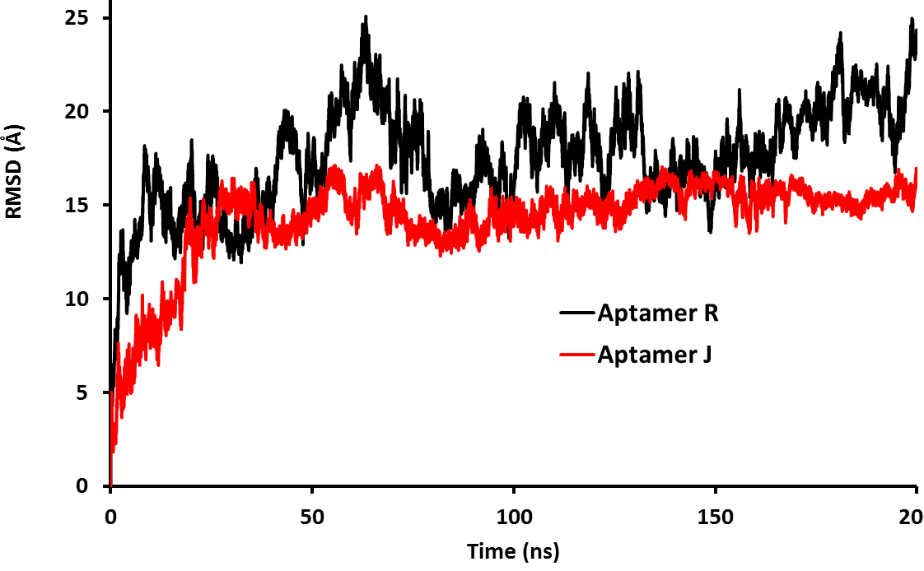

Figure S1: Root-mean-square deviation (RMSD) of the aptamers C atoms for the respective simulations relative to the first frame.

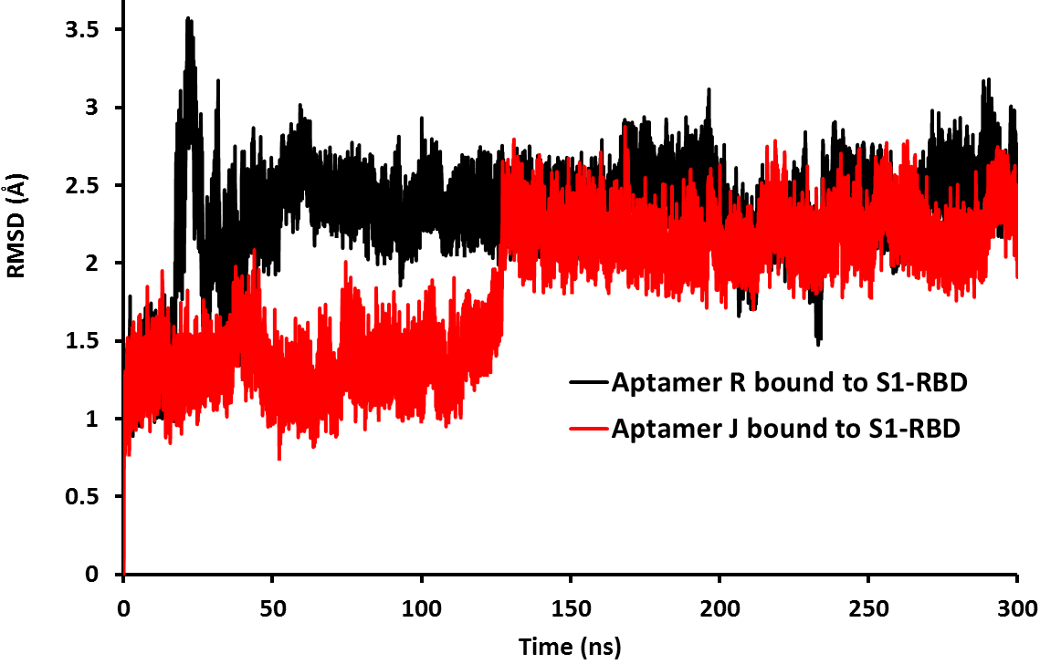
Figure S2: Root-mean-square deviation (RMSD) of the S1-RBD protein backbone atoms (N, Cα and C) for the respective simulations relative to the first frame.

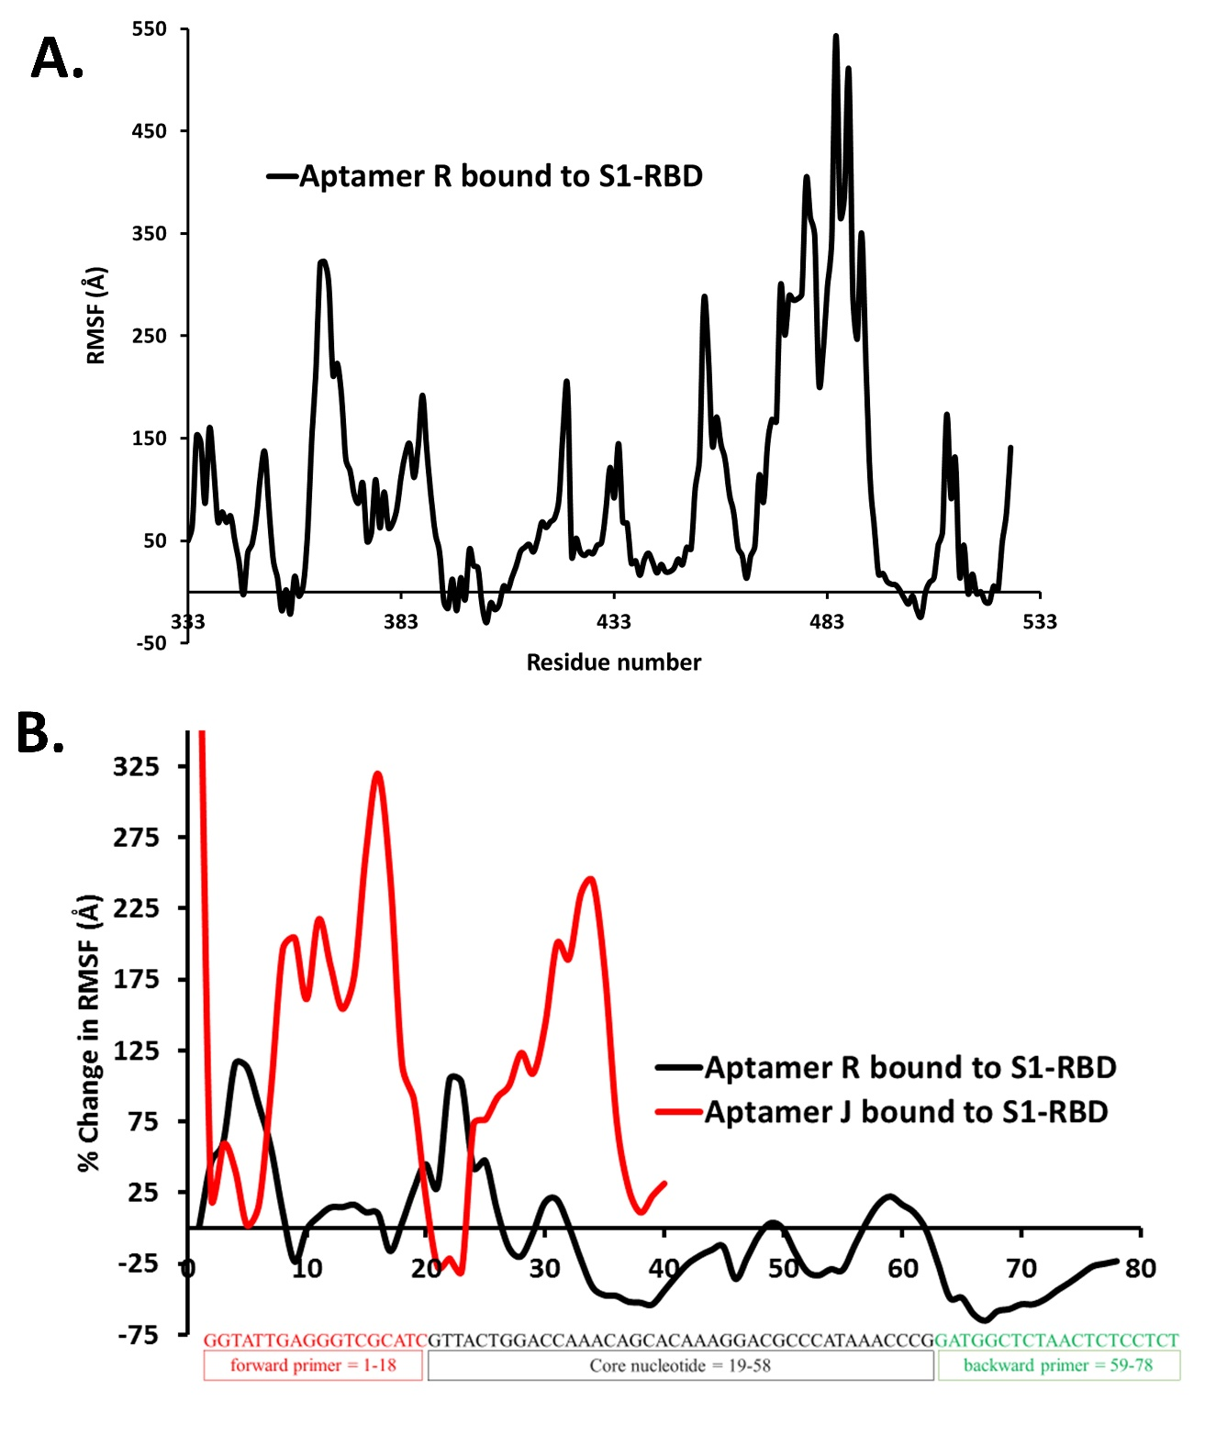
Figure S3: Showing the average percent change in root-mean-square fluctuations (RMSF) of A) the S1-RBD backbone atoms (N, Cα and C) upon binding of aptamer R and B) aptamer R and J in response to their binding to S1-RBD of SARS-CoV-2. Where a positive change in RMSF shows that residues have become more localized and a negative change is indicative of enhanced fluctuations upon aptamer binding.

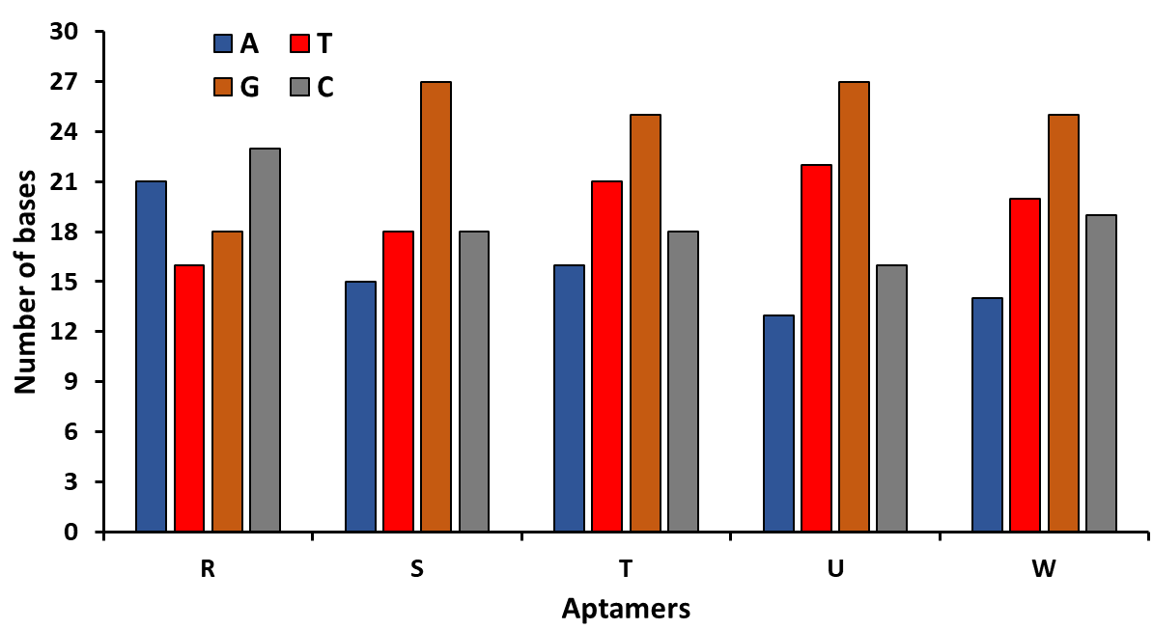
Figure S4: Illustrates total numbers of bases in selected five aptamer sequences.

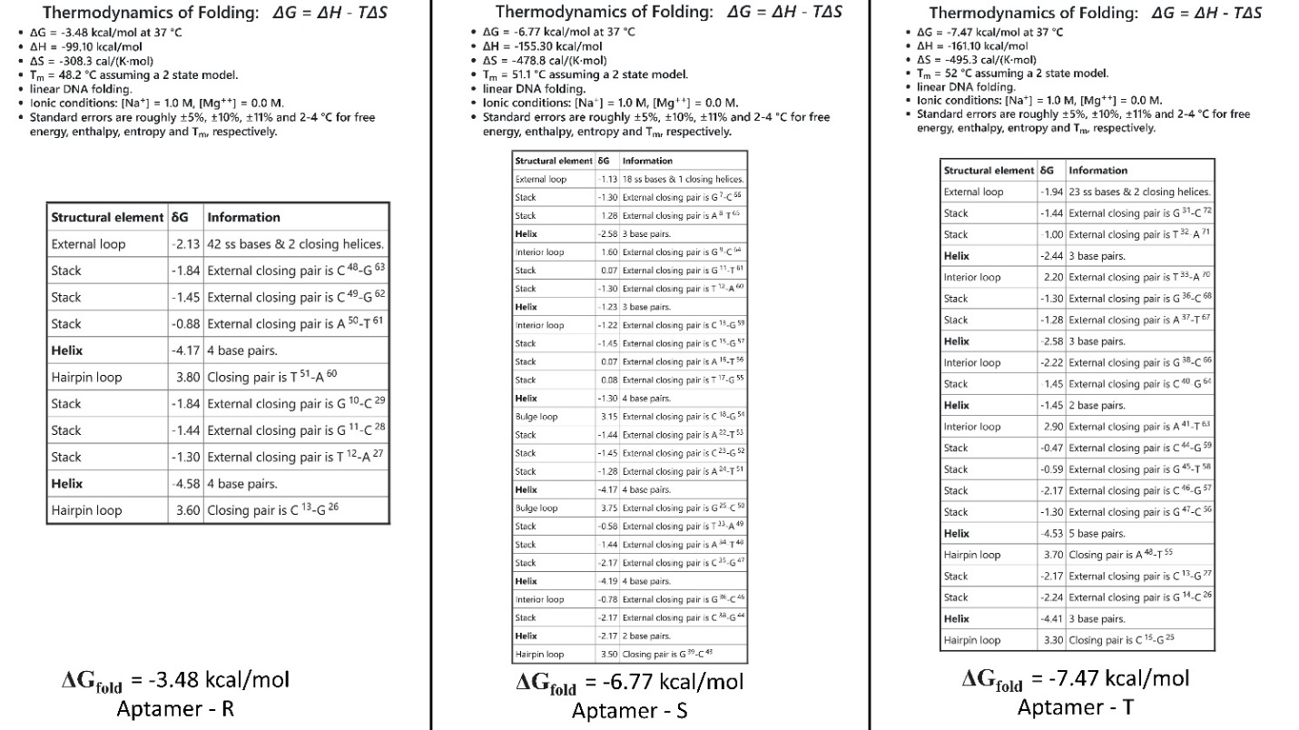
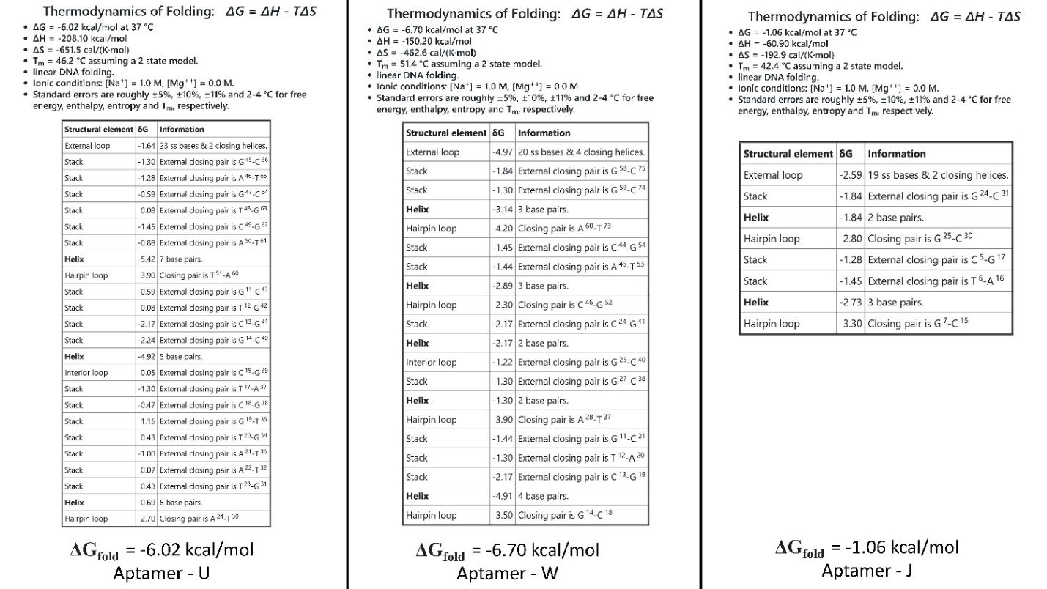
Figure S5: Illustrating the thermodynamics of folding for aptamers R, S, T, U, W, and J. predicted by mfold server¹.

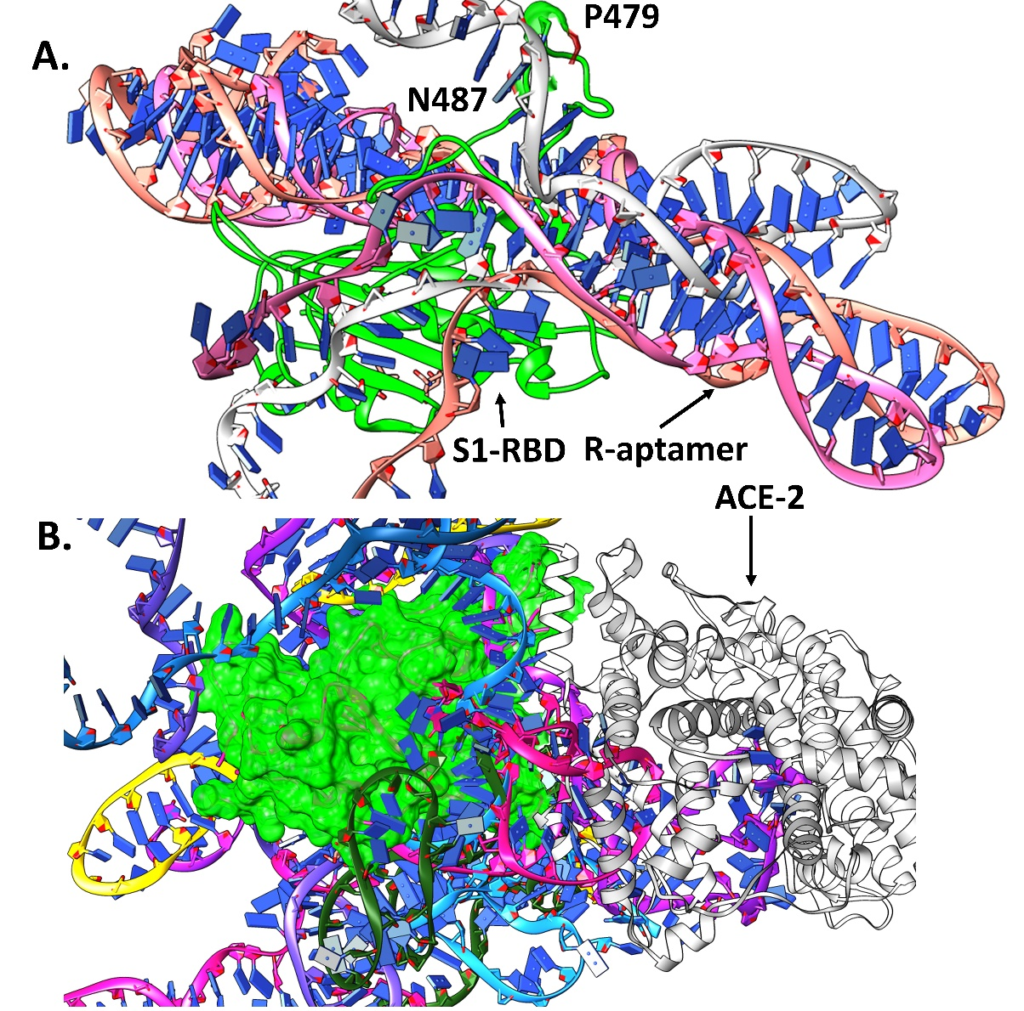
Figure S6: Illustrating the top 10 binding poses of R aptamer docked at the RBD (green) of S1-protein, where (A) shows that out of the top 10 poses, 3 R aptamer binds in a very identical fashion (where they bind at the RBM and will not allow the binding of S1-RBD with human ACE-2 receptor) and (B) shows that remaining 7 binding poses binds little far away from residue P479 and N487 but it binds in a way that will interfere with binding of ACE-2 receptor as observed by superimposing the docked complex (RBD - R aptamer) with ACE-2 receptor (grey) [PDB ID: 6MOJ].
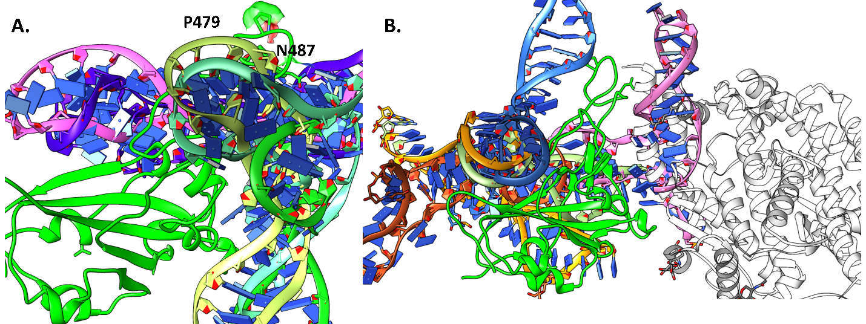
Figure S7: Illustrating the top 10 binding poses of J aptamer docked at the RBD (green) of S1-protein, where (A) shows that out of the top 10 poses 5 J aptamer binds in a very identical fashion (where they bind at the RBM and will not allow the binding of S1-RBD with human ACE-2 receptor) and (B) shows that remaining 5 binding poses does not bind at the RBM and expect 1 pose (pink) no other will interfere with binding of ACE-2 receptor as observed by superimposing the docked complex (RBD - R aptamer) with ACE-2 receptor (grey) [PDB ID : 6MOJ].

Table S1: Illustrates the folded 2D structure in Vienna format, folding energy (ΔG) in kcal/mol, and number of bases for a few potent aptamers.
 | Dot-bracket representation | ΔG_{fold} (kcal/mol) | # BP
R | .........((((............))))..................((((........))))............... | -3.48 | A's = 21, C's = 23, G's=18, T's = 16
R | .........((((............))))............((....)).....((.....))............... | -3.23 | A's = 21, C's = 23, G's=18, T's = 16
R | .........((((............))))............((....))........(((............)))... | -2.6 | A's = 21, C's = 23, G's=18, T's = 16
S | ......(((.(((.((((...((((.......((((.((...)).)))))))))))).)))..)))............ | -6.77 | A's = 15, C's = 18, G's=27, T's = 18
S | ......(((.(((.((((...((((..(((...)))((((....)))).)))))))).)))..)))............ | -6.56 | A's = 15, C's = 18, G's=27, T's = 18
S | ............(((...........))).......((((....)))).........(((............)))... | -6.16 | A's = 15, C's = 18, G's=27, T's = 18
S | ..........(((((.(((...............))).)))))..............(((............)))... | -5.99 | A's = 15, C's = 18, G's=27, T's = 18
S | ......(((((((.((((...((((.......((((.((...)).)))))))))))).)))............)))). | -5.96 | A's = 15, C's = 18, G's=27, T's = 18
T | ............(((.........)))...(((..(((.((..(((((......)))))...)).))).)))........ | -7.47 | A's = 16, C's = 18, G's=25, T's = 21
T | ......((((..(((.........)))...(((..(((.((..(((((......)))))...)).))).)))...)))). | -7.34 | A's = 16, C's = 18, G's=25, T's = 21
T | ........................((((.(((......))).))))....((.((....)).))................ | -7.22 | A's = 16, C's = 18, G's=25, T's = 21
T | ........................((((.(((......))).))))............(((....)))............ | -6.47 | A's = 16, C's = 18, G's=25, T's = 21
T | ........................((((.(((......))).))))............((((..........)))).... | -6.53 | A's = 16, C's = 18, G's=25, T's = 21
U | ..........(((((.((((((((.....)))))))).))))).(((((((........)))))))............ | -6.02 | A's = 13, C's = 16, G's=27, T's = 22
U | ............(((.........)))........((((.....(((((((........))))))).......)))). | -5.39 | A's = 13, C's = 16, G's=27, T's = 22
U | ......((((..(((.((((((((.....)))))))).)))...(((((((........))))))).......)))). | -5.04 | A's = 13, C's = 16, G's=27, T's = 22
W | ..........((((...))))..((.((........)).))..(((.....)))...(((............)))... | -6.7 | A's = 14, C's = 19, G's=25, T's = 20
W | ............(((..((.(((.....)))...))..)))..(((.....)))...(((............)))... | -6.25 | A's = 14, C's = 19, G's=25, T's = 20
W | ..........((((...))))....((((.....((((.(..((((.....)))).).)))).........))))... | -6.09 | A's = 14, C's = 19, G's=25, T's = 20
W | ..........((((...)))).....((((((..((((.(..((((.....)))).).))))..))..))))...... | -6.04 | A's = 14, C's = 19, G's=25, T's = 20
J | ....(((.......)))......((....))........ | -1.06 | A's = 15, C's = 13, G's=8, T's = 4
J | ((..(((.......))).))...((....))......... | -0.23 | A's = 15, C's = 13, G's=8, T's = 4
J | .........((............))............... | -0.22 | A's = 15, C's = 13, G's=8, T's = 4

Table S2: Based on the sequence number of A-T and G-C pairs that can be formed was calculated.
 | R | S | T | U | W
A-T | 16 | 15 | 16 | 13 | 14
G-C | 18 | 18 | 18 | 16 | 19
Total | 34 | 33 | 34 | 29 | 33

Table S3: Based on the sequence number of unpaired bases in the sequence was calculated
 | R | S | T | U | W | J
A | 5 | 3 | 0 | 0 | 0 | 11
T | 0 | 0 | 5 | 9 | 6 | 0
G | 0 | 9 | 7 | 11 | 6 | 0
C | 5 | 0 | 0 | 0 | 0 | 5
Total | 10 | 12 | 12 | 20 | 12 | 16

Table S4: Hydrogen bond % occupancy formed between aptamers (R and J) and S1-RBD of SARS-CoV-2.
Aptamer | Hydrogen Bond Acceptor | Hydrogen Bond Donor | % | Distance (Å) | Angle
R | A39@OP2 | ASN450@NDH | 88.12 | 2.8 | 165.2
R | C38@OP(1+2) | SER349@OG | 97.92 | 2.6 | 163.3
R | C38@OP1 | SER349@NH | 63.94 | 2.8 | 153.8
R | A39@OP2 | ASN448@N2H | 72.63 | 2.8 | 164.7
R | ASN450@OD1 | A40@N6H | 49.78 | 2.8 | 154.7
R | C66@OP2 | ARG403@N2H | 39.95 | 2.8 | 154.8
R | C66@OP(1+2) | ARG403@N1H | 66.93 | 2.8 | 154.5
R | A27@OP2 | NAG@O(3+4)H | 75.45 | 2.6 | 165.0
R | A37@OP1 | ASN354@N2H | 36.86 | 2.8 | 163.2
R | A37@OP1 | ARG466@N1H | 46.36 | 2.8 | 157.9
R | G46@OP2 | GLN498@NEH | 26.98 | 2.8 | 160.4
R | C47@OP1 | THR500@OGH | 26.16 | 2.7 | 163.0
R | C38@O4 | ARG346@N2H | 25.58 | 2.9 | 146.8
R | C66@OP2 | TYR453@OH | 25.45 | 2.7 | 160.9
R | C66@OP1 | TYR505@OH | 22 | 2.7 | 162.6
R | GLY447@O | G42@N2H | 18.28 | 2.8 | 157.3
R | C70@OP1 | SER477@OGH | 18.23 | 2.8 | 157.3
R | A31@OP2, O5 | ARG357@N1H | 41.49 | 2.8 | 156.2
R | G46@OP2 | GLY446@N1H | 15.62 | 2.9 | 163.7
R | T71@OP1 | SER477@OGH | 26.17 | 2.7 | 165.2
R | VAL445@O | G43@N(1+2)H | 24.43 | 2.9 | 152.0
R | G10@OP1 | ARG357@N2H | 12.9 | 2.8 | 160.5
R | C45@O2 | ASN501@N2H | 12.08 | 2.9 | 158.7
R | ASN448@OD1 | A41@N6H | 12.00 | 2.9 | 151.2
R | G11@OP1 | ASN334@NDH | 21.98 | 2.8 | 161.4
J | A35@OP2 | TYR489@OH | 73.32 | 2.7 | 165.0
J | G1@O5 | SER501@NH | 65.34 | 2.9 | 158.7
J | A36@N(1+7) | GLN493@NEH | 97.33 | 2.9 | 160.7
J | A35@OP2 | SER447@OGH | 49.03 | 2.6 | 165.3
J | A22@OP2 | ARG403@NH | 83.5 | 2.8 | 160.9
J | LEU492@O | C37@N4H | 38.19 | 2.9 | 160.7
J | C37@O2 | TYR449@OH | 30.53 | 2.8 | 162.9
J | A34@OP2 | GLY476@NH | 28.58 | 2.8 | 157.5
J | G25@OP2 | GLN409@NEH | 28.58 | 2.8 | 156.4
J | G24@N7 | LYS417@NH | 36.2 | 2.9 | 162.4
J | G25OP(1+2) | ARG408@N1H | 85.74 | 2.8 | 156.5
J | A35@OP2 | ASN487@N2H | 14.74 | 2.8 | 159.5
J | G17@OP2 | NAG@O(3+4)H | 27.29 | 2.6 | 165.7
J | A4@N1 | GLN498@NEH | 12.43 | 2.9 | 164.1
J | PHE490@O | A36@N6H | 10.66 | 2.9 | 148.1
J | LEU455@O | A34@N6H | 10.24 | 2.9 | 151.1
References:
1. Zuker, M., Mfold web server for nucleic acid folding and hybridization prediction. Nucleic Acids Res 2003, 31 (13), 3406-15.

