Supplementary table 1. Multivariate logistic analysis of major characteristics for diagnostic prediction in training group.
Characteristics | Multivariate analysis
 | OR (95% CI) | P
Clinical model 1
Age | 0.95（0.91,0.98） | <0.01
Size group
≤10mm | Ref | <0.01
>10mm | 3.14 (1.35,7.58)
ACR score | 1.28 (1.09,1.54) | <0.01
Psammoma body group
Absent | Ref
Present | 3.11 (1.37,7.29) | <0.01
Adler grade
0 | Ref
I | 0.25 (0.09,0.65) | <0.01
II | 1.04 (0.25,4.52) | 0.96
III | 0.24 (0.04,1.26) | 0.09
Clinical model 2
Age | 0.95 (0.91,0.99) | 0.01
Size | 1.16 (1.06,1.28) | <0.01
ACR TIRADS score | 1.28 (1.08,1.53) | <0.01
Psammoma body | 1.08 (1.01,1.16) | 0.03
Adler grade
0 | Ref
I | 0.28 (0.11,0.70) | <0.01
II | 1.16 (0.29,5.00) | 0.83
III | 0.16 (0.02,0.93) | 0.05

Supplementary table 2. Diagnostic performance of two clinical models that contained different variables.
Diagnostic performance | Clinical model1 | Nomogram1 | Clinical model 2 | Nomogram 2
Training group
Sensitivity | 56.1% | 68.2% | 90.9% | 86.4%
Specificity | 92.5% | 82.5% | 57.5% | 62.5%
AUC | 0.804 | 0.822 | 0.809 | 0.820
Validation group
Sensitivity | 79.4% | 100.0% | 94.1% | 94.1%
Specificity | 75.0% | 53.6% | 60.7% | 60.7%
AUC | 0.794 | 0.803 | 0.818 | 0.798

a.
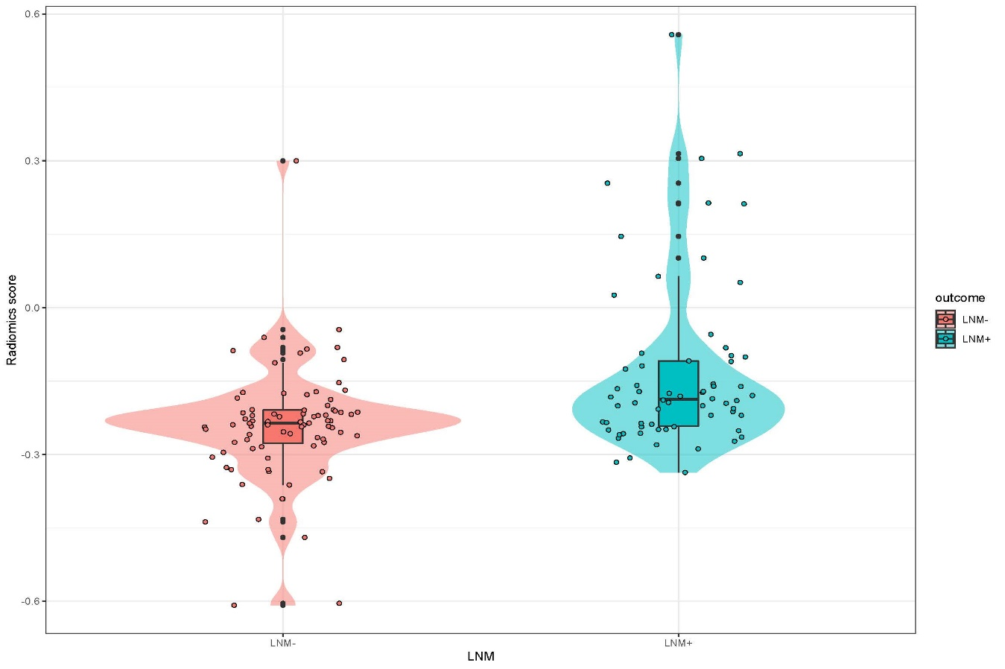
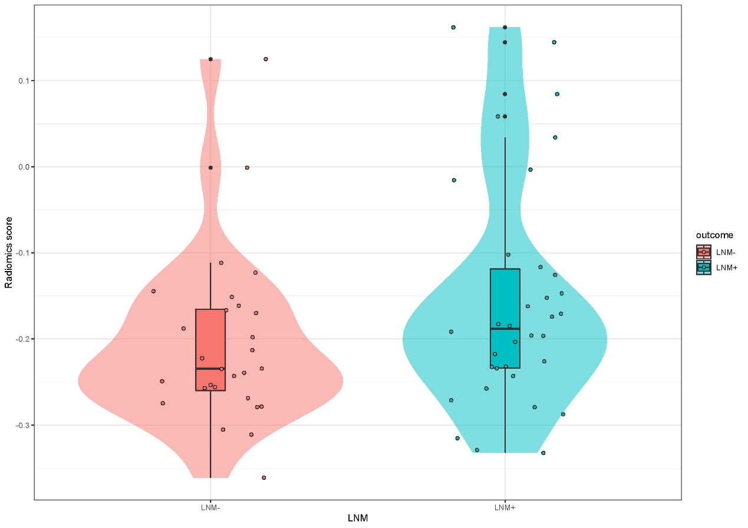
b.
Supplementary figure 1. Violin plots for radiomics model in the training group (a) and validation group (b).

