Supplementary Information for
Paleomagnetic evidence for Neoarchean plate mobilism

Jikai Ding^{a, b}, Chris Rogers^{c}, Ulf Söderlund^{d, e}, David A.D. Evansª, Zheng Gong^{a, f}, Richard E. Ernst^{c}, Kevin Chamberlain^{g}, Taylor Kilian^{h}

ª Department of Earth & Planetary Sciences, Yale University, New Haven, CT 06520, USA
^{b} State Key Laboratory of Biogeology and Environmental Geology, China University of Geosciences, Beijing 100083, China
^{c} Department of Earth Sciences, Carleton University, Ottawa, ON, Canada
^{d} Department of Geology, Lund University, Sölvegatan 12, SE-223 62 Lund, Sweden
^{e} Department of Geosciences, Swedish Museum of Natural History, Box 50 007, SE-104 05 Stockholm, Sweden
^{f} Department of Earth and Planetary Sciences, Harvard University, Cambridge, MA 02138, USA
^{g} Department of Geology & Geophysics, University of Wyoming, Laramie WY, USA
^{h} KoBold Metals, Berkeley, California 94704, USA

A1 Methods
A1.1 U-Pb ID-TIMS geochronology
Approximately 200 g of each sample was processed at the department of Geology, Lund University, following the procedure described by Söderlund and Johansson (2002). Approximately 40 brown baddeleyite grains of excellent quality were recovered from one sample from dike J20S24 near the Stillwater Mine (45°23'36.91"N, 109°52'58.26"W).
The best-quality baddeleyite grains were transferred to Teflon© dissolution capsules and rinsed repeatedly in ultrapure 7 M HNO₃ and H₂O in order to dilute the Pb blank. An ultrapure HF-HNO₃ mixture was added to the dissolution capsules together with a ²⁰⁵Pb-²³³⁻²³⁶U tracer solution. Capsules were then placed in an oven at 190°C for 3 days until the grains were fully dissolved. After dissolution, the samples were dried down on a hotplate and re-dissolved in ultrapure 6.2 M HCl with the addition of ultrapure 0.25 M H₃PO₄ before being dried down again on a hotplate. The samples were dissolved in 2 μl of silica gel and loaded on outgassed Re filaments. The U and Pb isotopic compositions were measured at the Department of Geosciences at the Swedish Museum of Natural History in Stockholm using a Thermo Finnigan Triton Mass Spectrometer equipped with Faraday cups and a Secondary Electron Multiplier (SEM). The intensities of ²⁰⁸Pb, ²⁰⁷Pb, ²⁰⁶Pb and ²⁰⁵Pb were measured in static mode using the Faraday detectors. An ETP SEM equipped with a RPQ filter was used to measure the intensity of ²⁰⁴Pb. The SEM-Faraday gain was controlled by measuring a ~5-10 mV signal alternating between Faraday and SEM detectors prior to each Pb analysis. The ²³³U, ²³⁶U and ²³⁸U isotopic measurements were made in dynamic (peak-switching) mode at filament temperatures greater than 1350°C. Procedural blanks are typically 0.3 pg Pb and 0.03 pg U at the Swedish Museum of Natural History. Mass fractionation is 0.1% per mass unit for Pb, determined by replicate analyses of NBS standards SRM 981 and SRM 983. U fractionation was determined directly from the measured ²³³U/²³⁶U isotopic ratio. Initial Pb compositions were taken from the model common Pb evolution curve (Stacey and Kramers, 1975). The decay constants used were 1.55125x10⁻¹¹ for ²³⁸U and 9.8485x10⁻¹⁰ for ²³⁵U (Jaffey et al., 1971), with the isotopic composition of U being ²³⁸U/²³⁵U = 137.88 (Steiger and Jager, 1977). The listed uncertainties in Pb/U ratios were calculated by propagating the within-run error for measured isotopic ratios, with the uncertainties in fractionation (±0.04 for Pb, absolute uncertainties), Pb and U blank concentration (±50%), and Pb blank composition (2.0% for ²⁰⁶Pb/²⁰⁴Pb and 0.2% for ²⁰⁷Pb/²⁰⁴Pb). Analytical results were calculated and plotted using the Microsoft Excel Macro, Isoplot (Ludwig, 2003).

A1.2 Rock Magnetic and Paleomagnetic analyses
In this study, a portable drill was used in sample collection for most sites; oriented block samples were collected when drilling was not feasible. Orientation for the core samples was achieved using a magnetic compass with clinometer, usually supplemented by a solar compass. No significant difference was observed between the results using the two orientation devices. All the samples were cut into 1–3 cylindrical paleomagnetic specimens (2.5 cm in diameter, and approximately 1 to 1.5 cm in height) in the laboratory.
All samples were subjected to stepwise thermal demagnetization in 15 to 25 steps up to 580 or 590 ºC in a nitrogen-gas environment using an ASC-Scientific TD-48 furnace in which’s internal residual fields is less than 10 nT. Sister samples for sites J20S24-26 were also selected for alternating-field demagnetization using a Molspin tumbler AF demagnetizer. Measurements of the natural remanent magnetization (NRM) and all subsequent demagnetization steps were conducted on an automated 2G-Enterprises DC SQuID magnetometer. The demagnetizations and remanence measurements were conducted in a shielded chamber, which has an ambient field typically less than 300 nT. To characterize the properties of magnetic carriers in the samples, rock magnetic studies were conducted on representative samples. Thermomagnetic curves of bulk susceptibility versus temperature were achieved by measuring the bulk susceptibility from –192 to 700 ºC followed by cooling back to room temperature in argon atmosphere. The measurements were conducted using an AGICO KLY-4S Kappabridge equipped with a high-temperature apparatus and a cryostat. All these experiments were conducted in the Paleomagnetic Laboratory at Yale University. In addition, hysteresis loops and backfield curves were obtained between –500 mT and 500 mT using a Princeton Measurement Corporation MicroMag 2900 Series alternating gradient magnetometer (AGM) at the Yale Archaeomagnetism Laboratory.
The paleomagnetic data were analyzed using the computer packages developed by Enkin (1990) and Cogné (2003). Directional data were fit using principal component analysis (Kirschvink, 1980), and the mean directions were calculated using Fisher statistics (Fisher, 1953). The paleogeographic reconstructions were made using the GPlates freeware package (Williams et al., 2012).

A2 Results
A2.1 Rock magnetic results
Temperature-dependent low-field magnetic susceptibility at high temperatures all shows that the Curie temperatures of the samples are in the range of 570–580 ºC (Fig. S1), which is a typical feature for near-stoichiometric magnetite (Dunlop and Özdemir, 1997). Low-field magnetic susceptibility measurements at low temperatures (–192 to 15 ºC) show a characteristic peak at around –153 ºC during heating (Fig. S1), which is consistent with the Verwey transition for magnetite (Verwey, 1939).
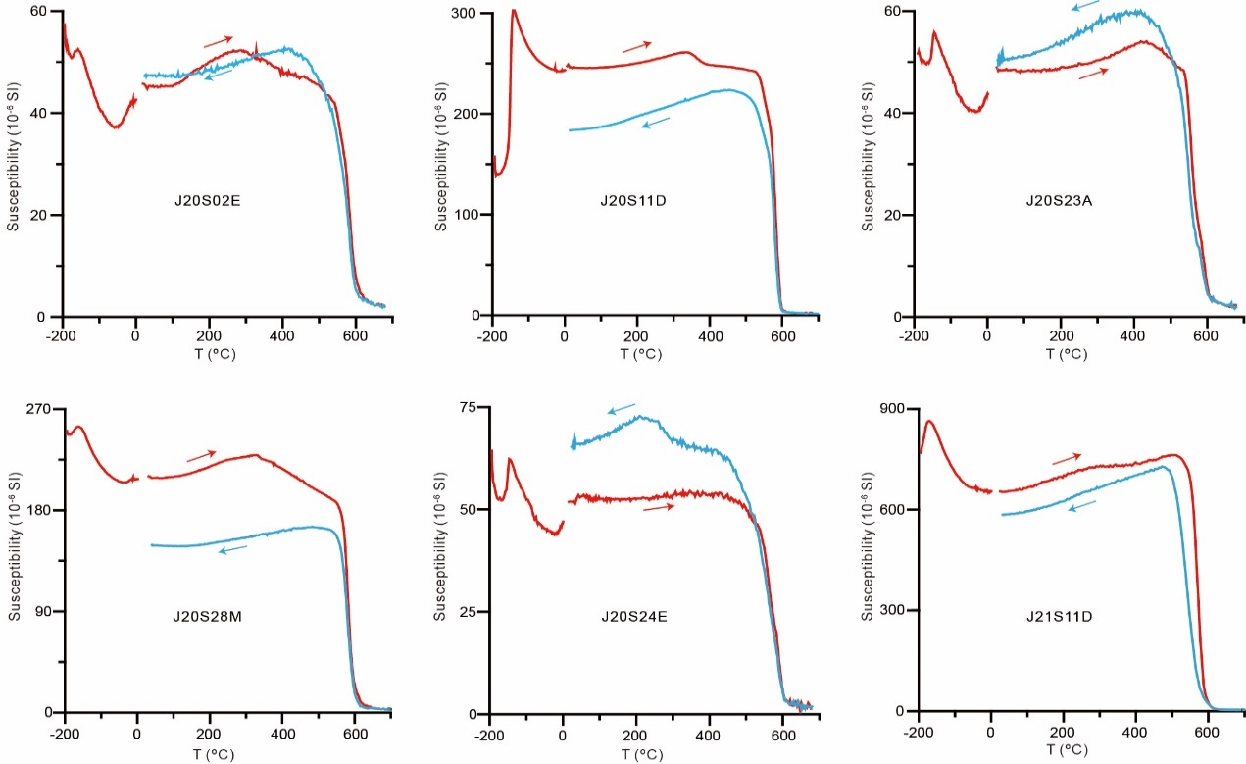
Fig. S1. Low-field magnetic susceptibility versus temperature curves during heating (red curve) and cooling (blue curve) for representative specimens of the ca. 2480 Ma Elbow Creek dikes.

Hysteresis loops and isothermal remanent magnetization (IRM) curves suggest that the samples already reach saturation magnetization (Ms) before 200 mT. The back-field demagnetization of IRM shows that the coercivities of remanence for most specimens are around 20 mT (Fig. S2). In the Day plot (Dunlop, 2002), most hysteresis data fall in the pseudo-single domain (PSD) grain size area or lie along the line which indicates a mixed population of single-domain (SD) and multi-domain (MD) grains (Fig. S2). These rock magnetic experiments suggest that SD or PSD magnetite is the main magnetic mineral in these samples.
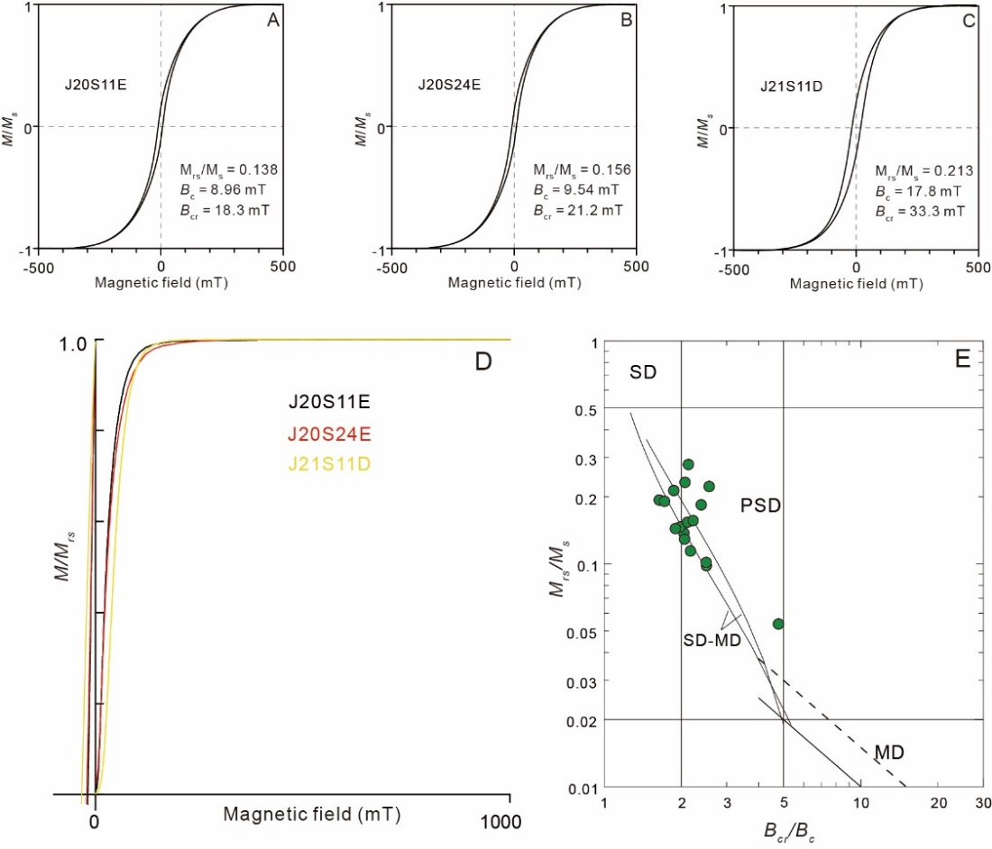
Fig. S2. Magnetic hysteresis loops (A-C), isothermal remanent magnetization (IRM) acquisition curves and back-field demagnetization of saturation IRM (D) for representative specimens of the ca. 2480 Ma dikes. (E) Day plot (Dunlop, 2002) of the hysteresis parameters. Ms, saturation magnetization; Mrs, saturation remanence; Bcr, coercivity of remanence; Bc, coercivity; SD, single-domain; PSD, pseudo-single domain; MD, multi-domain.
A2.2 Paleomagnetic results
After stepwise thermal demagnetization on all the samples from the dikes, the high temperature components (HTCs) were achieved from 20 dikes. Unfortunately, six sites from six dikes did not yield a stable HTC (Table S1).
A2.2.1 Component A
Twelve dikes yielded a consistent HTC (component A) which is directed south-southeast and down with moderate inclination (Fig. S3). Among them, nine dikes hold only two components, with low-temperature component (LTCs) removed before 370 ºC, usually directed north and down with intermediate inclinations (similar to the present magnetic field at the sampling sites; Fig. S4), while some LTCs were scattered. The HTC was isolated between 500 and 580 ºC, directed southeast and down with intermediate inclinations. The samples from three dikes (J20S11, J20S16 and J20S19) hold three components. The LTC was removed before 500 ºC, and is also distributed around the present magnetic field. Between 500 and 560 ºC, the middle temperature component (MTC) is directed SE and up with moderate inclination. After the LTCs and MTCs were removed, the HTCs were obtained from 565 to 590 ºC (Fig. S3).
A2.2.2 Component B
Five dikes yielded a different HTC (component B; Fig. S4) with southerly or northerly declination and shallow inclination. Among these, samples from dike J20S32 yielded a LTC before 300 ºC which distributed around the present-day magnetic field direction. The MTC was isolated from 370 to 470 ºC, but the MTCs from the samples were scattered. After the LTCs and MTCs were removed, the HTC was isolated between 500 and 580 ºC and directed north-northeast with shallow inclination. For dike J21S02, the LTC was isolated before 300 ºC, distributed around the present magnetic field. The HTC was isolated from 510 to 580 ºC, directed south with shallow inclination. For dike J21S04, the LTC was isolated before 300 ºC, directed south and up with moderate inclination. The HTC was isolated from 500 to 580 ºC which is also directed south with shallow inclination. The samples from dike J21S09 have only one component, with six of eight samples yielding an HTC directed northeast with shallow inclination. All the samples from dike J21S05 had only one component; five samples yielded an HTC at 580 ºC, directed southeast and up with gentle inclination, while the other three samples achieved an HTC by 370 ºC, directed south or SSE with shallow inclination.
A2.2.3 Components C and D
Three dikes (J20S14, J20S31 and J20S33) yield two other HTCs (Fig. S4). The samples from dike J20S14 and J20S31 had two components: the LTC was isolated before 300 ºC and is similar to the present-day magnetic field direction, whereas the HTC (component C) was isolated between 550 and 580 ºC, directed southeast or east and up with moderate inclination (Fig. S4). Two samples from dike J20S33 also had two components. The LTC was isolated before 300 ºC, and the HTC (component D) was removed by 580 ºC with easterly declination and shallow inclination (Fig. S4). Four samples from this dike had only one component, and they also yielded a HTC close to component D of the other two samples.
We selected four specimens from dike J20S24 and nine specimens from dike J20S2526 for alternating-field (AF) demagnetization. Most of the samples could isolate
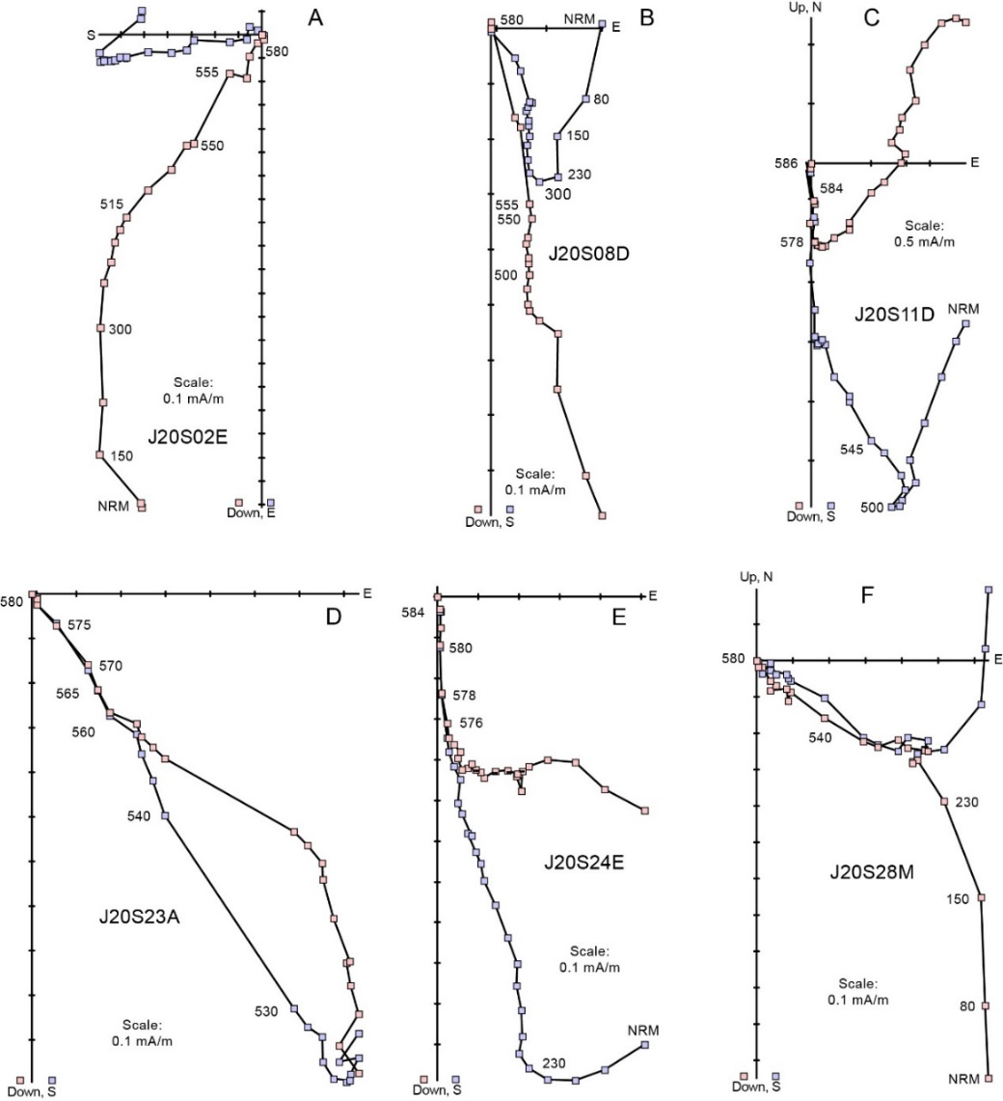
Fig. S3. Orthogonal plots of progressive thermal demagnetization results for representative ca. 2480 Ma Elbow Creek dike specimens in geographic coordinates. Blue (red) circles represent the horizontal (vertical) components of magnetization. Numbers show thermal demagnetization steps in unit of °C.
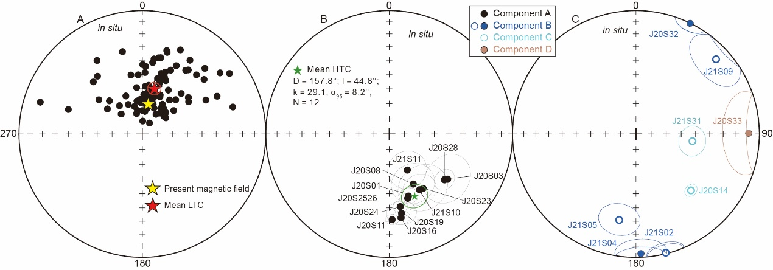
Fig. S4. Equal-area plots of the LTC and HTCs for the mafic dikes in the Stillwater Complex in geographic coordinates.

a soft component (SC) and a high-coercivity component (HC). The SCs were isolated before 11 mT, they were low-stability and randomly oriented. The HC was achieved when the alternating field was increased to 100 mT. The HC is directed south-southeast and down with shallow inclinations (Fig. S5). Compared with thermal demagnetization results, the inclination obtained using the AF demagnetization is 13.5° shallower for dike J20S24 and 19.8° shallower for dike J20S2526 (Fig. S5D). Based on the orthogonal plots, a LTC was isolated after the thermal demagnetization (Fig. S5A, C). In contrast, after the AF demagnetization, the specimens show only one component or the SC was weaker than the LTC, suggesting AF could not effectively replicate the HTC. Therefore, we only use the thermal demagnetization results for the final calculation.
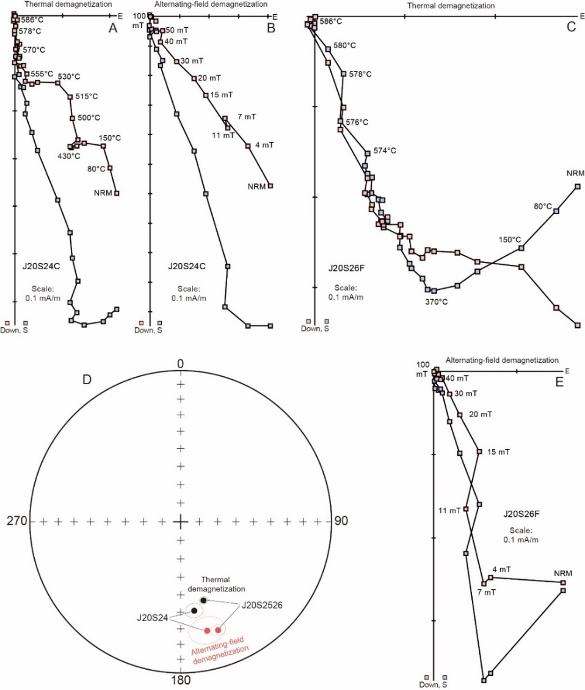
Fig. S5. Thermal and alternating-field demagnetization results for dike J20S24 and dike J20S2526. A, B, C, E, Orthogonal plots of thermal and alternating-field demagnetization results in geographic coordinates. D, Equal-area plots of alternating-field (red dots) and thermal (black dots) demagnetization means for dike J20S24 and dike J20S2526.

A2.3 Baked-contact tests
In order to conduct the baked-contact tests for the dikes, the host rocks were also collected and demagnetized. Two positive baked-contact tests demonstrate that the component HTC (component A) can be interpreted as primary in origin. The first positive baked-contact test is from dike J20S24, which is the U-Pb dated type locality for the Elbow Creek swarm. The site locality is a roadcut above the Stillwater Mine, containing numerous dikes with similar geochemistry (Rogers et al., 2016); host anorthosites are well exposed there and in adjacent roadcuts. The baked anorthosite exocontact samples (J21S12) were collected in 0.2–1.0 m away from the dike margin, and the unbaked host rocks (J20S27 and J21S13) were collected 100 m away from the dike. The samples from the site J21S12 yielded an HTC that is directed SE and down with moderate inclination, broadly similar to that of the dike. Samples from the unbaked anorthosites yielded an HTC directed southeast with shallow, generally upward inclination (Fig. S6).
The second baked-contact test was conducted for dike J20S28. The baked granite (biotite quartz monzonite, site J20S29) samples were collected ca. 2–10 m away from the margin of the hectometer-wide dike. The unbaked granite samples were collected ca. 400 m away (site J20S30). An HTC that is directed southeast and down with moderate inclination was isolated from site J20S29, which is identical to the HTC of the dike J21S12 (Fig. S6). The samples of distant host rock (site J20S30) yield a dual-polarity HTC directed southeast up or northwest down, with moderate inclination (Fig. S6). The HTC direction from the baked granite samples is similar to that of the dikes but is different from the unbaked samples, which demonstrates that the HTC from the dike is primary in origin (Fig. S6).
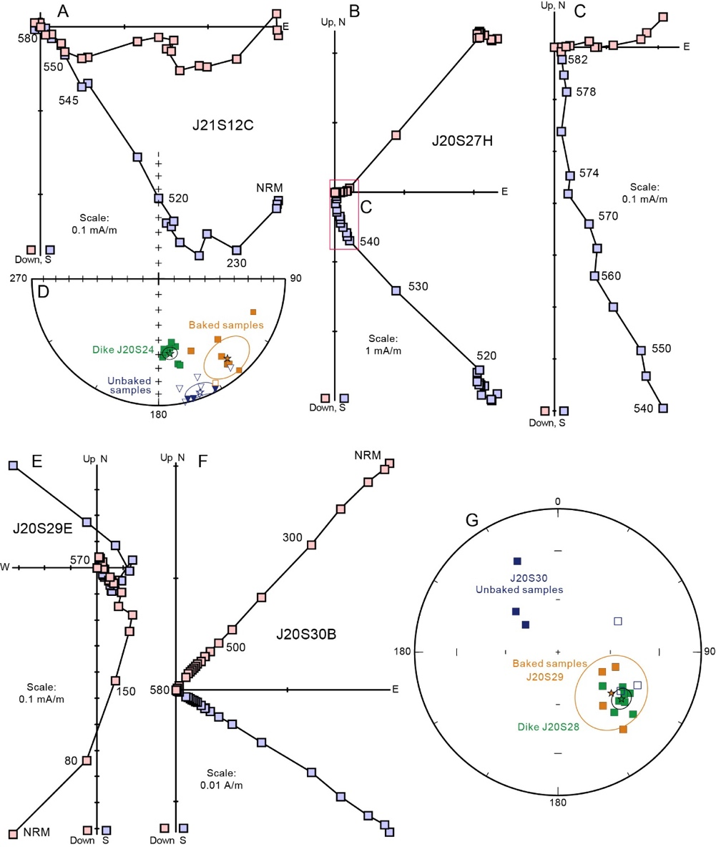
Fig. S6. Baked-contact tests for the dikes J20S24 (A-D) and J20S28 (E-G). (A-C) Orthogonal demagnetization diagrams of representative specimens from the baked (A) and unbaked (B-C) host rocks of dike J20S24. (D) Equal-area projection of the HTCs from the dike JLQ15 (green), baked (orange) and unbaked (blue) host specimens, and the mean HTC direction (stars). Numbers show thermal demagnetization steps in unit of °C.

Baked-contact tests were also conducted for dikes J20S03, J20S08, J20S11, J20S16 and J20S19. The HTCs of the baked samples from sites J20S12, J20S15 and J20S17 located amid the HTCs of the dikes and the unbaked host rocks (Fig. S7). The HTCs of the baked sampled from sites J20S09 and J20S20 is similar to the host rocks, but they are different from the HTCs of the dikes. The differences between the HTCs from the dikes and the host rocks suggest the component A could not be the results of regional remagnetization (Fig. S7).

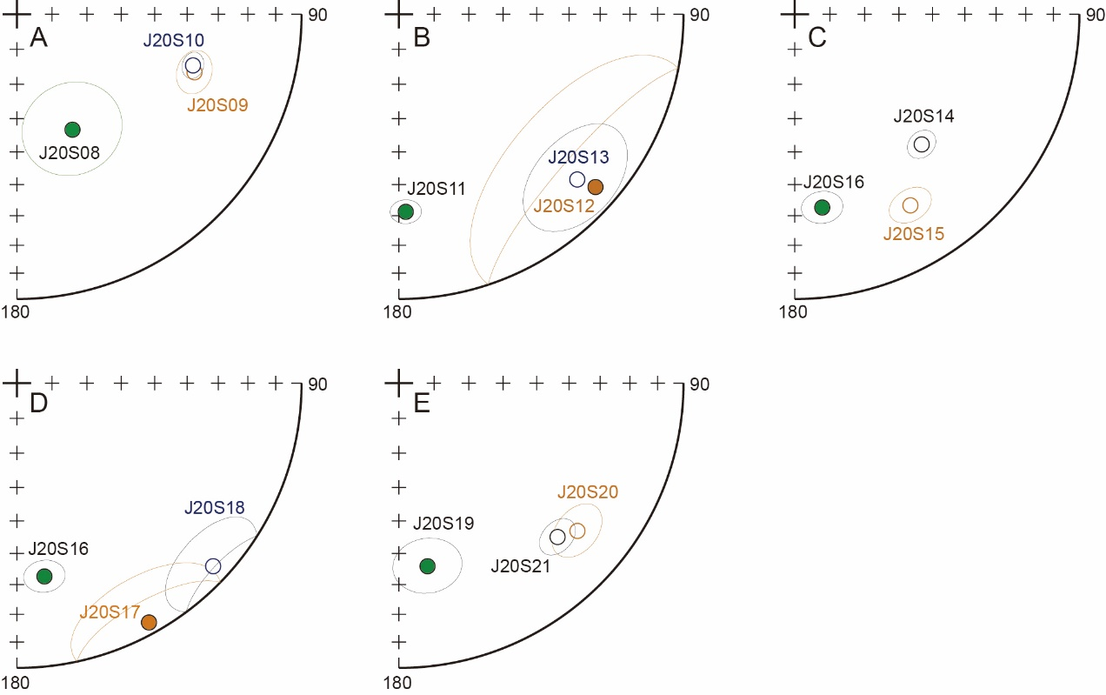
Fig. S7. The baked-contact tests for the dikes J20S08 (A), J20S11 (B), J20S16 (C, D), and J20S19 (E). In each trio of sites, numbering begins with the dike, continues with the exocontact of baked host rocks, and concludes with distal host rocks.

After demagnetization, the host rocks from sites J20S12, J20S13, J20S17, J20S18, J20S20, J21S12 and J21S13 also yielded a MTC directed southeast and up with moderate inclination (Fig. S8). The MTCs from these host rocks and the dikes J20S11, J20S16 and J20S19 are similar to the HTCs of the dike J20S14 (Fig. S8). Furthermore, the MTC was only isolated from the dikes and host rocks around dike J20S14, suggesting the MTC could be the result of hydrothermal remagnetization due to the intrusion of dike J20S14 (Fig. S8). Although not a strict baked-contact test due to merely a general spatial association with dike J20S14, the results suggest that its HTC (component B) should be primary.

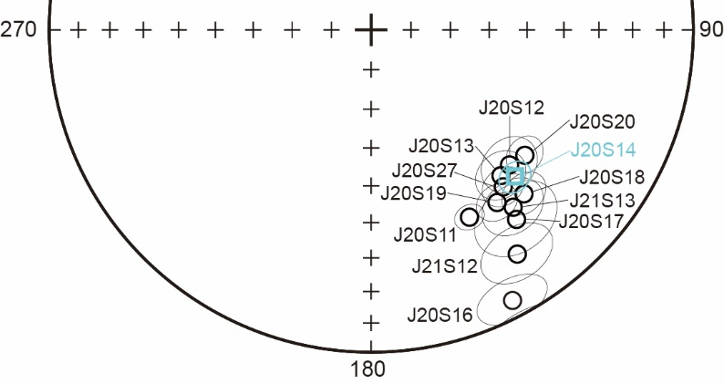
Fig. S8. The distribution of the middle temperature components (MTCs) from three dikes (J20S11, J20S16 and J20S19) and some host rocks, and the HTC of dike J20S14 (in geographic coordinates).

In summary, the positive baked-contact tests suggest that both the high-temperature component A of the twelve Elbow Creek dikes dated at 2480 Ma and the high-temperature component C from dike J20S14 should be primary.

A2.4 Tilt correction
Before tilt-correction, the mean HTC direction for the twelve Elbow Creek dikes is: D = 157.8º, I = 44.6º, k = 29.1, α95 = 8.2º. If we use the layers of the Stillwater Complex to apply a tilt correction, the HTCs became scattered (Fig. S9) and the mean direction is: D = 69.3º, I = 47.3º, k = 11.5, α₉₅ = 15.2º. When we apply the stepwise tectonic correction, the HTCs clustered optimally at the 19.4% unfolding level (Fig. S10). These results suggest the dikes were magnetized after the Stillwater Complex was tilted and broadly folded.
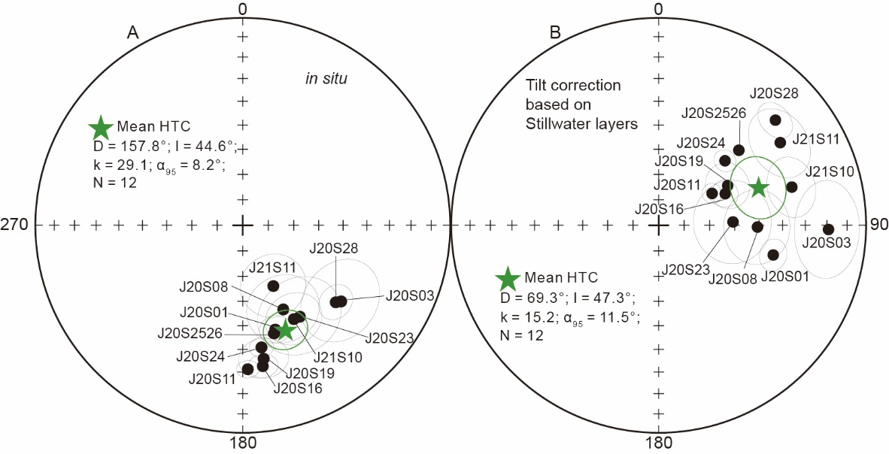
Fig. S9. The high temperature components (HTCs) of the dike rocks in geographic coordinates (A), and tilt correction using the layers of the Stillwater Complex (B).

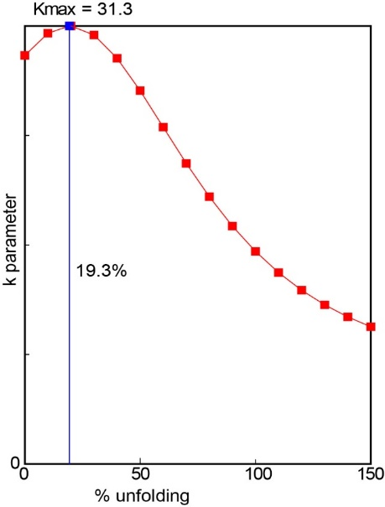
Fig. S10. Results of stepwise unfolding of the mean HTC direction based on the layers from the Stillwater Complex.
Because most locally preserved Cambrian strata locally preserved atop the central outcrop region of the Stillwater Complex have variable but low northerly dips (Page and Nokleberg, 1974; Geraghty, 2013), we apply a regional tilt correction using these strata. By averaging the structural attitudes of Paleozoic strata overlying the basement in the area of the sampling sites, the mean bedding is: 274.8º (right-hand strike) and 17.7º to the north (Fig. S11). After correction for this tilt, the mean direction for the twelve dikes with high-temperature component A is: D = 145.3º, I = 59.5º, k = 29.1, α₉₅ = 8.2º (Fig. S12). The mean paleomagnetic pole for the twelve VGPs from the twelve Elbow Creek dikes is: 2.1 ºN, 275.8 ºE, A₉₅ = 11.2º.
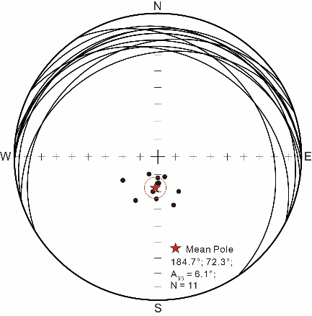
Fig. S11. Stereonet of bedding planes (and their poles) for the Cambrian strata.
Because the dikes all intruded into the Stillwater Complex, they are younger than ca. 2710 Ma. For component B, after tilt correction using the Paleozoic strata, the direction is similar to the C1 direction obtained from the Stillwater Complex (Fig. S12; Selkin et al., 2008), suggesting they intruded after the tilting of the Stillwater Complex, and possibly of similar age (but without any robust constraint). Component C is close to the paleomagnetic direction of Clay Butte dikes (Fig. S12; Kilian, 2015), which suggests they might have been emplaced at ca. 2210 Ma. Because the component D is similar to the characteristic remanence direction of the Gunbarrel dikes (Fig. S12), which also trend generally NW-SE throughout the Wyoming craton (Harlan et al., 1997), this yet-undated dike J20S33 may have intruded at ca. 780 Ma.
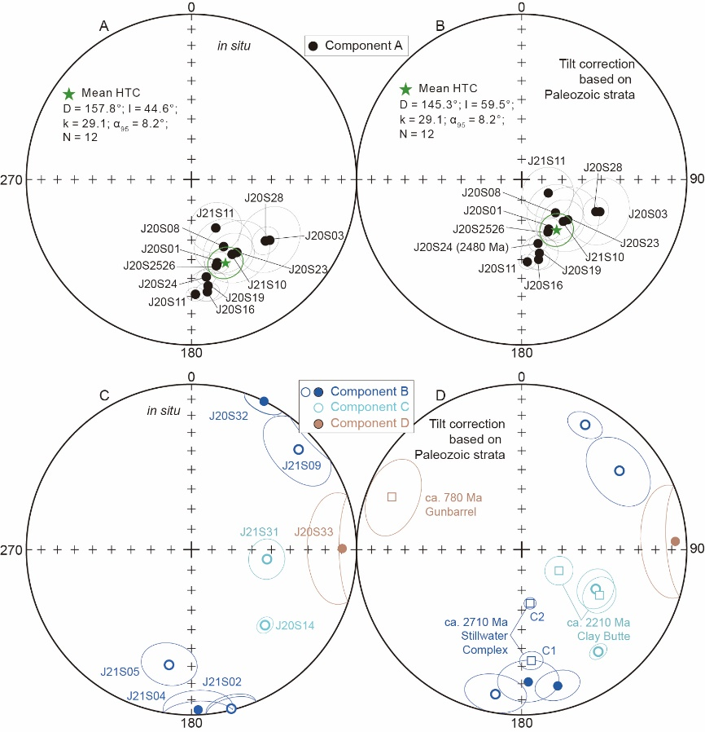
Fig. S12 The high temperature components (HTCs) of the dike rocks in geographic coordinates (A, C), and after tilt correction using the Cambrian strata (B, D).

A2.5 Paleo-secular variation
The angular dispersion (S) of the 12 VGPs from the twelve 2480 Ma Elbow Creek dikes is 19.2° using the method of Biggin et al. (2008), with the 1σ confidence interval of (16.1°, 22.3°) using the n-1 jackknife method. It is larger than the expected value (10.3°, 13.0°) according to the model for the 2.2–3.0 Ga period (Smirnov et al., 2011) or the expected value (11.5°, 14.3°) based on the model for the 1.5–2.9 Ga period (Veikkolainen and Pesonen, 2014) for the paleolatitude of 41.1°, which is attributed to that the two models were constructed on a small number of data. Based on the N-dependent A₉₅ envelope (Deenen et al., 2011), the A₉₅ of our pole (11.2°) falls within the expected A₉₅ envelope (A_{95min} = 4.4°, A_{95max} = 17.1°), suggesting the paleosecular variation has in fact been averaged out.

A2.6.1 Proposed ages for the onset of plate tectonics
Published papers used various lines of evidence to constrain the onset ages of plate tectonics, which ranges from Hadean to Neoproterozoic (Hopkins et al., 2008; Stern et al., 2016). In this supplementary section, plate tectonic indicators incudes metamorphic thermobaric ratios, paleomagnetism, high-P/low-T metamorphic rocks, ophiolites, arc volcanism, tectonic evidence, seismic reflection images, numerical models and geochemistry (Fig. S13). Many criteria may cross these boundaries, but for simplicity, they are presented in only one typology.
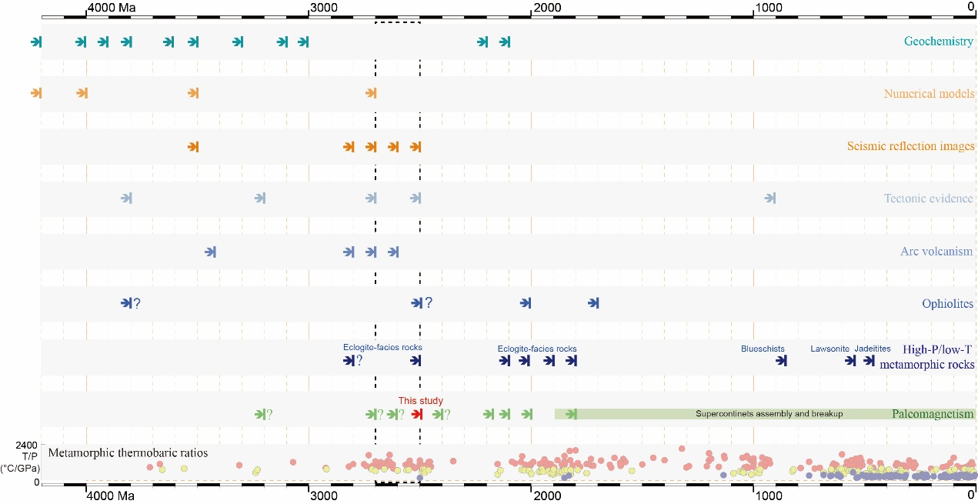
Fig. S13. Proposed ages for the initiation of modern style plate tectonics in the literature. The data and the references are listed in Table S5.
Modern-style plate tectonics is characterized by large lateral motions of rigid plates with deep and cold asymmetric subduction (Condie, 2008; Cawood et al., 2022). The evidence showing the rigidity of the lithosphere comes from some tectonic evidence, for example, the replacement of dome and keel structures by linear thrust imbricated belts (Lin et al., 2005). The large lateral motions of the continents were constrained by paleomagnetism, especially the relative motion, which indicates plate tectonics was in operation since late Archean. Most studies focused on finding evidence for subduction, which include high-P/low-T metamorphic rocks, seismic reflection images, geochemistry and arc volcanism. High-P/low-T metamorphic rocks and seismic reflection images could be used as reliable evidence for subduction. By detecting the signal of materials that were formed near or close to Earth’s surface and then recycled into the deep mantle, geochemistry and arc volcanism were used to identify subduction, while plate tectonics may not be the only way to accomplish such recycling. Ophiolites were emplaced in the subduction zones, and they were used as indicator of subduction. The undisputed ophiolites were found at around 2.0 Ga (Scott et al., 1992). Archean ophiolites were also reported, but this interpretation has been strongly contested (Kusky et al., 2001; Zhai et al., 2002). As illustrated by Brown et al. (2020), the metamorphic thermobaric ratios show that unimodal could fit the metamorphism older than 2.2 Ga, but a bimodal mixed-Gaussian distribution will fit the metamorphism younger than 2.2 Ga better. Thus, they suggested the plate tectonics was in operation by the early Paleoproterozoic.
A.2.6.2 Palomagnetic methods for relative mobilism
Previous estimates for the earliest relative motions between cratons, based on paleomagnetism, utilize any of four methods. The first is to take two or more cratons in their present configuration, follow their common apparent polar wander path (APWP) back in time, and determine the age beyond which paleomagnetic data become discrepant between those blocks. Examples include the Mesozoic amalgamation of North and South China blocks (Enkin et al., 1992), Devonian rotation between western versus eastern Siberian subcratons across the Vilyuy trough (Smethurst et al., 1998; Pavlov et al., 2008), and Paleoproterozoic amalgamation of Slave, Rae, and Superior cratons within the intact North American portion of Laurentia (Buchan et al., 2009, 2016; Mitchell et al., 2014; Pesonen et al., 2021). The second method is similar to the first, except that it utilizes an ancient yet robust reconstruction with poles and apparent polar wander paths rotated into that ancestral configuration. For example, the classic image of a coherent Pangea/Gondwanaland APWP by McElhinny (1973) shows both convergence of poles at the time of assembly and divergence at the time of breakup, bracketing a common APWP for supercontinental duration when all blocks are quantitatively restored into the correctly reconstructed reference frame. Evans and Pisarevsky (2008) illustrated a similar example for Proterozoic Laurentia and Baltica, which was expanded and updated by Pesonen et al. (2021). This technique is utilized in the present contribution, extending the record of amalgamation into Neoarchean time for Wyoming and Superior cratons in their ca. 2.6-2.1 Ga pre-Laurentian juxtaposition.
Evans and Pisarevsky (2008) also presented a third method, which measures the angular distances between coeval poles from two or more blocks at two time intervals: if the angular distances are discrepant beyond the combined uncertainties of all the poles, then there is no possible reconstruction that would allow the blocks to be rigidly connected in a single tectonic plate – in other words, relative motion must have occurred at sometime within the interval spanned by the pole ages. A fourth method presents visual comparisons of possible relative positions between cratons from different time intervals with coeval paleomagnetic poles, employing the freedom of paleolongitude in paleomagnetic data at each time step (Buchan et al., 2000, 2001; Pesonen et al., 2003; Cawood et al., 2006, 2018; Buchan, 2014). The reader is meant to infer that no possible rigid assembly of cratons could accommodate all the data, and thus relative motion must have occurred between the illustrated blocks. This method, however, can hide suitable solutions that are readily discoverable by the other methods. As an example, Cawood et al. (2018) compiled 11 paleomagnetic poles from Pilbara, Kaapvaal, Superior, and Karelia-Kola, through the interval ca. 2.78-2.44 Ga. Figures 7 and 8 from that paper are meant to show demonstrable relative motion among all four cratons through subsets of the time interval in question. Close inspection of their Figure 7, however, reveals possible enduring connections among all of the relevant comparisons. Indeed, Fig. S14A of the present contribution, below, shows an internally rigid arrangement of the four cratons that overlap all of these selected poles except for a slight mismatch of the 2426-Ma Kaapvaal pole that is 20 million years or more younger than its counterparts from the other cratons. Rather than appearing to indicate relative motion among the four blocks as intended by Cawood et al. (2018), the selected poles could in fact be consistent with their connection in a long-lived supercontinent, or moving via TPW rather than plate tectonics. Fig. S14B shows a similar result for the paleomagnetic data considered by Condie et al. (2022) between ca. 2.44 and 2.18 Ga. Fig. S14C shows how the internally rigid reconstruction is compatible with all of the craton/age comparisons in Cawood et al. (2018), especially when allowing for additional paleolongitude adjustments and flexibility of errors in the paleomagnetic poles.
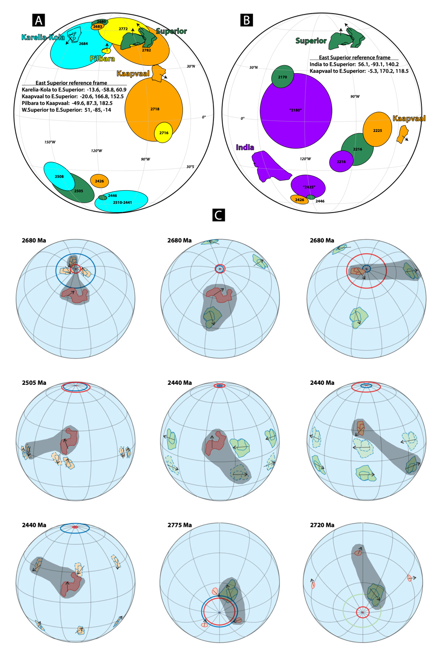
Fig. S14. Non-mobilistic interpretations of paleomagnetic data presented by Cawood et al. (2018) and Condie et al. (2022). Rather than presenting preferred reconstructions, this figure serves as a thought experiment on the inherent ambiguity of the method used in those studies. A. Possible long-lived reconstruction of Karelia-Kola, Pilbara, Kaapvaal, and Superior (with present-day north arrows), in the latter’s eastern reference frame, that satisfies within uncertainties the subset of 12 selected ca. 2780-2440 Ma paleomagnetic poles by Cawood et al. (2018). B. Possible long-lived reconstruction of Superior, Kaapvaal, and India, in the former’s eastern reference frame, that satisfies within uncertainties the subset of 8 selected ca. 2440-2180 Ma poles by Condie et al. (2022). C. Illustration of the methodological ambiguity of the method employed by Cawood et al. (2018), shading the polarity and paleolongitude options that most closely resemble the long-lived reconstruction shown in panel A. The equivalent illustration for Condie et al. (2022) would require visualization of the far hemisphere relative to what was shown in that study.
For cratons that lack complete APWPs or geologically robust reconstructions, a more definitive test of relative motions is the calculation of arc distances between sets of coeval poles, as presented by Evans and Pisarevsky (2008). In the case of Wyoming versus Superior between 2.71 and 2.5 Ga (this study), angular distance between the pole subsets of those two ages is comparable between the two cratons (Fig. 3B), which could by itself conceivably allow a rigid reconstruction spanning that age interval. However, such a scenario would restore Wyoming far to the northwest of Superior, eliminating the attractiveness of geological comparisons (i.e., Neoarchean accretionary history, Snowy Pass and Huronian sedimentary cover successions with numerous distinctive stratigraphic matches, large igneous province barcodes, and radiating dike geometries) and ca. 2.2-2.1 Ga paleomagnetic pole fits within the preferred Superia reconstruction. Thus, it is the geological robustness of the Wyoming-Superior direct juxtaposition (Roscoe and Card, 1993; Mammone et al., 2022), together with Paleoproterozoic paleomagnetic support (Kilian et al., 2016; this study), which allows us to employ the second technique described above. That method demonstrates significant relative plate convergence prior to the joint APWP – in this case, prior to 2.48 Ga – and likely ca. 2.63 Ga according to geochronology of the Oregon Trail Structural Belt (see main text for references and further discussion).
A2.7 The 2710-2170 Ma reconstruction for Wyoming and Superior
Based on the ca. 2710-2160 Ma poles from Superior and Wyoming, three reconstructions at 2710, 2500 and 2170 Ma are presented. Superior and Wyoming were separated at 2710 Ma. They assembled from ca. 2710 to 2500 Ma with the docking between the southern margin of Wyoming and the southern margin of Superior. They stayed at the low latitude region at ca. 2500 Ma. They kept the same connection from 2500 to 2170 Ma, and moved to the mid-latitude region at 2170 Ma with 90° anticlockwise rotation (Fig. S15). The connection also finds support from the striking stratigraphic and sedimentological similarities between the early Proterozoic Huronian Supergroup from Superior and the Snowy Pass Supergroup from Wyoming (Roscoe and Card, 1993; Mammone et al., 2022). In the ca. 2170 Ma reconstruction, those basins are contiguous (Fig. S16). Geochronological “barcode” matches of the ca. 2480-2450, 2210, 2160 and 2110 Ma dike swarms also support this connection, and four hypothesized plume centers for these groups of dikes are proposed (Fig. S16).

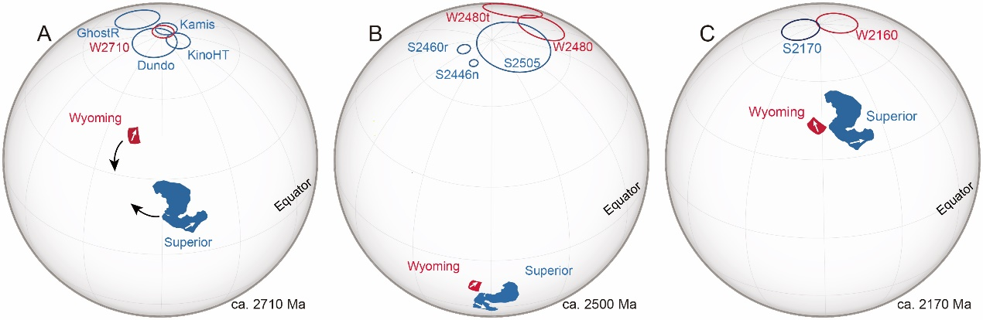
Fig. S15. Paleogeographic reconstruction for Superior and Wyoming at ca. 2710 (A), 2500 (B) and 2170 Ma (C). The paleomagnetic poles and Euler rotations are listed in Tables S3 and S4.

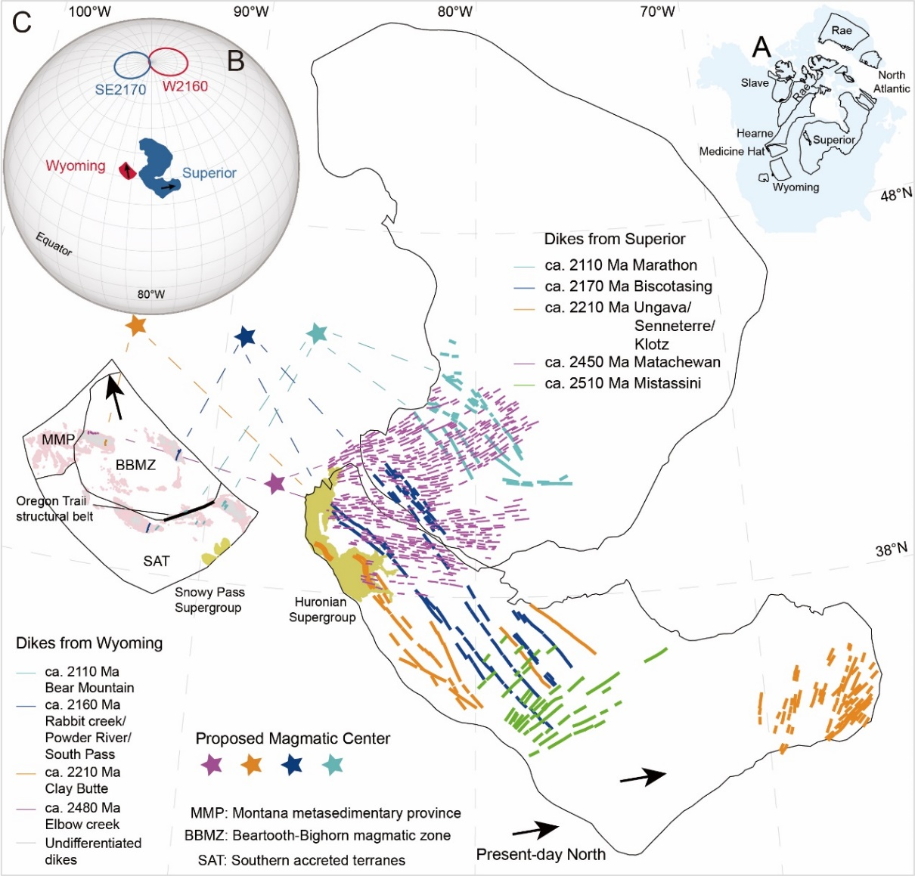
Fig. S16. Paleogeographic reconstruction for Superior and Wyoming at ca. 2170 Ma (Euler parameters for Wyoming to East Superior 48°, 265°, +125°CCW). (A) Schematic map showing the distribution of Wyoming and Superior in Laurentia. (B) Paleogeographic reconstruction for Pilbara and Wyoming based on the two paleomagnetic poles from the two cratons at ca. 2170 Ma. (C) the ca. 2510-2100 Ma dikes, and the Huronian and Snowy Pass Supergroups lend additional support to this proposed long-lived juxtaposition (Kilian et al., 2016).

References
Biggin AJ, Strik GH, Langereis CG., 2008. Evidence for a very-long-term trend in geomagnetic secular variation. Nature Geoscience, 1(6): 395-398.
Brown M, Johnson T, Gardiner NJ., 2020. Plate tectonics and the Archean Earth. Annual Review of Earth and Planetary Sciences, 48: 291-320.
Buchan K, Mertanen S, Park R, Pesonen L, Elming S-Å, Abrahamsen N, Bylund, G., 2000. Comparing the drift of Laurentia and Baltica in the Proterozoic: the importance of key palaeomagnetic poles. Tectonophysics, 319(3): 167-198.
Buchan KL, Ernst RE, Hamilton MA, Mertanen S, Pesonen LJ, Elming S-Å., 2001. Rodinia: the evidence from integrated palaeomagnetism and U–Pb geochronology. Precambrian Research, 110(1-4): 9-32.
Buchan KL, LeCheminant AN, van Breemen O., 2009. Paleomagnetism and U–Pb geochronology of the Lac de Gras diabase dyke swarm, Slave Province, Canada: implications for relative drift of Slave and Superior provinces in the PaleoproterozoicGeological Survey of Canada Contribution 20080350. Canadian Journal of Earth Sciences, 46(5): 361-379.
Buchan KL, Mitchell RN, Bleeker W, Hamilton MA, LeCheminant AN., 2016. Paleomagnetism of ca. 2.13–2.11 Ga Indin and ca. 1.885 Ga Ghost dyke swarms of the Slave craton: Implications for the Slave craton APW path and relative drift of Slave, Superior and Siberian cratons in the Paleoproterozoic. Precambrian Research, 275: 151-175.
Buchan KL., 2014. Reprint of “Key paleomagnetic poles and their use in Proterozoic continent and supercontinent reconstructions: A review”. Precambrian Research, 244: 5-22.
Cawood PA, Chowdhury P, Mulder JA, Hawkesworth CJ, Capitanio FA, Gunawardana PM, Nebel O,et al. 2022. Secular evolution of continents and the Earth system. Reviews of Geophysics 2022: e2022RG000789.
Cawood PA, Hawkesworth CJ, Pisarevsky SA, Dhuime B, Capitanio FA, Nebel O, 2018. Geological archive of the onset of plate tectonics. Philosophical Transactions of the Royal Society A: Mathematical, Physical and Engineering Sciences, 376(2132): 20170405.
Cawood, PA., Kröner, A., Pisarevsky, S., 2006. Precambrian plate tectonics: Criteria and evidence. Geological Society of America Today, 16(7), 4–11.
Cogné J., 2003. PaleoMac: a Macintosh™ application for treating paleomagnetic data and making plate reconstructions. Geochemistry, Geophysics, Geosystems, 4(1).
Condie KC, Kröner A., 2008. When did plate tectonics begin? Evidence from the geologic record. When did plate tectonics begin on planet Earth, vol. 440. Geological Society of America Special Papers, pp 281-294.
Condie KC, Pisarevsky SA, Puetz SJ, Spencer CJ, Teixeira W, Faleiros FM, 2022. A reappraisal of the global tectono-magmatic lull at∼ 2.3 Ga. Precambrian Research, 376: 106690.
Deenen MH, Langereis CG, van Hinsbergen DJ, Biggin AJ., 2011. Geomagnetic secular variation and the statistics of palaeomagnetic directions. Geophysical Journal International, 186(2): 509-520.
Dunlop D, Özden Ö, Fuller MD., 1997. Rock Magnetism: Fundamentals and Frontiers. Physics Today, 79(31): 64-66.
Dunlop DJ., 2002. Theory and application of the Day plot (Mrs/Ms versus Hcr/Hc) 1. Theoretical curves and tests using titanomagnetite data. Journal of Geophysical Research: Solid Earth, 107(B3): EPM 4-1-EPM 4-22.
Enkin R., 1990. The direction-correction test for paleomagnetism. His PhD Thesis, Universite de Paris, 7.
Enkin RJ, Yang Z, Chen Y, Courtillot V., 1992. Paleomagnetic constraints on the geodynamic history of the major blocks of China from the Permian to the present. Journal of Geophysical Research: Solid Earth, 97(B10): 13953-13989.
Evans D, Halls H., 2010 Restoring Proterozoic deformation within the Superior craton. Precambrian Research, 183(3): 474-489.
Evans DAD, Pisarevsky SA., 2008. Plate tectonics on early Earth? Weighing the paleomagnetic evidence. Geological Society of America Special Paper, 440: 249-263.
Fisher R., 1953. Dispersion on a sphere. Proceedings of the Royal Society of London Series A Mathematical and Physical Sciences, 217(1130): 295-305.
Geraghty E, 2013. Geologic map of the Stillwater Complex within the Beartooth Mountains Front Laramide triangle zone, south-central Montana. Montana Bureau of Mines and Geology, Open-File Report 645: 1-22.
Harlan SS, Geissman JW, Snee LW., 1997. Paleomagnetic and 40Ar/39Ar geochronologic data from Late Proterozoic mafic dikes and sills, Montana and Wyoming. US Government Printing Office.
Hopkins M, Harrison TM, Manning CE., 2008. Low heat flow inferred from> 4 Gyr zircons suggests Hadean plate boundary interactions. Nature, 456(7221): 493-496.
Jaffey AH, Flynn KF, Glendenin LE, Bentley WC, Essling AM, 1971. Precision measurement of half-lives and specific activities of ²³⁵U and ²³⁸U. Phys Rev C 4(5): 1889–1906.
Kilian TM, Bleeker W, Chamberlain K, Evans DA, Cousens B., 2016. Palaeomagnetism, geochronology and geochemistry of the Palaeoproterozoic Rabbit Creek and Powder River dyke swarms: implications for Wyoming in supercraton Superia. Geological Society, London, Special Publications, 424(1): 15-45.
Kilian TM, 2015. Precambrian paleomagnetism of mafic dike swarms and the Wyoming craton: implications for an Archean supercontinent. Yale University.
Kirschvink J., 1980. The least-squares line and plane and the analysis of palaeomagnetic data. Geophysical Journal International, 62(3): 699-718.
Kusky TM, Li J-H, Tucker RD., 2001. The Archean Dongwanzi ophiolite complex, North China Craton: 2.505-billion-year-old oceanic crust and mantle. Science, 292(5519): 1142-1145.
Lin S., 2005. Synchronous vertical and horizontal tectonism in the Neoarchean: Kinematic evidence from a synclinal keel in the northwestern Superior craton, Canada. Precambrian Research, 139(3-4): 181-194.
Mammone, N., Bekker, A., Chamberlain, K. and Kuznetsov, A.B., 2022. Testing the early Paleoproterozoic connection of the Superior and Wyoming cratons with geochronology and geochemistry. Precambrian Research, 381, p.106818.
McElhinny M., 1973. Plate tectonics and paleomagnetism. Cambridge Univ. Press.
Meert JG, Pivarunas AF, Evans DA, Pisarevsky SA, Pesonen LJ, Li Z.X, et al. Elming, S.Å., Miller, S.R., Zhang, S., Salminen, J.M., 2020 The magnificent seven: A proposal for modest revision of the quality index. Tectonophysics, 790: 228549.
Mitchell RN, Bleeker W, Van Breemen O, Lecheminant AN, Peng P, Nilsson MKM, Evand DAD, 2014. Plate tectonics before 2.0 Ga: Evidence from paleomagnetism of cratons within supercontinent Nuna. American Journal of Science, 314(4): 878-894.
Page NJ, Nokleberg WJ, 1974. Geologic map of the Stillwater Complex, Montana. United States Geological Survey, Miscellaneous Investigations Series, Map I-797.
Pavlov V, Bachtadse V, Mikhailov V., 2008. New Middle Cambrian and Middle Ordovician palaeomagnetic data from Siberia: Llandelian magnetostratigraphy and relative rotation between the Aldan and Anabar–Angara blocks. Earth and Planetary Science Letters, 276(3-4): 229-242.
Pesonen L, Elming S-Å, Mertanen S, Pisarevsky S, D'Agrella-Filho M, Meert J, Schmidt, P.W., Abrahamsen, N., Bylund, G., 2003. Palaeomagnetic configuration of continents during the Proterozoic. Tectonophysics, 375(1-4): 289-324.
Pesonen LJ, Evans DA, Veikkolainen T, Salminen J, Elming S-Å., 2021. Precambrian supercontinents and supercycles—an overview. Ancient Supercontinents and the Paleogeography of Earth: 1-50.
Rogers C, Mackinder A, Ernst RE, Cousens B, 2016. Mafic magmatism in the Belt-Purcell Basin and Wyoming Province of western Laurentia. Geological Society of America Special Paper 522: pp. 243-282.
Roscoe S, Card K., 1993. The reappearance of the Huronian in Wyoming: rifting and drifting of ancient continents. Canadian Journal of Earth Sciences, 30(12): 2475-2480.
Scott D, Helmstaedt H, Bickle M., 1992. Purtuniq ophiolite, Cape Smith belt, northern Quebec, Canada: A reconstructed section of Early Proterozoic oceanic crust. Geology, 20(2): 173-176.
Smethurst MA, Khramov AN, Pisarevsky S., 1998. Palaeomagnetism of the Lower Ordovician Orthoceras Limestone, St. Petersburg, and a revised drift history for Baltica in the early Palaeozoic. Geophysical Journal International, 133(1): 44-56.
Smirnov AV, Tarduno JA, Evans DAD., 2011. Evolving core conditions ca. 2 billion years ago detected by paleosecular variation. Physics of the Earth & Planetary Interiors, 187(3–4): 225-231.
Söderlund U, Johansson L., 2002. A simple way to extract baddeleyite (ZrO2). Geochemistry, Geophysics, Geosystems, 3(2): 1 of 7-7 of 7.
Stacey JS, Kramers JD, 1975. Approximation of terrestrial lead isotope evolution by a two-stage model. Earth Planet Sci Lett 26(2): 207–221.
Steiger RH, Jager E, 1977. Subcommission on geochronology: Convention on the use of decay constants in geo- and cosmochronology. Earth Planet Sci Lett 36(3): 359–362.
Ludwig KR, 2003. User’s Manual for Isoplot 3.00 - A Geochronological Toolkit for Microsoft Excel. Berkeley Geochronol Cent Spec Publ (4):71.
Stern RJ, Leybourne M, Tsujimori T., 2016. Kimberlites and the start of plate tectonics. Geology, 44(10): 799-802.
Veikkolainen T, Pesonen LJ., 2014. Palaeosecular variation, field reversals and the stability of the geodynamo in the Precambrian. Geophysical Journal International 2014, 199(3): 1515-1526.
Verwey E., 1939. Electronic conduction of magnetite (Fe 3 O 4) and its transition point at low temperatures. Nature, 144(3642): 327-328.
Williams SE, Muller RD, Landgrebe TC, Whittaker J., 2012. An open-source software environment for visualizing and refining plate tectonic reconstructions using high-resolution geological and geophysical data sets. GSA Today, 22(4-5): 4-9.
Zhai M, Zhao G, Zhang Q., 2002. Is the Dongwanzi complex an Archean ophiolite? science, 295(5557): 923-923.

