Supplementary material
Automated imaging coupled with AI-powered analysis accelerates the assessment of plant resistance to Tetranychus urticae

Supplementary tables

Table S1. 14 Arabidopsis thaliana natural accessions data
Species Variant | 1001 Genomes ID | NASC Stock Number | Country of Origin
Col-0 | 6909 | CS76778 | USA
Cvi-0 | 6911 | CS76789 | CPV
Got-7 | 6921 | CS76495 | GER
Kondara | 6929 | CS76532 | TJK
Ler-0 | 7213 | CS77020 | GER
Ms-0 | 6938 | CS76555 | RUS
Rrs-7 | 7514 | CS76593 | USA
Tamm-2 | 6968 | CS76610 | FIN
Ts-1 | 6970 | CS76615 | ESP
Bur-0 | 7058 | CS76734 | IRL
Stp-0 | 9584 | CS77283 | ESP
Can-0 | 7063 | CS76740 | ESP
Car-1 | 9530 | CS76742 | ESP
Dor-10 | 5856 | CS76806 | SWE

Table S2. Summary of Arabidopsis accessions susceptibility to Tetranychus urticae. We provide mean and standard error (SE) for each A. thaliana accession, and results of one-way ANOVA analysis for each trait: F-value, Partial Eta Squared (η_{p}²) and p-value.

Accession name | Mean ± SE
Accession name | Feeding symptoms area [mm²] | Relative feeding symptoms area | Oviposition rate | Relative oviposition rate | Feces area [mm²] | Relative feces area
Car-1 | 2.32 ± 0.51 | 0.31 ± 0.07 | 15.25 ± 1.84 | 0.61 ± 0.07 | 0.13 ± 0.03 | 0.92 ± 0.20
Cvi-0 | 7.27 ± 1.44 | 0.79 ± 0.13 | 32.33 ± 4.38 | 1.11 ± 0.15 | 0.15 ± 0.03 | 0.93 ± 0.15
Ms-0 | 10.17 ± 3.06 | 0.92 ± 0.24 | 55.33 ± 15.70 | 2.13 ± 0.45 | 0.33 ± 0.08 | 1.93 ± 0.36
Col-0 | 9.33 ± 0.68 | 1.00 ± 0.07 | 24.68 ± 1.66 | 1.00 ± 0.07 | 0.15 ± 0.01 | 1.00 ± 0.06
Ts-1 | 9.76 ± 1.53 | 1.15 ± 0.27 | 39.17 ± 5.61 | 1.57 ± 0.30 | 0.17 ± 0.03 | 1.19 ± 0.23
Got-7 | 18.06 ± 5.66 | 1.22 ± 0.34 | 1.42 ± 0.30 | 1.42 ± 0.30 | 0.25 ± 0.04 | 1.37 ± 0.17
Bur-0 | 6.92 ± 1.83 | 1.23 ± 0.36 | 31.25 ± 8.61 | 1.39 ± 0.44 | 0.18 ± 0.03 | 1.42 ± 0.31
Rrs-7 | 11.40 ± 3.05 | 1.28 ± 0.38 | 54.00 ± 6.86 | 1.78 ± 0.13 | 0.18 ± 0.04 | 1.11 ± 0.27
Dor-10 | 12.16 ± 3.29 | 1.52 ± 0.35 | 15.80 ± 6.33 | 0.67 ± 0.27 | 0.16 ± 0.02 | 1.06 ± 0.22
Kondara | 15.88 ± 2.26 | 1.77 ± 0.33 | 74.00 ± 20.83 | 2.41 ± 0.58 | 0.31 ± 0.06 | 1.91 ± 0.41
Ler-0 | 27.82 ± 7.92 | 2.85 ± 0.54 | 71.33 ± 13.12 | 2.46 ± 0.46 | 0.34 ± 0.06 | 1.97 ± 0.32
Tamm-2 | 38.50 ± 4.60 | 3.22 ± 0.73 | 104.33 ± 19.27 | 4.08 ± 0.79 | 0.32 ± 0.06 | 2.01 ± 0.47
Can-0 | 15.34 ± 6.35 | 4.12 ± 1.11 | 21.25 ± 2.60 | 1.79 ± 0.73 | 1.19 ± 0.03 | 2.78 ± 0.40
Stp-0 | 26.03 ± 4.64 | 4.46 ± 0.46 | 63.50 ± 11.92 | 4.84 ± 0.52 | 0.30 ± 0.05 | 2.94 ± 0.49
F-value | 11.09 | 15.20 | 11.00 | 17.32 | 5.65 | 7.94
η_{p}² | 0.530 | 0.607 | 0.524 | 0.634 | 0.361 | 0.443
p-value | <0.001 | <0.001 | <0.001 | <0.001 | <0.001 | <0.001

Supplementary figures

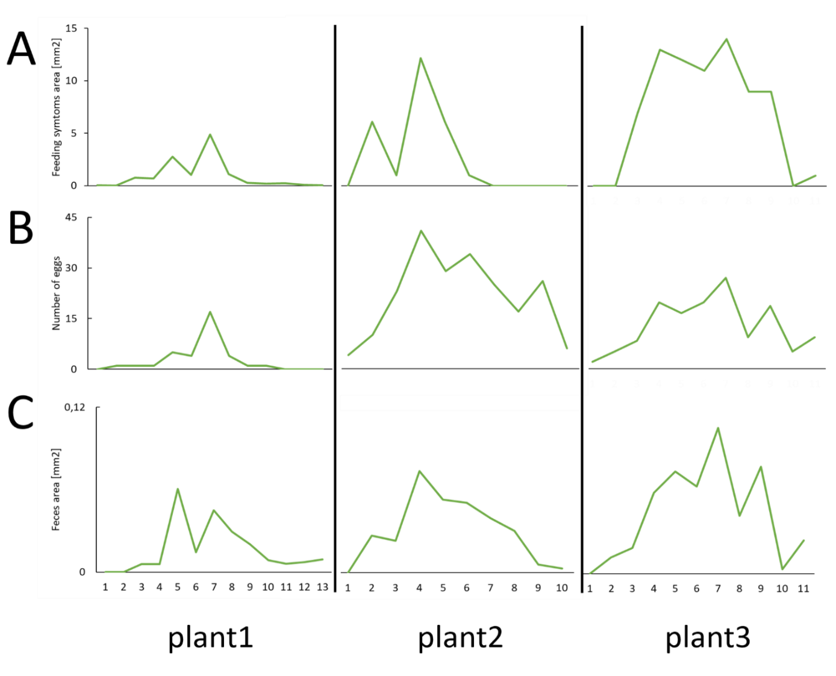
Fig. S1 Different type of trait distribution (A – area of feeding symptoms, B – number of eggs laid, C – feces area) on consecutive leaves of the rosette (starting from the oldest) of Kondara A. thaliana accession.

