Supplementary Materials
Native top-down proteomics reveals EGFR–ERα signaling crosstalk in breast cancer cells dissociates NUTF2 dimers to modulate ERα signaling and cell growth
Fabio P. Gomes¹, Kenneth R. Durbin², Kevin Schauer³, Jerome C. Nwachukwu⁴, Robin J. Russo^{4,5}, Jacqline W. Njeri^{4,5}, Anthony J. Saviola⁶, Daniel B. McClatchy¹, Jolene K. Diedrich¹, Patrick T. Garrett ¹, Alexandra B. Papa^{4,7}, Ianis Ciolacu^{4,7}, Neil L. Kelleher^{2,8}, Kendall W. Nettles^{4,5*}, and John R. Yates III^{1*}
¹The Scripps Research Institute, La Jolla, CA 92037
²Proteinaceous, Evanston, IL 60201
³Thermo Fisher Scientific, San Jose, CA 95134
⁴Department of Integrative Structural and Computational Biology, Wertheim UF Scripps Institute, Jupiter, FL 33458
⁵The Skaggs Graduate School of Chemical and Biological Sciences, The Scripps Research Institute, Ja Jolla, Ca 92037 ⁶The University of Colorado Anschutz Medical Campus, Aurora, CO 80045
⁷Florida Atlantic University, Jupiter, FL 33458
⁸Northwestern University, National Resource for Translational and Developmental Proteomics, Evanston, IL 60208

Corresponding Authors *(J.R.Y III) Email: jyates@scripps.edu. *(K.W.N.) Email: k.nettles@ufl.edu

Materials and Methods
Supplementary Figures
Supplementary Tables

Materials and Methods
Native Top-Down Proteomics (nTDP) Experimental Design Rationale
nTDP studies of simple and complex protein mixtures have been conducted using both offline (ion exchange chromatography (IEX)) ¹ and online (capillary zone electrophoresis (CZE)) liquid-phase separation strategies ²⁻⁴. However, methods that employ liquid-phase fractionations will require numerous developments/optimizations to provide reliable and comprehensive information about the higher-order molecular organization of the cells. For instance, IEX is known for its high separation efficiency, but this technique requires the use of fairly high salt concentrations that can disrupt fragile non-covalent interactions ². Although native CZE has shown the potential for high separation efficiency of protein complexes under nano electrospray ionization (ESI) conditions, the low sample loading capability of this technique hampers its widespread acceptance ⁵. Recent advances in MS instrumentation have led to the development of ion mobility spectrometry (IMS), which provides an extra dimension of gas-phase ion fractionation that enhances quadrupole selectivity and S/N ⁶. Among IMS techniques, high-field asymmetric ion mobility spectrometry (FAIMS) provides enhanced S/N and superior orthogonal selectivity to the mass spectrometer. FAIMS has been used for analysis of intact proteins (under denaturing and non-denaturing conditions) ^{6,7}.
Here, we demonstrate that gas-phase fractionation can be used for a large scale, sensitive, and efficient characterization of complexoforms within cells. It can replace or complement online liquid-phase separations, especially when the goal of the study is to achieve in-depth protein characterization rather than in-depth proteomic coverage. We used offline native size exclusion chromatography (nSEC) to reduce sample complexity and enhance the MS detectability of extremely low abundance endogenous protein assemblies. nSEC fractions were “injected-infused” at low nano-LC flow rate and ionized by nano ESI. The resulting protein ions were fractionated in the gas-phase with FAIMS prior to entering the mass spectrometer. Multistage tandem MS, a strategy that measures the intact mass of protein assemblies before ejecting and identifying monomeric proteoforms for subsequent dissociation and sequencing, was used to characterize the protein complexes and their constituent proteoforms.
MS Method Strategy. Much of the activity in the nTDP field has been focused on the characterization of highly purified individual protein complexes via direct infusion experiments using Orbitrap with extended mass range (EMR) ⁸, time of flight (TOF) ⁹, or Fourier-transform ion cyclotron resonance (FTICR) ¹⁰ mass analyzers. Recently, a native proteomics study using a conventional Orbitrap platform was reported, but it was limited to the characterization of protein complexes < 30kDa ³. Here, we employed FAIMS in a multistage MS approach for native top-down characterization of complexoforms in MCF-7 breast cancer cells. We pushed the Orbitrap Fusion Lumos without EMR capabilities to its limit to attain optimum transmission and detection of sub-70kDa intact biomolecular complexes. Carbonic anhydrase II (CA II, ~29.1kDa), streptavidin (SA, ~53kDa), and avidin (AV, ~67kDa) were used to develop and evaluate the nTDP method because these proteins are examples of protein-metal and protein-protein assemblies that can be found in breast cancer cells, and they span a suitable molecular weight range (~30-70kDa) for the Orbitrap Fusion Lumos (determined through meticulous optimization of key MS parameters). As shown in Supporting Information Figures S1-S3, all these protein systems showed a low charge state distribution, which confirmed that our nano ESI-FAIMS^{n} approach can maintain, isolate, and fragment protein-protein/metal assemblies to yield fingerprint spectra that can be used to elucidate monomeric proteoform arrangements in protein assemblies. In this nTDP workflow, high pressure (14mTorr) in IRM was necessary to ensure optimal collisional cooling of the intact protein ions from the noncovalent assemblies, which enabled them to be effectively transmitted, trapped, and ejected to the detector ¹¹. At higher pressures (e.g., 16mTorr), we noticed collisional gas instability in the mass spectrometer. A high resolving power in the MS³ stage was necessary to resolve overlapping isotope patterns, thereby characterizing the constituent proteoforms in protein assemblies. Tandem spectral quality also benefited from the high number of µscans and long ion injection times in the MS² and MS³ stages. Importantly, all these instrument parameters are directly associated with scan time. Since our approach is based on direct infusion and gas-phase fractionation, MS acquisition parameters can be set at higher values than are possible for online liquid-phase separation strategies without affecting data collection. For example, in CZE-MS approaches, scan time must be adjusted according to the short elution time of each protein peak, as spectral quality is driven by real-time peak area of protein precursor ions. Additionally, we evaluated the gas-phase fractionation efficiency of the method by analyzing the standard protein complex mixture, with CVs ranging from −45 to −30 V with 5 V stepping. The base peak ion mobiligram of each protein complex in the mixture is shown in the Figure S4, confirming the fractionation efficiency of the method for protein complexes up to 70kDa. Obtaining satisfactory fractionation was particularly important to this MS workflow, not only to reduce ion suppression effects and signal superposition, but also to avoid precursor overlap during quadrupole isolation of ions due to our large quadrupole isolation windows.

Protein Complex Standard Preparation. Ammonium acetate solution 7.5M (A2706) and carbonic anhydrase II (C2522) were purchased from Sigma-Aldrich. Avidin (PI21121) and streptavidin (434301) were purchased from Thermo Fisher Scientific. Proteins were diluted using 100 mM ammonium acetate, and were desalted and concentrated (~1-30µM) using 10kDa molecular weight cutoff filters (Millipore). The desalting procedure was repeated 10 times (12,000 × g for 5 min at 4°C) to minimize salt effects.

Cell Lines. MCF7-EGFR cells were derived by stably transducing MCF7 cells with a lentivirus expressing wildtype human EGFR ¹². MCF7 cells were also stably transduced with lentiviruses expressing wildtype human NUTF2 with a C-terminal DYKDDDDK (FLAG) or hemagglutinin (HA) epitope tag, or the empty lentiviral vector as a control. The HA epitope-tagged NUTF2-K4M, -K4Q, and -K55R lentiviral vectors were generated from the wildtype NUTF2 vector using the Q5® Site-Directed Mutagenesis Kit (New England BioLabs, E0554S). All cells were cultured in Dulbecco’s modified Eagle medium (DMEM) (Thermo Fisher Scientific, 11995073) supplemented with 10% fetal bovine serum (Sigma-Aldrich, F0926), GlutaMAX (Thermo Fisher Scientific, 35050061), non-essential amino acids (Thermo Fisher Scientific; 11140050), penicillin, streptomycin, and neomycin (Thermo Fisher Scientific, 15640055), and maintained at 37°C in a 5% CO₂ incubator.

Protein Extraction. Cells were cultured in 15 cm dishes for 3 days, placed on ice for 5 min, aspirated and rinsed with chilled 1X phosphate-buffered saline (PBS), lifted into 2 ml per dish of PBS, collected in 15 mL conical tubes, and then centrifuged (1,200 rpm for 3 min). The supernatant was carefully removed, and the pellet was stored at -80°C.The cell pellet (equivalent to ~100µL) was resuspended in 500µL of ice-cold 200 mM ammonium acetate pH 6.9 with protease and phosphatase inhibitors (Thermo Fisher Scientific). Proteins were mechanically extracted from MCF-7 cell lines using a Dounce homogenizer (20 strokes). Cellular debris and intact organelles were pelleted by centrifugation (17,000 × g for 15 min at 4 °C) and the supernatant, which contained proteins, was filtered with a 0.45 µm syringe filter, transferred to a clean microcentrifuge tube, and quantified using a BCA assay kit (Thermo Fisher Scientific). The lysate was immediately fractionated.

nSEC Conditions. A standard protein mixture was used to develop the nSEC strategy and to monitor the performance of the method. This mixture was composed of 3 proteins (bovine serum albumin (BSA), Sigma-Aldrich, A3059), ovalbumin (OV), Sigma-Aldrich, A2512), and myoglobin (M), Sigma-Aldrich, M1882). Five milligrams of each standard protein was placed in a single vial and dissolved in 500uL of ultrapure water. The protein mixture was then filtered using a 0.45 µm syringe filter and 20µL (~600 µg of total protein) was injected (triplicate measurements) into an Agilent 1200 HPLC system. Approximately 200µg of total protein (cell lysate) was injected (16 replicates) using the HPLC system. The mobile phase was 200 mM ammonium acetate pH 6.9. Samples were fractionated in the cold room (~7°C) on a PolyHYDROXYETHYL A column (200 x 9.4 mm; 3 µm; 300 Å) using isocratic elution at a flow rate of 0.5 mL/min. Fractions were collected from ~9-30 min at 1 min intervals. A 20uL injection loop was used for the protein standard mixture and a 200μL injection loop was used for the cell lysates. The elution profile was monitored by UV absorbance at 280 nm using the Agilent ChemStation Software. Each nSEC fraction was then concentrated/desalted using a 10kDa molecular weight cutoff filter, quantified using a BCA assay kit, and diluted with 100 mM ammonium acetate to approximately ~1µg (total protein) in 18uL for subsequent FAIMS-MS^{n} analysis.

One-Dimensional Native Polyacrylamide Gel Electrophoresis (Native-PAGE). Ten microliter aliquots from each nSEC fraction were added to each lane of a 10-20% tris-glycine polyacrylamide gel (Thermo Fisher Scientific). Five microliters of NativeMark™ Unstained Protein Standard (Thermo Fisher Scientific) was used for molecular weight estimation and the gel was electrophoresed at 225 V for ~37 min. Commassie blue (Invitrogen) was used for visualization.

Nano LC Conditions. The FAIMS Pro device was placed between an Easy-nLC 1200 system and Orbitrap Fusion Lumos mass spectrometer (Thermo Fisher Scientific). Standard protein complexes and nSEC fractions were infused into the mass spectrometer on a fused silica capillary (∼5 cm × 75 μm i.d., with a 2 μm pulled tip), using the Easy-nLC platform in direct infusion mode at a constant flow rate of 150nL/min. Ultrapure water was used as a carrier fluid. The auto sampler temperature was set to 4°C. The “injection-infusion” volume was 18µL (~1µg of total protein) for each nSEC fraction, which was sufficient to acquire data for 90 min for each fraction. All fractions were “injected-infused” in triplicate.

FAIMS Conditions. The FAIMS Pro device was connected to an Orbitrap Fusion Lumos mass spectrometer. FAIMS was set to the standard resolution mode (inner and outer electrodes at 100 ºC), with supplementary FAIMS gas flow (nitrogen) of 5L/min. The FAIMS Pro front plate was set to 250 V and the dispersion voltage was -5 kV. FAIMS was operated in static mode. Compensation voltage (CV) scans for the optimization of the transmission of each standard protein complex were individually performed using a scan range of -60 V to -10 V at a rate of -10 V per scan (0.2 seconds each CV transmission). Subsequent FAIMS analyses were performed according to the optimal CV transmissions for the protein complex mixture (-45 V to -30 V at a rate of -5 V per scan (4 minutes for each CV transmission) and fractions (-40 V to -30 V at a rate of -5 V per scan (30 minutes for each CV transmission)).

MS Conditions. MS measurements were performed on an Orbitrap Fusion Lumos mass spectrometer. Before native top-down experiments were run, a full set of MS calibrations was performed in positive mode in “standard pressure” with the ion-route multipole (IRM) pressure at 8mTorr. The mass spectrometer was then changed to “intact protein mode” and the pressure in the IRM was set to 14mTorr for calibration of the optics in high mass range. The instrument was operated in “intact protein mode”, with a pressure of 14mTorr in the IRM. All calibrations were performed using the Pierce FlexMix Calibration Solution (Pierce). The mass spectrometer was operated in positive mode and spray voltages ranged from 1300 and 2500 V. The mass range was set to “high m/z”. The inlet capillary temperature was 200ºC and in-source fragmentation voltage was set to 25-50 V. The automatic gain control (AGC) was set to accumulate 4E5-1E6 ions (full MS) and 4.5E5-1E6 ions (MS²) in a maximum injection time of 25-200 milliseconds (full MS) and 50-1000 milliseconds (MS²). An AGC value of 1E6 ions in 2500-3000 milliseconds was set for the MS³ stage. Full MS scan and MS² spectra were acquired with a resolving power of 7.5-60k and MS³ spectra were acquired using a resolving power of 240k. The full MS and MS² spectra were acquired by averaging 3-5 µscans, while the MS³ spectra were acquired by averaging 7-10 µscans. MS² was set to 20 m/z isolation in the quadrupole, and monomeric subunits were ejected from the protein assemblies using normalized higher-energy collisional dissociation (HCD) with a collision energy of 15-20%. In the MS³ stage, monomeric proteoforms were isolated by the quadrupole (isolation width of 50 m/z) and fragmented using 35% HCD. Precursor ions were dynamically excluded for 6000 seconds after being selected (10-20 m/z) and “exclude isotopes” was enabled. The MS³ spectra were acquired in data-dependent mode (top 3-5).

Data Analysis. Raw files were processed using ProSight Native (Proteinaceous, Inc., Evanston, IL). Protein complex masses were determined from MS¹ spectra by charge state deconvolution using the kDecon algorithm in ProSight Native. Subunit masses from MS² spectra and fragment ions from MS³ spectra were determined using a modified THRASH algorithm in ProSight Native. Subunit identifications were made via ProSight Annotated Proteoform searches against the full human SwissProt UniProt database containing annotated modifications. Searches were performed using precursor mass tolerance windows of 100-10 Da and a fragment ion mass tolerance of 10 ppm. Additional complex and subunit analyses were performed by manual analysis in QualBrowser, Freestyle software (Thermo Fisher Scientific), ProSight Lite ¹³, and TDValidator (Proteinaceous, Inc., Evanston, IL) ¹⁴. To obtain fragment ions for ProSight Lite analysis, the MS³ spectral data were deconvoluted using the QualBrowser. ProSight Lite, with mass tolerance of either 20 or 10 ppm, was utilized to support the assignment of product ions from deconvoluted MS³ spectra and to produce graphic interpretation of the MS³ spectra, with b/y ion bond cleavages indicated in blue. TDValidator (Proteinaceous, Inc) was used to confirm the location of cofactor ligands and PTMs. Theoretical fragment ion isotopic distributions containing metal cofactors and PTMs were produced using the BRAIN algorithm in TDValidator. The intensity of the protein assemblies was determined by averaging the spectra of the target species for 90 minutes in each of the three replicates. The averaged intensity of each species among the three replicates was calculated. For the monomeric proteoforms, the intensity of each species was obtained by deconvoluting the spectrum of the target species to zero-charge mass spectrum and averaging them in each of the three replicates using the TDValidator software. Monomeric subunits of the protein assemblies were considered identified when the P-Score was ≤1 × 10⁻⁰⁵ with a minimum of 4 matching fragment ions (Table S1). Protein-metal assemblies were putatively considered identified when the difference between observed and theoretical masses was ≤ 2 Da and the number of non-covalent ligands bound to the complex was ≤ 4. To expand the list of identifications, the mass shifts from observed masses of the protein assemblies were matched with the mass shifts of metal cofactors and/or PTMs. Protein assemblies were considered identified when they were observed in at least two of the three replicates with a minimum of 2 charge states.

Transactivation Assays. MCF7 cells in 96-well plates containing phenol red-free DMEM plus 10% charcoal-stripped FBS, 1X GlutaMAX, and 1X nonessential amino acids, were co-transfected with 50 ng per well of 3x estrogen-response element-driven luciferase (3xERE-Luc), mouse mammary tumor virus promoter-driven luciferase (MMTV-Luc), or 5x NF-κB response element-driven luciferase (5xκBRE-Luc) reporter plasmid; 10 ng per well of empty vector or human NUTF2 expression vectors; and 5 ng per well empty vector, wildtype human Erα (WT) or mutant Erα-Y537S expression vector, using FuGENE® HD transfection reagent (Promega, cat no. ME2311). The next day, the medium was replaced with phenol red-free DMEM plus 10% complete FBS, 1X GlutaMAX, and 1X nonessential amino acids (complete medium) and treated with vehicle, 1 µM 4-hydroxytamoxifen (4OHT), 100 nM Dexamethasone (Dex), or 20 ng/ml Tumor necrosis factor-alpha (TNFα). After 24 h, luciferase activity was measured using the Britelite™ plus reporter gene assay system (PerkinElmer, cat no. 6066761).

DNA-binding Assay. HEK293T cells in 96-well plates containing phenol red-free DMEM plus 10% charcoal-stripped FBS, 1X GlutaMAX, and 1X nonessential amino acids, were co-transfected using FuGENE® HD transfection reagent (Promega, cat no. ME2311) with 50 ng per well of 3x estrogen-response element-driven luciferase (3xERE-Luc), 10 ng per well of empty vector or human NUTF2 expression vectors and 5 ng per well of ERα-VP16 fusion protein expression vector. The next day, the medium was replaced with complete medium and treated with vehicle or 1 µM 4-hydroxytamoxifen (4OHT). After 24 h, luciferase activity was measured using the Britelite™ plus reporter gene assay system (PerkinElmer, cat no. 6066761).

Western Blot. Whole cell lysates: Cells were lysed directly in 4% SDS or 2X sample buffer (Bio-Rad, cat no. 1610737), denatured at 95°C for 10 min, analyzed by SDS-PAGE, and transferred to PVDF membranes. Soluble fractions: Cells were place on ice for 5 min, lysed in M-PER™ (Thermo Fisher Scientific, cat no. 78501) on ice for 15 minutes, and centrifuged at 13,000 rpm for 15 min at 4°C. Supernatants were carefully transferred to fresh tubes, mixed with sample buffer (ThermoFisher Scientific, cat no. J61337-AC), denatured at 95°C for 10 min, analyzed by SDS-PAGE, and transferred to PVDF membranes. The membrane was incubated for 1 h in blocking solution i.e., 5% bovine serum albumin in 1X Tris-buffered saline plus 0.1% Tween-20 (TBS-T) and probed overnight at 4°C with anti-HA (F-7) mouse IgG_{2a} monoclonal antibody (mAb) (Santa Cruz Biotechnology, cat no. sc-7392X, 1:2,000), anti-FLAG (D6W5B) rabbit IgG mAb (Cell Signaling Technology, cat no. 14793, 1:1,000), anti-NUTF2 (5A3) mouse IgG_{2a} mAb (Cell Signaling Technology, cat no. 3053S, 1:1,000), anti-Ran (A-7) mouse IgG_{2b} mAb (Santa Cruz Biotechnology, cat no. sc-271376, 1:100), and/or anti-β-actin (C4) mouse IgG₁ mAb (Santa Cruz Biotechnology, cat no. sc-47778, 1:500). The next day, the membrane was washed 4X with 1X TBS-T for 5 minutes per wash, and incubated in the dark for 1 hour at room temperature with blocking solution containing the following fluorescent secondary antibodies: Anti-mouse IgG polyclonal antibody (pAb) DyLight 800 (Cell Signaling Technology, cat no. 5257S, 1:15,000), anti-mouse IgG pAb DyLight 680 (Thermo Fisher Scientific, cat no. 35519, 1:10,000), anti-mouse IgG_{2b} pAb IRDye® 800CW (LI-COR Biosciences, cat no. 926-32352, 1:15,000), and anti-rabbit IgG pAb IRDye® 800CW (LI-COR biosciences, cat no. 926-32211, 1:10,000). The membranes were washed again with TBS-T and rinsed twice with 1X TBS. The membranes were then imaged using the Odyssey® M imaging system (LI-COR Biosciences).

Immunofluorescence. Cells in complete medium were cultured on 8-well Millicell® EZ slides (Millipore Sigma, cat no. PEZGS0816). After 3 days, the cells were placed on ice for 5 minutes and fixed in 4% formaldehyde for 15–20 minutes. After a 15-minute permeabilization with 1X PBS plus 0.1% Triton-X100, the cells were rinsed with cold PBS, and incubated in blocking buffer (Rockland Immunochemicals, cat no. MB-070) for 1 hour at room temperature. The cells were then probed with Erα (H222) rat IgG mAb (Santa Cruz Biotechnology. cat no. sc-53492; 1:50) and HA (F-7) mouse IgG_{2a} mAb (Santa Cruz Biotechnology. cat no. sc-7392X, 1:1,000) overnight at 4°C. The next day, the cells were washed with 1X TBS-T, 4 times for 5 minutes per wash, and probed for 1 hour in the dark at room temperature, with the following fluorescent secondary antibodies: Anti-rat IgG pAb Alexa Fluor 488 (Thermo Fisher Scientific, cat no. A-11006;1:100) and mouse IgGκ binding protein CruzFluor 594 (Santa Cruz Biotechnology. cat no. sc-516178, 1:100). The cells were washed again with TBS-T and rinsed twice with 1X TBS. Coverslips were carefully mounted on the slides using EverBrite Hardset Mounting Medium with DAPI (Biotium, cat no. 23004), and cured for 24 hours at room temperature. The slides were imaged on a Zeiss LSM 880 confocal microscope and adjusted for presentation using ImageJ/Fiji software version 1.53t.

Proliferation Assay. Cell proliferation assays were performed in 384-well format as previously described ¹². Briefly, cells were cultured for 5 days in complete medium plus test compounds. Afterwards, the cells were compared using the CellTiter-Glo® luminescent cell viability assay (Promega, cat no. G7573). Luminescence was measured using an Envision plate reader (PerkinElmer).

Quantitative RT-PCR (qPCR). Cells were cultured for 3 days in 6-well plates containing 2 ml per well of complete medium. After ligand treatment, total RNA was extracted using the Rneasy® mini kit (QIAGEN, cat no. 74106), and reverse transcribed using the High-Capacity RNA-to-cDNA Kit (Thermo Fisher Scientific, cat no. 4387406). Real time PCR was performed on a LightCycler 480 system (Roche Diagnostics), using the TaqMan™ Fast Advanced Master Mix (Thermo Fisher Scientific, cat no. 4444557) and TaqMan™ gene expression assays (Thermo Fisher Scientific, cat no. 4331182) for GREB1 (Hs00536409_m1) and GAPDH (Hs02758991_g1). Relative mRNA levels were normalized to GAPDH using the previously described ΔΔCT method ¹⁵.

Quantitative Chromatin Immunoprecipitation (qChIP). Cells were cultured for 3 days in 10 cm dishes containing 10 ml per well of complete medium. 1 hour after ligand treatment, the cells were fixed in 1% formaldehyde for 15 min at room temperature. Fixation was stopped with 0.1 M Glycine for 5 min. Cells were placed on ice, rinsed with 1X PBS, and transferred to pre-chilled microfuge tubes. The tubes were centrifuged at 2,000 rpm for 5 min at 4°C, the supernatant was removed, and the cell pellet was resuspended in 500 µl of sonication buffer [10 mM Tris pH 8.0, 0.25% SDS, 2 mM EDTA] plus protease inhibitor cocktail (PIC) (Millipore Sigma, cat no. P8340). The samples were sonicated for 15 s and placed on ice for 30 s per cycle. After 5 cycles, the samples were precleared using 25 μl of Dynabeads™ Protein G (Invitrogen, #10004D), rotated at 4°C for 1 h and centrifuged at 12,000 rpm for 15 min at 4°C. The precleared supernatant was carefully transferred to a fresh microfuge tube. 20 μl samples were mixed with 155 μl of sonication buffer + PIC, and rotated with 1 μg of HA (F-7) (Santa Cruz Biotech, cat no. sc-7392X), ERα (F-10) (Santa Cruz Biotech, cat no. sc-8002), or Ran (A-7) (Santa Cruz Biotech, cat no. sc-271376) mouse monoclonal antibodies, or normal mouse IgG (Santa Cruz Biotech, sc-2025) at 4°C for 2 h. Antibody complexes were precipitated with 25 μl of Dynabeads™ Protein G, and rotated at 4°C for 1 h. The beads were then washed on ice sequentially with 200 μl of Low-salt wash buffer [0.1% SDS, 1.0 % Triton X-100, 2 mM EDTA, 20 mM Tris-HCl (pH 8.1), 150 mM NaCl], high-salt wash buffer [0.1% SDS, 1.0 % triton X-100, 2 mM EDTA, 20 mM Tris-HCl (pH 8.1), 500 mM NaCl], and LiCl wash buffer [0.25 M LiCl, 1% IGEPAL-CA630, 1% sodium deoxycholate, 1 mM EDTA, 10 mM Tris (pH 8.1)]. The samples were rinsed with 200 μl of ice-cold 1X TE buffer. As an “input” control, 20 μl of each sample was incubated at 4°C for 3 h. The input samples and beads were then mixed with 85 μl of 1X TE buffer and 100 μg of proteinase K (Thermo Fisher Scientific, #25530-049), incubated at 55°C for 1 h, and then at 65°C for 10 h to reverse the crosslinks. DNA fragments were isolated using the QIAquick PCR purification kit (QIAGEN, cat. no. 28104) and analyzed by real-time PCR using the TaqMan 2X master mix (Thermo Fisher Scientific, cat. no. 4369016) and the custom GREB1-ERE1 and ROCK2-PRO assays (Thermo Fisher Scientific, cat. no. 4331348, assay IDs AIQJCJF and APPRUVZ, respectively).

Gene expression profiling by RNA-seq. Total RNA was isolated from 3 separate cell passages as biological replicates using the RNeasy kit (QIAGEN) according to the manufacturer’s instructions. RNA was quantified using the Qubit 2.0 Fluorometer (Invitrogen) and run on the Agilent 4200 TapeStation RNA tape (Agilent Technologies) for quality assessment. Only samples with RNA integrity number ≥ 9.5 were used. Messenger RNA was selectively isolated using the NEBNext poly(A) mRNA magnetic isolation module (Cat. #: E7490, NEB) according to the manufacturer’s instructions. Libraries were prepared with NEBNext Ultra II Directional RNA kit (Cat. # E7760, NEB) according to the manufacturer’s instructions. Sequencing data were uploaded to the Galaxy web platform (v2.2.1) ¹⁶, aligned to the human reference genome hg38 (female) using Hisat2 (v2.2.1) ¹⁷ and counted using featureCounts in the Subread (v2.0.1) package. Raw and processed RNA-seq datasets were deposited in the gene expression omnibus (GEO), with accession no. GSE230939 and GSE231397. Differential expression analysis was performed using DESeq2 (v1.36.0) ¹⁸. Gene set and pathway enrichment analysis was performed using the Search Tool for the Retrieval of Interacting Genes/Protein (STRING) database v12.0 ¹⁹. Upstream transcriptional regulators were predicted from public ChIP-seq datasets using epigenetic landscape in silico analysis (LISA; http://www.lisa.cistrome.org) ²⁰.

SUPPLEMENTARY FIGURES
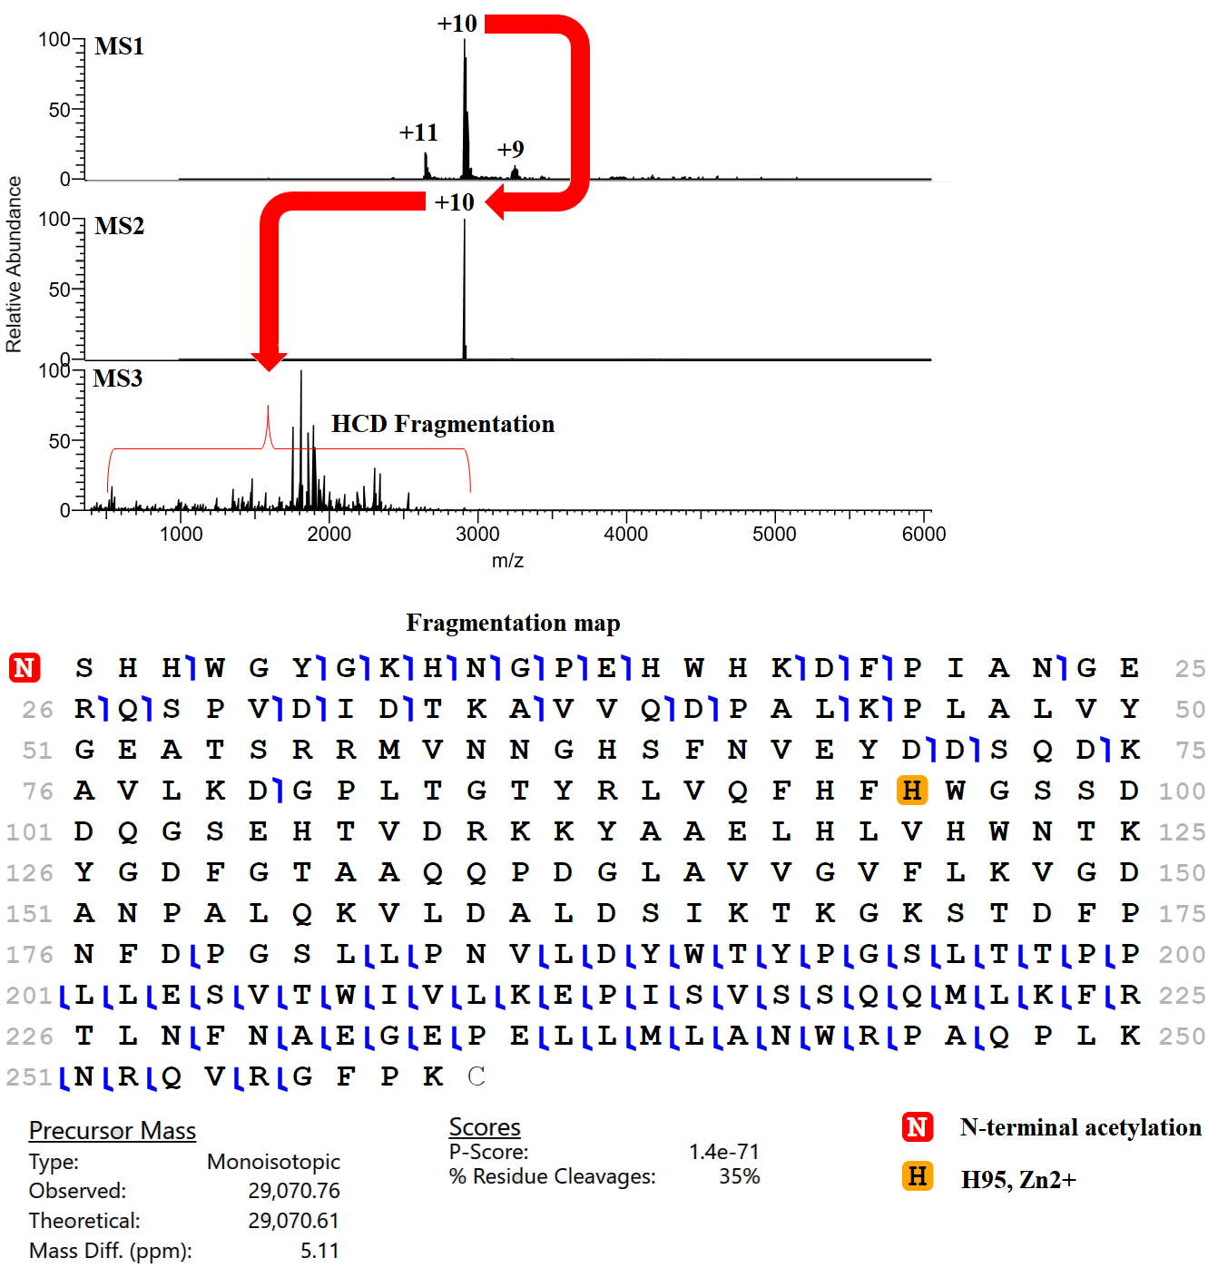

Figure S1. nTDP spectra of CA II and its fragmentation map generated by the ProSight Lite.
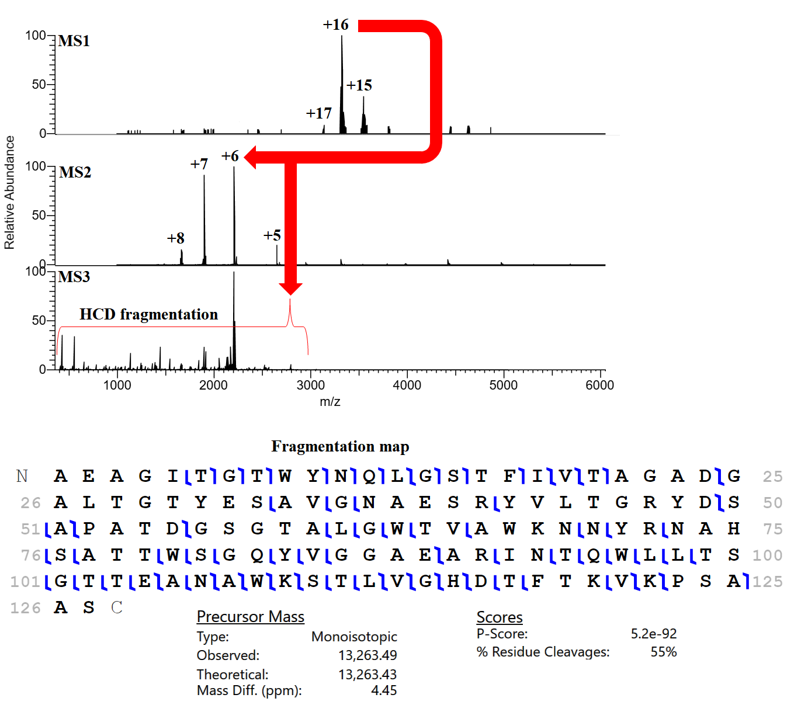
Figure S2. nTDP spectra of SA and its fragmentation map generated by the ProSight Lite.
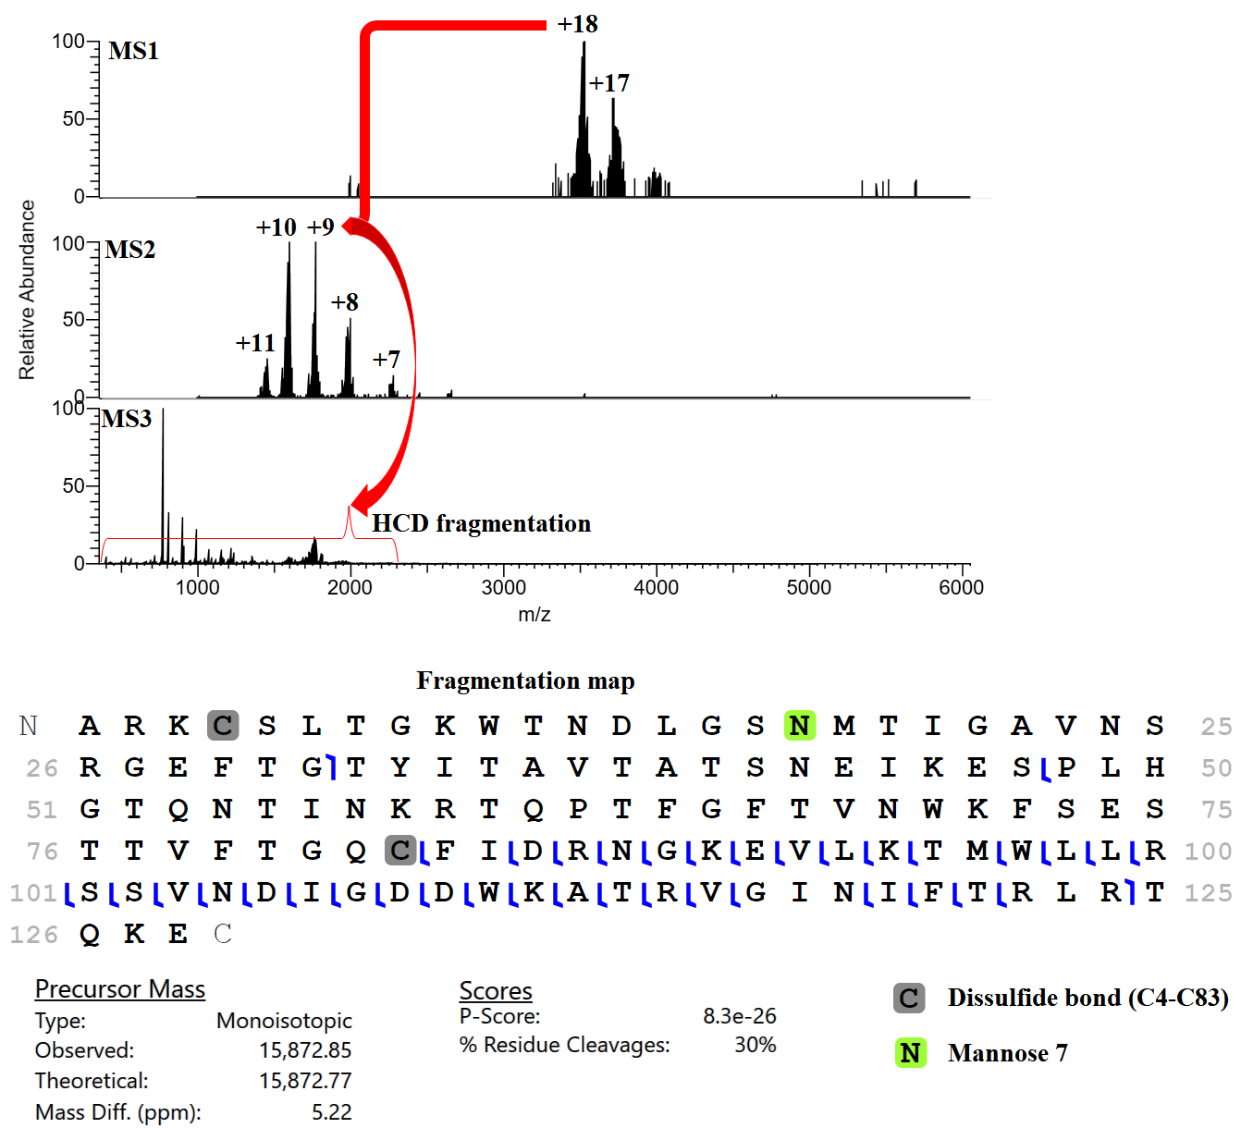
Figure S3. nTDP spectra of AV and its fragmentation map generated by the ProSight Lite.

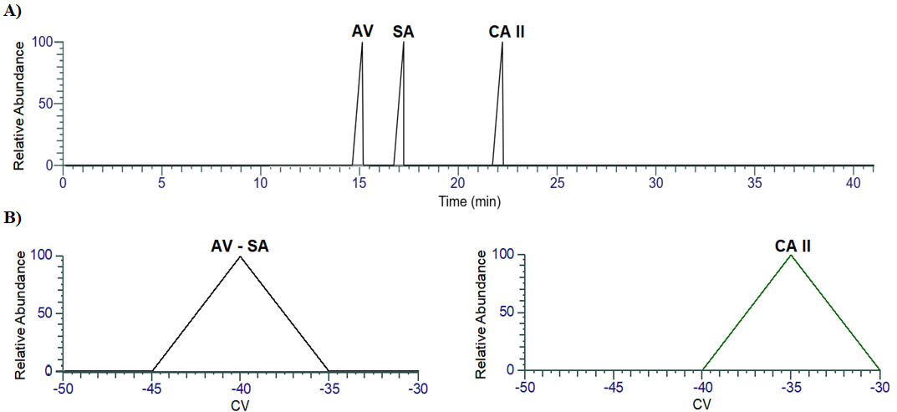
Figure S4. Base peak mobiliogram of the standard protein complexes with their CVs. (A) Base peak mobiliogram of the standard protein complexes. (B) CVs of the standard protein complexes.
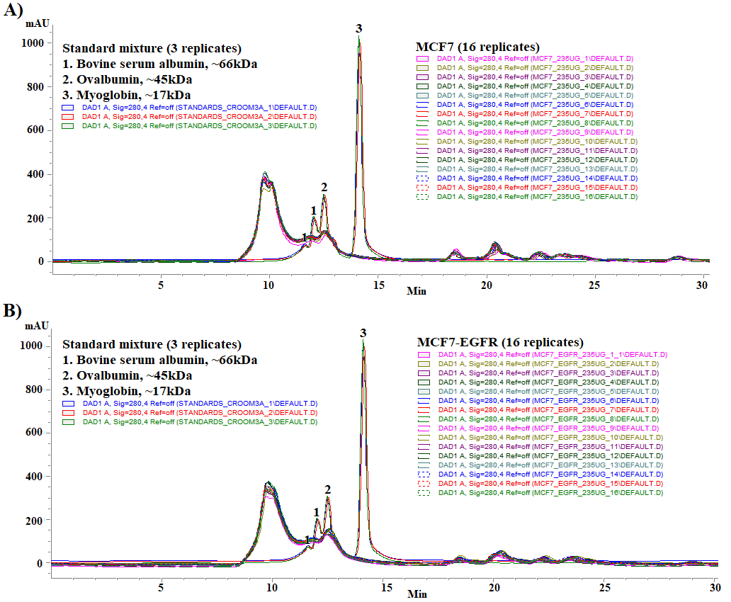
Figure S5. nSEC chromatographic profiles of protein assemblies in MCF-7 and MCF-7-EGFR cells and standard proteins. (A) Protein assemblies in MCF-7 cells (16 overlapped replicates) and protein standards (3 overlapped replicates). (B) Protein assemblies in MCF-7-EGFR cells (16 overlapped replicates) and protein standards (3 overlapped replicates).
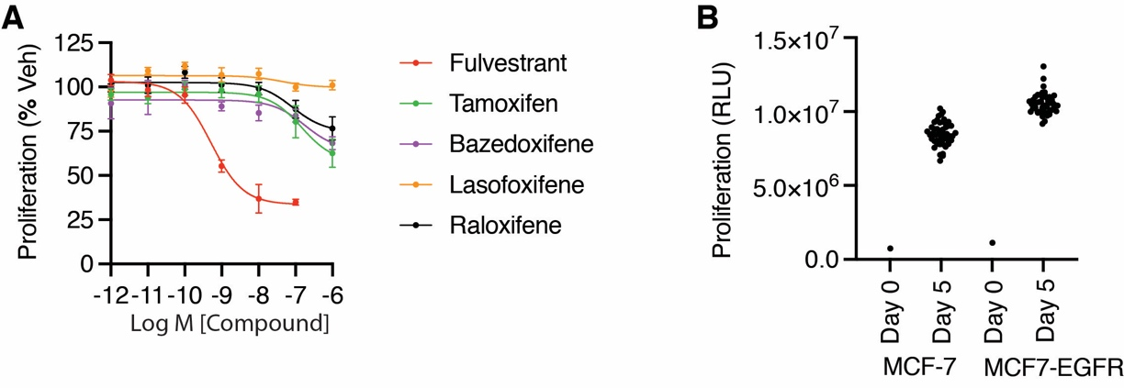

Figure S6. MCF-7-EGFR cells are resistant to SERMs and grow faster. (A) MCF-7-EGFR Cells were treated with the indicated compounds for 5 days and assayed for cell number. Data is normalized to DMSO vehicle and the starting cell number. Mean +SEM of 4 replicates. (B) MCF-7 and MCF-7-EGFR cells were grown for 5 days and assayed for proliferation. Day 5 EGFR cells grew significantly faster than the MCF-7 (Student’s T test, p = 9 x 10-²⁴). Day 5 was 48 wells per cell type.

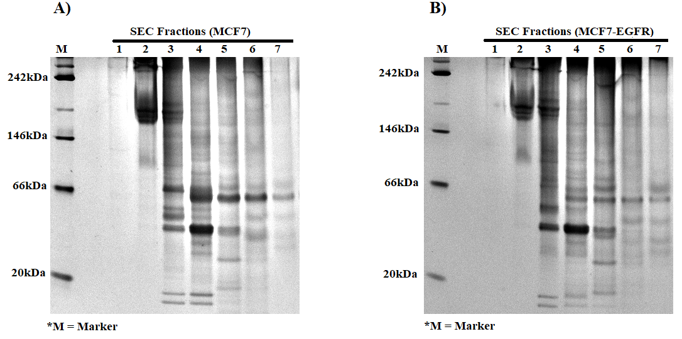

Figure S7. Native Gels of protein assemblies in MCF-7 and MCF-7-EGFR cells. (A) Native gel of MCF-7 cells. (B) Native gel of MCF-7-EGFR cells.

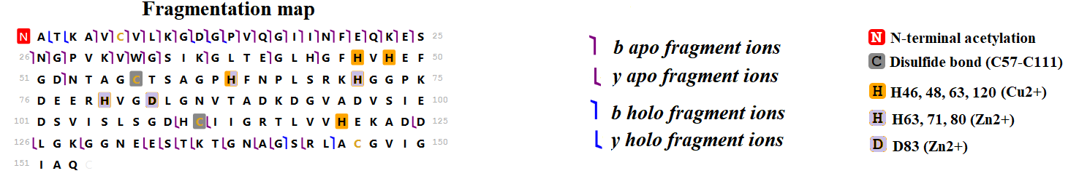

Figure S8. Fragmentation map of SOD1 with apo and holo fragment ions that was generated using TDValidator software.

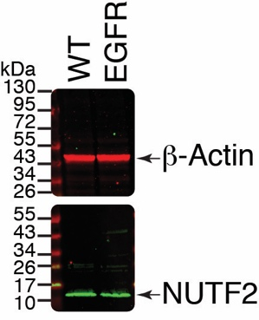

Figure S9. Western blot of NUTF2 protein expression in MCF-7 and MCF-7-EGFR cells.

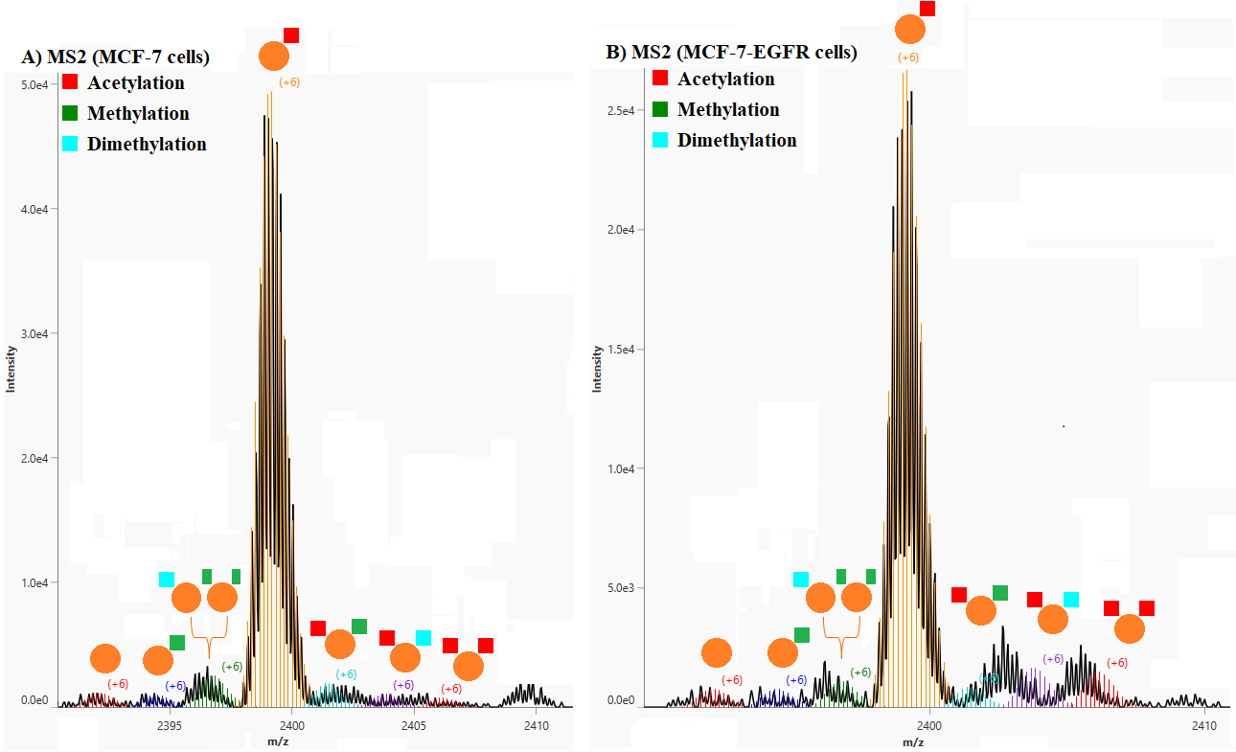
Figure S10. MS2 spectra that were generated by TDValidator with overlayed isotopic distribution of the NUFT2 proteoforms in MCF-7 and MCF-7-EGFR cells. (A) NUFT2 proteoforms in MCF-7 cells. (B) NUFT2 proteoforms in MCF-7-EGFR cells.

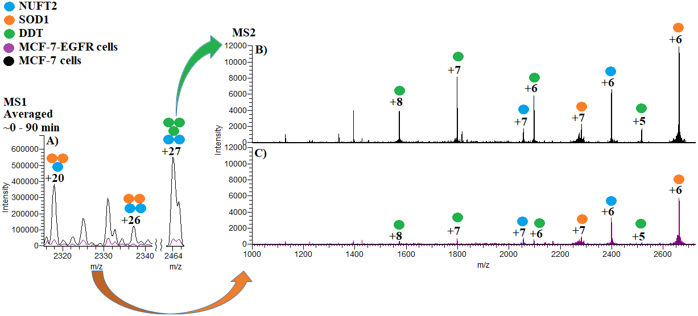
Figure S11. Protein-NUFT2 interactions in MCF-7 and MCF-7-EGFR cells. (A) Native MS spectra of the SOD1-NUFT2 and DDT-NUFT2 interactions in MCF-7 and MCF-7-EGFR cells. (B) MS2 spectrum of the SOD1, DDT, NUFT2 species in MCF-7 cells. (C) MS2 spectrum of the SOD1, DDT, NUFT2 monomeric subunits in MCF-7-EGFR cells.
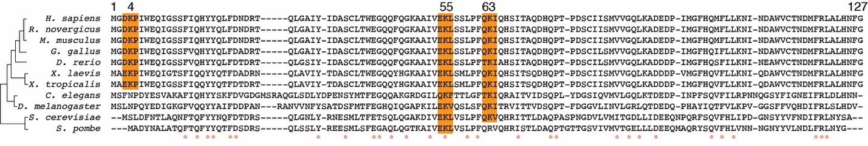
Figure S12. Sequence alignment of NUTF2 homologs. The PTM sites K4, K55, and K63 are highlighted.

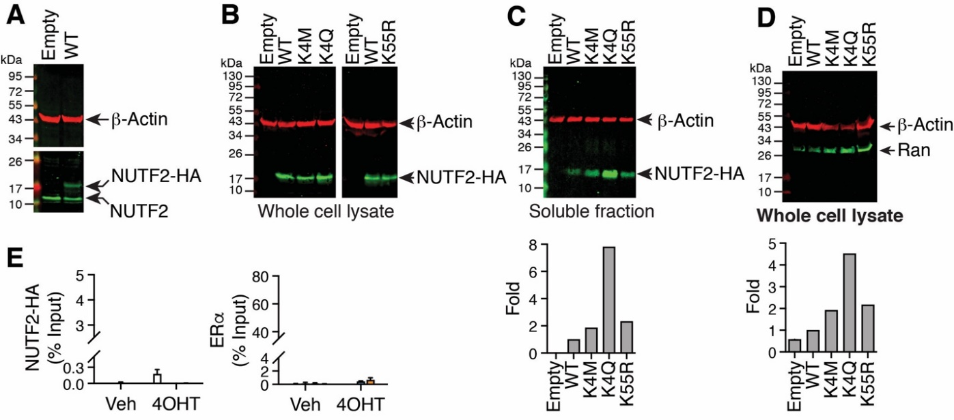
Figure S13. Expression of HA-NUTF2 in MCF-7 cells. (A) Exogenous and endogenous NUTF2 levels in stable MCF7 cells. Whole cell lysates were analyzed by western blot. (B-C) Exogenous NUTF2 levels in stable MCF7 cells. Whole cell lysates were analyzed by western blot. For the HA tag. Empty, empty vector. Quantitation was performed with Image J. (D) Endogenous Ran levels in stable MCF7 cells. Whole cell lysates were analyzed by western blot. (E) ChIP-PCR at the ROCK2 promoter: NUTF2 expressing MCF-7 cells treated for 1 h with vehicle or 1 µM 4OH were compared by qChIP assay using ERα and HA-tag antibodies.
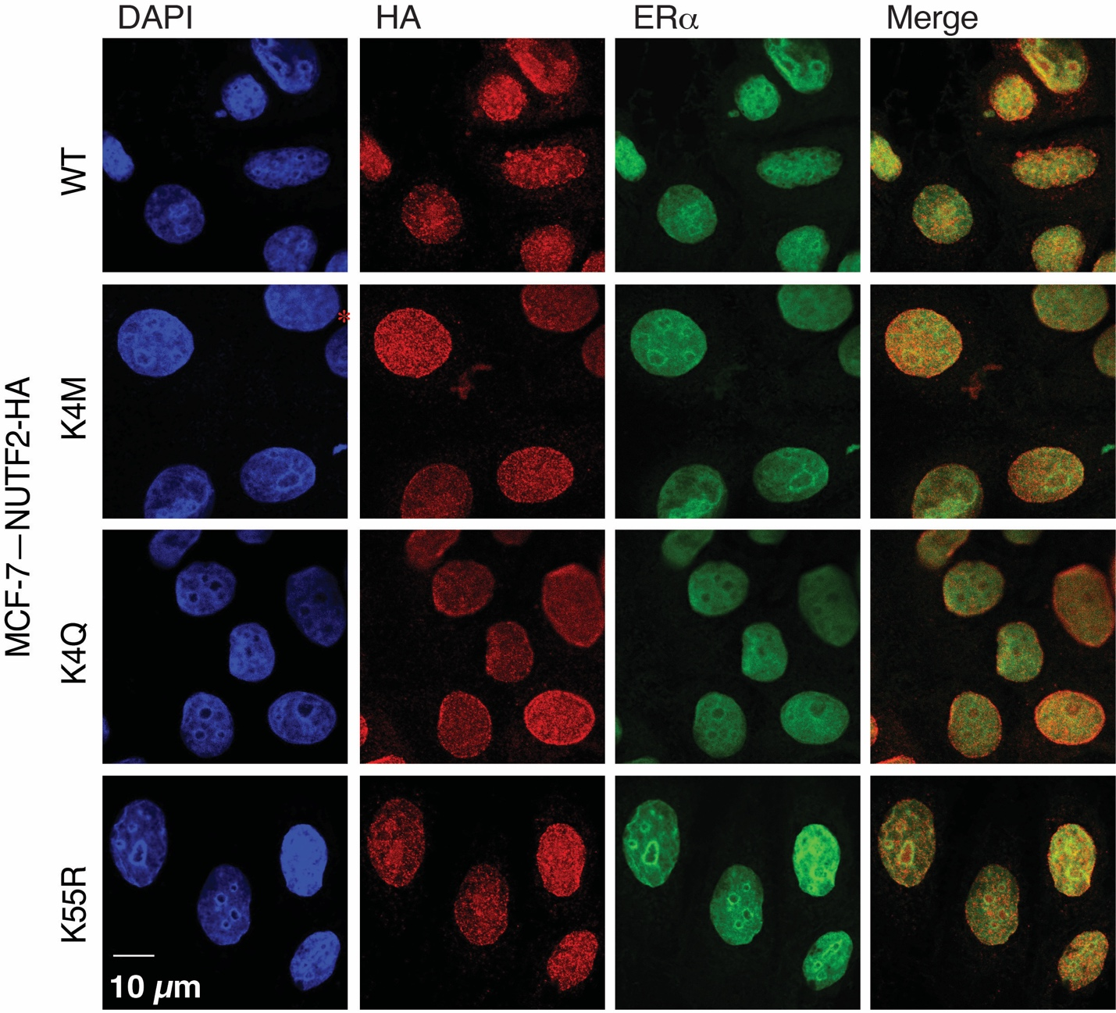
Figure S14. Confocal Microscopy of MCF-7–NUTF2 stable cell lines. Cells were fixed, permeabilized and stained with DAPI or antibodies against the HA-tagged NUTF2 plasmid or ERα.
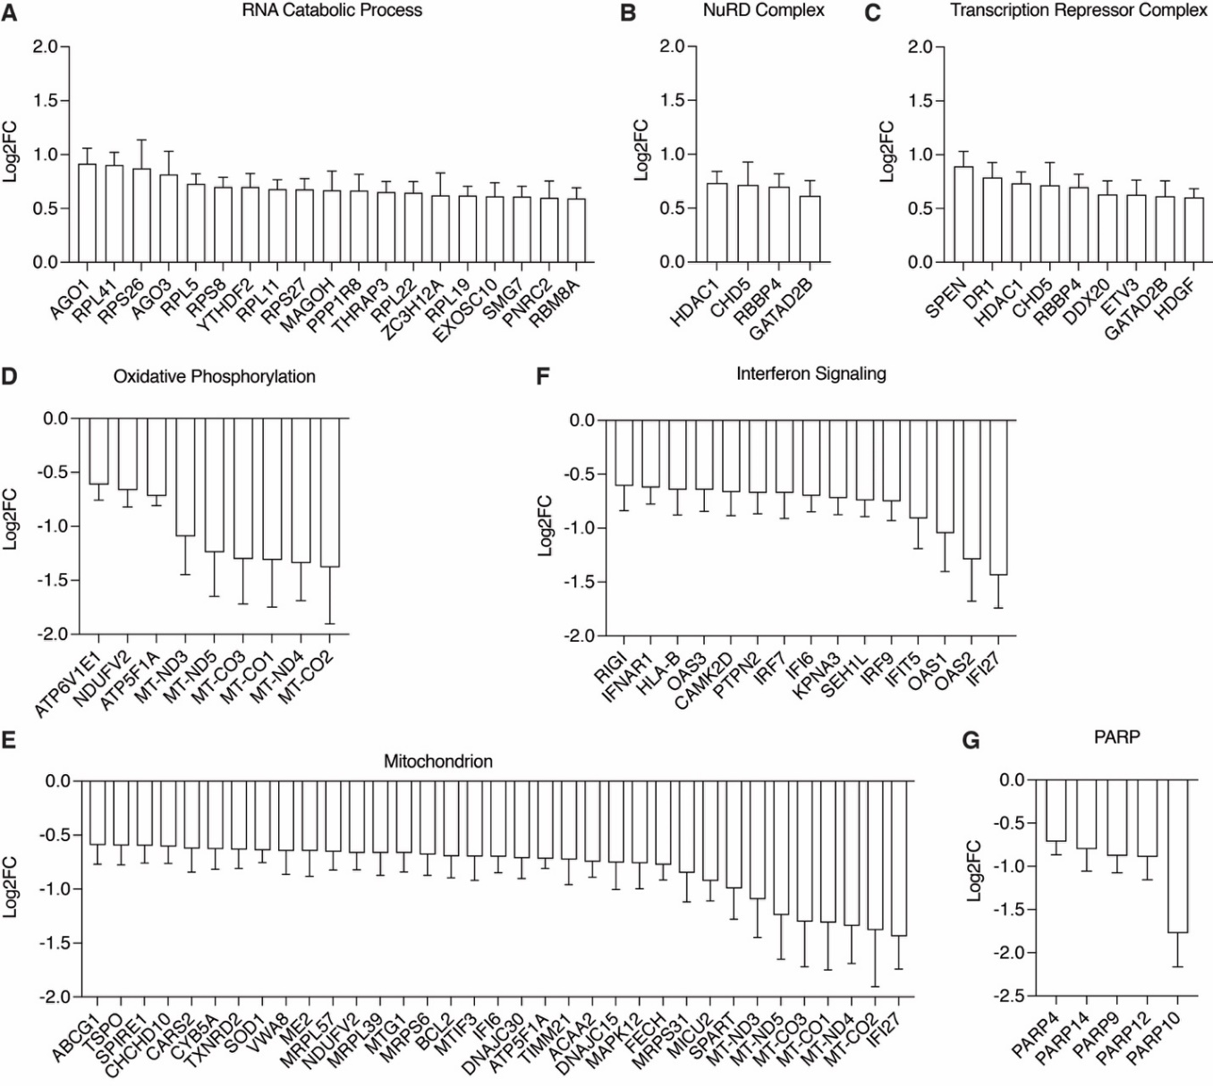
Figure S15. Gene set enrichment analysis of NUTF2 expressing/empty vector expressing MCF-7 cells.

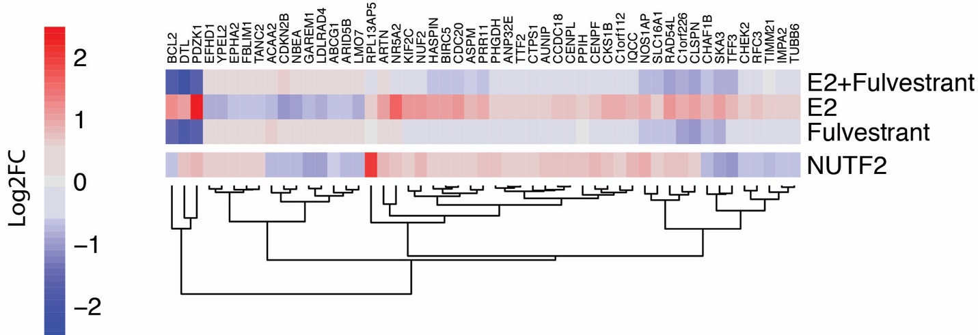
Figure S16. Genes regulated by NUTF2 and estradiol (E2). Hierarchical clustering was used to compare gene sets. MCF-7 cells were grown in steroid depleted media for three days and treated with E2, fulvestrant, or E2+ fulvestrant for 24 hrs. Three biological replicates from different passages of cells were used for each condition.

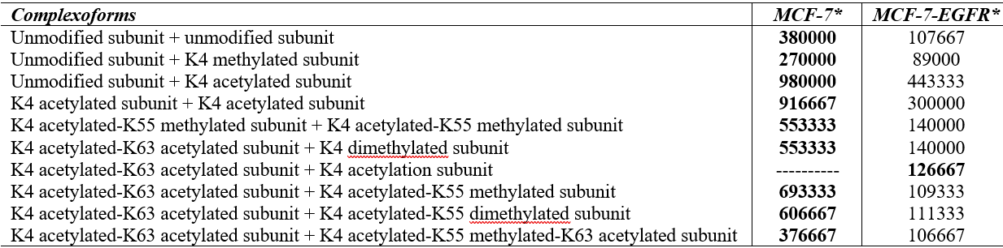
Table S2. Intensity of the NUFT2 complexoforms (averaged in the three replicates).

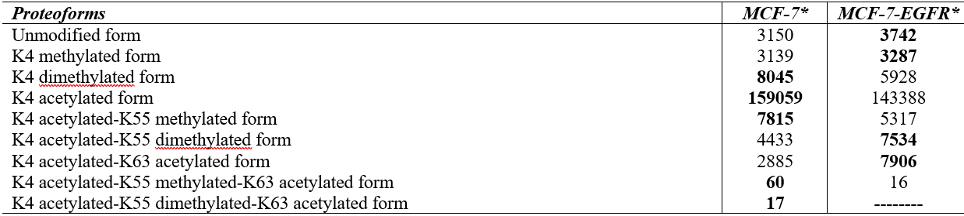
Table S3. Intensity of the NUFT2 proteoforms (averaged in the three replicates).

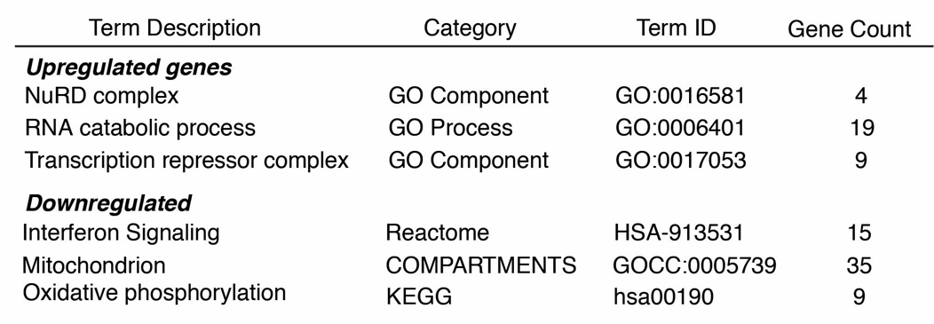
Table S4. Gene set enrichment analysis.
References
1 Skinner, O. S. et al. Top-down characterization of endogenous protein complexes with native proteomics. Nat Chem Biol 14, 36-41, doi:10.1038/nchembio.2515 (2018).
2 Mehaffey, M. R., Xia, Q. & Brodbelt, J. S. Uniting Native Capillary Electrophoresis and Multistage Ultraviolet Photodissociation Mass Spectrometry for Online Separation and Characterization of Escherichia coli Ribosomal Proteins and Protein Complexes. Analytical Chemistry 92, 15202-15211, doi:10.1021/acs.analchem.0c03784 (2020).
3 Shen, X. et al. Native Proteomics in Discovery Mode Using Size-Exclusion Chromatography–Capillary Zone Electrophoresis–Tandem Mass Spectrometry. Analytical Chemistry 90, 10095-10099, doi:10.1021/acs.analchem.8b02725 (2018).
4 Jooß, K. et al. Separation and Characterization of Endogenous Nucleosomes by Native Capillary Zone Electrophoresis–Top-Down Mass Spectrometry. Analytical Chemistry, doi:10.1021/acs.analchem.0c04975 (2021).
5 Shen, X. et al. Investigating native capillary zone electrophoresis-mass spectrometry on a high-end quadrupole-time-of-flight mass spectrometer for the characterization of monoclonal antibodies. Int J Mass Spectrom 462, doi:10.1016/j.ijms.2021.116541 (2021).
6 Hale, O. J., Illes-Toth, E., Mize, T. H. & Cooper, H. J. High-Field Asymmetric Waveform Ion Mobility Spectrometry and Native Mass Spectrometry: Analysis of Intact Protein Assemblies and Protein Complexes. Analytical Chemistry 92, 6811-6816, doi:10.1021/acs.analchem.0c00649 (2020).
7 Gerbasi, V. R. et al. Deeper Protein Identification Using Field Asymmetric Ion Mobility Spectrometry in Top-Down Proteomics. Anal Chem 93, 6323-6328, doi:10.1021/acs.analchem.1c00402 (2021).
8 VanAernum, Z. L. et al. Surface-Induced Dissociation of Noncovalent Protein Complexes in an Extended Mass Range Orbitrap Mass Spectrometer. Analytical Chemistry 91, 3611-3618, doi:10.1021/acs.analchem.8b05605 (2019).
9 Larson, E. J. et al. High-Throughput Multi-attribute Analysis of Antibody-Drug Conjugates Enabled by Trapped Ion Mobility Spectrometry and Top-Down Mass Spectrometry. Analytical Chemistry 93, 10013-10021, doi:10.1021/acs.analchem.1c00150 (2021).
10 Li, H., Nguyen, H. H., Ogorzalek Loo, R. R., Campuzano, I. D. G. & Loo, J. A. An integrated native mass spectrometry and top-down proteomics method that connects sequence to structure and function of macromolecular complexes. Nature chemistry 10, 139-148, doi:10.1038/nchem.2908 (2018).
11 Chernushevich, I. V. & Thomson, B. A. Collisional Cooling of Large Ions in Electrospray Mass Spectrometry. Analytical Chemistry 76, 1754-1760, doi:10.1021/ac035406j (2004).
12 Min, J. et al. Dual-mechanism estrogen receptor inhibitors. Proc Natl Acad Sci U S A 118, doi:10.1073/pnas.2101657118 (2021).
13 Fellers, R. T. et al. ProSight Lite: graphical software to analyze top-down mass spectrometry data. Proteomics 15, 1235-1238, doi:10.1002/pmic.201570050 (2015).
14 Fornelli, L. et al. Accurate Sequence Analysis of a Monoclonal Antibody by Top-Down and Middle-Down Orbitrap Mass Spectrometry Applying Multiple Ion Activation Techniques. Analytical Chemistry 90, 8421-8429, doi:10.1021/acs.analchem.8b00984 (2018).
15 Bookout, A. L., Cummins, C. L., Mangelsdorf, D. J., Pesola, J. M. & Kramer, M. F. High-throughput real-time quantitative reverse transcription PCR. Curr Protoc Mol Biol Chapter 15, Unit 15.18, doi:10.1002/0471142727.mb1508s73 (2006).
16 The Galaxy platform for accessible, reproducible and collaborative biomedical analyses: 2022 update. Nucleic Acids Res 50, W345-w351, doi:10.1093/nar/gkac247 (2022).
17 Kim, D., Langmead, B. & Salzberg, S. L. HISAT: a fast spliced aligner with low memory requirements. Nature methods 12, 357-360, doi:10.1038/nmeth.3317 (2015).
18 Love, M. I., Huber, W. & Anders, S. Moderated estimation of fold change and dispersion for RNA-seq data with DESeq2. Genome Biol 15, 550, doi:10.1186/s13059-014-0550-8 (2014).
19 Szklarczyk, D. et al. STRING v11: protein-protein association networks with increased coverage, supporting functional discovery in genome-wide experimental datasets. Nucleic Acids Res 47, D607-d613, doi:10.1093/nar/gky1131 (2019).
20 Qin, Q. et al. Lisa: inferring transcriptional regulators through integrative modeling of public chromatin accessibility and ChIP-seq data. Genome Biol 21, 32, doi:10.1186/s13059-020-1934-6 (2020).

