Deforestation limits evolutionary rescue under climate change in Amazonian lizards
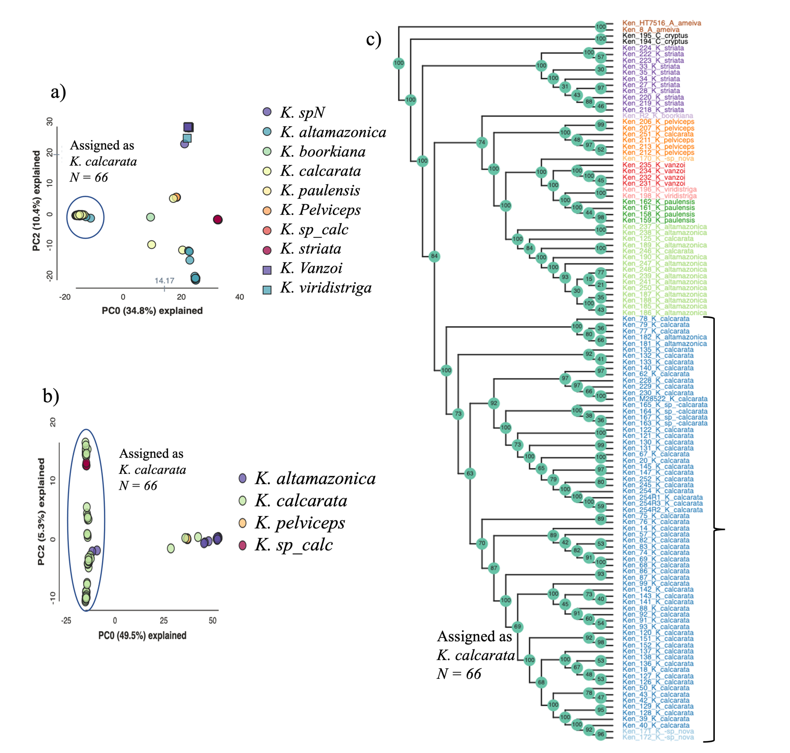
Josué A. R. Azevedo; Søren Faurby; Guarino R. Colli; Alexandre Antonelli; Fernanda P. Werneck

Supplementary Figures

Figure S1 – Samples delimited into the different species of Kentropyx. (a) Principal components analysis (PCA) showing genomic distances derived from 139,205 SNPs, including the 117 samples (see Table S1) for all species. (b) PCA including only the K. calcarata species group (including samples unsurely identified as Kentropyx sp. or Kentropyx cf. calcarata). Two samples initially identified in museums as K. altamazonica clustered with K. calcarata here and in the species tree. Three samples identified initially as K. calcarata clustered with other species and were removed from downstream analyses. (c) SVDquartets tree showing sample identification as in Table S1. Sixty-six samples were grouped by both methods as Kentropyx calcarata and used in downstream analyses.
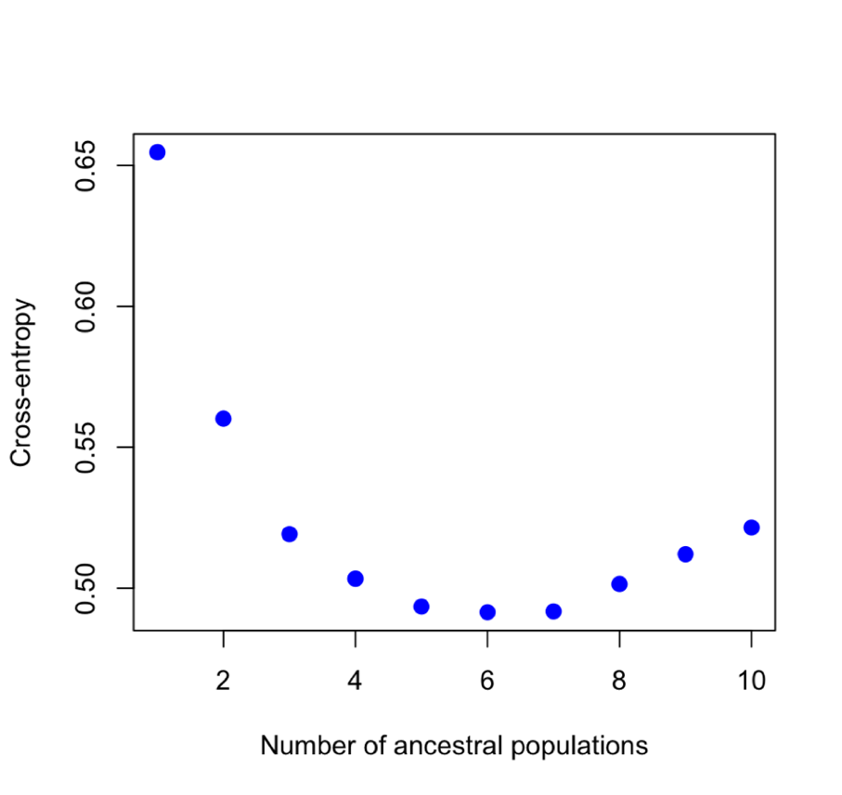
Figure S2 – Sparse nonnegative matrix factorization (sNMF) cross-entropy results. The number of populations k = 6 was significantly smaller than k = 5 or 7 and selected for the downstream analyses.

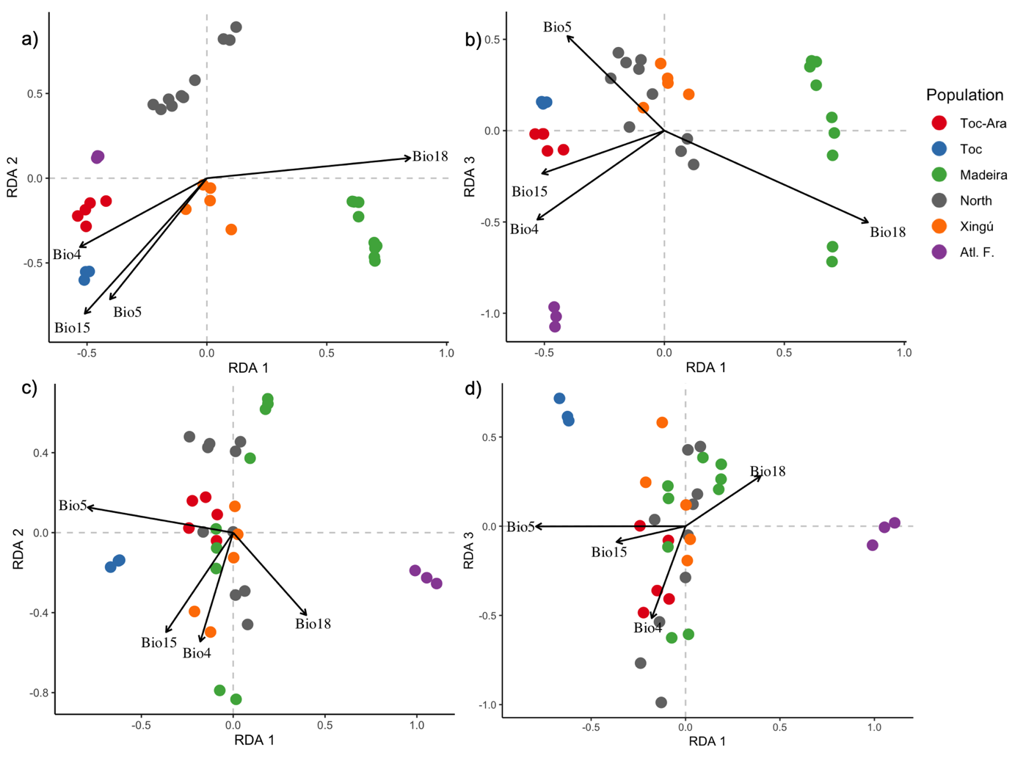
Figure S3 – RDA plots for Kentropyx calcarata individuals. In the upper panel (a-b) genome-environmental association RDA results not accounting for the neutral genetic structure. Lower panel (c-d) RDA results accounting for the neutral genetic structure. Individuals are represented by dots colored by the populations identified in the sNMF analysis. Arrow size indicates the relative importance of each bioclimatic variable, while the arrow's direction represents the direction of the variable's variation. When accounting for the neutral genetic variation, the variation among delimited populations were less related to the climate gradient (potentially reducing false positives).

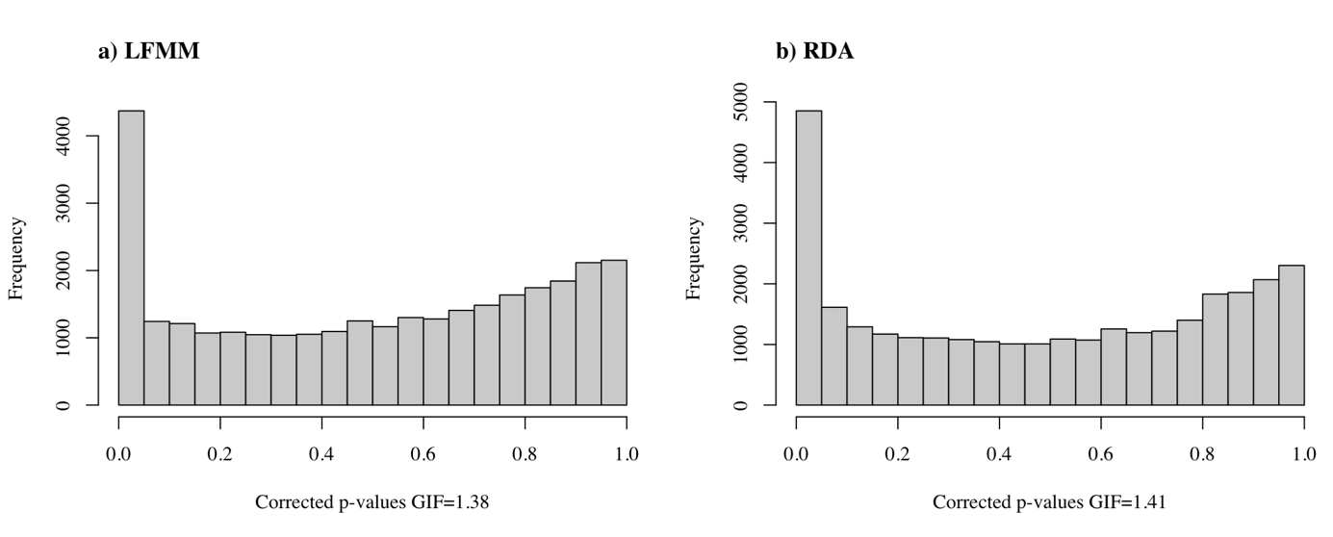
Figure S4 – Distribution of P-values from the LFMM and RDA analyses for each of the 30,589 SNPs. (a) LFMM p-values considering the SNPs and the reduced representation (PC1) of the four bioclimatic variables after correcting for the genomic inflation factor (GIF). (b) RDA p-values after the GIF correction.

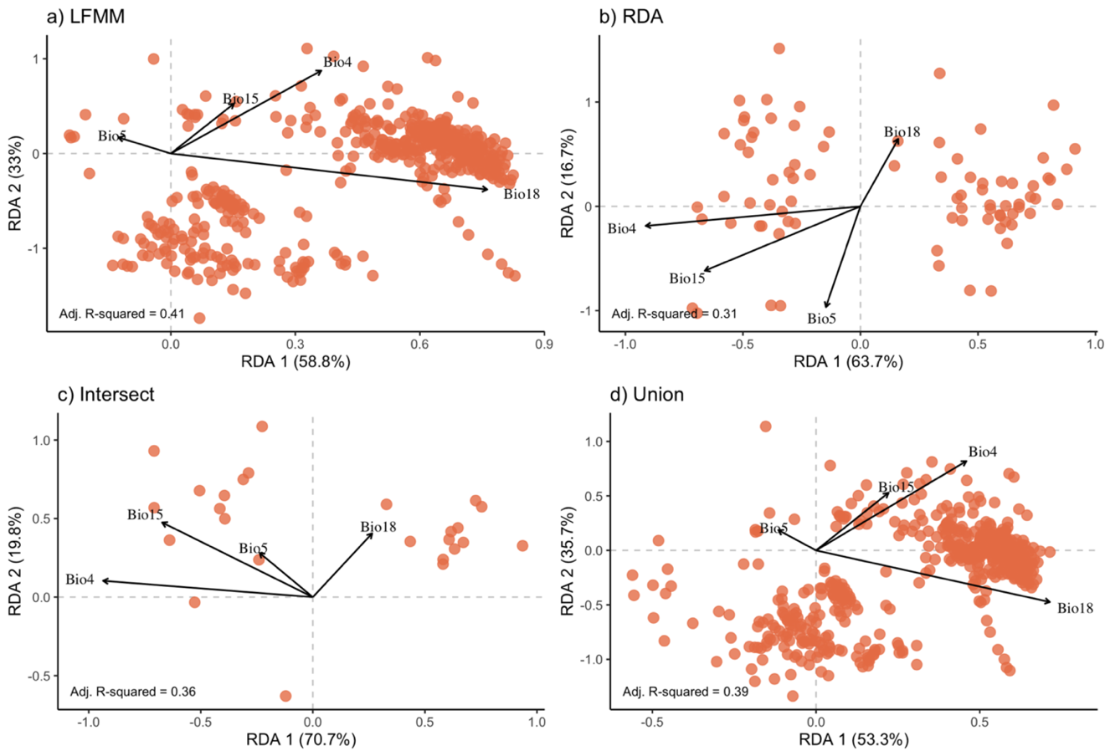
Figure S5 – RDA plots for Kentropyx calcarata candidate SNPs. Adaptively enriched RDA axis showing the distribution of distinct sets of candidate SNPs from (a) LFMM only, (b) RDA only, (c) RDA-LFMM intersect (congruent between both methods and used in downstream analyses), and (d) all SNPs found with both analyses (RDA-LFMM union). Orange dots represent the SNPs.

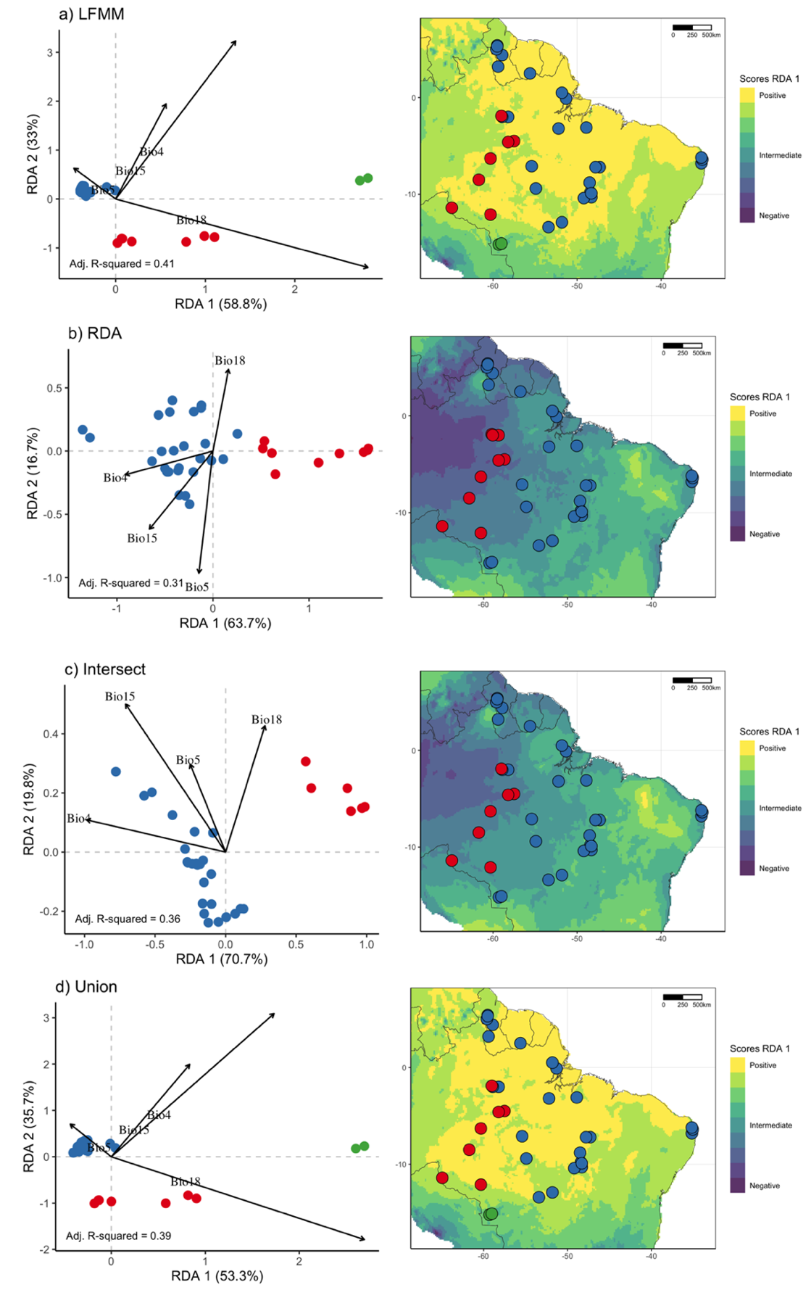
Figure S6 – Distribution of individuals and genotype classification for Kentropyx calcarata for distinct sets of candidate SNPs across a climate gradient (adaptively-enriched RDA, left) and over the adaptive landscape (cells with higher predicted similarity present similar color). Individuals were classified into two main groups (k-means classification): one at central-southwestern Amazonia (wet/non-seasonal individuals) and another one across eastern Amazonia and the ecotone with Cerrado and northern savannas.
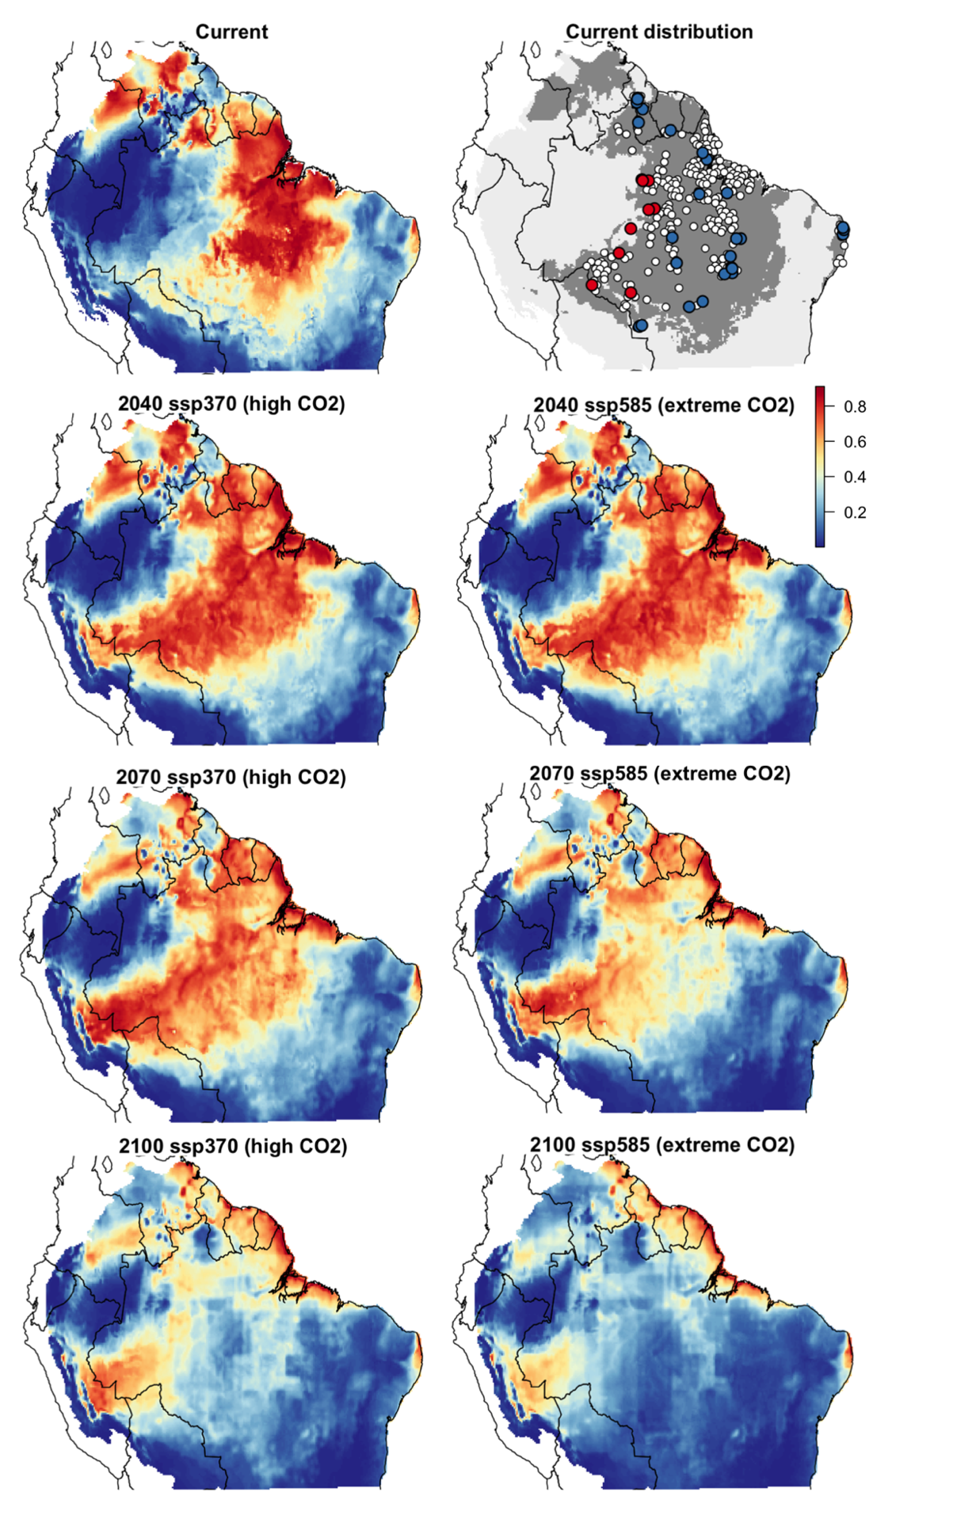
Figure S7 – Predictions of environmental niche models for all records of the species. The map in gray tones indicate the presence-absence after applying the threshold (not removing deforested sites). Red dots indicate individuals classified as wet/non-seasonal genotypes, blue indicates dry/seasonal genotypes and white are the remaining presence records for the species. The remaining maps show suitability values across time in two distinct Shared Socioeconomic Pathways (SSPs).

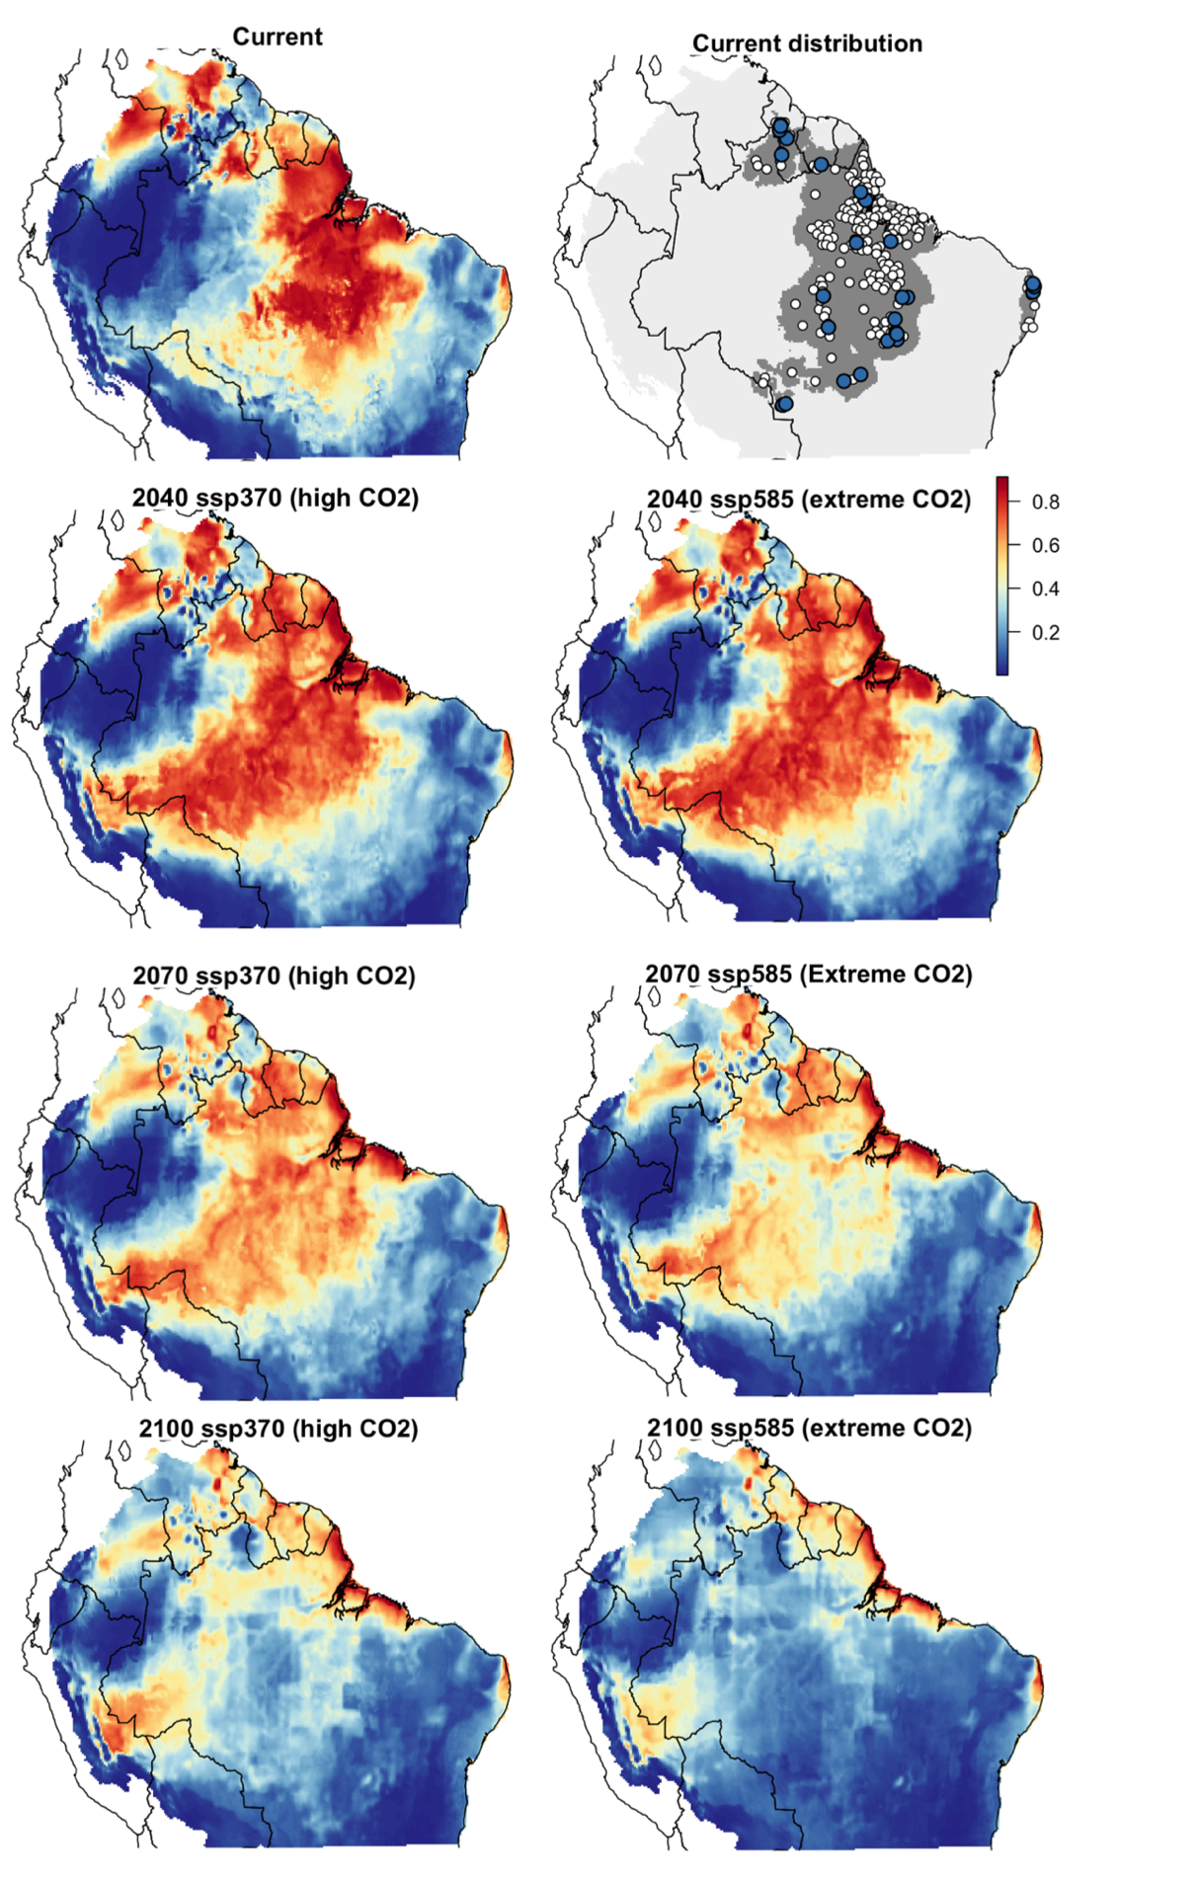
Figure S8 – Predictions of environmental niche models for Dry/seasonal genotypes. The map in gray tones indicate the presence-absence after applying the threshold (not removing deforested sites). Blue dots represent dry/seasonal genotypes with genomic information and white dots are literature presence records classified as the same genotype for modelling. The remaining maps show suitability values across time in two distinct Shared Socioeconomic Pathways (SSPs).

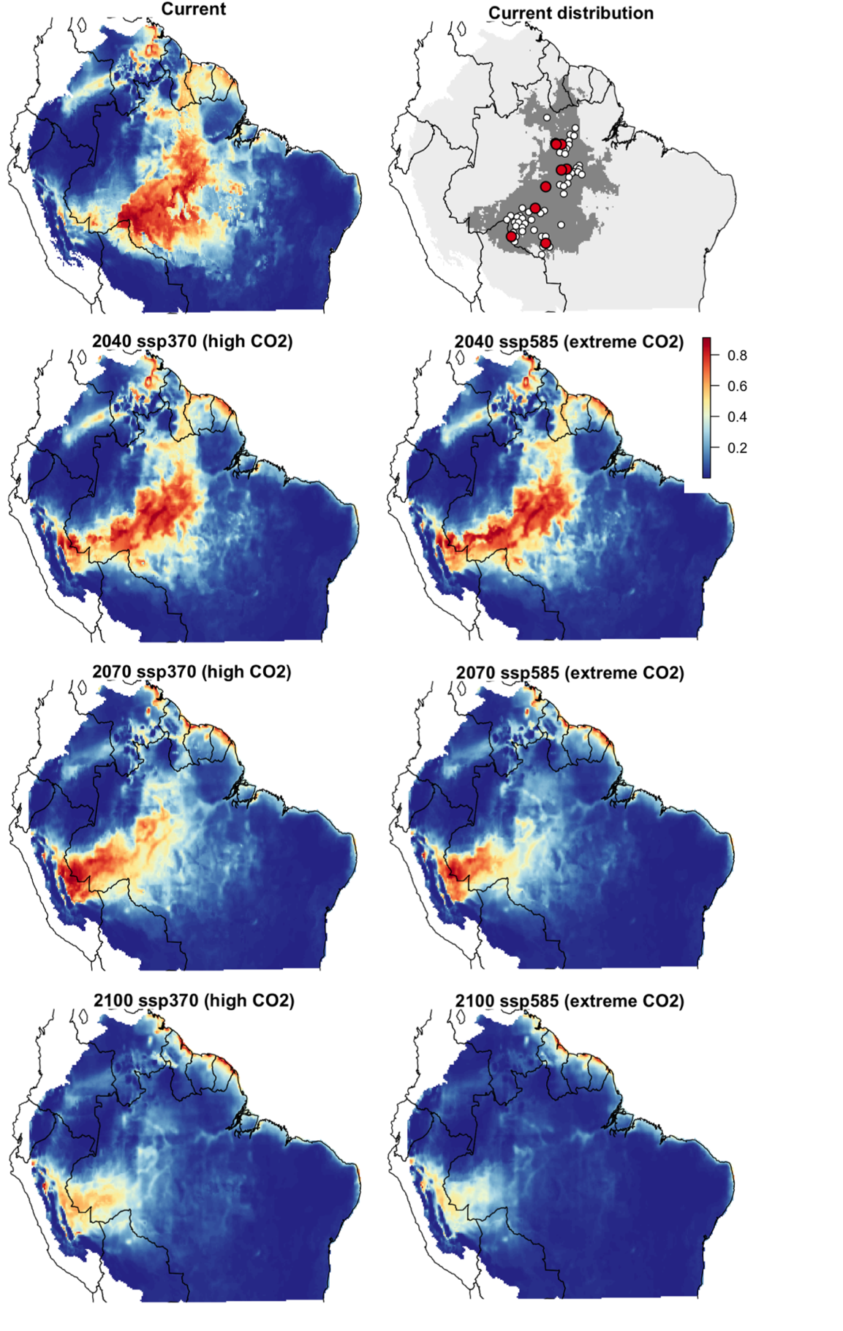
Figure S9 – Predictions of environmental niche models for Wet/non-seasonal genotypes. The map in gray tones indicate the presence-absence after applying the threshold (not removing deforested sites). Red dots represent wet/non-seasonal genotypes with genomic information and white dots are literature presence records classified as the same genotype for modelling. The remaining maps show suitability values across time in two distinct Shared Socioeconomic Pathways (SSPs).
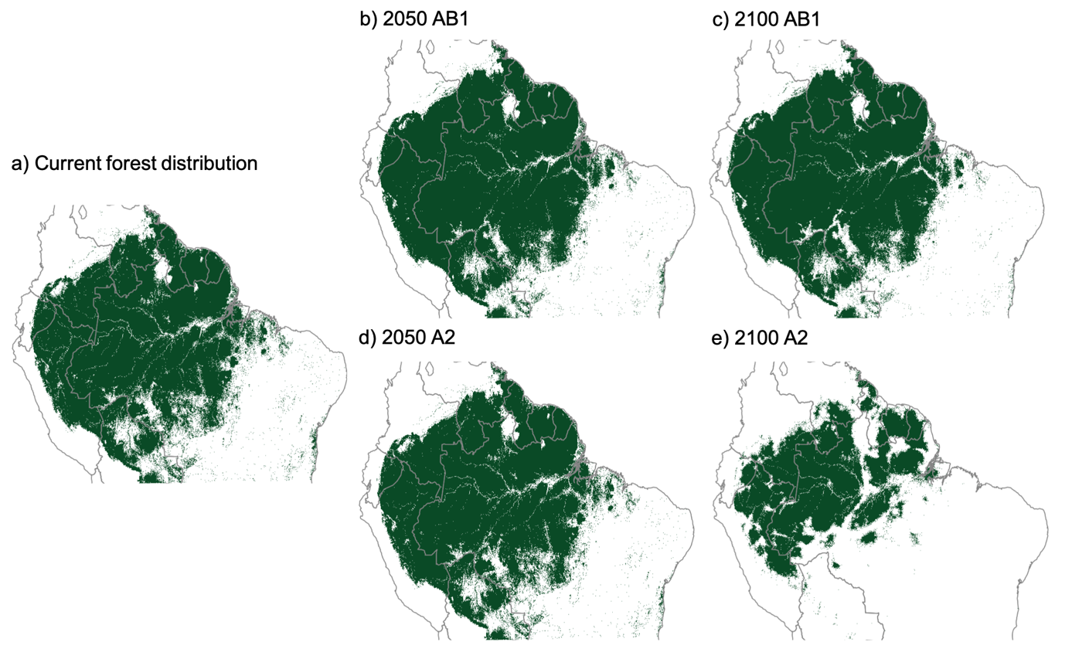
Figure S10 – Predictions of future forest cover in South America (in green) modified from Liu et al. (2017) based on global land-use and land-cover models estimated from remote sensing, GCMs, future land use simulations, and dispersal constraints. (a) Current forest cover. (b) Predictions for the AB1 (moderate) scenario in 2050 and (c) 2100. (d) Predictions for the A2 (extreme) scenario in 2050 and (e) in 2100.

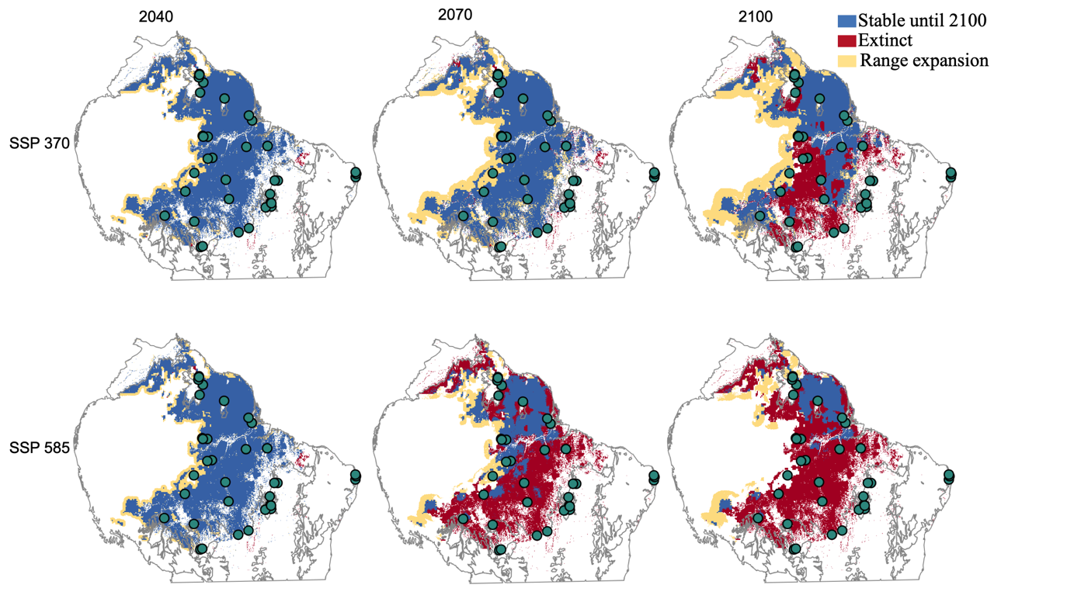
Figure S11 – Predictions range shift for all records of the species derived from SDM projections until 2100 (SSP 3-7.0: ‘moderate/middle-range’ and SSP 5-8.5: ‘extreme’ scenarios) with dispersal limitation constraints (lack of forest cover, Fig S10).

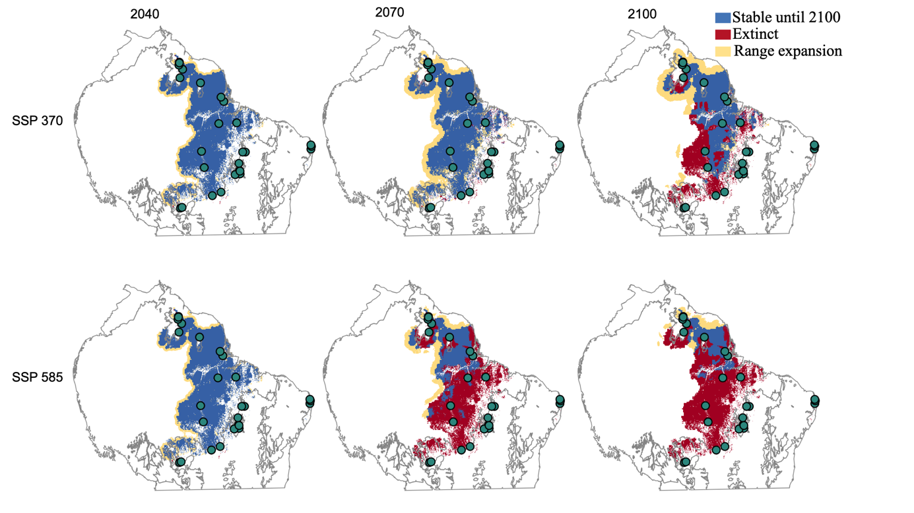
Figure S12 – Predictions range shift for the Dry/Seasonal genotype
derived from SDM projections until 2100 (SSP 3-7.0: ‘moderate/middle-range’ and SSP 5-8.5: ‘extreme’ scenarios) with dispersal limitation constraints (lack of forest cover, Fig S10).

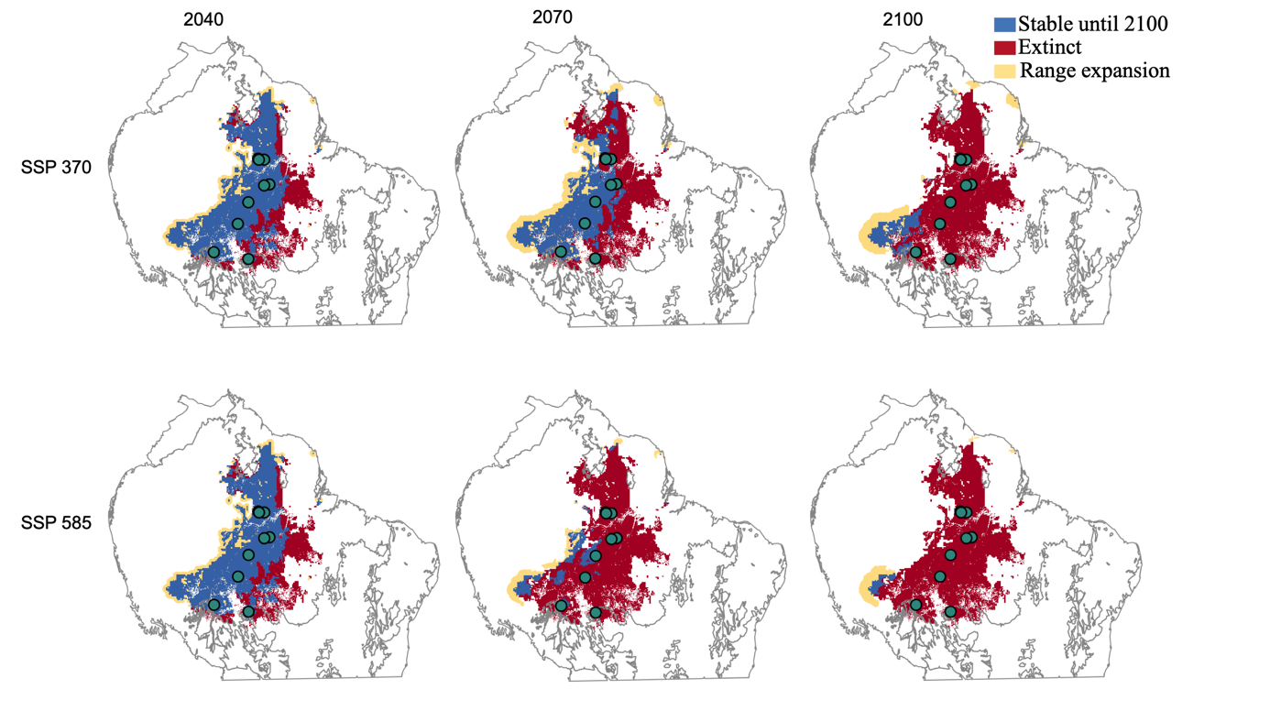
Figure S13 – Predictions range shift for the Wet/non-seasonal genotype derived from SDM projections until 2100 (SSP 3-7.0: ‘moderate/middle-range’ and SSP 5-8.5: ‘extreme’ scenarios) with dispersal limitation constraints (lack of forest cover, Fig S10).

