Supplementary Tables
Table S1. Summary of the metaproteome and metagenome annotations. Including, taxonomic annotations (LCA score ≥80%) and functional annotations (BLASTP, Uniprot) obtained from mPies for the 16S-TaxDB, 18S-TaxDB (note taxonomy is from BLASTP results), MG-DB, and 16S-TaxDB-2nd protein search databases. The metagenome annotations are derived from DRAM and include hits to the KEGG and PFam databases [EXCEL FILE].

Table S2. Summary of the taxonomic classifications of the metagenome reads obtained using Kaiju [EXCEL FILE].

Table S3. Relative quantification and functional annotations of the expressed Pseudoalteromonas sp. proteins (% relative abundance) using the recovered metagenome-assembled genome as a protein search database [EXCEL FILE].

Supplementary Figures
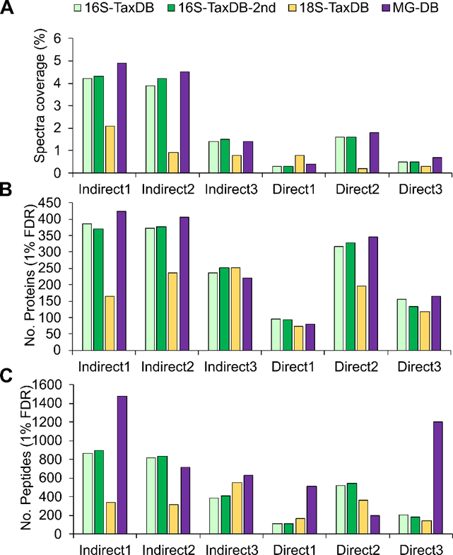
Fig. S1. Coverages of identified peptide spectra across four protein search databases for the indirect and direct extraction metaproteomes (A); corresponding number of identified proteins at a False Discovery Rate of 1% (B); number of identified peptides (C).
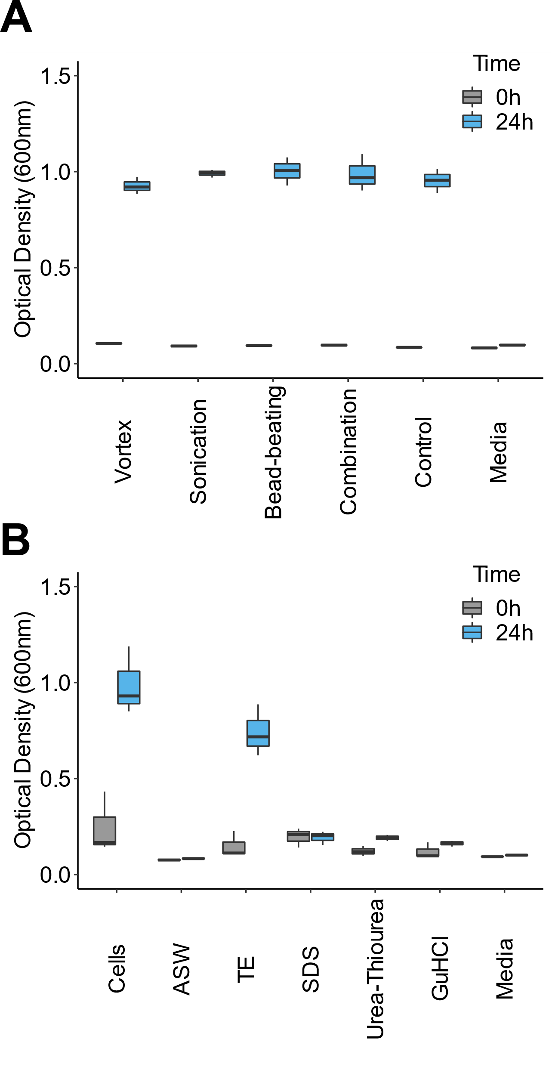
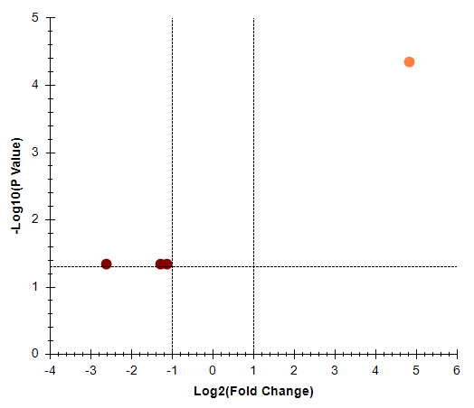
Fig S3. Microbial growth after 24 hr incubation in nutrient rich media following: mechanical detachment of plastisphere cells (n=3; A), and viability of chemically lysed cells (n=3; B). ASW = artificial seawater. Control = plastics on ice in ASW; cells = detached cells, no cell lysis.
Fig. S2. Significant up- / down-regulation of quantified proteins between Indirect (maroon circles) and Direct (orange circles) extraction (cut-off = 2-Fold Change, adjusted P-value < 0.05).
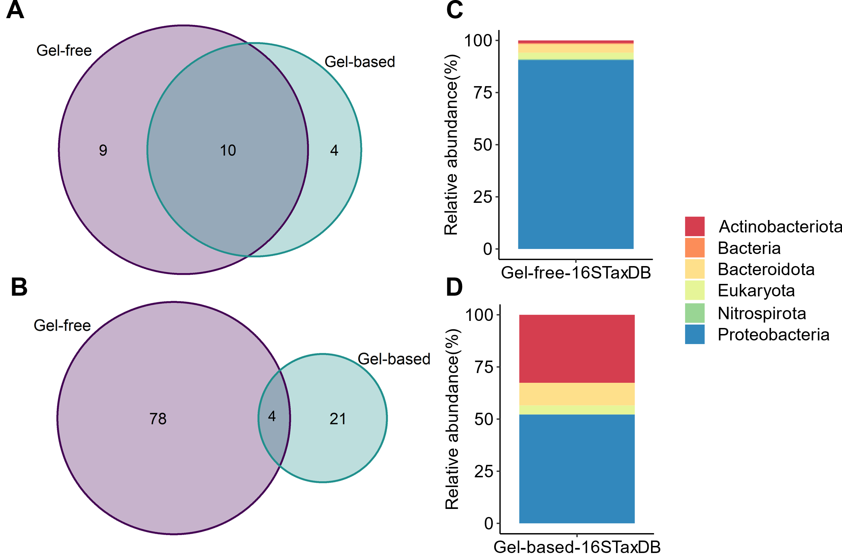
Fig. S4. Comparison of annotated proteins from the gel-free and gel-based metaproteomes. Numbers of shared and unique genera-level taxonomic annotations (A), and protein functions (B), phylum level taxonomic annotations of identified proteins in the gel-free (C) and gel-based (D), metaproteomes.

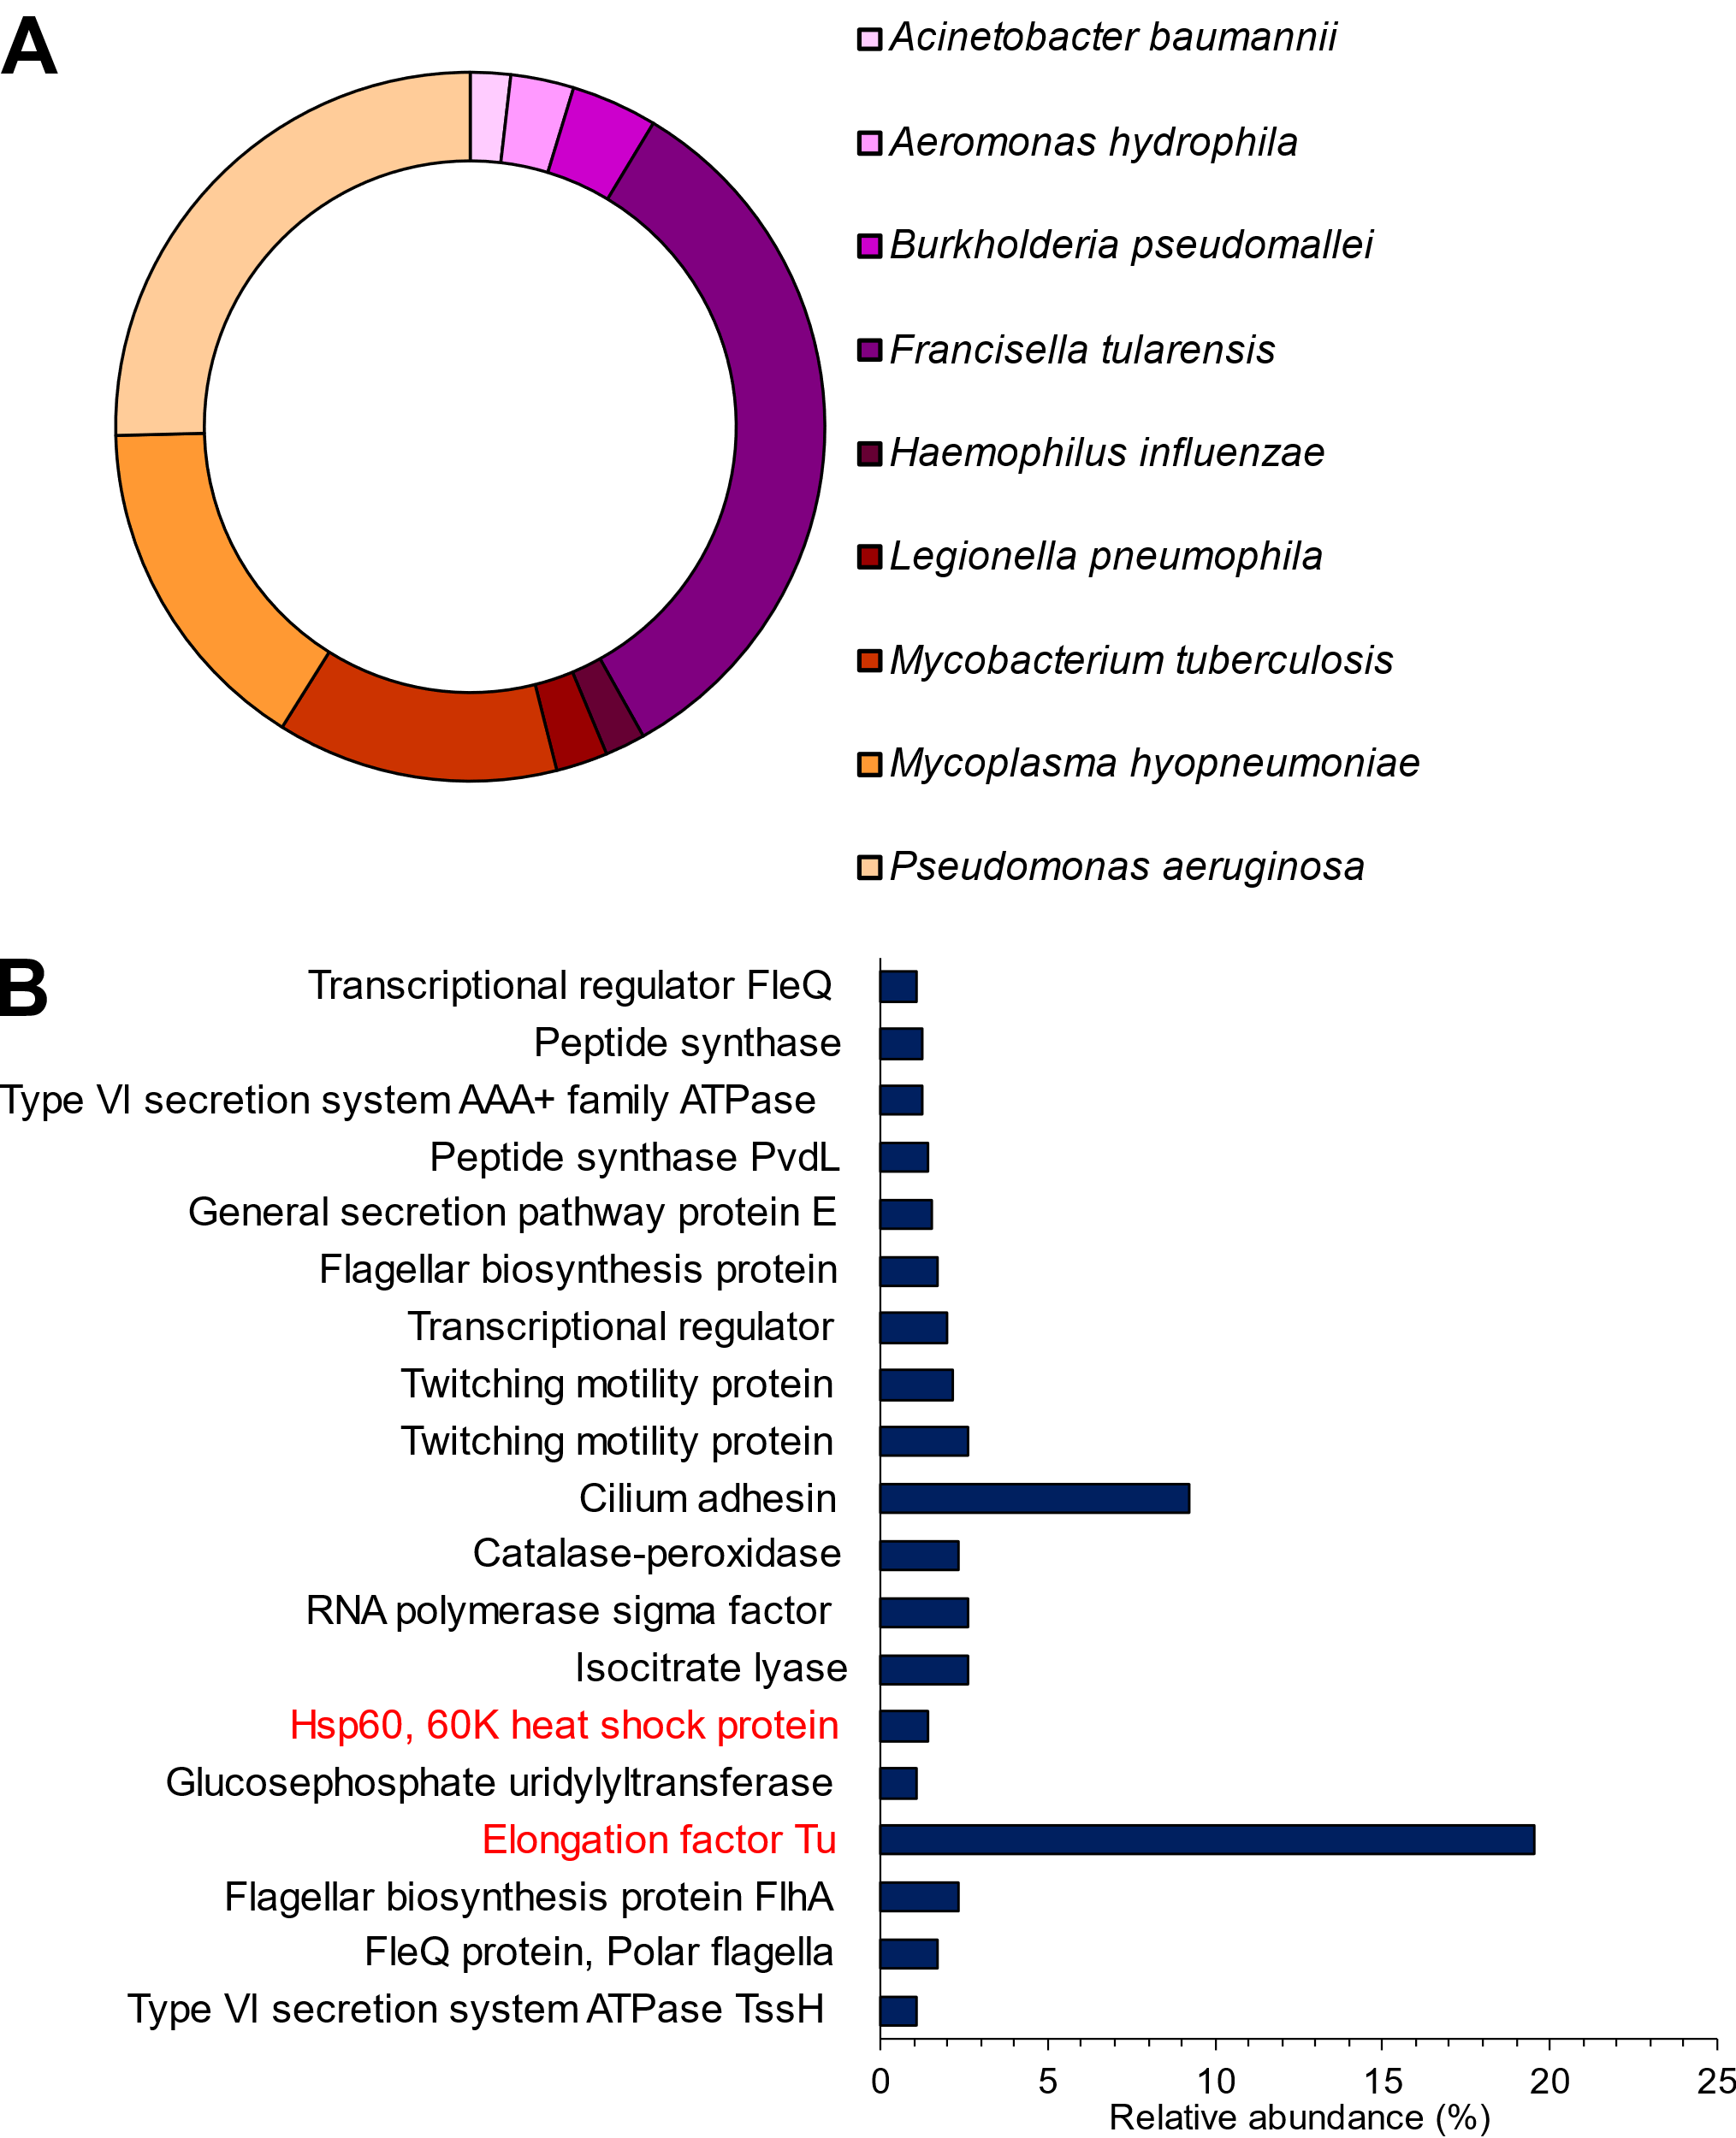
Fig. S5. Identification of bacterial virulence factors in the plastisphere through alignment of the metagenome reads to VFDB, revealed the presence of pathogenic taxa (A) and their virulence genes (B), shown as a proportion (Relative abundance, %) of the reads aligning to VFDB. Virulence factors highlighted in red were also identified within the metaproteomic data using multiple databases (16S-TaxDB, MG-DB, 16S-TaxDB-^{2nd} and VFDB).

