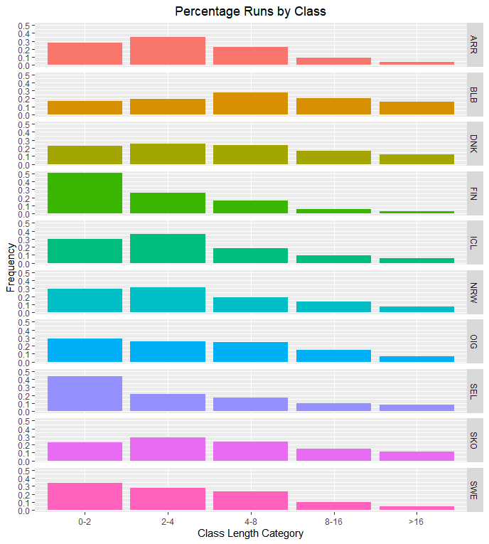

A

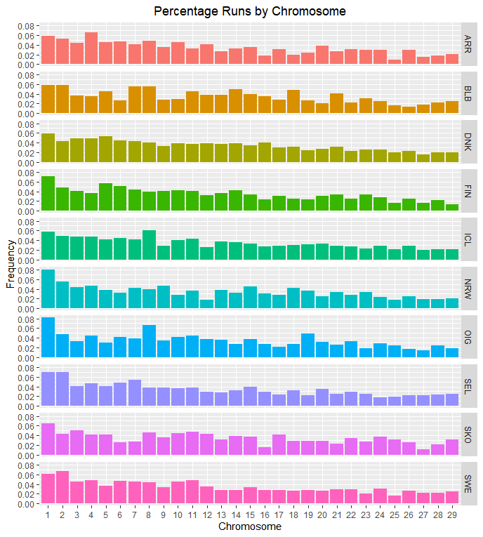
B
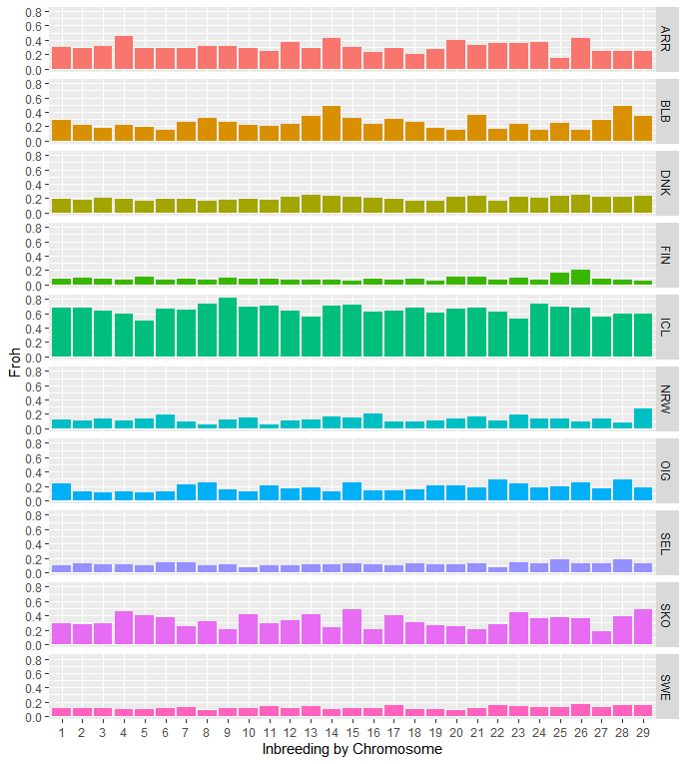
C

Supplementary Figures 4 A-C. Genomic patterns of homozygosity in the target breeds. A) Distribution of ROH per classes of length (the five ROH classes under consideration); B) Percentage of ROH per chromosome and C) genomic inbreeding coefficient (FROH) per chromosome.

