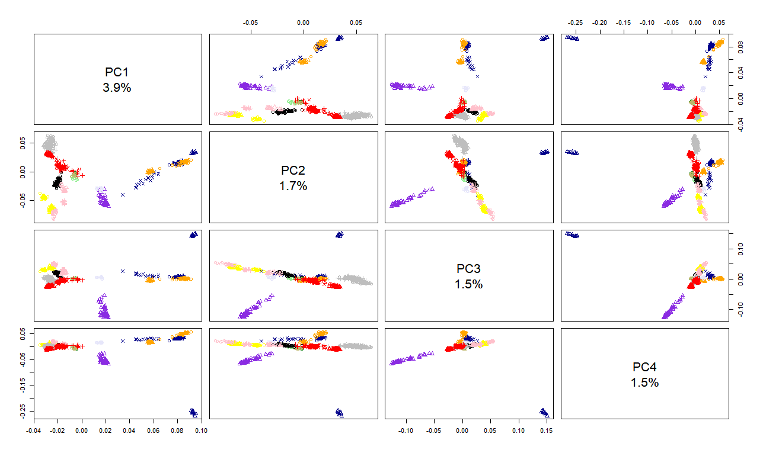Supplementary Figure 1. Total amount of the genetic variance in percentage accounted for the first four PCs. PCA and variance for the WHOLE dataset.
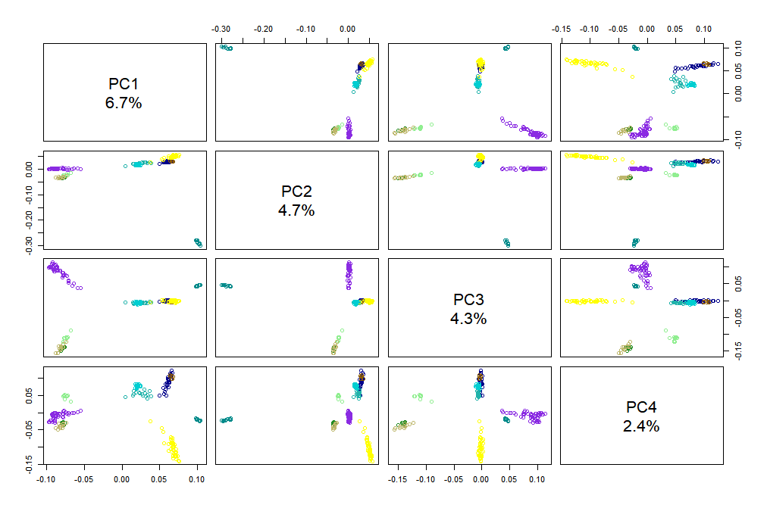
Supplementary Figure 2. Total amount of the genetic variance in percentage accounted for the first four PCs. PCA and variance for the target NW-EU dataset.

