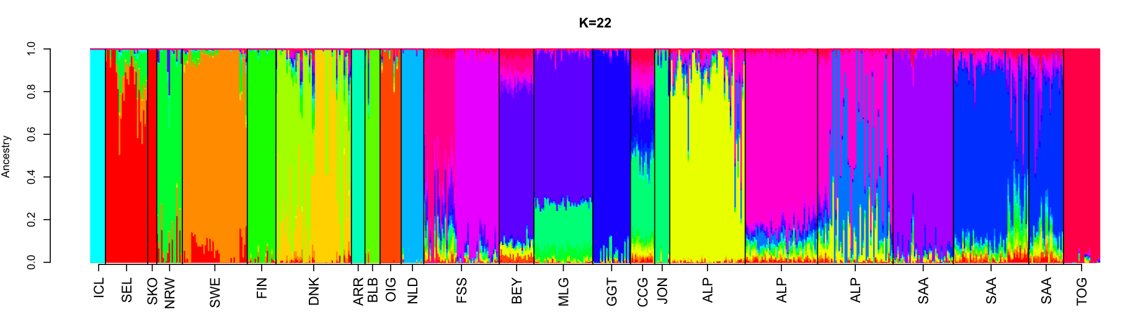
A
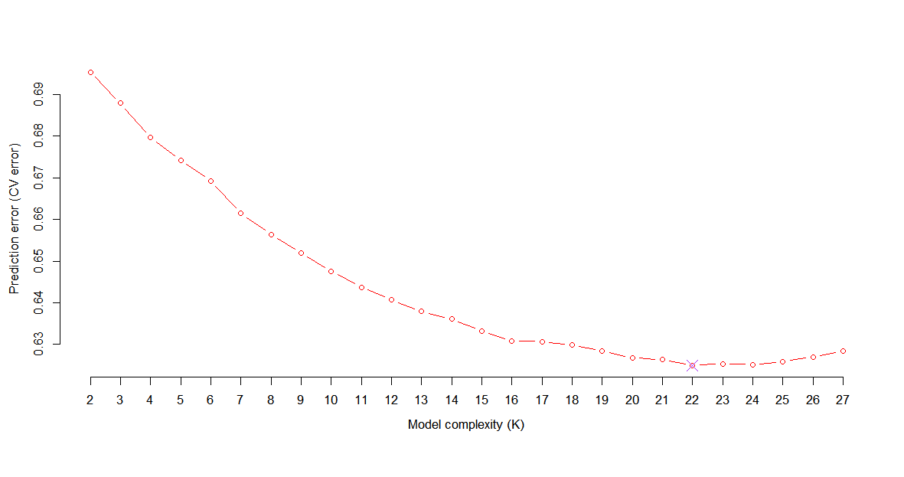
B

Supplementary Figures 3 A-B. A) The most probable number of K (genetic components) is 22. The Alpine populations are ALP_CH, ALP_IT and ALP_FR, and Saanen are SAA_CH, SAA_FR and SAA_IT, from left to right. B) Cross-validation plot for the unsupervised clustering method of ADMIXTURE.

