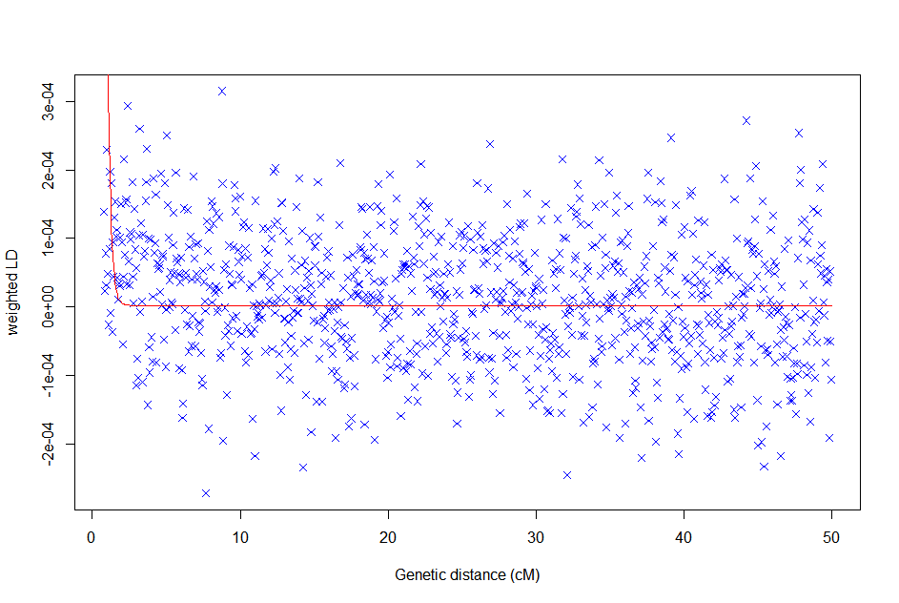
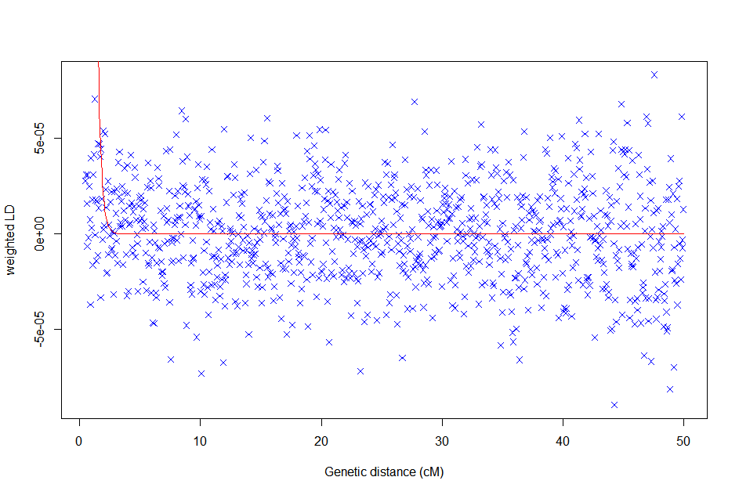

A) ICL|NRW|SEL B) BLB|NRW|OIG
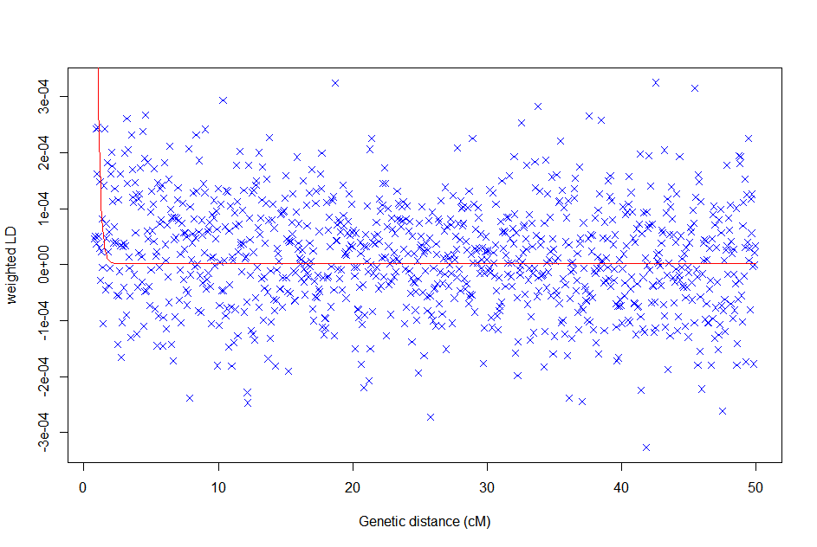
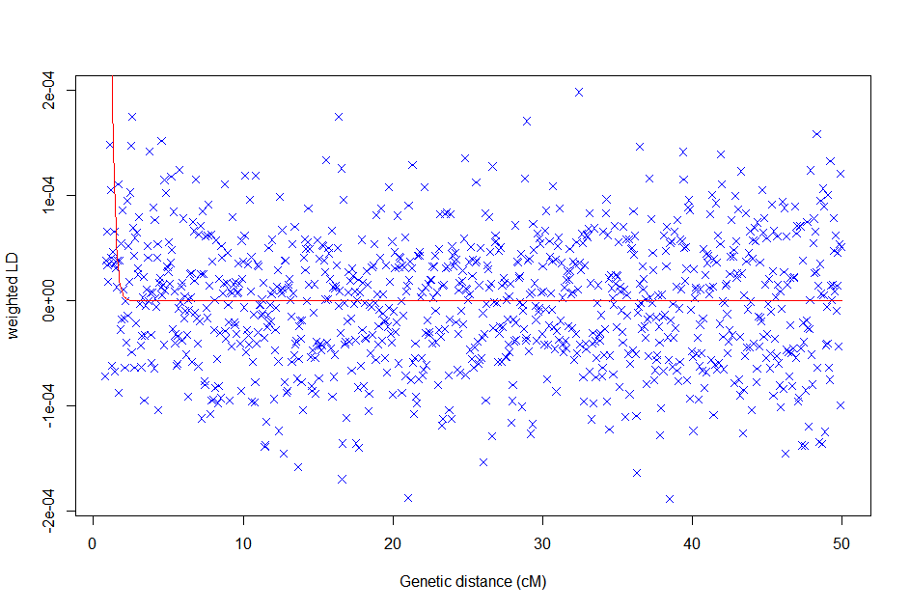

C) BLB|BEY|FSS D) OIG|SWE|BLB
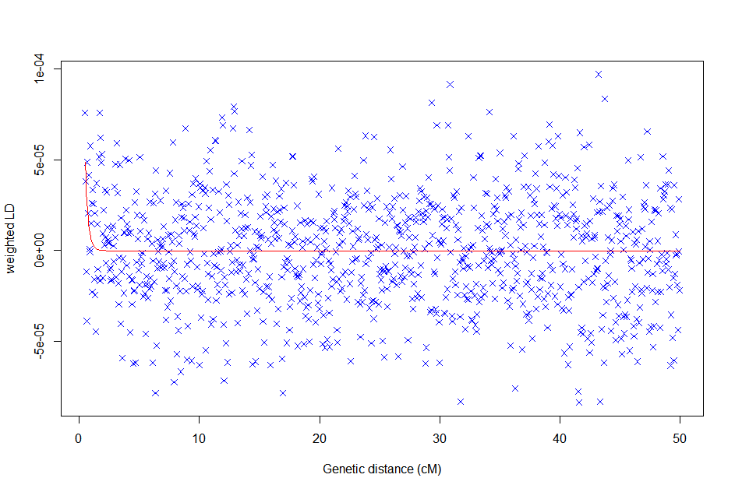

E) OIG|NRW|BLB
Supplementary Figure 6. Weighted LD decay curves with different pairs of source populations. Weighted LD curves for Icelandic landrace (ICL) using Norwegian landrace–Norwegian coastal Selje populations (A) and for the Irish breed Bilberry (BLB, B and C) and The Old Irish Goat (OIG, D-E), using both Scandinavian and Southern European breeds (Norwegian Landrace, NRW; Swedish Landrace, SWE; Fossée, FSS; Bermeya, BEY) as references. Data for each curve are plotted and fit starting from the corresponding ALDER-computed LD correlation thresholds. The best-fit exponential decay curve is labelled in red.

