BIOGRAPHIES OF AUTHORS

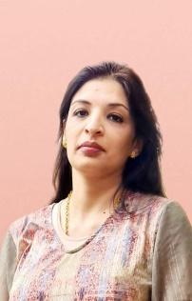 | Heba Emad Namiq received the B.Sc. degree in Computer and Information Technology/Software Engineering From the University of Technology-Baghdad in 2006 and works at university of Baghdad /college of science for women . Student in M.Sc. in Computer at the university of technology – department of computer engineering . can be contacted.
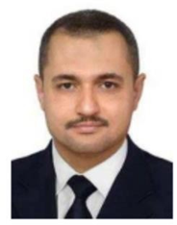 | Dr. Ayman Dawood Salman received the B.Sc. degree in Electrical and Electronic Eng. From the University of Technology-Baghdad in 1998 and got his M.Sc. in Computer and Information Technology/Software Engineering from the University Technology-Baghdad also in 2004. Then he graduated with a doctor Eng. degree in the Communication Networks Group, Institute of Information Technology, Technical University of Ilmenau, Germany. Primary research focuses on MANETs, emphasising QoS routing and multimedia communication, IoT, WSN, and SDN. Currently, he works as an Assist Professor at the university of technology – department of computer engineering. He can be contacted at email: aymen.d.salman@uotechnology.edu.iq
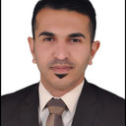
Ahmed Musa Dinar is currently a Lecturer at the Department of Computer Engineering, University of Technology, Baghdad, Iraq. He received a B.Sc. degree in computer and software engineering from Al-Mustansiriya University, Iraq, in 2007 and M.Sc. degree in computer engineering from University of Technology, Iraq in 2014. He obtained his Ph.D. in Computer Engineering from UTeM, Malaysia in 2020. His research interests mainly focus on sensors and computing tools for biomedical applications. 120050@uotechnology.edu.iq

