Dynamics of Land, Ocean, and Atmospheric Parameters Associated with Tauktae Cyclone
Rajesh Kumar¹, Prity S. Pippal^{1*}, Akshansha Chauhan², Ramesh P. Singh³, Ramesh Kumar¹, Atar Singh¹, Jagvir Singh⁴
¹Department of Environmental Science, Central University of Rajasthan, Ajmer, India
² AIRMO GmbH, Claude-Dornier-str 1, building 401, 82234, Wessling, Germany
³School of Life and Environmental Sciences, Schmid College of Science and Technology, Chapman University, USA
⁴Ministry of Earth Sciences, Government of India, Prithvi Bhawan, Lodhi Road, New Delhi, India
*Corresponding author: 2020phdevs004@curaj.ac.in

Table S1: Coordinate for boxes.
Table S2: Coordinates for locations.
Figure S1: Air temperature over Box-1 (Land) and Box-5 (Ocean) for 2020 and 2021 for May month.
Figure S2: Vorticity on different days, before the cyclone (14 May), the day of landfall (17 May), and after the cyclone (19 May).
Figure S3: RH at constant (850hPa) pressure level for four boxes over land from 01-31 May 2021.
Figure S4: Aerosol index 1-31 May 2021 a) representing the aerosol index over western India while b) representing the two columnar plots, red colour for box 1(land) and green colour for box 5 (Ocean).

Table S1: Coordinate location for Argo
Station No. | Argo station ID | Latitude | Longitude
AG-1 | 2902265 | 16.40 | 70.80
AG-2 | 2902277 | 18.40 | 67.40

Table S2: Coordinates for locations
 | East (LAT) | North (LON) | East (LAT) | North (LON)
Location 1 | 70 | 22 | 72 | 24
Location 2 | 73 | 19 | 75 | 21
Location 3 | 73 | 16 | 75 | 18
Location 4 | 74 | 12 | 76 | 14

Figure S1: Air temperature over Box-1 (Land) and Box-5 (Ocean) for 2020 and 2021 for the month of May.
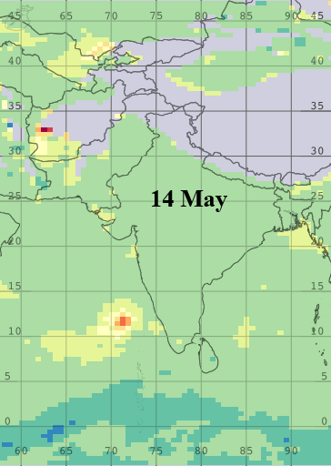
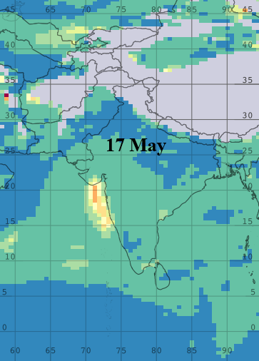
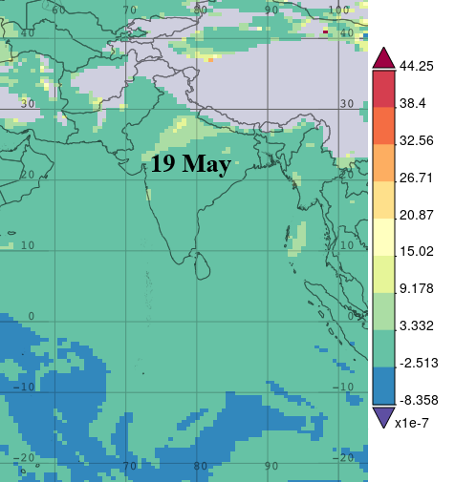
Figure S2: Vorticity on different days, before the cyclone (14 May), the day of landfall (17 May), and after the cyclone (19 May).
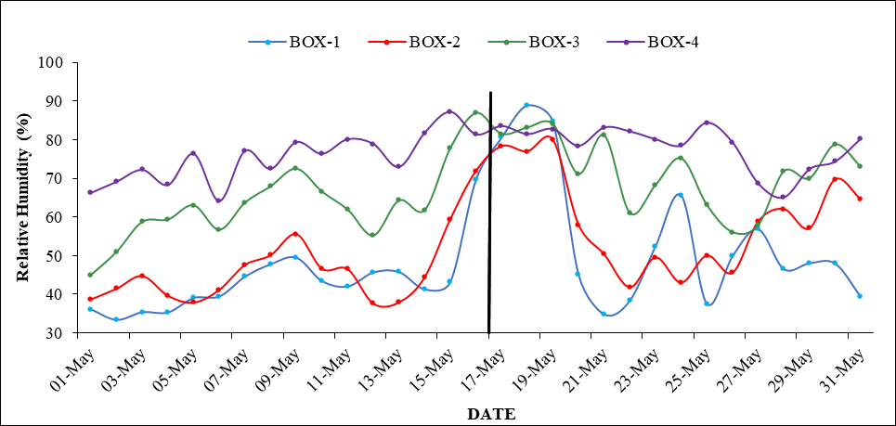
Figure S3: RH at 850hPa pressure level for four boxes over land from 01-31 May 2021.
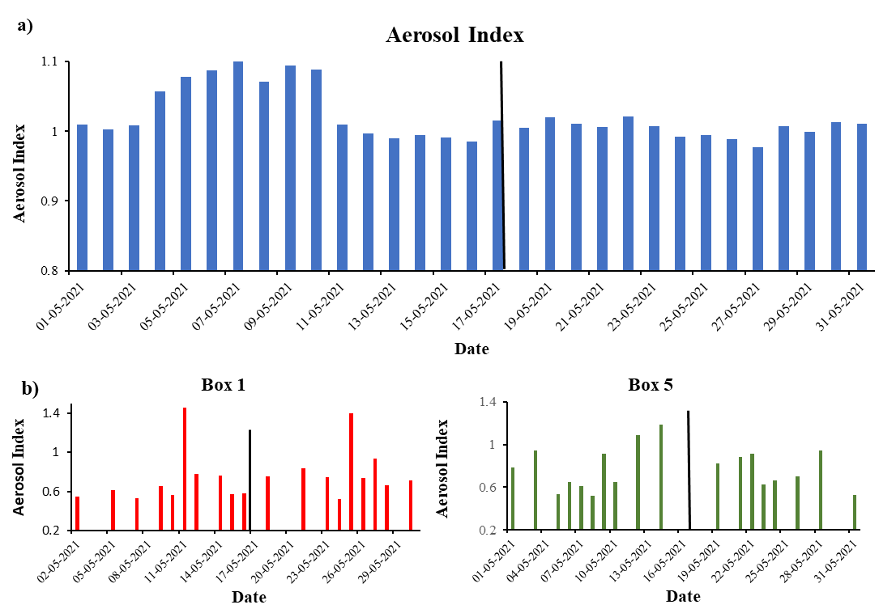
Figure S4: Aerosol index (AI) 1-31 May 2021 a) representing the Aerosol index over western India while b) representing the two columnar plots, red colour for box 1(land) and green colour for box 5 (Ocean).

