Supplemental Figure 1. Concentrations versus time profile for Spironolactone (A), TMS (B) and CAN (C)
A.
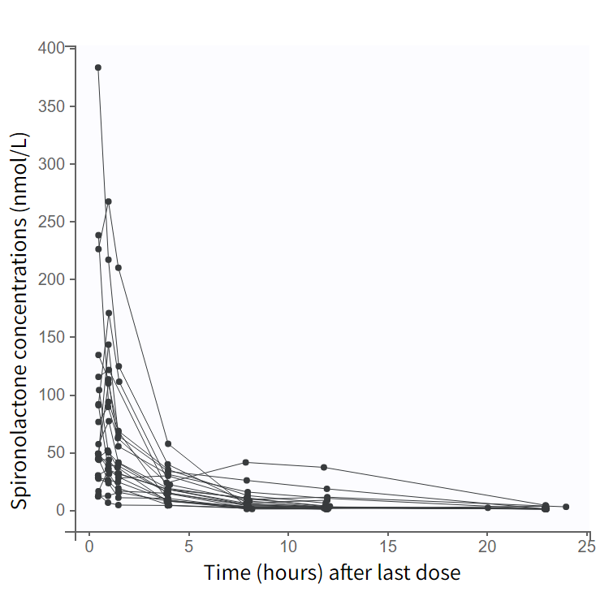
B.
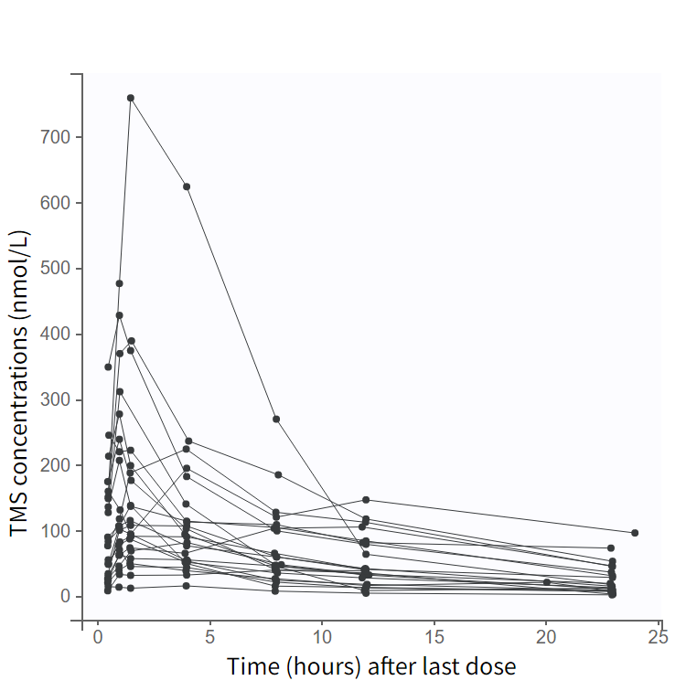
C.
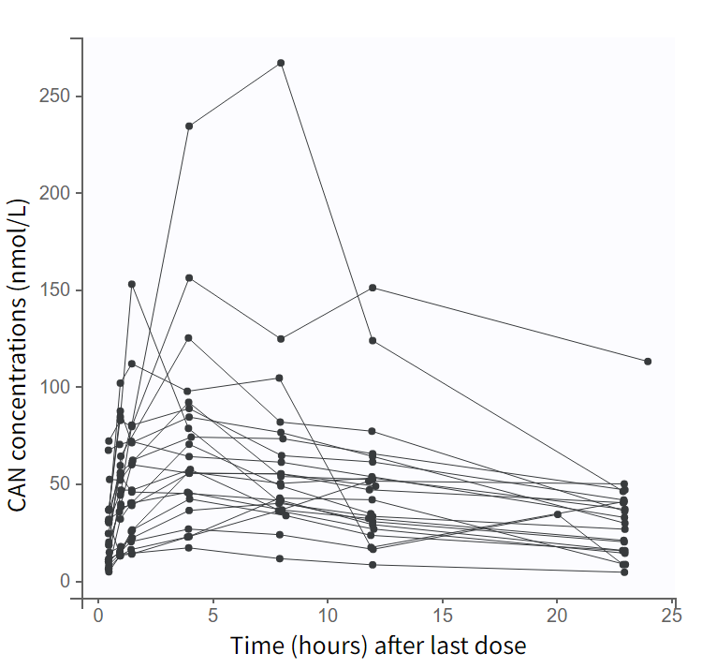

Supplemental figure 2. Individual fit plots for spironolactone, TMS and CAN for 3 typical patients with postnatal age of 25 days (A), 2 months (B) and 9 months (C). Each plot shows concentrations (nmol/L) against time since first dose (hours), with continuous line representing predicted concentrations and points representing observed concentrations.

A.
Spironolactone
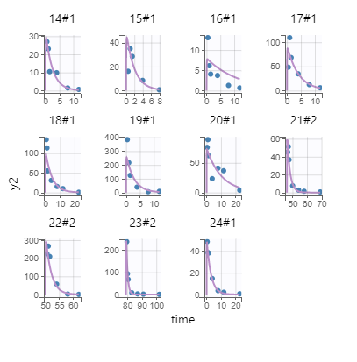

TMS
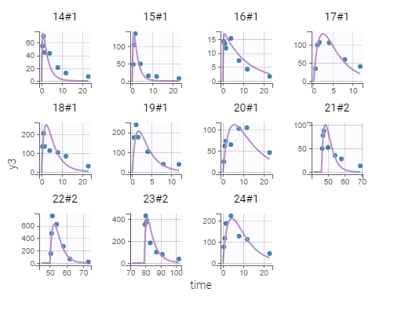

CAN
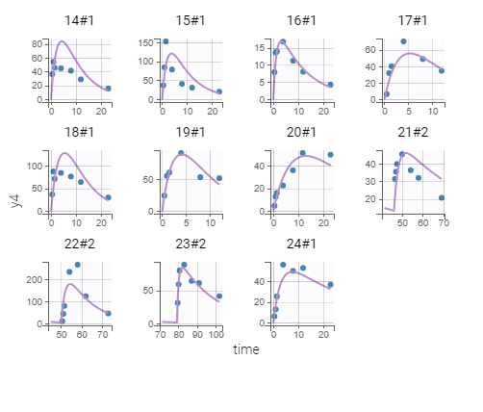

B.
Spironolactone

TMS

CAN

C.
Spironolactone
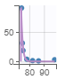

TMS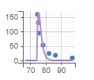

CAN
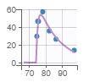

Supplemental Table 1. Population pharmacokinetic parameters of spironolactone (structural model - first modelling step)

Parameters ª | Mean estimate | RSE (%) ^{b}
Fixed effects  Ka  V_{SP}/F  CL_{SP}/F | 17.5  175  55.1 | 45.4  24.2  24.3
Inter-individual variability (%)  V_{SP}/F  CL_{SP}/F | 113  115 | 15.6  15.4
Residual variability (%)  Proportional error  Additive error | 31.5  1.01 | 10.4  15.6

ª Ka, First order absorption rate constant (h⁻¹); V_{SP}/F, apparent volume of distribution of spironolactone (L); CL_{SP}/F, apparent clearance of spironolactone (L/h);
^{d} RSE, Relative standard error

Supplemental Table 2. Sensitivity analysis evaluating the impact of fixing fmet to 1.

Parameters ª | Final model  (RSE %) | Model 2  (RSE %) | Model 3  (RSE %)
Fixed effects  Ka  V_{SP}/F  V_{SP}/F = ϴ1 x (CW/4300)  ϴ1  CL_{SP}/F  CL_{SP}/F = ϴ2 x (CW/4300) ^{0.75} x (PNA/60) ^{ϴ3}  ϴ2  ϴ3  f_{met}  f_{metCAN}  V_{TMS}=V_{CAN}  V_{TMS}=V_{CAN} = ϴ4 x (CW/4300)  ϴ4  CL_{TMS}  CL_{TMS} = ϴ5 x (CW/4300) ^{0.75}  ϴ5  CL_{CAN}  CL_{CAN} = ϴ6 x (CW/4300) ^{0.75}  ϴ6 | 17.5 (fixed)  141.7 (19.5)  44.9 (16)  0.23 (0.1)  1 (fixed)  0.15 (9)  12.8 (16)  8.5 (23.4)  0.95 (20.3) | 17.5 (fixed)  141 (19.7)  44.9 (16.4)  0.29 (0.21)  0.9 (fixed)  0.15 (15.1)  11.7 (17.6)  8.1 (26)  0.85 (25.2) | 17.5 (fixed)  140 (20)  45.1 (16.2)  0.25 (0.10)  0.8 (fixed)  0.16 (7.5)  10.9 (15.1)  6.7 (23.1)  0.81 (19.7)
Inter-individual variability (%)  V_{SP}/F  CL_{SP}/F  F_{metCAN}  V_{TMS}=V_{CAN}  CL_{TMS}  CL_{CAN} | 90 (15.7)  74 (15.7)  14 (51.8)  61 (19.9)  103 (16.4)  78 (17.7) | 90 (16.9)  76 (15.9)  17 (108)  58 (22.3)  106 (18.3)  79 (19.7) | 92 (16.4)  74 (16)  16 (53.8)  59.3 (20.1)  103 (16.7)  79 (19.8)
Residual variability (%)  Proportional error for spironolactone  Additive error for spironolactone  Proportional error for TMS  Additive error for TMS  Proportional error for CAN | 30 (10.9)  1.36 (21.3)  26 (16.8)  14.2 (18.8)  35 (7.6) | 30 (10.9)  1.35 (24.3)  24 (21.4)  15.5 (24.3)  35 (8) | 30 (11.9)  1.52 (21.9)  26 (16.2)  13.8 (17.4)  35 (7.2)

