Supplementary material for

Forest Types for Afforestation: Benefits for Carbon Sequestration and Food Systems under Stringent Climate Mitigation

The AIM/Hub model

The AIM/Hub (former AIM/CGE) model builds on the work by Fujimori et al.¹, and has been widely used for climate change studies ^{2, 3}. In the model, supply, demand, trade, and investment are described as individual behavioral functions that respond to changes in the price of production factors and commodities, as well as changes in technology. The functions also respond to preference parameters on the basis of the assumed population, GDP, and consumer preferences. The model contains 17 regions and 42 industrial classifications including 10 agricultural sectors. Production functions are formulated as multinested constant elasticity substitution (CES) functions where land is a production factor for agricultural and forest commodities. Allocation of land by sectors is formulated as a multinominal logit function to reflect differences in substitutability across land categories with land rent ⁴. All the scenarios were based on shared socioeconomic pathway 2 (SSP2) assumptions.

The AIM/PLUM model

Regional aggregated land demand projected by AIM/Hub (17 regions) was fed into the land-use allocation model and was downscaled into half-degree grid cells. The afforestation area and cropland was allocated based on profit maximization where a land owner would decide land-use sharing to obtain the highest profit under a given biophysical land productivity (production per unit area). Since this process was conducted in each region and grid cell, land transactions across the regions were not allowed. The allocation was conducted in 10-year steps. There were seven crop types, with or without irrigation (Table S 1). The crop types were aggregated as cropland for model verification according to the availability of historical cropland data. Land for wood production was excluded from this work. To convert quantities of harvested wood into areas of land, information regarding the historical map of harvested aboveground biomass, and the subsequent recovery following wood harvesting and land-use abandonment are needed. However, no global, gridded, or historical record of these data are available ⁵.

Table S 1 Land-use categories included in the land-use allocation model
Categories (l) |  | Code |  | Future  estimation
Cropland |  | CL
 | Rice irrigated |  | PDRIR | X
 | Wheat irrigated |  | WHTIR | X
 | Other coarse grains irrigated |  | GROIR | X
 | Oil crops irrigated |  | OSDIR | X
 | Sugar crops irrigated |  | C_BIR | X
 | Rice rainfed |  | PDRRF | X
 | Wheat rainfed |  | WHTRF | X
 | Other coarse grains rainfed |  | GRORF | X
 | Oil crops rainfed |  | OSDRF | X
 | Sugar crops rainfed |  | C_BRF | X
 | Other crops |  | OTH_A | X
Bioenergy crops |  | BIO |  | X
Afforestation |  | AFR |  | X
Settlement |  | SL |  | X
Ice and water |  | OL |  | X
Other land-use |  | OTH |  | X
 | Forest |  | FRS | X
 | Pasture |  | PAS | X
 | Other natural vegetation |  | ONV | X

Figure S 1 Modelling framework.

Figure S 2 Forest types selected in the scenarios (Aff-Cmax, Aff-Div and Aff-Cur) (a,b,c) and global carbon sequestration through afforestation across different forest types (d)

Figure S 3 Global distribution of growth rate of afforestation (a.b.c.) and bioenergy crop (d.) under different scenarios. Panels a,b,c show mean yield throughout this century in the different selection schemes of forest types (Aff-Cur, Aff-Div and Aff-Cmax). Panel d shows mean yield of switchgrass and miscanthus at rainfed land⁶.

Figure S 4 Global distribution of cumulative carbon sequestration of afforestation (a.b.d.e) and bioenergy crop (c. f.) under different scenarios throughout this century (MtCO₂ equivalent per grid). Carbon sequestration of BECCS in panels c and f are calculated from bio-crop yield, a share of electrification of BECCS, a share of CCS usage for bioenergy and carbon capture ratio.

Figure S 5 Emissions pathways and primary energy decomposition over time under different scenarios. The 2C-Aff is a set of afforestation-only scenarios.

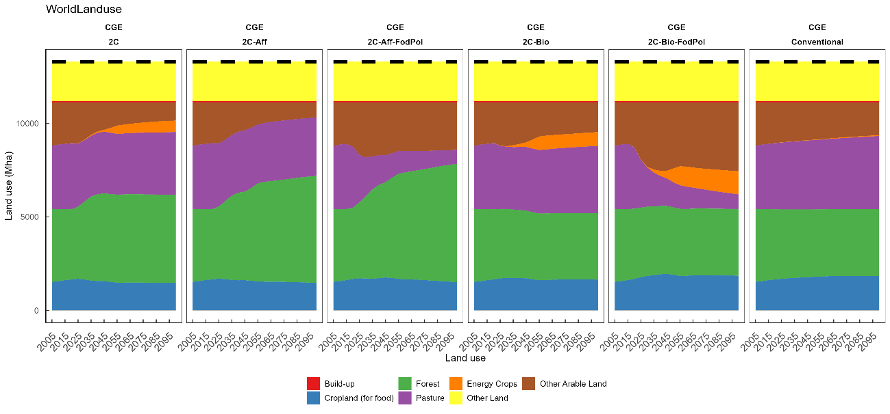
Figure S 6 Global land use change over time under different scenarios. The 2C-Aff is a set of afforestation-only scenarios.

Figure S 7 Changes in multiple variables for over-time. The 2C-Aff is a set of afforestation-only scenarios.

References
1. Fujimori S, Masui T, Matsuoka Y. AIM/CGE [basic] manual. Tsukuba, Japan: Center for Social and Environmental Systems Research, NIES; 2012.

2. Hasegawa T, Fujimori S, Takahashi K, Yokohata T, Masui T. Economic implications of climate change impacts on human health through undernourishment. Climatic Change 2016: 1-14.

3. Hasegawa T, Fujimori S, Shin Y, Tanaka A, Takahashi K, Masui T. Consequence of Climate Mitigation on the Risk of Hunger. Environmental Science & Technology 2015, 49(12): 7245-7253.

4. Fujimori S, Hasegawa T, Masui T, Takahashi K. Land use representation in a global CGE model for long-term simulation: CET vs. logit functions. Food Sec 2014, 6(5): 685-699.

5. Hurtt GC, Chini LP, Frolking S, Betts RA, Feddema J, Fischer G, et al. Harmonization of land-use scenarios for the period 1500–2100: 600 years of global gridded annual land-use transitions, wood harvest, and resulting secondary lands. Climatic Change 2011, 109(1-2): 117-161.

6. Yamagata Y, Hanasaki N, Ito A, Kinoshita T, Murakami D, Zhou Q. Estimating water–food–ecosystem trade-offs for the global negative emission scenario (IPCC-RCP2.6). Sustainability Science 2018, 13(2): 301-313.

