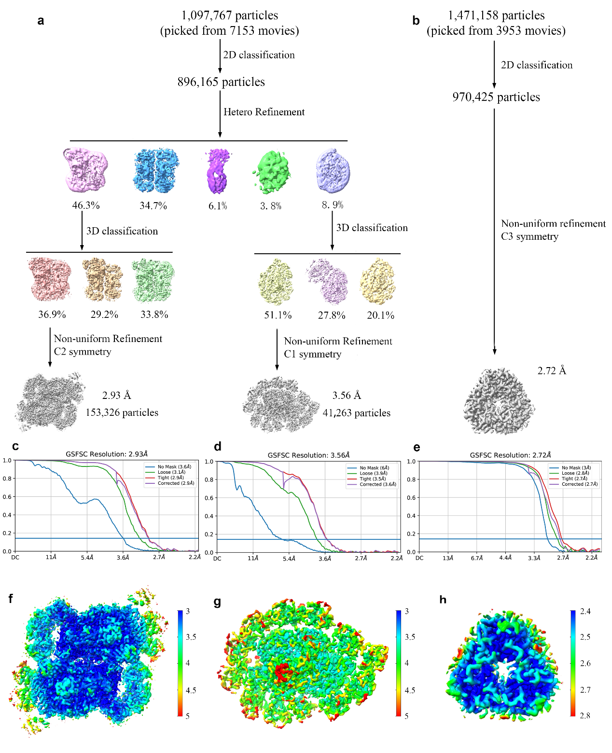
Supplementary Figure 1. Single particle analysis of Cm-PSII-FCPII, Cm-PSI-FCPII and Cm-FCP trimer. a,b, Flowchart of single particle analysis of Cm-PSII-FCPII, Cm-PSI-FCPII and Cm-FCP trimer. c-e, The gold standard Fourier shell correlation (FSC) curve of the final density maps of Cm-PSII-FCPII, Cm-PSI-FCPI and Cm-FCP trimer, respectively. f-h, Full local resolution maps of Cm-PSII-FCPII, Cm-PSI-FCPI and Cm-FCP trimer, respectively.
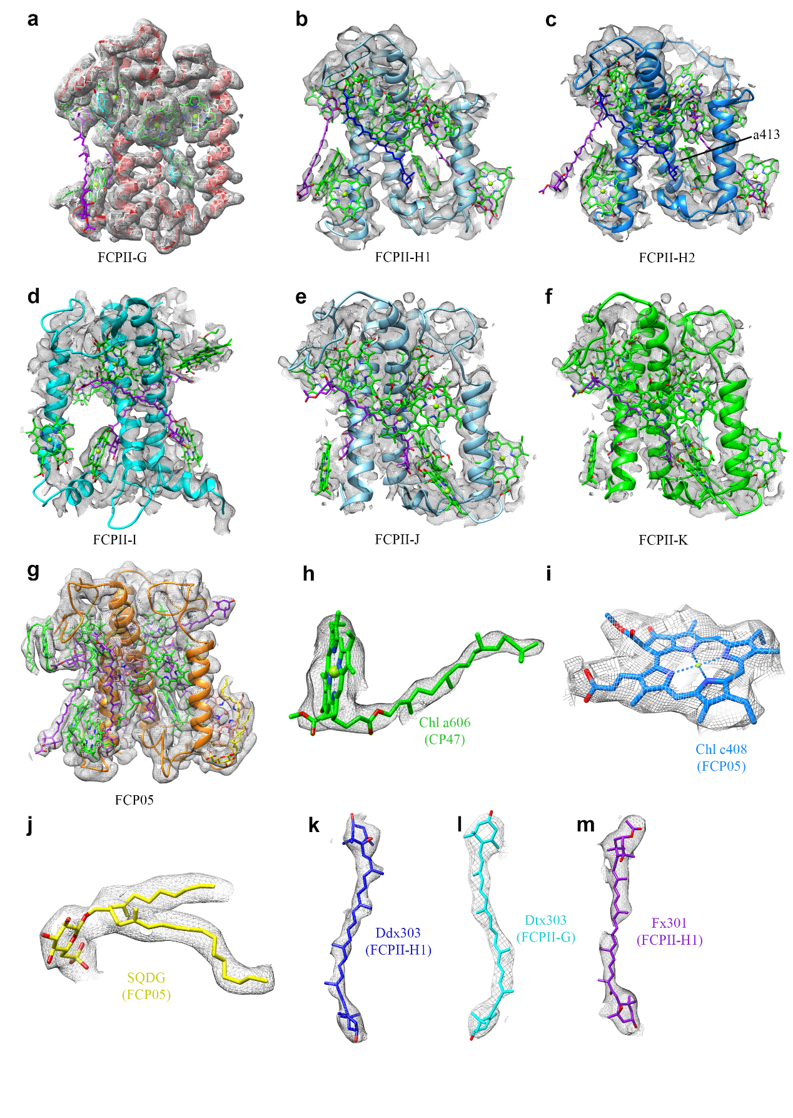
Supplementary Figure 2. Density maps of selected subunits and cofactors.

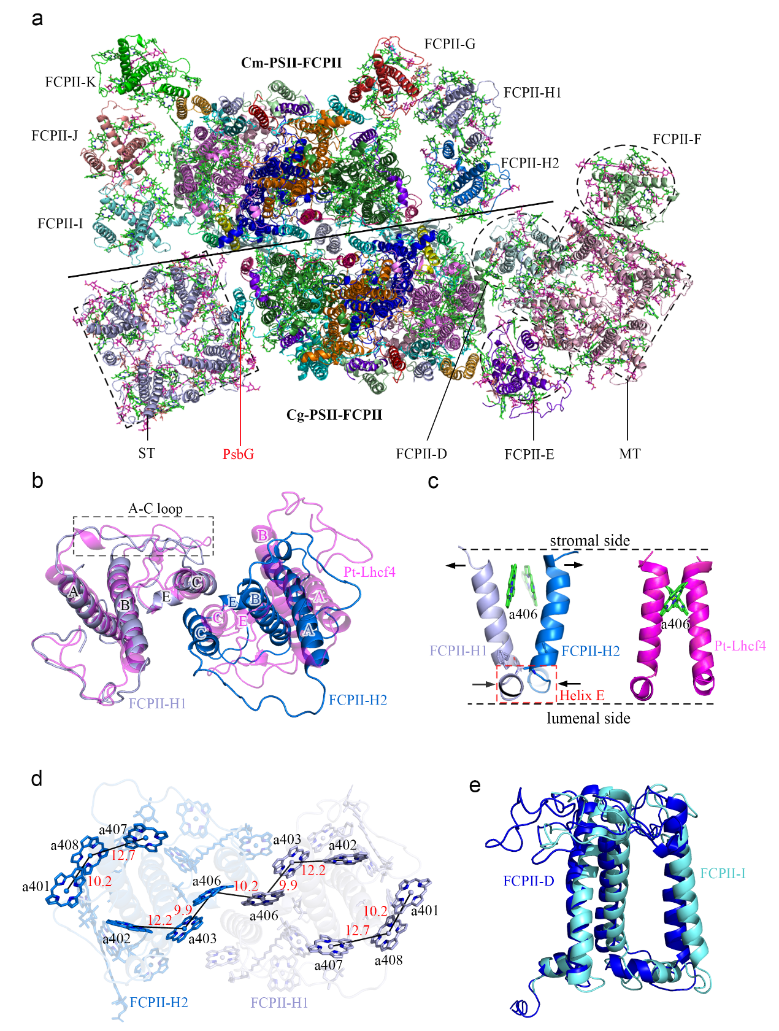
Supplementary Figure 3. Comparison of the structure of Cm-PSII-FCPI with those of Cg-PSII-FCPII and Pt-Lhcf4. a, Overall comparison of structural models of Cm-PSII-FCPII (the top half) and Cg-PSII-FCPII (the bottom half). b, Overall comparison of two FCP dimers, Cm-FCPII-H and Pt-Lhcf4. c, Comparison of coupled helices C in Cm-FCPII-H and Pt-Lhcf4. d, Distribution of stromal Chl clusters in FCPII-H. e, Alignment of Cg-FCPII-D and Cm-FCPII-I.
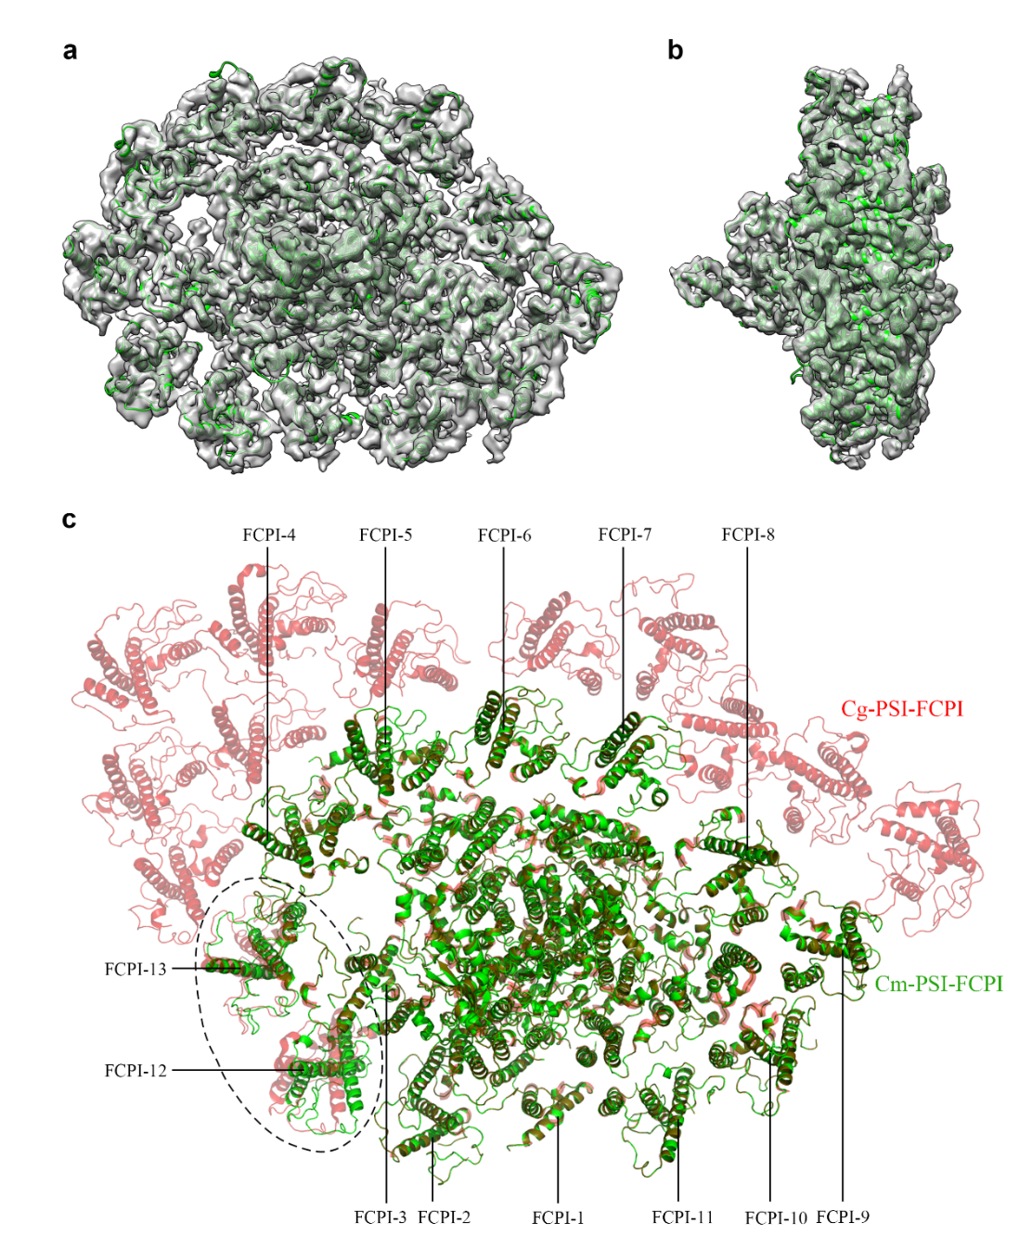
Supplementary Figure 4. Overall structure of Cm-PSI-FCPI. a, b, Fitment of structural models of Cm-PSI-FCPI in the density map from the top and side views, respectively. c, Comparison of structural models of Cm-PSI-FCPI and Cg-PSI-FCPI, where a dashed circle indicates subunits where displacements occur.

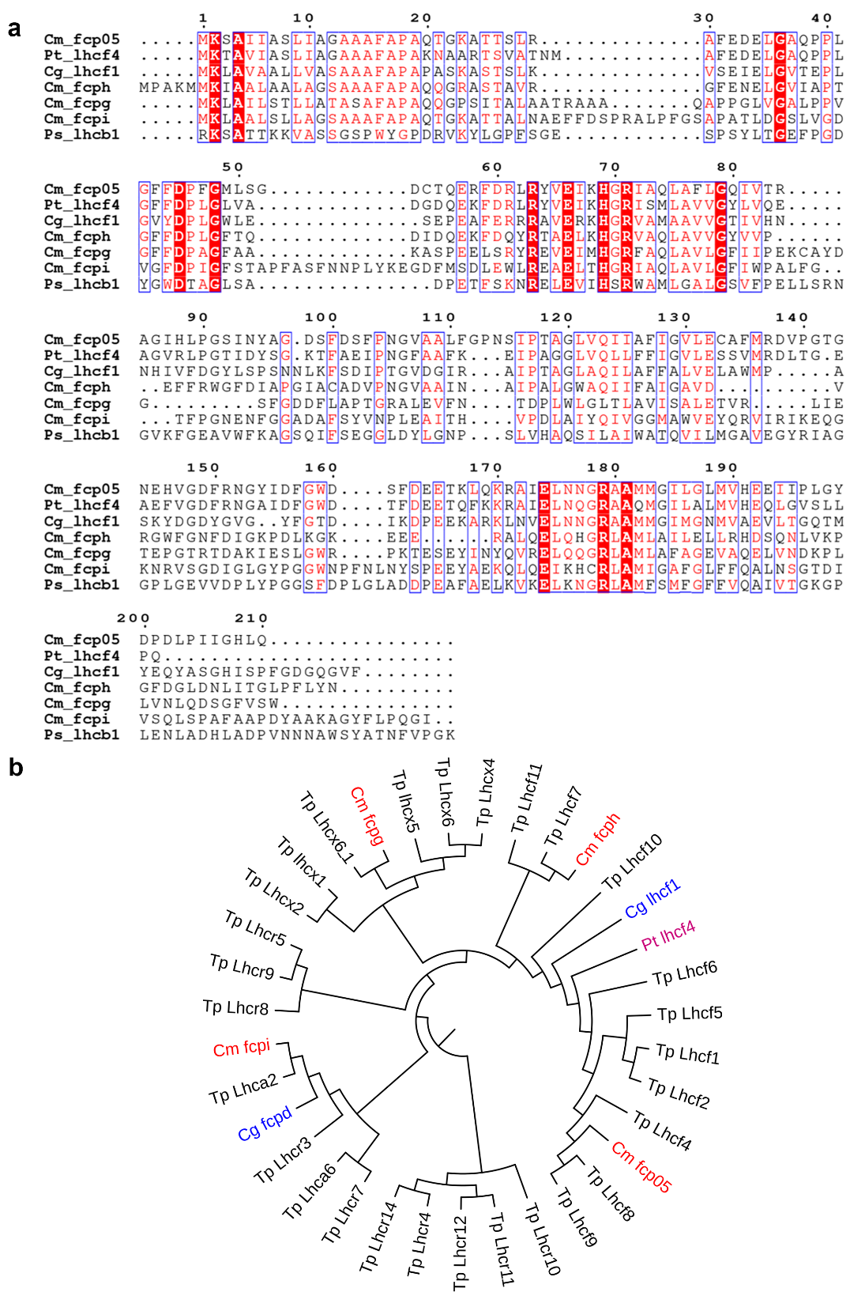
Supplementary Figure 5. Comparison of sequences and the phylogenetic tree. a, Allignment of Cm-fcp05 (C. meneghiniana), Pt-lhcf4 (P. tricornutum), Cg-lhcf1 (C. gracilis), Cm-fcph (C. meneghiniana), Cm-fcpg (C. meneghiniana), Ps-lhcb1 (P. sativum). The sequences of Cm-fcph and Cm-fcp05 are obtained by transcriptome sequencing in the present study. Cm-fcp05 is largely similar to the sequence of C. cryptica fcp05. Sequences of Cm-fcpg and Cm-fcpi are not obtained from transcriptome, thus two homogenous sequences from C. cryptica were used. Sequences of Pt_lhcf4, Cg_lhcf1 and Ps_lhcb1 were obtained from PDB 6A2W, 7VD6 and 2BHW, respectively. b, Phylogenic analysis of representative antenna subunits selected from different diatom species. The sequences of T. p. (Thalassiosira pseudonana) and P. t. (Phaeodactylum tricornutum) were obtained from the Uniprot database. The sequences of Cg-lhcf1 and Cg-fcpd are extracted from two published structures, 7VD6 and 6JLU.
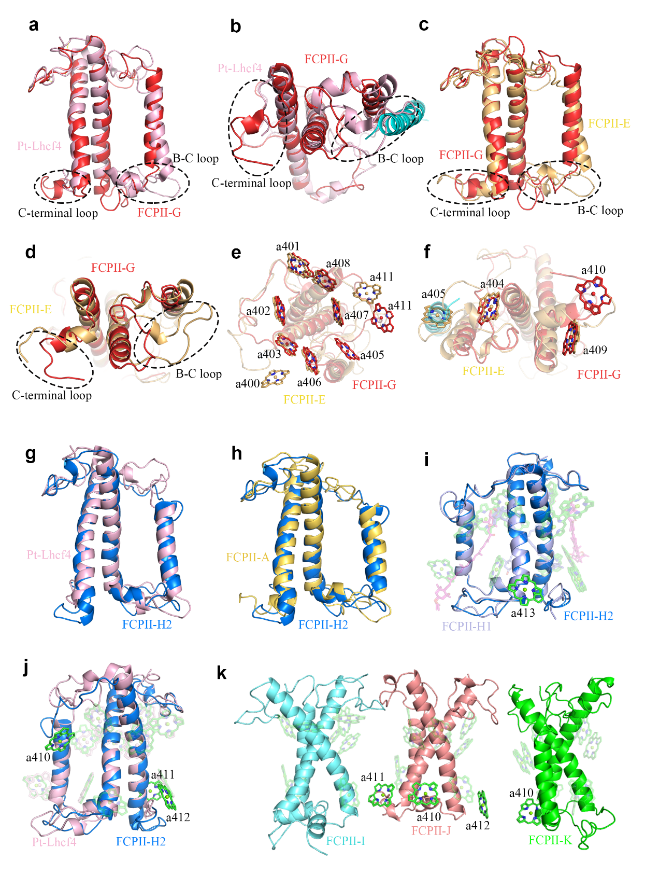
Supplementary Figure 6. Comparisons of the structure of Cm-FCPs with those of Cg-FCPII-A and Pt-Lhcf4. a, b, Comparison of apoproteins between FCPII-G and Pt-Lhcf4. c,d, Comparison of apoproteins between FCPII-G and FCPII-E. e, f, Comparison of Chls between Cm-FCPII-G and Cg-FCPII-E at the stromal and luminal sides, respectively. Tp-PsbG forms intense interaction with Cm-FCPII-G and makes Chl a405 shifted to the stromal side. g, h, Comparison of apoproteins between FCPII-H2, Pt-Lhcf4 and FCPII-A, respectively. i, Comparison of Chls between FCPII-H2 and FCPII-H1, showing the presence of an extra Chl a413. j, Comparison of Chls between FCPII-H2 and Pt-Lhcf4. k, Demonstration of the extra Chls in FCPII-I/J/K in comparison with Pt-Lhcf4, which are important for lumenal energy transfer.

Supplementary Table 1. Cryo-EM data collection, refinement, and validation statistics.
Data collection and processing |  | PSII-FCPII | FCP trimer
Magnification |  | 22,500 × | 81,000 ×
Voltage (kV) |  | 300 | 300
Electron Exposure (e⁻/Å²) |  | 50 | 60
Defocus range (μm) |  | -1.5 ~ -2.5 | -1.0~-2.0
Pixel size (Å) |  | 1.06 | 1.04
Symmetry imposed |  | C2 | C3
Number of initial particles |  | 1,097,767 | 1,471,158
Number of final particles |  | 153,326 | 970,425
Map resolution (Å) |  | 2.93 | 2.72
FSC threshold |  | 0.143 | 0.143
Refinement
Number of atoms |  | 73258 | 7088
Protein residues |  | 7688 | 543
Ligands |  | 335 | 57
Root mean square deviations
Bond lengths (Å) |  | 0.005 | 0.006
Bond angles (°) |  | 0.823 | 1.097
Validation
MolProbity score |  | 1.92 | 1.85
Clashscore |  | 10.45 | 9.68
Ratamer outliers (%) |  | 0.33 | 0.46
Ramachandran plot
Favored (%) |  | 94.47 | 95.16
Allowed (%) |  | 4.99 | 4.84
Disallowed (%) |  | 0.00 | 0.00

Supplementary Table 2. Pigments assigned in related subunits of Cm-PSII-FCPII and Cm-FCP05.
Subunits | Chl a | Chl c | BCR | Fx | Ddx | Dtx
D1 | 4 |  | 1
CP47 | 16 |  | 3
CP43 | 13 |  | 4
D2 | 2 |  | 1
PsbH |  |  | 1
PsbW | 1
PsbZ | 1
FCPII-G | 11 |  |  | 2 |  | 1
FCPII-H1 | 12 |  |  | 2 | 2
FCPII-H2 | 13 |  |  | 2 | 2
FCPII-I | 9 |  |  | 2
FCPII-J | 12 |  |  | 2
FCPII-K | 10 |  |  | 2
Cm-PSII-FCPII | 208 | 0 | 20 | 24 | 8 | 2
Cm-FCP05 | 8 | 3 |  | 7

