SUPPLEMENTARY MATERIAL

Chlorphenamine Adsorption on Commercial Activated Carbons: Effect of Operating Conditions and Surface Chemistry
Jesús Alberto Martínez-Espinosa¹, Roberto Leyva-Ramos^{2, *}, Dora Iliana Medina³, Antonio Aragón-Piña⁴, Diana Elizabeth Villela-Martínez², Damarys Haidee Carrales-Alvarado²,
¹Tecnologico de Monterrey, School of Engineering and Sciences, Atizapán de Zaragoza, Estado de México, 52926, México
²Centro de Investigación y Estudios de Posgrado, Facultad de Ciencias Químicas, Universidad Autónoma de San Luis Potosí, Av. Dr. M. Nava No.6, San Luis Potosí, SLP 78210, México
³Tecnologico de Monterrey, Institute of Advanced Materials for Sustainable Manufacturing, Monterrey 64849, Nuevo Leon, México
⁴Instituto de Metalurgia, Universidad Autónoma de San Luis Potosí, San Luis Potosí, SLP 78210, México

Corresponding Author:
*Roberto Leyva-Ramos, E-mail: rlr@uaslp.mx, Ph. 52-4448132157

Figure S.1. N₂ adsorption-desorption isotherms of MM (a), M10 (b) and GB (c).

Figure S.2. Pore size distribution and cumulative pore volume distributions for MM (a), M10 (b) and GB (c).

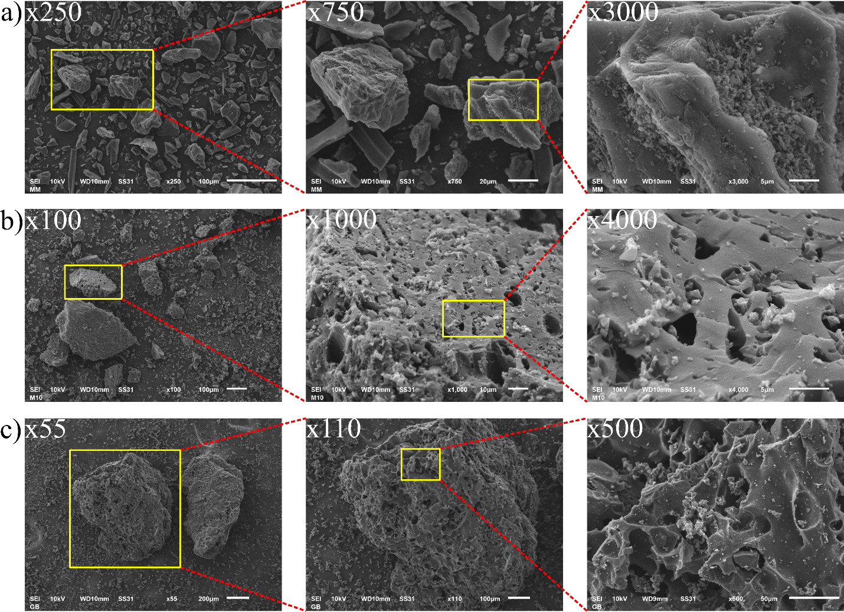
Figure S.3. SEM images of MM (a), M10 (b), and GB (c).

