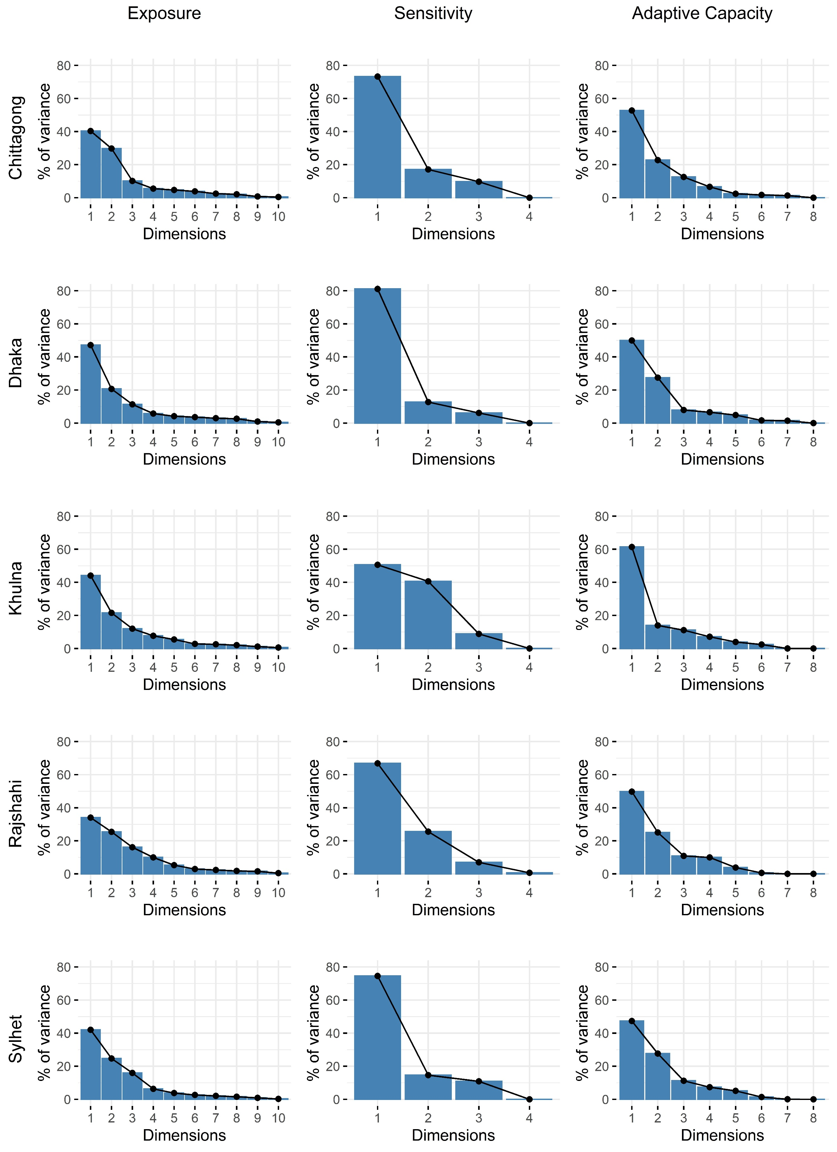
Figure S1 Scree plots outputs of exposure, sensitivity and adaptive capacity

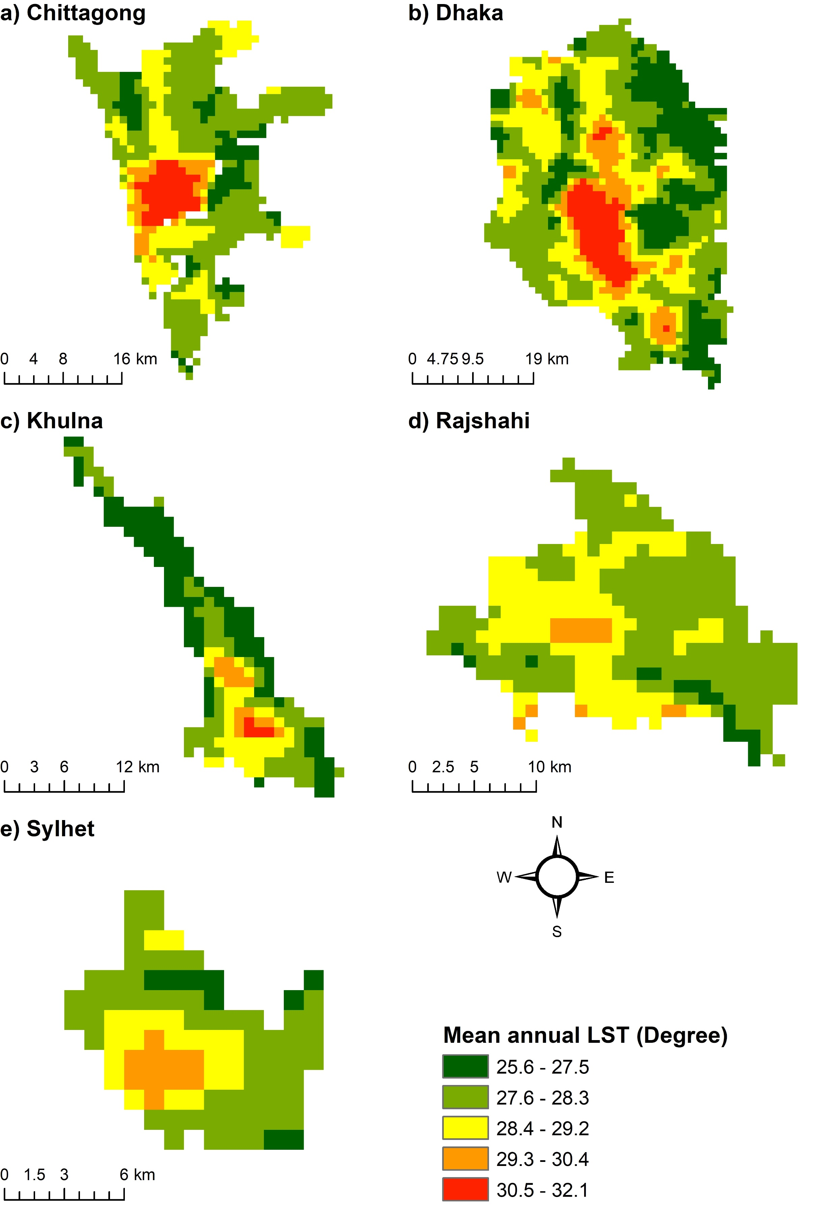
Figure S2 Spatial distribution of mean annual LST (2000-2019) in five major cities of Bangladesh
Table S1 Indicators of heatwave vulnerability
Indicators |  | Description | Unit / Resolution / Format | Data source
Latent | Observed | Description | Unit / Resolution / Format | Data source
Exposure | Land surface temperature (LST) | LST is closely associated with air temperature, which is an indicator of heatwave (Zhang et al., 2018). | MODIS MOD11A2 LST product (v006) at 1 km spatial resolution | (Wan et al., 2015)
Exposure | Population density | Rapid population growth leads to urban expansion, poverty, congestion, changes in climatic conditions, decline in waterbodies, and thus, increase heatwave vulnerability (Costello et al., 2009; Wheeler et al., 2015). | Number of people per grid cell at 100 m resolution | (WorldPop, 2018)
Exposure | Albedo (wsa) | The albedo defines reflectivity of the earth. The low‑albedo surfaces have the potential to increase surface thermal stress and mortality rate (Kalkstein et al., 2022; Salvati & Kolokotroni, 2020; Sharma et al., 2022) | MODIS MCD43A3 product at 500 m spatial resolution | (Schaaf & Wang, 2015)
Exposure | Aerosol optical depth (aod) | aod indicates concentration of pollutants on the environment, and its concentration is positively associated with heat stress (Xiang et al., 2022) | MODIS MCD19A2 product at 1 km spatial resolution | (Lyapustin & Wang, 2018)
Exposure | Nighttime lights (ntl) | ntls are a sign of anthropogenic activity on earth's surface. NTL data helps extract urban areas by monitoring the city lights at night (Dewan et al., 2021; Li et al., 2019). NTL data used in this study consisting of the Defense Meteorological Satellite Program – Operational Linescan system (DMSP-OLS) and the Visible Infrared Imaging Radiometer Suite (VIIRS) data. | Grided data | (Dewan et al., 2021)
Exposure | Biophysical composition index (bci) | bci defines imperviousness of surface that shows a positive relation with urban heat stress. | Estimated from MODIS data at 1 km spatial resolution | (Dewan et al., 2021)
Exposure | Urbanization rate (ui) | ui is an important determinant since expanding built-up area, development of structural expansions, and congested urban areas are all vulnerable at the same time (Dewan et al., 2021; Gabriel & Endlicher, 2011). | Estimated from MODIS data at 1 km spatial resolution | (Dewan et al., 2021)
Exposure | Elevation | Physical factors are slightly associated with heat stress and they are significant among different geographical regions (Mora et al., 2017) | Gridded data at 30 m resolution | (Jaxa, 2015)
 | Relative humidity | Monthly average humidity data from 1988−2012, across different weather stations | Vector data | http://www.barc.gov.bd/
 | Sunshine | Monthly average daylight hour data from 1988−2012, across different weather stations | Vector data | http://www.barc.gov.bd/
Sensitivity | Vulnerable men (Age <=9 or >= 65 years) | Vulnerable men include male populations aged either <9 years or > 65 years. Older adults > 65 are more susceptible to the effects of urban heat because of ongoing health issues. Children under the age of nine are much more susceptible to heatwaves than adults due to their lower sweating level and mass index (Inostroza et al., 2016; Wolf & McGregor, 2013). | Number of people per grid cell at 100 m resolution | (WorldPop, 2018)
Sensitivity | Wealth index | Poverty is associated with poor housing, inadequate nutrition, and restrictive socioeconomic conditions, which make people sensitive to heatwaves (Adnan et al., 2022; Inostroza et al., 2016). | Gridded demographic health index (DHS) wealth index data at 1 km resolution | (Steele et al., 2017)
Sensitivity | Female population | Women respond to heatwave differently than men do because they have larger body fat percentages and less physical strength (Raja et al., 2021; Yang et al., 2019). | Number of people per grid cell at 100m resolution | (WorldPop, 2018)
Sensitivity | Occupied in industrial or agricultural sectors | Outside workers (e.g., agricultural and industrial labor) are more vulnerable to heatwaves (Adnan et al., 2022; Wolf & McGregor, 2013) | Number of people employed in industrial agricultural sector | (De Bono & Chatenoux, 2014)
Adaptive  capacity | EVI | EVI is a measure of vegetation cover. High percentage of green cover and reduced vulnerability to heatwaves are indicators of a higher EVI score (Inostroza et al., 2016; Raja et al., 2021) | Estimated from MODIS data at 1 km spatial resolution | (Dewan et al., 2021)
Adaptive  capacity | FVG | Fraction of green vegetation (FVG) indicates vegetation canopies. High FVG lowers urban heat (Refslund et al., 2014). | Estimated from MODIS data at 1 km spatial resolution | (Dewan et al., 2021)
Adaptive  capacity | Moisture stress index (MSI) | Soil and plant moisture indicate how hot or cold an urban area is (Dewan et al., 2021; Rinner et al., 2010). | Estimated from MODIS data at 1k m spatial resolution | (Dewan et al., 2021)
Adaptive  capacity | NDWI | NDWI can be used to detect waterbodies. A high NDWI means more waterbodies and a reduced susceptibility to heatwaves (Inostroza et al., 2016; Wolf & McGregor, 2013). | Estimated from MODIS data at 1 km spatial resolution | (Dewan et al., 2021)
Adaptive  capacity | Access to medical services | Access to medical center is indicated by the distance (km) of an area from the nearest health facility (Adnan et al., 2022; Kim et al., 2017). | (Inostroza et al., 2016; Kim et al., 2017) | Spatial data, UNISDR
Adaptive  capacity | Meteorological factors  (Rainfall, windspeed, cloud cover) | Rainfall, wind speed and cloud cover are significant meteorological parameters to mitigate the potential impact of heat stress. | Gridded rainfall data at 1 km resolution.  Station data of windspeed and cloud cover | (Dewan et al., 2022)

References
Adnan, M. S. G., Dewan, A., Botje, D., Shahid, S., & Hassan, Q. K. (2022). Vulnerability of Australia to heatwaves: A systematic review on influencing factors, impacts, and mitigation options. Environmental Research, 213, 113703.
Costello, A., Abbas, M., Allen, A., Ball, S., Bell, S., Bellamy, R., Friel, S., Groce, N., Johnson, A., & Kett, M. (2009). Managing the health effects of climate change: lancet and University College London Institute for Global Health Commission. The lancet, 373(9676), 1693-1733.
De Bono, A., & Chatenoux, B. (2014). A Global Exposure Model for GAR 2015, the Global Assessment Report on Disaster Risk Reduction 2015
Dewan, A., Kiselev, G., Botje, D., Mahmud, G. I., Bhuian, M. H., & Hassan, Q. K. (2021, 2021/04/15/). Surface urban heat island intensity in five major cities of Bangladesh: patterns, drivers and trends. Sustainable Cities and Society, 102926. https://doi.org/https://doi.org/10.1016/j.scs.2021.102926
Dewan, A., Shahid, S., Bhuian, M. H., Hossain, S. M. J., Nashwan, M. S., Chung, E.-S., Hassan, Q. K., & Asaduzzaman, M. (2022). Developing a high-resolution gridded rainfall product for Bangladesh during 1901–2018. Scientific Data, 9(1), 471.
Gabriel, K. M., & Endlicher, W. R. (2011). Urban and rural mortality rates during heat waves in Berlin and Brandenburg, Germany. Environmental pollution, 159(8-9), 2044-2050.
Inostroza, L., Palme, M., & de la Barrera, F. (2016). A heat vulnerability index: spatial patterns of exposure, sensitivity and adaptive capacity for Santiago de Chile. PLoS One, 11(9), e0162464.
Jaxa. (2015). ALOS Global Digital Surface Model “ALOS World 3D–30m”(AW3D30) https://www.eorc.jaxa.jp/ALOS/en/dataset/aw3d30/aw3d30_e.htm
Kalkstein, L. S., Eisenman, D. P., de Guzman, E. B., & Sailor, D. J. (2022). Increasing trees and high-albedo surfaces decreases heat impacts and mortality in Los Angeles, CA. International journal of biometeorology, 66(5), 911-925.
Kim, D.-W., Deo, R. C., Lee, J.-S., & Yeom, J.-M. (2017). Mapping heatwave vulnerability in Korea. Natural Hazards, 89(1), 35-55.
Li, L., Yu, T., Zhao, L., Zhan, Y., Zheng, F., Zhang, Y., Mumtaz, F., & Wang, C. (2019). Characteristics and trend analysis of the relationship between land surface temperature and nighttime light intensity levels over China. Infrared Physics & Technology, 97, 381-390.
Lyapustin, A., & Wang, Y. (2018). MCD19A2 MODIS/Terra+Aqua Land Aerosol Optical Depth Daily L2G Global 1km SIN Grid V006 [Data set] https://doi.org/https://doi.org/10.5067/MODIS/MCD19A2.006
Mora, C., Dousset, B., Caldwell, I. R., Powell, F. E., Geronimo, R. C., Bielecki, C. R., Counsell, C. W., Dietrich, B. S., Johnston, E. T., & Louis, L. V. (2017). Global risk of deadly heat. Nature climate change, 7(7), 501-506.
Raja, D. R., Hredoy, M. S. N., Islam, M. K., Islam, K. A., & Adnan, M. S. G. (2021). Spatial distribution of heatwave vulnerability in a coastal city of Bangladesh. Environmental Challenges, 4, 100122.
Refslund, J., Dellwik, E., Hahmann, A. N., Barlage, M. J., & Boegh, E. (2014). Development of satellite green vegetation fraction time series for use in mesoscale modeling: application to the European heat wave 2006. Theoretical and applied climatology, 117, 377-392.
Rinner, C., Patychuk, D., Bassil, K., Nasr, S., Gower, S., & Campbell, M. (2010). The role of maps in neighborhood-level heat vulnerability assessment for the city of Toronto. Cartography and Geographic Information Science, 37(1), 31-44.
Salvati, A., & Kolokotroni, M. (2020). Impact of urban albedo on microclimate and thermal comfort over a heat wave event in London.
Schaaf, C., & Wang, Z. (2015). MCD43A3 MODIS/Terra+Aqua BRDF/Albedo Daily L3 Global - 500m V006 [Data set] https://doi.org/https://doi.org/10.5067/MODIS/MCD43A3.006
Sharma, A., Andhikaputra, G., & Wang, Y.-C. (2022). Heatwaves in South Asia: characterization, consequences on human health, and adaptation strategies. Atmosphere, 13(5), 734.
Steele, J. E., Sundsøy, P. R., Pezzulo, C., Alegana, V. A., Bird, T. J., Blumenstock, J., Bjelland, J., Engø-Monsen, K., De Montjoye, Y.-A., & Iqbal, A. M. (2017). Mapping poverty using mobile phone and satellite data. Journal of The Royal Society Interface, 14(127), 20160690.
Wan, Z., Hook, S., & Hulley, G. (2015). MOD11A2 MODIS/Terra Land Surface Temperature/Emissivity 8-Day L3 Global 1km SIN Grid V006 [Data set] https://doi.org/https://doi.org/10.5067/MODIS/MOD11A2.006
Wheeler, B. W., Lovell, R., Higgins, S. L., White, M. P., Alcock, I., Osborne, N. J., Husk, K., Sabel, C. E., & Depledge, M. H. (2015). Beyond greenspace: an ecological study of population general health and indicators of natural environment type and quality. International journal of health geographics, 14(1), 1-17.
Wolf, T., & McGregor, G. (2013). The development of a heat wave vulnerability index for London, United Kingdom. Weather and Climate Extremes, 1, 59-68.
WorldPop. (2018). Global High Resolution Population Denominators Project - Funded by The Bill and Melinda Gates Foundation (OPP1134076) https://doi.org/https://dx.doi.org/10.5258/SOTON/WP00645
Xiang, Y., Ye, Y., Peng, C., Teng, M., & Zhou, Z. (2022). Seasonal variations for combined effects of landscape metrics on land surface temperature (LST) and aerosol optical depth (AOD). Ecological Indicators, 138, 108810.
Yang, J., Yin, P., Sun, J., Wang, B., Zhou, M., Li, M., Tong, S., Meng, B., Guo, Y., & Liu, Q. (2019). Heatwave and mortality in 31 major Chinese cities: definition, vulnerability and implications. Science of The Total Environment, 649, 695-702.
Zhang, W., McManus, P., & Duncan, E. (2018). A raster-based subdividing indicator to map urban heat vulnerability: A case study in sydney, australia. International journal of environmental research and public health, 15(11), 2516.

