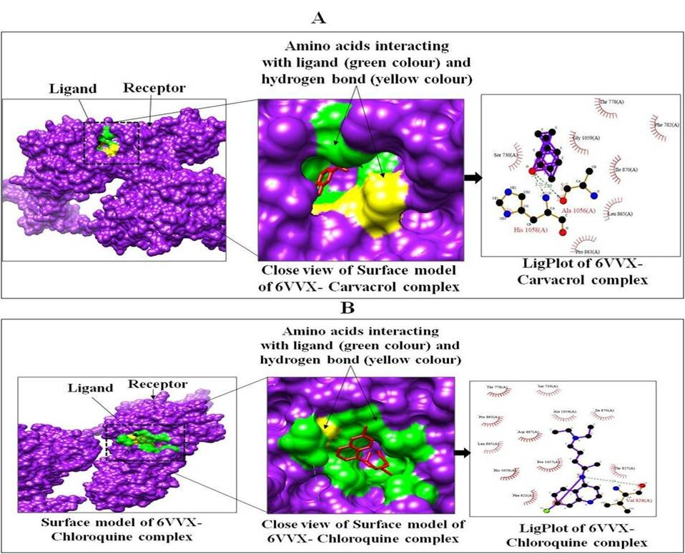
Fig. S1: Interactions between targeted protein receptor SARS-CoV-2 spike glycoprotein (PDB ID: 6VXX) with Carvacrol (A), Chloroquine (B) using Chimera and LigPlot analysis

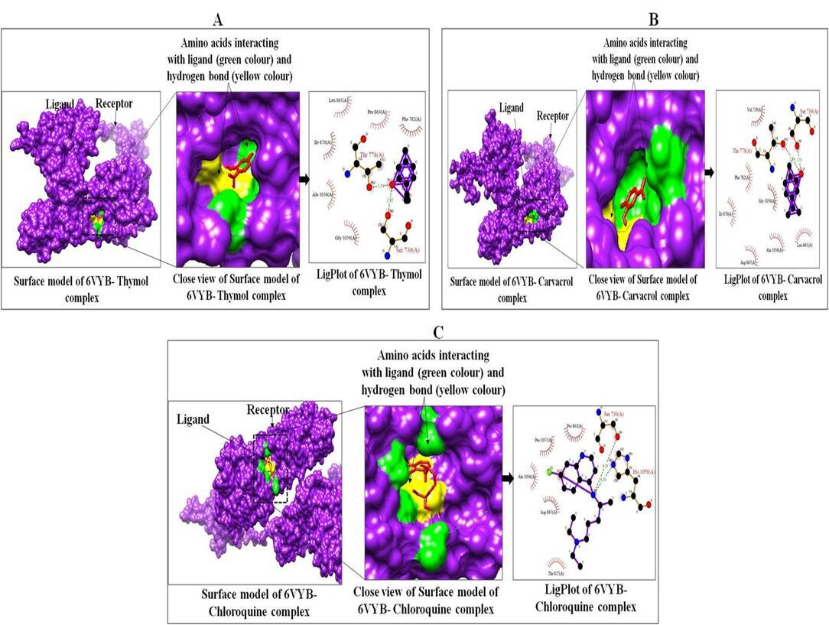
Fig. S2: Interactions between targeted protein receptor SARS-CoV-2 spike ectodomain structure (PDB ID: 6VYB) with Thymol (A), Carvacrol (B) and Chloroquine (C) using Chimera and LigPlot analysis.

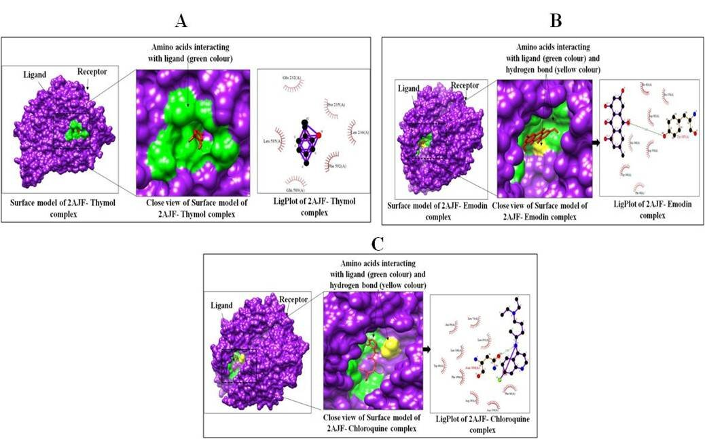
Fig. S3: Interactions between targeted protein receptor SARS coronavirus spike receptor-binding domain (PDB ID: 2AJF) with Thymol (A), Emodin, (B) Chloroquine (C) using Chimera and LigPlot analysis.

