S1. Aerial photograph of the experimental pond facility, indicating length and width. Humans are pictures adjacent to the pond for scale. Photo courtesy of Thor Veen.
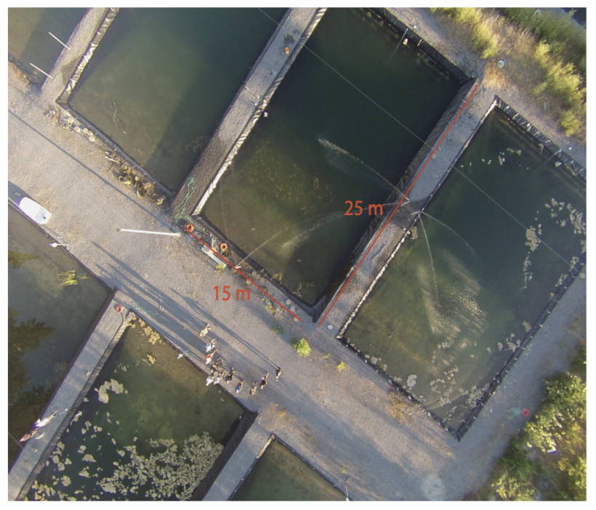

S2. Experimental setup and timeline. A shared color between ponds indicate they had the same founders.
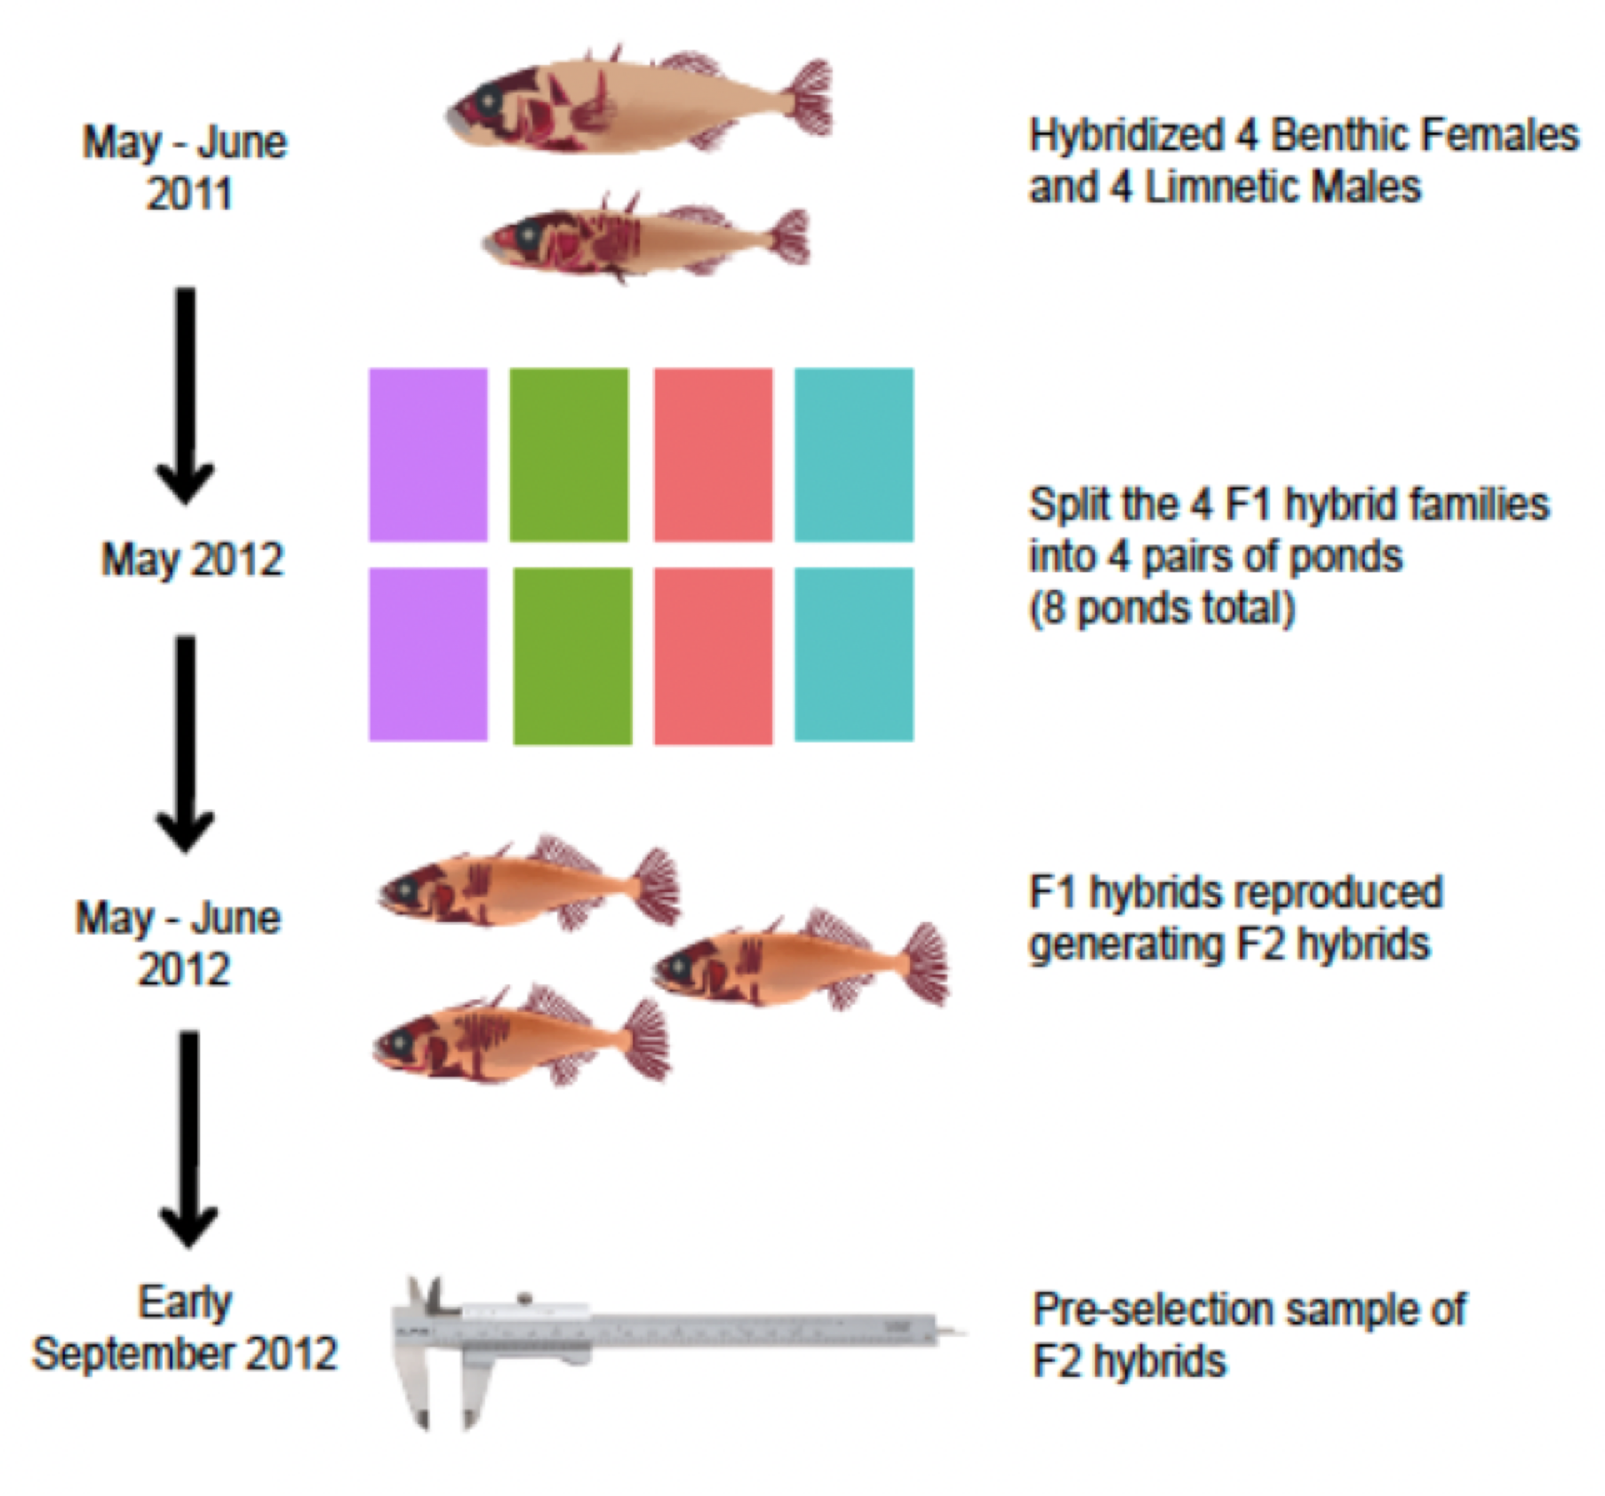

S3. Melanocyte counting at the fin junction
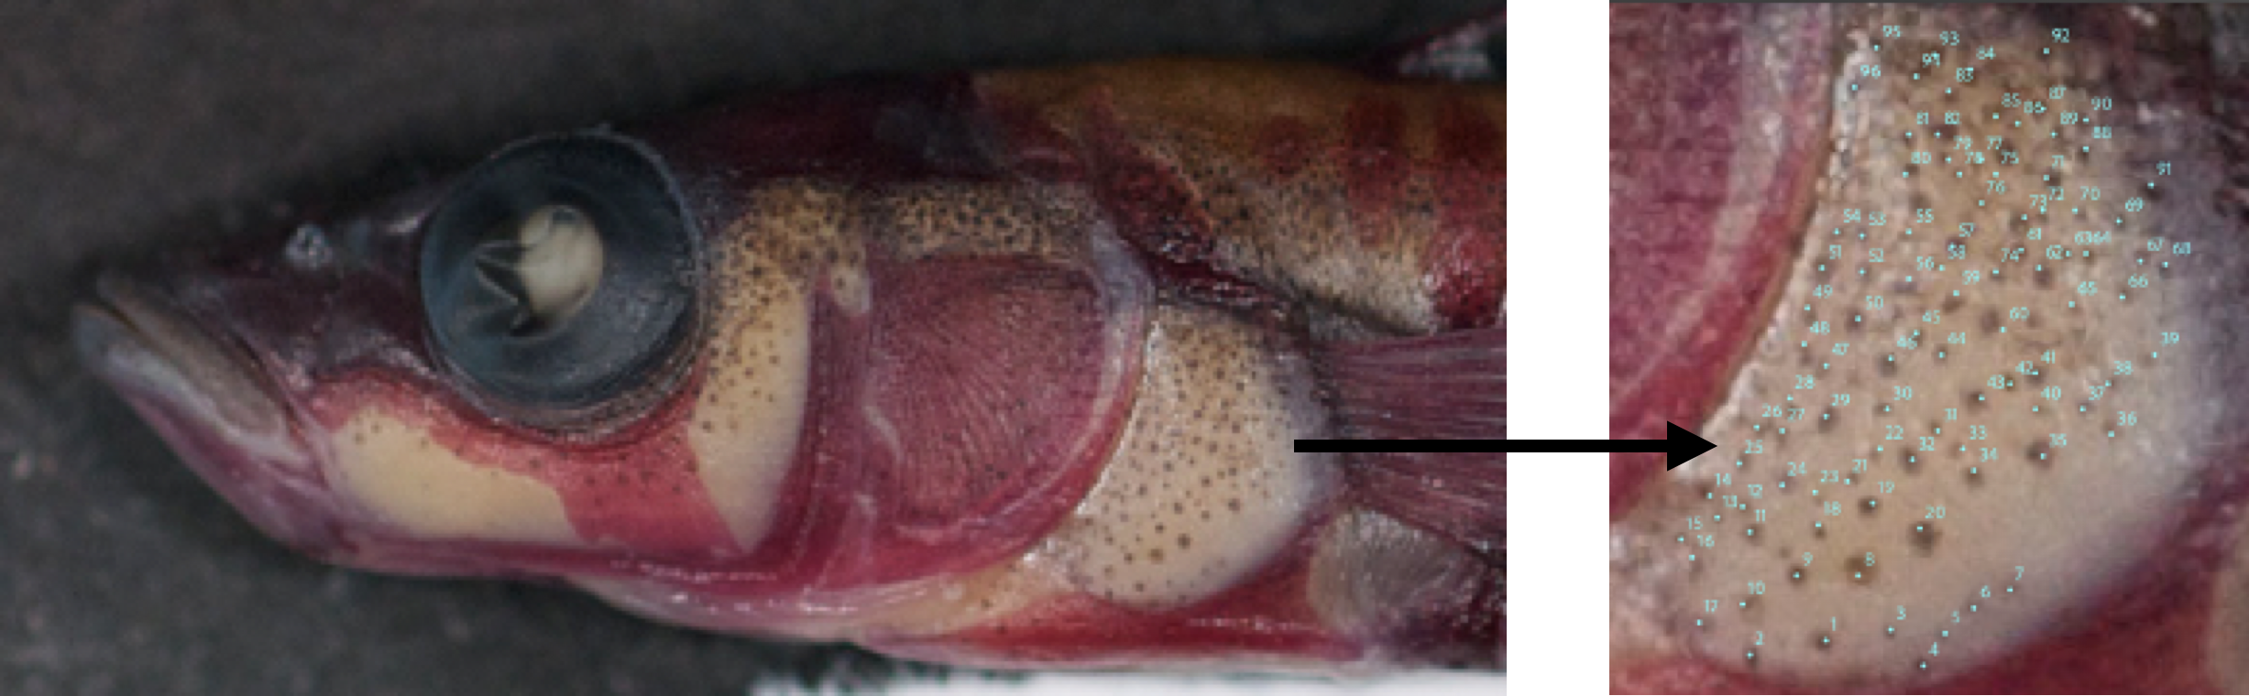

S4. Lateral barring at the ventral flank
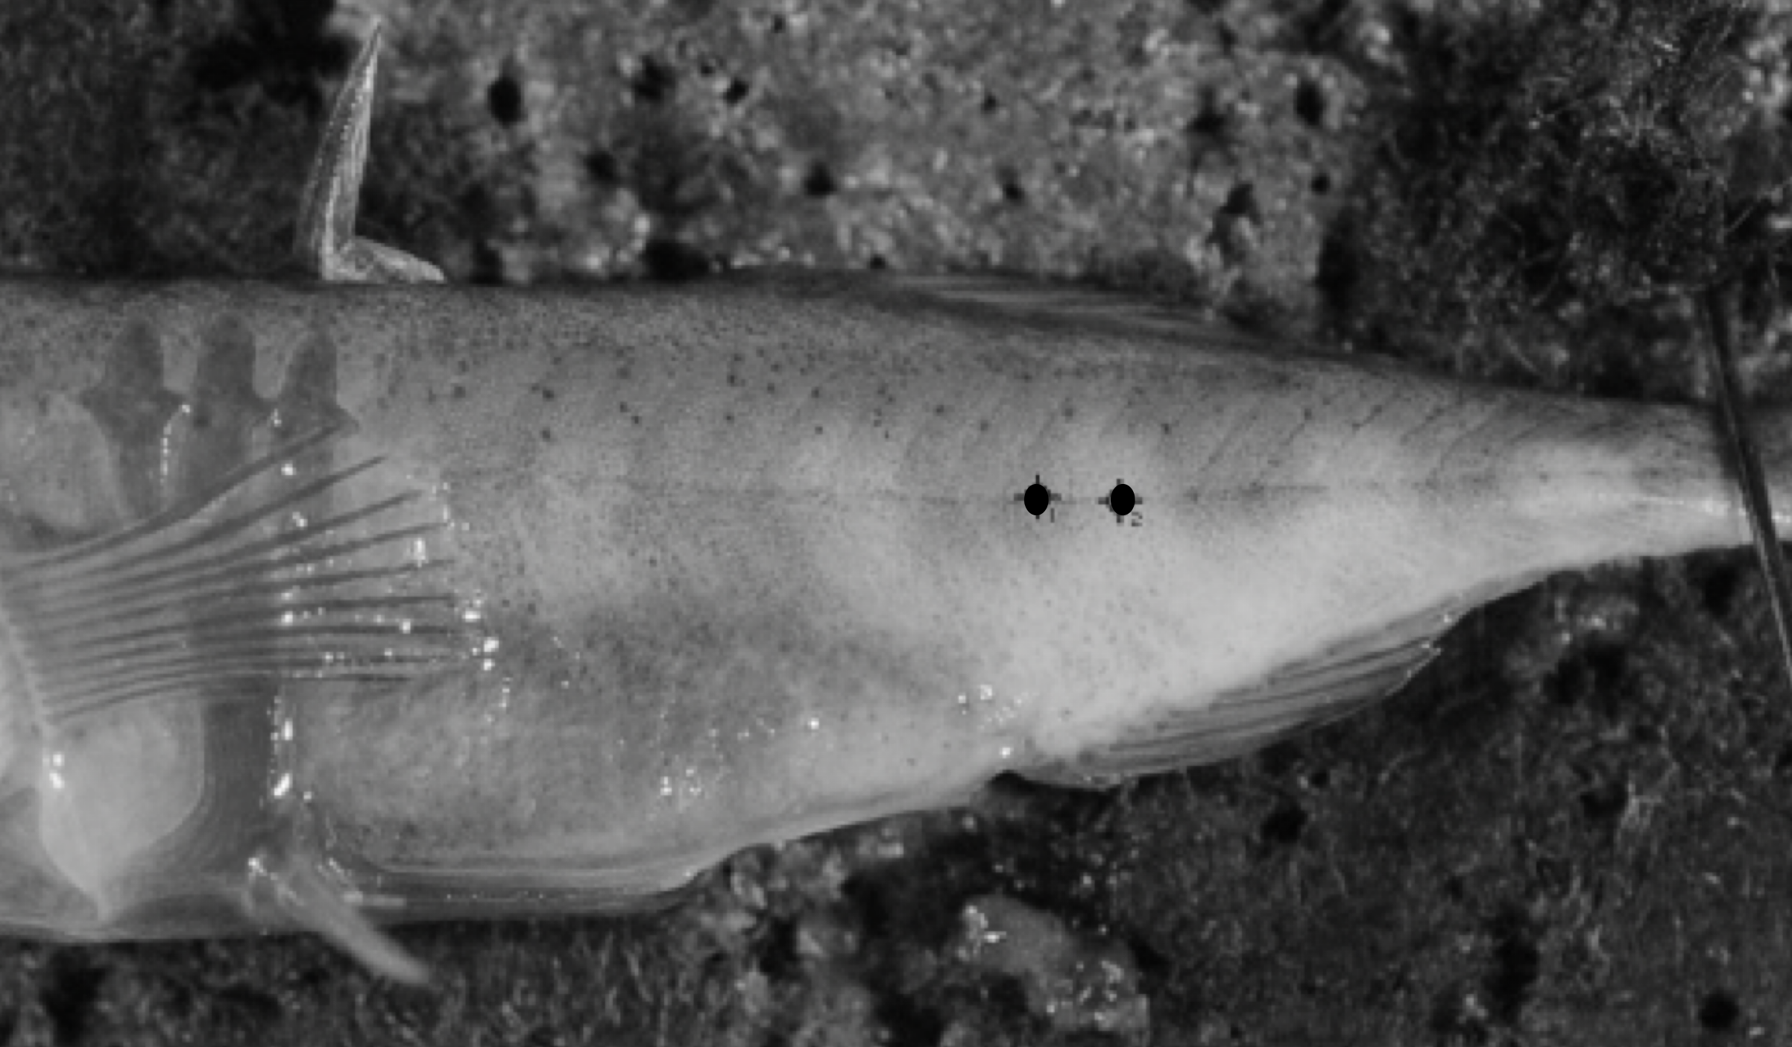

S5. Marine stickleback photographed against an X-rite color checker passport
