Evolutionary history of arbuscular mycorrhizal fungi and genomic signatures of obligate symbiosis

Anna Rosling^{1*, **}, Shadi Eshghi Sahraei^{1*}, Faheema Kalsoom Khan², Alessandro Desirò³, Abigail E Bryson³, Stephen J Mondo⁴, Igor V Grigoriev^{4,5}, Gregory Bonito³, Marisol Sánchez-García^{1,6 **}

Supplementary tables and figures
Table S1. List of published genome assemblies included in the analysis.
Table S2. Genome statistics for all taxa included in the analysis.
Table S3. Genes identified as Missing Glomeromycota Core Genes (MGCGs)
Table S4. CAZyme genes families previously analyzed as plant cell wall degrading enzymes (PCWDEs)
Table S5. Five CAZyme genes families found to be rapidly evolving with expansions at the Gigasporaceae
Table S6. CAZyme genes families identified in this study as missing only in Glomeromycota.

Figure S1. Copy of Fig 1B with numbers corresponding to Table S1 included for each analysed genome
Figure S2. Gene copy number for five genes previously identified as MGCGs
Figure S3. Total number of genes annotated into the six CAZyme classes
Figure S4. Contractions (A) and expansions (B) of carbohydrate-active enzyme (CAZyme) gene families
Figure S5. Total number of genes annotated into the eight families of proteolytic enzymes
Figure S6. Contractions (A) and expansions (B) of Peptidase gene families

Supplementary data file 1. Pfam domains in Glomeromycota, Mucoromycota and Mortierellomycota.
Supplementary data file 2. Carbohydrate-active enzyme (CAZyme) gene families in Glomeromycota, Mucoromycota and Mortierellomycota.

Table S1. List of published genome assemblies included in the analysis.
Number Id | Species | Strain Id | Phyla | Published in
1 | Funneliformis mosseae * | UK204 | Glomeromycota | Montoliu-Nerin et al., 2021 (49)
2 | Funneliformis mosseae | 87-6 pot B 2015 | Glomeromycota | Montoliu-Nerin et al., 2021 (49)
3 | Oehlia diaphana ** | DAOM 227022 V1.0 | Glomeromycota | Morin et al., 2019 (54)
4 | Rhizophagus irregularis *** | DAOM229456 | Glomeromycota | Morin et al., 2019 (54)
5 | Rhizophagus irregularis | DAOM197198 | Glomeromycota | Chen et al., 2018 (60)
6 | Rhizophagus irregularis-w3 | DAOM197198 | Glomeromycota | Montoliu-Nerin et al., 2021 (49)
7 | Acaulospora colombiana | CL356 | Glomeromycota | Montoliu-Nerin et al., 2021 (49)
8 | Acaulospora morrowiae | CL551 | Glomeromycota | Montoliu-Nerin et al., 2020 (59)
9 | Diversispora epigaea | IT104 | Glomeromycota | Sun et al., 2019 (55)
10 | Diversispora eburnea | AZ414A | Glomeromycota | Montoliu-Nerin et al., 2021 (49)
11 | Gigaspora rosea | DAOM 194757 | Glomeromycota | Morin et al., 2019 (54)
12 | Gigaspora margarita | 120-4 pot B 10/14 | Glomeromycota | Montoliu-Nerin et al., 2021 (49)
13 | Dentiscutata erythropus | MA453B | Glomeromycota | Montoliu-Nerin et al., 2021 (49)
14 | Cetraspora pellucida | FL966 | Glomeromycota | Montoliu-Nerin et al., 2021 (49)
15 | Racocetra fulgida | IN212 | Glomeromycota | Montoliu-Nerin et al., 2021 (49)
16 | Claroideoglomus candidum | NC172 | Glomeromycota | Montoliu-Nerin et al., 2021 (49)
17 | Claroideoglomus candidum | (CCK) pot B 6-9 | Glomeromycota | Montoliu-Nerin et al., 2021 (49)
18 | Claroideoglomus claroideum | SA101 | Glomeromycota | Montoliu-Nerin et al., 2020 (59)
19 | Geosiphon pyriformis | - | Glomeromycota | Malar et al., 2021 (30)
20 | Ambispora gerdemannii | MT106 | Glomeromycota | Montoliu-Nerin et al., 2021 (49)
21 | Ambispora leptoticha | FL130A | Glomeromycota | Montoliu-Nerin et al., 2021 (49)
22 | Paraglomus brasilianum | BR232B | Glomeromycota | Montoliu-Nerin et al., 2021 (49)
23 | Paraglomus occultum | IA702 | Glomeromycota | Montoliu-Nerin et al., 2021 (49)
24 | Endogone sp. | FLAS 59071 | Mucoromycota | Chang et al., 2019 (28)
25 | Jimgerdemannia flammicorona | AD002 | Mucoromycota | Chang et al., 2019 (28)
26 | Jimgerdemannia lactiflua | OSC166217 | Mucoromycota | Chang et al., 2019 (28)
27 | Hesseltinella vesiculosa | NRRL3301 V2.0 | Mucoromycota | Mondo et al., 2017 (62)
28 | Mucor circinelloides | CBS277.49 | Mucoromycota | Corrochano et al., 2016 (63)
29 | Mucor circinelloides | MU402 | Mucoromycota | Navarro-Mendoza et al., 2019 (66)
30 | Mucor lanceolatus | UBOCC-A-109153 | Mucoromycota | Lebreton et al., 2020 (57)
31 | Mucor endophyticus | UBOCC-A-113049 | Mucoromycota | Lebreton et al., 2020 (57)
32 | Rhizopus microsporus var. Microsporus | ATCC52813 | Mucoromycota | Mondo et al., 2017 (62)
33 | Rhizopus delemar | RA99 880 | Mucoromycota | Ma et al., 2009 (58)
34 | Lichtheimia corymbifera | JMRC:FSU:9682 | Mucoromycota | Schwartze et al., 2014 (54)
35 | Umbelopsis isabellina | WA0000067209 | Mucoromycota | Muszewska et al., 2021 (65)
36 | Umbelopsis vinacea | WA0000051536 | Mucoromycota | Muszewska et al., 2021 (65)
37 | Lobosporangium transversale | NRRL 3116 | Mortierellomycota | Mondo et al., 2017 (62)
38 | Mortierella sp_AD | AD185 | Mortierellomycota | Unpublished genome ¹
39 | Benniella erionia | GBAus27b | Mortierellomycota | Vandepol et al., 2021 (43)
40 | Mortierella alpina | AD266 | Mortierellomycota | Unpublished genome ²
41 | Linnemannia elongata | AG-77 v.2 | Mortierellomycota | Uehling et al., 2017 (67)
42 | Podila humilis | PM1414 | Mortierellomycota | Vandepol et al., 2021 (43)
43 | Podilia verticillate**** | NRRL6337 | Mortierellomycota | Vandepol et al., 2021 (43)
44 | Podila minutissima | AD051 | Mortierellomycota | Vandepol et al., 2021 (43)
45 | Actinomortierella capitata | AV005 | Mortierellomycota | Unpublished genome ³
- | Basidiobolus meristosporus | CBS 931.73 v1.0 | Outgroup | Mondo et al., 2017 (62)

* The strain UK2014 was initially listed as F. caledonius but has been reidentified as F. mosseae (W. Wheeler personal communication) in line with phylogenomic analyses (49).
** The genus Oehlia is represented by O. diaphana strain DAOM227022. A genome assembly of this strain was previously included in phylogenomic analyses under the name R. cerebriforme (30, 54, 59), but based on molecular and morphological data, this strain was shown to represent O. diaphana (68).
*** DAOM229456 corresponds to MUCL43196 in (54) where this strain was published under the name R. diaphanus but phylogenetic analyses suggest that this strain actually belongs to R. irregularis (68).
**** Species name kept in this paper as previously earlier published, although the species name should probably be P. humilis.

- https://mycocosm.jgi.doe.gov/MorAD185_1_1/MorAD185_1_1.home.html
- https://mycocosm.jgi.doe.gov/Moralp1_1/Moralp1_1.home.html
- https://mycocosm.jgi.doe.gov/Morcap1/Morcap1.home.html

Table S2. Genome statistics for all taxa included in the analysis.
Species name | Strain number | Assembly size (Mb) | Number of contigs | N50 (bp) | %GC | Number of genes | BUSCO
Funneliformis mosseae * | UK204 | 146 | 31,052 | 9,933 | 26 | 20,376 | C: 251  F: 28
Funneliformis mosseae | 87-6 pot B 2015 | 146 | 27,134 | 11,988 | 25 | 19,051 | C: 250  F: 31
Oehlia diaphana ** | DAOM227022 | 137 | 2,592 | 147,873 | 22 | 21,549 | C: 278  F: 7
Rhizophagus irregularis | DAOM197198 | 126 | 2,764 | 137,499 | 24 | 23,252 | C: 283  F: 2
Rhizophagus irregularis | DAOM197198 (w3) | 125 | 11,196 | 51,491 | 26 | 26,580 | C: 271  F: 13
Rhizophagus irregularis *** | DAOM229456 | 116 | 15,939 | 21,163 | 27 | 23,258 | C: 281  F: 5
Acaulospora colombiana | CL356 | 300 | 75,131 | 8,208 | 29 | 13,269 | C: 110  F: 103
Acaulospora morrowiae | CL551 | 219 | 64,585 | 6,189 | 28 | 21,890 | C: 235  F: 47
Diversispora epigaea | IT104 | 157 | 731 | 452,614 | 25 | 28,348 | C: 278  F: 7
Diversispora eburnea | AZ3414A | 65 | 9,803 | 22,612 | 26 | 13,318 | C: 237  F: 45
Gigaspora rosea | DAOM 194757 | 568 | 7,499 | 232,087 | 27 | 31,331 | C: 278  F: 6
Gigaspora margarita | 120-4 potB 10/4 | 575 | 173,647 | 5,875 | 27 | 57,019 | C: 249  F: 32
Dentiscutata erythropus | MA453B | 294 | 73,964 | 7,545 | 28 | 34,459 | C: 253  F: 25
Cetraspora pellucida | FL966 | 435 | 90,930 | 10,017 | 26 | 26,560 | C: 251  F: 27
Racocetra fulgida | IN212 | 296 | 105,307 | 4,839 | 28 | 24,442 | C: 101  F: 94
Claroideoglomus candidum | NC172 | 68 | 12,232 | 15,216 | 28 | 16,486 | C: 246  F: 33
Claroideoglomus candidum | (CCK) pot B 6-9 | 70 | 12,603 | 15,877 | 28 | 16,750 | C: 249  F: 32
Claroideoglomus claroideum | SA101 | 68 | 11,246 | 15,947 | 28 | 16,816 | C: 239  F: 43
Geosiphon pyriformis | - | 128 | 792 | 703,035 | 28 | 11,949 | C: 271  F: 8
Ambispora gerdemannii | MT106 | 88 | 19,363 | 10,266 | 28 | 15,654 | C: 264  F: 20
Ambispora leptoticha | FL130A | 197 | 58,506 | 5,886 | 24 | 16,806 | C: 253  F: 30
Paraglomus brasilianum | BR232B | 58 | 7,115 | 21,894 | 37 | 12,781 | C: 263  F: 22
Paraglomus occultum | IA702 | 50 | 8,053 | 16,033 | 37 | 12,217 | C: 224  F: 38
Endogone sp. | FLAS59071 | 96 | 15,409 | 11,261 | 39 | 9,569 | C: 175  F: 43
Jimgerdemannia flammicorona | AD002 | 231 | 35,354 | 10,860 | 43 | 13,838 | C: 168  F: 53
Jimgerdemannia lactiflua | OSC166217 | 180 | 45,525 | 5,625 | 44 | 12,651 | C: 111  F: 90
Hesseltinella vesiculosa | NRRL3301 V2.0 | 27 | 114 | 571,097 | 46 | 11,141 | C: 281  F: 7
Mucor circinelloides | CBS277.49 | 37 | 26 | 4,318,338 | 42 | 11,686 | C: 270  F: 12
Mucor circinelloides | MU402 | 37 | 24 | 4,574,267 | 42 | 11,843 | C: 282  F: 2
Mucor lanceolatus | UBOCC-A-109153 | 43 | 1,531 | 141,562 | 34 | 10,644 | C: 279  F: 7
Mucor endophyticus | UBOCC-A-113049 | 35 | 159 | 1,956,696 | 34 | 11,445 | C: 285  F: 4
Rhizopus microsporus | ATCC52813 | 26 | 131 | 1,118,338 | 37 | 10,905 | C: 283  F: 5
Rhizopus delemar | RA99 880 | 46 | 81 | 3,104,119 | 35 | 17,467 | C: 242  F: 35
Lichtheimia corymbifera | JMRC:FSU:9682 | 34 | 207 | 367,562 | 40 | 13,404 | C: 262  F: 6
Umbelopsis isabellina | WA0000067209 | 22 | 60 | 1,335,078 | 42 | 9,033 | C: 276  F: 8
Umbelopsis vinacea | WA0000051536 | 23 | 148 | 1,328,092 | 43 | 9,240 | C: 276  F: 11
Lobosporangium transversale | NRRL 3116 | 43 | 138 | 672,590 | 42 | 11,822 | C: 282  F: 6
Mortierella sp_AD | AD185 | 56 | 51 | 2,641,002 | 50 | 15,422 | C: 287  F: 3
Benniella erionia | GBAus27b | 45 | 140 | 820,600 | 51 | 13,953 | C: 283  F: 4
Mortierella alpina | AD266 | 40 | 40 | 2,137,591 | 50 | 12,145 | C: 288  F: 2
Linnemannia elongata | AG-77 v.2 | 50 | 473 | 517,143 | 48 | 14,969 | C: 284  F: 5
Podila humilis | PM1414 | 36 | 523 | 118,088 | 49 | 12,012 | C: 257  F: 6
Podilia verticillata **** | NRRL6337 | 42 | 55 | 2,912,254 | 48 | 12,569 | C: 287  F: 3
Podila minutissima | AD051 | 43 | 92 | 1,101,483 | 49 | 13,383 | C: 285  F: 3
Actinomortierella capitata | AV005 | 36 | 47 | 2,013,012 | 50 | 10,395 | C: 286  F: 4
Basidiobolus meristosporus | CBS 931.73 v1.0 | 89 | 1,366 | 106,019 | 43 | 16,111 | C: 281  F: 7

* The strain UK2014 was initially listed as F. caledonius but has been reidentified as F. mosseae (W. Wheeler personal communication) in line with phylogenomic analyses (49).
** The genus Oehlia is represented by O. diaphana strain DAOM227022. A genome assembly of this strain was previously included in phylogenomic analyses under the name R. cerebriforme (30, 54, 59), but based on molecular and morphological data, this strain was shown to represent O. diaphana (68).
*** DAOM229456 corresponds to MUCL43196 in (54) where this strain was published under the name R. diaphanus but phylogenetic analyses suggest that this strain actually belongs to R. irregularis (68).
**** Species name kept in this paper as previously earlier published, although the species name should probably be P. humilis.

Table S3. Genes identified as Missing Glomeromycota Core Genes (MGCGs) by Tang et al. (2016), with summary of occurrence across genomes analyzed in this study. Bold black font highlights seven true MGCGs, bold green font indicate six genes missing in Glomeromycota and Endogonales, while grey font indicate eight genes missing in all three phyla with 23 genomes assemblies in Glomeromycota (23 Glom.), 13 in Mucoromycota (13 Muc.) and 9 in Mortierellomycota (9 Mort.).
Pathway | Gene name | In  Out | Average nr. of gene copies |  |  | Nr. of genomes with copies
Pathway | Gene name | In  Out | Glom. | Muc. | Mort. | 23 Glom. | 13 Muc. | 9 Mort.
Fatty acid synthesis | FAS1 | P | 0 | 1.2 | 1 | 0 | 12 | 9
Fatty acid synthesis | FAS2 | P | 0 | 1.7 | 2 | 0 | 12 | 9
Thiamine metabolism  /transport | THI4 | P | 0 | 0.6 | 1 | 0 | 8** | 9
Thiamine metabolism  /transport | THI6 | P | 0 | 0.7 | 1 | 0 | 9** | 9
Thiamine metabolism  /transport | THI7 | P | 0 | 0.2 | 0 | 0 | 3 | 9
Thiamine metabolism  /transport | THI20 | P | 0 | 0.8 | 1 | 0 | 10** | 9
Thiamine metabolism  /transport | THI21 | P | 0 | 0.8 | 1 | 0 | 10** | 9
Thiamine metabolism  /transport | THI22 | P | 0 | 0.8 | 1 | 0 | 10** | 9
Thiamine metabolism  /transport | THI72 | P | 0 | 0.2 | 0 | 0 | 3 | 0
Thiamine metabolism  /transport | NRT1 | P | 0 | 0.2 | 0 | 0 | 3 | 0
Detoxifica-tion  /stress response | RHR2 | P | 0 | 1.2 | 1.2 | 0 | 12 | 8
Detoxifica-tion  /stress response | ARR3 | P | 0 | 1.2 | 1.3 | 0 | 11 | 8
Detoxifica-tion  /stress response | DOG1 | P | 0 | 1.1 | 0.9 | 0 | 11 | 8
Detoxifica-tion  /stress response | DOG2 | P | 0 | 1 | 1 | 0 | 11 | 9
Detoxifica-tion  /stress response | DSD1 | - | 0.04 | 0.9 | 0 | 1 | 12 | 0
Detoxifica-tion  /stress response | YHB1* | - | 0.04 | 0 | 0 | 1 | 0 | 0
Detoxifica-tion  /stress response | PUG1 | - | 0 | 0 | 0 | 0 | 0 | 0
Detoxifica-tion  /stress response | RTA1 | - | 0 | 0 | 0 | 0 | 0 | 0
ER quality control | PNG1 | - | 0 | 0.8 | 1 | 0 | 10 | 9
ER quality control | MNN2 | - | 0 | 0 | 0 | 0 | 0 | 0
ER quality control | MNN5 | - | 0 | 0 | 0 | 0 | 0 | 0
Proteases  /peptidases | ECM14 | P | 0.04 | 0.3 | 5.6 | 1 | 2 | 9
Sulfonate catabolism | JLP1 | P | 0 | 1.8 | 2.2 | 0 | 10** | 9
Sugar metabolism | SUC2 | - | 0 | 0.1 | 0 | 0 | 1 | 0
Allantoin permease | DAL4 | P | 0 | 0.2 | 0 | 0 | 3 | 0
Alcohol metabolism | ADH4 | P | 0.1 | 0.7 | 1 | 1 | 8 | 9
Alcohol metabolism | AAD15 | P | 0 | 0.3 | 0 | 0 | 3 | 0
Uracil metabolism | FUI1 | P | 0 | 0.2 | 0 | 0 | 3 | 0
Uracil metabolism | FUR4 | P | 0 | 0.2 | 0 | 0 | 3 | 0
Chaperones | MCX1 | P | 0.04 | 1.5 | 1.4 | 1 | 12 | 9
Aromatic ami-acid metabolism | ARO8 | - | 0.2 | 1.7 | 2.2 | 5 | 13 | 9
Aromatic ami-acid metabolism | ARO9 | - | 0.2 | 1.7 | 2.2 | 4 | 13 | 9
Channels  /transporters | TOK1 | P | 0 | 0 | 0 | 0 | 0 | 0
Channels  /transporters | PHO89 | P | 1.1 | 1.1 | 3 | 12 | 8 | 9
Channels  /transporters | MCH2 | P | 0.1 | 8 | 5.6 | 3 | 12 | 9
Cell cycle | AXL2 | - | 0 | 0 | 0 | 0 | 0 | 0
Others | URE2 | P | 1.7 | 0.3 | 0 | 15 | 3 | 0
Others | FRE8 | - | 0 | 0 | 0 | 0 | 0 | 0
Others | YLR278C | - | 0 | 0 | 0 | 0 | 0 | 0
*Also detected in R. irregularis by Kobayashi et al. (2018)
** Missing in the three analyzed Endogonales genomes and hence not uniquely lost in Glomeromycota
Table S4. CAZyme genes families previously analyzed as plant cell wall degrading enzymes (PCWDEs) often contracted in ECM fungi, with summary of occurrence across genomes in the three phyla with 23 genomes assemblies in Glomeromycota (Glom.), 13 in Mucoromycota (Muc.) and 9 in Mortierellomycota (Mort.). Bold font highlights genes family missing only in Glomoermycota while grey font indicates gene families that are absent in the outgroup and recorded in such low number that these genes are possibly absent across all analyzed taxa.
Decay activity (Ref.) | CAZyme family | In  Out | Ave. nr. of gene copies |  |  | Nr. of genomes with copies
Decay activity (Ref.) | CAZyme family | In  Out | Glom. | Muc. | Mort. | Glom.⁵ | Muc. | Mort.
LPMO (14, 21, 27, 28) | AA9 ¹ | - | 0.1 | 0 | 0 | 1 | 0 | 0
Laccase (27) | AA1 | P | 10.6 | 4.9 | 3.9 | 22 | 13 | 9
POD (21, 27) | AA2 ² | P | 1.9 | 2.5 | 1.9 | 23 | 13 | 9
Carbohydrate binding module (14, 28) | CBM1 | - | 0 | 0.2 | 0 | 0 | 2 | 0
Carbohydrate esterases (21) | CE1 | P | 0 | 0.8 | 1 | 0 | 10 | 9
Carbohydrate esterases (21) | CE16 | P | 2.4 | 4.9 | 0.3 | 23 | 13 | 3
Cellobiohydrolases Endoglucanases (14, 21, 28) | GH6 | - | 0 | 0.1 | 0 | 0 | 1 | 0
Cellobiohydrolases Endoglucanases (14, 21, 28) | GH7 | - | 0.04 | 0 | 0 | 1 | 1 | 0
Cellobiohydrolases Endoglucanases (14, 21, 28) | GH12 ³ | - | 0 | 0.2 | 0 | 0 | 3 | 0
Glycoside hydrolase (21, 28) | GH5 ⁴ | P | 4.6 | 7.2 | 8.4 | 23 | 13 | 9
Xylanases (21, 28) | GH10 | - | 0.1 | 0.2 | 0 | 1 | 3 | 0
Pectin-acting enzymes (21, 28) | GH28 | - | 0.04 | 3.6 | 0.7 | 1 | 12 | 5
Pectin-acting enzymes (21, 28) | GH43 | - | 0.04 | 0.6 | 0 | 1 | 5 | 0
Endoglucanase (27, 28) | GH45 | - | 0 | 0.5 | 0 | 0 | 4 | 0
Xylosidas (21) | GH3 | P | 0.04 | 5.1 | 0.8 | 1 | 13 | 7
Polysaccharide lysase (14, 28) | PL1 | - | 0 | 0.2 | 0 | 0 | 2 | 0
Polysaccharide lysase (14, 28) | PL3 | - | 0 | 0 | 0.7 | 0 | 0 | 5
¹ AA9 was previously classified as GM61
² AA2 encompass peroxidases listed as POD (21)
³ GH12 was not included in (14)
⁴ In our analysis GH5 has not been divided into subgroups and the numbers are thus not directly comparable to earlier studies.
⁵ Note that gene families detected only once were all detected in Acaulospora colombiana

Table S5. Five CAZyme genes families found to be rapidly evolving with expansions at the Gigasporaceae node. Summary of occurrence across genomes in the three phyla 23 taxa in Glomeromycota (Glom.), 13 in Mucoromycota (Muc.) and 9 in Mortierellomycota (Mort.).
Short information | CAZyme family | In  Out | Ave. nr. of gene copies |  |  | Nr. of genomes with copies
Short information | CAZyme family | In  Out | Glom. | Muc. | Mort. | Glom. | Muc. | Mort.
catalyse the oxidation of alcohols or carbohydrates with formation of hydrogen peroxide or hydroquinones (46) ¹ | AA3 | P | 6.6 | 3.2 | 7.1 | 23 | 12 | 9
Enzyme involved in chitin degradation (47) | AA7 | P | 6.4 | 1.3 | 6.2 | 23 | 10 | 9
Distantly related to GT28 | GT1 | P | 3.0 | 2.6 | 1.4 | 20 | 13 | 8
Chitin synthase | GT2-Chitin | P | 13.9 | 19.1 | 16.0 | 23 | 13 | 9
Lysozymes (48) ² | GT25 | - | 5.8 | 0.5 | 0 | 13 | 3 | 0

- https://www.cazypedia.org/index.php/Auxiliary_Activity_Family_3
- https://www.cazypedia.org/index.php/Glycoside_Hydrolase_Family_25

Table S6. CAZyme genes families identified in this study as missing only in Glomeromycota. Summary of occurrence across genomes in the three phyla 23 assemblies of Glom., 13 Mucoromycota (Muc.) and 9 Mortierellomycota (Mort.). Note that CE1 is not listed in this table since its already presented in Table S4.
Short information | CAZyme family | In  Out | Total nr. of gene copies |  |  | Nr. of genomes with copies
Short information | CAZyme family | In  Out | Glom. | Muc. | Mort. | Glom. | Muc. | Mort.
Chitin-binding¹ * | CBM5 | P | 0 | 0.3 | 1.2 | 0 | 2 | 8
Chitin-binding¹ * | CBM12 | P | 0 | 0.3 | 0.3 | 0 | 2 | 3
Mannosidase Galactosidase ² | GH2 | - | 0 | 0.5 | 1.0 | 0 | 5 | 9
Bacterial Glycoside hydrolases ³ | GH8 | P | 0 | 1.2 | 1.6 | 0 | 12 | 9
Fucosidases ⁴ | GH29 | - | 0 | 1.2 | 0.1 | 0 | 8 | 1
Fucosidases ⁵ | GH95 | - | 0 | 0.2 | 1.0 | 0 | 2 | 8
Mainly phosphorylases ⁶ | GH65 | - | 0 | 0.2 | 0.9 | 0 | 2 | 7
Various glucans ⁷ | GH74 | - | 0 | 0.3 | 0.1 | 0 | 3 | 1
Acetylglucosaminidases ⁸ | GH89 | P | 0 | 0.2 | 2.2 | 0 | 2 | 9
Mannanases ⁹ | GH134 | - | 0 | 1.5 | 0.1 | 0 | 5 | 1
Alginate lyases ¹⁰ | PL14 | P | 0 | 2.9 | 2.7 | 0 | 13 | 9
Mannuronan lyase ¹¹** | PL36 | P | 0 | 1.9 | 0.1 | 0 | 12 | 1
- https://www.cazypedia.org/index.php/Carbohydrate_Binding_Module_Family_5
- https://www.cazypedia.org/index.php/Glycoside_Hydrolase_Family_2
- https://www.cazypedia.org/index.php/Glycoside_Hydrolase_Family_8
- https://www.cazypedia.org/index.php/Glycoside_Hydrolase_Family_29
- https://www.cazypedia.org/index.php/Glycoside_Hydrolase_Family_95
- https://www.cazypedia.org/index.php/Glycoside_Hydrolase_Family_65
- https://www.cazypedia.org/index.php/Glycoside_Hydrolase_Family_74
- https://www.cazypedia.org/index.php/Glycoside_Hydrolase_Family_89
- https://www.cazypedia.org/index.php/Glycoside_Hydrolase_Family_134
- https://www.cazypedia.org/index.php/Polysaccharide_Lyase_Family_7
- Helbert et al 2019 https://doi.org/10.1073/pnas.1815791116
* Two related families of chitin binding modules, CBM5 so far only in bacteria
** This family has some similarity to PL14

Figure S1. Copy of Fig 1B with numbers corresponding to Table S1 included for each analyzed genome assemblies. Non-metric multidimensional (nMDS) of gene content based on domains identified using the Pfam database. Distances are calculated using Bray-Curtis dissimilarity on relative domain abundance per genome assembly, and visualized with colors for each phylum: Glomeromycota (purple), Mucoromycota (yellow) and Mortierellomycota (dark blue).

Figure S2. Gene copy number for five genes (AR08, AR09, MCH2, URE2, PHO89) previously identified as Missing Glomeromycota Core Genes (MGCGs) across taxa in the analyzed phyla. Circles represent the number of genes annotated in each assembly, scaled individually for each gene family for readability with maximum number of genes indicated at the bottom of each column. Estimated BUSCO completeness of the analyzed genome assemblies is indicated by bars to the right. Species are organized according to Fig. 1 and Endogonales as well as orders in Glomeromycota are highlighted by colored boxes. Observe that MCH2 is detected in one copy in each of the three Claroideoglomus genome assemblies.

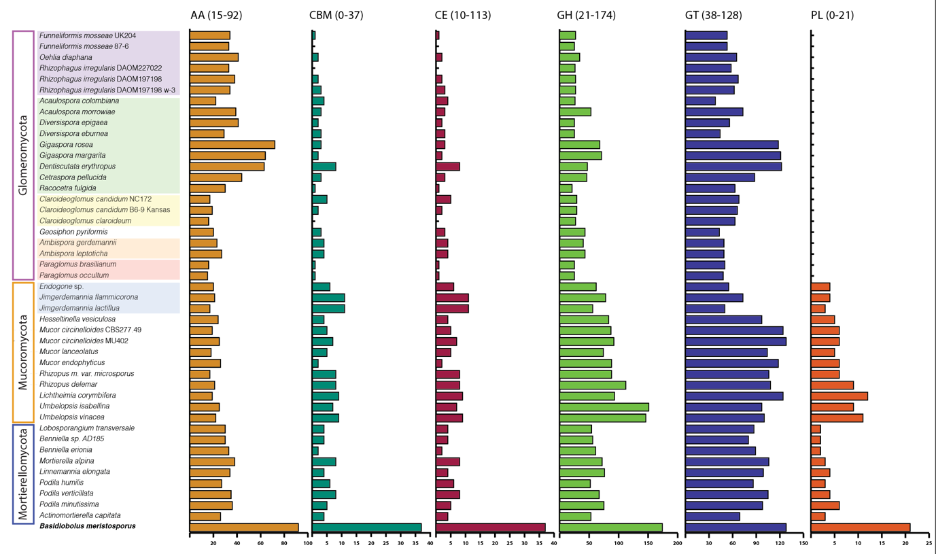
Figure S3. Total number of genes annotated into the six CAZyme classes: auxillary activity (AA) in okra, carbohydrate binding module (CBM) in dark green, carbohydrate esterase (CE) in maroon, glycoside hydrolase (GH) in green, glycosyl transferase (GT) in dark blue and polysaccharide lyase (PL) in red, across taxa in the analyzed phyla phylogeny. The range of genes in each class is given in parenthesis. Species are organized according to Fig. 1 and Endogonales as well as orders in Glomeromycota are highlighted by colored boxes.
Figure S4. Contractions (A) and expansions (B) of carbohydrate-active enzyme (CAZyme) gene families among Glomeromycota (purple), Mucoromycota (yellow) and Mortierellomycota (dark blue) as determined by computational analysis of gene family evolution (CAFE).
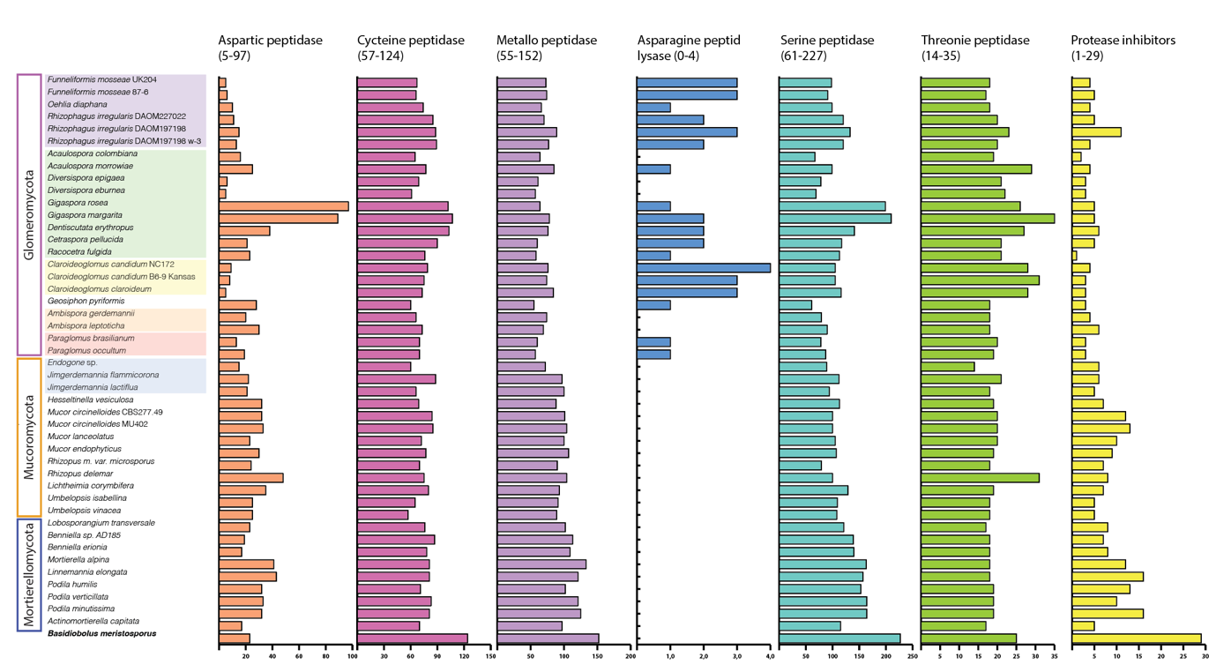
Figure S5. Total number of genes annotated into the eight families of proteolytic enzymes: aspartic peptidase (orange), cysteine peptidase (magenta), metallo peptidases (purple), asparagine peptide lysase (blue), serin peptidase (cyan), threonine peptidase (green) and protease inhibitors (yellow) across taxa in the analyzed phyla phylogeny. The range of genes in each class is given in parenthesis. Species are organized according to Fig. 1 and Endogonales as well as orders in Glomeromycota are highlighted by colored boxes.

Figure S6. Contractions (A) and expansions (B) of Peptidase gene families among Glomeromycota (purple), Mucoromycota (yellow) and Mortierellomycota (dark blue) as determined by computational analysis of gene family evolution (CAFÉ).

