Ultrasound-Targeted Microbubble Destruction Promotes PDGF-Primed Bone Mesenchymal Stem Cells Transplantation for Myocardial Protection in Acute Myocardial Infarction of rats

Zhenxing Sun^{a,b,c, d}, Yu Cai^{c,d}, Yihan Chen^{c,d}, Qiaofeng Jin^{c,d}, Ziming Zhang^{c,d}, Li Zhang^{c,d}, Yuman Li^{c,d}, Lei Huang^{c,d}, Jing Wang^{c,d}, Yali Yang^{c,d}, Qing Lv^{c,d}, Zhengyang Han^{c,d,e} †, Mingxing Xie^{c,d}†, Xiangming Zhu^{a,b} †

- School of Continuing Education, Anhui Medical University, Hefei 230031, China
- Department of Ultrasound, The First Affiliated Hospital of Wannan Medical College, Wuhu 241001, Anhui, China
- Department of Ultrasound medicine, Union Hospital, Tongji Medical College, Huazhong University of Science and Technology, Wuhan 430022, China
- Hubei Province Key Laboratory of Molecular Imaging, Wuhan 430022, China
- Department of Ultrasound, The First Affiliated Hospital of Zhengzhou University, Zhengzhou 450099, Henan, China

† Co-senior author

Corresponding address:
Xiangming Zhu, No.2 Zheshan west Road, Wuhu City 241001, Anhui province, China. Tel: 0553-5738279. Email: zhuxmwuhu@163.com

Mingxing Xie, No. 1277 Jiefang Ave, Wuhan 430022, China. Tel: 86-27-85726430. E-mail address: xiemx@hust.edu.cn

Zhengyang Han, No.1 Longhu Zhonghuan Road, Jinshui District, Zhengzhou 430022, Henan. Tel: 0371-66913114. E-mail address: 1415034454@qq.com

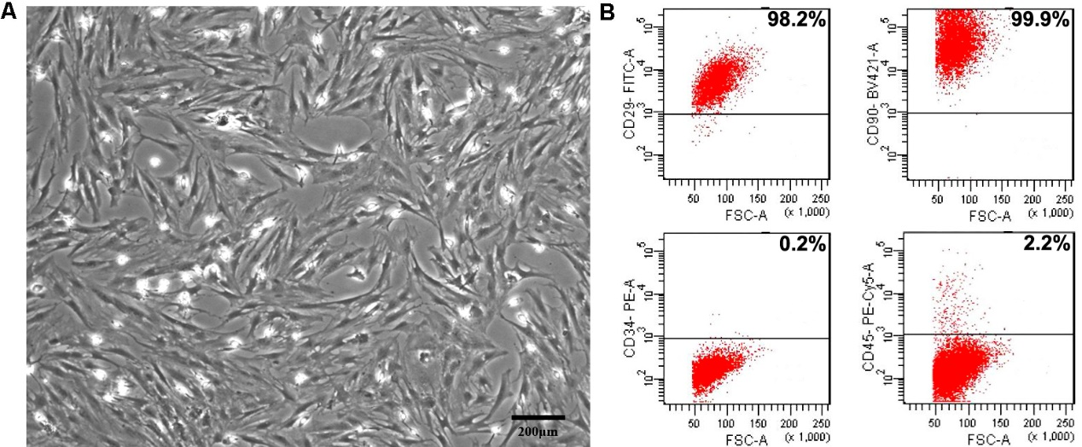
Figure S1. Characterization of MSCs.
A. The morphology observation of MSCs under the optical microscopy. Bar, 50μm; B. Flow cytometry of MSCs for mesenchymal CD29, 90, 34, and 45 markers. Unstained cells were used as control. Bar, 200μm.
Figure S2 Representative flow cytometry images of GFP-labeled MSCs in hearts

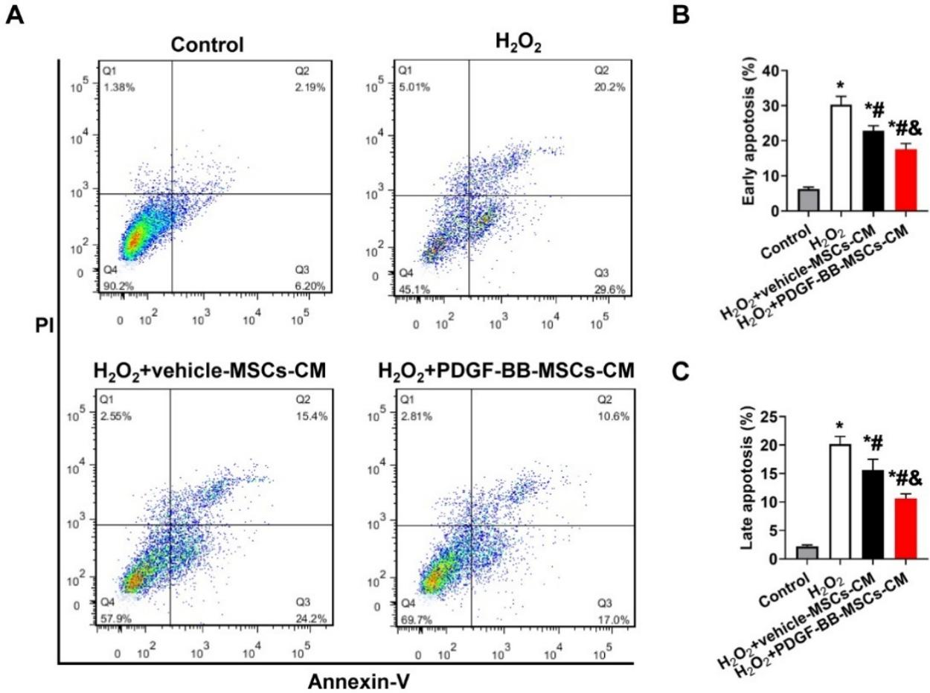
Figure S3 Anti-apoptotic effect of CM from PDGF-BB-primed MSC on H9C2 myocardial cells subjected to H₂O₂.
(A-C) H9c2 apoptosis was assessed by Annexin V/PI staining followed by flow cytometry analysis. H₂O₂, 200 µM, 6 hours. N=6. *p<0.01 vs. Control; # p<0.01 vs. H₂O₂; & p<0.01 vs.H₂O₂-vehicle-MSCs-CM.

