Supplementary
The 1936/37 Norwegian Antarctic Expedition
The 1936-37 Norwegian Antarctic expedition, also known as the Thorshavn IV expedition (named after the main vessel), was financed by the Norwegian whaling ship owner and consul Lars Christensen, who had special interest in Antarctica. In 1926, he initiated a yearly Antarctic exploration program. His expeditions led to the Norwegian claims of Bouvet Island (1927), Peter I Island (1929), and Queen Maud Land (1939). Thorshavn IV was Christensen's final expedition, and its specific aim was to capture aerial images for topographic mapping of areas discovered on previous trips.
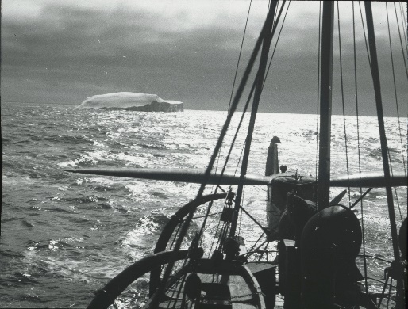
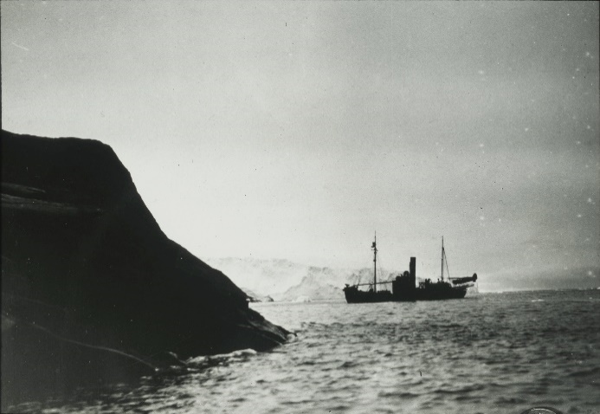
The expedition included Lars Christensen, his wife Ingrid Christensen, who had become the first woman to reach the Antarctic continent on a previous expedition, and their youngest daughter (Fig. S3, S4, and S6). They departed from Cape Town on December 28th, 1936, on M/T Thorshavn (Fig. S5) and after a short stop at Kerguelen, they arrived at 90° East between Shackleton and the West Ice Shelf, where they had planned to start the mapping. Due to unstable weather conditions, they sailed west, and on January 24th, they completed the first mapping by photographing the West Ice Shelf. From there, they continued westward, and at around 82° East, they started consistently mapping the coast. On February 7th, the expedition had reached its end at Princess Astrid Coast and started its journey home (Fig. S7). The expedition had an effective flight time of 44 hours, corresponding to a flying distance of 10,000 km. Approximately 2,000 km of the coastline was photographed from an altitude of approximately 1400-2000 m a.s.l., resulting in a total of 2,200 aerial images. They used a 1936-model Stinson Reliant floatplane (call sign LN-BAR) chartered from Widerøe Airlines. The aircraft was equipped with a 350 HP Wright engine and an extra fuel tank, giving it a flying range of approximately 1200 km (Fig. S1 and S2). An automatic Zeiss camera with a focal length of 21 cm, was mounted at the floor of the airplane recording images in a 20° angle below the horizontal plane.
Fig. S1. Whaling ship Firern (loaded with floatplane LN-BAR) captured near Klarius Mikkelsen Fjell in Lars Christensen Land.
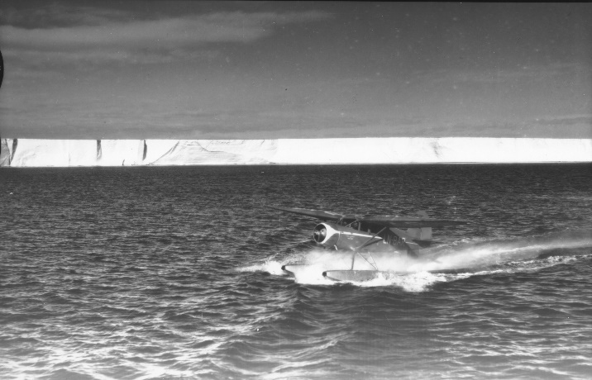
Fig. S2. Stinson Reliant floatplane (call sign LN-BAR) used for aerial photographing.
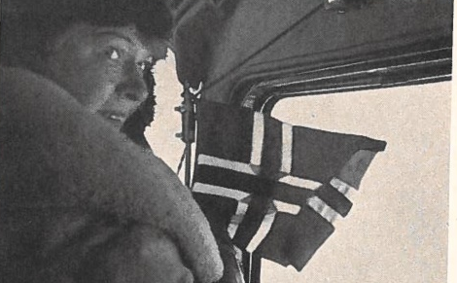
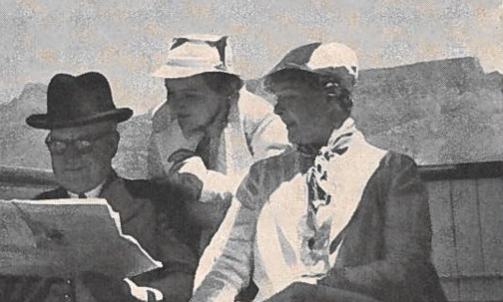
Fig. S4. Ingrid Christensen onboard the floatplane, ready to drop the Norwegian flag near 38º East, 69º South – a region later named Prince Harald Land.
Fig. S3. Lars Christensen, Ingrid Christensen and their daughter onboard M/T Thorshavn outside Cape Town, South Africa.

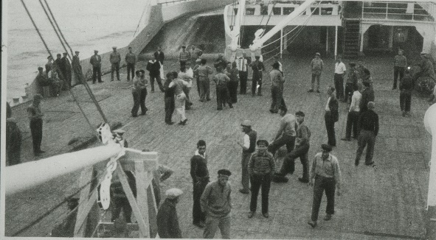
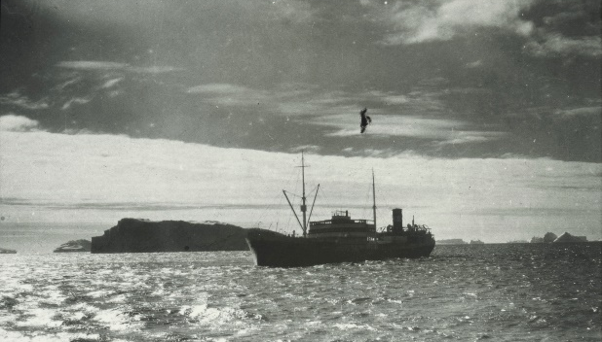
Fig. S5. M/T Thorshavn outside Ingrid Christensen Land.
Fig. S6. The crew onboard M/T Thorshavn during the 1936-1937 Antarctic expedition.
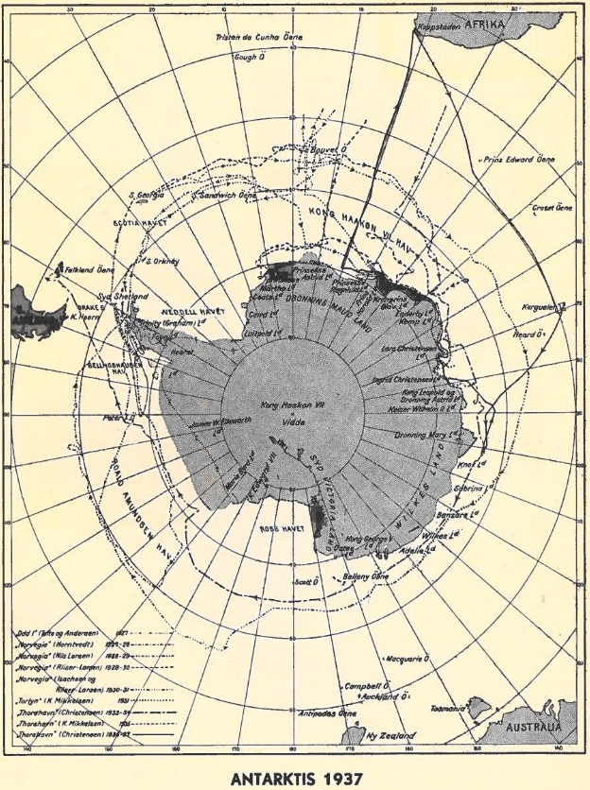

Placement of elevation comparison circles
Fig. S7. Map showing all Antarctic expeditions financed by Lars Christensen, adapted from Christensen 1938²² with the red line showing the 1936/37 expedition route.
To ensure an optimal positioning of the 150-meter radius elevation comparison circles used for calculating glacier elevation changes, a multi-step approach is employed at each glacier:
First, we convert each historical DEM into a binary dataset, where a value of 0 represents no data and a value of 1 represents the presence of elevation data. Next, we aggregate the binary datasets to generate a composite map that highlights the areas across the glacier with the highest density of historical observations (Fig. S8). To maximize data coverage and ensuring comprehensive representation of the glacier's surface, the circles are positioned in close proximity to each other, extending from the front to the back of the glacier, and targeting areas with a high concentration of historical elevation observations. All circles are positioned within the minimum boundary area defined by the GCPs, to ensure that we include only observations with accurate georeferencing. Moreover, we make efforts to position the circles close to the centerline of the glacier. This is particularly crucial for glaciers that exhibit surface undulations, such as Hoseason and Utstikkar Glacier (Fig. S13 and s15). By adopting this circle placement strategy, we aim to capture the overall characteristics of the glacier, including both the peaks and valleys of these undulations. Surface undulations are formed when the glacier flows over uneven bedrock⁶¹ and as the glacier moves, the undulations also move.
For glaciers that have only one historical DEM, we omit the generation of a composite map. However, we employ a similar approach to position the elevation comparison circles to ensure consistency in our methodology across all glaciers and facilitate easy comparison with the REMA DEM strips, which may also contain areas of data gaps (Fig. S12B and S13C). Due to the data gaps in the historical DEMs, it is not always feasible to adhere to the described positioning approach. This is particularly evident in cases such as Honnörbrygga and Brunvoll Glacier (Fig. S12 and S16), where the circles are positioned across the glacier area instead of close to the centerline. The only exception to this general approach of placing elevation comparison circles is Brown Glacier (Fig. S19), where elevation changes are calculated across the entire glacier area as the historical DEM contains no void areas.
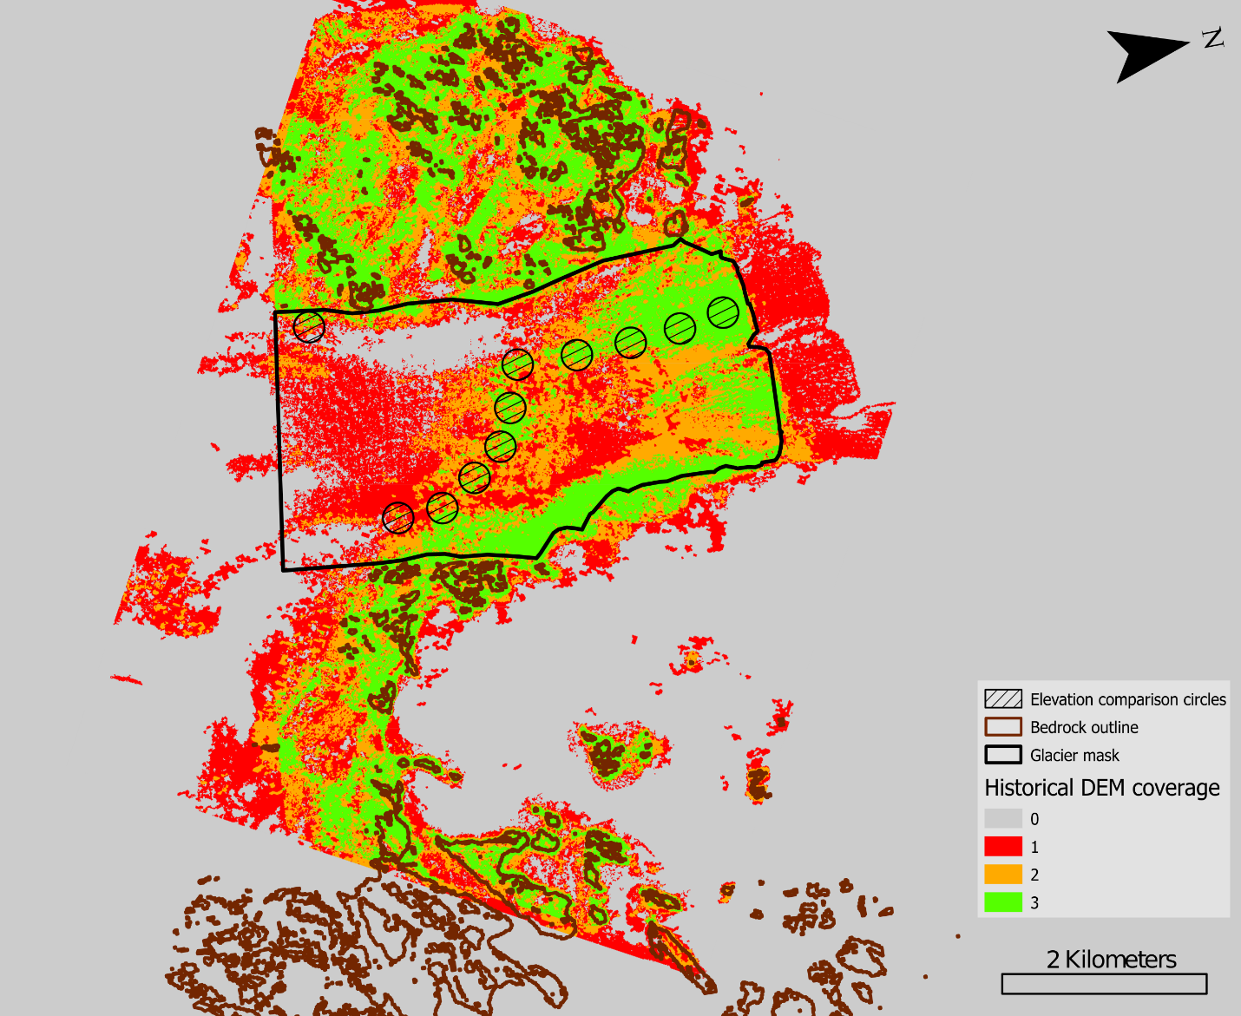Figure S8. Composite map of historical DEM coverage, with the pixel color indicating the number of historical observations.

Sensitivity analysis of elevation changes
To evaluate the impact of circle placement on the mean dH values for each epoch and glacier, we perform sensitivity tests. We calculate the mean dH of all combinations of N/2 circles (N being the total number of circles) and determine the standard deviation (std) across all these combinations (Fig. S9). To account for the sampling uncertainty introduced by circle placement, we adopt two times the standard deviation (2*std) as an additional uncertainty when interpreting the mean dH obtained using all circles (Fig 2). Notably, we observe that glaciers with large surface undulations (e.g. Hoseason Gl.) exhibited larger sampling uncertainty compared to the estimated model uncertainty of our generated DEMs. Conversely, glaciers with a more uniform surface (e.g. Honnörbrygga Gl.) show smaller sampling uncertainty (Fig 2).
To further assess the sensitivity of our results, we also perform a positional shift analysis by slightly adjusting the positions of the circles and examining the resulting impact on the calculated dH values. However, it is important to note that due to data gaps in the historical DEMs, we are unable to conduct this analysis for all glaciers. Therefore, we specifically select two types of glaciers with good historical data coverage for this analysis: Utstikkar Glacier, characterized by significant surface undulations, and Honnörbrygga Glacier, which exhibits a relatively smooth surface. For Honnörbrygga Glacier the circles are shifted approximately 150 m in front of the initial position (Fig S10A.). On the other hand, for Utstikkar Glacier, the circles are shifted across the glacier area while attempting to maintain a consistent distance from the glacier front (Fig. S10B). However, due to data gaps, it is not possible to shift the circle farthest from the front. For Hönnorbrygga Glacier, we calculate the mean dH of all 257 combinations of circles, whereas for Utstikkar Glacier the mean dH is based on 1000 random combinations. We exclude combinations that involved both the original and shifted versions of the same circle, eliminating any duplication. Next, we compare the mean dH from the shifted circle combinations with the dH from the initial placement and find a limited effect on the dH results. Specifically, at Honnörbrygga Glacier, we observe a difference of 0.9 m for the period 1937-2016 and 0.2 m for the period 2016-2020, giving a total difference of 1.1 m from 1937 to 2020. For Utstikkar Glacier, the shifted mean dH is slightly smaller than the original dH estimate, with difference in dH ranging from 0.4 m to 1.2 m across all epochs, leading to a total dH difference of 1.4m. To account for this sampling issue, we add an additional conservative uncertainty of 1.5 m on top of the existing sampling uncertainty (Fig. 2). These findings provide confidence that the mean dH determined from the initial circle placement represents the changes occurring across the glacier and provides a more comprehensive assessment of the overall reliability of our results.

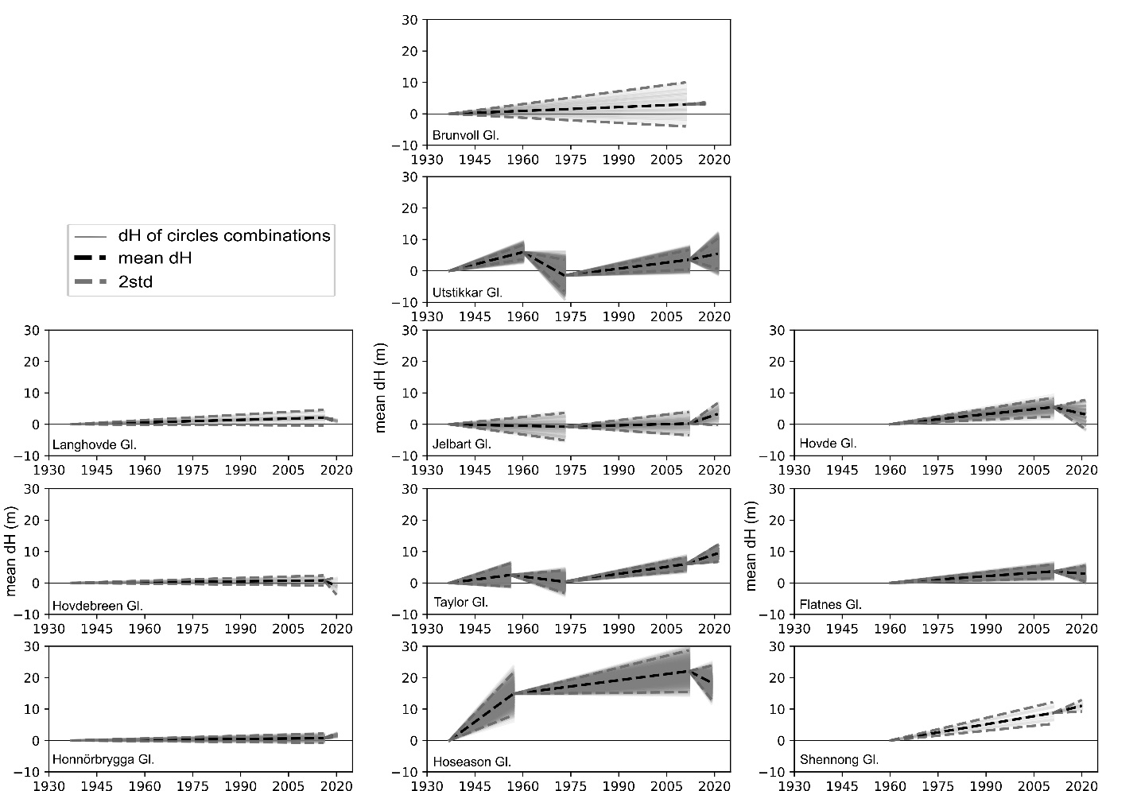
Fig. S9. Sensitivity analysis for each glacier showing the mean dH of all combinations of N/2 circles, the 2*std across all these combinations, and the mean dH.
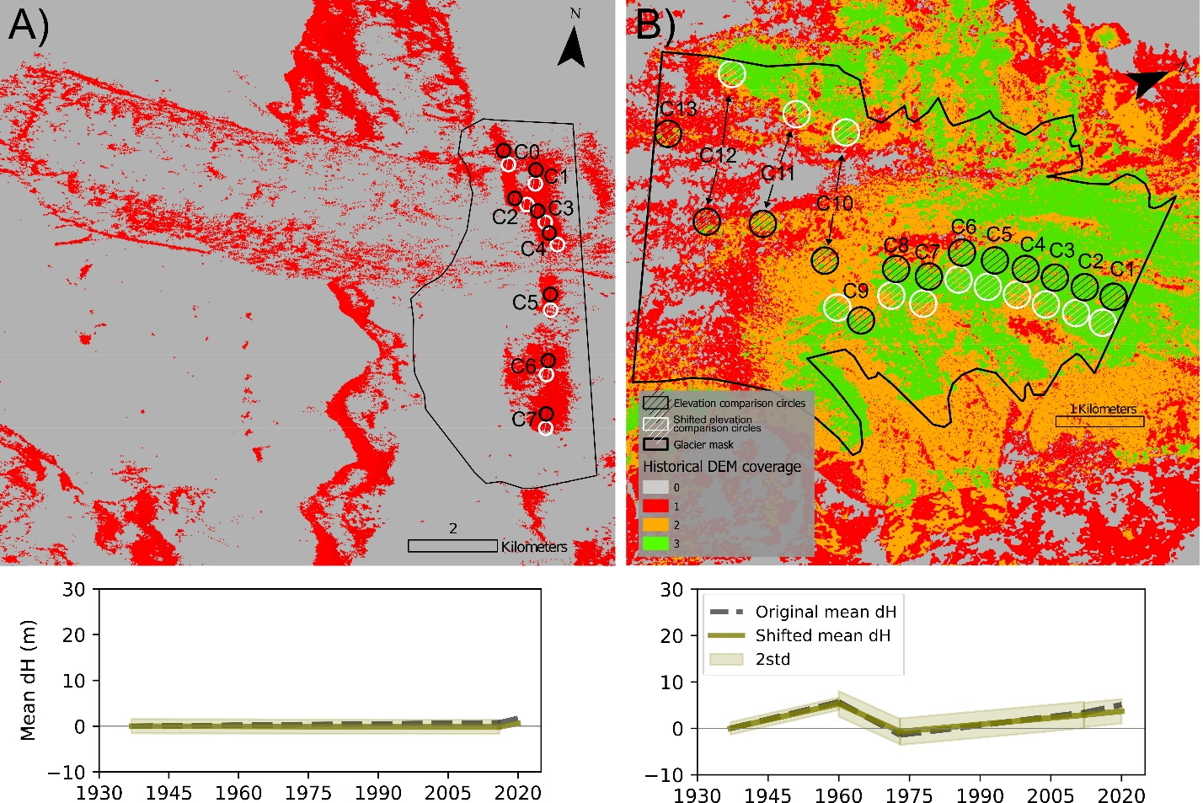
Figure S10. Composite map of historical DEM coverage and plot showing a comparison of the original mean dH and the shifted mean dH (calculated based on all possible combinations of circles) for A) Honnörbrygga Glacier and B) Utstikkar Glacier.

Table S1. Overview of all glacier included in the study and their historical observations.
Region name | Glacier name | Historical frontal position | Historical ice thickness | Historical velocity
Lützow-Holm Bay | Honnörbrygga | X | X
Lützow-Holm Bay | Hovdebreen | X | X
Lützow-Holm Bay | Langhovde | X | X
Lützow-Holm Bay | Telen | X
Lützow-Holm Bay | Skallen | X
Lützow-Holm Bay | Shirase | X
Kemp and Mac Robertson Land | Hoseason | X | X | X
Kemp and Mac Robertson Land | Taylor | X | X | X
Kemp and Mac Robertson Land | Jelbart | X | X | X
Kemp and Mac Robertson Land | Utstikkar | X | X | X
Kemp and Mac Robertson Land | Brunvoll | X | X
Kemp and Mac Robertson Land | Unnamed | X
Kemp and Mac Robertson Land | Forbes | X
Kemp and Mac Robertson Land | Mulebreen | X
Ingrid Christensen Coast | Shennong | X | X
Ingrid Christensen Coast | Flatnes | X | X
Ingrid Christensen Coast | Hovde | X | X
Ingrid Christensen Coast | Brown | X | X
Ingrid Christensen Coast | Dolk | X
Ingrid Christensen Coast | Chaos | X
Ingrid Christensen Coast | Sørdals | X

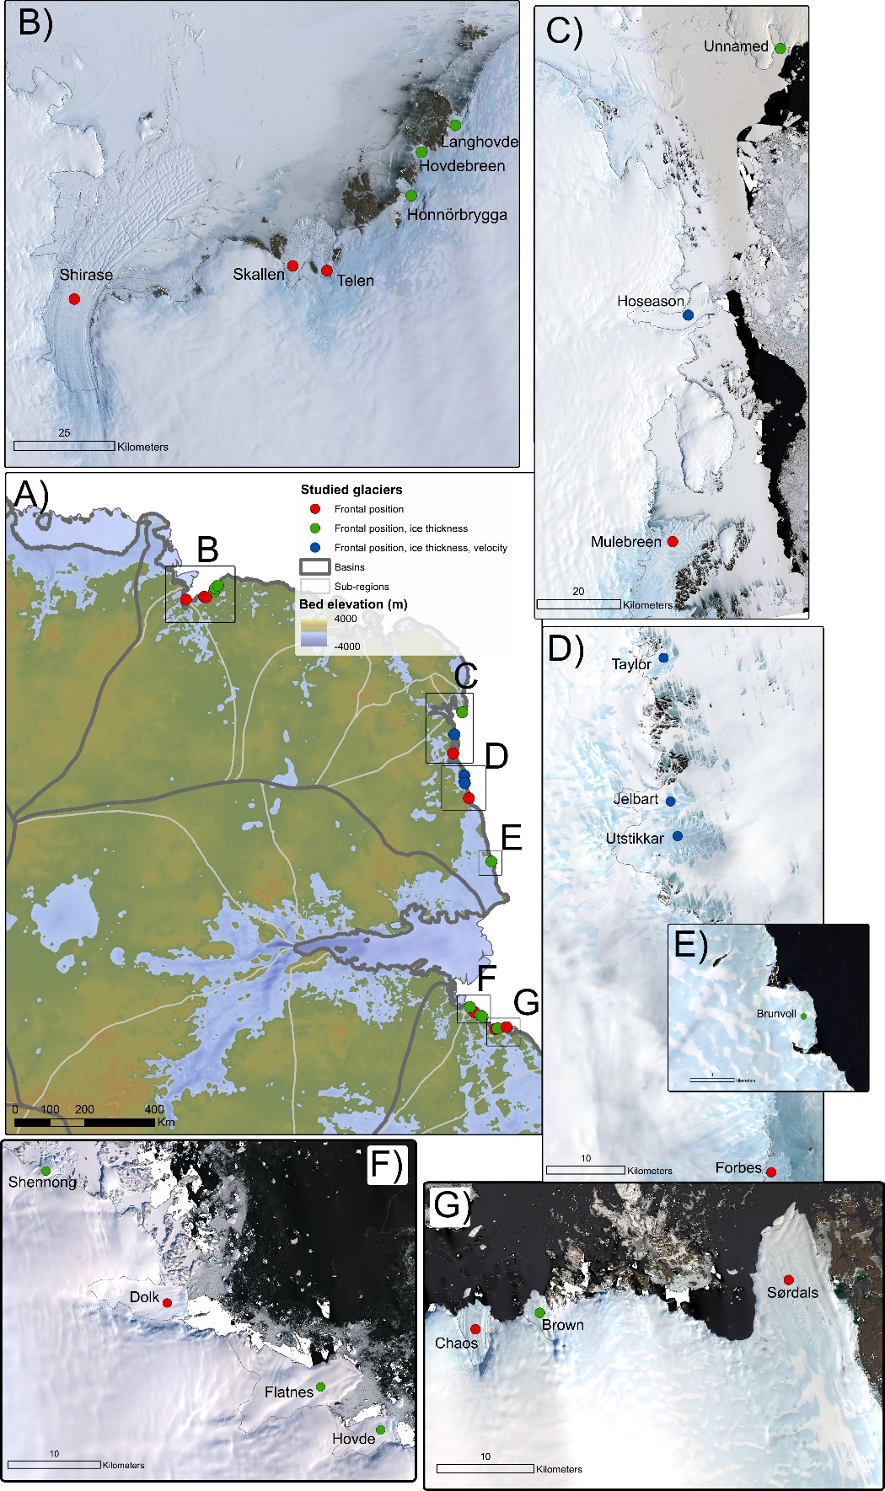
Fig. S11. Overview of all glacier included in the study and their historical observations. The overview map A) also show basins and sub-regions. Panels B), C), D), E), F), and G) show close-ups of all studied glaciers on Landsat scenes from 2022-2023.
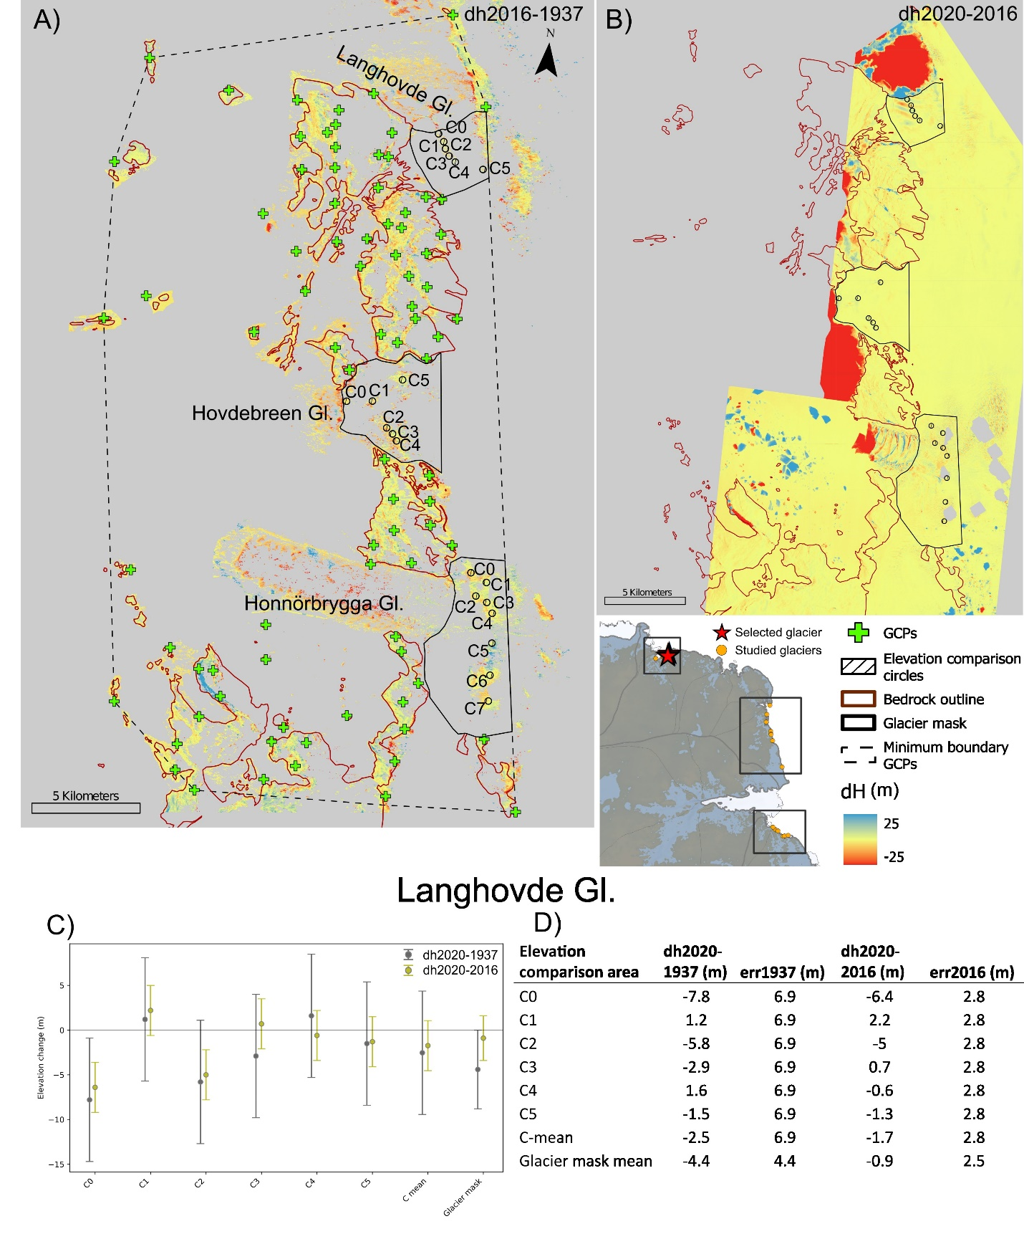
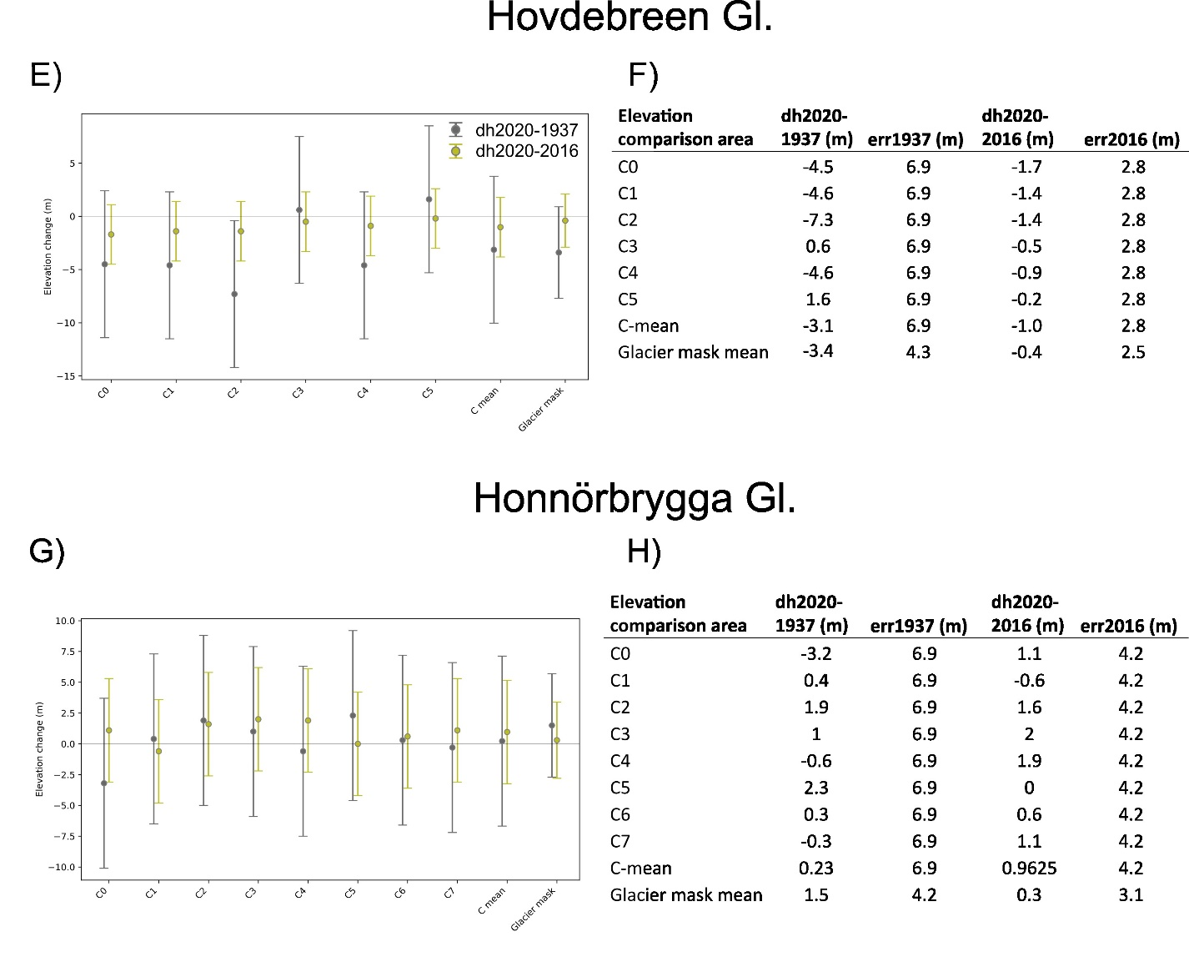
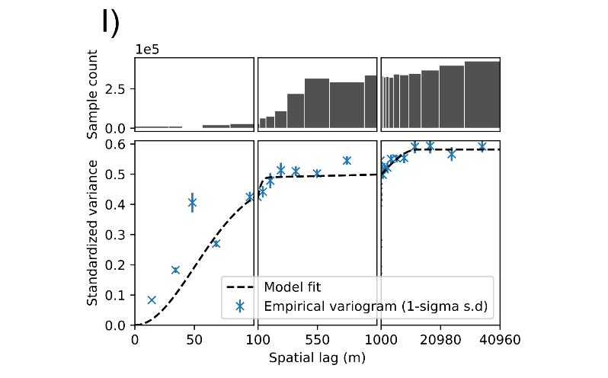
Fig. S12. Elevation changes at Langhovde, Hovdebreen, and Honnörbrygga Glacier A) 2016-1937 and B) 2020-2016. Elevation changes of elevation comparison circle and the glacier area shown as C), E), and G) scatterplot and as D), F) and H) tables for Langhovde Gl., Hovdebreen Gl. and Honnörbrygga Gl., respectively. I) Spatial variogram of the 1937 historical DEM. Note that A) shows the dH2016-1937, whereas the scatterplots and tables show the dH2020-1937, as no 2020 reference DEM strips covered the entire SfM-model area.

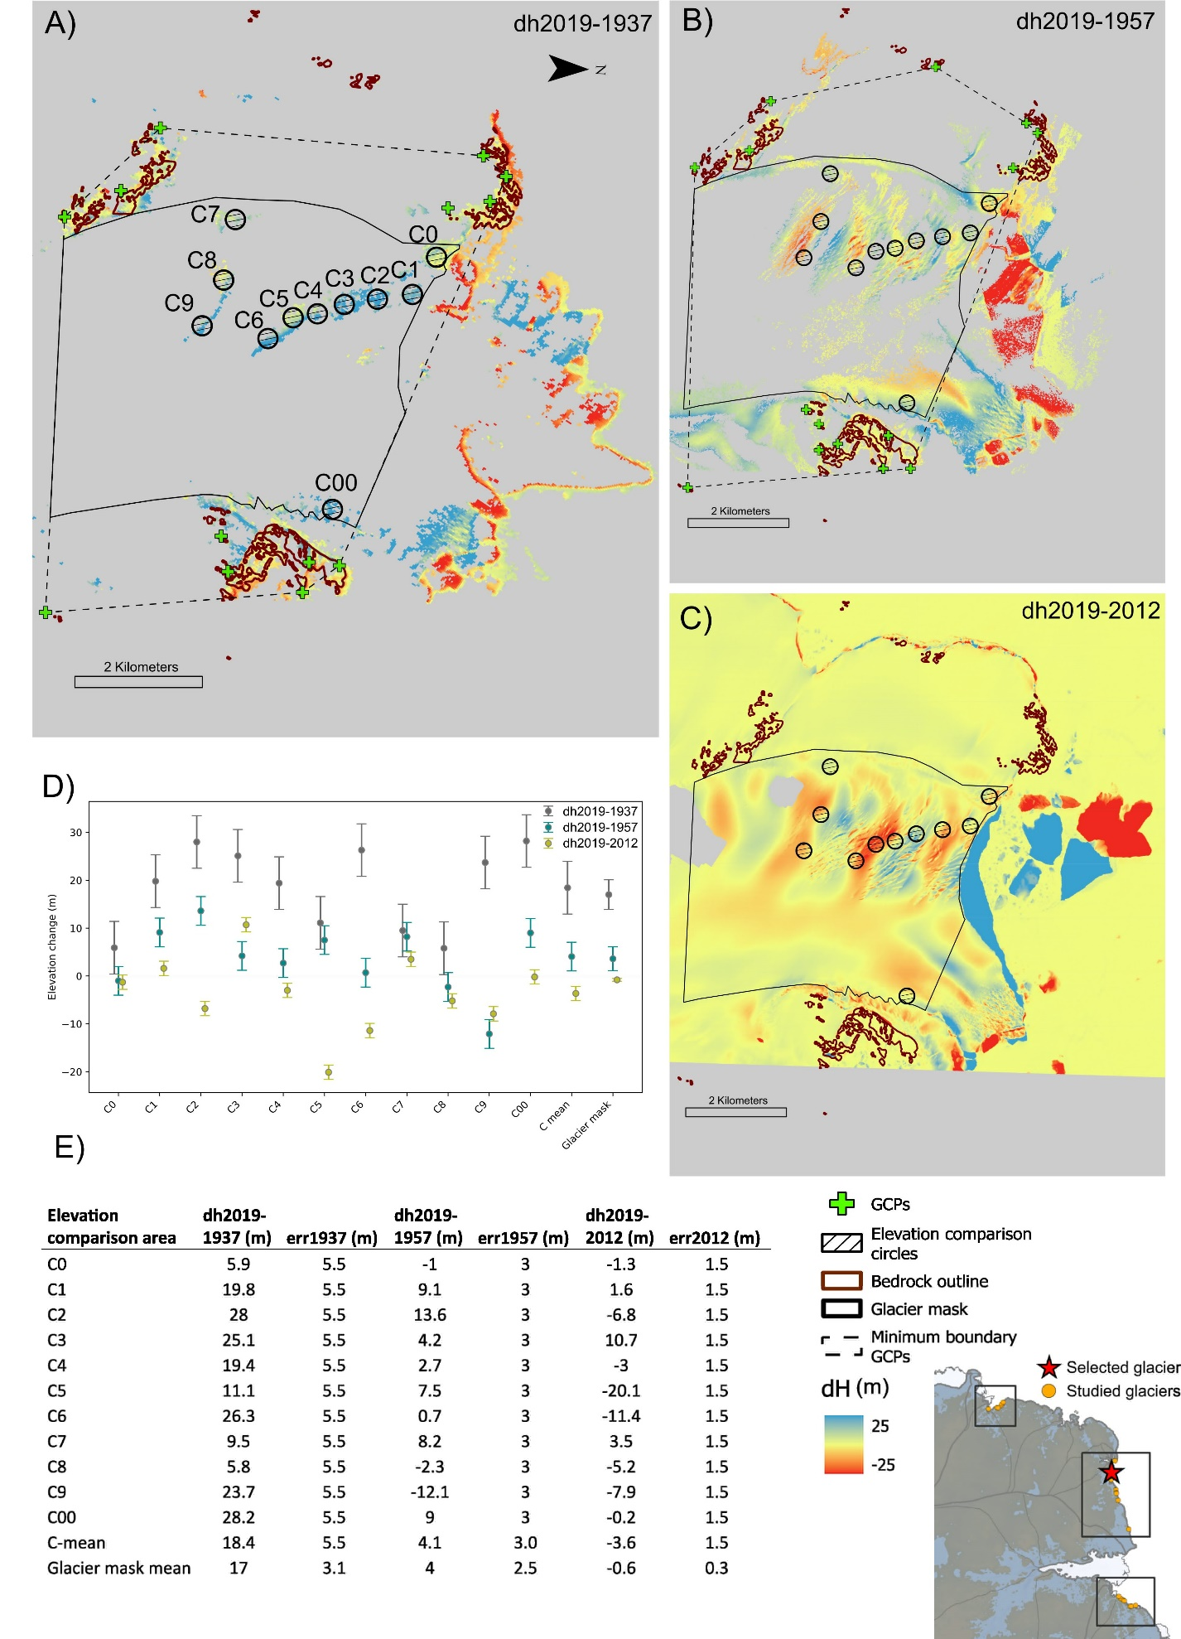
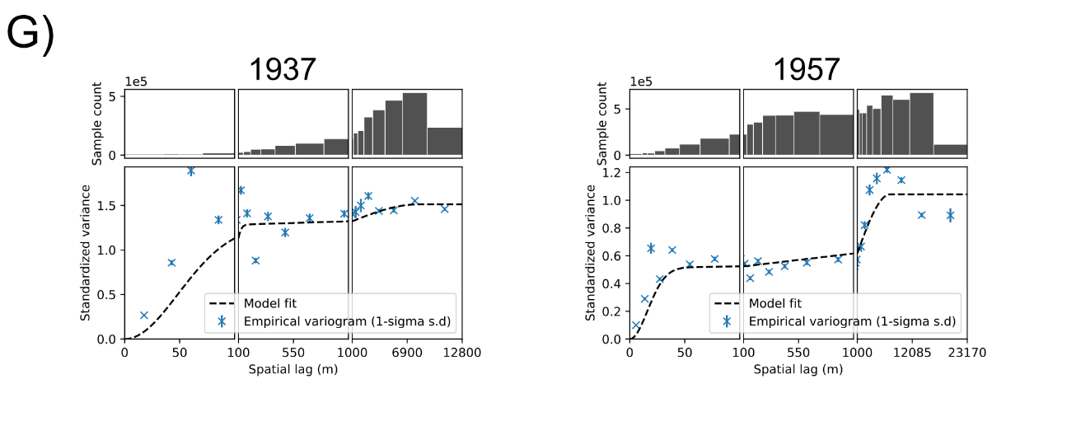
Fig. S13. Elevation changes at Hoseason Glacier A) 2019-1937, B) 2019-1957, C) 2019-2012. Elevation changes of elevation comparison circle and the glacier area shown as D) scatterplot and E) table.
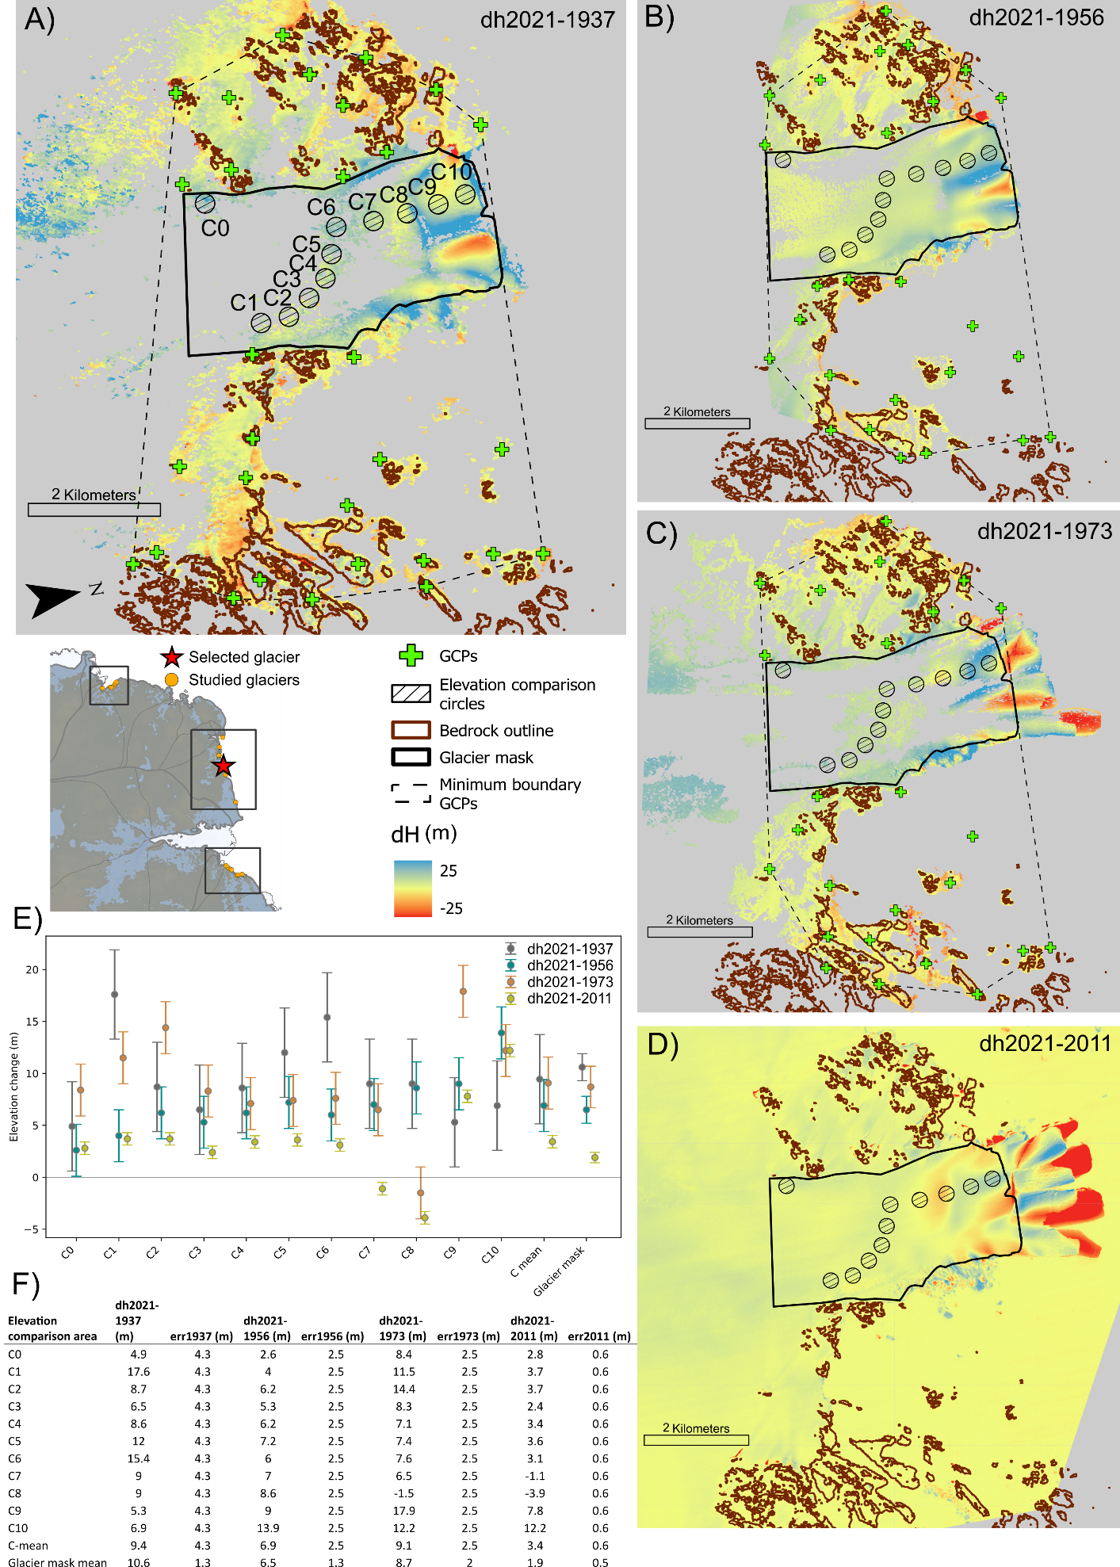
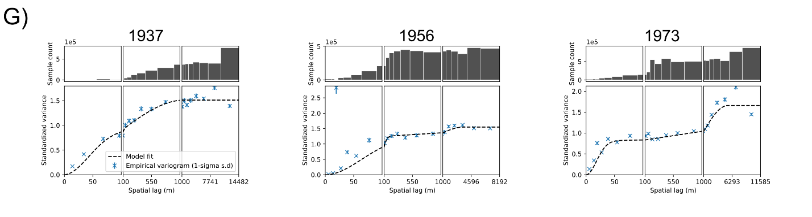
Fig. S14. Elevation changes at Taylor Glacier A) 2021-1937, B) 2021-1956, C) 2021-1973, and D) 2021-2011. Elevation changes of elevation comparison circle and the glacier area shown as E) scatterplot and F) table. G) Spatial variograms for each of the historical DEMs
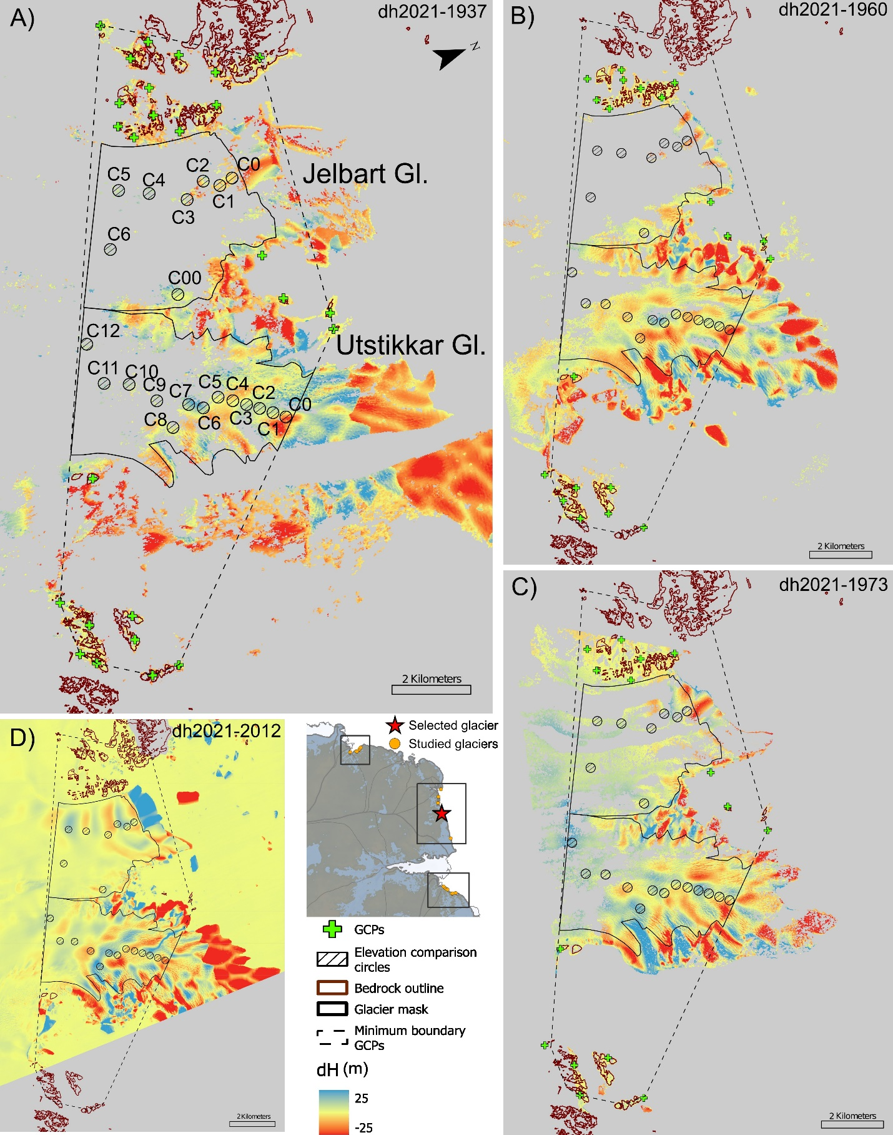
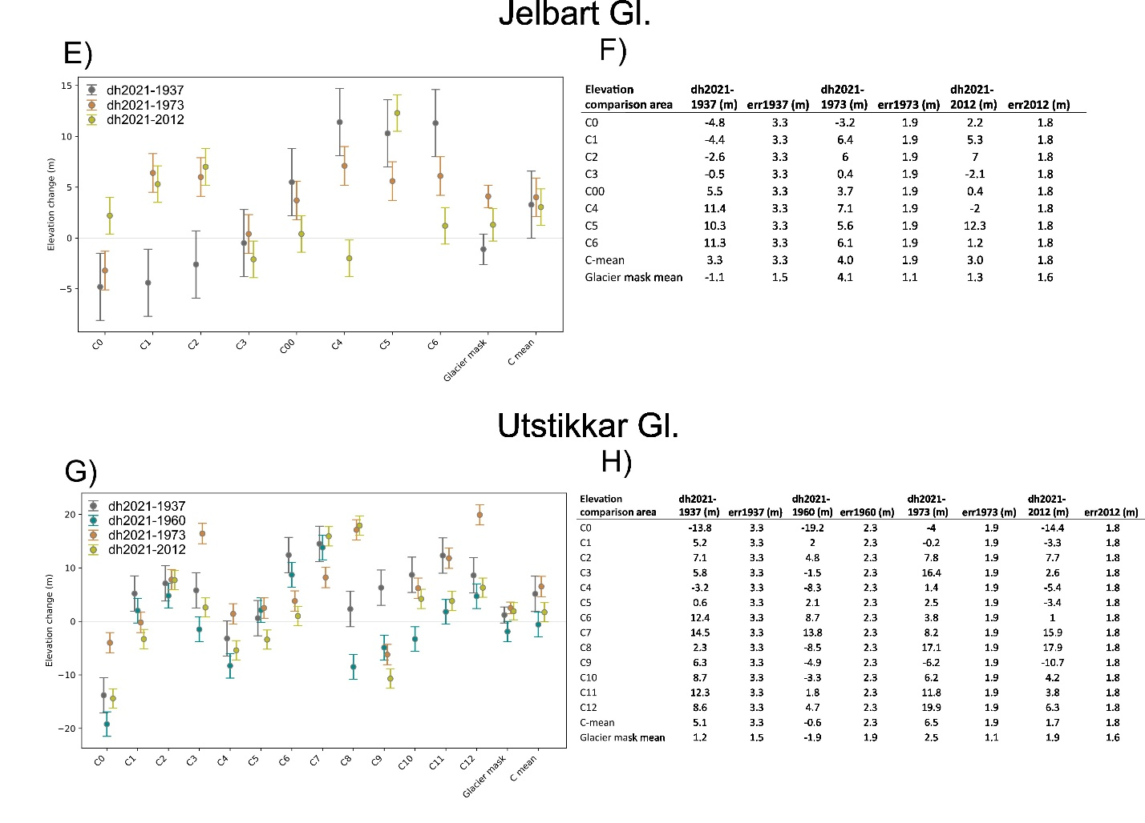
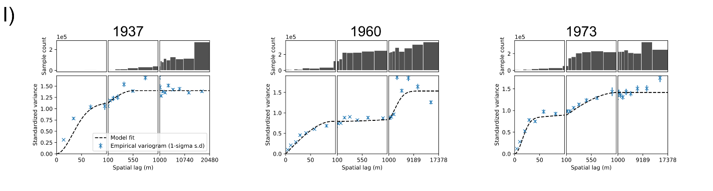
Fig. S15. Elevation changes at Jelbart and Utstikkar Glacier A) 2021-1937, B) 2021-1960, C) 2021-1973, and D) 2021-2012. Elevation changes of elevation comparison circle and the glacier area shown as E) and G) scatterplots and F) and H) tables for Jelbart Gl. and Utstikkar Gl., respectively. I) Spatial variograms for each of the historical DEMs. Note that for Jelbart Gl. we do not include data from the 1960 DEM, due to poor coverage.
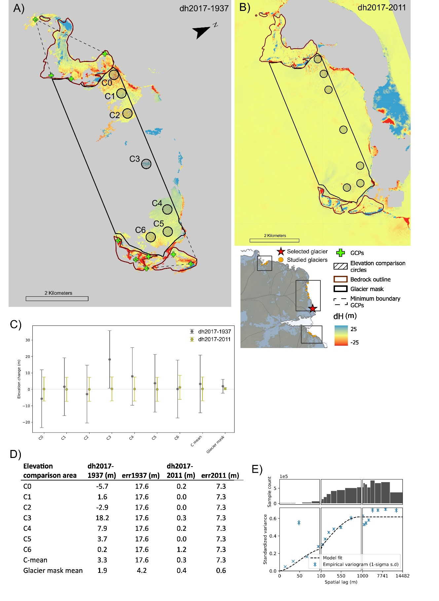
Fig. S16. Elevation changes at Brunvoll Glacier A) 2017-1937, B) 2017-2011. Elevation changes of elevation comparison circle and the glacier area shown as C) scatterplot and D) table. E) Spatial variogram of the historical DEM.
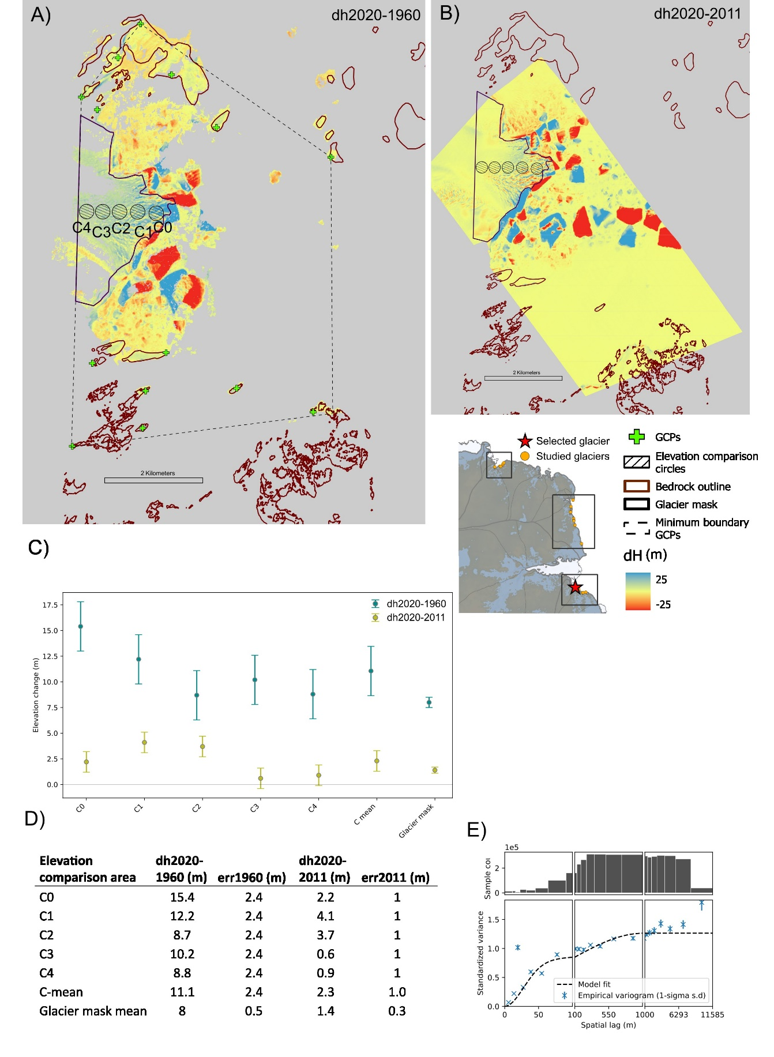
Fig. S17. Elevation changes at Shennong Glacier A) 2020-1960, B) 2020-2011. Elevation changes of elevation comparison circle and the glacier area shown as C) scatterplot and D) table. E) Spatial variogram of the historical DEM.
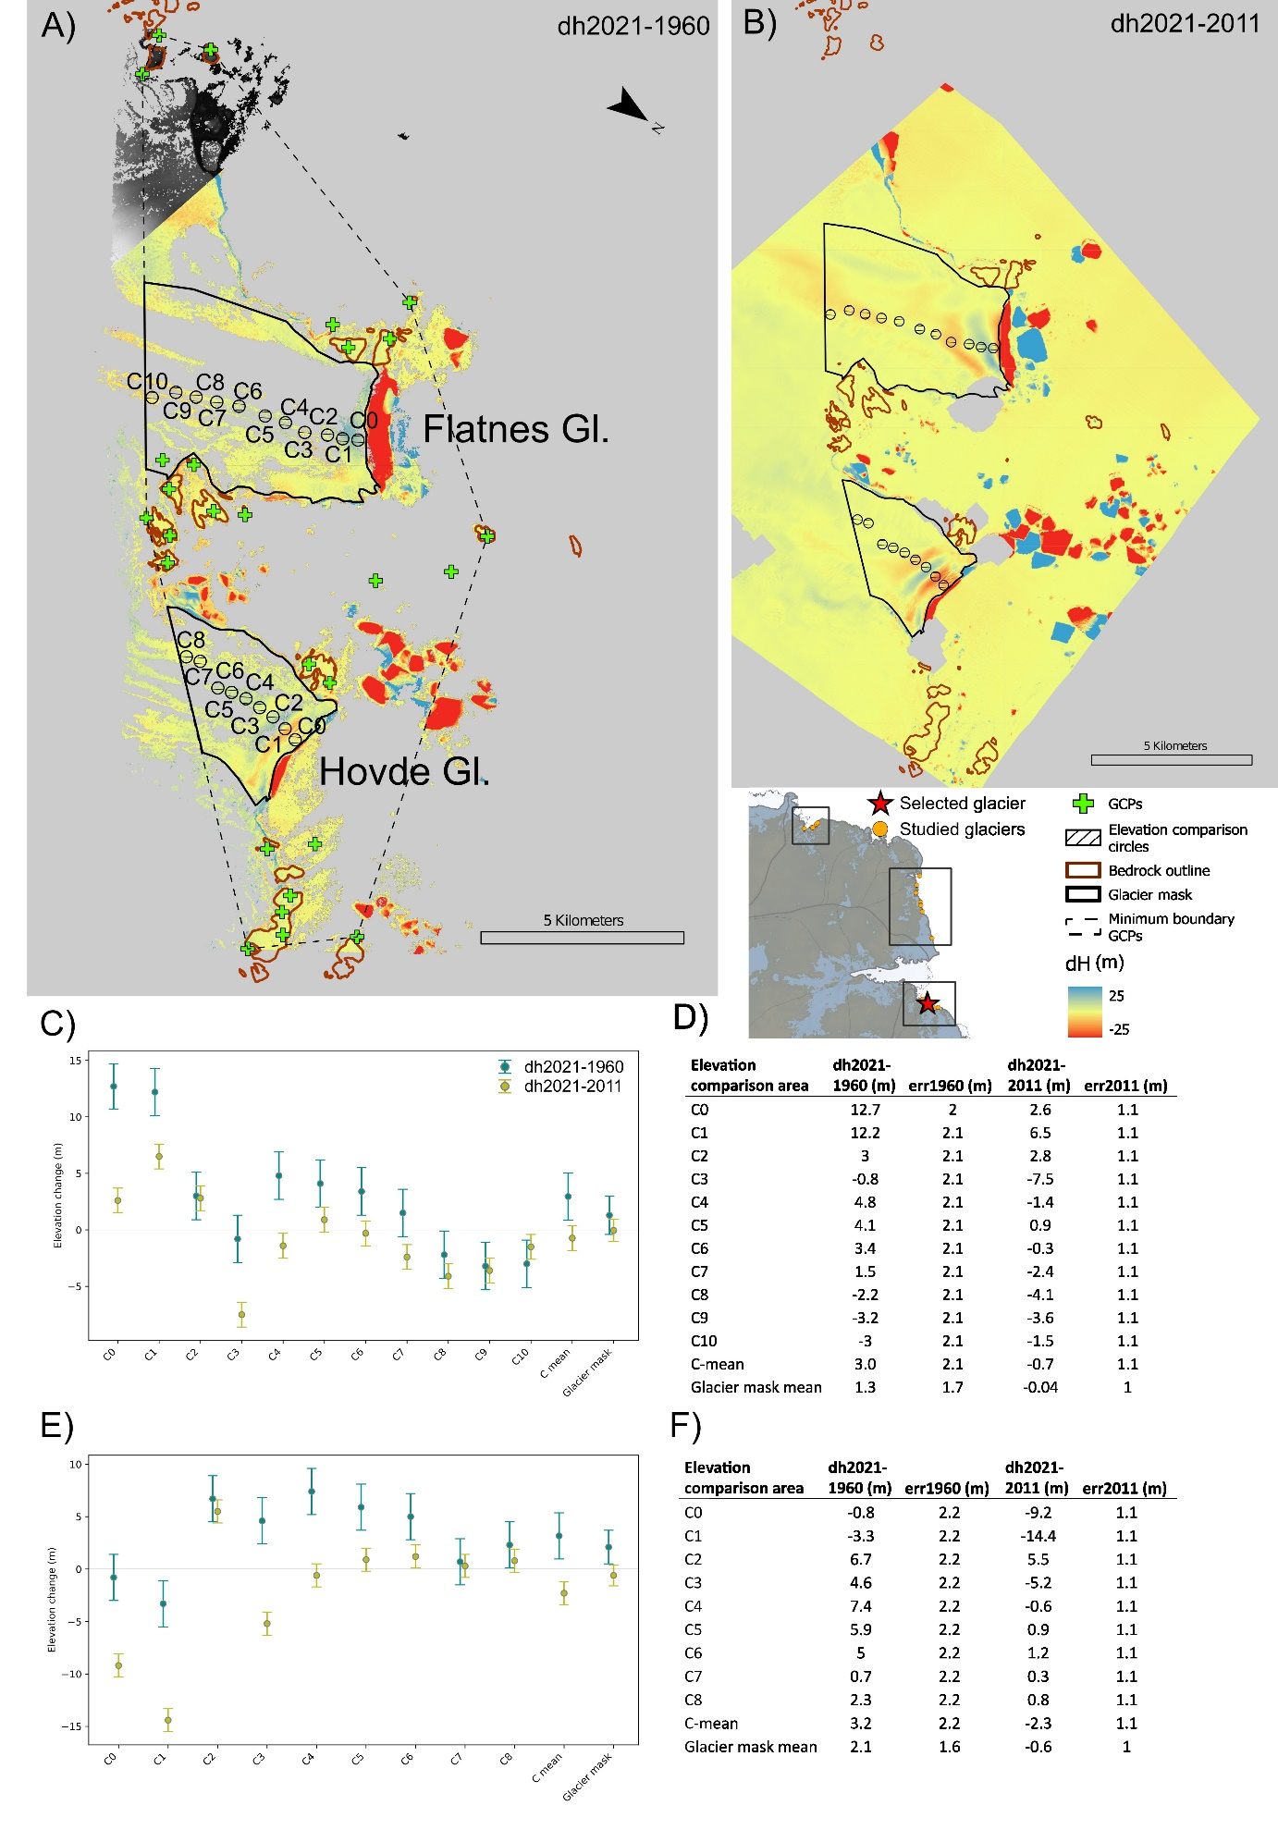
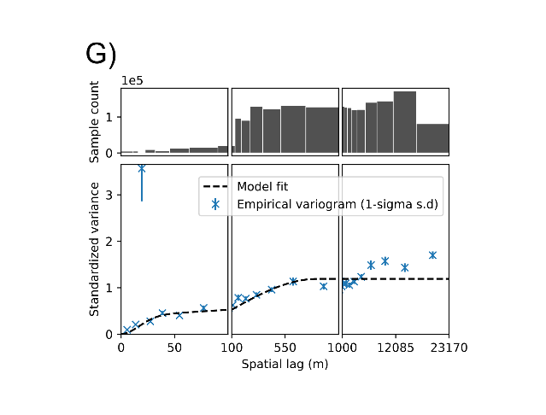
Fig. S18. Elevation changes at Flatnes and Hovde Glacier A) 2021-1960, B) 2021-2011. Elevation changes of elevation comparison circle and the glacier area shown as C) and E) scatterplots and D) and F) tables for Flatnes Gl. and Hovde Gl., respectively. G) Spatial variogram of the historical DEM. Due to incomplete coverage of the 2021 reference DEM, the top left corner of A) shows the 1960 DEM in a black-to-white colorscale, which is included to show the full extent of the 1960 DEM.
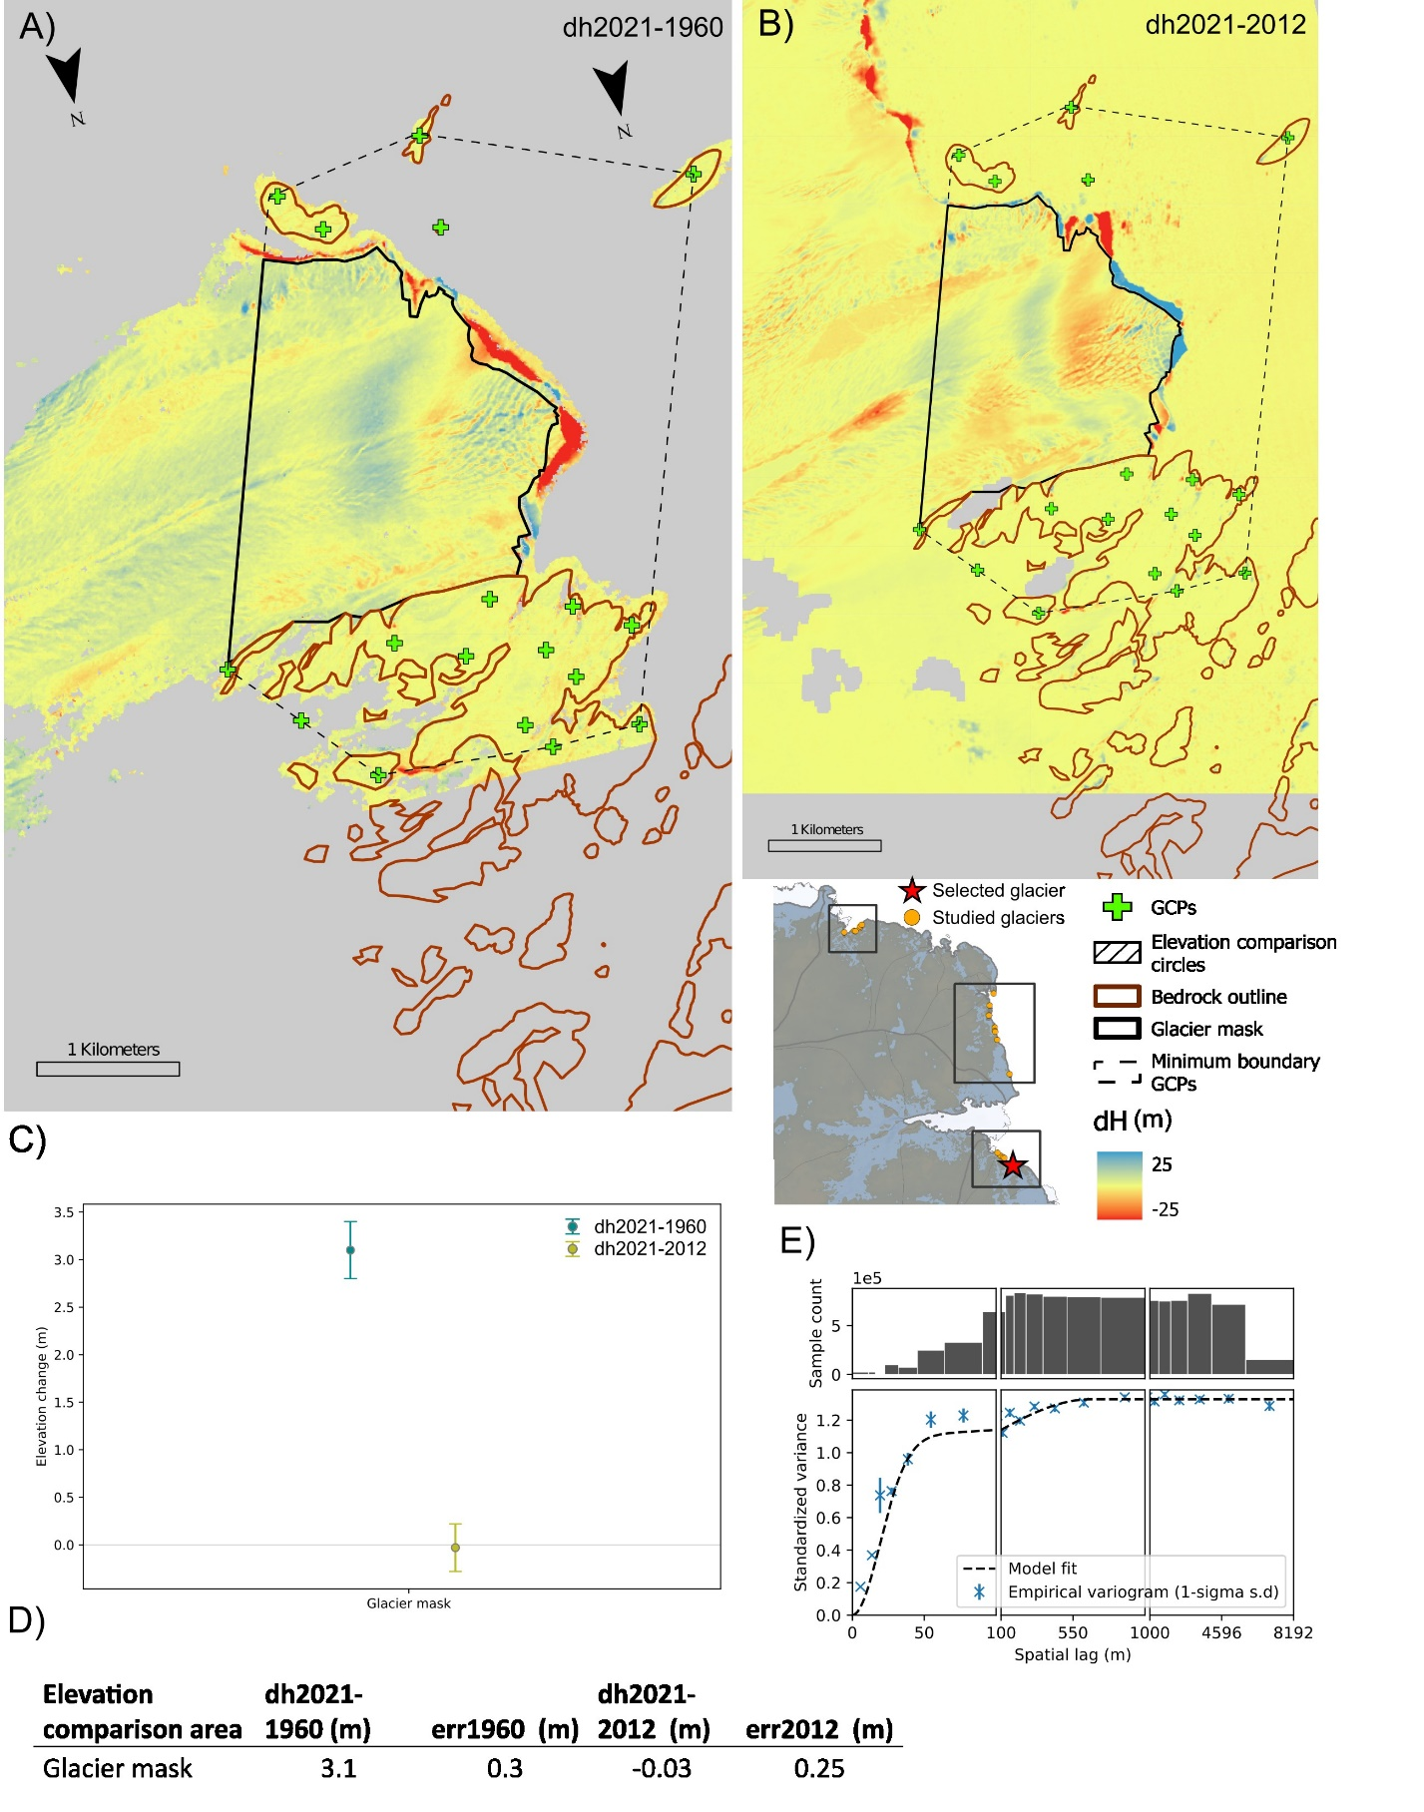
Fig. S19. Elevation changes at Brown Glacier A) 2021-1960, B) 2021-2012. Elevation changes of the glacier area shown as C) scatterplot and D) table. E) Spatial variogram of the historical DEM

Table S2. Mean GCP error of the produced models
Model (glacier) | Year | Mean GCP error (m)
Langhovde, Hovdebreen, Honnörbrygga | 1937 | 15.3
Hoseason | 1937 | 16.2
Hoseason | 1957 | 13.1
Taylor | 1937 | 6.6
Taylor | 1956 | 7.4
Taylor | 1973 | 8.6
Jelbart and Utstikkar | 1937 | 12.6
Jelbart and Utstikkar | 1960 | 9.1
Jelbart and Utstikkar | 1973 | 4.7
Brunvoll | 1937 | 5.7
Shennong | 1960 | 7.8
Flatnes and Hovde | 1960 | 11.3
Brown | 1960 | 14.7
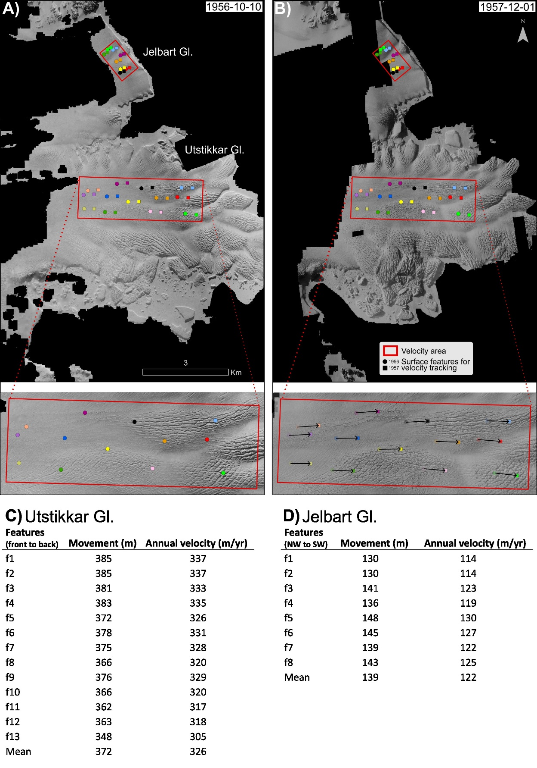
Fig. S20. A,B) Orthophoto mosaics of Jelbart and Utstikkar Gl. used for historical velocity estimations from images captured on 1956-10-10 and 1957-12-01. The velocity area (red box) is used for extracting ITS_LIVE annual velocity estimates and errors. Close up shows the 13 surface features used for historical velocity estimates of Utstikkar Gl. C) and D) Overview of all surface features used for calculating the historical velocities of Utstikkar and Jelbart Gl., respectively.
Fig. S21. A) Map showing the regions used for extraction of ERA5 snowfall and temperature data and RACMO SMB, as well as the location of Syowa, Mawson and Davis climate station. Panel B), C), D), show RACMO annual SMB (kg/m²) plotted as 5 year moving average on top of annual average for B) Lützow-Holm Bay, C) Kemp and Mac Robertson Land, D) Ingrid Christensen Coast.
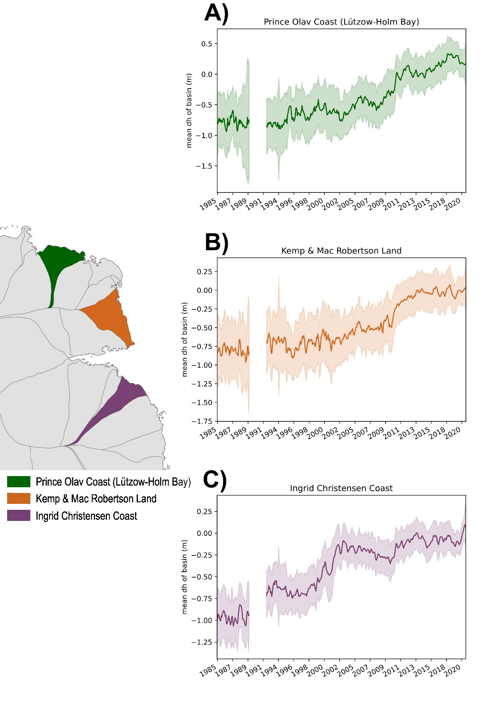
Fig. S22. Basin-wide mean dH from 1985 to 2020, with reference to 2013-12-16 of A) Prince Olav Coast (Lützow-Holm Bay), B) Kemp and Mac Robertson Land, C) Ingrid Christensen Coast. Data were obtained from satellite altimetry⁶².

