2023.6.14
original uncropped scans of membranes used for Western blot analysis
Figure 1
Sham
24h
0min
6h
12h
48h
5d
7d
NLRP3
GSDMD

pro-caspase-1
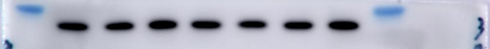
cleaved caspase-1
GAPDH

II
0min
7d
5d
48h
12h
6h
24h
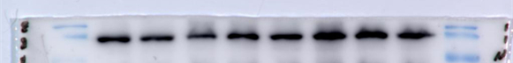
NLRP3
Sham
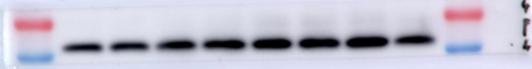
GSDMD

pro-caspase-1

cleaved caspase-1
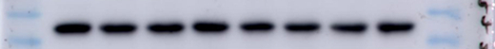
GAPDH

CIP
7d
5d
48h
24h
12h
0min
Sham
6h
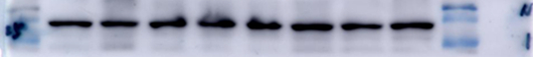
NLRP3
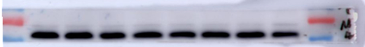
GSDMD

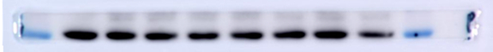
pro-caspase-1
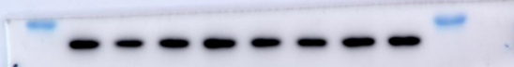
cleaved caspase-1

GAPDH
四组
CIP
Sham
II
CIP+II
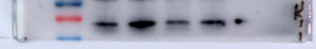
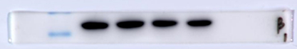
Klotho
GAPDH

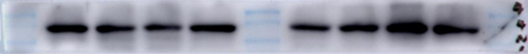
NLRP3
Sham
CIP
II
CIP+II
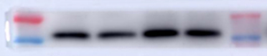
GSDMD

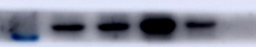
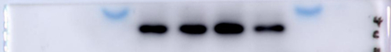
pro-caspase-1
cleaved caspase-1

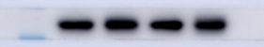
GAPDH

Figure 2
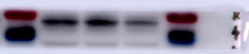
Klotho
sh-KL+CIP+II
sh-NC+CIP+II
CIP+II

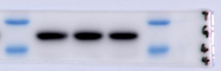
GAPDH

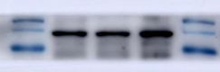
NLRP3
sh-KL+CIP+II
sh-NC+CIP+II
CIP+II

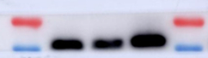
GSDMD

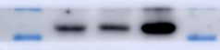
pro-caspase-1

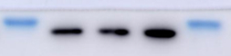
cleaved caspase-1
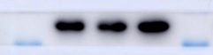
GAPDH

Figure 3
sh-KL+CIP+II
CIP+II
sh-NC+CIP+II
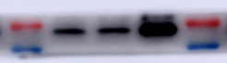
Klotho
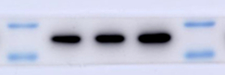
GAPDH

CIP+II
sh-KL+CIP+II
sh-NC+CIP+II
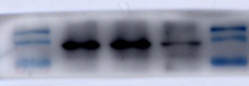
NLRP3
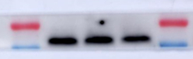
GSDMD

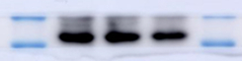
pro-caspase-1

cleaved caspase-1

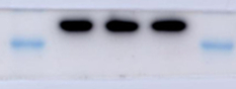
GAPDH

Figure 4
sham
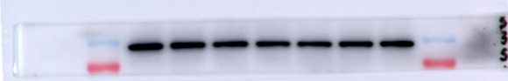
STAT4
0min
6h
24h
12h
5d
7d
48h

GAPDH
CIP
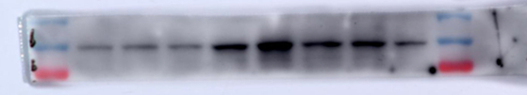
STAT4
7d
5d
48h
24h
12h
Sham
0min
6h

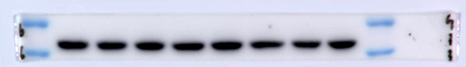
GAPDH

Figure 5
Con
PCDNA3.1-STAT4
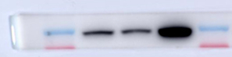
STAT4
NC

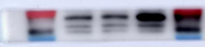
Klotho
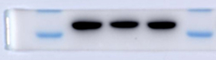
GAPDH

Con
NC
STAT4 siRNA
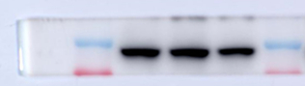
STAT4
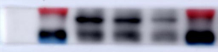
Klotho
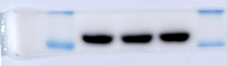
GAPDH

Figure 6
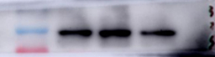
STAT4
sh-STAT4+CIP
sh-NC+CIP
CIP

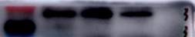
Klotho
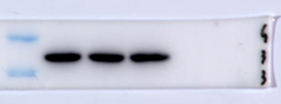
GAPDH

Figure 7

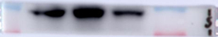
Klotho
sh-STAT4+CIP+II
sh-NC+CIP+II
CIP+II
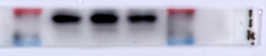
STAT4

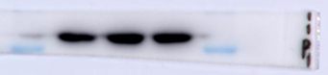
GAPDH

CIP+II
sh-NC+CIP+II
sh-STAT4+CIP+II
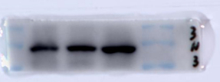
NLRP3

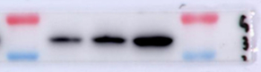
GSDMD

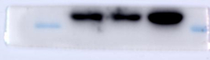
pro-caspase-1
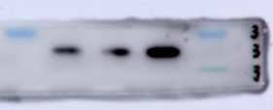
cleaved caspase-1

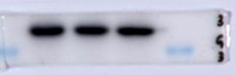
GAPDH

