Supplementary Information

Esophageal cancer derived exosomes imbalance circulating Tfh/Tfr via EXO-PDL1 to promote immunosuppression
Zijie Li¹, Yuehua Zhang², He Hao³, Lu Chen², Tingting Lv¹, Xiaokuan Zhang¹, Yuying Qi¹, Zhiyu Wang^{1, 2*}
¹Hebei Medical University, Shijiazhuang 050011, Hebei, China
²Department of Immuno-Oncology, The Fourth Hospital of Hebei Medical University, Shijiazhuang 050010, Hebei, China
³Department of Internal Medicine, Affiliated Cancer Hospital of Zhengzhou University, Henan Cancer Hospital, Zhengzhou, Henan, 450008, China
*Correspondence to: drwangzhiyu@hebmu.edu.cn (Zhiyu Wang)
Table S1 Demographic and Clinical Characteristics of Study Subjects
 | EC (n=45) | HD (n=33)
Age (year) | 52.3±16.6 | 47.3±8.9
Females, n (%) | 13 (28.9) | 15 (45.5)
Tumor location
Ut | 1(0.02)
Mt | 23(51.1)
Lt | 15(33.3)
Ae | 6(13.3)
Differentiation
Well | 11(24.4)
Moderate | 13(28.9)
Poor | 21(46.7)
Tumor depth
T1 | 3(6.7)
T2 | 11(24.4)
T3 | 21(46.7)
T4 | 10(22.2)
Nodal metastasis
N0 | 19(42.2)
N1 | 18(40.0)
N2 | 8(17.8)
Metastasis
M0 | 43(95.6)
M1 | 2(4.4)
Pathological stage
Stage I | 5(11.1)
Stage II | 15(33.3)
Stage III | 17(37.8)
Stage IV | 8(17.8)
Total | 45 | 33
Data are mean ± SD or percentage of patients.

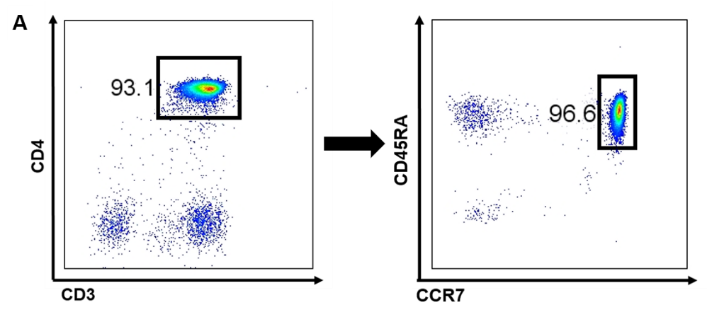
Figure S1. A, Naïve CD4⁺ T cells were isolated and the purity was >90%.
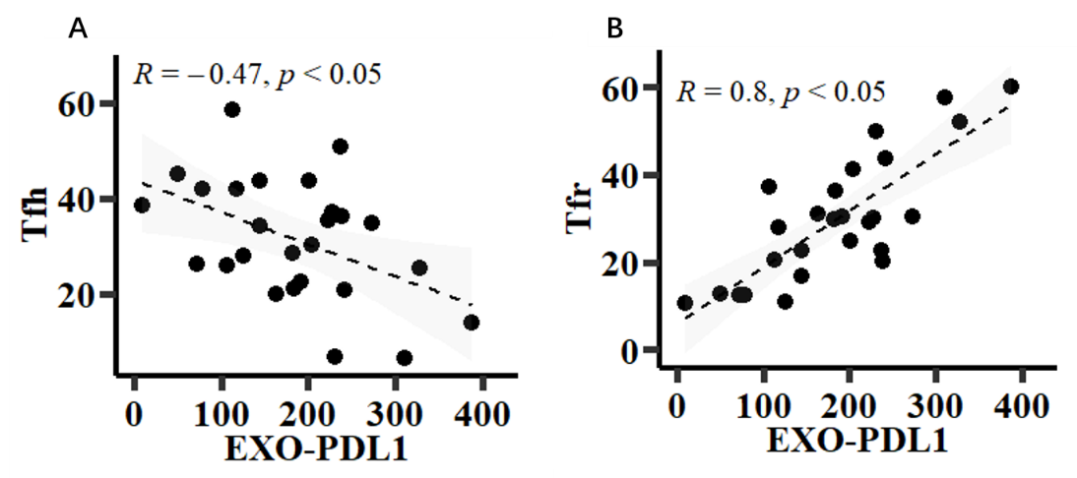
Figure S2. A-B, The correlation between circulating Tfh, Tfr and EXO-PDL1.

Table S2 Cytokines and Antibodies used in the Study.
Antibodies for Stimulations
TCR anti-CD3 | HIT3a | 2μg/ml | eBioscience
anti-CD28 | CD28.2 | 0.5μg/ml | eBioscience
Anti-PDL1 | 29E.2A3 | 1.5mg/ml | Bioxcell
Anti-IgG2b | MPC-11 | 1.5mg/ml | Bioxcell

Table S3 Antibodies and kits for Flow Cytometry used in the Study.
Antigen | Clone or Catalog | Company | Antigen | Clone or Catalog | Company
CD3-PE | 1077632 | BD biosciences | ICOS-AF647 | DX29 | BD biosciences
CD4-PE-Cy7 | EH12.1 | BD biosciences | CTLA4-PE | L3D10 | BioLegend
CD4-FITC | SK3 | BD biosciences | IL-10-APC | JES3-19F1 | BD biosciences
CD45RA-APC | 0357872 | BD biosciences | IL-10 isotype-APC | 1250579 | BD biosciences
CXCR5-APC-R700 | RF8B2 | BD biosciences | IFN-γ-PE-Cy7 | 4S.B3 | BD biosciences
FOXP3-BB700 | 236A/E7 | BD biosciences | IFN-γ isotype -PE-Cy7 | 1235790 | BD biosciences
PD-1-BB515 | EH12.1 | BD biosciences | IL-21-PE | 3A3-N2.1 | BD biosciences
Fixation/Permeabilization Solution Kit | 554715 | BD biosciences | / | / | /

