Supplementary Information for

Induced polarization imparts piezoelectricity in non-crystalline polymer films

Xiaodong Yan^{1,2†}, Xuemu Li^{1,2†}, Zhihe Long^{1,2}, Zehua Peng^{1,2}, Jing Fu³, Zhuomin Zhang^{1,2}, Shiyuan Liu^{1,2}, Ying Hong^{1,2}, Qi Li³, Shujun Zhang⁴, Zhengbao Yang^{1,2*}, Dragan Damjanovic⁵

¹Department of Mechanical and Aerospace Engineering, Hong Kong University of Science and Technology, Clear Water Bay, Hong Kong, China
²Department of Mechanical Engineering, City University of Hong Kong, Hong Kong, China
³State Key Laboratory of Power System, Department of Electrical Engineering, Tsinghua University, Beijing 100084, China
⁴Institute for Superconducting and Electronic Materials, Australian Institute for Innovative Materials, University of Wollongong, North Wollongong, New South Wales 2500, Australia
⁵Institute of Materials, Swiss Federal Institute of Technology-EPFL, Lausanne 1015, Switzerland
† These authors contributed equally to this work

Corresponding author: zbyang@ust.hk

The PDF file includes:

Materials and Methods
Supplementary Text
Figs. S1 to S11
References

Materials and Methods
Preparation of Inks
Inks of P(VDF-TrFE) copolymer are prepared by dissolving 1 g P(VDF-TrFE) powder (VDF/TrFE = 70/30 mol%, Piezo Technologies, France) in 10 mL N, N-dimethylformamide (DMF, Sigma-Aldrich), and stirring at 70 °C for 12 hours to form homogeneous solutions.
Inks of PVA are prepared by dissolving 5 g PVA particles (with average molecular weight 57,000‒66,000 g mol⁻¹ and 98‒99% hydrolyzed, Alfa Aesar) in 100 mL distilled water at 70 °C for 3 hours. Once the PVA is completely dissolved, it is stirred overnight at room temperature to form homogeneous solutions.
Inks of PZT are prepared by the following steps. Firstly, the Pb_{1.2}(Zr_{0.52}Ti_{0.48})O₃ sol was prepared. The lead(II) acetate trihydrate (Pb(CH₃COO)₂)·3H₂O (99%, TCI) is first dissolved in acetic acid (99%, TCI) at 120 °C and mixed by magnetic stirring. When it is completely dissolved, the solution is cooled down to room temperature. The zirconium(IV) n-propoxide (C₁₂H₂₈O₄Zr, 70 wt. % in 1-propanol, TCI) is mixed with the titanium(IV) butoxide (C₁₆H₃₆O₄Ti, 99%, TCI) in another container. Then, zirconium(IV) n-propoxide and titanium(IV) butoxide are added to lead(II) acetate solution, and diluted by ethylene glycol (99.5%, Dieckmann) to 0.2 mol L⁻¹ with stirring for 6 hours in the atmosphere. Finally, inks of PZT slurry are prepared by adding the proper amount of commercial PZT powders (typically 30‒50 wt.%, particle size of < 500 nm) in the PZT sol and homogenizing the mixture by ball milling.

Deposition of thin films
The films are prepared by electrohydrodynamic deposition (Fig. S1). Inks are loaded into a 5 mL syringe and supplied to a metal nozzle (the inner and outer diameters of 0.6/0.91 mm) by a syringe pump (Lead fluid apparatus, Pump TYD01) with the flow rate of 10‒20 μL min⁻¹. Si (100) wafer (thickness of 500 μm, n-type) is used as substrate, and cleaned with ethanol prior to deposition. A positive potential is applied to the nozzle using a high voltage supply (DW-P303-1ACH2, Dongwen High Voltage Power Supply Co., Ltd.), while the nozzle-to-substrate distance is kept at 8–10 mm. The substrate is positioned on an electrically grounded plate, mounted atop of an X-Y translation stage. Electrohydrodynamic jetting is formed by increasing the nozzle voltage up to 3000‒7000 V, until the pendant liquid drop elongates, splits into multiple micro/nano jets and falls onto the substrate. During deposition, the substrate is alternately rastered with the major scan in the X and Y directions with a speed of 10‒30 mm s⁻¹. Deposition is carried out under ambient conditions, with a relative humidity of 50–70% and temperature of 22–26 °C. After two layers depositions, the wet P(VDF-TrFE) polymer films are dried at 70 °C for 5 min and annealed at 110 °C for 24 hours. The wet PVA films are dried at 70 °C for 30 min. For deposited PZT precursors, sol-infiltration on every five layers of the as-prepared films by means of spin-coating is performed. Sintering treatment at 800 °C for 30 min is performed for synthesizing perovskite structures.

Structural characterizations
The P(VDF-TrFE) film was immersed in liquid nitrogen, and the cross-section of the sample was obtained after bending and brittle fracture. The cross-sectional morphology of the sample was observed by a scanning electron microscope (Quanta 450, FEI). The heat flow curves of the samples were obtained by a differential scanning calorimeter (DSC3, Mettler Toledo) at a heating rate of 5 °C min⁻¹. The crystal structure of the sample was examined by X-ray diffractometer (D8 Advance, Bruker). For in-situ crystal structure measurement, gold electrodes were prepared by magnetron sputter (Q150T ES Plus, Quorum Technologies), the thickness of the gold electrodes was ~10 nm, and the diameter of the circular electrodes was controlled by a mask to be 10 mm. The voltage was applied to the sample through a high-voltage DC power supply (TCM6000i, Dalian Teslaman Tech. Co., Ltd.), and the X-ray diffraction was performed after the voltage was stabilized.

Dielectric properties measurement
The capacitance and loss of the P(VDF-TrFE) film sample were measured by an inductance-capacitance-resistance (LCR) meter (E4980A, Agilent Technologies, Inc.), and the applied voltage was 1 V. During the measurement, the sample chamber was evacuated, and the temperature was controlled by a program controller, the heating rate was 3 °C min⁻¹. The capacitance of the sample in the frequency range of 10⁻³ Hz to 10⁷ Hz was measured by a broadband impedance spectrometer (Concept 40, Novocontrol Technologies).

Ferroelectric properties measurement
For the ferroelectric properties, in the process of magnetron sputtering, the diameter of the circular electrode is controlled by a mask to be 2 mm, and the polarization-electric field hysteresis loop of the sample is obtained by using a ferroelectric instrument (CPE1801, PolyK Technologies, LLC). The voltages with unipolar or bipolar triangle waveform at a frequency of 100 Hz are applied.

Strain measurement
We measured the displacement of the sample by contactless laser method. The electric field was applied to the film without artificial poling treatment, the type, amplitude, and frequency of the electric field were controlled by a function generator (DG1062, RIGOL Technologies Co., Ltd.), a power amplifier (E01.A2, Harbin Core Tomorrow Science and Technology Co., Ltd.), and a high-voltage DC power supply (TCM6000i, Dalian Teslaman Tech. Co., Ltd.). The displacement of the sample was captured by a laser vibrometer (NLV-2500, Polytec GmbH.) with the sensor sensitivity of 50 nm V⁻¹ and the resolution of 15 pm. Then, the displacement signal and the input voltage signal are simultaneously monitored by the digital storage oscilloscope (RTE 1024, Rohde & Schwarz USA, Inc.).

Supplementary Text
Section 1. Dielectric polarization mechanism
Four types of polarization can be induced in dielectrics¹: an electronic polarization due to the displacement of electrons with respect to the positive nuclei within the atom; an ionic polarization due to the displacement of charged atoms with respect to each other in the molecule and in certain ionic crystals; dipole polarizations due to the effect of the applied field on the orientations of molecules with permanent dipole moments; and finally interfacial polarizations caused by the accumulation of free ions at the interfaces between materials having different conductivities and dielectric constants.
Dielectric polarizations are classified as instantaneous polarizations and absorptive polarizations¹. Instantaneous polarizations may be thought of as polarizations which can form completely in times less than say 10⁻¹⁰ s. Among the above polarization types, electronic polarization and ionic polarization are instantaneous polarization. Dipole polarizations can form in times from 10⁻⁸ to 10⁻² s. However, the interfacial polarization takes longer to establish, >1 s.

Section 2. Calculation of crystallinity
The degree of crystallinity (x_{c}) can be calculated using the following equation²:
(1)
where ΔH_{m} is the enthalpy of melting of the sample, which can be obtained by integrating the melting peak in the DSC curves, near 150 °C for P(VDF-TrFE). ΔH₀ is the enthalpy of melting of materials with 100% crystalline, for pure P(VDF-TrFE), ΔH₀ is 40 J g⁻¹.

Section 3. The sign of the electrostrictive coefficient
When the dielectric material is excited by electric field with a sine wave, the input voltage and the generated electrostrictive strain can be expressed as³
(2)
(3)
where L is the sample thickness. According to the phase relationship of the harmonic function, if M is positive, we know that no matter the input sine is located at the peak (2πft = π/2) or the valley (2πft = 3π/2), the output strain is located at the peak (4πft = nπ, n is odd number). Conversely, if M is negative, the output strains are all located in valley. As shown by the blue dot line in the Fig. S7a of the Supplementary Information, indicating that the sign of the electrostriction coefficient of P(VDF-TrFE) is negative. We also found that the phase difference of the displacement sines of P(VDF-TrFE) and PZT films is π (Fig. S7), further confirming that their signs is opposite.

Section 4. The sign of the piezoelectric strain coefficient
There is no doubt that the direction of induced polarization must be along that of the DC bias field. Under a positive bias field, when the input AC sine is at the peak, the direction of the AC field is consistent with the polarization direction, thus its sign is positive. For P(VDF-TrFE), at this time, the displacement sine is in the valley, thus the sample shrinks relative to the initial thickness, the strain is negative, as shown by the blue diamond symbol in the Fig. S8a. According to the piezoelectric equation, the sign of the piezoelectric coefficient is negative. But, the output displacement sine of the PZT has the same phase as the input AC sine (Fig. S8b), thereby the sign of the piezoelectric coefficient is positive.
In addition, we intercepted the simultaneous data of displacement and AC voltage, and plotted them in Figs. S8c and d. As we can see, for P(VDF-TrFE) films, the slope of the curve is < 0, indicating a negative piezoelectric coefficient.

Section 5. Morphology of amorphous materials
Amorphous materials, lacking the three-dimensional long-range order of a crystalline material, possess a more random arrangement of molecules, exhibit short-range order over a few molecular dimensions. Unlike crystalline materials which exhibit strong Bragg diffraction, the diffraction patterns of amorphous materials are characterized by broad and diffuse peaks⁴.

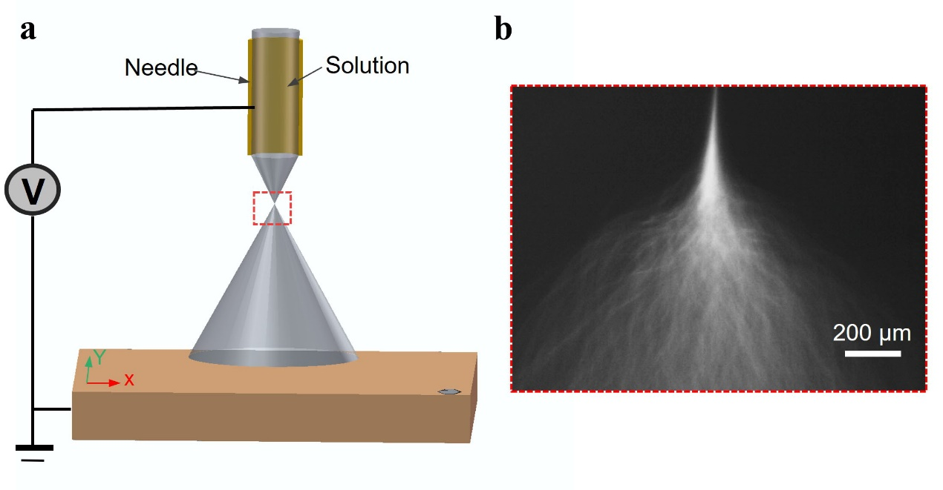
Fig. S1. a, Schematic diagram of the setup for preparing P(VDF-TrFE) thin films by electrohydrodynamic deposition process. b, Ink morphology near the nozzle observed by microscope, pendant liquid drops splits into multiple micro/nano jets.

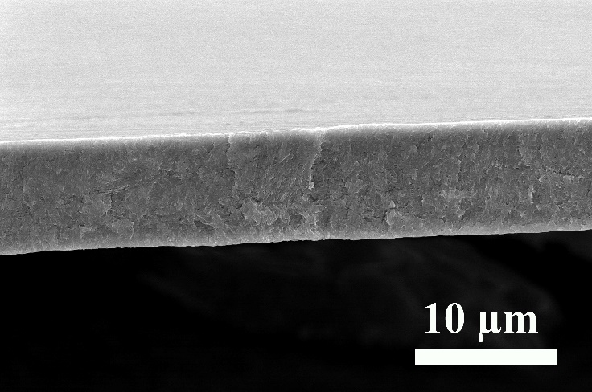
Fig. S2. Cross-sectional morphology of P(VDF-TrFE) film observed by scanning electron microscopy.

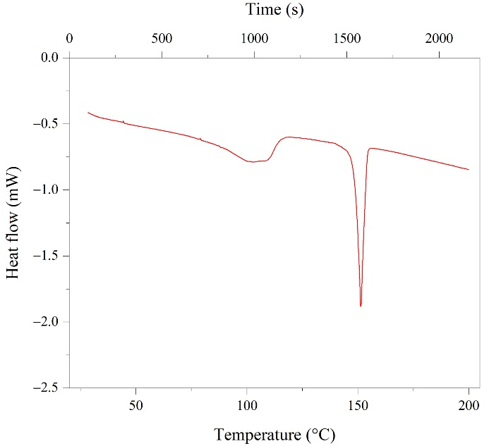
Fig. S3. Heat flow data of P(VDF-TrFE) film measured at heating rate of 5 °C min⁻¹.
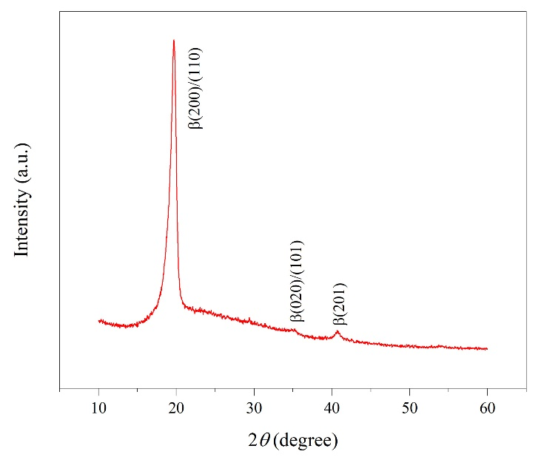
Fig. S4. X-ray diffraction pattern of P(VDF-TrFE) film.

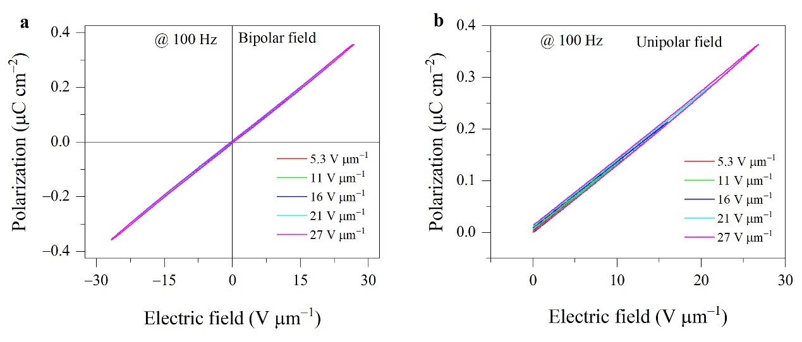
Fig. S5. Polarization-electric field curves of P(VDF-TrFE) film under the bipolar (a) and unipolar (b) electric field, measurement frequency is 100 Hz.

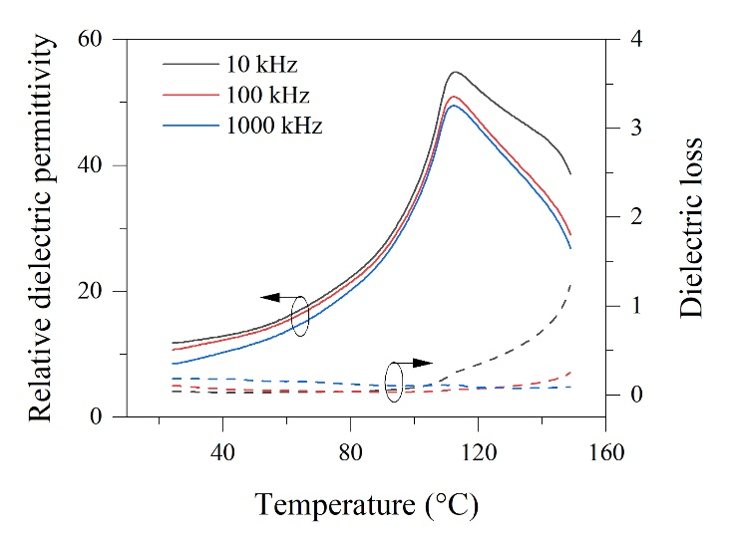
Fig. S6. Temperature-dependent relative dielectric permittivity and loss of P(VDF-TrFE) film at frequencies of 10 kHz, 100 kHz, 1000 kHz.

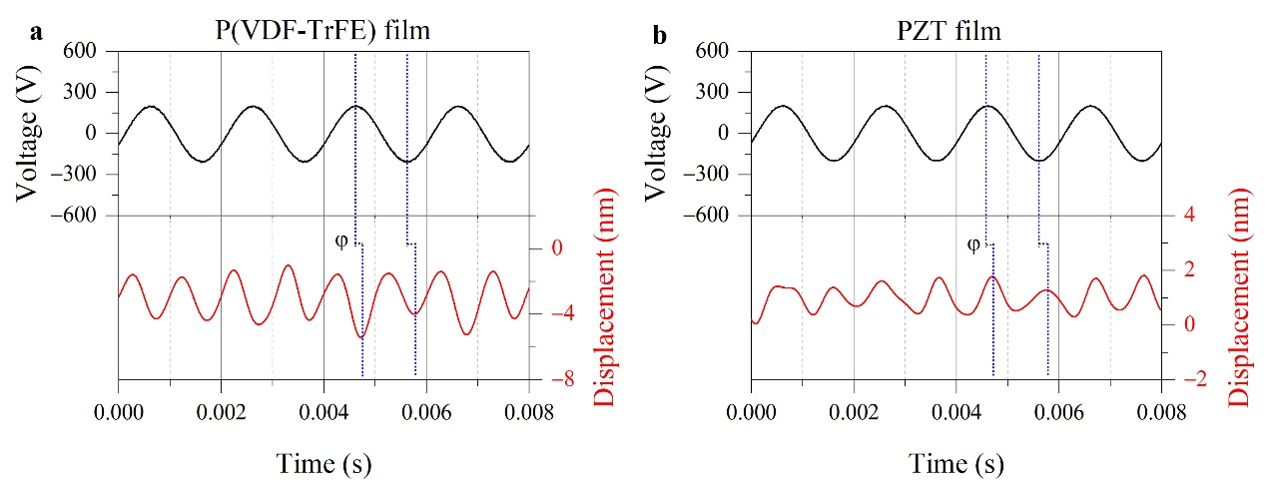
Fig. S7. Time-resolved harmonic displacement response under AC electric field for the P(VDF-TrFE) (a) and PZT (b) films. The blue dotted lines mark the positions of the peak and valley. The φ represents that the displacement sine lags the input electrical sine.

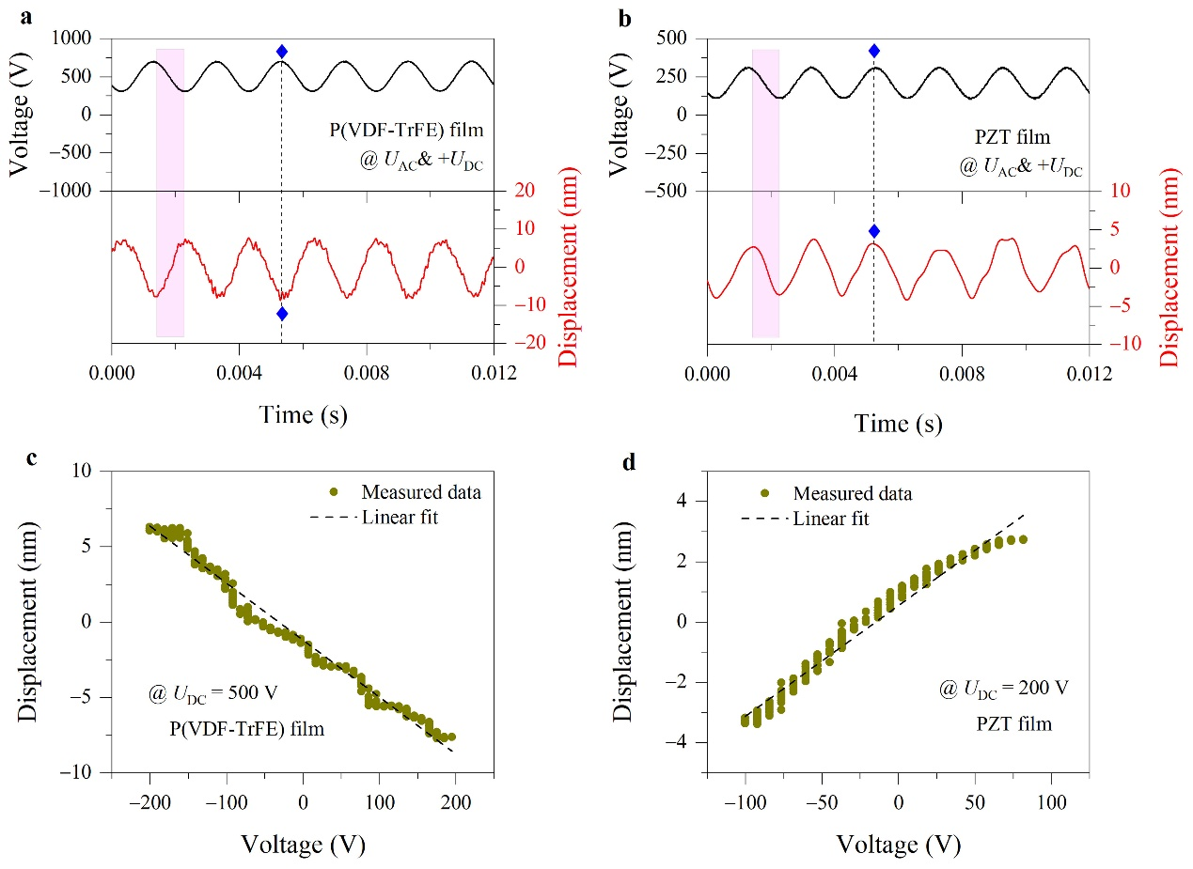
Fig. S8. Time-resolved electromechanical displacements under AC+DC electric field for the P(VDF-TrFE) (a) and PZT (b) films. It is noted that under the DC bias field, there is a constant term in the displacement, but in the experiment, the constant term fluctuates due to the strong low-frequency noise. The offset of the displacement signal has been discarded before the curve is plotted. The blue diamond symbols are used to judge the phase relationship. The displacement vs voltage for the P(VDF-TrFE) (c) and PZT (d) films. The data comes from the shaded area in Figs. S8a and b, respectively.

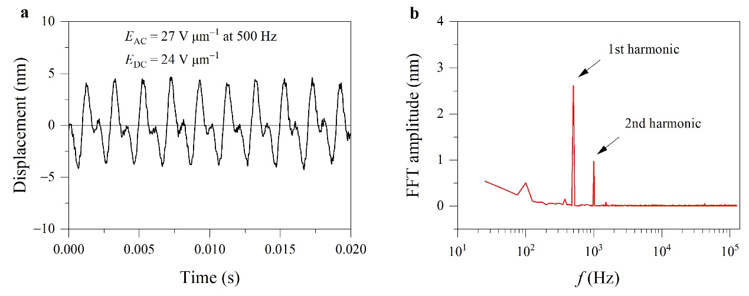
Fig. S9. a, Time-resolved electromechanical displacements consist of first and second harmonic waveform, measured at 500 Hz and excited by E_{AC} = 27 V µm⁻¹ under E_{DC} = 24 V µm⁻¹. The offset of the displacement signal has been discarded before the curve is plotted. b, The corresponding fast Fourier transform amplitude spectra of the generated electromechanical displacements as a function of frequency.

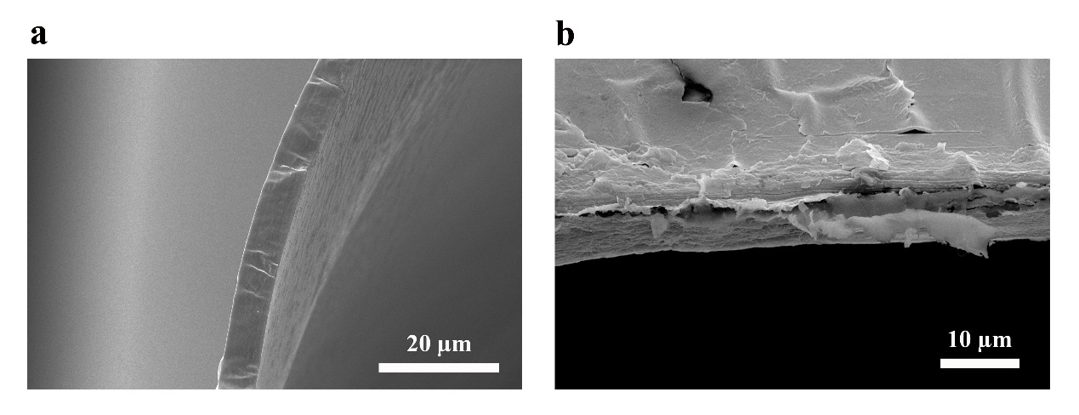
Fig. S10. Cross-sectional morphology of polyvinyl alcohol (a) and small intestinal submucosa (b) films observed by scanning electron microscopy.

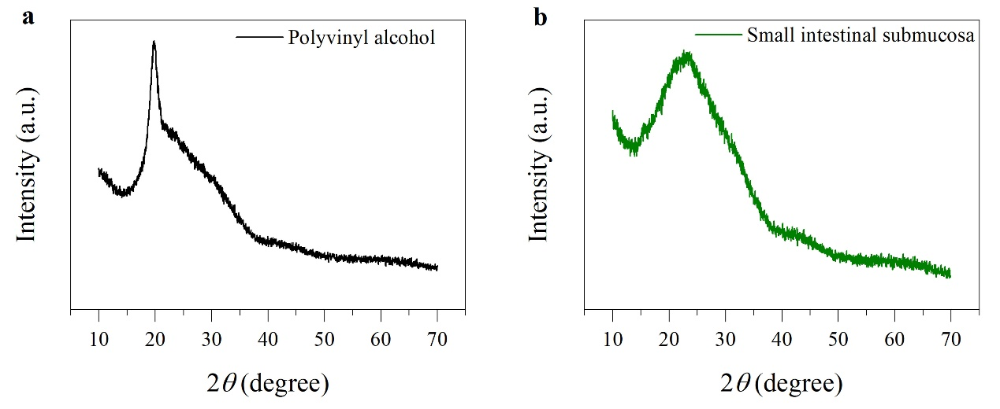
Fig. S11. X-ray diffraction pattern of polyvinyl alcohol (a) and small intestinal submucosa (b) films.

References
1 Murphy, E. J. & Morgan, S. O. The dielectric properties of insulating materials. The Bell System Technical Journal 16, 493-512 (1937). https://doi.org/10.1002/j.1538-7305.1937.tb00765.x
2 Kuang, X., Gao, Q. & Zhu, H. Effect of calcination temperature of TiO₂ on the crystallinity and the permittivity of PVDF-TrFE/TiO₂ composites. J. Appl. Polym. Sci. 129, 296-300 (2013). https://doi.org/10.1002/app.38729
3 Park, D.-S. et al. Induced giant piezoelectricity in centrosymmetric oxides. Science 375, 653-657 (2022). https://doi.org/10.1126/science.abm7497
4 Billinge, S. J. L. The rise of the X-ray atomic pair distribution function method: a series of fortunate events. Philos. Trans. R. Soc. A-Math. Phys. Eng. Sci. 377, 20180413 (2019). https://doi.org/10.1098/rsta.2018.0413

