Supplementary Information

Submerged Photosynthesis of TiO₂-CuO Hetero-nanoparticles for the Solar Photo-electrolysis of Multiple Environmental Hazardous Substances
Zhehan Yu¹, Shilei Zhu², Lihua Zhang^{*, 1}, Seiichi Watanabe^{*, 1}
1 Center for Advanced Research of Energy and Materials, Faculty of Engineering, Hokkaido University, Sapporo 060-8628, Japan
2 College of Physics, Taiyuan University of Technology, Taiyuan 030024, China
Corresponding author: Lihua Zhang, zhanglihua@eng.hokudai.ac.jp
Seiichi Watanabe, sw004@eng.hokudai.ac.jp

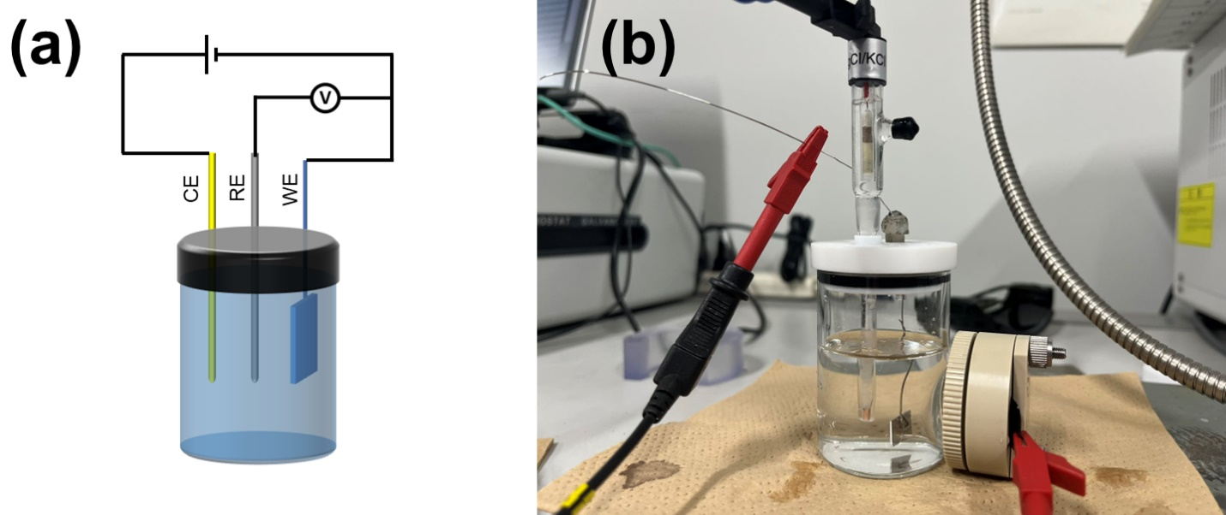
Fig. S1 (a) schematic diagram of three electrode system, (b) three-electrode system used in our experiment

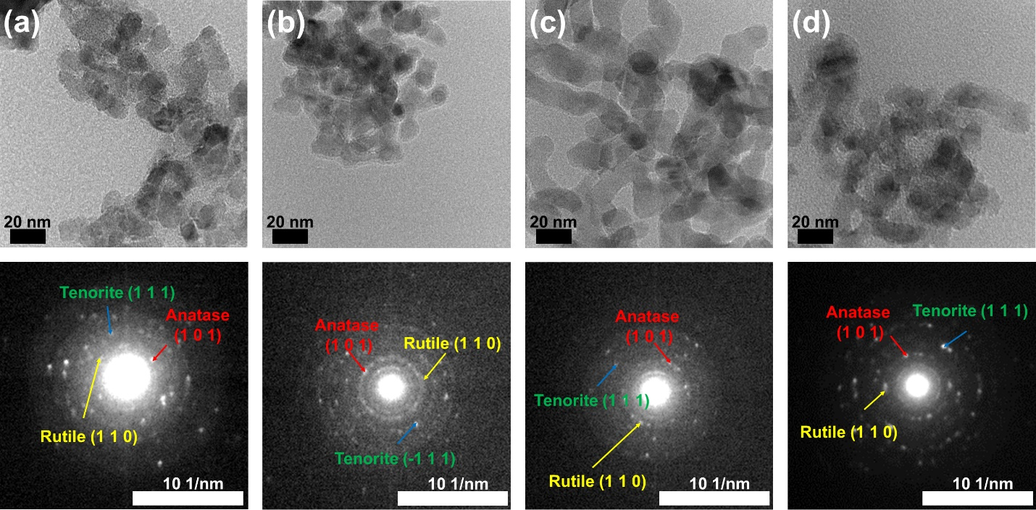
Fig. S2 TEM (top) and SAED (bottom) of (a) TCO 100, (b) TCO 500, (c) TCO 800, and (d) TCO 1000

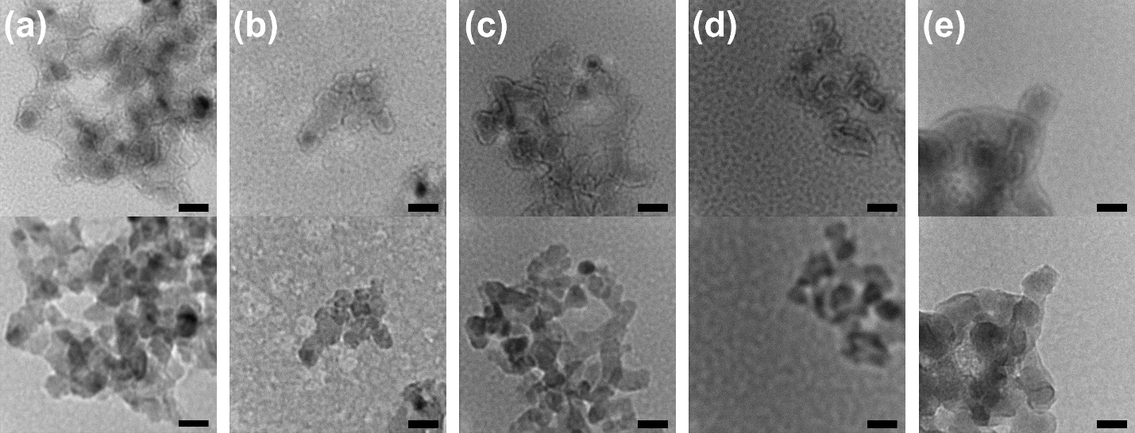
Fig. S3 Overfocus (top) and underfocus (bottom) TEM images of (a) TCO 100, (b) TCO 200, (c) TCO 500, (d) TCO 800, and (e) TCO 1000 (scale bar: 20 nm)

Fig. S4 XPS spectra of different TCO samples: (a) Ti 2p range, (b) Cu 2p range, (c) O 1s range

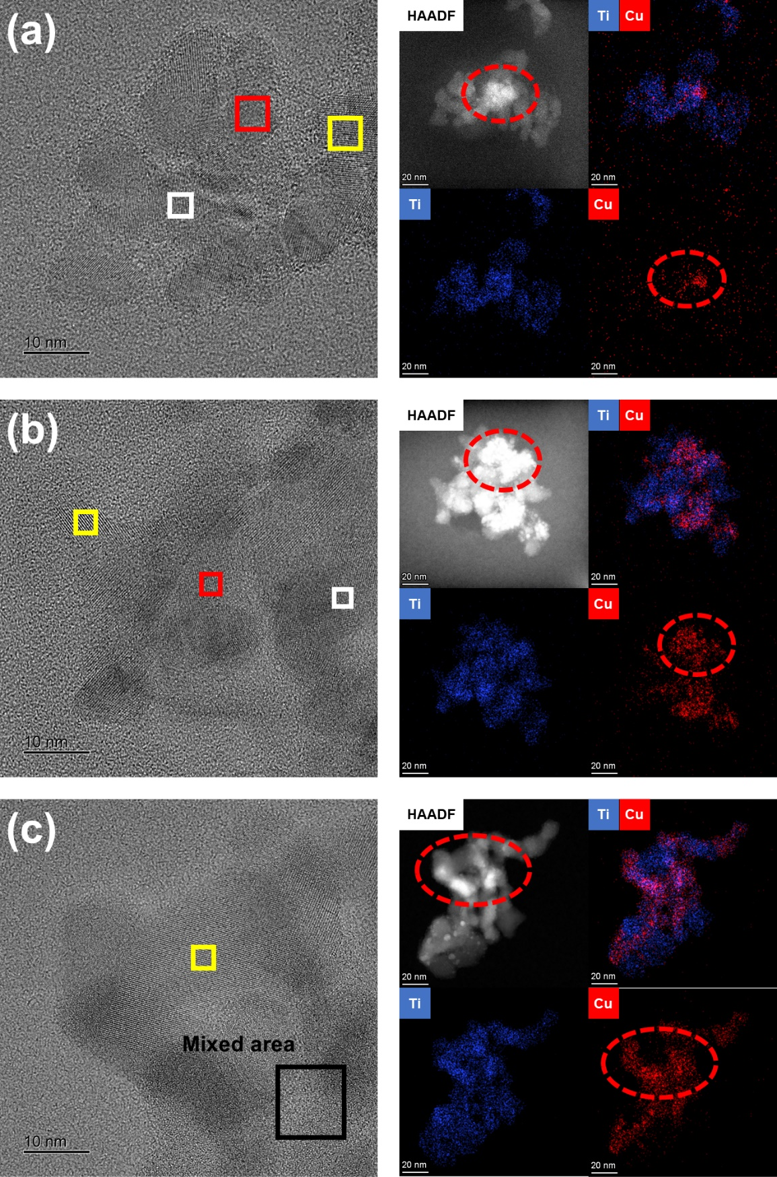
Fig. S5 HRTEM (left) and HAADF-EDS (right) of (a) TCO 100, (b) TCO 500, and (c) TCO 1000. The red, blue, white mark represent rutile, anatase, tenorite, respectively

Scheme S1: EELS low loss thickness estimation.
The electron energy loss spectroscopy (EELS) was carried out by high resolution TEM. The low-loss EELS spectra of TCO 200 is shown in Fig. S5, which can be used to estimate the thickness of the selected position. The thickness was required by the following equation:
$$\begin{aligned}t/λ=ln\left({I_{t}}/{I_{0}}\right)\#\left(1\right)\end{aligned}$$
where t is the thickness of sample, λ is the inelastic mean free path of electron, I_{t} is the total integrated intensity of all EELS spectrum, I₀ means the total integrated intensity of zero loss peak (ZLP). The inelastic mean free path is calculated by the following equation from Seah and Dench
$$\begin{aligned}λ=2170aE^{-2}+0.72a^{3/2}E^{1/2}\#\left(2\right)\end{aligned}$$
where a is the average single layer thickness for the selected material, and E is the electron energy above the Fermi level. Based on the formula, the inelastic mean free path of TCO is 86.37 nm. I_{t} and I₀ are calculated as 3.55 × 10⁶ and 2.81 × 10⁶, respectively. Based on the calculation above, the estimated thickness at position 1 is 20.34 nm.
Fig. S6 The low-loss EELS of TCO 200 with the position

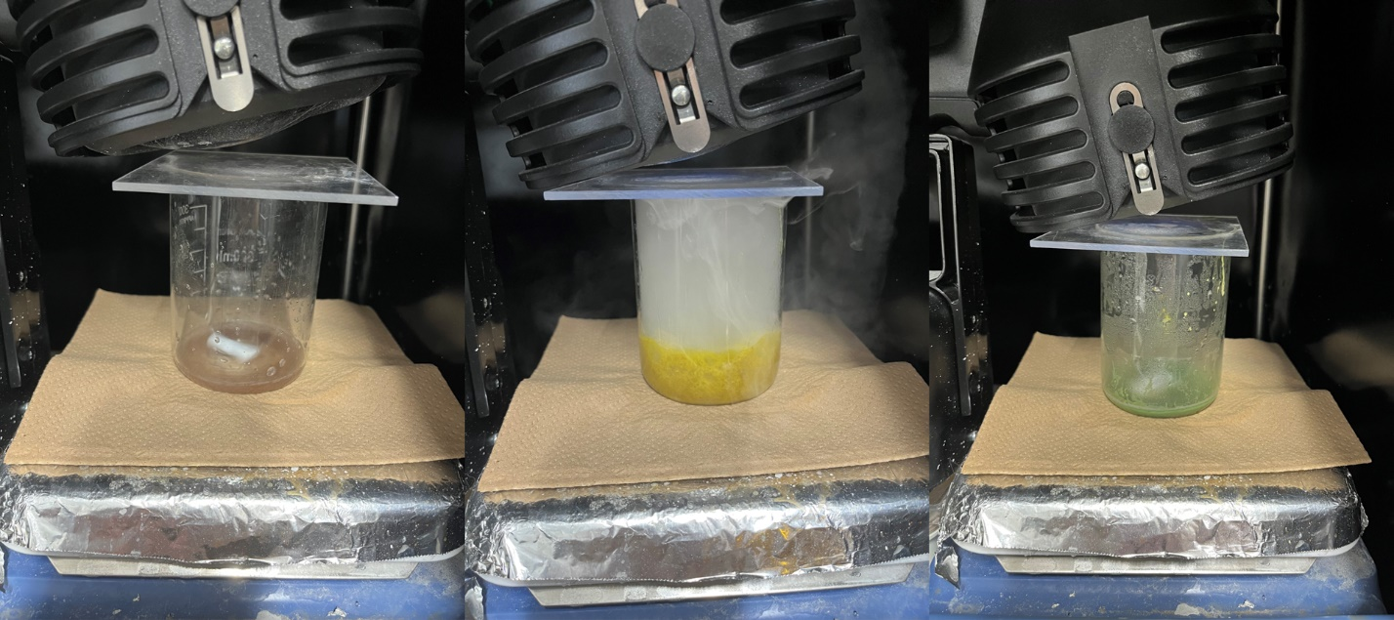
Fig. S7 The fabrication process of TCO samples: (a) addition, (b) step 1, (c) step 2.

Fig. S8 LSV curves of 0.1 M NH₃ degraded in 0.25 M H₂SO₄ by (a) TCO 500, (b) TCO 800, and (c) TCO 1000

Fig. S9 RhB degradation curve by carbon paper electrode (line: solar light, dash: dark)

Fig. S10 The UV-vis absorbance spectra of RhB degraded under different conditions

