
ence
Number:
e,
ETHICS COMMITTEE APPLICATION FORM
- Applicant name:
Soha Said Mohamed Abd el Latif
 | Principal investigator | Other  •k  researchers
Name | Soha Said Mohamed Abd el Latif
Position/Professional status | Pharmacist at Alexandria Main University Hospital (department of clinical oncology).
Qualifications | B.Sc Pharmaceutical Sciences Faculty of Pharmacy,  Alexandria University, 2005.  Master in Clinical Pharmacy (Pharm D), Faculty of Pharmacy, Alexandria University, 2013.  Diploma in Biostatistics,  High Institute of Public Health Alexandria University, 2017.
Affili ation | Alexandria Main University  Hospital, Alexandria University
Telephone/fax | 01159144804
Email address | Sohasaid05@gmail.com
To be filled if not a thesis (Please copy and paste for additional researchers)
1
thdria
Primary contact name: Soha Said Mohamed Abd el Latif
- Purpose of research proposal:
Degree: a Master thesis Doctor thesis
Non degree a Research Paper a Research Project a Others
- Full title of study:
Environmental Risk Factors and Plasma Concentration ofLead and Copper in
Colorectal Cancer patients in Alexandria
- Nature or type of research:
Biomedical
POpulation a Health policy
Environmental a Other
- Subject of research:

Human a Animal species a Food samples
Biological samples)
Environmental samples a Other
- Funding / Support of the research: How will the research be funded?
The research will be funded by the researcher.
- What are the benefits from the research to the community and participants?
• To aware the community and participants about the environmental risk factors and exposure to lead and copper in this will help in reducing incidence of colorectal cancer .

- What are the potential risks, adverse effects, or hazard from the above research? There are no potential risks, adverse effects or hazards from the above research.
- Is there any investigational medicinal or any other product involved? Yes Nor If yes:
9.1- Does it have a license in the country in which the study will take place?

9.2-Will it be used outside the terms of its license (including use at a higher dose)?

Informed consent
- State the consent process: how it will be done, steps to provide information (written sheet, videos, interactive material).
An informed written consent will be taken from the study participants after explanation of the purpose and benefits of research.
- Informed consent form: Yes I No
If no, please state why:
Note: Please attach a sample of Informed Consent Form (ICF) which includes the information provided to participant on a separate sheet. Attach any other documents if used.
Confidentiality, data and sample security:
- What measures have been put in place to ensure confidentiality of personal data: collection, storage, access to and disposal of data and security of biological samples?
Questionnaires will be coded by serial number and not by name. Biological samples will be disposed safely.
Payments and incentives:
- Will individual participan« receive any payment or incentive for taldng part in the research?
No

Management of the research
14-1s permission / approval of relevant authority required?
Yes
No
If yes, state name(s)
Director of Alexandria Main University Hospital.
15-How do you intend to report the results? To whom will results be made available? How will the findings be reported to the research participants?
The results will be reported during presentation of the thesis and data will be available for scientific publication in peer reviewed journals.
A copy of the thesis will be available at the High Institute of Public Health Library, Bibliotheca Alexandrina Library, as well as Alexandria Central Library and Ain Shams University Library.
Findings will also be reported to the responsible authorities.
N.B:
For any inqulnes please contact any member of the Ethics Committee.
Declaration:
We agree that:
If approved, this study will be conducted in accordance with the protocol, other details described in this application and International ethical guidelines for research.
The study will not start until ethical approval has been obtained.
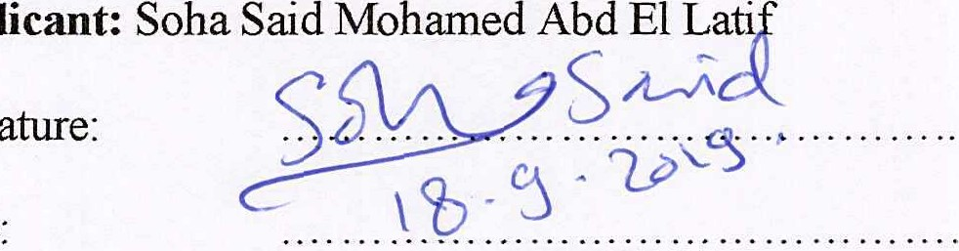
Signature:
Applicant:
Date
Supervisor :Prof ,Dr.Mamdouh Hanfey Abdou
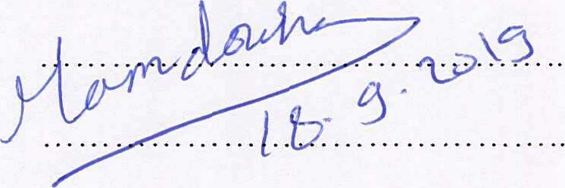
Signature:
Date:
Please retain for yourself and provide electronic and paper copies of this application and protocol, if you are a student, for your supervisor.
You have to scan this page and submit it electronically and a hard copy to be sent directly to the Ethics Committee Secretary with your application.

ETHICS COMMITTEE DECISION FORM
Submission date:
Application presented to Ethics Committee member on:
Research title:
Environmental Risk Factors and Plasma Concentration ofLead and Copper in
Colorectal Cancerpatients in Alexandria
Result:
1. Approval
- Approval after the following modifications

- Rejection for the following reasons

Table (supplementary material II): Coordinates of the curve of lead (Alexandria Main University Hospital, 2020).

Positive if Greater than or Equal to | Selectivity | 1-Specificty
0.131  0.134  0.139  0.164  0.187  0.188 | 0.64  0.64  0.64  0.64  0.60  0.60 | 0.44  0.40  0.36  0.32  0.32  0.28

Table (supplementary material III): Coordinates of the curve of copper (Alexandria Main University Hospital, 2020).
Positive if Greater than or Equal to | Selectivity | 1-Specificty
1.17  1.19  1.24  1.29  1.30  1.31 | 0.56  0.56  0.56  0.56  0.52  0.52 | 0.44  0.40  0.36  0.32  0.28  0.28

