Online Resource
Biodiversity and Conservation

Patterns in pollination networks from a grassland-forest ecotone: the role of habitat and plant population structure
Mateus Raguse-Quadros*, Gabriela da Cunha Souza, Pedro Maria Abreu Ferreira, Betina Blochtein
*Laboratório de Entomologia, Escola de Ciências da Saúde e da Vida, Pontifícia Universidade Católica do Rio Grande do Sul, Porto Alegre, RS, Brazil; Corresponding author e-mail address: mateusraguse@hotmail.com
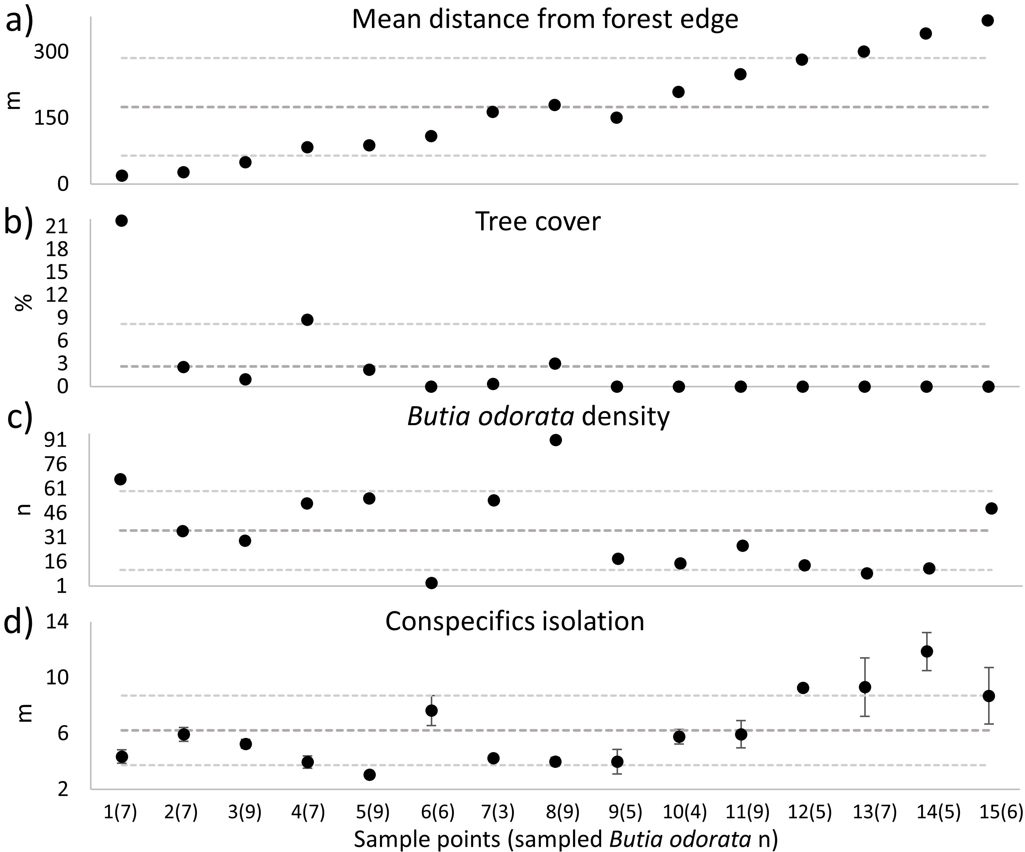
Fig. OR1 Habitat and population descriptors of 15 sample points of a Butia odorata palm grove. (a) Mean distance of each focal B. odorata individual from the forest edge; (b) Percentage of tree cover; (c) Density of B. odorata individuals; (d) Isolation (mean distance) of focal B. odorata individuals from their four closest conspecifics. Dark gray dashed lined: overall mean of the sample points; Light gray dashed lines: lower and upper limit of the standard deviation of the overall mean; Dot bars in d represent standard error
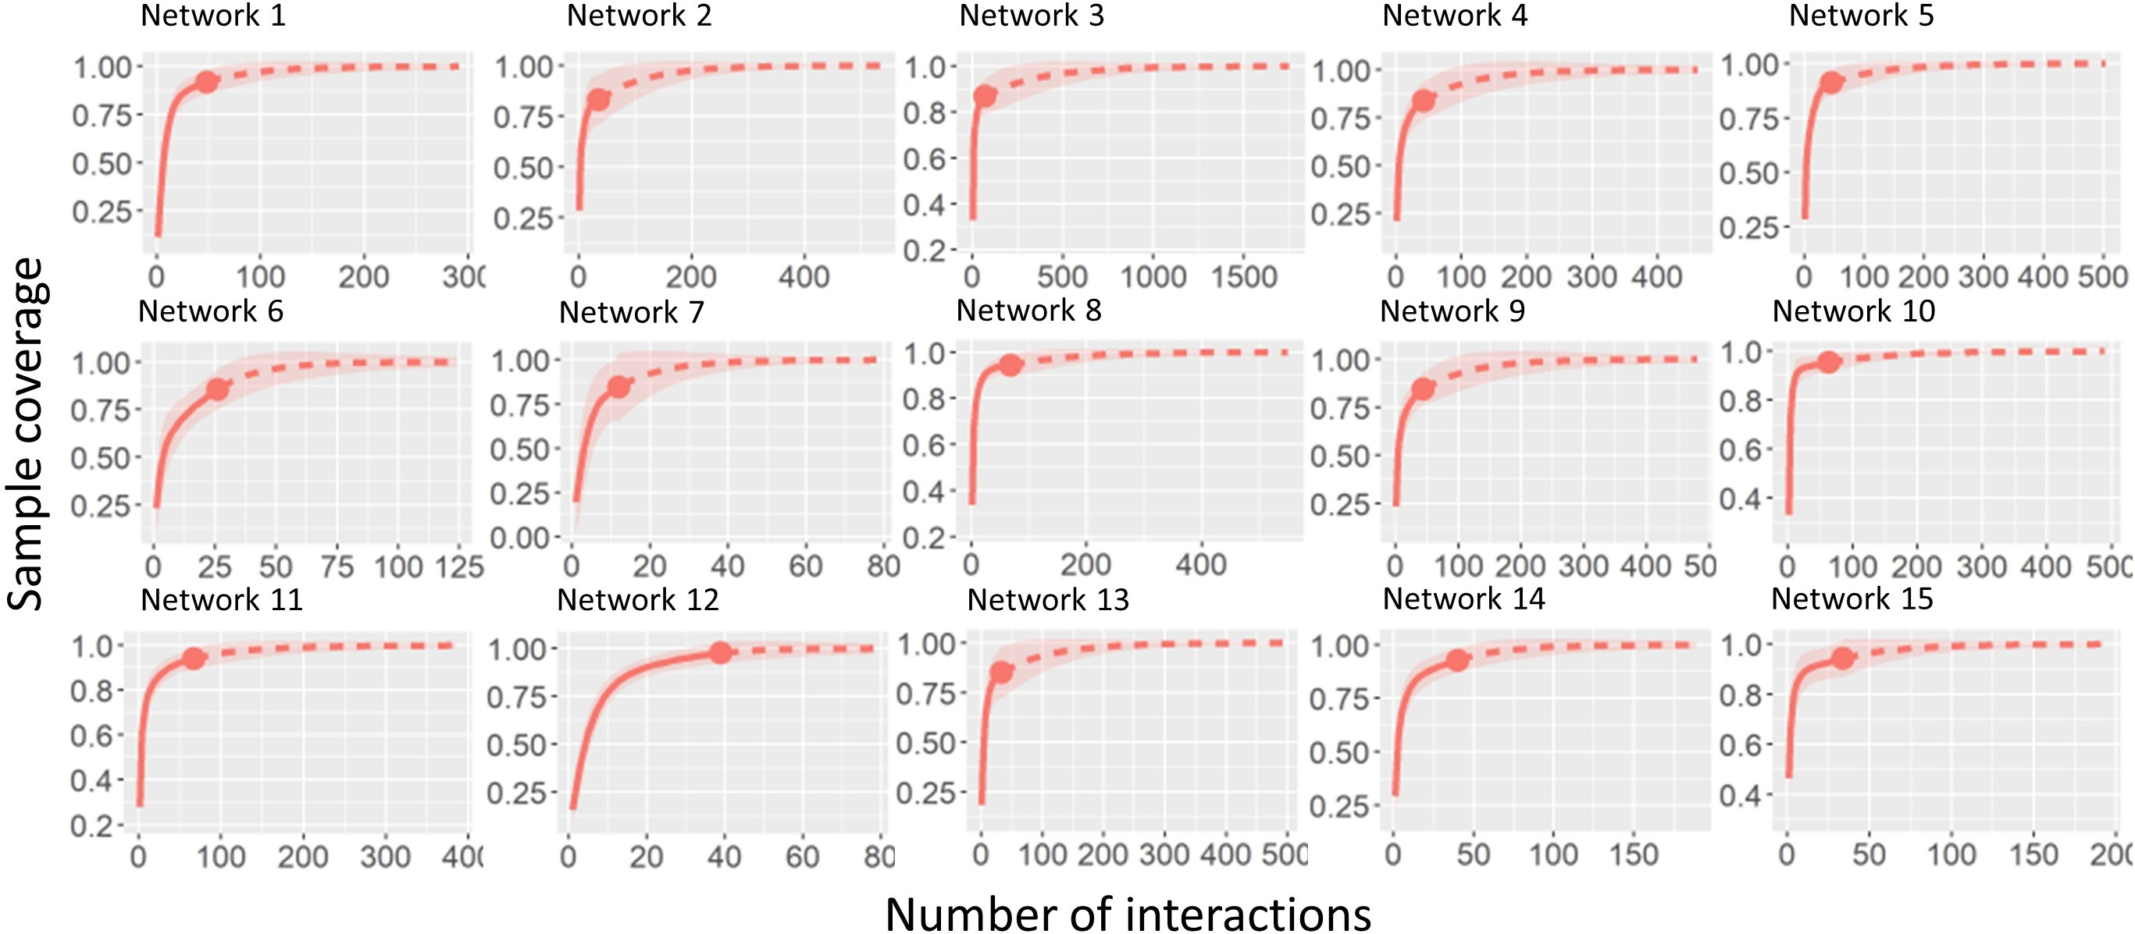
Fig. OR2 Sample completeness rarefaction based on the number of interactions (observed individuals of higher trophic level) of pollinators with Butia odorata individuals in 15 networks in a Butia odorata palm grove. Red line: accumulation of interactions by estimated sample completeness; red dot: estimated sample completeness for the observed number of interactions; dashed line: number of interactions estimated by sample completeness; light red area: 95% confidence interval
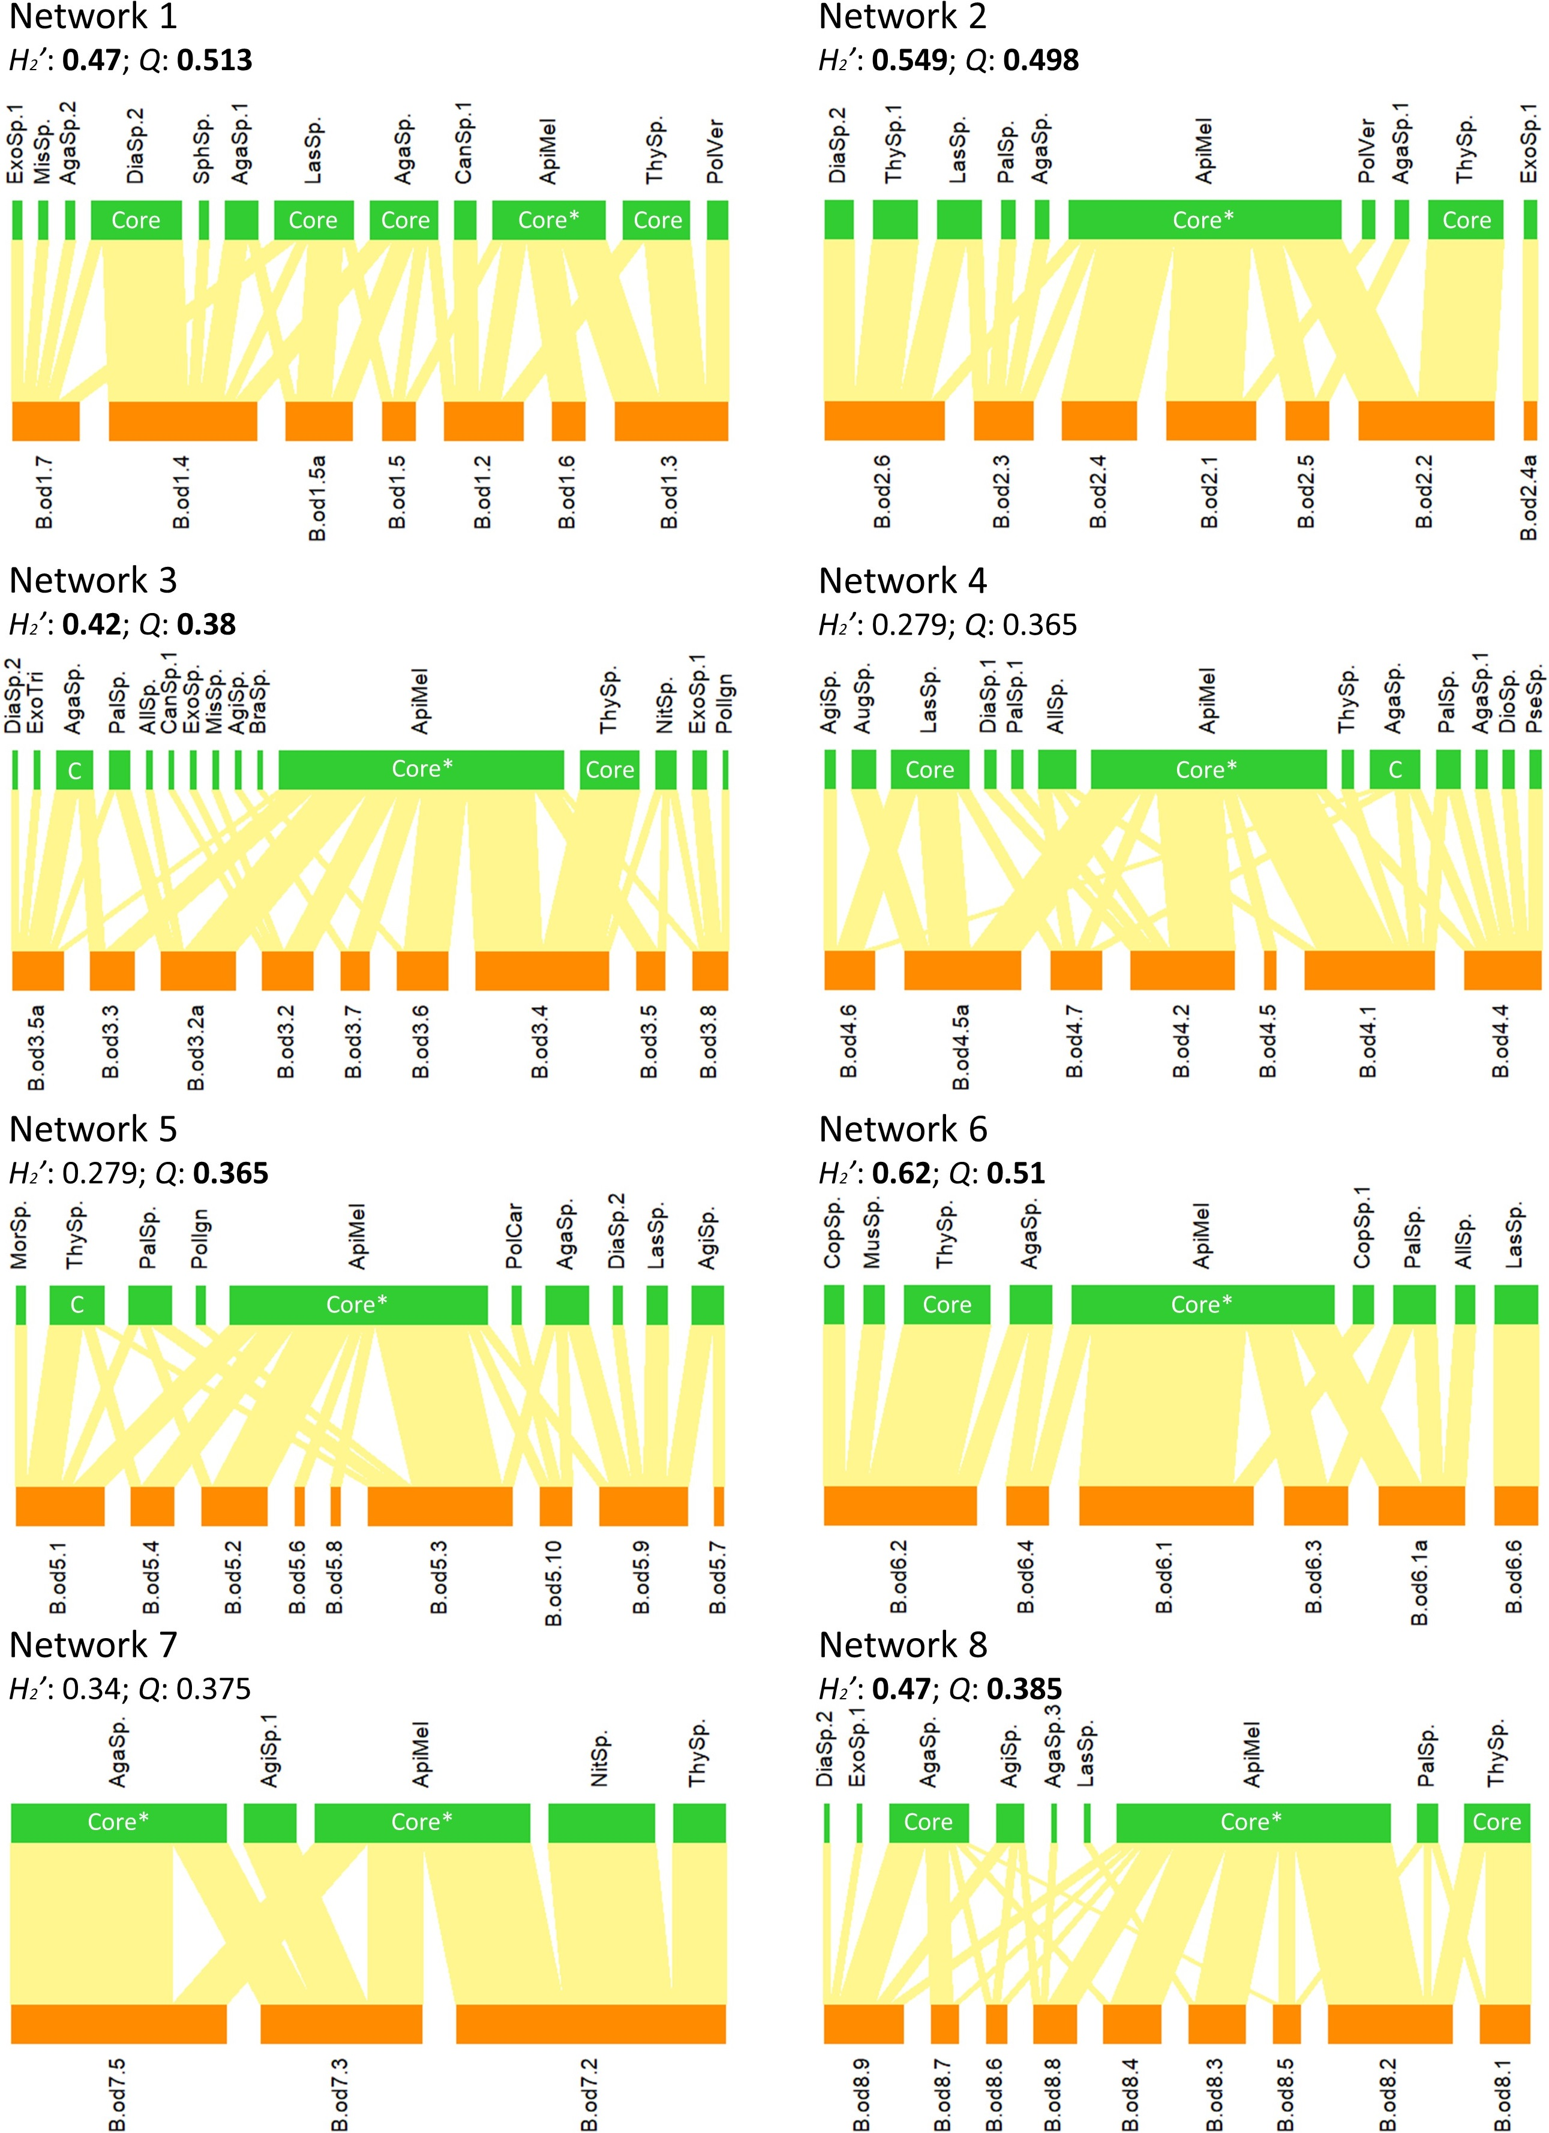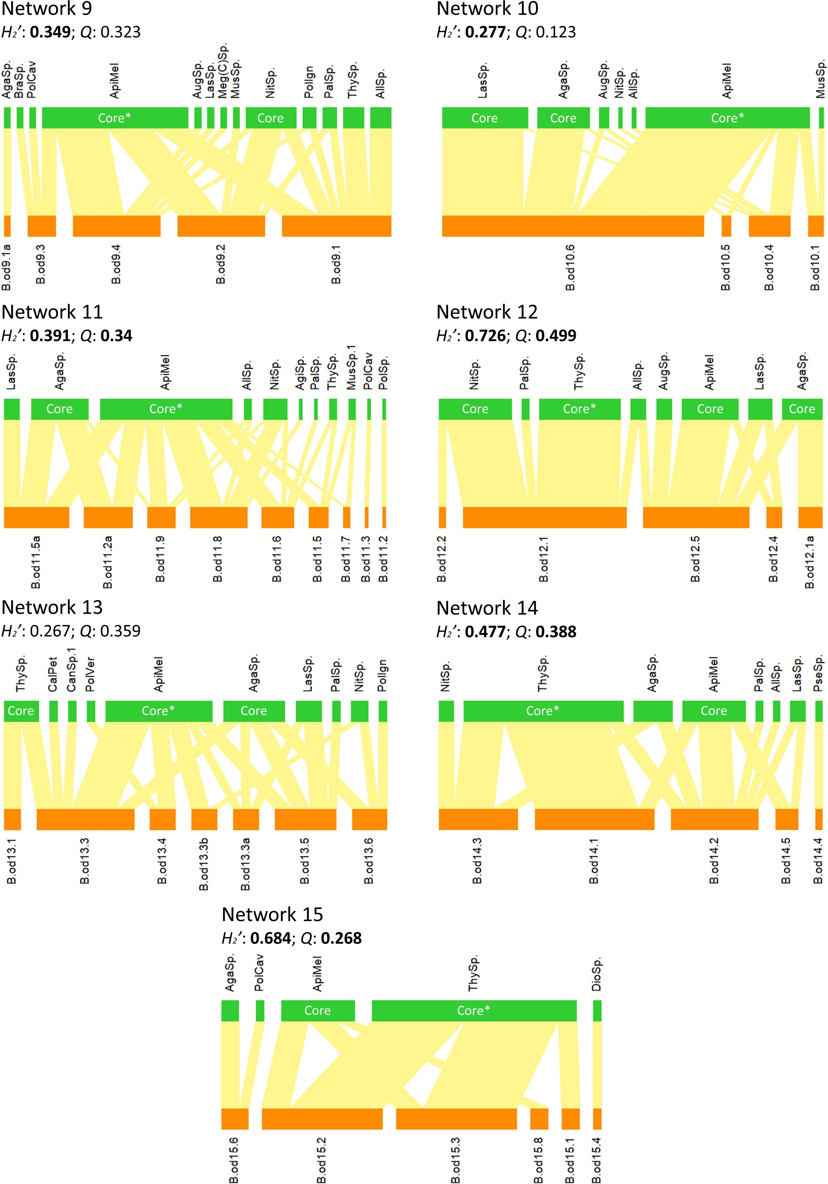
Fig. OR3 Biplot of 15 networks of interactions between Butia odorata individuals and their pollinating insect species in a palm grove. Values in bold: metrics that differed from chance compared to null models (p-value < 0.05). “Core” or “C”: core species (Gc index > 0) in the networks (“*” species with the highest Gc in the network). B.od‘x’.‘y’: ‘x’: sampling point identification; ‘y’: individual identification. Pollinator species: AgaSp.: Augochlorella sp.; AgaSp.1: cf. Augochlorella sp. 1; AgaSp.2: cf. Augochlorella sp. 2; AgaSp.3: cf. Augochlora sp. 3; AgiSp.: Augochlorini sp.; AgiSp.1: Augochlorini sp. 1; AllSp.: Allograpta sp.; ApiMel: Apis mellifera; AugSp. Augochloropsis sp.; BraSp.: Brachygastra sp.; CalPet: Callonychium (Callonychium) cf. petuniae; CanSp.1: Cantharidae sp. 1; CopSp. Copestylum sp.; CopSp.1: Copestylum sp. 1; DiaSp.1: cf. Dialictus sp. 1; DiaSp.2: Dialictus sp. 2; DioSp.: cf. Dioprosopa sp.; ExoSp.: cf. Exomalopsis (Exomalopsis) sp.; ExoSp.1 cf. Exomalopsis (Exomalopsis) sp. 1; ExoTri: Exomalopsis (Phanomalopsis) cf. trifasciata; LasSp.: Lasioglossum sp.; Meg(C)Sp.: Megachile cf. (Chrysosarus) sp.; MisSp.: Mischocyttarus sp.; MorSp.: cf. Mordellidae sp.; MusSp.: cf. Muscidae sp.; MusSp.1: Muscidae sp. 1; NitSp.: Nitidulidae sp.; PalSp. Palpada sp.; PalSp.1: Palpada sp. 1; PolCar: Polistes carnifex; PolCav: Polistes cavapytiformis; PolIgn: Polybia ignobilis; PolSp.: Polybia (Trichinothoras) sp.; PolVer: Polistes versicolor; PseSp.: Pseudagapostemon sp.; SphSp.: cf. Sphiximorpha sp.; ThySp.: Thynnidae sp.; ThySp.1: Thynnidae sp. 1

Table OR1 List of 38 potential pollinator species of Butia odorata and diversity metrics of 15 interaction networks in a Butia odorata palm grove. Species in bold: core species (Gc index > 0) in at least one of the interaction networks
Family (Order) | Species | Occurrence per network |  |  |  |  |  |  |  |  |  |  |  |  |  |  | Total
Family (Order) | Species | 1 | 2 | 3 | 4 | 5 | 6 | 7 | 8 | 9 | 10 | 11 | 12 | 13 | 14 | 15 | Total
Apidae (Hymenoptera) | Apis mellifera | 10 | 18 | 38 | 18 | 23 | 12 | 4 | 37 | 20 | 31 | 32 | 7 | 12 | 8 | 8 | 278
Thynnidae (Hymenoptera) | Thynnidae sp. | 6 | 5 | 8 | 1 | 5 | 4 | 1 | 9 | 3 | 0 | 3 | 10 | 4 | 20 | 22 | 101
Halictidae (Hymenoptera) | Augochlorella sp. | 6 | 1 | 5 | 4 | 4 | 2 | 4 | 11 | 1 | 10 | 14 | 5 | 7 | 5 | 2 | 81
Halictidae (Hymenoptera) | Lasioglossum sp. | 7 | 3 | 0 | 6 | 2 | 2 | 0 | 1 | 1 | 17 | 4 | 3 | 3 | 2 | 0 | 51
Nitidulidae (Coleoptera) | Nitidulidae sp. | 0 | 0 | 3 | 0 | 0 | 0 | 2 | 0 | 7 | 1 | 6 | 9 | 2 | 2 | 0 | 32
Syrphidae (Diptera) | Palpada sp. | 0 | 1 | 3 | 2 | 4 | 2 | 0 | 3 | 2 | 0 | 1 | 1 | 1 | 1 | 0 | 21
Syrphidae (Diptera) | Allograpta sp. | 0 | 0 | 1 | 3 | 0 | 1 | 0 | 0 | 3 | 1 | 2 | 2 | 0 | 1 | 0 | 14
Halictidae (Hymenoptera) | Dialictus sp. 2 | 8 | 1 | 1 | 0 | 1 | 0 | 0 | 1 | 0 | 0 | 0 | 0 | 0 | 0 | 0 | 12
Halictidae (Hymenoptera) | Augochlorini sp. | 0 | 0 | 1 | 1 | 3 | 0 | 0 | 4 | 0 | 0 | 1 | 0 | 0 | 0 | 0 | 10
Halictidae (Hymenoptera) | Augochloropsis sp. | 0 | 0 | 0 | 2 | 0 | 0 | 0 | 0 | 1 | 2 | 0 | 2 | 0 | 0 | 0 | 7
Vespidae (Hymenoptera) | Polybia ignobilis | 0 | 0 | 1 | 0 | 1 | 0 | 0 | 0 | 2 | 0 | 0 | 0 | 1 | 0 | 0 | 5
Halictidae (Hymenoptera) | Augochlora sp. 1 | 3 | 1 | 0 | 1 | 0 | 0 | 0 | 0 | 0 | 0 | 0 | 0 | 0 | 0 | 0 | 5
Apidae (Hymenoptera) | cf. Exomalopsis (Exomalopsis) sp. 1 | 1 | 1 | 2 | 0 | 0 | 0 | 0 | 1 | 0 | 0 | 0 | 0 | 0 | 0 | 0 | 5
Cantharidae (Coleoptera) | Cantharidae sp. 1 | 2 | 0 | 1 | 0 | 0 | 0 | 0 | 0 | 0 | 0 | 0 | 0 | 1 | 0 | 0 | 4
Vespidae (Hymenoptera) | Polistes versicolor | 2 | 1 | 0 | 0 | 0 | 0 | 0 | 0 | 0 | 0 | 0 | 0 | 1 | 0 | 0 | 4
Vespidae (Hymenoptera) | Polistes cavapytiformis | 0 | 0 | 0 | 0 | 0 | 0 | 0 | 0 | 1 | 0 | 1 | 0 | 0 | 0 | 1 | 3
Thynnidae (Hymenoptera) | Thynnidae sp. 1 | 0 | 3 | 0 | 0 | 0 | 0 | 0 | 0 | 0 | 0 | 0 | 0 | 0 | 0 | 0 | 3
Muscidae (Diptera) | cf. Muscidae sp. | 0 | 0 | 0 | 0 | 0 | 1 | 0 | 0 | 1 | 1 | 0 | 0 | 0 | 0 | 0 | 3
Vespidae (Hymenoptera) | Brachygastra sp. | 0 | 0 | 1 | 0 | 0 | 0 | 0 | 0 | 1 | 0 | 0 | 0 | 0 | 0 | 0 | 2
Vespidae (Hymenoptera) | Mischocyttarus sp. | 1 | 0 | 1 | 0 | 0 | 0 | 0 | 0 | 0 | 0 | 0 | 0 | 0 | 0 | 0 | 2
Halictidae (Hymenoptera) | Pseudagapostemon sp. | 0 | 0 | 0 | 1 | 0 | 0 | 0 | 0 | 0 | 0 | 0 | 0 | 0 | 1 | 0 | 2
Syrphidae (Diptera) | cf. Dioprosopa sp. | 0 | 0 | 0 | 1 | 0 | 0 | 0 | 0 | 0 | 0 | 0 | 0 | 0 | 0 | 1 | 2
Muscidae (Diptera) | Muscidae sp. 1 | 0 | 0 | 0 | 0 | 0 | 0 | 0 | 0 | 0 | 0 | 2 | 0 | 0 | 0 | 0 | 2
Mordellidae (Coleoptera) | cf. Mordellidae sp. | 0 | 0 | 0 | 0 | 1 | 0 | 0 | 0 | 0 | 0 | 0 | 0 | 0 | 0 | 0 | 1
Vespidae (Hymenoptera) | Polistes carnifex | 0 | 0 | 0 | 0 | 1 | 0 | 0 | 0 | 0 | 0 | 0 | 0 | 0 | 0 | 0 | 1
Vespidae (Hymenoptera) | Polybia (Trichinothoras) sp. | 0 | 0 | 0 | 0 | 0 | 0 | 0 | 0 | 0 | 0 | 1 | 0 | 0 | 0 | 0 | 1
Halictidae (Hymenoptera) | cf. Augochlorella sp. 2 | 1 | 0 | 0 | 0 | 0 | 0 | 0 | 0 | 0 | 0 | 0 | 0 | 0 | 0 | 0 | 1
Halictidae (Hymenoptera) | cf. Augochlora sp. 3 | 0 | 0 | 0 | 0 | 0 | 0 | 0 | 1 | 0 | 0 | 0 | 0 | 0 | 0 | 0 | 1
Halictidae (Hymenoptera) | Augochlorini sp. 1 | 0 | 0 | 0 | 0 | 0 | 0 | 1 | 0 | 0 | 0 | 0 | 0 | 0 | 0 | 0 | 1
Andrenidae (Hymenoptera) | Callonychium (Callonychium) cf. petuniae | 0 | 0 | 0 | 0 | 0 | 0 | 0 | 0 | 0 | 0 | 0 | 0 | 1 | 0 | 0 | 1
Halictidae (Hymenoptera) | cf. Dialictus sp. 1 | 0 | 0 | 0 | 1 | 0 | 0 | 0 | 0 | 0 | 0 | 0 | 0 | 0 | 0 | 0 | 1
Apidae (Hymenoptera) | cf. Exomalopsis (Exomalopsis) sp. | 0 | 0 | 1 | 0 | 0 | 0 | 0 | 0 | 0 | 0 | 0 | 0 | 0 | 0 | 0 | 1
Apidae (Hymenoptera) | Exomalopsis (Phanomalopsis) cf. trifasciata | 0 | 0 | 1 | 0 | 0 | 0 | 0 | 0 | 0 | 0 | 0 | 0 | 0 | 0 | 0 | 1
Megachilidae (Hymenoptera) | Megachile sp. | 0 | 0 | 0 | 0 | 0 | 0 | 0 | 0 | 1 | 0 | 0 | 0 | 0 | 0 | 0 | 1
Syrphidae (Diptera) | Copestylum sp. | 0 | 0 | 0 | 0 | 0 | 1 | 0 | 0 | 0 | 0 | 0 | 0 | 0 | 0 | 0 | 1
Syrphidae (Diptera) | Copestylum sp. 1 | 0 | 0 | 0 | 0 | 0 | 1 | 0 | 0 | 0 | 0 | 0 | 0 | 0 | 0 | 0 | 1
Syrphidae (Diptera) | Palpada sp. 1 | 0 | 0 | 0 | 1 | 0 | 0 | 0 | 0 | 0 | 0 | 0 | 0 | 0 | 0 | 0 | 1
Syrphidae (Diptera) | cf. Sphiximorpha sp. | 1 | 0 | 0 | 0 | 0 | 0 | 0 | 0 | 0 | 0 | 0 | 0 | 0 | 0 | 0 | 1
Total abundance |  | 48 | 35 | 68 | 42 | 45 | 26 | 12 | 68 | 44 | 63 | 67 | 39 | 33 | 40 | 34 | 664
Mean total abundance |  | 6.9 | 5 | 7.6 | 6 | 5 | 4.3 | 4 | 7.6 | 8.8 | 15.8 | 7.4 | 7.8 | 4.7 | 8 | 5.7 | -
Peripheral species total abundance |  | 11 | 12 | 17 | 14 | 17 | 10 | 4 | 11 | 17 | 5 | 21 | 8 | 10 | 7 | 4 | 168
Peripheral species mean abundance |  | 1.6 | 1.7 | 1.9 | 2 | 1.9 | 1.7 | 1.3 | 1.2 | 3.4 | 1.3 | 2.3 | 1.6 | 1.4 | 1.4 | 0.7 | -
Core species total abundance |  | 37 | 23 | 51 | 28 | 28 | 16 | 8 | 57 | 27 | 58 | 46 | 31 | 23 | 33 | 30 | 496
Core species mean abundance |  | 5.3 | 3.3 | 5.7 | 4 | 3.1 | 2.7 | 2.7 | 6.3 | 5.4 | 14.5 | 5.1 | 6.2 | 3.3 | 6.6 | 5 | -
Total richness |  | 12 | 10 | 15 | 13 | 10 | 9 | 5 | 9 | 13 | 7 | 11 | 8 | 10 | 8 | 5 | 38
Mean richness (per inflorescence) |  | 3.4 | 2.3 | 3 | 3.7 | 2.7 | 2.3 | 2.7 | 2.8 | 4 | 3.3 | 2.7 | 2.6 | 2.9 | 2.8 | 1.5 | -
Peripheral species total richness |  | 7 | 8 | 12 | 10 | 8 | 7 | 3 | 6 | 11 | 4 | 9 | 4 | 7 | 5 | 3 | 37
Peripheral species mean richness (per inflorescence) |  | 1.1 | 1.3 | 1.7 | 1.9 | 1.4 | 1.5 | 1 | 1.1 | 2.6 | 1.3 | 1.6 | 0.8 | 1.3 | 1.2 | 0.5 | -
Core species total richness |  | 5 | 2 | 3 | 3 | 2 | 2 | 2 | 3 | 2 | 3 | 2 | 4 | 3 | 3 | 2 | 6
Core species mean richness (per inflorescence) |  | 2.3 | 1 | 1.3 | 1.9 | 1.2 | 0.8 | 1.7 | 1.7 | 1.4 | 2 | 1.1 | 1.4 | 1.6 | 1.6 | 1 | -
No. of inflorescences sampled |  | 7 | 7 | 9 | 7 | 9 | 6 | 3 | 9 | 5 | 4 | 9 | 5 | 7 | 5 | 6 | 98

Table OR2 Significance (p-value) and standardized estimate (st. est.) of causal relationships in Structural Equations Models of network structure and diversity metrics with population and habitat descriptors of 15 pollination interaction networks of Butia odorata individuals and their insect pollinators. Values in bold: statistically significant causal relationship (p-value < 0.05); values in italics: marginally significant causal relationships (0.06 > p-value ≥ 0.05); Cor.: correlation of errors between exogenous variables; --: causal relationships that have not been tested
 |  | Predictor variables
 |  | Distance from the forest edge |  | Tree cover (log) |  | Population density |  | Conspecifics isolation |  | R²
 |  | p-value | st. est. | p-value | st. est. | p-value | st. est. | p-value | st. est. | R²
Response variables | H₂’ | 0.0656 | -0.9693 | 0.1467 | -0.7022 | 0.047 | 0.9546 | 0.0075 | 1.4282 | 0.55
Response variables | Q z-score | 0.174 | -0.7547 | 0.745 | -0.164 | 0.114 | 0.8012 | 0.027 | 1.2123 | 0.46
Response variables | Pollinators mean abundance (log) | 0.23 | 0.8158 | 0.395 | 0.5398 | 0.25 | -0.6951 | 0.26 | -0.6951 | 0.17
Response variables | Peripheral pollinators mean abundance | 0.624 | 0.2455 | 0.523 | 0.3058 | 0.05 | -0.9733 | 0.051 | -0.9819 | 0.52
Response variables | Core pollinators mean abundance (log) | 0.245 | 0.7971 | 0.449 | 0.4839 | 0.471 | -0.435 | 0.466 | -0.4461 | 0.15
Response variables | Pollinators mean richness | 0.06 | 0.8932 | 0.015 | 1.1668 | 0.007 | -1.2827 | 0.008 | -1.2532 | 0.64
Response variables | Peripheral pollinators mean richness (log) | 0.957 | 0.0233 | 0.395 | 0.3609 | 0.028 | -0.9841 | 0.052 | -0.8592 | 0.63
Response variables | Core pollinators mean richness | 0.058 | 1.062 | 0.02 | 1.3073 | 0.163 | -0.6723 | 0.139 | -0.728 | 0.50
Response variables | Tree cover (log) | 0.009 | -0.5079 | -- | -- | 0.007 | 0.526 | -- | -- | 0.71
Cor. | Distance from the forest edge | -- | -- | -- | -- | 0.243 | -0.3211 | 0.002 | 0.7229 | --
Cor. | Population density | 0.243 | -0.3211 | -- | -- | -- | -- | 0.016 | -0.6075 | --
Cor. | Conspecifics isolation | 0.002 | 0.7229 | -- | -- | 0.016 | -0.6075 | -- | -- | --

Table OR3 Structural metrics calculated for 15 pollination interaction networks between insect species and Butia odorata individuals. Lower trophic level partners: Number of palm tree individuals’ inflorescences in the network; Upper trophic level richness: number of pollinator species sampled in the network’s inflorescences; Total interactions: number of pollinator individuals collected in each network; values in bold: metrics that differed from chance compared to null models (p-value < 0.05)
Network | Lower trophic level partners | Upper trophic level richness | Total interactions | Specialization (H₂’) | Modularity (Q)
 |  |  |  |  | Observed | z-score
1 | 7 | 12 | 48 | 0.47 | 0.513 | 5.813
2 | 7 | 10 | 35 | 0.549 | 0.498 | 4.938
3 | 9 | 15 | 68 | 0.42 | 0.38 | 1.857
4 | 7 | 13 | 42 | 0.279 | 0.365 | 0.851
5 | 9 | 10 | 45 | 0.279 | 0.365 | 2.208
6 | 6 | 9 | 26 | 0.62 | 0.51 | 3.707
7 | 3 | 5 | 12 | 0.34 | 0.375 | 0.889
8 | 9 | 9 | 68 | 0.47 | 0.385 | 5.875
9 | 5 | 13 | 44 | 0.349 | 0.323 | 1.374
10 | 4 | 7 | 63 | 0.277 | 0.123 | 1.218
11 | 9 | 11 | 67 | 0.391 | 0.34 | 3.735
12 | 5 | 8 | 39 | 0.726 | 0.499 | 6.497
13 | 7 | 10 | 33 | 0.267 | 0.359 | 0.38
14 | 5 | 8 | 40 | 0.477 | 0.388 | 4.808
15 | 6 | 5 | 34 | 0.684 | 0.268 | 2.293

