Title: Transcriptomic convergence despite genomic divergence drive field cancerization in synchronous squamous tumors
Short Title: Field cancerization in synchronous tumors

Chin-Ann J. Ong^{,1,2,3,4,}*, Nicholas B. Shannon^{#,1,2}, Weng Khong Lim^{5,6}, Qiu Xuan Tan^{1,2}, Daniel R.Y. Yap², Sze Min Lek², Joey W.S. Tan^{1,2}, Shih Jia J. Tan², Josephine Hendrikson^{1,2}, Wai Har Ng^{1,2}, Ying Liu^{1,2}, Gillian Ng^{1,2}, Kelvin K.N. Koh², Cedric C.Y. Ng⁷, Vikneswari Rajasegaran⁷, Choon Kiat Ong^{6,8}, Tony K.H. Lim^{9,10}, Bin Tean Teh^{4,6,7}, Oi Lian Kon^{2,3}, Claramae S. Chia^{1,3},
Khee Chee Soo^{1,3}, N. Gopalakrishna Iyer^{6,11,12,}*
#Equal contribution, *Co-corresponding authors

¹ Department of Sarcoma, Peritoneal and Rare Tumours (SPRinT), Division of Surgery and Surgical Oncology, National Cancer Centre Singapore, Singapore
² Laboratory of Applied Human Genetics, Division of Medical Sciences, National Cancer Centre Singapore, Singapore
³ SingHealth Duke-NUS Oncology Academic Clinical Program, Duke-NUS Medical School, Singapore
⁴ Institute of Molecular and Cell Biology, A*STAR Research Entities, Singapore
⁵ SingHealth Duke-NUS Institute of Precision Medicine, National Heart Centre Singapore, Singapore, Singapore
⁶ Cancer and Stem Biology Program, Duke-NUS Medical School, Singapore, Singapore
⁷ Laboratory of Cancer Epigenome, Division of Medical Sciences, National Cancer Centre Singapore
⁸ Lymphoma Genomics Translational Laboratory, Division of Medical Sciences, National Cancer Centre Singapore
⁹ Department of Anatomical Pathology, Singapore General Hospital, Singapore
¹⁰ Pathology Academic Clinical Program, SingHealth Duke-NUS Academic Medical Centre, Singapore, Singapore
¹¹ Department of Head and Neck Surgery, Division of Surgery and Surgical Oncology, National Cancer Centre Singapore
¹² Cancer Therapeutics Research Laboratory, Division of Medical Sciences, National Cancer Centre Singapore

Co-Corresponding Authors:
Professor N. Gopalakrishna Iyer
Cancer Therapeutics Research Laboratory, Division of Medical Sciences, National Cancer Centre Singapore
Department of Head and Neck Surgery, Division of Surgery and Surgical Oncology, National Cancer Centre Singapore
11 Hospital Crescent Singapore 169610
Tel no.: (65) 98797755 Fax no.: (65) 6225 7559 Email: gopaliyer@singhealth.com.sg

Assistant Professor Chin-Ann Johnny Ong
Laboratory of Applied Human Genetics, Division of Medical Sciences, National Cancer Centre Singapore
Department of Sarcoma, Peritoneal and Rare Tumours (SPRinT), Division of Surgery and Surgical Oncology, National Cancer Centre Singapore
11 Hospital Crescent Singapore 169610
Tel no.: (65) 6436 8318 Fax no.: (65) 6225 7559 Email: johnny.ong.c.a@singhealth.com.sg

Supplemental text for methods

Patient selection and multi-sampling of specimens
We interrogated the mutational landscape of samples taken from three patients. Systematic multi-sampling of tumors and intervening normal mucosa was conducted on tumors that were surgically removed as part of standard care. Meticulous annotations of the specimen collection sites were recorded (Supplementary Table S1). This study was approved by the SingHealth Centralized Institutional Review Boards (CIRB 2008/467/B, 2011/678/B, and 2007/438/B). All patients gave informed consent.

Tissue samples were either snap frozen in liquid nitrogen immediately after collection and stored at −80°C or fixed in formalin and embedded in paraffin. Blood from eligible patients was drawn in two EDTA tubes and aliquoted into multiple cryotubes to be stored at −80°C.

DNA and RNA isolation for high throughput sequencing
DNA and RNA of the biopsies were extracted using the AllPrep DNA/RNA Mini Kit (catalogue no. 80204), according to the manufacturer’s instructions (QIAgen; Hilden, Germany). DNA bloods were extracted using QIAamp DNA blood mini kit (catalogue no. 51104) (QIAgen). DNA and RNA were quantified using the Qubit dsDNA BR and RNA BR Assay kit (Life Technologies, Carlsbad, CA, USA).

For the fresh frozen samples, whole-exome sequencing (WES) libraries were prepared using the Sureselect XT target enrichment kit (Agilent, Santa Clara, CA, USA; cat. #5500-0105, version 1.6). Libraries were constructed with an insert length of 300bp. Enriched libraries were sequenced on the Illumina Nextseq System using the paired-end 150 bases configuration.

RNA extracted from the same set of frozen samples was subjected to RNA sequencing. Enriched libraries were generated using the Truseq Stranded Total RNA Library Prep Gold kit (Illumina, San Diego, CA, USA; cat. #20020598) and subsequently sequenced on the HiSeq2000 system using the paired-end 76 bases run setting.

Gene set enrichment analysis
RNAseq data was analyzed using the DNAnexus platform. Reads were mapped using TopHat2 v2.0.12 and CuffDiff v2.1.1 on the genome version ucsc_hg19. Fragments per Kilobase of transcript per Million (FPKM) and fragment counts for each transcript, primary transcript and gene in each sample was normalized as part of CuffDiff.

Tissue microarray (TMA) construction, and immunohistochemical (IHC) staining and scoring
Tissue microarrays (TMAs) were constructed using tumors collected from 328 patients treated for histologically confirmed head and neck SCC (HNSCC) and who underwent treatment at the National Cancer Centre Singapore or Singapore General Hospital between 1998 and 2010. TMA blocks were sectioned into 4µM slices and mounted on slides. Immunohistochemical (IHC) staining was performed using the BOND-MAX autostainer (Leica Microsystems, Ltd; Milton Keynes, UK) according to manufacturer’s recommendations.

IHC staining was assessed by two independent scorers blinded to prior information of clinicopathological variables and survival data. Scoring was performed by assigning the stain intensity to a value of 0 (negative staining) to 3 (strong positive staining). Results were binarized to low (0,1) or high (2,3) expression of marker.

Laser capture microdissection (LCM) and targeted resequencing
Using the P53 image with pathological annotations as a reference, cutting outlines were drawn closely around individual cells to prevent tissue contamination (Supplementary Fig. S1a). Pathologist identified basal, squamous, and tumor areas for microdissection (Supplementary Fig. S1a). Formalin-fixed paraffin-embedded (FFPE) samples matched to the sequenced frozen specimens were subjected to laser capture microdissection (LCM) and targeted resequencing. Briefly, 5µm tissue sections were mounted on the PEN membrane slides (Arcturus, Life Technologies). The tissue section was deparaffised with xylene, dehydrated in a series of graded ethanol, and stained with 3:1 hematoxylin:eosin (Merck, cat. #1.05174 and Sigma, cat. #HT110116). Laser-captured cells were collected on LCM Macro CapSure caps (Life Technologies) using the Arcturus XT LCM instrument (Life Technologies). Microdissected samples were stored at −80°C until further processing. DNA isolation from the microdissected samples were carried out using the QIAamp DNA FFPE tissue kit (QIAgen).

We selected 151 genes associated with head and neck cancer for target enrichment. The gene panel consisted of genes derived from our in-house exome sequencing data and the scholarly literatures. The DNA libraries were constructed using the SureSelectXT HS Target Enrichment System. Sequencing was performed on the HiSeq 4000 system using the paired-end 150 bases run.

Analysis of genomic data and copy number changes
Raw sequencing reads generated through WES were aligned to the human reference genome (hs37d5) using BWA-MEM, and post-processed to sort the reads by genomic coordinate and to remove PCR duplicates using Sambamba. The resulting alignment files in the BAM format were used for subsequent somatic mutation calling step. Briefly, the Strelka2 program was used to identify somatic mutations in tissue (either tumor or adjacent mucosa), with patient whole-blood as a control. Candidate single nucleotide variants (SNVs) that passed default Strelka2 filtering criteria, and that had a variant allele frequency (VAF) exceeding 20% were retained. These variants were annotated using Annovar to determine their impact on protein sequence, frequency in population variation databases as well clinical variant databases, and in-silico functional prediction scores. The limma R package was used to read CGH data, perform background correction, and normalize within arrays. The snapCGH R package was used for genome segmentation. Genes were classified as gained (≥3 copies), lost (≤1 copy), or normal based on log2 ratios. Genes were compared for copy number status across samples.

Mutational signature analysis
The deconstructSigs R package was used to estimate the contribution of known mutational processes to the somatic mutations observed in a tumor or adjacent mucosa sample. The known mutational processes were obtained from the COSMIC mutational signatures database (https://cancer.sanger.ac.uk/cosmic/signatures). The algorithm produces a list of mutational processes predicted to be present in a sample and their relative proportions.

Targeted resequencing data analysis
Targeted regions were sequenced to an average coverage of 1503X. The somatic mutation calling and variant annotation process was identical to the one used for WES data above. Variants were filtered to retain only SNVs that were nonsense, splicing, and nonsynonymous. Only variants with a VAF exceeding 10% in at least one sample were considered. Variants that had SIFT and Polyphen2 HDIV predictions were required to have damaging (SIFT) and damaging or probably damaging (Polyphen2 HDIV) predictions, respectively.

Supplementary Table S1. List of tissue samples subjected to exome sequencing and RNA sequencing.
Patient | Sample ID
HN129 | Pyriform sinus tumor (T1-1)
HN129 | Pyriform sinus tumor (T1-2)
HN129 | Hypopharynx tumor (T2-1)
HN129 | Esophageal tumor (T3-1)
HN129 | Esophageal tumor (T3-2)
HN129 | Left aryepiglottic fold mucosa (M2)
HN129 | Middle esophageal mucosa (M3)
HN129 | Intervening mucosa between T1 & T3 (M5)
HN146 | Pyriform sinus tumor (T1-1)
HN146 | Pyriform sinus tumor (T1-2)
HN146 | Esophageal tumor (T2-1)
HN146 | Esophageal tumor (T2-5)
HN146 | Hypopharyngeal mucosa (M2)
HN146 | Middle esophageal mucosa (M4)
HN49 | Primary tongue tumor (T1)
HN49 | Primary tongue tumor (T2)
HN49 | Secondary glottis tumor (T1)
HN49 | Secondary glottis tumor (T2)
HN49 | Glottis mucosa (M1)
HN49 | Glottis mucosa (M4)

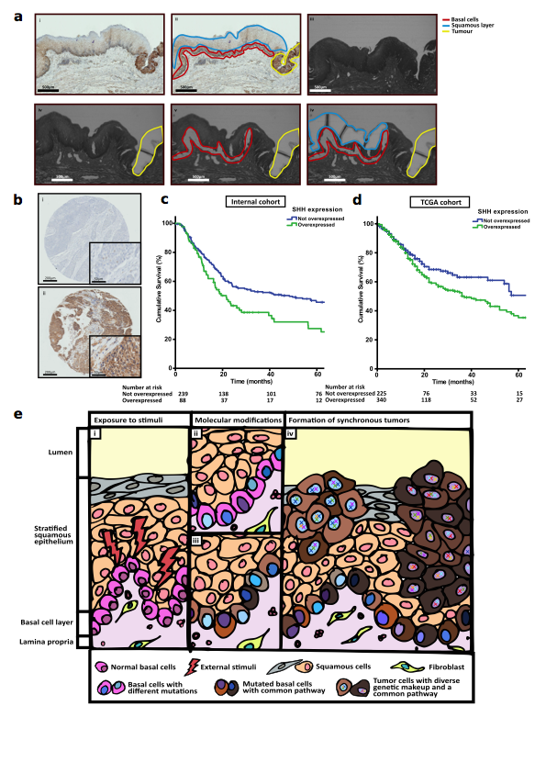
Supplementary Figure S1. a) Representative histological images illustrating (i) P53 staining, (ii) reference slides with P53 staining and areas marked out for microdissection, (iii) serial section used for LCM, (iv) after LCM of tumor region (yellow), (v) after LCM of tumor (yellow) and basal layer (red) and (vi) after LCM of squamous layer (blue), basal layer (red) and tumor cells (yellow). Scale bar: 500 μm. b) Representative IHC staining of Shh marker in a local cohort of HNSCC TMA core demonstrating (i) no expression and (ii) overexpression. c) Kaplan-Meier survival curve illustrating poorer prognosis in local cohort of patients with upregulated Hh signaling (p=0.014). d) Kaplan-Meier survival curve illustrating poorer prognosis in TCGA HNSCC patients with upregulated Hh signaling (p = 0.015). e) Proposed field change phenomenon. (i) Exposure of normal tissue to external stimuli. (ii) & (iii) Basal cell layer undergo genetic and transcriptomic modifications when exposed to external stimuli. (iv) Different shades of blue in the nuclei of basal cells represent genomic divergence. (v) Varying shades of brown in the cytoplasm of basal cells represent common transcriptomic profile (e.g. Hedgehog pathway). (vi) Formation of synchronous tumors harboring common signaling pathway but divergent genomic make-up. Shh, sonic hedgehog.

