Table 1 | Optimization of reaction conditions^{a, b}
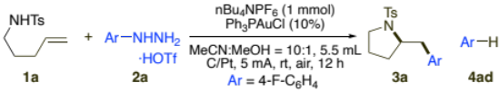
Entry | Variation from “standard conditions” | convn. (2a) | 3a^{c} | 4ad^{c}
1 | none | 100% | 32% | 29%
2 | MeCN:MeOH = 4:1 | 100% | 16% | 30%
3 | MeCN:MeOH = 1:1 | 100% | 12% | 26%
4 | tBuOH instead of MeOH | 100% | 10% | 22%
5 | DCM instead of MeOH | 100% | 0% | 48%
6 | Other [Au] | 100% | <15% | Up to 50%
7 | Other electrolytes | 100% | Up to 35% | Up to 40%
8 | Double concentration (1a, 2a, [Au]) | 100% | 54% | 22%
9 | 3 eq. 2a | 100% | 40% | 27%
10 | 0.5 mmol 1a, 1.5 mmol 2a, 0.05 mmol [Au] | 100% | 70% | 21%
11 | 0.5 mmol 1a, 1.5 mmol 2a, 0.05 mmol [Au]  (Add 0.5 mmol 2a, run rxn for 10 h)*3 | 100%  (100% for 1a) | 92% | 18%
12 | No [Au] | 100% | 0% | 57%
13 | No current | 0% | - | -
ªConditions: 1a (0.2 mmol), 2a (0.4 mmol), Ph₃PAuCl (0.02 mmol), nBu₄NPF₆ (1 mmol), MeCN (5 mL), MeOH (0.5 mL), C/Pt, 5 mA constant current, undivided cell, air, rt, 12 h.
^{b1}H NMR yields using 1,3,5-trimethoxybenzene as an internal standard.
^{c}3a yield based on 1a, 7 yield based on 2a.

Table 2 | Substrate scope for alkene, internal alkyne and hydrazine.^{[a][b]}
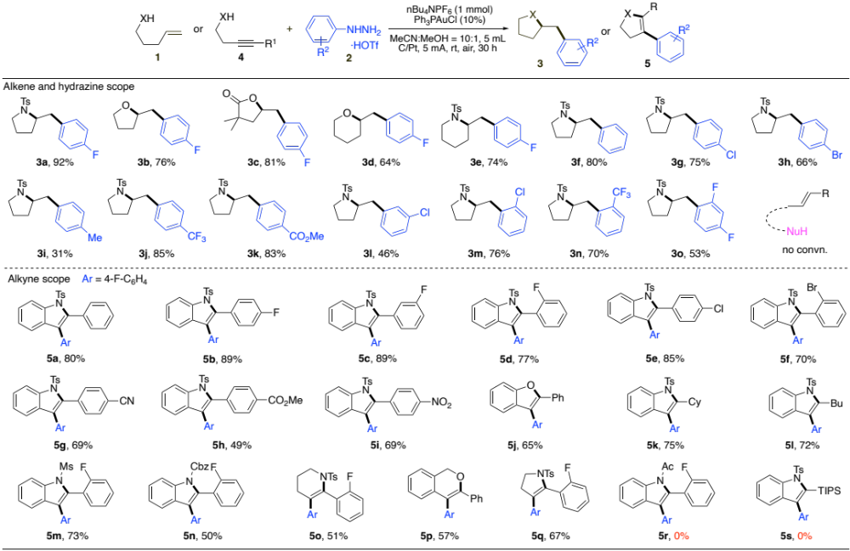
ªConditions: 1 or 4 (0.5 mmol), 2 (1.5 mmol), Ph₃PAuCl (0.05 mmol), nBu₄NPF₆ (1 mmol), MeCN (5 mL), MeOH (0.5 mL), C/Pt, 5 mA constant current, undivided cell, air, rt, add 0.5 mmol 2, run rxn for 10 h, repeat 3 times.
^{b}isolated yields.

