Extended Data
Supplementary Table 1: Summary of adverse events from endoscopy to day 90.
Event | Adverse Events |  |  |  | Serious Adverse Events
Event | Placebo (n=6) |  | FMT (n=15) |  | Placebo (n=6) | FMT (n=15)
Event | Events | Number of Individuals | Events | Number of Individuals | Events (Number of individuals) | Events (Number of individuals)
Reflux
Abdominal distention/bloating |  |  | 1* | 2 |  | 1(1)
Flatulence
Diarrhoea | 1 | 1 | 1* | 3
Constipation | 1 | 1
Nausea |  |  | 2 | 2
Vomiting | 1 | 1 | 1* | 3
Foul taste/smell
Infection |  |  | 4 | 2 |  | 2(2)
Other gastrointestinal | 2 | 2 | 2 | 2 |  | 1(1)
Musculoskeletal | 3 | 1 | 4 | 2
Neurological | 1 | 1 | 6 | 4 |  | 1(1)
Other | 5 | 5 | 29 (1/29*) | 13 | 1* | 4(3)

* Deemed possibly, probably or definitely related to the intervention

Supplementary Table 2: Principal Component Analysis followed by varimax rotation.
Explained variance | Category | Substantially Contributing variables
Clinical Characteristics
12.44% | Liver Function | Gender⁻, Bilirubin⁺, ALT⁺, AST⁺
5.31% | Ascites | Ascites⁻, Haemoglobin⁺
6.29% | Patient Characteristics | Age⁺, Aetiology⁺, Faecal IL-6⁻
5.49% | Infection/MELD | MELD⁻, INR⁻, IL-12⁺, Diabetes
Intestinal Barrier Function and Immunity
11.06% | Faecal cytokines | IL-17A⁺, IL-17E⁺, IL-17F⁺, IFNγ⁺, IL-10⁺, TNFα⁺
8.38% | Neutrophils | Neutrophils⁺, NLR⁺, WCC⁺
5.16% | Faecal IL-1β & D-lactate | Faecal IL-1β⁺, E. faecalis⁺, Faecal D-lactate⁺
5.08% | Faecal FABP2 & Serum Albumin | Faecal IL-23⁺, Faecal FABP2⁺, Serum Albumin⁻
4.81% | Lymphocytes & Neutrophils | Lymphocytes⁻, NLR⁺
Ammonia and Urea Cycle
6.63% | Renal function | Creatinine⁺, Urea⁺
4.38% | Ammonia Enzyme EC.2.9.1.1 | E.coli Count⁺, E.coli Enzyme EC.2.9.1.1⁺
4.15% | Plasma Ammonia | Plasma Ammonia⁺, GGT⁺, E. faecalis Count⁺
3.03% | Faecal Ammonia | Faecal Ammonia⁺, Faecal IL-12⁺
Table Legend: The components derived from the principal component analysis, the proportion of explained variation and the main contributing variables to each component. Superscript +/- indicates whether the variable is positively or negatively, respectively associated with the component. Principal component analysis followed by a varimax rotation of this dataset found 44 unique factors which together explained the entirety of the variance within this dataset. Thirteen of these components had an eigenvalue greater than 1 and so were deemed to explain a substantial proportion of variation. Together, these factors explained 82.52% of the variance within this dataset. [Abbreviations ALT: Alanine aminotransferase; AST: Aspartate aminotransferase; IFN: interferon; IL: interleukin; MELD: Model for End-Stage Liver Disease; INR: International normalised ratio (Clotting factor); NLR: Neutrophil-Lymphocyte Ratio; WCC: white cell count; GGT- Gamma-glutamyl Transferase; EC.2.9.1.1: L-seryl-tRNA (Sec) selenium transferase, an enzyme that metabolises L-serine from dietary protein to ammonia].

Extended Data Figure 1:
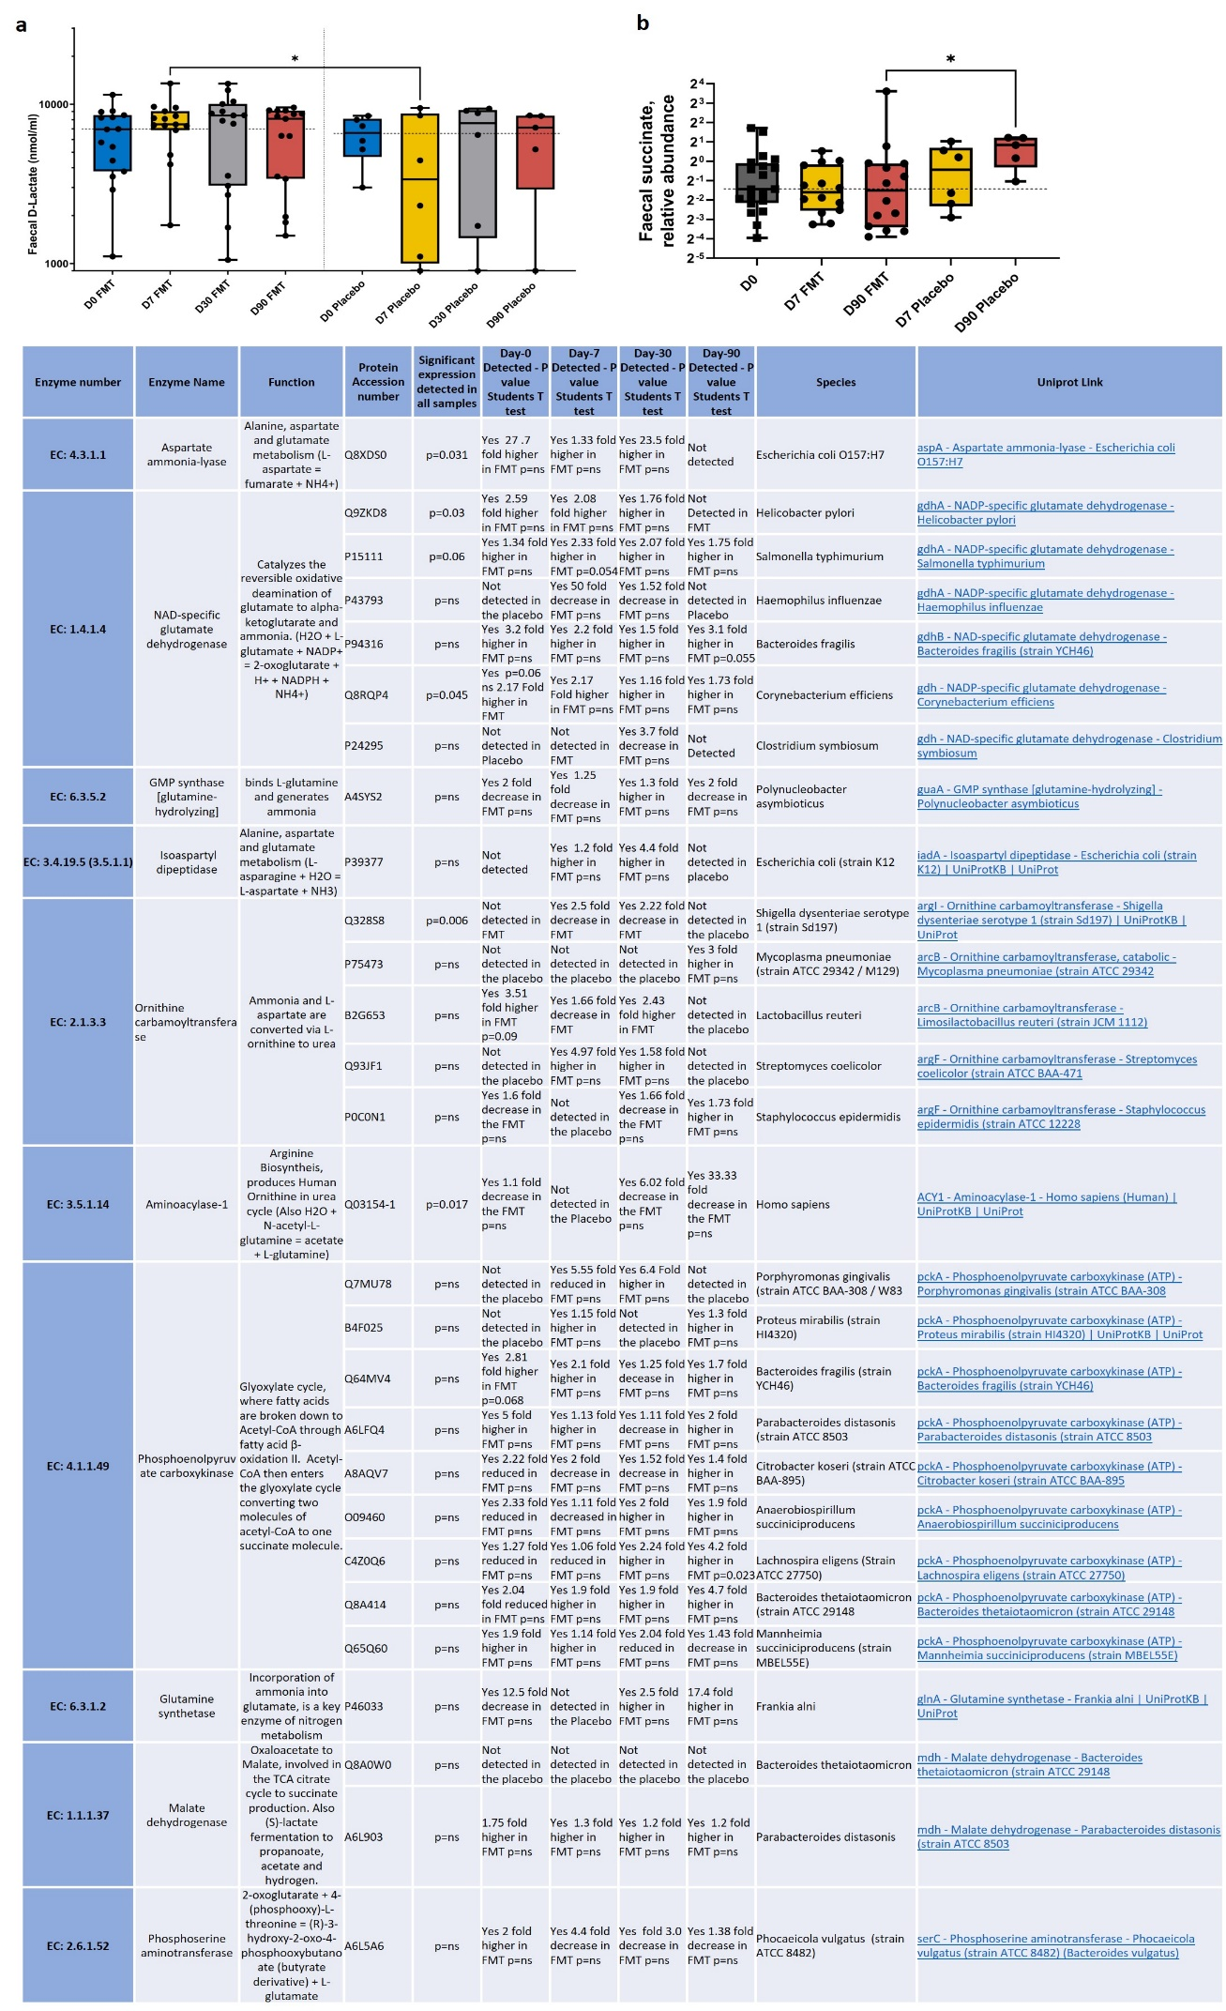
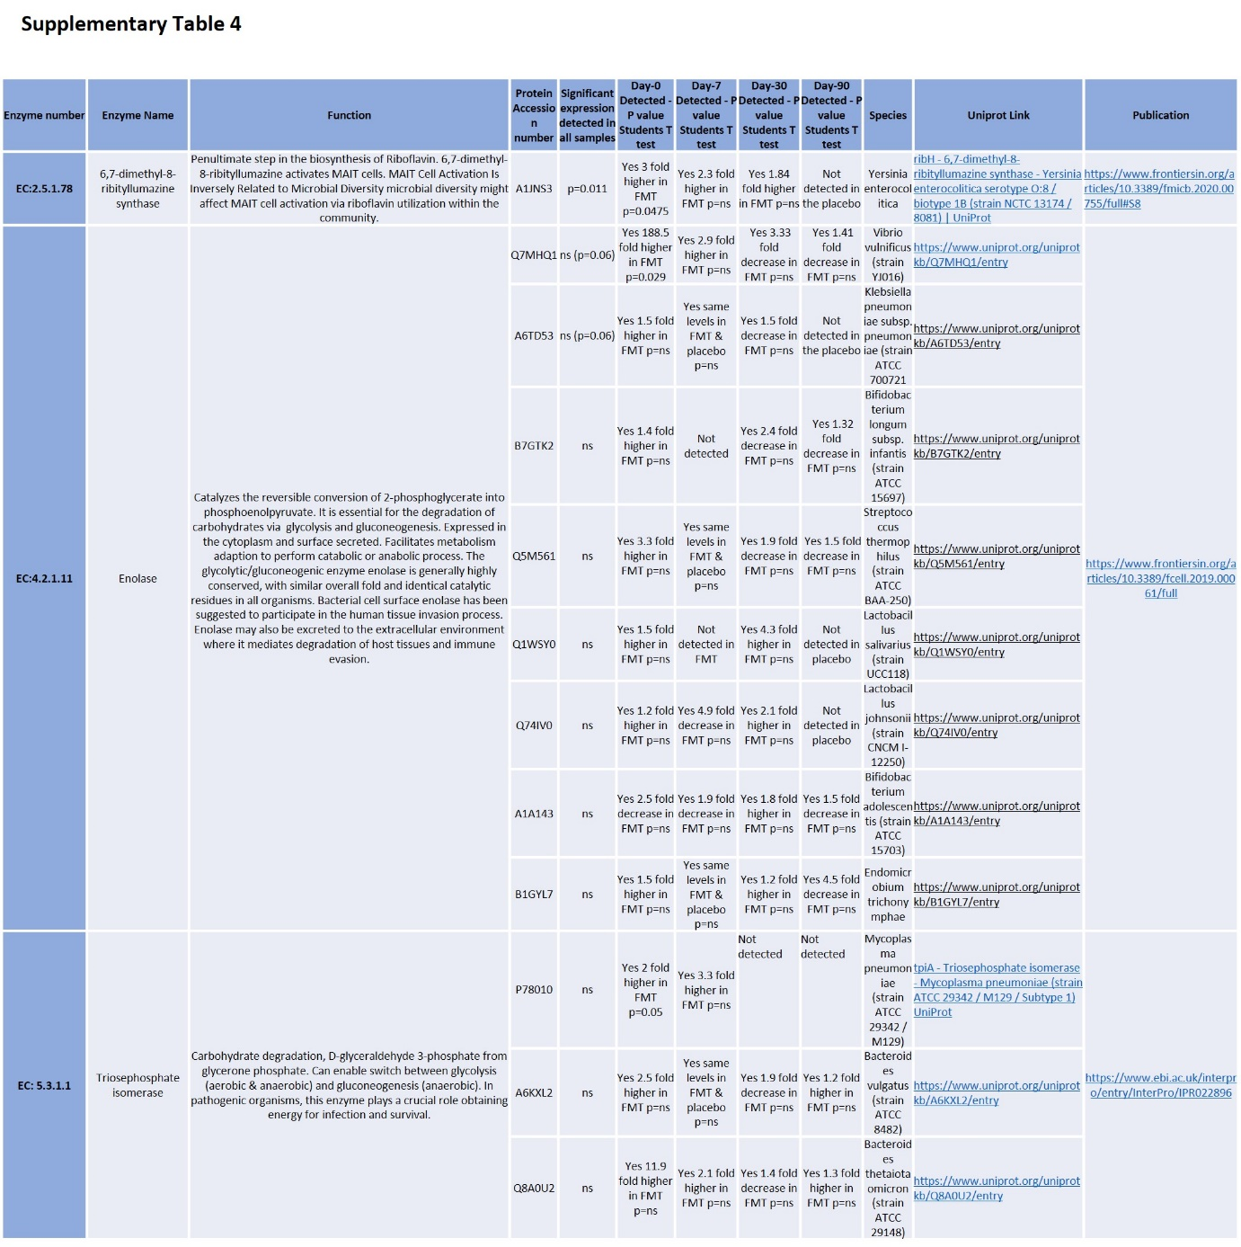

Extended Data Figure 1 Legend
Faecal D-Lactate levels (a) and faecal succinate levels (b) at baseline and at days 7, 30 or 90 post-FMT or placebo administration are shown. Undigested carbohydrate is fermented to D-lactate by lactic acid–producing bacteria (LAB) present in the colon. In dysbiosis LAB species are either lost or, with excessive carbohydrate consumption, overgrown. At day-7 faecal D-lactate levels increased post-FMT treatment compared to placebo [p=0.043; Extended data Figure 1]. Indicative that the enhanced carbohydrate fermentation is due to an increase in depleted LAB. Levels of faecal succinate detected in the stool remained stable across over 90-days in the FMT group. However, there was a significant increase in faecal succinate in the placebo group at day 90 compared to the FMT group (p=0.026; extended data Figure 1b).

Faecal proteomic analysis by LC-MS/MS quantified 301 proteins, mostly enzymes; 154 proteins found were of human origin and 147 proteins were bacterial in origin. [Supplementary Table 3 and 4]. Analysis post-FMT or placebo administration revealed increases in the abundance of human proteins involved in antimicrobial mucosal barrier defence [Supplementary Table 3], including molecules produced by neutrophils were observed in the FMT group [Figure 3k]. At baseline the neutrophil cathepsin G inhibitor was the most significantly expressed protein detected (p=6.8E⁻⁰⁶), however, by day-7 post-FMT this protein decreased and cathepsin G was the most considerably expressed protein detected in stool. Markers of barrier disruption were enhanced in the stool of the placebo group in comparison to the post-FMT group. Bacterial and human proteins involved in glycolysis and modulation of cell metabolism were modified.

Extended Data Figure 2: Faecal Microbiota Transplant modulates the translocating microbiome.
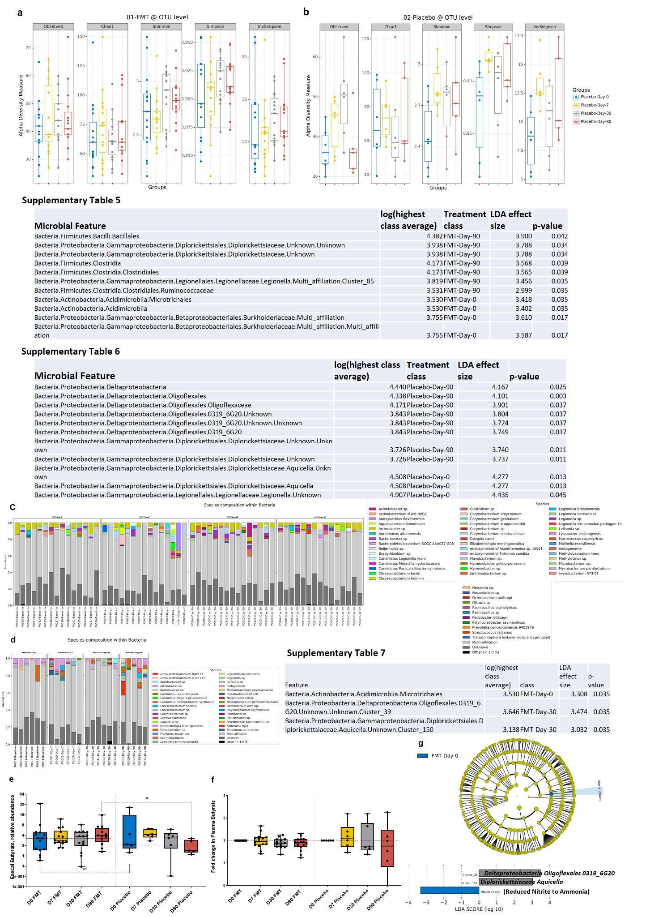

Extended Data Figure 2 Legend
The alpha diversity of the microbiome at the OTU level in whole blood was analysed with different methods 1) Observed, 2) Chao1, 3) Shannon, 4) Simpson, and 5) Inverse Simpson and represented as the median plus interquartile range in patients from baseline (D0) at 7, 30 or 90 days post-FMT (a) or placebo (b) administration. Supplementary Tables 5 and 6 show the FMT and placebo-treated LEfSe analysis performed on the complete sequence data (no OTU abundance threshold). From the complete sequence data, taxa are represented as the top 15 most abundant species for the FMT-treated group (c) and from the placebo-treated group (d). Faecal (e) and plasma (f) butyrate levels expressed as fold change in relative abundance in patients from baseline (D0) to 7, 30 or 90 days post-FMT or placebo administration. The LEfSe analysis was performed on the complete sequence data (no OTU abundance threshold). The cladogram represented here indicates the bacterial taxa that are significantly different between the placebo and FMT-treated groups (Supplementary Table 7) p-value<0.05, Kruskal-Wallis test) in patients from baseline (D0) in comparison to 30 days post-FMT (g) administration.

Extended Data Figure 3: Faecal Microbiota Transplant reduces ammonia-driven systemic inflammation.
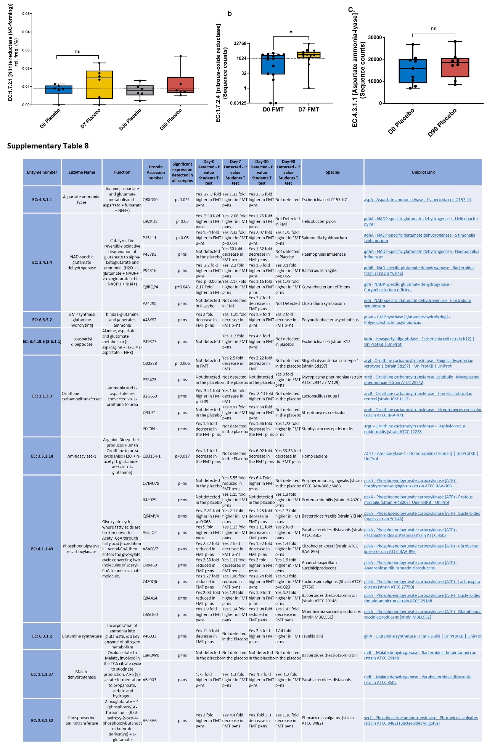

Extended Data Figure 3 Legend
Blood microbiome STAMP analysis revealed increases in the abundance of microbial enzymes involved in nitrogen assimilation and a reduction in those required for denitrification and ammonification. No significant change was observed in EC.1.7.2.1 [nitrite reductase] which converts nitrite to nitric oxide (NO) in the placebo-treated group (a). EC.1.7.2.4 [nitrous-oxide reductase] further reduces NO to nitrogen and was significantly increased (p=0.021) (b). The E.coli enzyme EC.4.3.1.1 [aspartate ammonia-lyase] was significantly enhanced in the blood microbiome 90-days following FMT treatment which was not observed in the placebo (c). Faecal proteomic analysis by LC-MS/MS quantified 301 proteins, mostly enzymes; 154 proteins found were of human origin and 147 proteins were bacterial in origin. In converse to the enzymes found in the blood, increases in the abundance of microbial enzymes involved in denitrification and ammonification were observed in the stool versus a reduction of those required for nitrogen assimilation and excretion via the urea cycle [Supplementary Table 8].

