- Synthesis of chalcones

1.1 Derivatives of 4-hydroxy benzaldehyde

Methylation
A total of 500 mg of 4-hydroxybenzaldehyde (1 eq./4.09 mmol) and 1.13 g of potassium carbonate (K₂CO₃ - 2 eq./8.18 mmol) were weighed and added to a 50 mL Erlemeyer flask, with dimethylformamide (DMF) as solvent (Figure 1). Then, 319 mg of dimethyl sulfate ((CH₃O)₂SO₂ -1 eq, 4.09 mmol) was added, the reaction was kept under magnetic stirring for 24 hours being monitored by Thin Layer Chromatography Analytical (CCDA). After the 24 hours the reaction was stopped and processed by partitioning in ethyl acetate (C₄H₈O₂) and water, where the extracted organic phase was treated with anhydrous sodium sulfate (Na₂SO₄) and then concentrated under reduced pressure, obtaining an approximate yield of 93.29% (Winter et al., 2016).

Figure 1 - Methylation on the free hydroxyl of 4-hydroxybenzaldehyde.
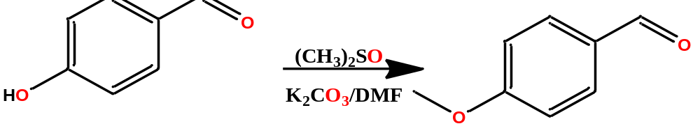
Source: Author, 2021.

Ethylation
4-Hydroxybenzaldehyde (1 eq./4.09 mmol) was ethylated using ethyl bromide (C₂H₅Br - 1 eq./2.17 mmol) and K₂CO₃ (2 eq./4.34 mmol) as catalyst, using DMF as solvent, under magnetic stirring for 24 hours (Figure 2). The reaction was monitored by CCDA and after 24 hours was processed by partitioning in ethyl acetate and water, where the extracted organic phase was treated with anhydrous sodium sulfate and then concentrated under reduced pressure. A white powder was obtained with an approximate yield of 92.15% (Winter et al., 2016).

Figure 2 - Ethylation at the free hydroxyl of 4-hydroxybenzaldehyde.
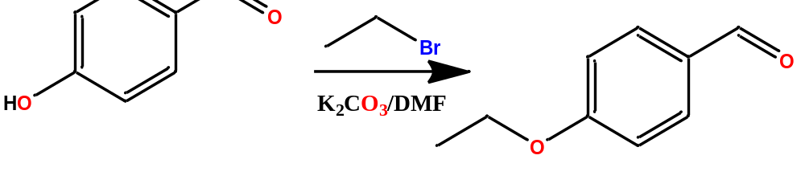
Source: Author, 2021.

Allylation
4-hydroxybenzaldehyde (1 eq./4.09 mmol) was allylated using allyl bromide (C₃H₅Br - 1 eq, 2.17 mmol) and K₂CO₃ (2 eq./4.34 mmol) as catalyst, with DMF as solvent, the reaction was kept under magnetic stirring for 24 hours (Figure 3), being monitored by CCDA. After the 24 hour period, the reaction was processed by partition in ethyl acetate and water, where the extracted organic phase was treated with anhydrous sodium sulfate and then concentrated under reduced pressure. A white powder was obtained with an approximate yield of 90.67% (Winter et al., 2016).

Figure 3 - Allylation in the free hydroxyl of 4-hydroxybenzaldehyde.

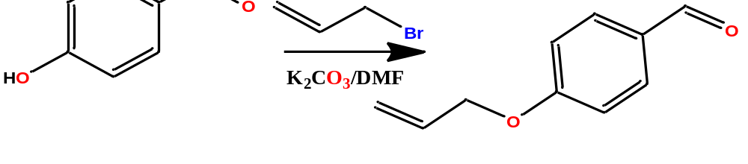
Source: Author, 2021.

Claisen-Schimidt condensation
3,4-(methylenedioxy)acetophenone (1 eq./1.85 mmol) was subjected to a Claisen-Schimidt condensation with the derivatives obtained from 4-hydroxy benzaldehyde (1 eq. /2.37 mmol), using potassium hydroxide (KOH - 2 eq./3.70 mmol) as catalyst and methyl alcohol as solvent (Figure 4), the system was left under stirring for 8 hours obtaining a precipitate. The precipitate was filtered and washed with water and methanol, subsequently it was dried at room temperature, obtaining an amorphous powder of yellowish colour, with yields ranging between 85% and 92% (Winter et al., 2016).

Figure 4 - Aldol condensation of derivatives obtained from 4-hydroxybenzaldehyde with 3,4-(methylenedioxy)acetophenone.

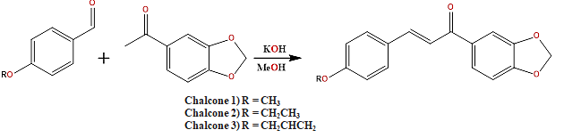
Source: Author, 2021.

Chalcone 1 = (E)-3-(4-(aliloxi)fenil)-1-(benzo[d] [1,3]dioxol-5-il)prop-2-en-1-ona

Chalcone 2 = (E)-1-benzo[d][1,3]dioxol-5-il)-3-(4-etoxifenil)prop-2-en-1-ona

Chalcone 3 = (E)-1-benzo[d][1,3]dioxol-5-il)-3-(4-metoxifenil)prop-2-en-1-ona

1.2 Synthesis of bromo-chalcone

Preparation of bromo-vanillin
Initially a bromination was performed on vanillin (Figure 5), for this 2 g of vanillin (1 mmol) was weighed and added to a round bottom flask of volume 150 ml. Then DMF was added in sufficient amount for complete dissolution of vanillin. The next step was the addition of 100 mL of a solution with acetic acid and bromine (Br₂/AcOH - 0.32 molar), the reaction system was left under magnetic stirring at room temperature (approximately 30 °C) for 14 hours. After 14 hours, the stirring was stopped, there was a decantation of the white solid, the system was filtered and the solid obtained was washed with distilled water, dried in a desiccator under reduced pressure, obtaining 900 mg of the precipitate with a yield of 45%. This process was monitored by CCDA (Winter et al., 2016).

Figure 5 – Bromination reaction of vanillin.

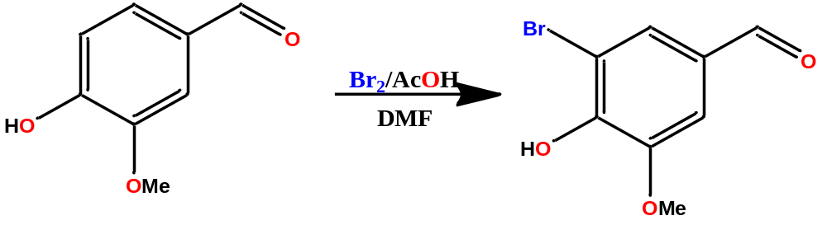
Source: Author, 2021.

Ethylation of bromo-vanillin
Bromo-vanillin was ethylated using the same method as described above, with bromo-vanillin (1 eq./2.17 mmol), ethyl bromide (1 eq./2.17 mmol) and K₂CO₃ (2 eq./4.34 mmol) as catalyst, DMF was used as solvent. The reaction was kept under magnetic stirring for 24 hours (Figure 6), being monitored by CCDA. After 24 hours the reaction was processed by partition in ethyl acetate and water, where the extracted organic phase was treated with anhydrous sodium sulfate and then concentrated under reduced pressure. A white powder was obtained with an approximate yield of 89.40 % for bromo ethyl vanillin (Winter et al., 2016).

Figure 6 - Ethylation on the free hydroxyl of bromo-vanillin.
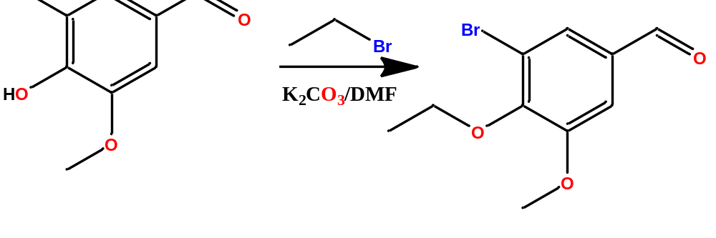
Source: Author, 2021.

Shyntesis of bromo-chalcone
Once bromo ethyl vanillin was obtained, it (1 eq./1.85 mmol) was subjected to an aldolic condensation with 3,4-(methylenedioxy)acetophenone (1 eq./1.85 mmol), using KOH (2 eq./3.70 mmol) as catalyst and methyl alcohol as solvent (Figure 7). The system was left under stirring for 8 hours obtaining a yellowish precipitate that was filtered and washed with water and methanol, then dried at room temperature, obtaining an amorphous powder of yellowish colour, with an approximate yield of 90% (Winter et al., 2016).

Figure 7 - Aldolic condensation between bromo ethyl vanillin and 3,4-(methylenedioxy) acetophenone.

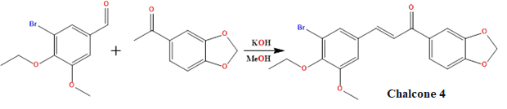
Source: Author, 2021.

Chalcone 4 = (E)-1-benzo[d][1,3]dioxol-5-il)-3-(3-bromo-4-etoxi-5-metoxifenil)prop-2-en-1-ona

- Characterization of chalcones

Chalcone 1
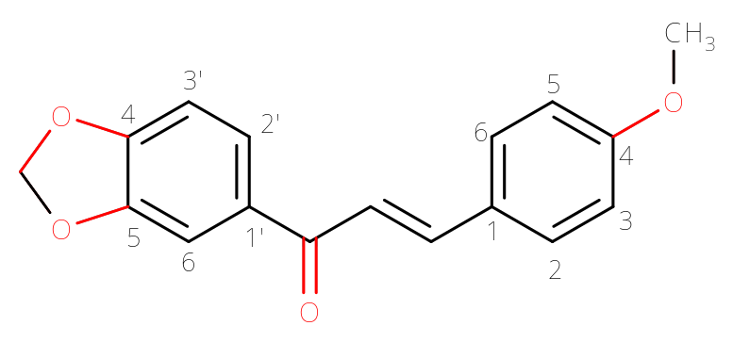

Yellowish amorphous solid with a melting point between 147.1 - 148.0 °C.
 | ^{δ}H | ^{δ}C
C
1 | - | 127.81
4 | - | 161.66
1’ | - | 133.32
4’ | - | 151.59
5’ | - | 148.31
C=O | - | 188.33
CH
2 | 7.56(d); J = 8.7 | 130.20
3 | 6.90(d); J = 8.7 | 114.38
5 | 6.90(d); J = 8.7 | 114.38
6 | 7.56(d); J = 8.7 | 130.20
2’ | 7.62(dd); J = 8.1 and 1.7 | 124.54
3’ | 6.86(d); J = 8.1 | 107.95
6’ | 7.51(d); J = 1.6 | 108.49
α | 7.34(d); J = 15.5 | 119.47
Β | 7.74(d); J = 15.5 | 144.14
O₂CH₂ | 6.03(s) | 101.90
OCH₃ | 3.83(s) | 55.47

Chalcone 1 - ¹H (CDCl₃, 400MHz)
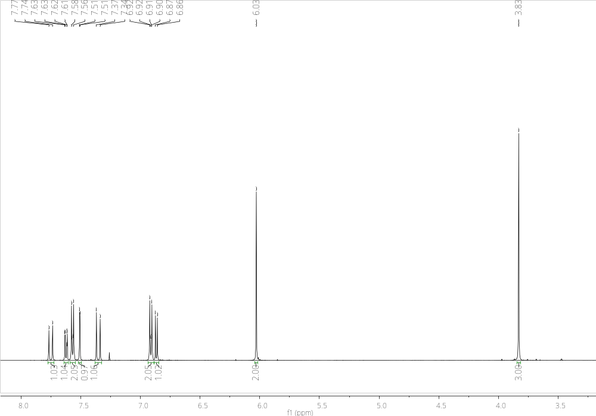
Chalcone 1 - Expansion ¹H (CDCl₃, 400MHz)
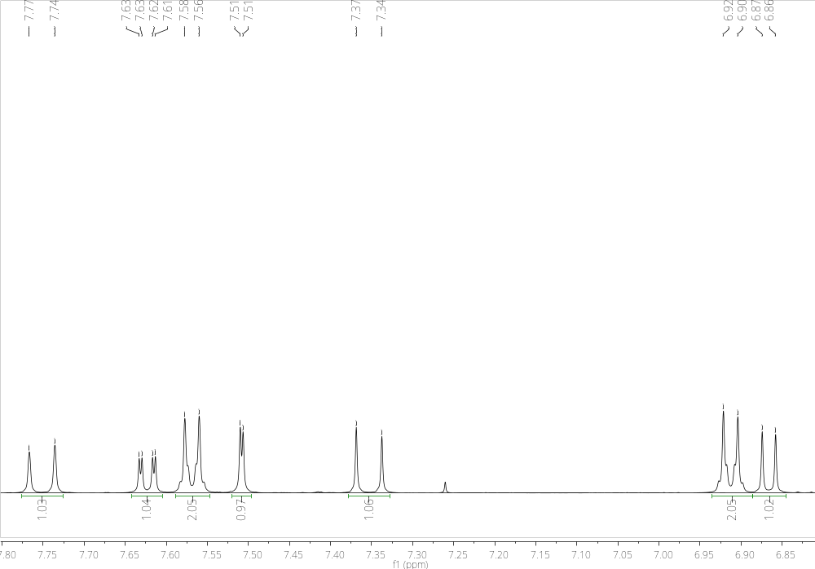
Chalcone 1 - ¹³C (CDCl₃, 100MHz)
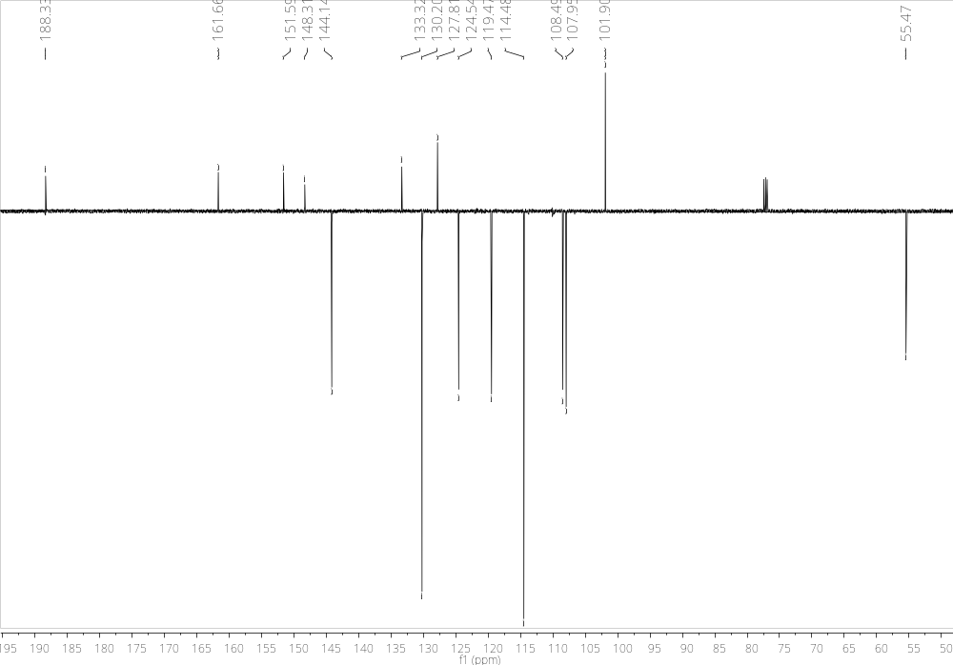

Chalcone 2
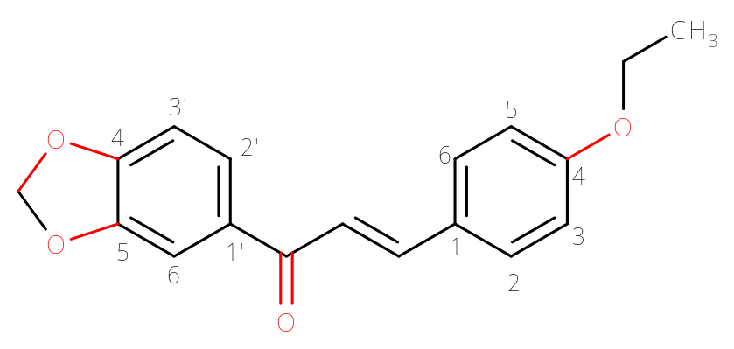

Yellowish amorphous solid with a melting point between 125.0 - 126.0 °C.
 | ^{δ}H | ^{δ}C
C
1 | - | 127.47
4 | - | 160.94
1’ | - | 133.20
4’ | - | 151.42
5’ | - | 148.15
C=O | - | 188.12
CH
2 | 7.54(d); J = 8.7 | 130.07
3 | 6.88(d); J = 8.7 | 114.80
5 | 6.88(d); J = 8.7 | 114.80
6 | 7.54(d); J = 8.7 | 130.07
2’ | 7.60(dd); J = 8.2 and 1.7 | 124.38
3’ | 6.85(d); J = 8.2 | 107.79
6’ | 7.49(d); J = 1.7 | 108.34
α | 7.33(d); J = 15.6 | 119.7
β | 7.73(d); J = 15.6 | 144.08
O₂CH₂ | 6.01(s) | 101.74
OCH₂CH₃
CH₂ | 4.04(q) | 63.47
CH₃ | 1.40 (s) | 14.65

Chalcone 2 - 1H (CDCl3, 400MHz)
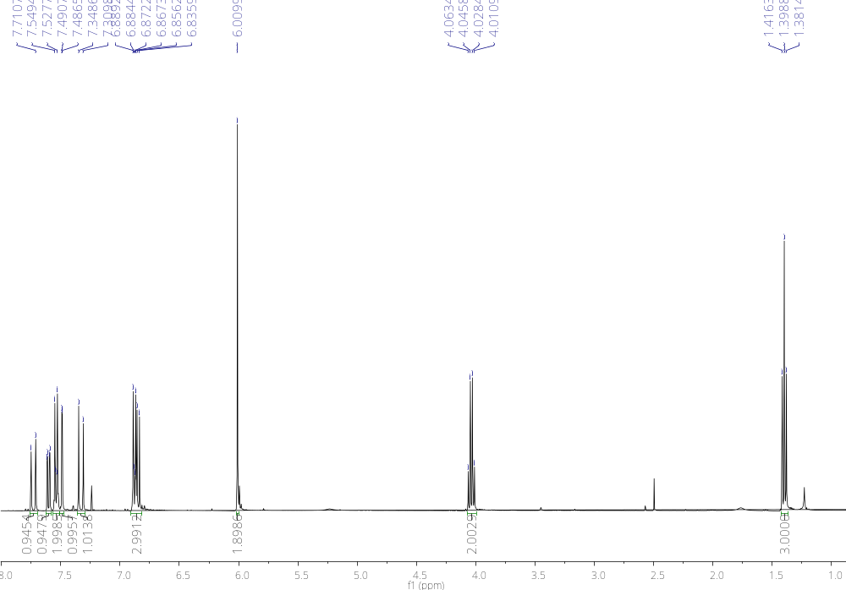
Chalcone 2 - Expansion 1H (CDCl3, 400MHz)
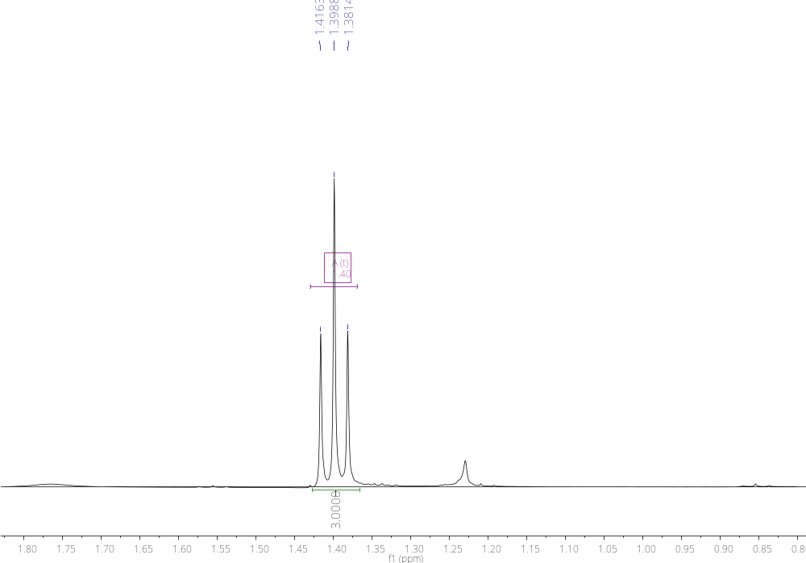
Chalcone 2 - Expansion ¹H (CDCl₃, 400MHz)
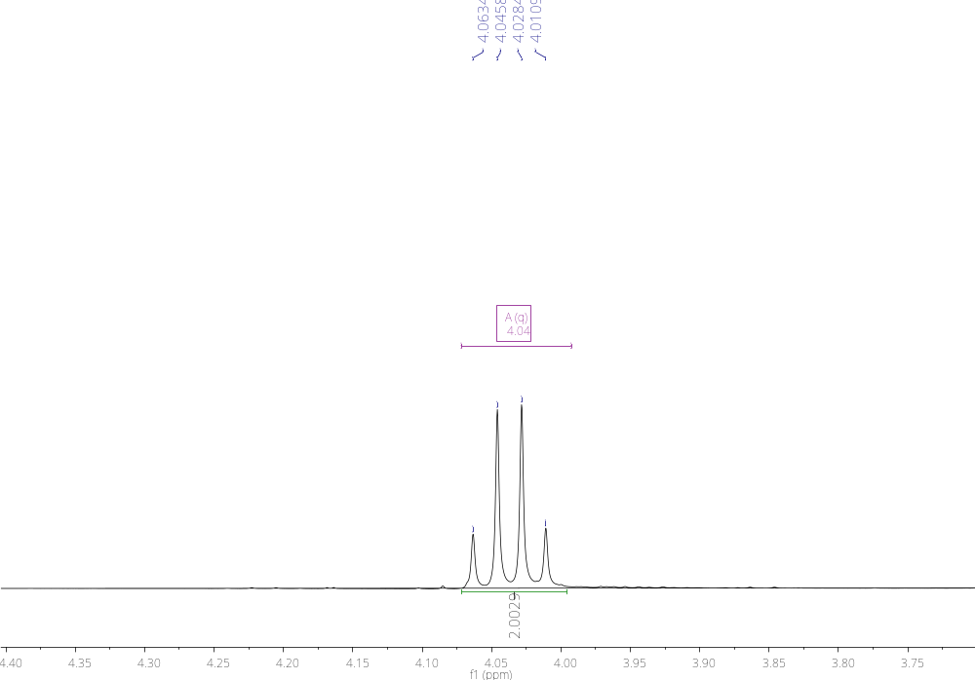
Chalcone 2- Expansion ¹H (CDCl₃, 400MHz)
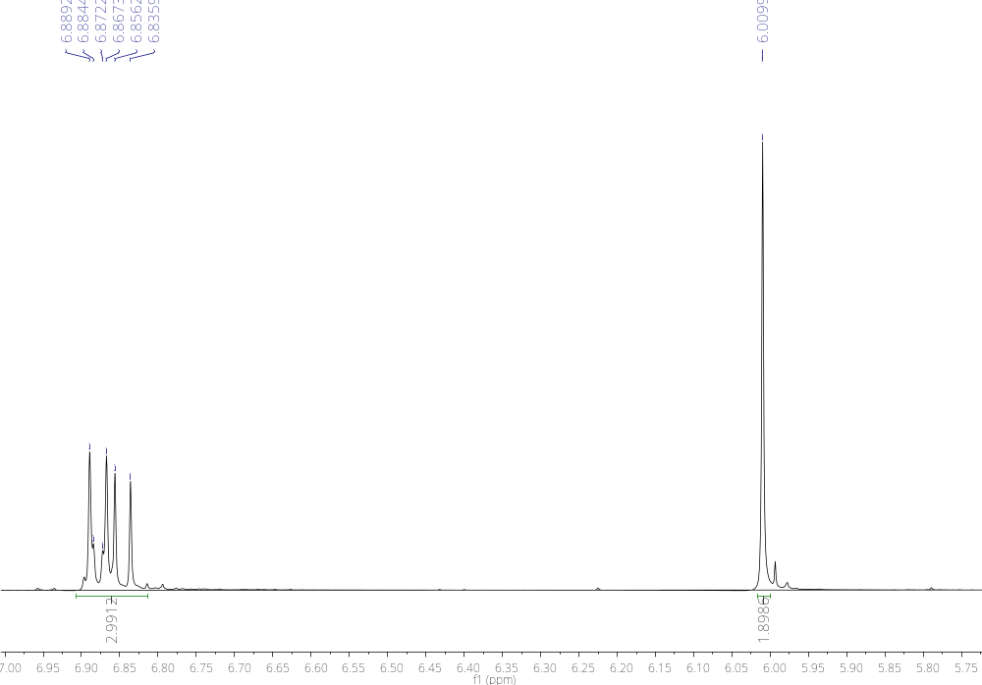
Chalcone 2 - Expansion ¹H (CDCl₃, 400MHz)
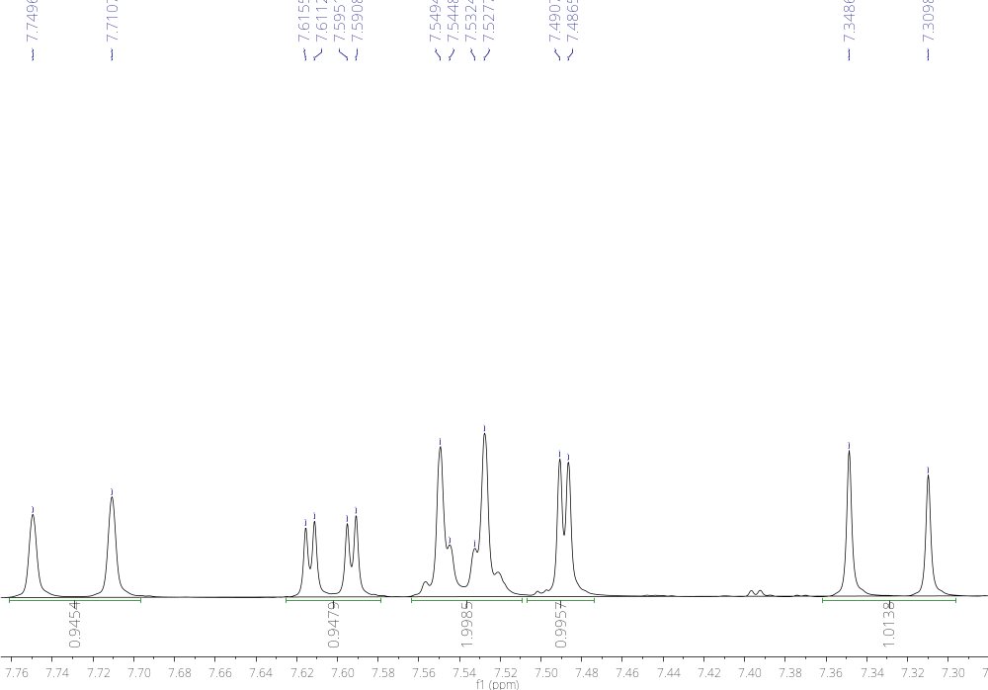
Chalcone 2 - ¹³C (CDCl₃, 100MHz)
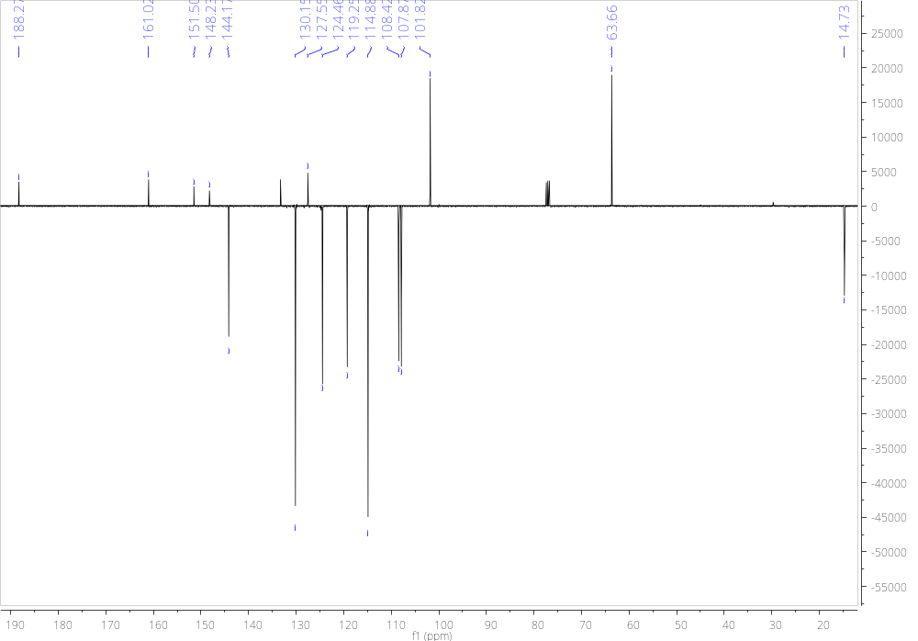

Chalcone 3
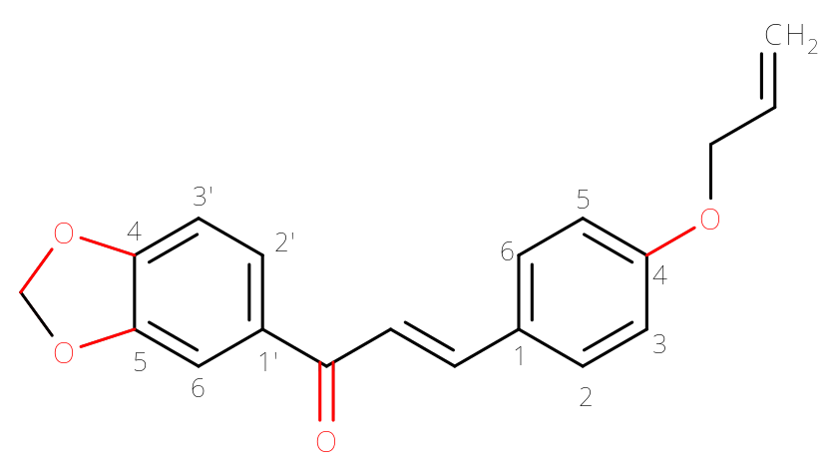

Amorphous, yellowish solid with a melting point between 104.7 - 105.0 °C.
 | ^{δ}H | ^{δ}C
C
1 | - | 127.81
4 | - | 160.53
1’ | - | 133.20
4’ | - | 151.47
5’ | - | 148.19
C=O | - | 188.23
CH
2 | 7.55(d); J = 8.7 | 130.06
3 | 6.91(d); J = 8.7 | 115.10
5 | 6.91(d); J = 8.7 | 115.10
6 | 7.55(d); J = 8.7 | 130.06
2’ | 7.61(dd); J = 8.2 and 1.6 | 124.42
3’ | 6.86(d); J = 8.1 | 107.83
6’ | 7.49(d); J = 1.6 | 108.37
α | 7.33(d); J = 15.6 | 119.42
β | 7.73(d); J = 15.6 | 144.00
O₂CH₂ | 6.02(s) | 101.77
OCH₂CHCH₂
CH₂ | 4.55(d); J = 5.3 | 68.83
CH | 6.03(m) | 132.71
CH₂ | HA 5.40(dd);  J = 17.3 e 1.4  HB 5.29(dd);  J = 10.5 e 1.4 | 117.98
Chalcone 3 - 1H (CDCl3, 400MHz)
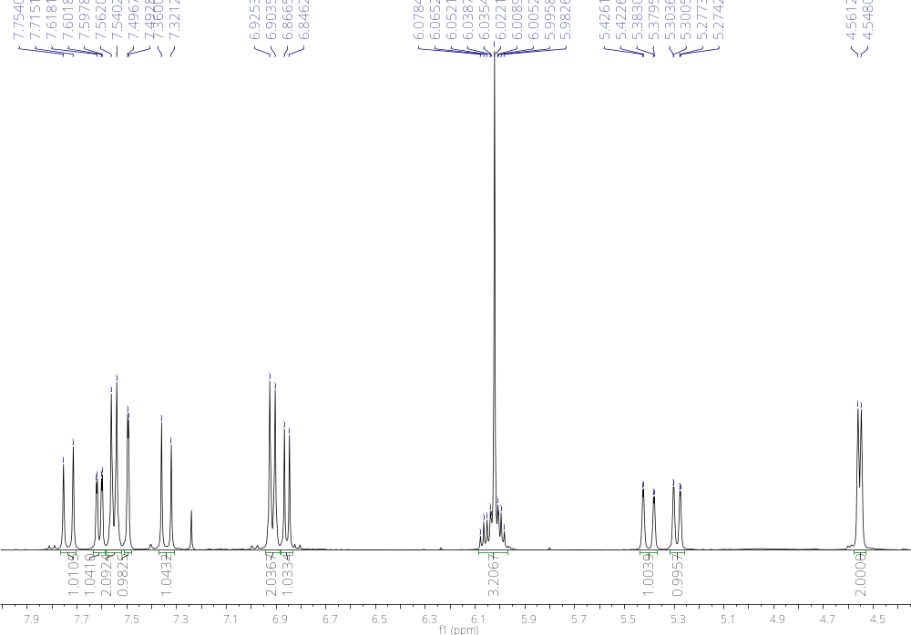
Chalcone 3 - Expansion 1H (CDCl3, 400MHz)
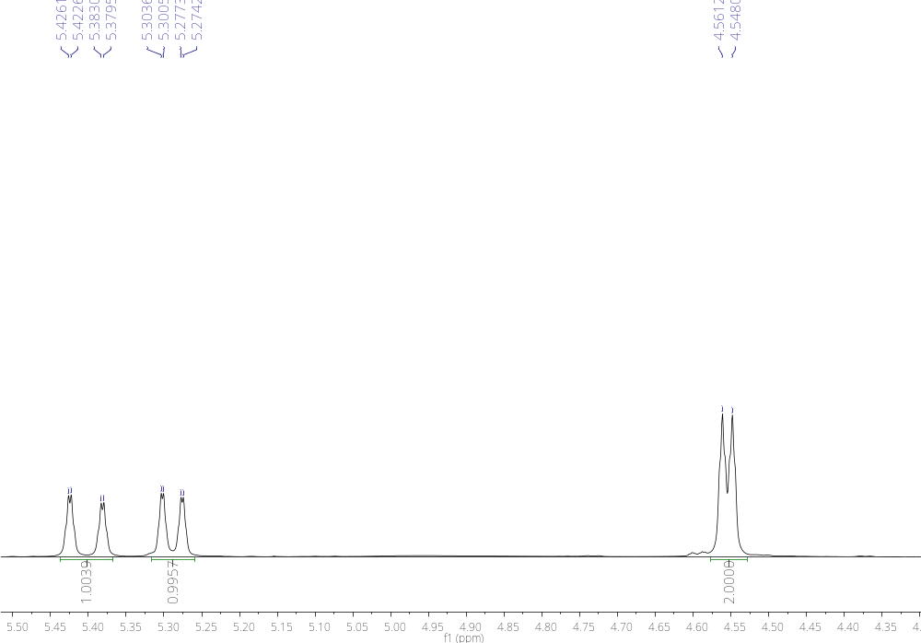
Chalcone 3 - Expansion 1H (CDCl3, 400MHz)
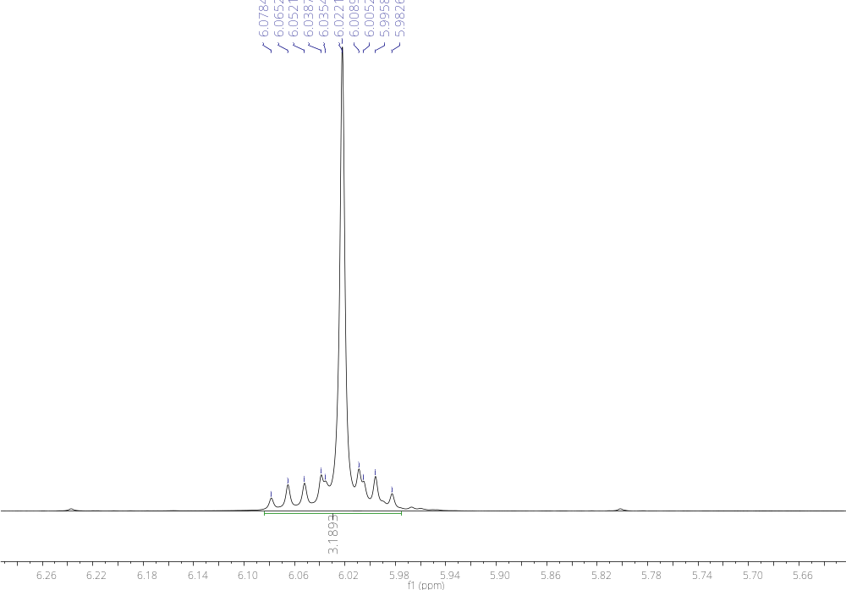
Chalcone 3 - Expansion 1H (CDCl3, 400MHz)
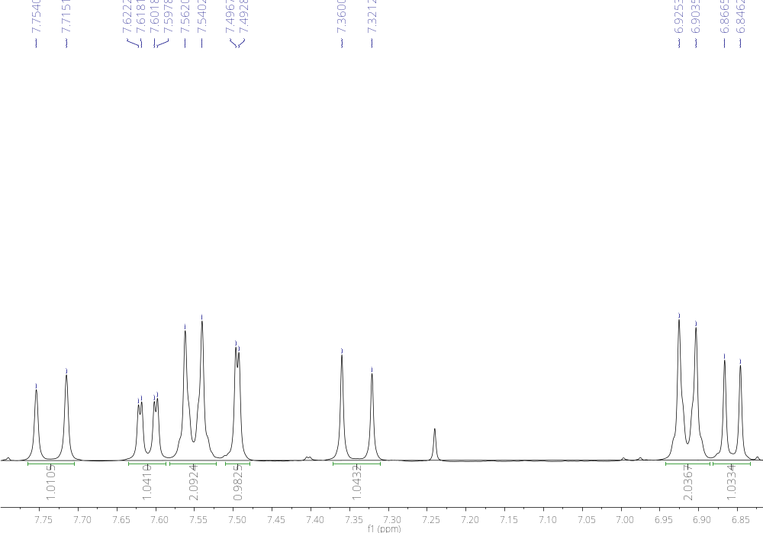
Chalcone 3 - ¹³C (CDCl₃, 100MHz)
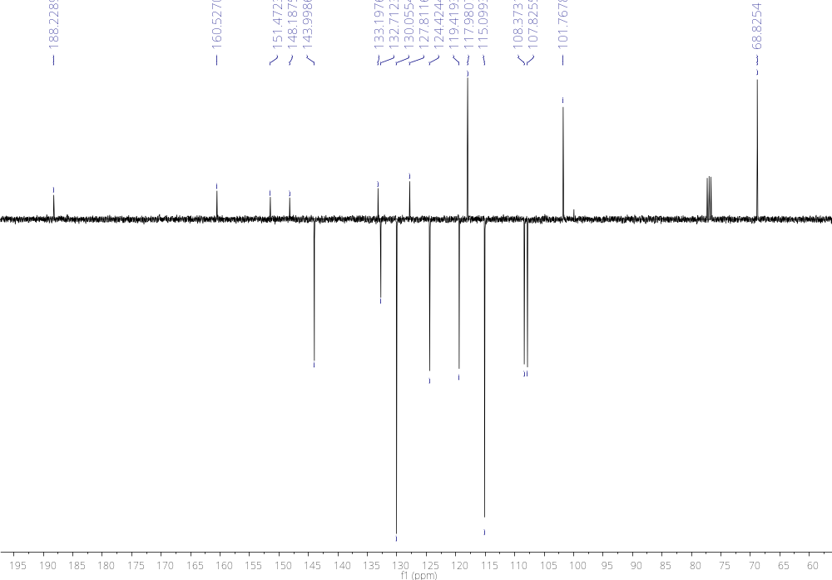

Chalcone 4
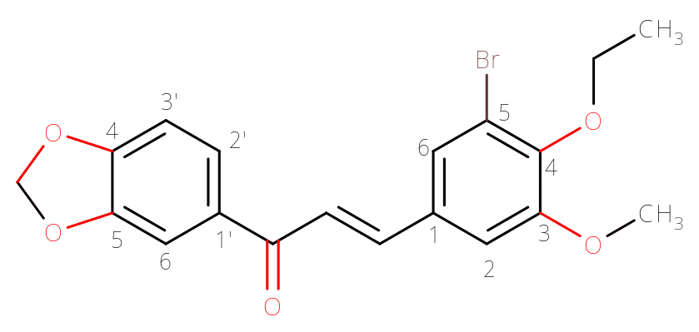
Amorphous, yellowish solid with a melting point between 112.6 - 115.2 °C.
 | ^{δ}H | ^{δ}C
C
1 | - | 131.83
3 | - | 153.91
5 | - | 118.63
4 | - | 148.34
1’ | - | 132.80
4’ | - | 151.81
5’ | - | 148.34
C=O | - | 187.89
CH
2 | 7.03(d); J = 1.9 | 111.50
6 | 7.44(d); J = 1.9 | 124.80
2’ | 7.62(dd); J = 8.2 and 1.8 | 124.69
3’ | 6.88(d); J = 8.2 | 107.87
6’ | 7.50(d); J = 1.8 | 108.32
α | 7.35(d); J = 15.5 | 121.93
β | 7.62(d); J = 15.5 | 142.42
O₂CH₂ | 6.05(s) | 101.90
OCH₃ | 3.89(s) | 56.19
OCH₂CH₃
CH₂ | 4.11(q); J = 7.1 | 69.43
CH₃ | 1.41(s); J = 7.1 | 15.50

Chalcone 4 - ¹H (CDCl₃, 400MHz)
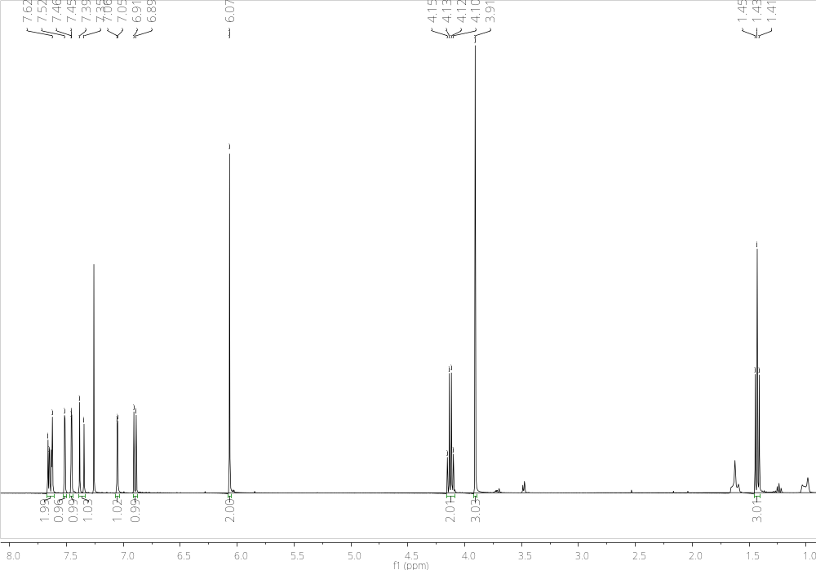

Chalcone 4 - Expansion ¹H (CDCl₃, 400MHz)
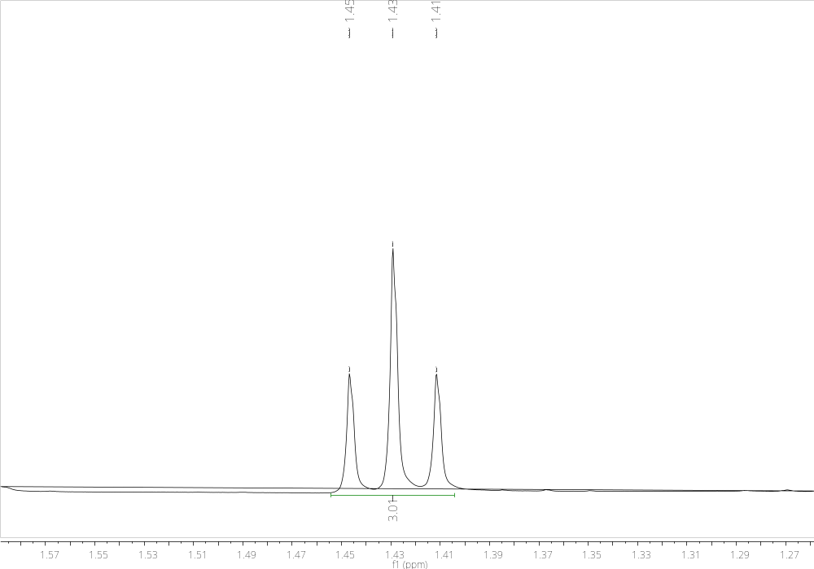
Chalcone 4 - Expansion ¹H (CDCl₃, 400MHz)
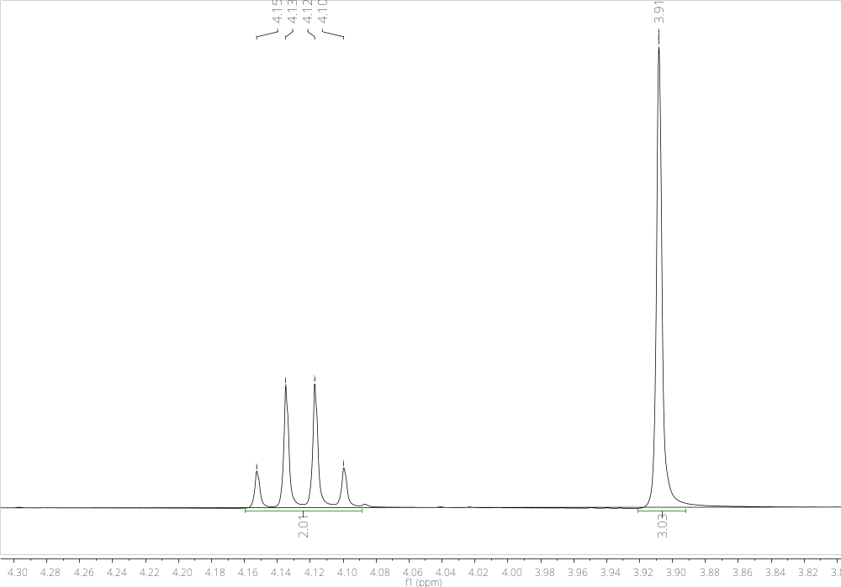
Chalcone 4 - Expansion ¹H (CDCl₃, 400MHz)
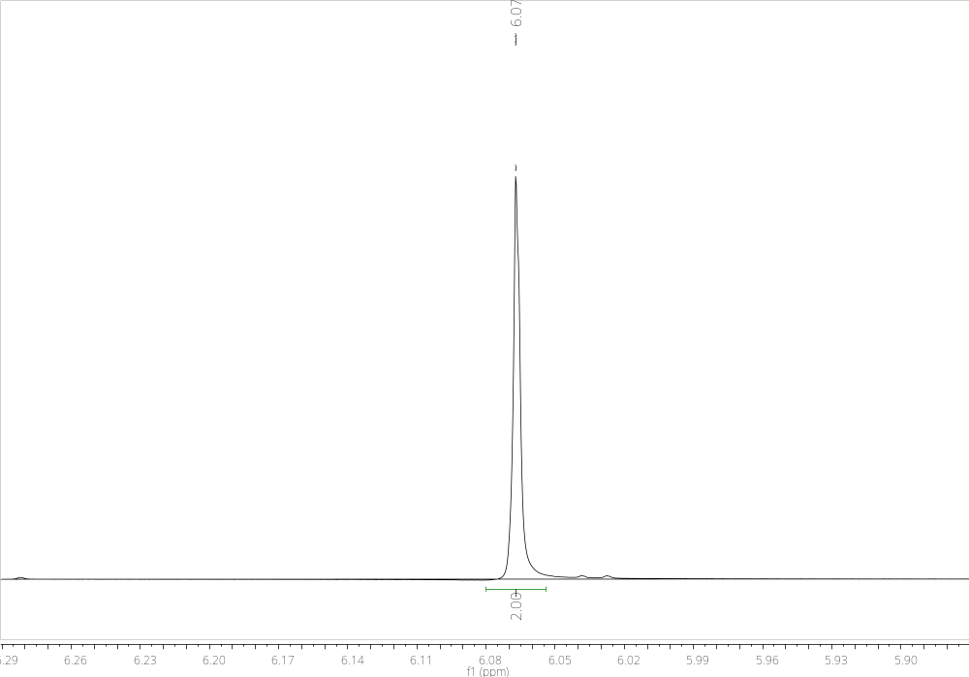
Chalcone 4 - Expansion ¹H (CDCl₃, 400MHz)
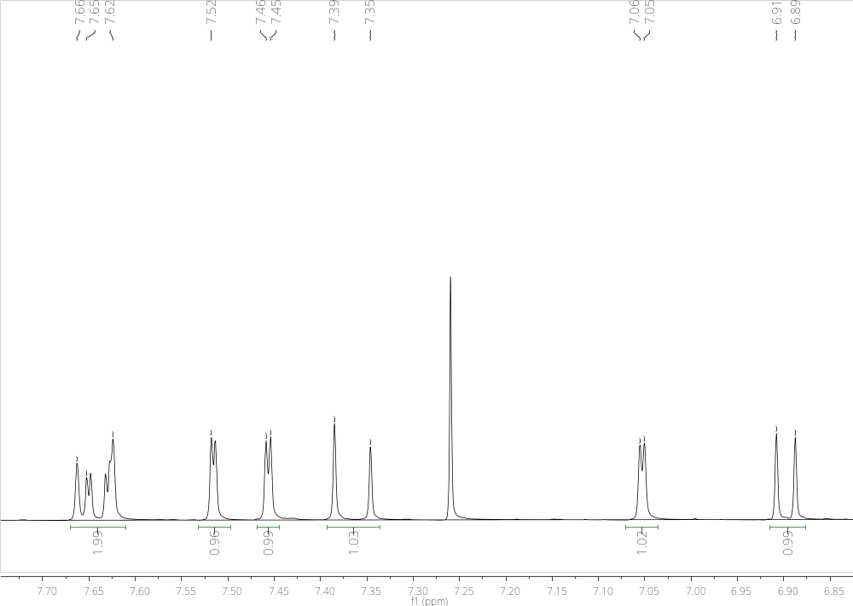
Chalcone 4 - ¹³C (CDCl₃, 100MHz)
