Extended Data:
Cascade-amplification of melanoma-targeted radio-immunotherapy via fusogenic liposomes functionalized with multivariate-gated aptamer assemblies
Rui Xue,^{1†} Xijiao Ren,^{2†} Shuang Wang,¹ Xinyue Ge,¹ Xuemei Yao,¹ Liqi Li,³ Junxia Min,⁵ Menghuan Li, ¹* Zhong Luo,^{1,2}* Fudi Wang ^{4,5}*
¹ School of Life Science, Chongqing University, Chongqing 400044, P. R. China.
² Key Laboratory of Biorheological Science and Technology, Ministry of Education, Chongqing University, Chongqing 400044, P. R. China.
³ Department of General Surgery, Xinqiao Hospital, Army Medical University, Chongqing 400037, P. R. China.
⁴ The First Affiliated Hospital Basic Medical Sciences, School of Public Health Hengyang Medical School University of South China, Hengyang 421001, P. R. China.
⁵ The Second Affiliated Hospital, The First Affiliated Hospital School of Public Health Institute of Translational Medicine State Key Laboratory of Experimental Hematology, Zhejiang University School of Medicine, Hangzhou 310058, China.
†Rui Xue and Xijiao Ren contributed equally to this work.
Email:
Fudi Wang: fwang@zju.edu.cn
Zhong Luo: luozhong918@cqu.edu.cn
Menghuan Li: menghuanli@cqu.edu.cn
Fig.1. Sequences for aptamers and peptide nucleic acids used in this paper.

Fig.2. Physicochemical characterization of liposomal samples. (a) Zeta potential changes of Lip@AUR-ACP-aptPD-L1 during synthesis, I: Lip, II: Lip@AUR, III: Lip@AUR-ACP, IV: Lip@AUR-ACP-aptPD-L1. (b) Particle size changes of Lip@AUR-ACP-aptPD-L1 during synthesis, I: Lip, II: Lip@AUR, III: Lip@AUR-ACP, IV: Lip@AUR-ACP-aptPD-L1.

Fig.3. Standard curve calibration analysis for drug loading into the liposomes. (a) The fluorescence values of AUR at different concentrations and (b) the corresponding standard curve. (c) Fluorescence spectra of eCpG^{Cy5} at different concentrations. (d) Fluorescence spectra of aptPD-L1^{FAM} at different concentrations.

Fig.4. Schematic demonstration for the calculation of average number of aptamers on the liposomal surface. Notable parameters are described in the figure text.

Fig.5. Cytotoxicity analysis. MTT assay was used to determine the melanoma killing effect of Lip@AUR and Lip@AUR-aptPD-L1 under different concentrations.

Fig.6. Interaction between liposomes and normal cells. CLSM imaging on the fusion of Lip@Dil-aptPD-L1 with NIH3T3 cell membrane at different time points, I: PBS, II: Lip@Dil, III: Lip@Dil-aptPD-L1.

Fig.7. AUR delivery efficacy of liposomes. The content of AUR in B16F10 cells treated with I: PBS, II: Lip@AUR, and III: Lip@AUR-aptPD-L1 via ICP test.

Fig.8. Radiosensitization effect of liposomes in vitro. (a-b) MTT assay on the cytotoxic impact combined Lip@AUR-aptPD-L1 and IR treatment on (a)B16F10 cells or (b) immune cells.

Fig.9. Radiosensitization effect of AUR-containing liposomes under low-dose IR. Viabilities of B16F10 cells after treatment with Lip@AUR-aptPD-L1 combined with 4Gy radiation.

Fig. 10. Transcriptome sequencing of Lip@AUR-aptPD-L1 treated B16F10 cells. (a) KEGG pathway classification results of B16F10 cells. (b) KEGG enrichment results of B16F10 cells.

Fig.11. Quantitative WB analysis in vitro. (a-b) Statistical analysis of WB results regarding proteins of interest in B16F10 cells treated by I: PBS, II: Lip, III: Lip-aptPD-L1, IV: Lip-ACP-aptPD-L1, V: Lip@AUR-aptPD-L1, VI: Lip@AUR-ACP-aptPD-L1. (a) IR excluded. (b) IR included.

Fig.12. Immunosuppressive cell recruitment in vitro. (a-b) Frequency of (a)Tregs+ (CD25+/CTLA-4+) and (b) MDSCs+ (CD11b+/GR1+) in the tumor cell chamber after treatment with I: PBS, II: Lip, III: Lip@AUR, IV: Lip@AUR-aptPD-L1.

Fig.13. Immunostimulatory analysis in vitro. (a-b) Frequencies of (a) mature DCs (CD80+/CD86+) and (b) activated cytotoxic T cells (CD8a+/IFN-γ+) after treatment with I: PBS, II: Lip, III: Lip@AUR, IV: Lip@AUR-aptPD-L1.

Fig.14. Analysis of treatment-induced ICD in vitro. (a-c) The release of key DAMPs including (a)ATP, (b)HMGB1 and (c)CRT. I: PBS, II: Lip, III: Lip-aptPD-L1, IV: Lip@AUR-aptPD-L1.

Fig.15. AND-gate ACP activation in vitro. (a-b) The release of eCpG from B16F10 cell surface by (a)CLSM imaging and (b)fluorescence spectroscopy.

Fig.16. Treatment-induced stimulatory effect on the adaptive immune system. (a-b) Frequencies of (a) activated DCs (MHCII+) and (b) cytotoxic T cells (CD8a+/IFN-γ+) after treatment with I: PBS, II: Lip, III: Lip-aptPD-L1, IV: Lip-ACP-aptPD-L1, V: Lip@AUR-aptPD-L1, VI: Lip@AUR-ACP-aptPD-L1.

Fig.17. Liposome-augmented radio-immunotherapy boosted DCs function. (a-b) Secretion levels of (a) TNF-α and (b) IL-2 by DCs after treatment with I: PBS, II: Lip, III: Lip-aptPD-L1, IV: Lip-ACP-aptPD-L1, V: Lip@AUR-aptPD-L1, VI: Lip@AUR-ACP-aptPD-L1.

Fig.18. Quantitative analysis of treatment-induced immune activation in vitro. (a-b) Quantitative analysis of DCs maturation parameters (a) (CD80+/CD86+) and (b) (MHCII+). (c-d) Quantitative analysis of effector T cell activation parameters (c) (CD3+/CD8+) and (d) (CD8a+/IFN-γ+). I: PBS, II: Lip, III: Lip-aptPD-L1, IV: Lip-ACP-aptPD-L1, V: Lip@AUR-aptPD-L1, VI: Lip@AUR-ACP-aptPD-L1.

Fig.19. Antitumor evaluation in vitro. (a-b) MTT assay on the B16F10 inhibition effect of I: Lip, II: Lip-aptPD-L1, III: Lip-ACP-aptPD-L1, IV: Lip@AUR-aptPD-L1, V: Lip@AUR-ACP-aptPD-L1. (a) IR excluded or (b) IR included.

Fig.20. Radiosensitization effect in vitro. γ-H2AX immunofluorescence of B16F10 cells after different treatments. I: PBS, II: Lip, III: Lip-aptPD-L1, IV: Lip-ACP-aptPD-L1, V: Lip@AUR-aptPD-L1, VI: Lip@AUR-ACP-aptPD-L1.

Fig.21. Blood circulation time of different samples.

Fig.22. Biodistribution analysis. (a-d) ICP analysis of AUR deposition in major organs and tumors of B16F10 tumor-bearing mice after injection with I: AUR, II: Lip@AUR, III: Lip@AUR-aptPD-L1 at (a) 0h, (b) 6h, (c)12h and (d) 24h.

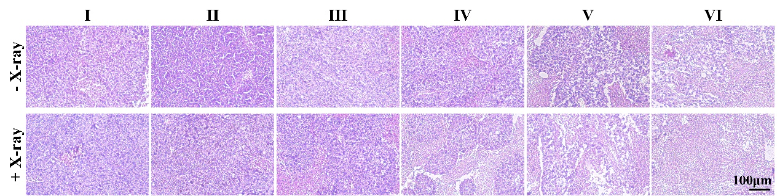
Fig.23. Histological analysis on the treatment-induced antitumor effects. H&E staining of tumor tissues after treatment with I: PBS, II: Lip, III: Lip-aptPD-L1, IV: Lip-ACP-aptPD-L1, V: Lip@AUR-aptPD-L1, VI: Lip@AUR-ACP-aptPD-L1.

Fig.24. Radiosensitization effect in vivo. γ-H2AX immunofluorescence in tumor tissues after treatment with I: PBS, II: Lip, III: Lip-aptPD-L1, IV: Lip-ACP-aptPD-L1, V: Lip@AUR-aptPD-L1, VI: Lip@AUR-ACP-aptPD-L1.

Fig.25. Evaluation on treatment-induced tumor cell ICD in vivo. (a-b) Immunofluorescence staining of (a)CRT and (b)HMGB1 proteins in tumor tissues after treatment with I: PBS, II: Lip, III: Lip-aptPD-L1, IV: Lip-ACP-aptPD-L1, V: Lip@AUR-aptPD-L1, VI: Lip@AUR-ACP-aptPD-L1.

Fig.26. Combined Lip@AUR-aptPD-L1 and IR treatment suppressed immunosuppressive cell infiltration into tumors. (a-b) Frequencies of (a)Tregs+ (CD25+/CTLA-4+) and (b) MDSCs+ (CD11b+/GR1+) in tumor tissues after treatment with I: PBS, II: Lip, III: Lip-@AUR, IV: Lip@AUR-aptPD-L1.

Fig.27. Treatment-induced remodeling of tumor immune microenvironment. (a-b) Frequencies of (a) activated DCs (MHCII+) and (b) effector T cells (CD8a+/IFN-γ+) in tumor tissues after treatment with I: PBS, II: Lip, III: Lip-aptPD-L1, IV: Lip-ACP-aptPD-L1, V: Lip@AUR-aptPD-L1, VI: Lip@AUR-ACP-aptPD-L1.

Fig.28. T cell infiltration in tumor tissues. (a-b) Immunofluorescence staining of (a)CD4 T cells and (b)IFN-γ⁺ CD8+ T cells in tumor tissues after treatment with I: PBS, II: Lip, III: Lip-aptPD-L1, IV: Lip-ACP-aptPD-L1, V: Lip@AUR-aptPD-L1, VI: Lip@AUR-ACP-aptPD-L1.

Fig.29. Biocompatibility analysis. Changes in mouse body weight after different treatments. I: PBS, II: Lip, III: Lip-aptPD-L1, IV: Lip-ACP-aptPD-L1, V: Lip@AUR-aptPD-L1, VI: Lip@AUR-ACP-aptPD-L1, VII: PBS+IR, VIII: Lip+IR, IX: Lip-aptPD-L1+IR, X: Lip-ACP-aptPD-L1+IR, XI: Lip@AUR-aptPD-L1+IR, XII: Lip@AUR-ACP-aptPD-L1+IR.

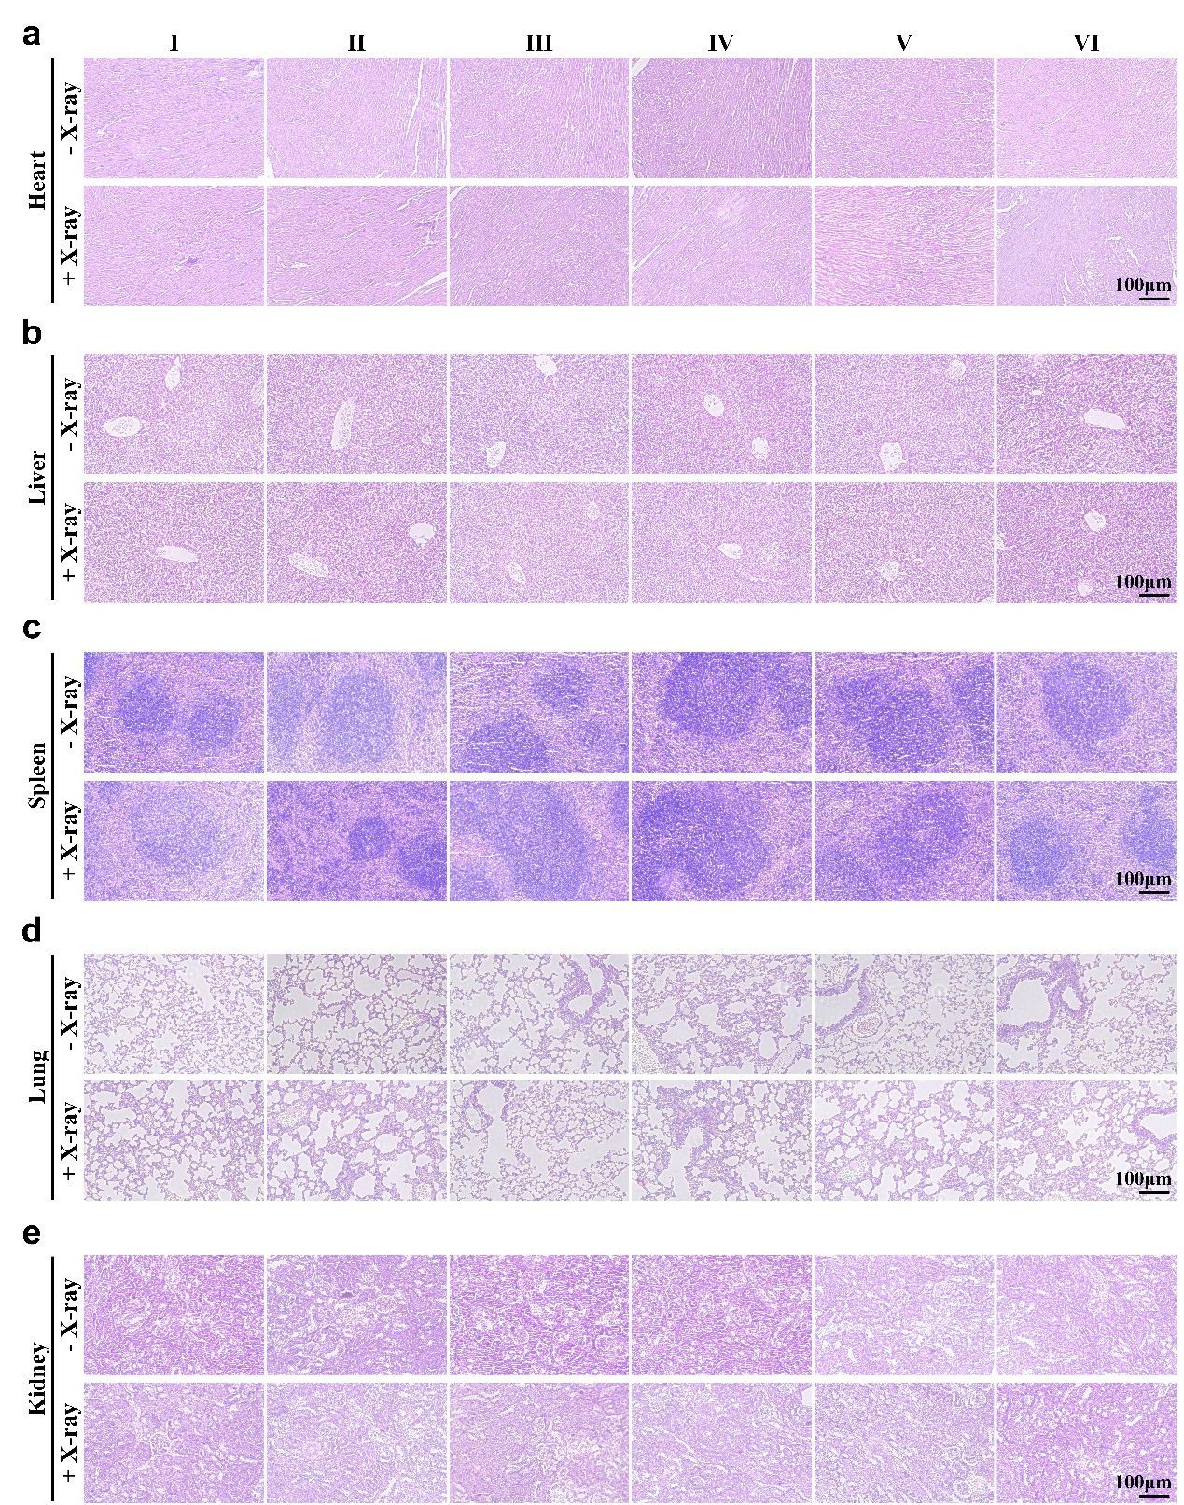
Fig.30. Histological analysis on the biocompatibility of the liposome-augmented radio-immunotherapy in vivo. (a-e) H&E staining of major organs of mice after treatment with I: PBS, II: Lip, III: Lip-aptPD-L1, IV: Lip-ACP-aptPD-L1, V: Lip@AUR-aptPD-L1, VI: Lip@AUR-ACP-aptPD-L1.

Fig.31. Evaluation on treatment-evoked systemic immunity. (a-b) Frequencies of (a) mature DCs (CD80+/CD86+) and (b) effector T cells (CD4+/CD8+) in the primary tumor tissue after treatment with I: PBS, II: Lip, III: Lip-aptPD-L1, IV: Lip-ACP-aptPD-L1, V: Lip@AUR-aptPD-L1, VI: Lip@AUR-ACP-aptPD-L1.

