Table 1 – Head measurements of male and female Caucasians (in milimiters) (Thai et al., 2014)
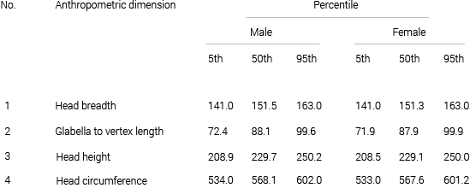

Table 2 - Head measurements of male and female Afro Americans (in milimiters) (Thai et al., 2014)
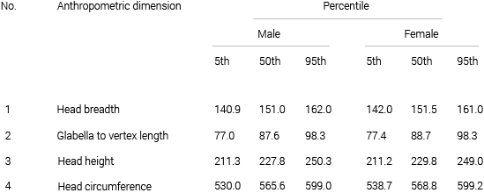

Table 3 - Head measurements of male and female Asians (in milimiters) (Thai et al., 2014)
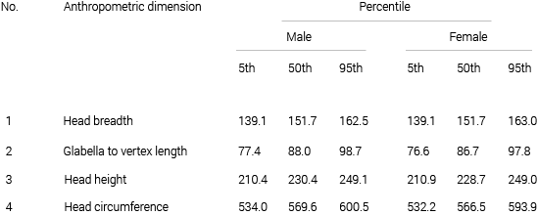

Table 4 - Head measurements of male and female Hispanics (in milimiters) (Thai et al., 2014)
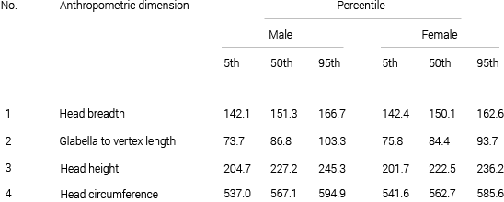

Table 5 – Helmet dimensions for fitting an array of different head shapes and sizes (dimensions in mm)
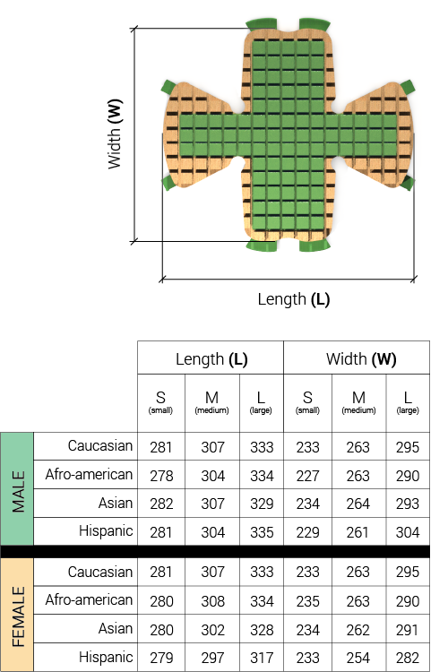

Table 6 – LCA comparison between the proposed helmet solution and an average traditional helmet
