Anamorphoses of geographical regions to illustrate residents’ cognitive maps:
The following images were created to graphically illustrate how residents’ cognitive maps compare against an accurate map of their region. These images were created on QGIS software by morphing the geographical map containing the positions of the landmarks used in both studies towards the positions of the landmarks as reported by the participants.
In general, the cognitive maps tend to be compressed compared to their geographical counterparts. The comparison between Parisian private and public transport users’ cognitive maps highlights a more specific difference in how specific parts of the regions are compressed in relation to others. The result supports the previously evoked need to delve further into distortions that are specific to central and peripheral regions.

Study 1 (Paris)
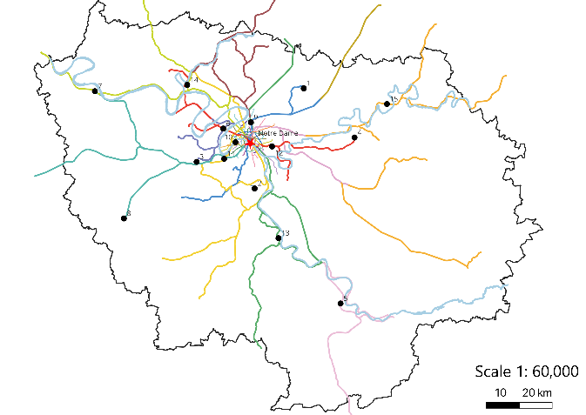
Veridical region with geographical positions of the 15 landmarks
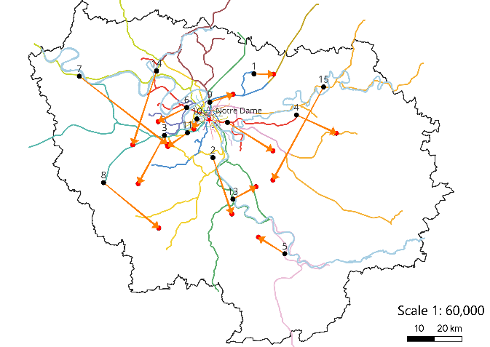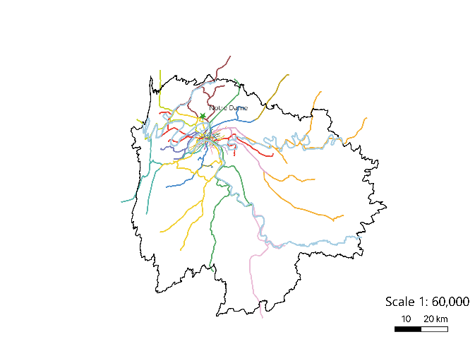
Veridical region with geographical positions of the 15 landmarks & as plotted by resident public transport users of the region: Map of Paris according to its resident public transport users

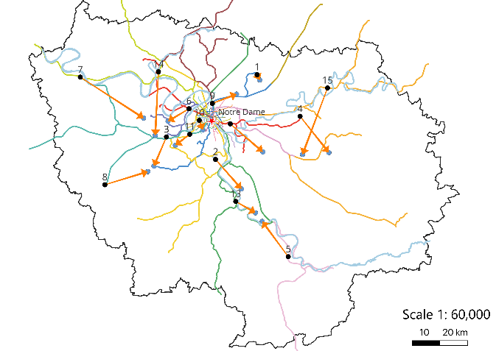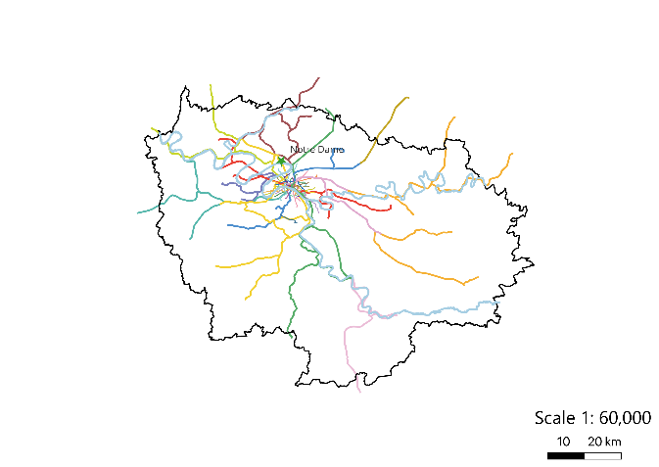
Veridical region with geographical positions of the 15 landmarks & as plotted by resident private transport users of the region: Map of Paris according to its resident private transport users

Study 2 (Paris)
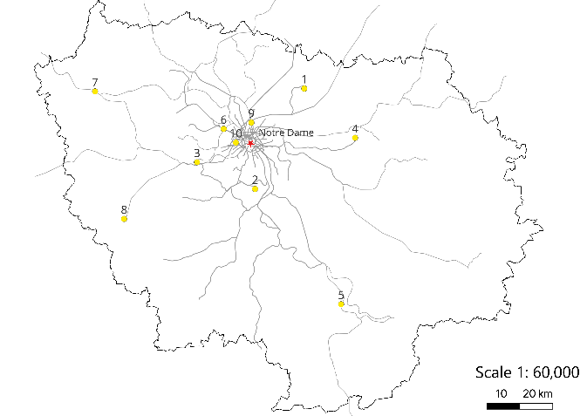
Veridical region with geographical positions of the 10 landmarks

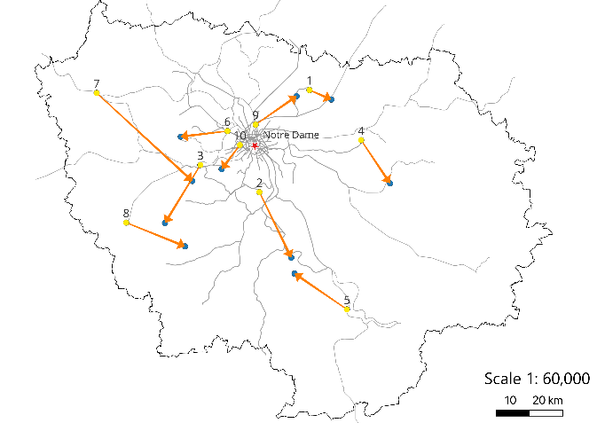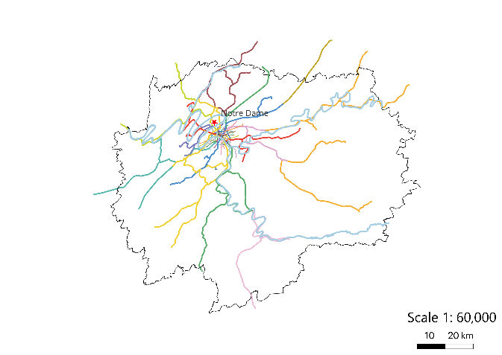
Veridical region with geographical positions of the 10 landmarks & as plotted by residents of the region on a blank layout: Map of Paris according to its residents who performed the task on a blank layout

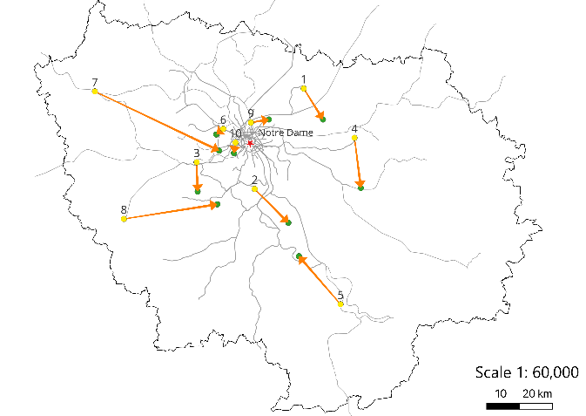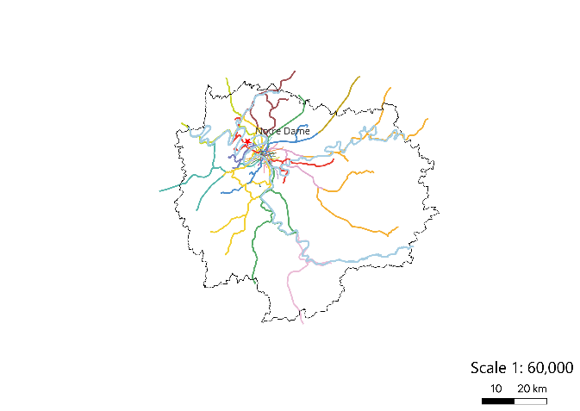
Veridical region with geographical positions of the 10 landmarks & as plotted by residents of the region on a geographic layout: Map of Paris according to its residents who performed the task on a geographic layout

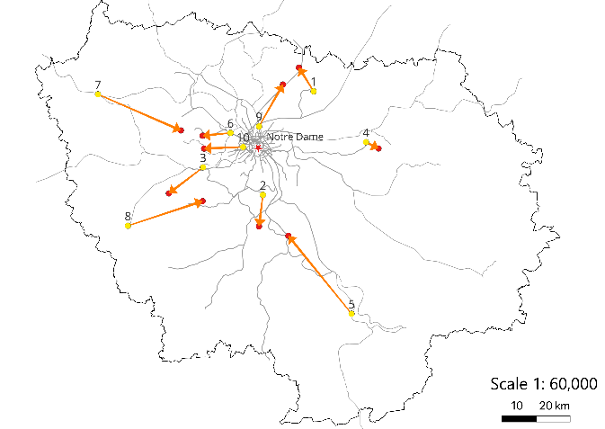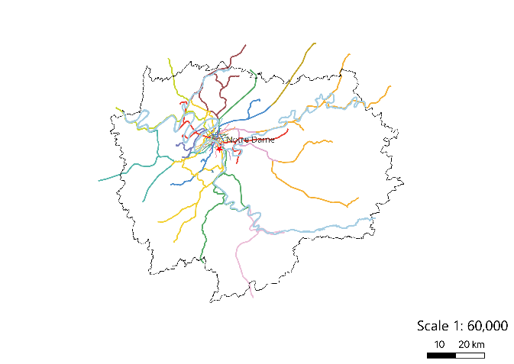
Veridical region with geographical positions of the 10 landmarks & as plotted by residents of the region on a schematic layout: Map of Paris according to its residents who performed the task on a schematic layout

Study 2 (Berlin)
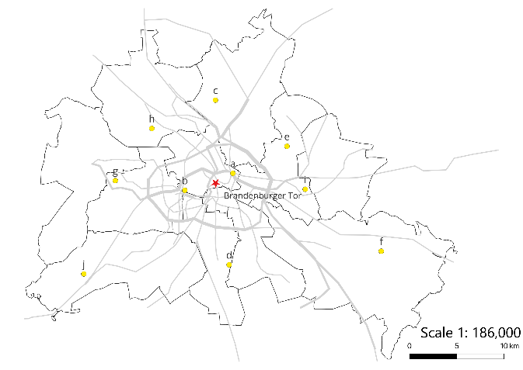
Veridical region with geographical positions of the 10 landmarks
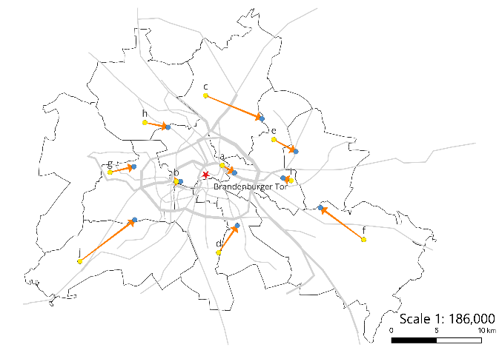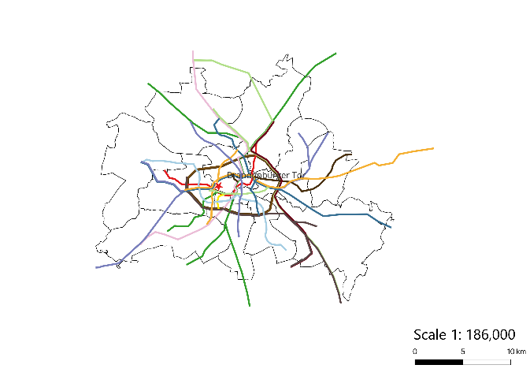
Veridical region with geographical positions of the 10 landmarks & as plotted by residents of the region on a blank layout: Map of Berlin according to its residents who performed the task on a blank layout

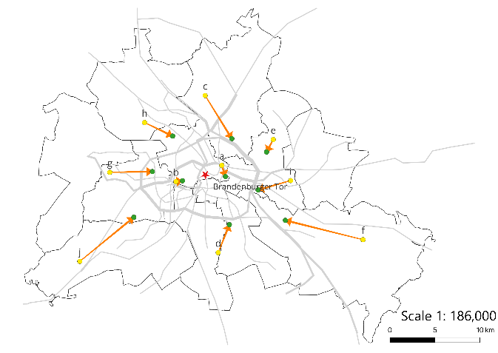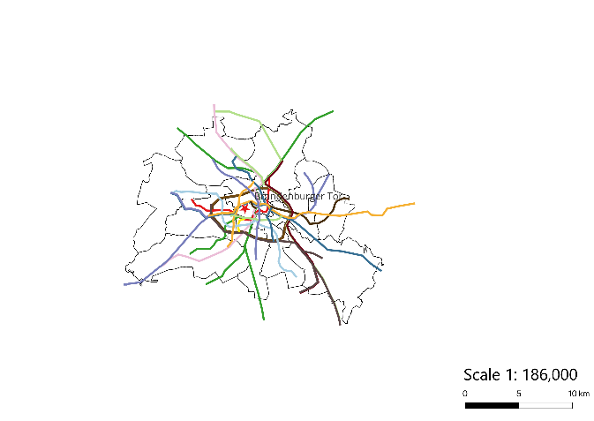
Veridical region with geographical positions of the 10 landmarks & as plotted by residents of the region on a geographic layout: Map of Berlin according to its residents who performed the task on a geographic layout

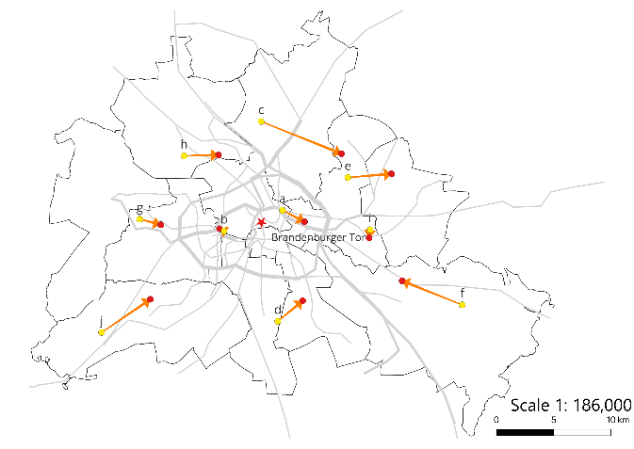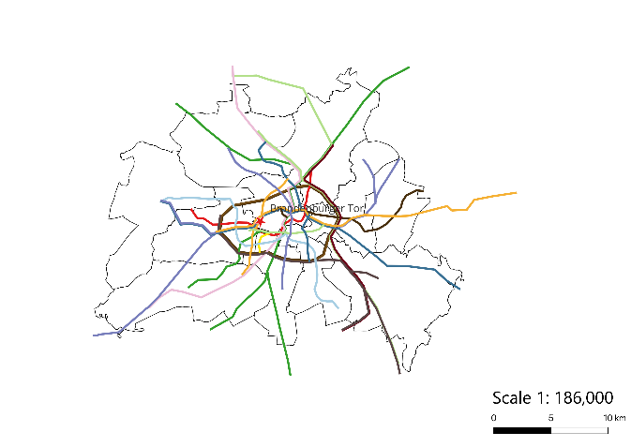
Veridical region with geographical positions of the 10 landmarks & as plotted by residents of the region on a schematic layout: Map of Berlin according to its residents who performed the task on a schematic layout

Study 2 (London)
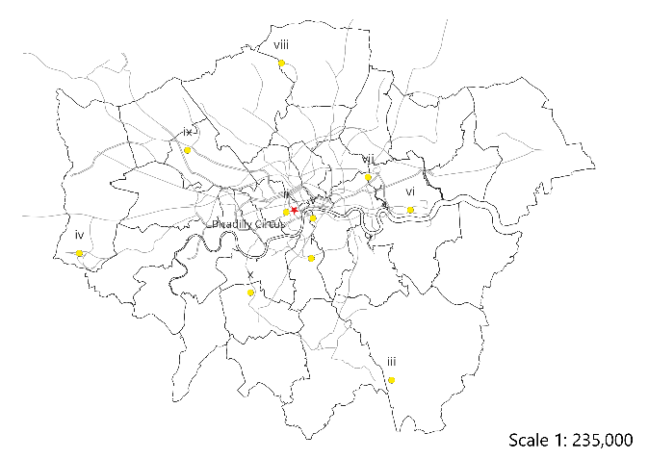
Veridical region with geographical positions of the 10 landmarks

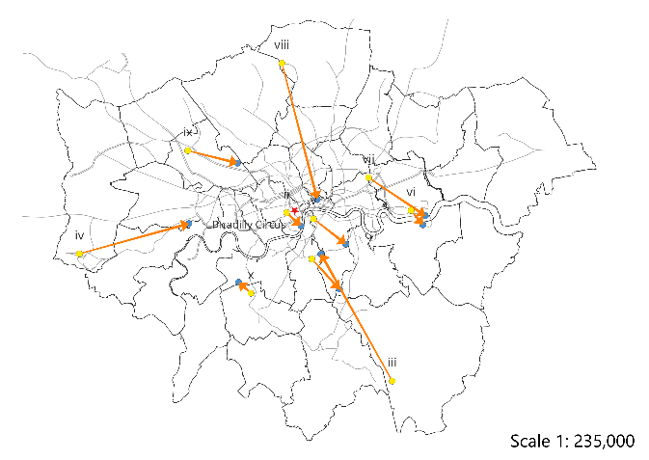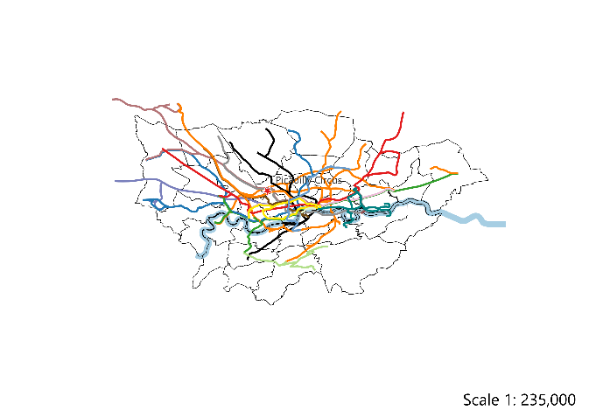
Veridical region with geographical positions of the 10 landmarks & as plotted by residents of the region on a blank layout: Map of London according to its residents who performed the task on a blank layout

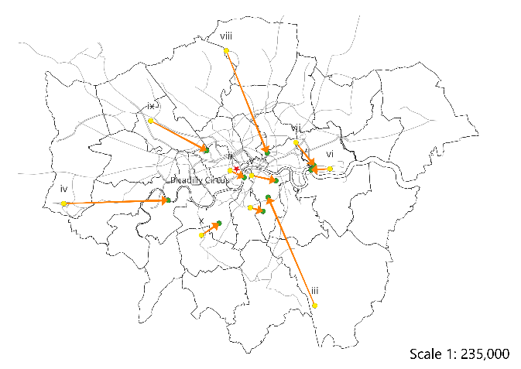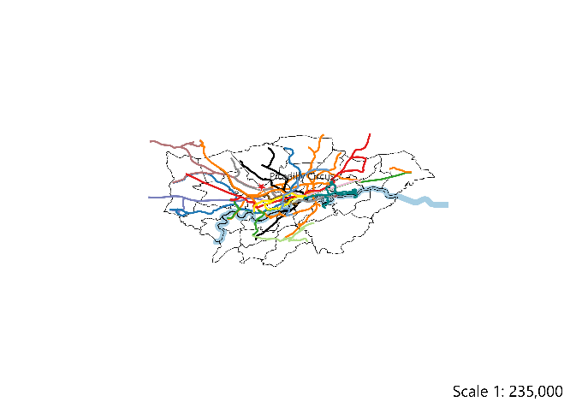
Veridical region with geographical positions of the 10 landmarks & as plotted by residents of the region on a geographic layout: Map of London according to its residents who performed the task on a geographic layout

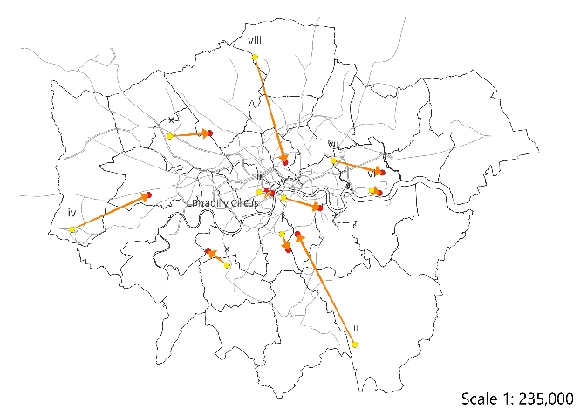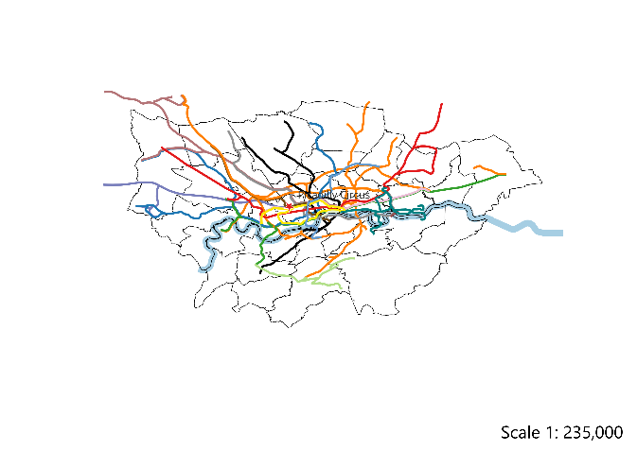
Veridical region with geographical positions of the 10 landmarks & as plotted by residents of the region on a schematic layout: Map of London according to its residents who performed the task on a schematic layout

