Title: Coeruptive and posteruptive crustal deformation associated with the 2018 Kusatsu-Shirane phreatic eruption based on PALSAR-2 time-series analysis
Author #1: Yuji Himematsu, National Research Institute for Earth Science and Disaster Resilience, Tsukuba, Japan. himematsu@bosai.go.jp
Author #2: Taku Ozawa, National Research Institute for Earth Science and Disaster Resilience, Tsukuba, Japan. taku@bosai.go.jp
Author #3: Yosuke Aoki, Earthquake Research Institute, The University of Tokyo, Tokyo, Japan. yaoki@eri.u-tokyo.ac.jp

Corresponding author: Yuji Himematsu (himematsu@bosai.go.jp)

Short title: Co-eruptive and posteruptive deformation by the 2018 Kusatsu-Shirane phreatic eruption based on PALSAR-2 data

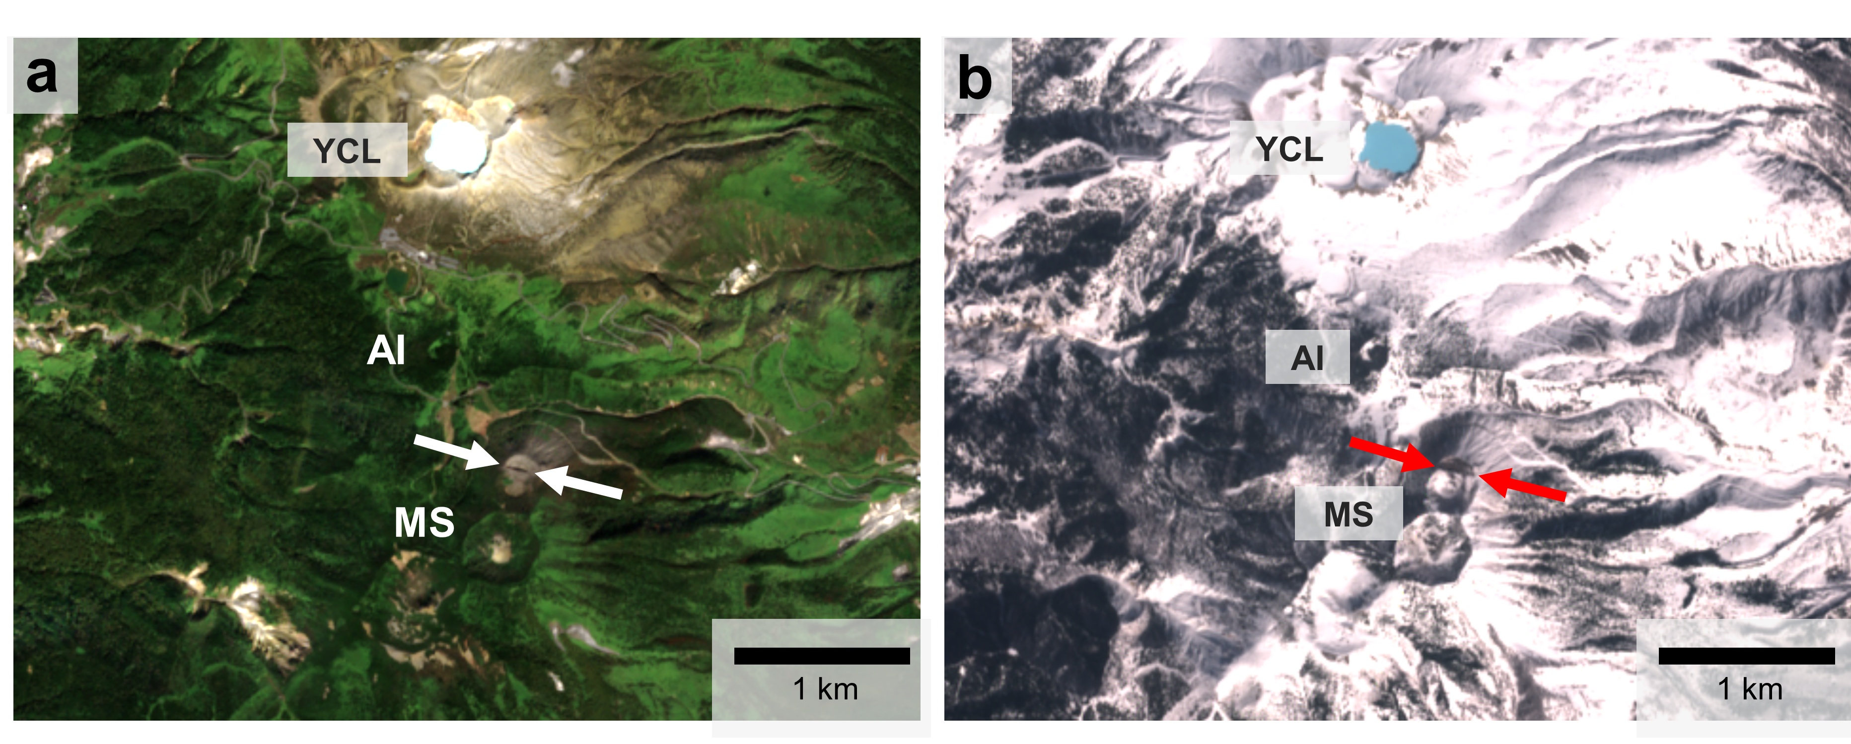
Figure S1. Optical true images of Sentinel-2 data in autumn and winter over Kusatsu-Shirane volcano. These images were acquired on (a) October 10, 2019, and (b) February 27, 2018. White and red arrows indicate the location of the 2018 eruption crater. Kusatsu-Shirane volcano comprises Yugama crater lake (YCL), Ainomine volcano (AI), and Moto-Shirane volcano (MS).

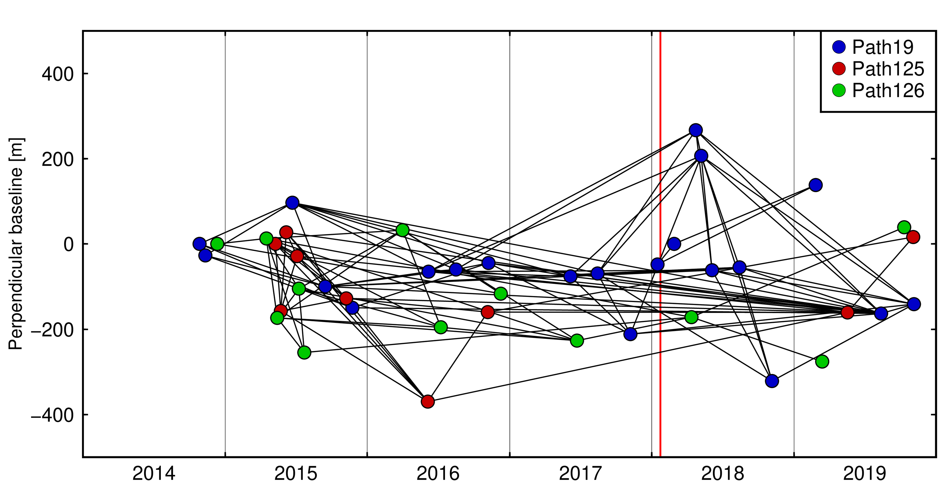
Figure S2. Plot of PALSAR-2 perpendicular baselines and combinations of SAR data for the multi-temporal InSAR analyses. Colored dots are the image acquisition date and perpendicular baselines. Both temporal and spatial baselines are in reference to those of the first image in each observation path. Black lines show image combinations for the multi-temporal InSAR analysis. Red vertical line indicates the timing of the 2018 Kusatsu-Shirane phreatic eruption.

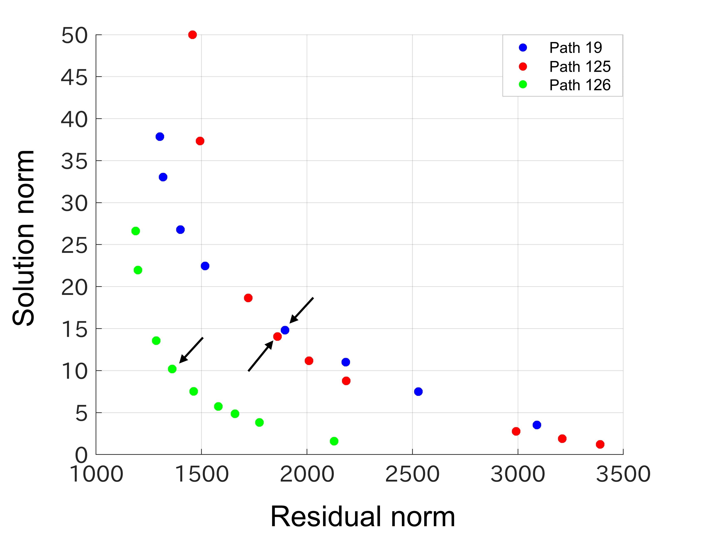
Figure S3. L-curve plot for determination of optimal temporal smoothness in the multi-temporal InSAR analysis. We employed a value at a maximum curvature point (black arrows) in the plot as an optimal temporal smoothness.

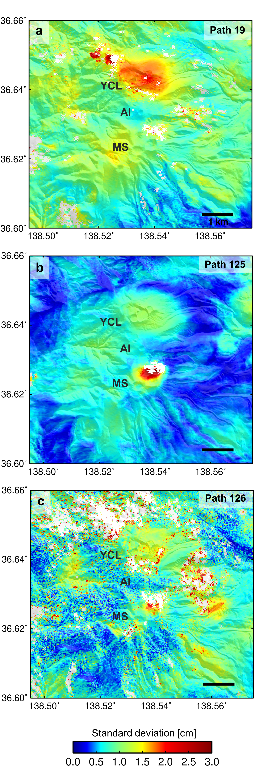
Figure S4. Standard deviation of the inferred displacement velocity from 2014–2019. Abbreviations of the volcano name are same in Figure S1.

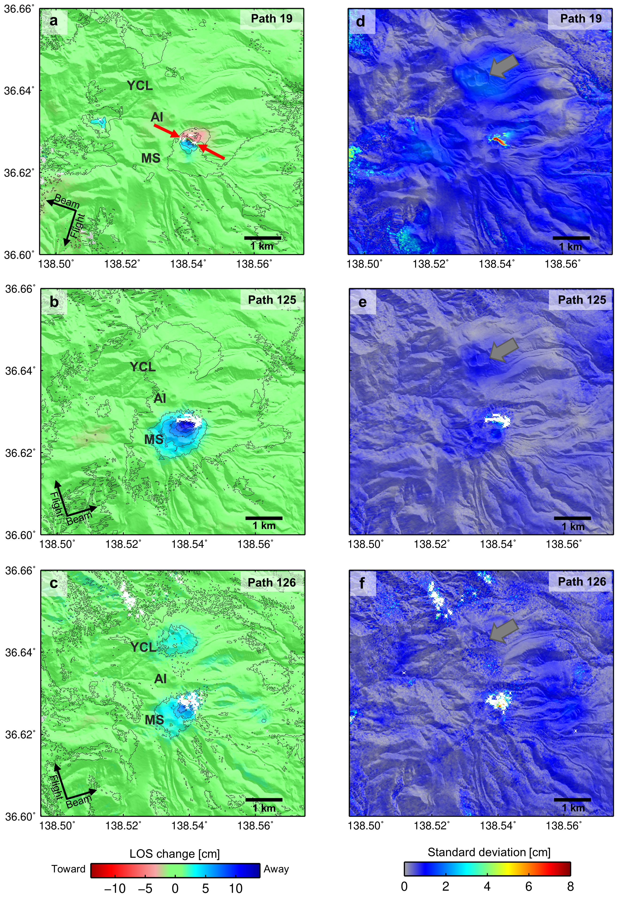
Figure S5. Co-eruptive deformations using the averaging InSAR data spanning the 2018 phreatic eruption. Details of the averaged data are shown in Table S2. Gray thick arrow in panels d-f indicates the location of Yugama crater lake. (a-c) Averaged interferograms in paths 19, 125, and 126. Contours indicate 2 cm LOS change intervals. Red arrows indicate the location of the 2018 eruption crater. (d-f) Standard deviation of the averaged interferograms in paths 19, 125, and 126. Abbreviations of the volcano name are same in Figure S1.

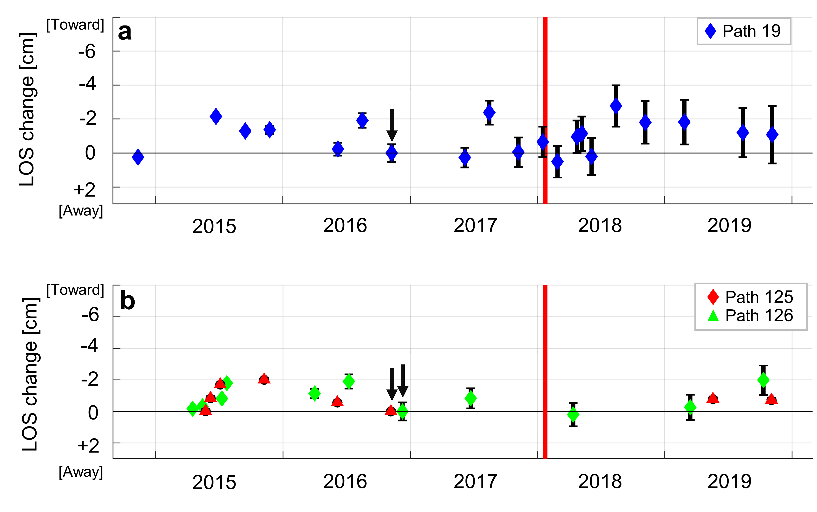
Figure S6. Time series of line-of-sight (LOS) change on Yugama crater lake based on the multi-temporal InSAR analyses. Vertical bars behind each marker denote standard deviations of LOS changes within a 500 m by 500 m region at 2 km away from the 2018 eruption crater to the east. Red vertical line indicates the timing of the 2018 Kusatsu-Shirane phreatic eruption. We set the reference date to November–December 2016, as shown by the black arrows, because of the differences in the first SAR image acquisition periods along each path.

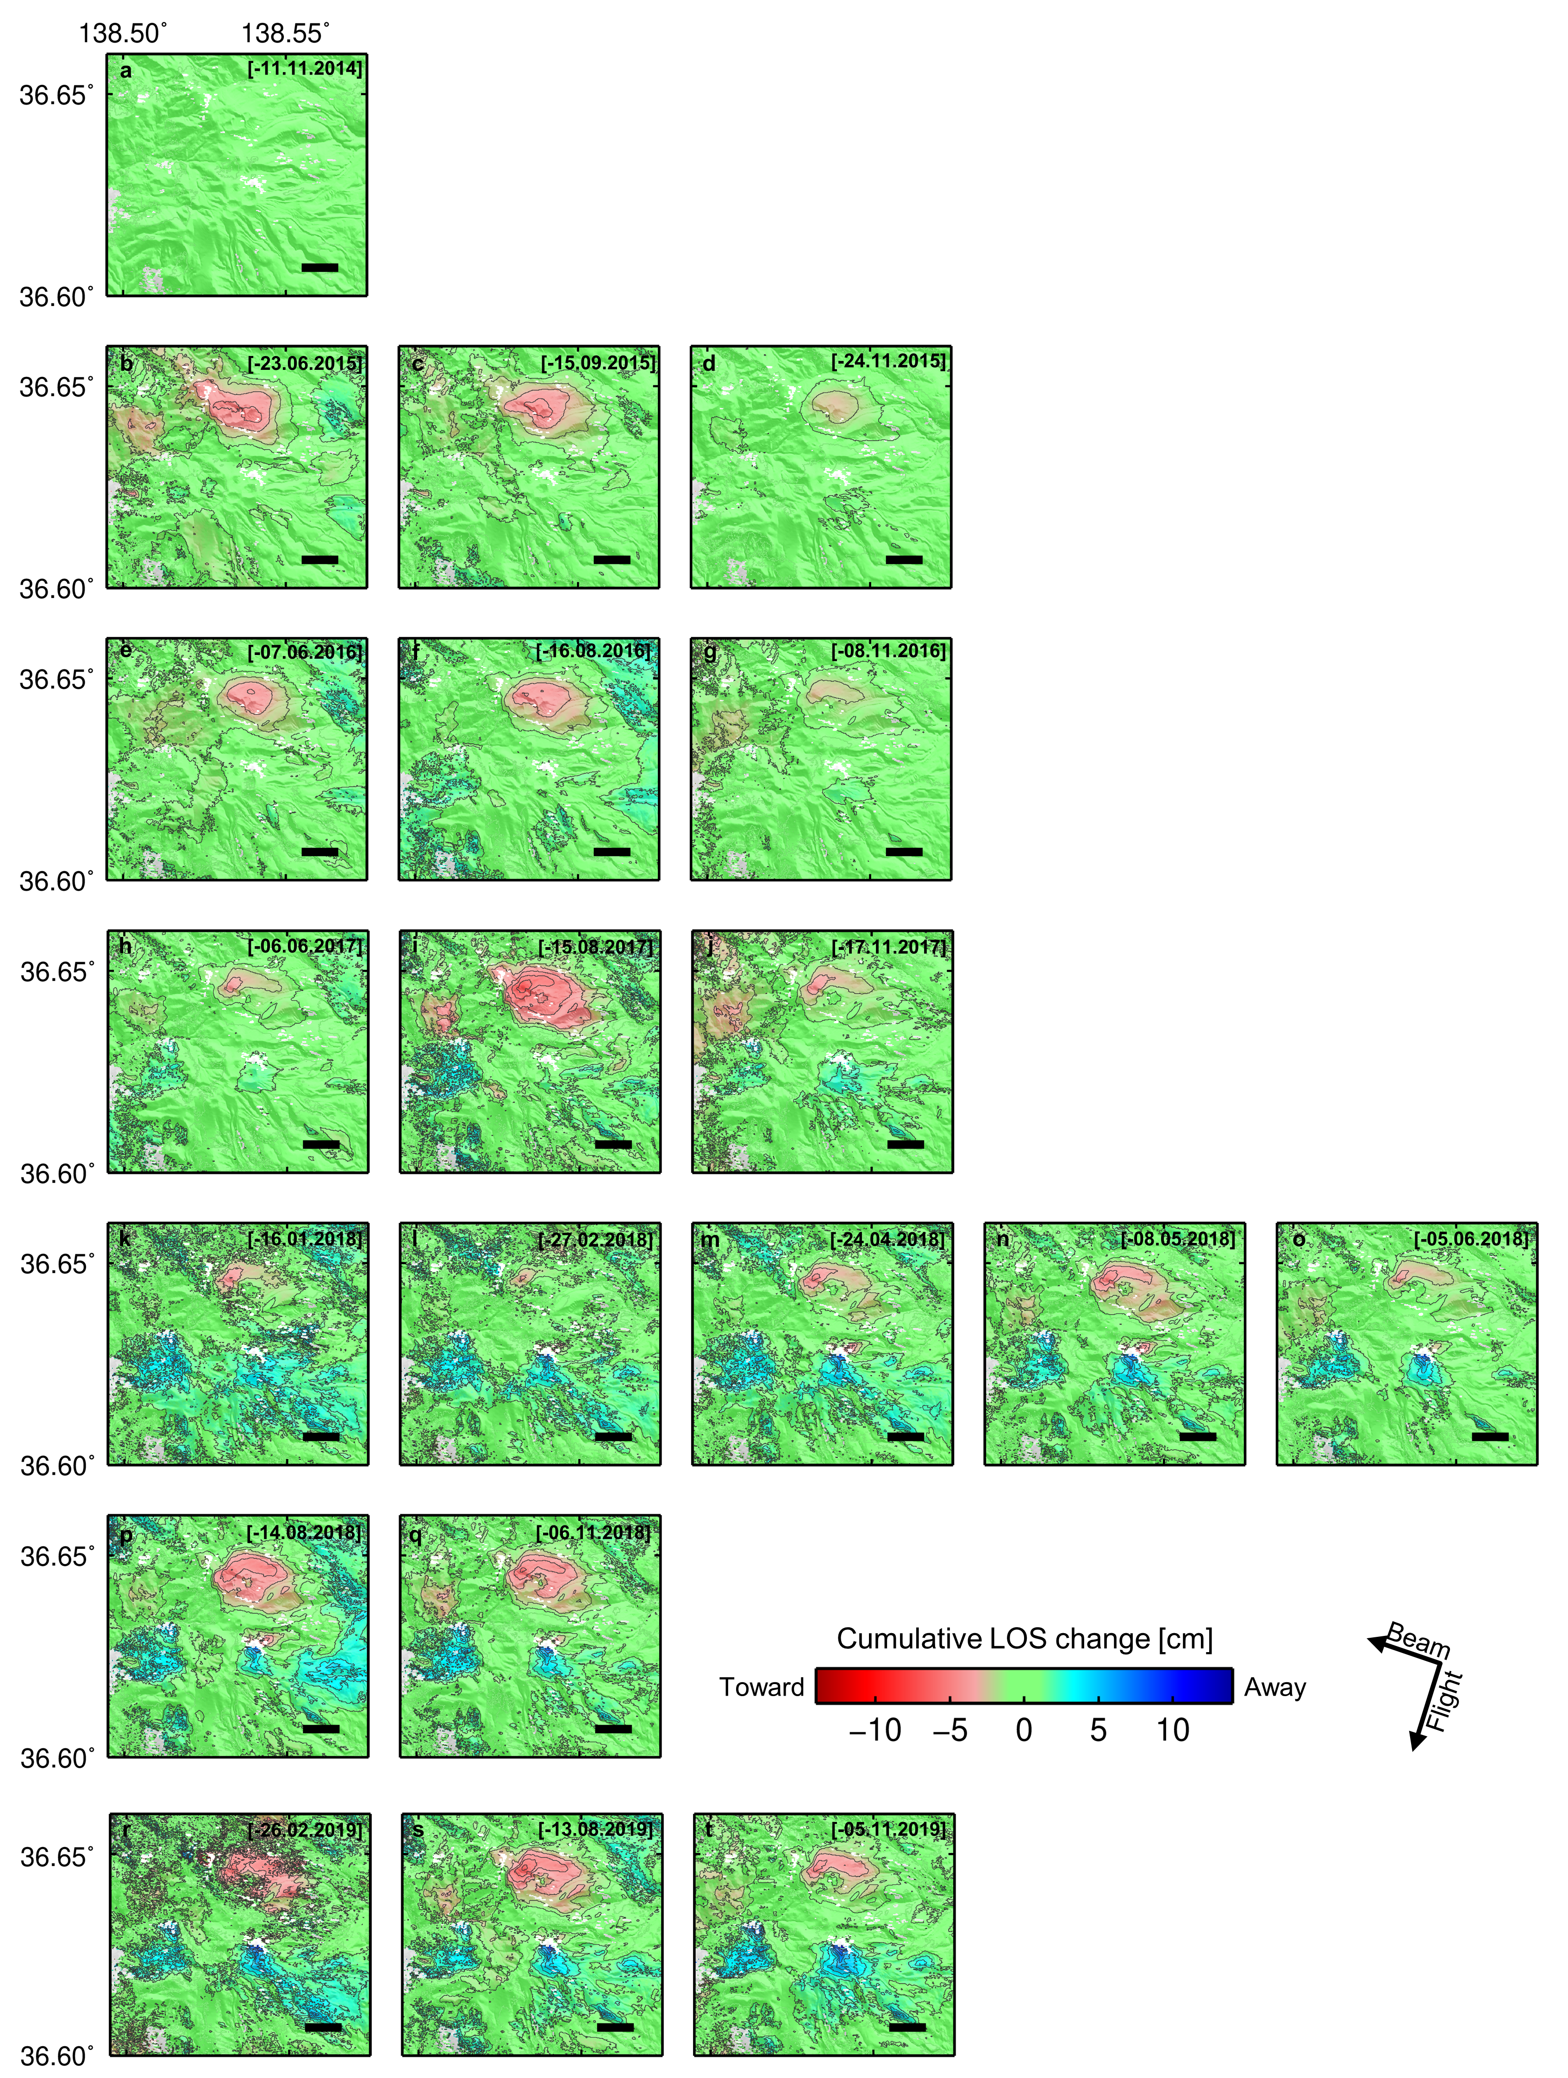
Figure S7. Time-series of PALSAR-2 LOS changes in path 19. Reference of LOS time series is set to 28 October 2014. Contours show 1cm interval of LOS change. Positive LOS change indicate displacement away from the satellite (blue color). Horizontal bar on right-bottom of each panel indicate 1 km distance scale.

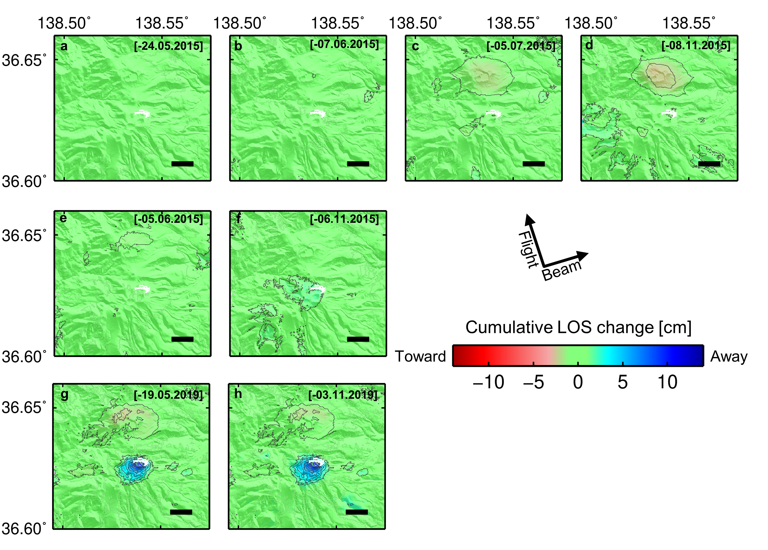
Figure S8. Time-series of PALSAR-2 LOS changes in path 125. Reference of LOS time series is set to 21 December 2014. Others are same in Figure S7.

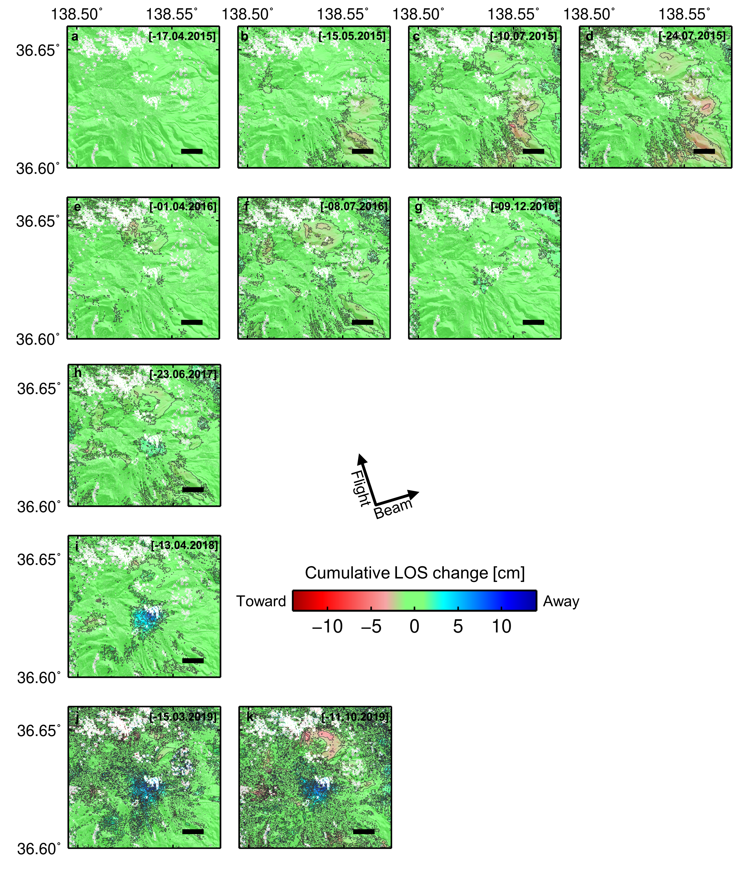
Figure S9. Time-series of PALSAR-2 LOS change in path 126. Reference of LOS time series is set to 12 December 2014. Others are same in Figure S7.

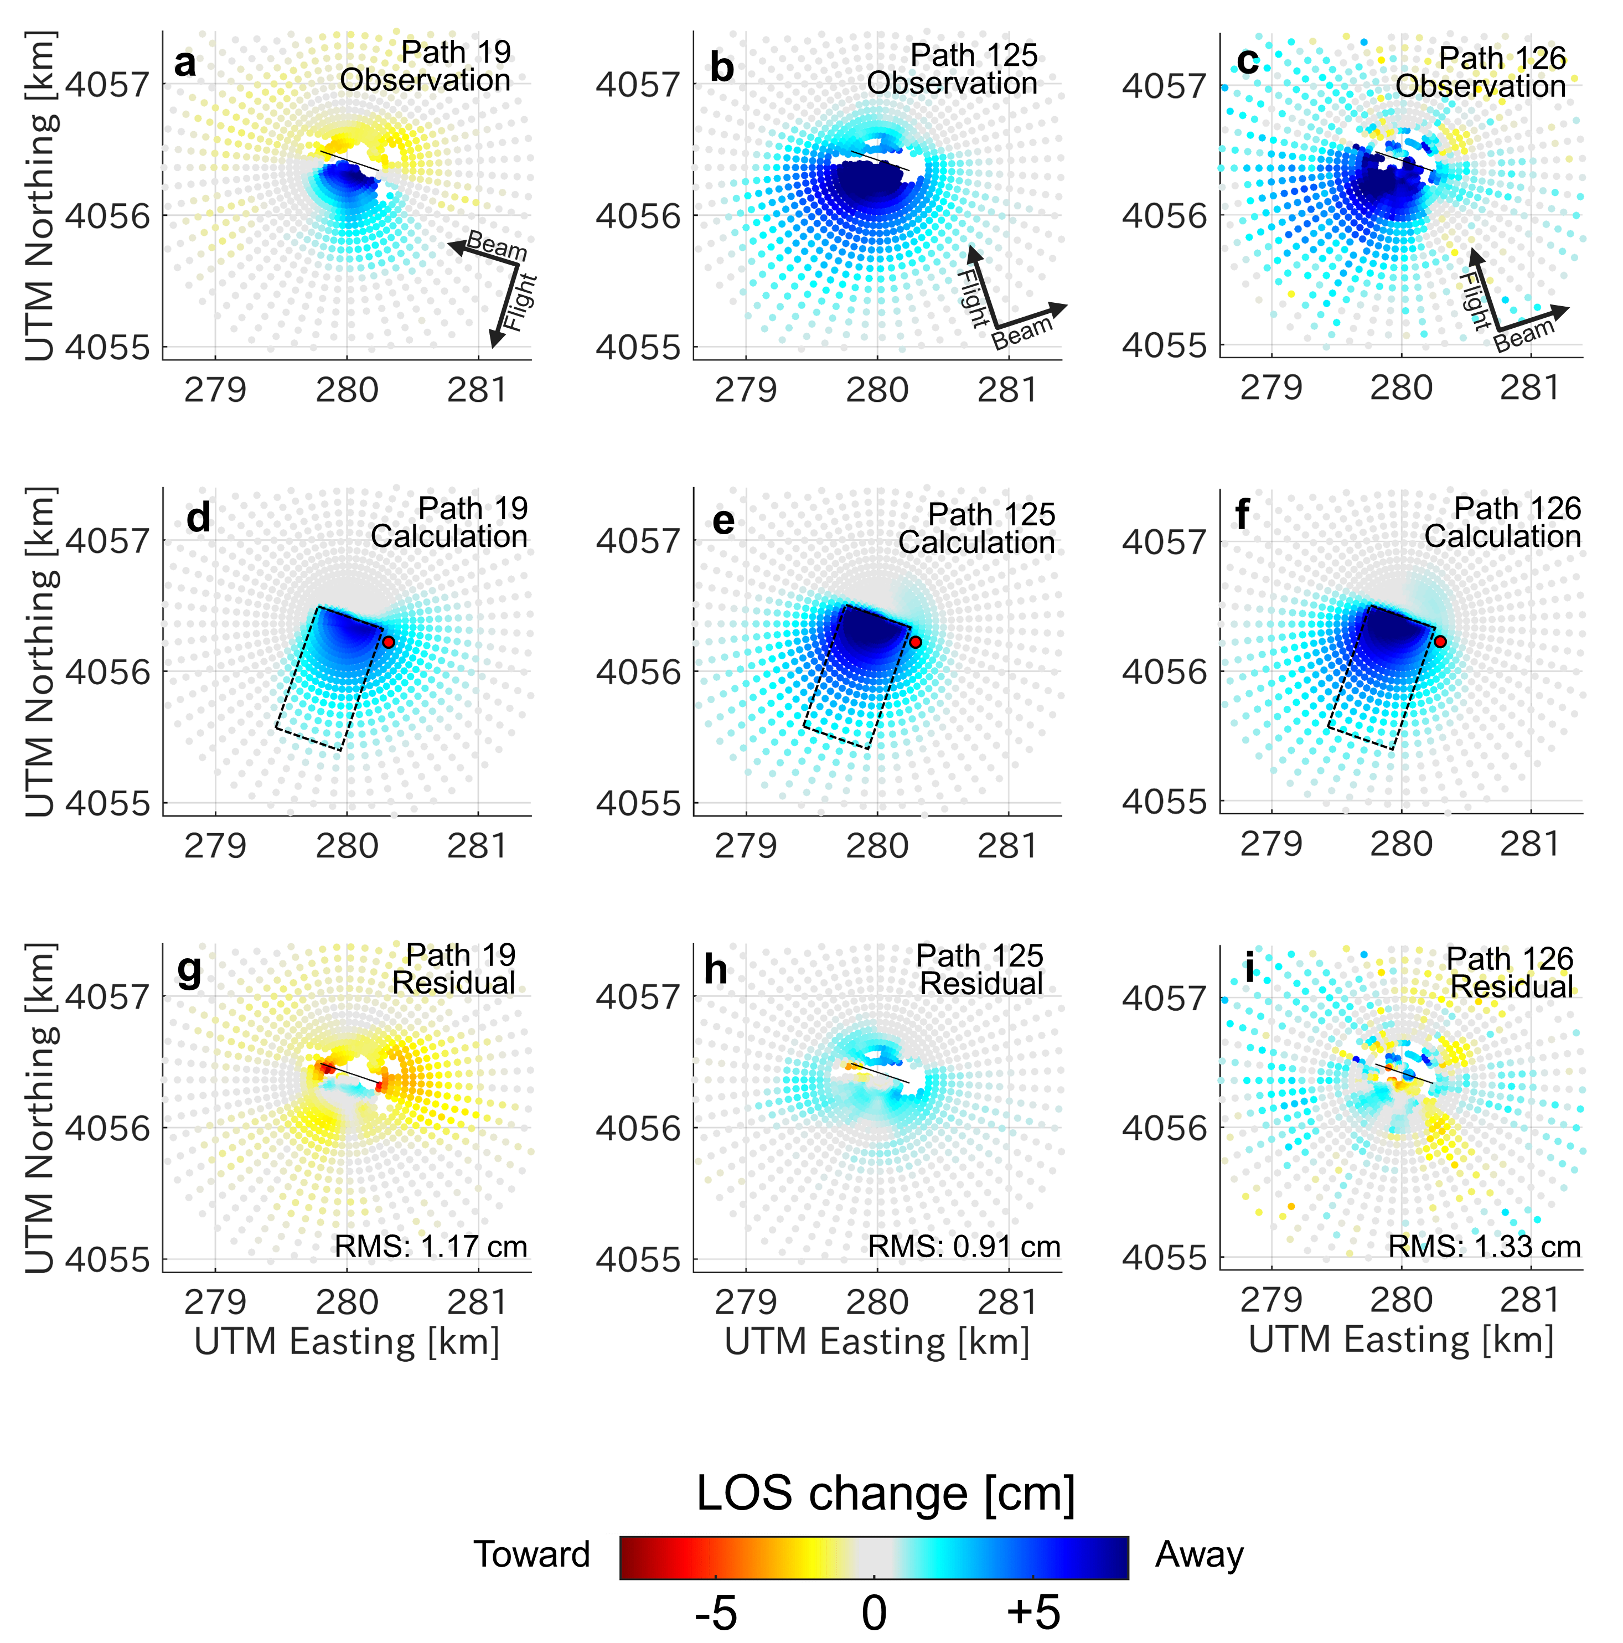
Figure S10. Data fitting using analytical solutions of the surface deformation caused by both a plane dislocation and an isotropic deflation (Model C). (a–c) Subsampled observed LOS changes in each path. Black arrows indicate the satellite flight direction (Flight) and LOS direction (Beam). (d–f) Computed LOS changes using analytical solution volume change of point source. Black dashed boxes trace the outline of the inferred dislocation plane. Red dots indicate the best-fit location of the point source. (g–i) Residuals subtracting the observation from the calculated data. Positive LOS changes indicate displacements away from the satellite. The inferred optimal parameters are shown in Table 1.
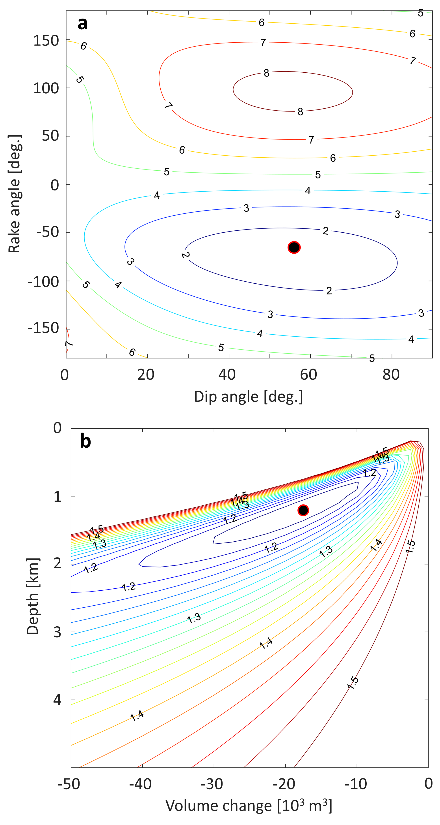

Figure S11. Root-mean-square error (RMSE) distributions for a plane dislocation and an isotropic deflation in Model C. (a) RMSE distribution of a rake angle versus a dip angle under a width of 1500 m, a length of 500 m, and a slip of 0.17 m. (b) RMSE distribution of depth versus volume change of a point source under the best-fit location of the isotropic deflation source. Black dots indicate a point of minimum RMSE, indicating best-fit parameters. Numbers above contour lines are the total RMSE.

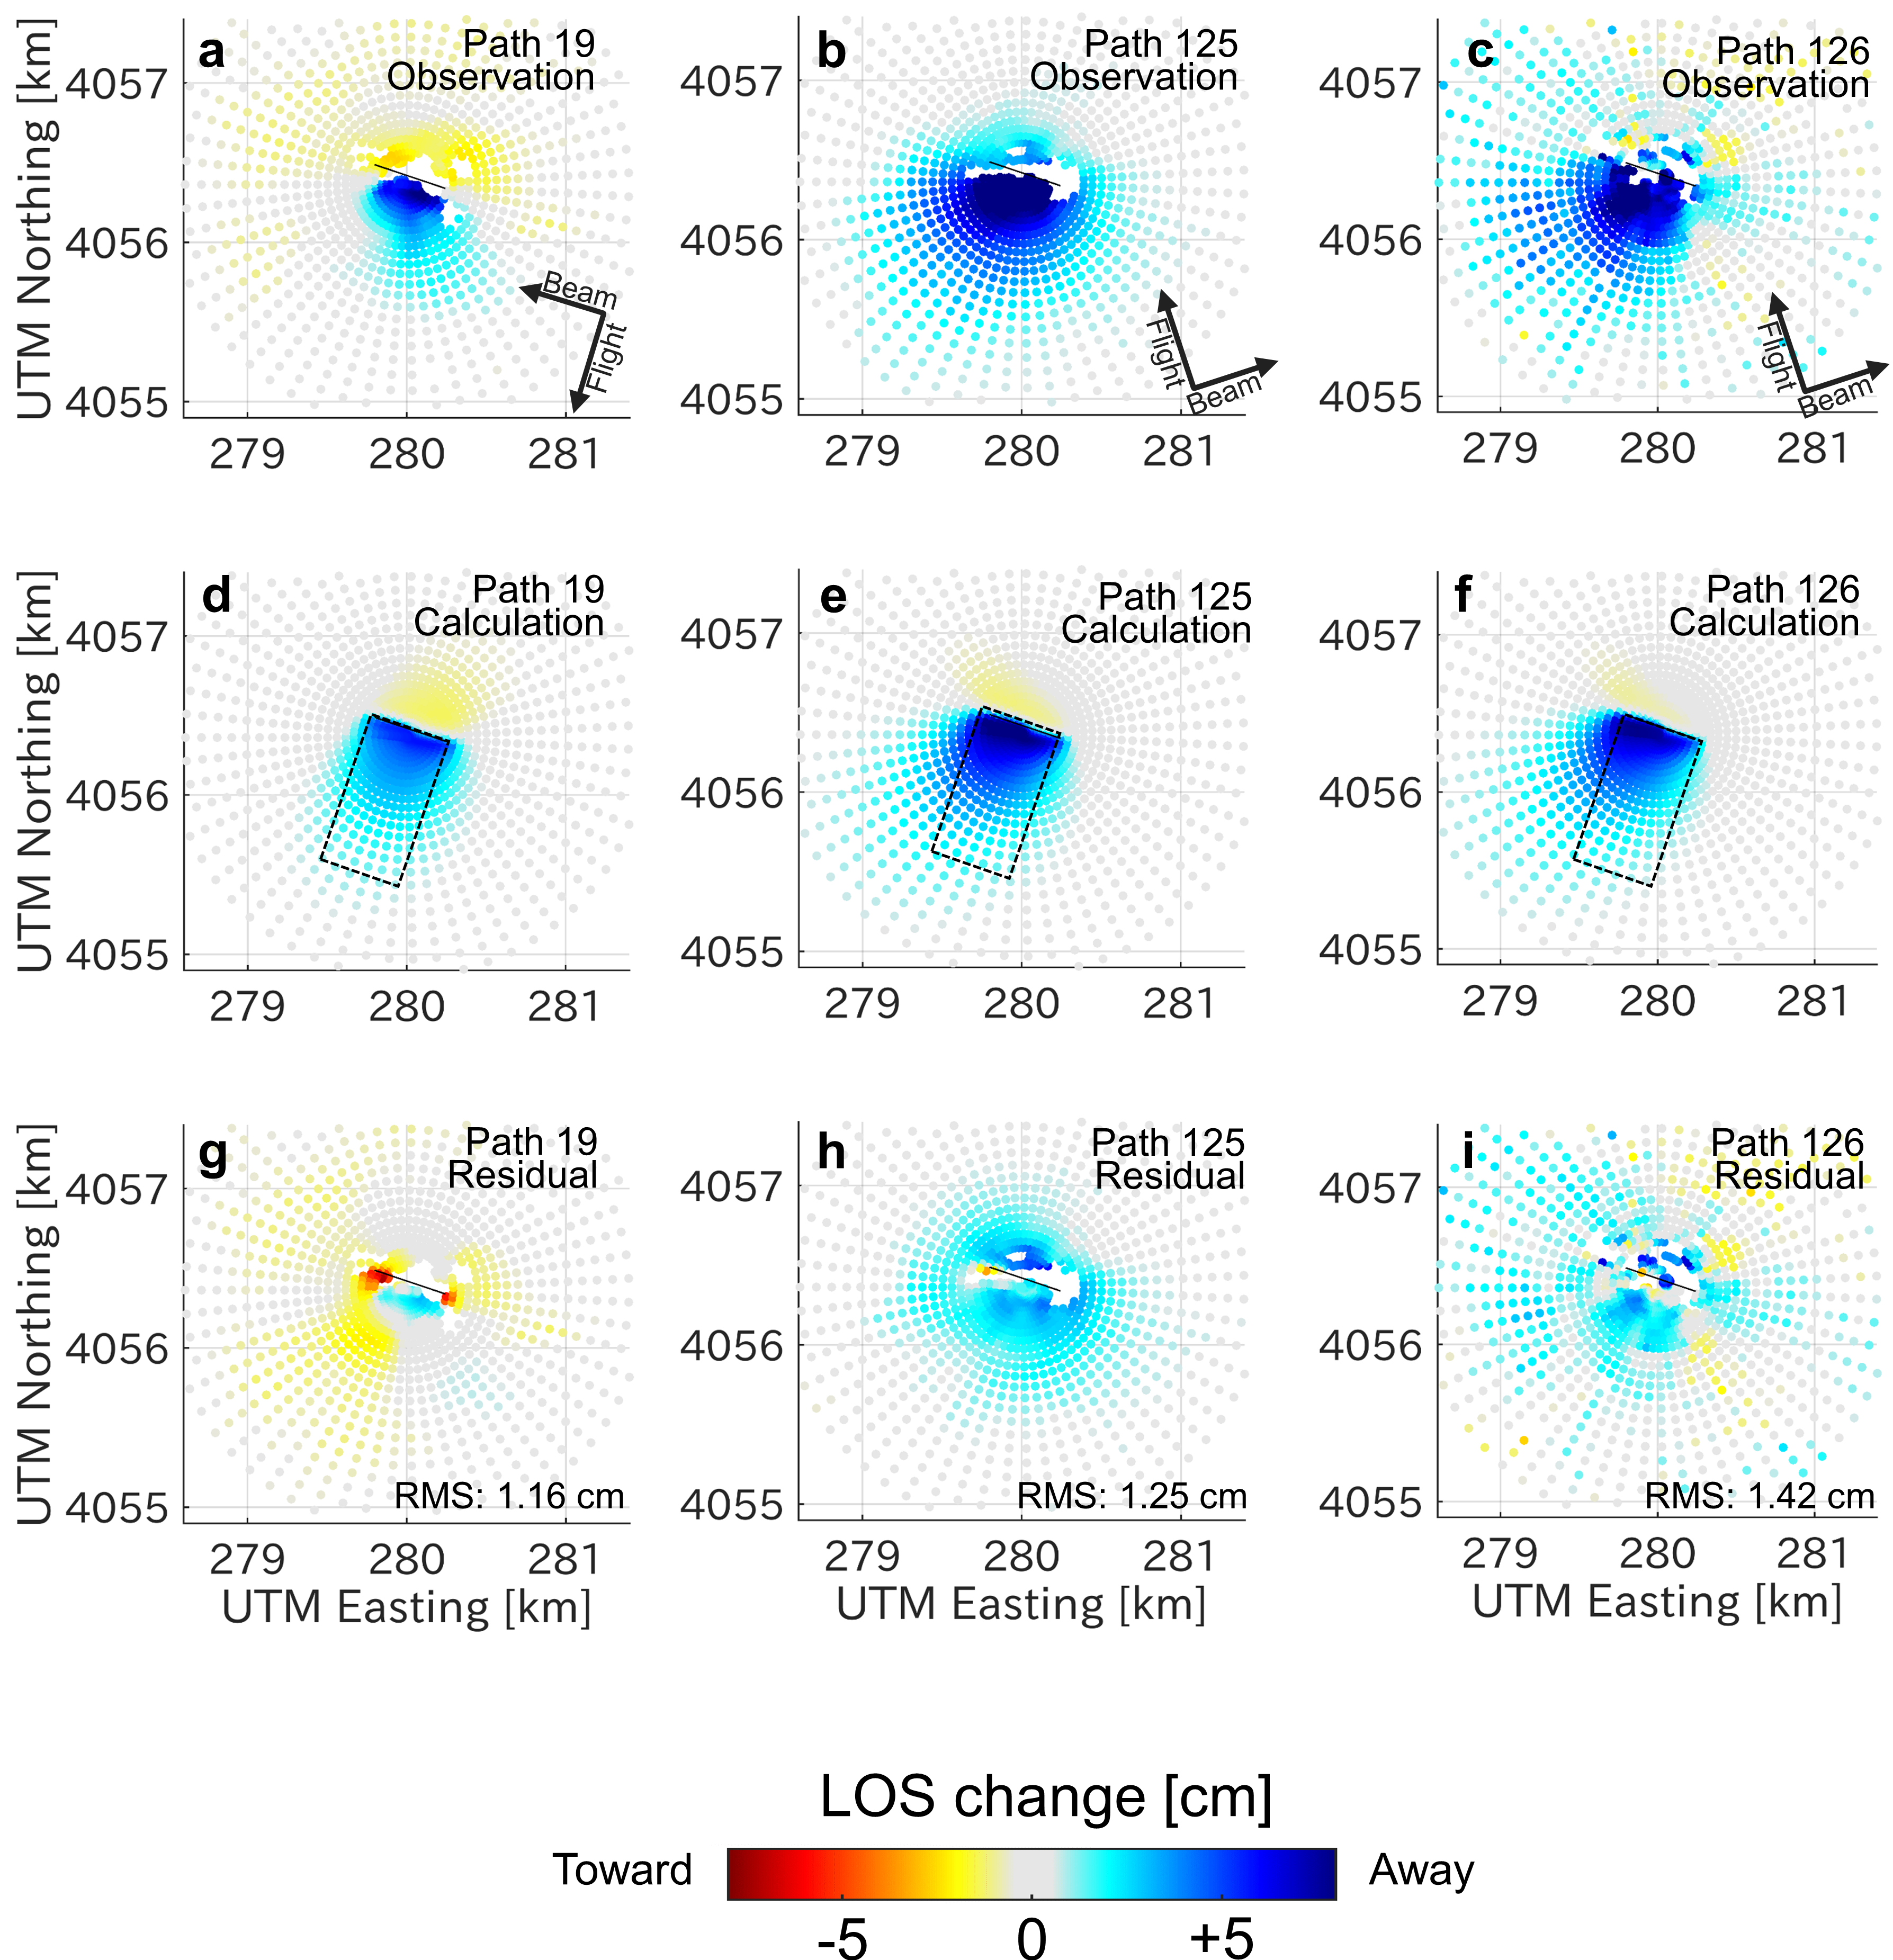

Figure S12. Data fitting using analytical solutions of the surface deformation caused by a planer dislocation (Model A). (a–c) Subsampled observed LOS changes in each path. (d–f) Computed LOS changes using analytical solution of surface deformation due to a planar dislocation. (g–i) Residuals subtracting the observation from the calculated data. The best-fit parameters are shown in Table 1. Details are same in Figure S10.

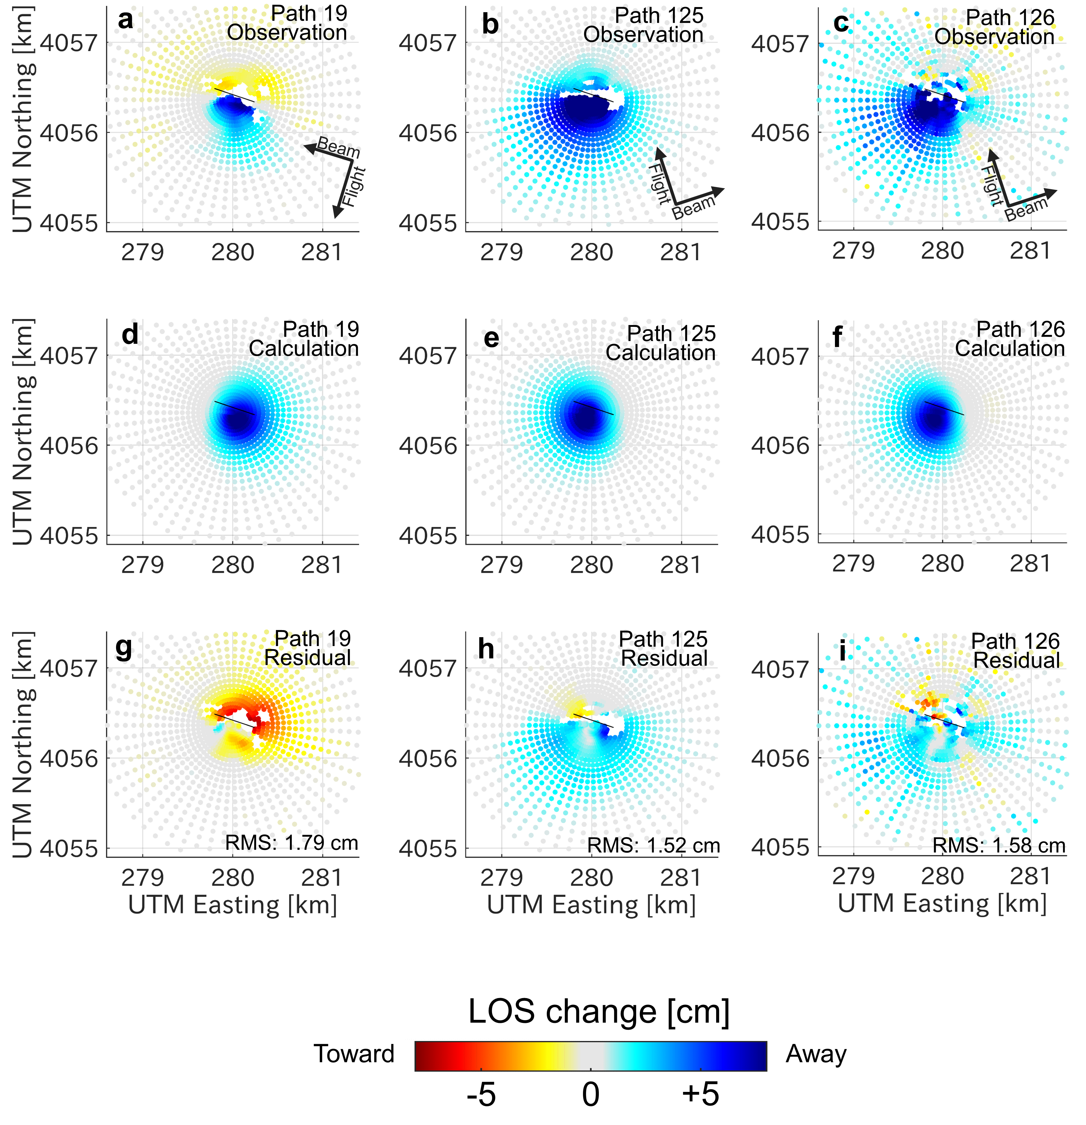
Figure S13. Data fitting using analytical solutions of the surface deformation caused by an isotropic deflation (Model B). (a–c) Subsampled observed LOS changes in each path. (d–f) Computed LOS changes using analytical solution volume change of point source. (g–i) Residuals subtracting the observation from the calculated data. The inferred optimal parameters are shown in Table 1. Details are same in Figure S10.

Table S1. Parameters of PALSAR-2 image acquisition and information for the multi-temporal InSAR analysis in this study.
 | Path 19 | Path 125 | Path 126
First image acquisition date  [dd.mm.yyyy] | 28.10.2014 | 21.12.2014 | 12.12.2014
Last image acquisition date  [dd.mm.yyyy] | 05.09.019 | 03.11.2019 | 11.10.2019
Number of images | 21 | 9 | 12
Number of interferogram | 70 | 24 | 26
Incidence angle [degree] | 36.18 | 31.88 | 42.27
Heading angle [degree] | -169.73 | -12.85 | -12.83

Table S2. Pairs of SAR image acquisition date for the averaged InSAR data in Figure S4.
 | Master [dd.mm.yyyy] | Slave [dd.mm.yyyy]
Path 19 | 06.06.2017 | 05.06.2018
 | 06.06.2017 | 14.08.2018
 | 15.08.2017 | 14.08.2018
 | 15.08.2017 | 06.11.2018
Path 125 | 07.06.2015 | 19.05.2019
 | 05.07.2015 | 19.05.2019
 | 08.11.2015 | 19.05.2019
 | 05.06.2016 | 19.05.2019
 | 06.11.2016 | 19.05.2019
Path 126 | 24.07.2015 | 13.04.2018
 | 01.04.2016 | 13.04.2018
 | 08.07.2016 | 13.04.2018
 | 23.06.2017 | 13.04.2018

Table S3. Range and interval for the searching best-fit parameters.

Plane dislocation | (min, max, interval) | Point source deflation | (min, max, interval)
Slip [m] | 0.15, 0.35, 0.02 | UTM Easting [m] | 279500, 280500, 50
Width [m] | 1000, 2200, 200 | UTM Northing [m] | 4056000, 4057000, 50
Length [m] | 400, 800, 100 | Depth [m] | 0, 2500, 50
Dip [degree] | 0, 90, 2 | Volume change [m³] | -100000, 0, 5000
Rake [degree] | -180, 180, 2
From left, minimum, maximum, and interval of the parameter searching range.

Table S4. Best-fit RMS residuals of Model A (Planar dislocation) and Model B (Point source deflation) in each path.
 | Model A  [Plane dislocation] | Model B  [Point source deflation] | Model C  [Plane dislocation & Point source deflation]
RMS total [cm] | 1.27 | 1.63 | 1.14
RMS (Path 19) [cm] | 1.16 | 1.79 | 1.17
RMS (Path 125) [cm] | 1.25 | 1.52 | 0.91
RMS (Path 126) [cm] | 1.42 | 1.58 | 1.33

