Supplementary information

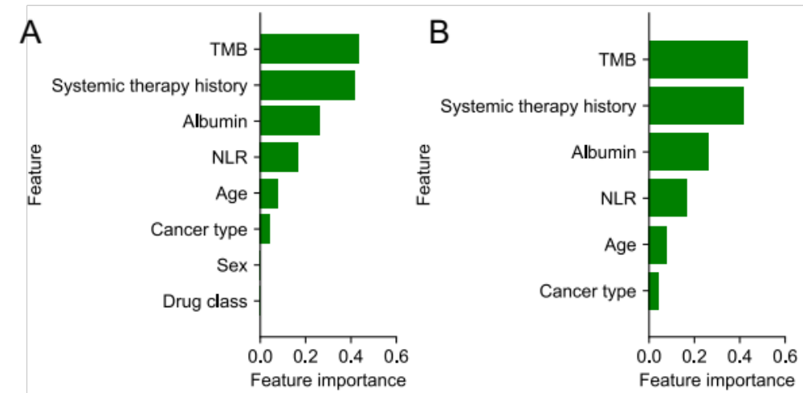

Supplementary Figure 1. Feature selection and feature importance by the logistic LASSO regression model.
A. Feature importance of from the 8-feature logistic regression classifier using features commonly measured across most patients.
B. Feature importance of the 6-feature logistic regression classifier LLR6. The feature importance is calculated as the absolute values of the corresponding coefficients in the logistic regression models. Importance for cancer type is calculated as the average importance of individual cancer types.

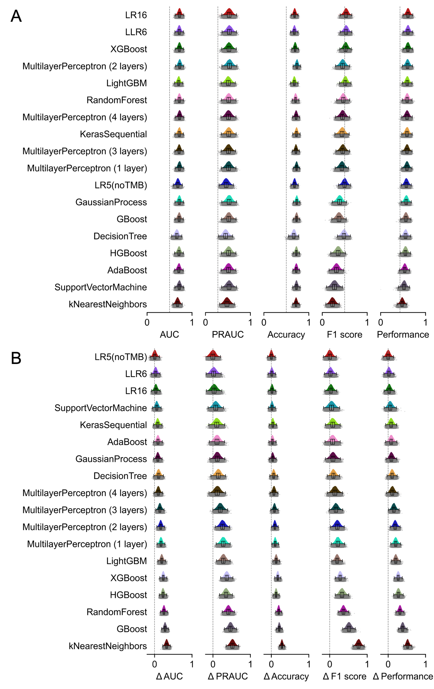
Supplementary Figure 2. Comparison of predictive power of pan-cancer models for ICB response prediction.
A. Model predictive power on the validation data. Model performance is defined as the geometric mean of four metrics, i.e., AUC, AUPRC, accuracy, and F1 score.
B. Difference of model predictive power between the training and the validation data Various performance metrics were calculated with 2000-repeated 5-fold cross-validation.
All machine learning models take all 16 measured features from the Chowell et al. cohort as input, with the exception of the LLR6 and LR5 models, which utilize 6 and 5 features, respectively.

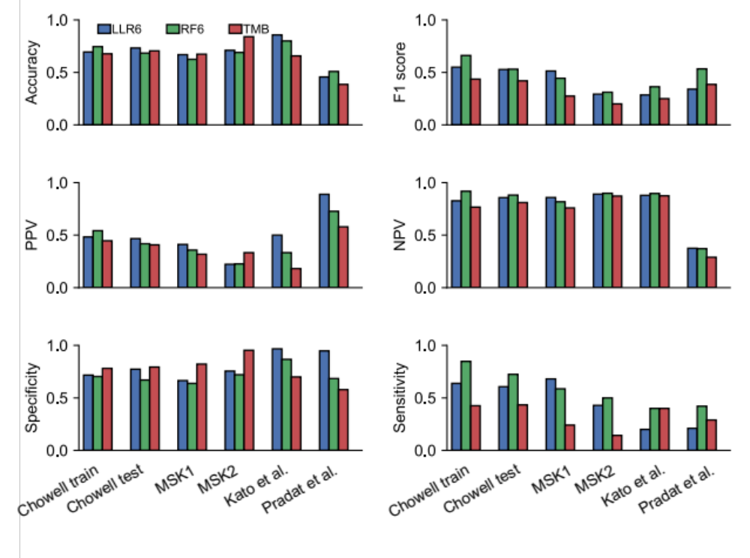
Supplementary Figure 3. Comparison of model predictive power on the training set and across multiple unseen test sets.
Multiple metrics were used to compare predictive power of LLR6, RF6, and the TMB biomarker, including accuracy, F1 score, positive predictive value (PPV), negative predictive value (NPV), specificity, and sensitivity.
The optimal thresholds of 0.5 and 0.27 that differentiate responders from non-responders were determined on the training data for LLR6 and RF6 models using the Youden’s index respectively. As for the TMB model, the threshold of 10 Mut/Mb was utilized.

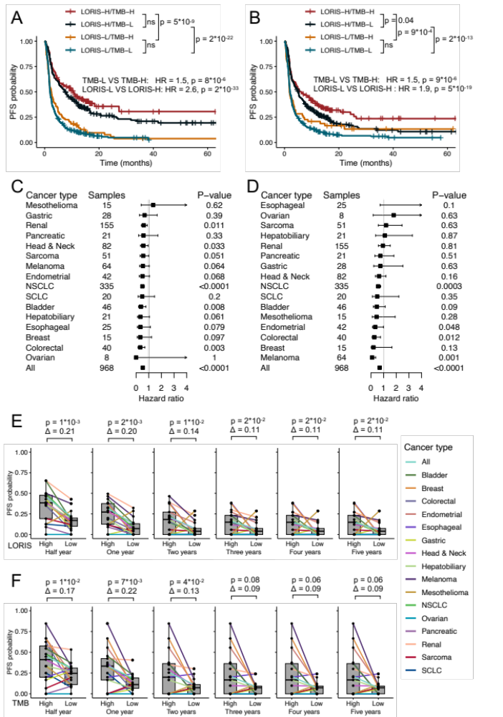
Supplementary Figure 4. LORIS predicts PFS following immunotherapy for both pan-cancer and individual cancer types.
A. Kaplan–Meier analysis of pan-cancer PFS with TMB binned at 10 Mut / Mb and LORIS binned at 0.5. P values next to the legend indicate pairwise comparisons. H, high; L, low.
B. Same as panel A, but TMB is binned at the highest 20th percentile, and LORIS is binned at the 50th percentile for each cancer type.
C-D. Forest plot of PFS within each cancer type using LORIS (binned at the 50th percentile; C) or TMB (binned at the highest 20th percentile; D) in a multivariable model with adjustment for cancer type, age, drug class of ICB and year of ICB start.
E-F. Comparison of half-year, 1-year, 2-year, 3-year, 4-year, and 5-year PFS stratified by cancer type for high versus low LORIS (50th percentile; E) and high versus low TMB (highest 20th percentile; F). Survival probability differences and paired Wilcoxon-test p-values are displayed in panels E and F.
Data are from combined Chowell test (n = 515) and MSK1 (n = 453) sets.

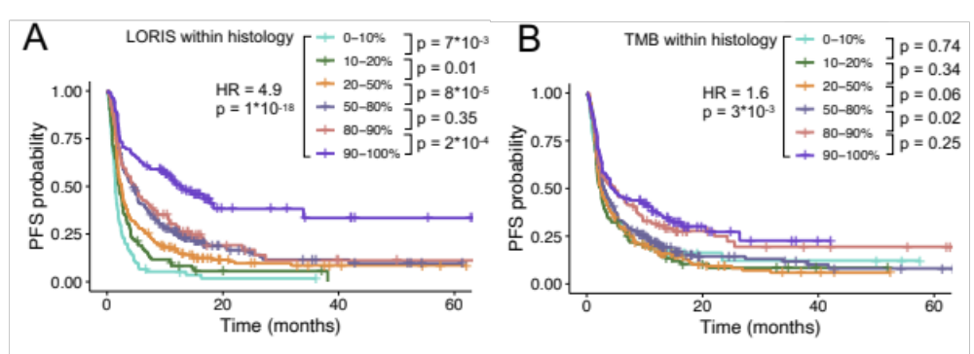

Supplementary Figure 5. Near-monotonic relationship between LORIS and pan-cancer PFS following immunotherapy.
Kaplan–Meier analysis of LORIS (A) or TMB (B) binned at the different percentiles in each cancer type. P values next to the legend indicate pairwise comparisons; hazard ratio (HR) is shown for the lowest-percentile groups (0-10%) and the highest-percentile groups (90-100%).
Data are from combined Chowell test (n = 515) and MSK1 (n = 453) sets.

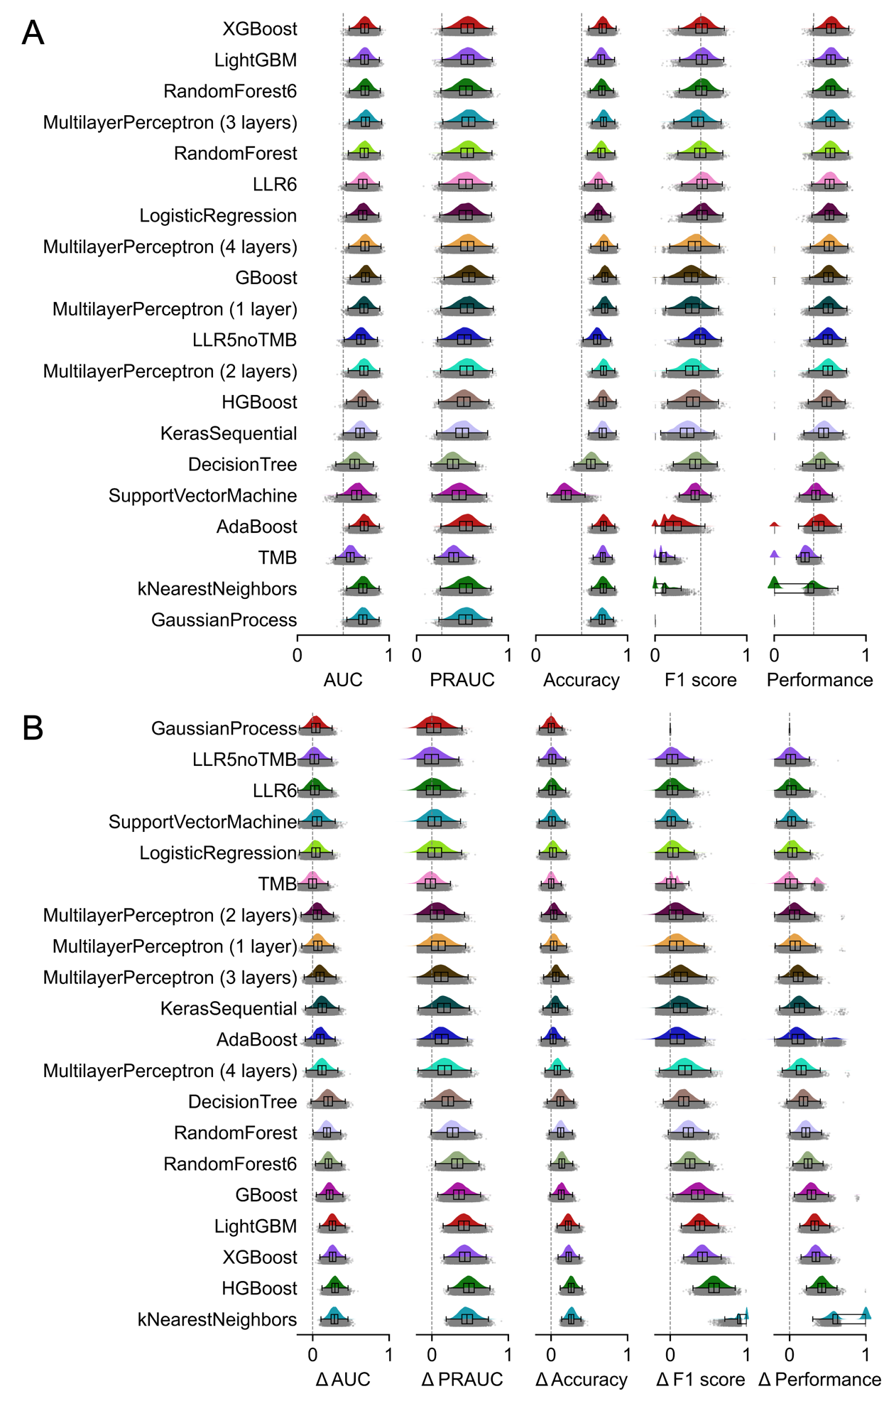
Supplementary Figure 6. Evaluation and comparison of predictive power of NSCLC-specific models.
A. Model predictive power on the validation data. Model performance is defined as the geometric mean of four metrics, i.e., AUC, AUPRC, accuracy, and F1 score.
B. Difference of model predictive power between the training and the validation data. Various performance metrics were calculated with 2,000-repeated 5-fold cross-validation.
All machine learning models are trained on the Chowell et al. cohort using the NSCLC patients and take all 16 measured features as input except the LLR6 and RandomForest6 models, which use 6 features.

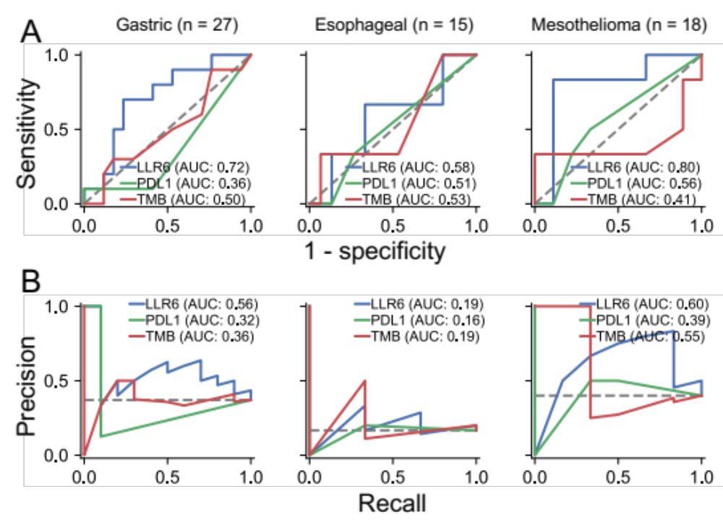

Supplementary Figure 7. The NSCLC-specific LLR6 model also predicts ICB response in three other cancer types.
A. Receiver operating characteristic curves and corresponding area under the curve (AUC) of the NSCLC-specific LLR6 model, the PD-L1 TPS biomarker, and the TMB biomarker on gastric cancer, esophageal cancer, and mesothelioma.
B. Precision recall curves and corresponding area under the curve (AUC) of the NSCLC-specific LLR6 model, the PD-L1 TPS biomarker, and the TMB biomarker on gastric cancer, esophageal cancer, and mesothelioma.

