Supplementary Information

Table S1. Details of the studied compounds; i.e. chemical and general class, R² values, LOD and LOQ

Compound name | Chemical class | General class | R² | LOD (mg/Kg) | LOQ (mg/Kg)
Atrazine | Triazine | Herbicide | 0.998 | 0.0025 | 0.0025
γ-HCH (lindane) | Organochlorine | Insecticide | 0.999 | 0.0025 | 0.0025
Chlorothalonil | Organochlorine | Fungicide | 0.999 | 0.0025 | 0.0025
α-Endosulfan | Organochlorine | Insecticide | 0.996 | 0.005 | 0.005
β-Endosulfan | Organochlorine | Insecticide | 0.999 | 0.005 | 0.01
Endosulfan sulfate | Organochlorine | Insecticide | 0.998 | 0.0025 | 0.005
Dieldrin | Organochlorine | Insecticide | 0.999 | 0.0025 | 0.0025
Endrin | Organochlorine | Insecticide | 0.999 | 0.005 | 0.01
Mirex | Organochlorine | Insecticide | 0.999 | 0.0025 | 0.005
Parathion-methyl | Organophosphate | Insecticide | 0.998 | 0.0025 | 0.0025
Chlorpyrifos | Organophosphate | Insecticide | 0.997 | 0.0025 | 0.005
Captan | Organophosphate | Insecticide | 0.999 | 0.01 | 0.025
Triazophos | Organophosphate | Insecticide | 0.999 | 0.005 | 0.01
Bifenthrin | Pyrethroid | Insecticide | 0.999 | 0.0025 | 0.0025
Fenpropathrin | Pyrethroid | Insecticide | 0.999 | 0.005 | 0.005
β-Cyfluthrin | Pyrethroid | Insecticide | 0.996 | 0.005 | 0.005
α-Cypermethrin | Pyrethroid | Insecticide | 0.997 | 0.0025 | 0.005
Imazalil | Enilconazole (imidazole) | Fungicide | 0.999 | 0.005 | 0.01
*R²: correlation coefficient, LOD: limit of detection, LOQ: limit of quantification

Table S2. Instrumental methods’ acquisition parameters for the selected pesticides in Tomato and Aubergine/Eggplant

MSD-SIM  group ID | Time window  (minutes) | Compound name | Retention time (minutes) |  | Quantifier and qualifier ions (m/z) | Dwell time (milliseconds)
MSD-SIM  group ID | Time window  (minutes) | Compound name | µECD | MSD | Quantifier and qualifier ions (m/z) | Dwell time (milliseconds)
1 | 3.00 | Atrazine | 9.157 | 4.934 | 200, 202, 215, 173 | 50
1 | 3.00 | ɣ-HCH (lindane) | 9.407 | 4.996 | 181, 183, 219 | 50
2 | 5.20 | Chlorothalonil | 10.131 | 5.504 | 266, 264, 229, 133 | 50
2 | 5.20 | Parathion-methyl | 11.085 | 6.232 | 125, 263, 109, 79 | 50
3 | 6.7 | Chlorpyrifos | 12.593 | 7.336 | 97, 197, 199, 314 | 50
4 | 7.70 | Captan | 14.080 | 8.110 | 79, 114, 149, 151 | 50
4 | 7.70 | α-Endosulfan | 15.306 | 8.692 | 241, 239, 237, 195 | 50
5 | 8.85 | Dieldrin | 16.627 | 9.332 | 79, 108, 277, 279 | 50
5 | 8.85 | Imazalil | 16.438 | 9.369 | 41, 173, 175, 215 | 50
6 | 9.67 | Endrin | 17.473 | 9.842 | 263, 265, 245, 317 | 50
6 | 9.67 | β-Endosulfan | 17.804 | 10.107 | 195, 207, 237, 241 | 50
7 | 10.35 | Triazophos | 18.681 | 11.230 | 161, 162, 172, 77 | 50
7 | 10.35 | Endosulfan sulfate | 19.014 | 11.244 | 387, 274, 237, 229 | 50
8 | 11.70 | Bifenthrin | 20.384 | 12.776 | 181, 182, 165, 209 | 50
8 | 11.70 | Fenpropathrin | 20.478 | 12.816 | 97, 125, 265 | 50
8 | 11.70 | Mirex | 20.998 | 13.016 | 237, 119, 143, 332 | 50
9 | 13.50 | β-Cyfluthrin | 22.693 | 14.678 | 163, 206, 199, 227 | 50
9 | 13.50 | α-Cypermethrin | 23.023 | 14.846 | 181, 209, 165 | 50
*Quantifier ion (target or parent ion) is given in bold font, m/z: mass to charge ratio, SIM: selective ion monitoring, µECD: micro electron capture detector, MSD: mass spectrometric detector

Table S3. Inter-day method validation parameters (i.e. % Recovery (Accuracy) and % RSD (precision)) for the selected pesticides in Tomato and Aubergine/Eggplant

Compound name | % Recovery (Accuracy) |  |  |  |  |  | % RSD (Precision)
Compound name | 0.05mg/Kg |  | 0.01mg/Kg |  | 0.005mg/Kg |  | 0.05mg/Kg |  | 0.01mg/Kg |  | 0.005mg/Kg
Compound name | Tom. | Aub./EP | Tom. | Aub./EP | Tom. | Aub./EP | Tom. | Aub./EP | Tom | Aub./EP | Tom. | Aub./EP
Atrazine | 65.9 ± 3.3 | 67.7 ± 6.8 | 72.4 ± 4.3 | 68.1 ± 2.9 | 66.8 ± 0.1 | 63.1 ± 7.3 | 3.8 | 5.8 | 3.7 | 2.5 | 0.1 | 9.5
Chlorothalonil | 70.4 ± 0.9 | 80.5 ± 14.5 | 77.9 ± 4.8 | 73.7 ± 4.7 | 89.6 ± 13.8 | 79.5 ± 2.5 | 1.4 | 18.5 | 5.2 | 5.5 | 15.3 | 3.1
Parathion methyl | 77.5 ± 4.1 | 79.4 ± 6.4 | 77.5 ± 2.5 | 78.5 ± 7.5 | 91.1 ± 0.6 | 98.8 ± 0.9 | 5.2 | 7.6 | 3.2 | 9.6 | 0.7 | 0.9
Chlorpyrifos | 99.7 ± 6.4 | 78.1 ± 0.3 | 95.5 ± 25.5 | 93.1 ± 14.3 | 116.1 ± 4.3 | 101.2 ± 16.4 | 6.3 | 0.4 | 26.7 | 15.7 | 3.7 | 16.3
Dieldrin | 89.6 ± 13.8 | 70.8 ± 3.5 | 117.2 ± 3.2 | 89.2 ± 16.7 | 79.4 ± 6.8 | 77.9 ± 6.8 | 15.3 | 4.4 | 2.7 | 18.7 | 7.6 | 7.8
Endrin | 77.5 ± 5.5 | 79.5 ± 2.5 | 79.0 ± 2.6 | 87.2 ± 4.2 | 98.8 ± 0.9 | 82.6 ± 5.4 | 7.1 | 3.1 | 2.5 | 4.8 | 0.9 | 6.1
∑ Endosulfan | 91.1 ± 0.6 | 78.5 ± 2.5 | 71.1 ± 0.1 | 103.5 ± 8.6 | 69.2 ± 8.1 | 116.1 ± 4.3 | 0.7 | 3.2 | 0.1 | 7.8 | 11.6 | 3.7
Bifenthrin | 79.8 ± 1.2 | 81.5 ± 2.5 | 108.9 ± 4.1 | 116.9 ± 3.9 | 91.1 ± 0.6 | 77.5 ± 5.5 | 1.5 | 3.1 | 3.7 | 3.3 | 0.7 | 7.1
Fenpropathrin | 79.6 ± 8.3 | 81.5 ± 6.5 | 77.5 ± 6.5 | 89.5 ± 13.5 | 79.5 ± 2.5 | 75.1 ± 6.2 | 10.1 | 8.8 | 8.4 | 15.1 | 3.1 | 8.0
α-Cypermethrin | 133.5 ± 0.9 | 71.5 ± 0.8 | 111.6 ± 7.9 | 69.4 ± 9.4 | 137.6 ± 6.9 | 66.8 ± 7.7 | 0.9 | 0.9 | 6.6 | 9.9 | 7.6 | 41.8
*∑Endosulfan: mean of isomer α, β and sulfate, Tom: tomato, Aub/EP: Aubergine/Eggplant

FIGURES

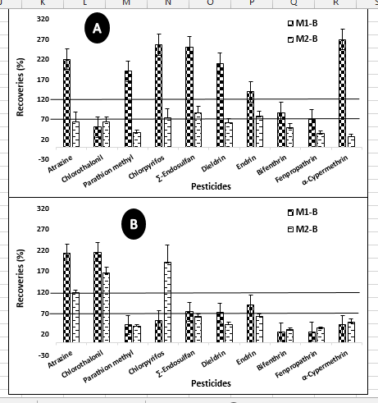
Figure S1. Percentage recoveries of the selected pesticide residues with both the extraction methods (i.e. M₁: original/un-buffered and M₂: acetate-buffered/AOAC-2007.01) followed by cleanup-B, in (A) Tomato and (B) Aubergine/Eggplant (each batch in triplicate)

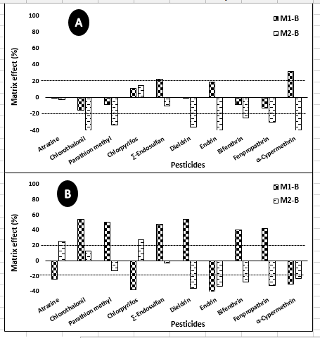
Figure S2. Percentage matrix effects of the selected pesticide residues with both the extraction methods (i.e. M₁: original/un-buffered and M₂: acetate-buffered/AOAC-2007.01) followed by cleanup-B, in (A) Tomato and (B) Aubergine/Eggplant (each batch in triplicate)

