Supplementary Data

Nucleotide sequence data obtained for identification of detected bacteria shown in Table 3

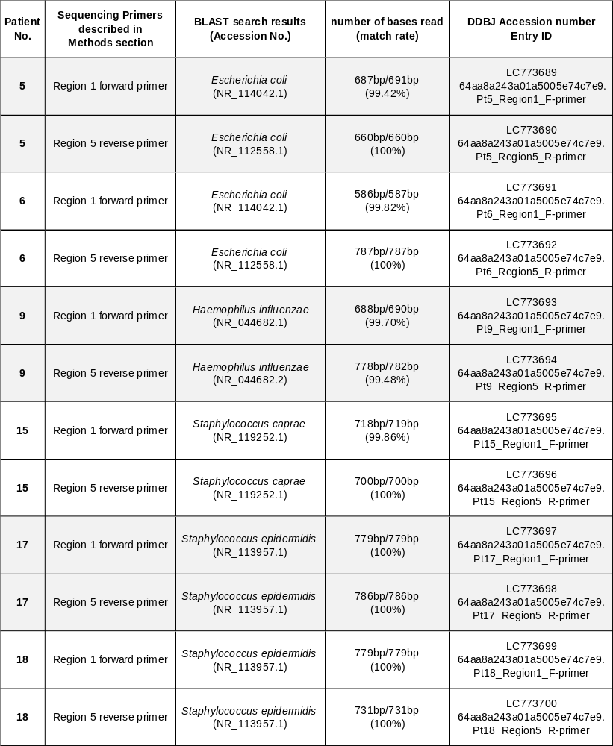

Patient 5
Sequence data using Region 1 forward primer (Part 1)

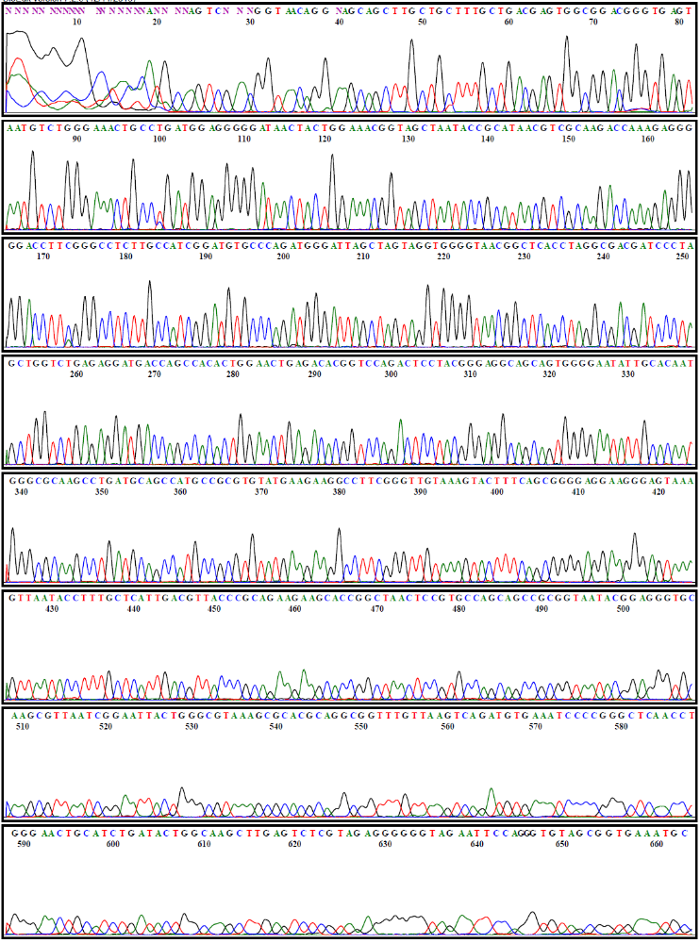

Patient 5
Sequence data using Region 1 forward primer (Part 2)

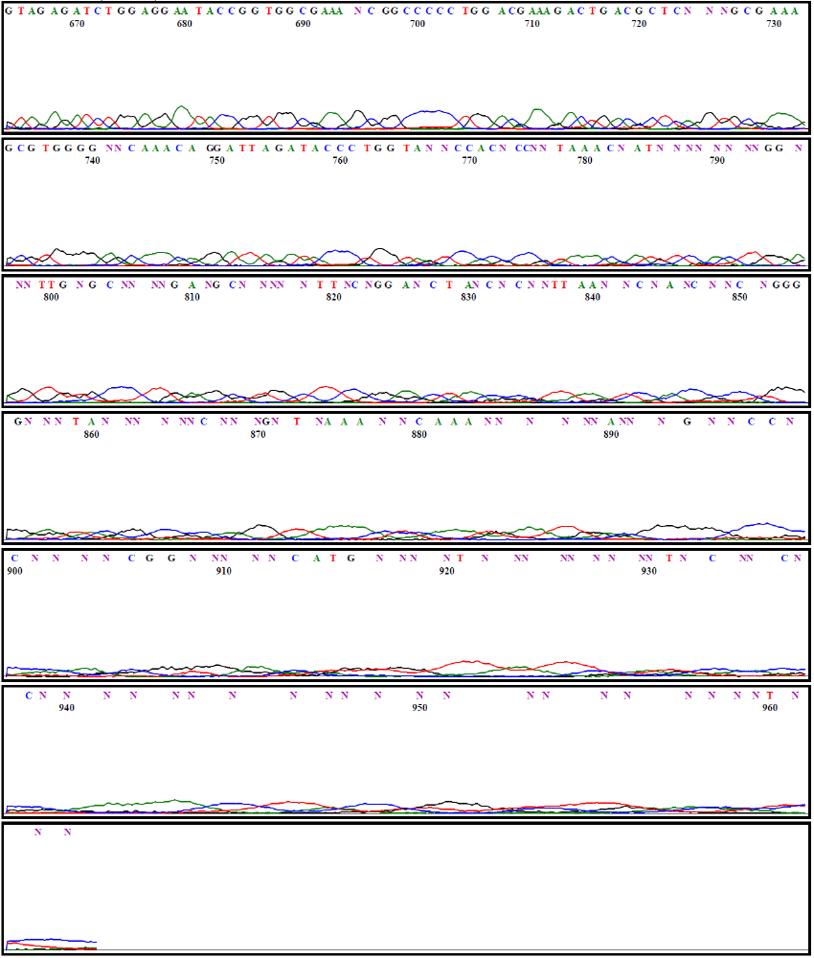

Patient 5
Sequence data using Region 5 reverse primer (Part 1)

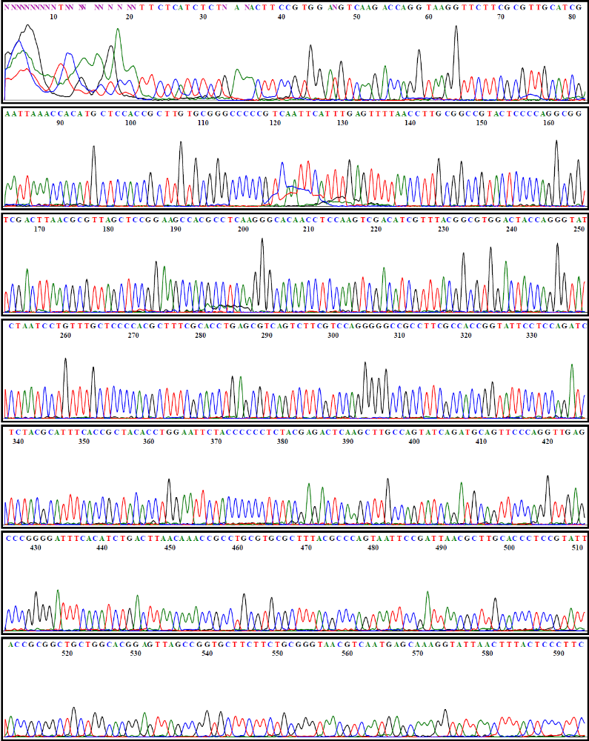

Patient 5
Sequence data using Region 5 reverse primer (Part 2)

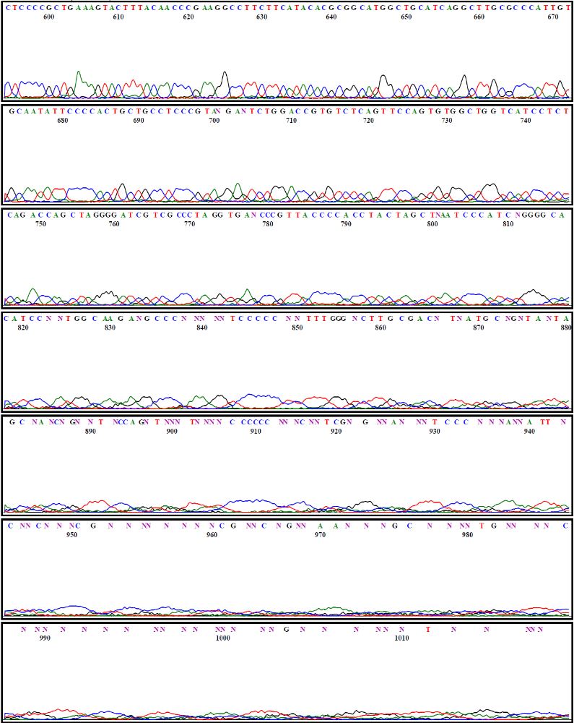

Patient 6
Sequence data using Region 1 forward primer (Part 1)

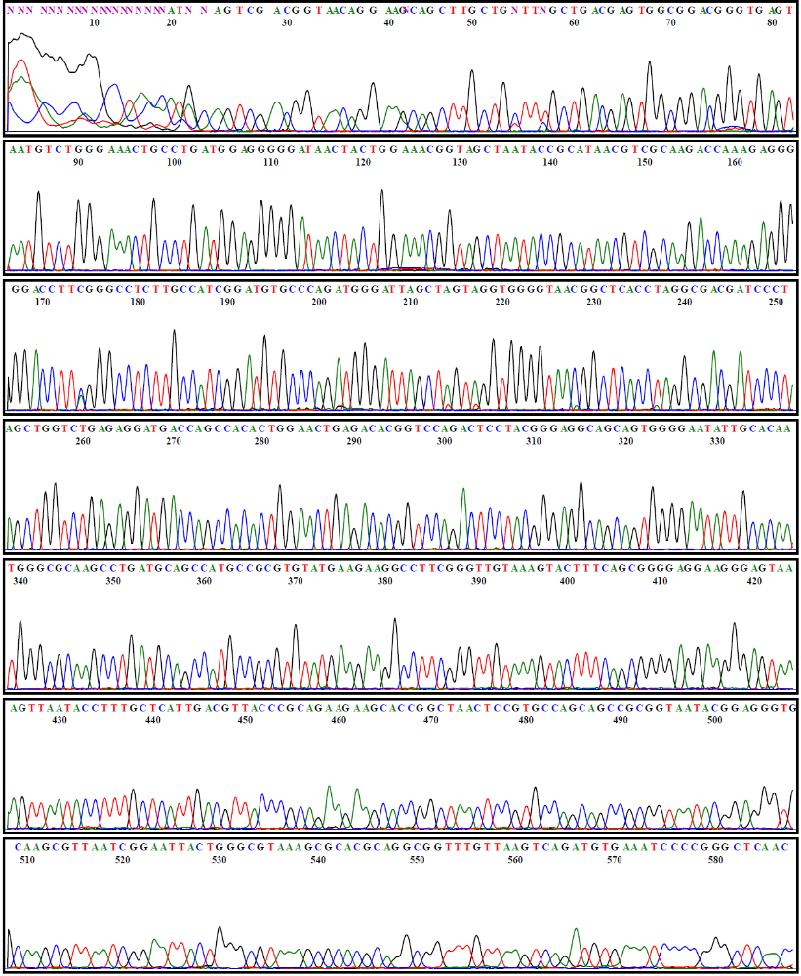

Patient 6
Sequence data using Region 1 forward primer (Part 2)

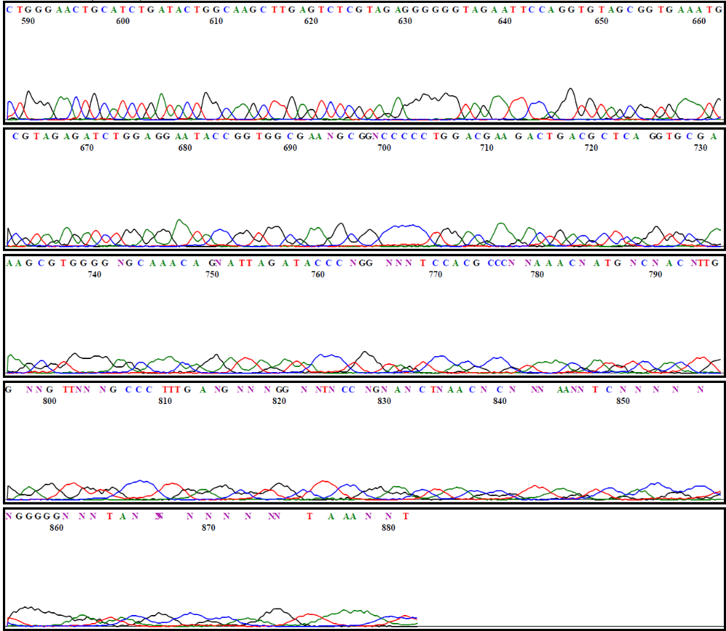

Patient 6
Sequence data using Region 5 reverse primer (Part 1)

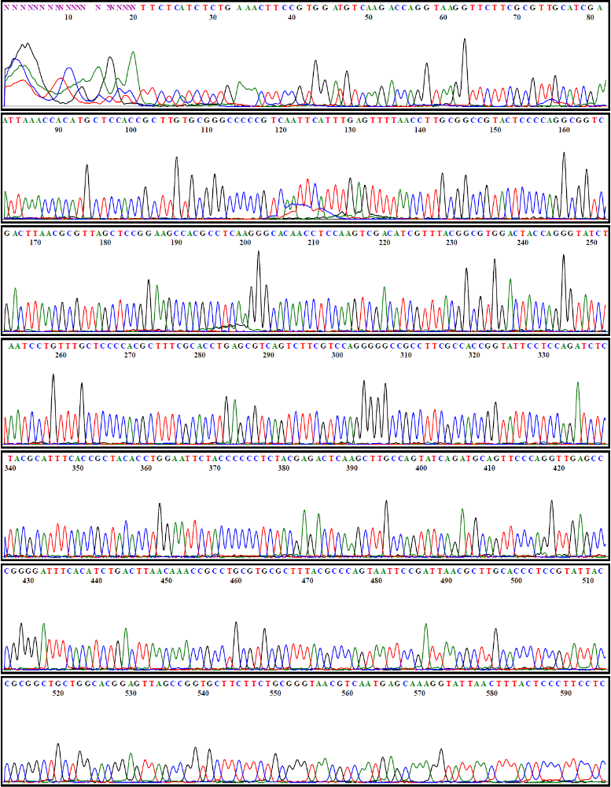

Patient 6
Sequence data using Region 5 reverse primer (Part 2)

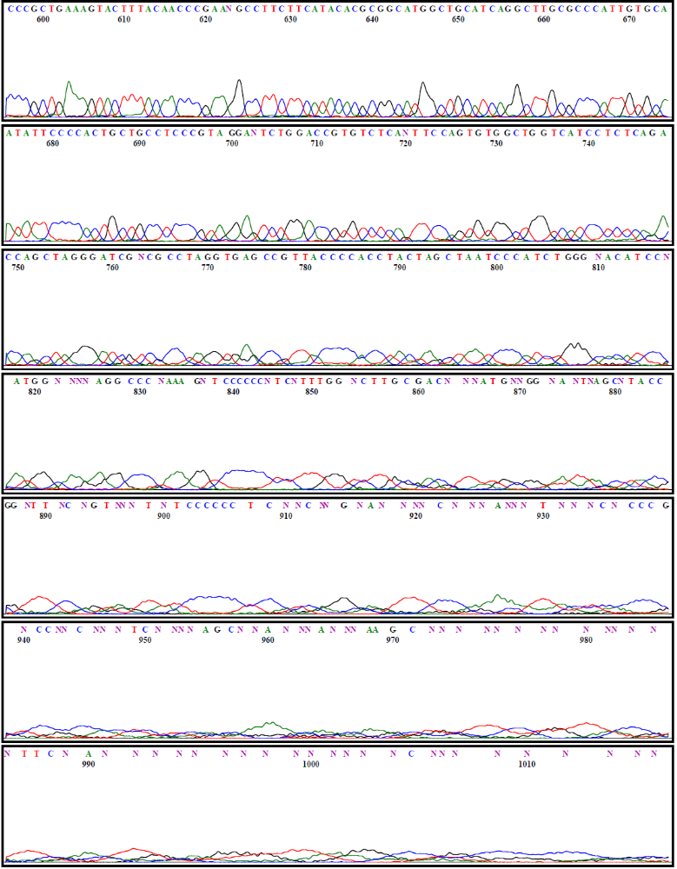

Patient 9
Sequence data using Region 1 forward primer (Part 1)

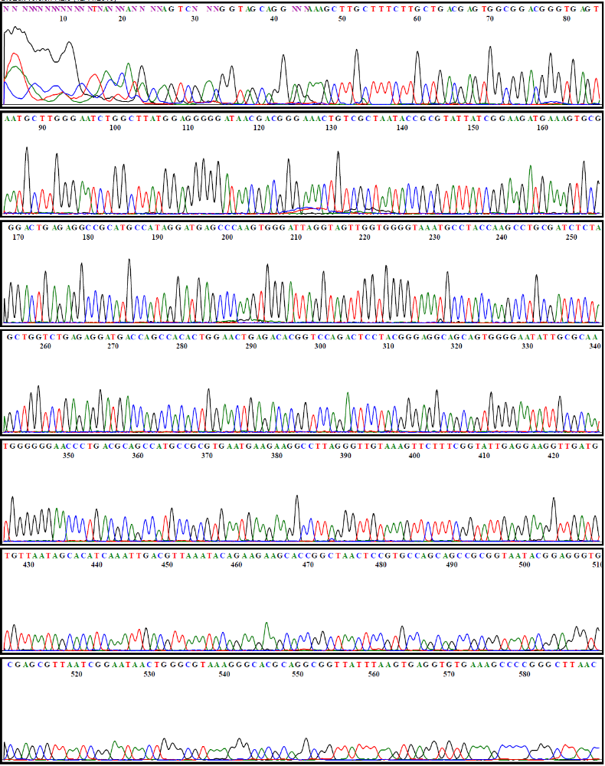

Patient 9
Sequence data using Region 1 forward primer (Part 2)

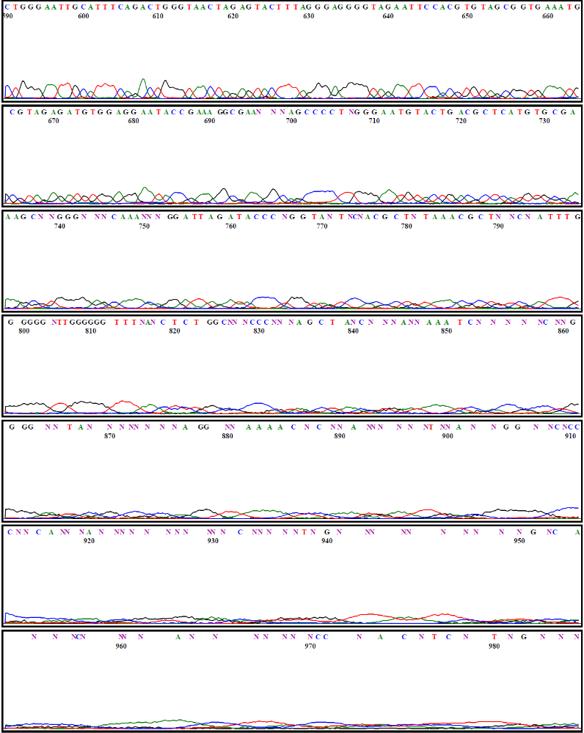

Patient 9
Sequence data using Region 5 reverse primer (Part 1)

Patient 9
Sequence data using Region 5 reverse primer (Part 2)

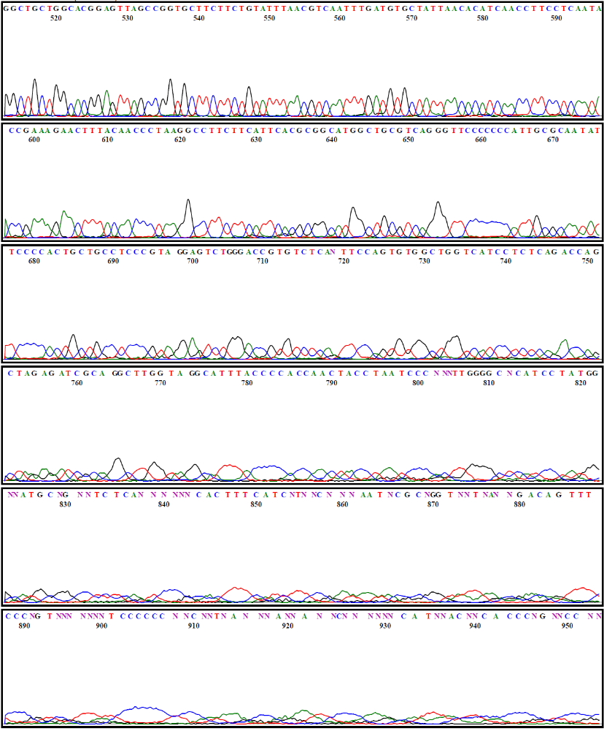

Patient 15
Sequence data using Region 1 forward primer (Part 1)

Patient 15
Sequence data using Region 1 forward primer (Part 2)

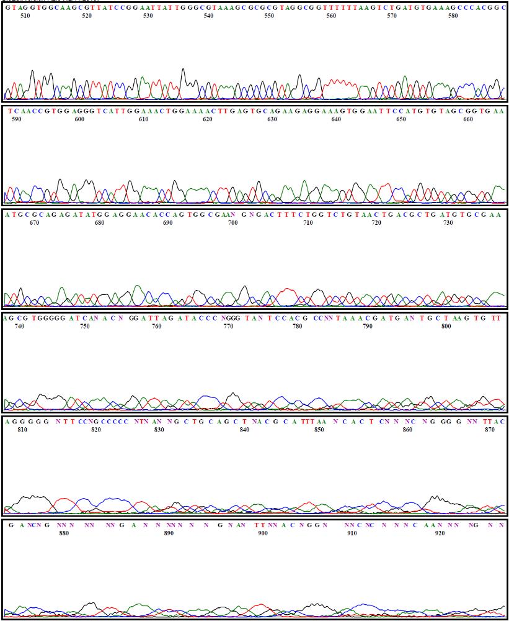

Patient 15
Sequence data using Region 5 reverse primer (Part 1)

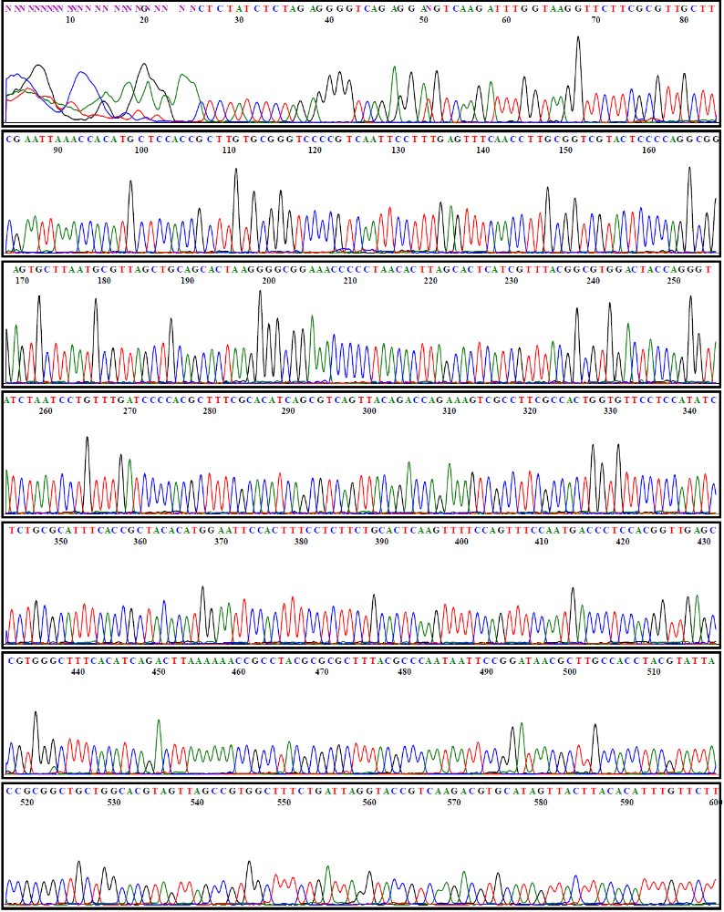

Patient 15
Sequence data using Region 5 reverse primer (Part 2)

Patient 17
Sequence data using Region 1 forward primer (Part 1)

Patient 17
Sequence data using Region 1 forward primer (Part 2)

Patient 17
Sequence data using Region 5 reverse primer (Part 1)

Patient 17
Sequence data using Region 5 reverse primer (Part 2)

Patient 18
Sequence data using Region 1 forward primer (Part 1)

Patient 18
Sequence data using Region 1 forward primer (Part 2)

Patient 18
Sequence data using Region 5 reverse primer (Part 1)

Patient 18
Sequence data using Region 5 reverse primer (Part 2)

