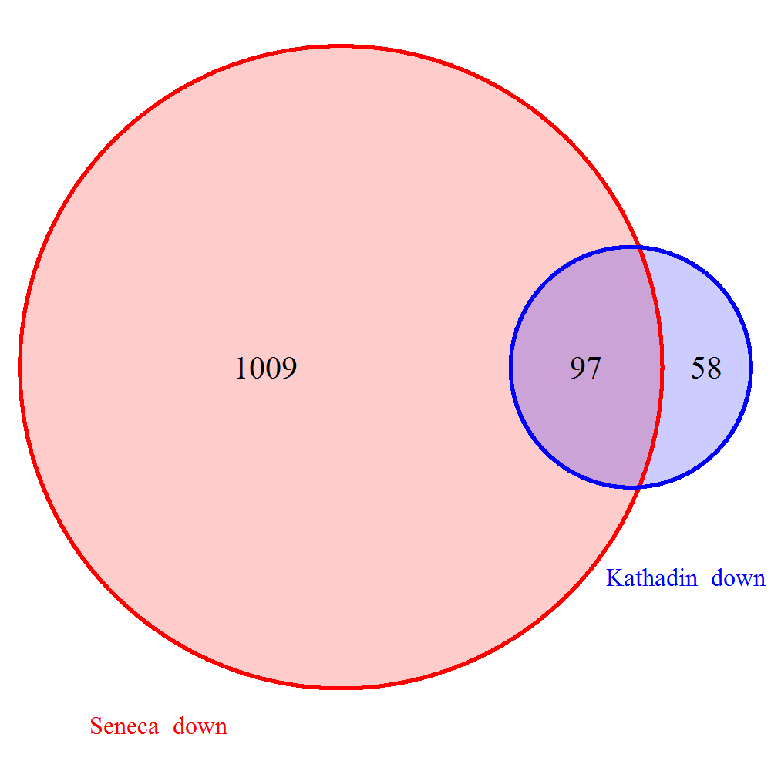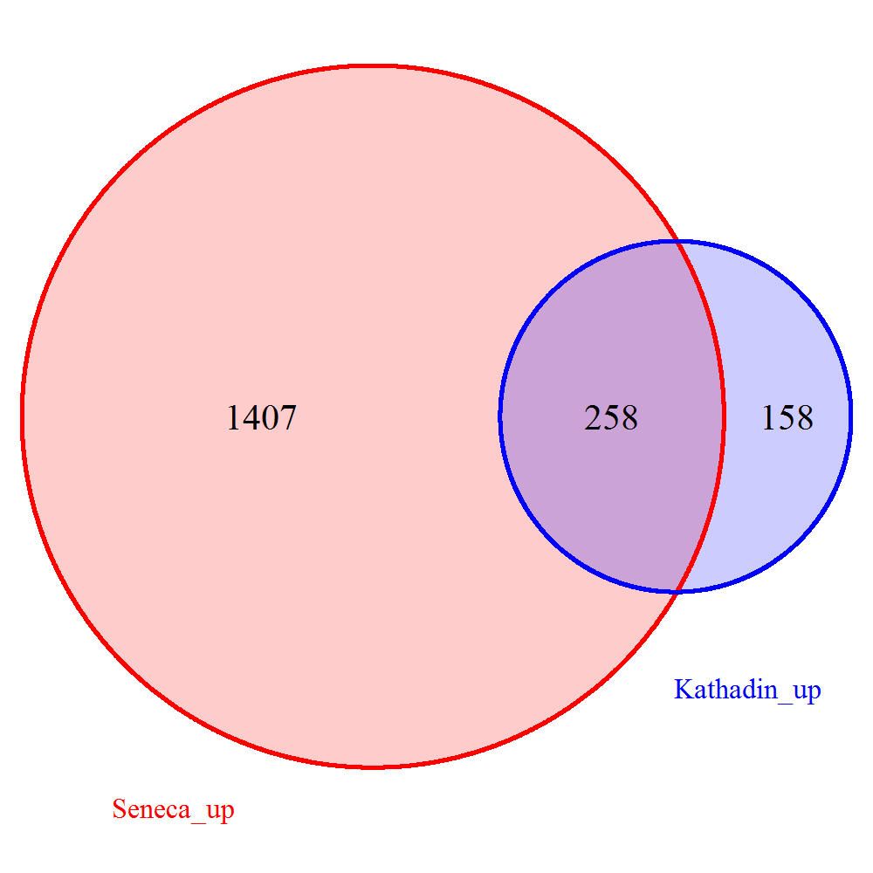
Figure S1. Venn diagrams representing the number of differentially expressed genes (DEGs) identified in cultivars Katahdin and Seneca.

Figure S2. Heatmap of log10 of TPM values representing expression profiles of genes involved in the regulation of cell cycle progression in cultivars Katahdin and Seneca.

