Supplement 4: Receiver operating characteristic curve for the detection of ocular surface squamous neoplasia on (A) optical coherence tomography, (B) impression cytology, and (C) methylene blue stain.
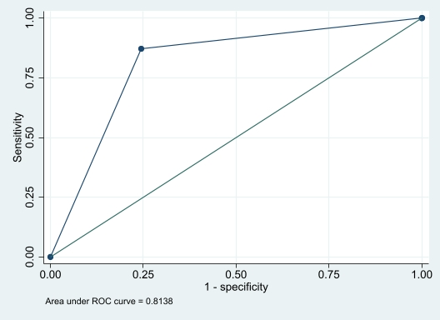
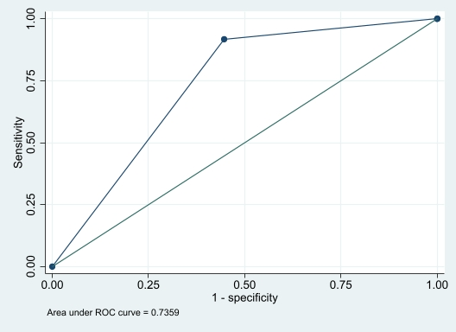
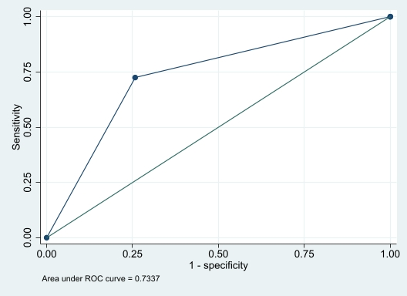
A
C
B

