Preparation and characterization of titanium oxide nanocapsules containing retinoic acid for sustained release

Xuecheng Yu ^{1, &}, Yunhe Zhao ^{2, &}, Gang Chen ³, Jing Yu ³, Ruolan Wang ¹, Yuhao Deng ², Xiaoying Wang ², Xinru Yuan ¹, Xue-Feng Yu ^{1, 4}, Rui He ^{1, *}

¹ Shenzhen Institute of Advanced Technology, Chinese Academy of Sciences, Shenzhen 518055, China
² Wuhan Science and Technology Institute of Advanced Technology, Wuhan 430000, China
³ Blank me R&D Center, Yongxi Tech Co., LTD, Shanghai 200011, China
⁴ Hubei Three Gorges Laboratory, Yichang 443007, China
& These authors contributed equally to this work.
* Corresponding author.
E-mail address: rui.he1@siat.ac.cn (R. H.)

- Table S1 RA-TiO₂ nanocapsules under different synthesis conditions
- Fig. S1 The schematic diagram of sustained-release tests by elution process
- Fig. S2 The schematic diagram of photostability experiments

Table S1 Preparation of RA-TiO₂ nanocapsules under different synthesis conditions

Experimental number | Solubilizing agent | Core material contents | Shell-forming agents | Aqueous phase additives
1 (Fig. 2a) | None | 1 wt% | Ethyl titanate | Octadecyl trimethylammonium chloride(OTAC)
2 (Fig. 2b) | Ethanol | 30 wt% | Ethyl titanate | OTAC
3 (Fig. 2c) | Ethanol | 20 wt% | Ethyl titanate | OTAC
4 (Fig. 2d) | Ethanol | 15 wt% | Ethyl titanate | OTAC
5 (Fig. 2e) | Ethanol | 10 wt% | Butyl titanate | OTAC
6 (Fig. 2f) | Ethanol | 10 wt% | Ethyl titanate | None
7 (Fig. 2g) | Ethanol | 10 wt% | Ethyl titanate | Sodium dodecyl sulfate
8 (Fig. 2h) | Ethanol | 10 wt% | Ethyl titanate | Ammonium chloride
9 (Fig. 2i) | Ethanol | 10 wt% | Ethyl titanate | OTAC

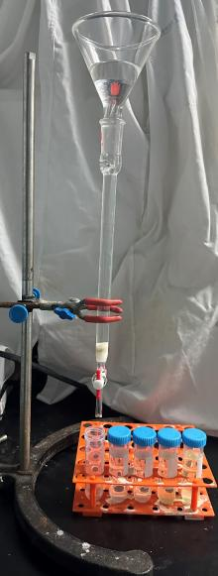
Fig. S1 The schematic diagram of sustained-release tests by elution process

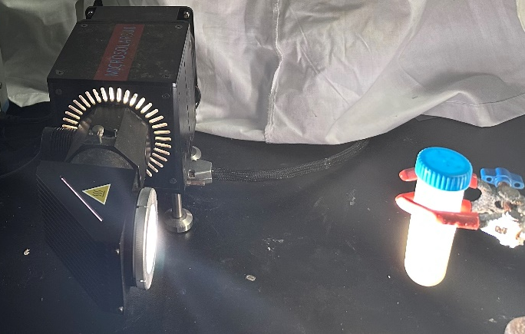
Fig. S2 The schematic diagram of photostability experiments under sunlight irradiation

