Supplementary Material for “A pangenome graph reference of 30 chicken genomes allows genotyping of large and complex structural variants.”

Edward S. Rice¹,², Antton Alberdi³, James Alfieri⁴, Giridhar Athrey⁵, Jennifer R. Balacco⁶, Philippe Bardou⁷, Heath Blackmon⁸, Mathieu Charles⁹, Hans H. Cheng¹⁰, Olivier Fedrigo⁶, Steven R. Fiddaman¹¹, Giulio Formenti⁶, Laurent Frantz²,¹², M. Thomas P. Gilbert³, Cari J. Hearn¹⁰, Erich D. Jarvis⁶,¹³, Christophe Klopp¹⁴, Sofia Marcos³,¹⁵, Deborah Velez-Irizarry¹⁰, Luohao Xu¹⁶, Wesley C. Warren¹⁷*

¹ Bond Life Sciences Center, University of Missouri, Columbia, MO, USA
² Faculty of Veterinary Medicine, Ludwig-Maximilians-Universität, München, Germany
³ Center for Evolutionary Hologenomics, Globe Institute, University of Copenhagen (UCPH), Copenhagen, Denmark
⁴ Department of Ecology & Evolutionary Biology, Texas A&M University, College Station, TX, USA
⁵ Department of Poultry Science, Texas A&M University, College Station, TX, USA
⁶ Vertebrate Genome Laboratory, The Rockefeller University, New York, NY, USA
⁷ Sigenae, GenPhySE, Université de Toulouse, INRAE, ENVT, F-31326, Castanet Tolosan, France
⁸ Department of Biology, Texas A&M University, College Station, TX, USA
⁹ INRA Centre de Toulouse Midi-Pyrénées: Castanet Tolosan, Midi-Pyrénées, FR
¹⁰ USDA, ARS, USNPRC, Avian Disease and Oncology Laboratory, East Lansing, MI, USA
¹¹ Department of Biology, University of Oxford, OX1 3SZ, UK
¹² School of Biological and Behavioural Sciences, Queen Mary University of London, London E1 4DQ, UK
¹³ The Howard Hughes Medical Institute, Chevy Chase, MD, USA
¹⁴ Sigenae, Genotoul Bioinfo, MIAT UR875, INRAE, Castanet Tolosan, France
¹⁵ Applied Genomics and Bioinformatics, University of the Basque Country (UPV/EHU), Leioa, Bilbao, Spain
¹⁶ Key Laboratory of Freshwater Fish Reproduction and Development (Ministry of Education), Key Laboratory of Aquatic Science of Chongqing, School of Life Sciences, Southwest University, Chongqing 400715, China
¹⁷ Department of Animal Sciences, University of Missouri, Columbia, MO, USA

* To whom correspondence should be addressed: warrenwc@missouri.edu

Contents:

Supplementary Note 1
Supplementary Figures S1-S4
Supplementary Tables 1-3
Supplementary Note 1

The reference genomes bGalGal1b and bGalGal1w are haploid assemblies of the two haplotypes of a female (WZ) F1 hybrid of a female (WZ) broiler and a male (ZZ) white leghorn layer, separated using trio binning. Thus, the assembled individual has a W chromosome inherited from the broiler and a Z chromosome inherited from the white leghorn layer. W-linked sequence was therefore binned with the maternal haplotype and Z-linked sequence with the paternal haplotype. However, after assembly, the assembled Z chromosome was removed from the paternal layer assembly bGalGal1w and placed in the maternal broiler assembly bGalGal1b so that bGalGal1b, intended to be the primary reference assembly for the species, could include both a W and a Z chromosome for alignment [1]. Any contigs belonging on the Z chromosome but not properly assigned to it were thus left behind in the assembly bGalGal1w, separated from the rest of the Z chromosome sequence.

Two unassigned contigs in bGalGal1w, JAENSL010000411 and JAENSL010000412, are included in the pangenome alignments of the K locus (Supplementary Figure S4a). These contigs share a 31kb overlap with 97% identity. Based on the long, high-identity overlap between the contigs, we believe they should have been joined into a single contig, but were not due to the high error rate in the PacBio CLR reads used in this assembly and the duplicated nature of this sequence making unique alignment of reads difficult during the polishing step. The new contig formed by joining these two contigs at the overlap aligns closely to the region of chrZ duplicated in Huxu, contains the ev21 insertion, and is 177.8kb long, close to the 176kb estimate of the length of the tandem duplication provided by Elferink et al. [2] (Supplementary Figure S4b). Thus, this sequence appears to be the tandem duplication present in the late feathering locus, and should have been assigned to the single Z chromosome that is part of the bGalGal1w haplotype but was included in the bGalGal1b reference for convenience (Supplementary Figure S4c).
Supplementary Figure S1. Sequence added to the graph by each sample, with samples ordered by how much sequence they contribute.

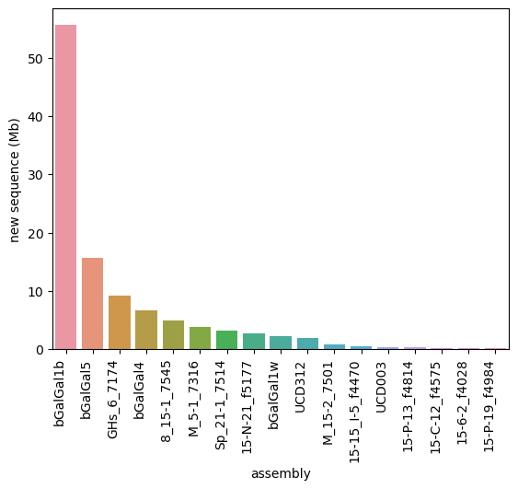
Supplementary Figure S2. Changing the parameters segment length (s), mapping percent identity (p), and minimum match length (k) affects graph structure of the PGGB graph of chr13. (a-b) 100 different parameter combinations give different values for numbers of nodes in thousands (a) and maximum degree (b). (c) While the numbers of nodes and edges differ with parameter changes, the degree (i.e., the slope of the line) remains the same. (d-e) A one-dimensional view of the graph shows that poor parameter choices such as s=100000, p=99, k=350 (d) lead to regions of the genome that should align being separated, while better parameter choices such as s=50000, p=97, k=150 (e) allow better, but still imperfect, alignments.

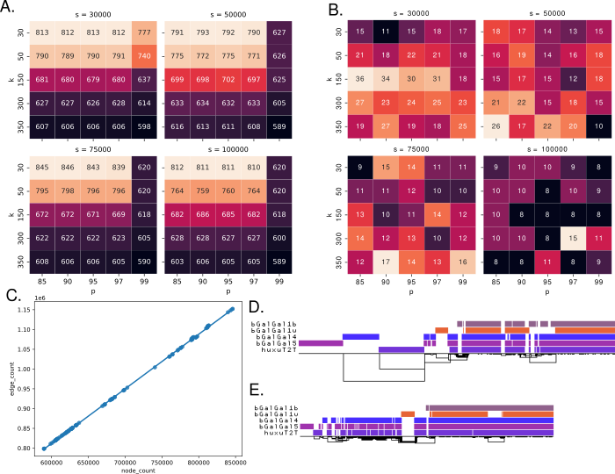
Supplementary Figure S3. A comparison of the graph structures of chr13 between (a) PGGB and (b) minigraph-cactus shows that the PGGB graph is more fragmented and contains misalignments.
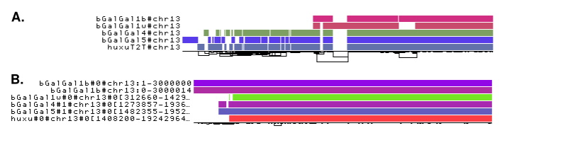
Supplementary Figure S4. Two unplaced contigs in bGalGal1w are part of the pangenome graph of the K locus, showing that bGalGal1w contains the slow feathering allele. (a) The pangenome graph of the K locus on chrZ shows two unplaced contigs from bGalGal1w are included in the graph. The contigs have a 31kb overlap with 97% identity. (b) Merging the two contigs at the overlap creates a new contig that covers the duplication present in the slow feathering allele and contains the ev21 insertion. (c) We hypothesize that these two contigs are a misassembly of the slow feathering allele, and should have been included in chrZ, which was included in bGalGal1b for the sake of a complete reference genome despite coming from the paternal layer haplotype of bGalGal1w.

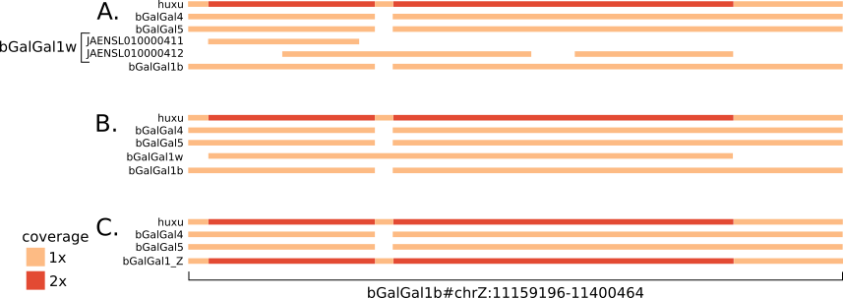
Supplementary Figure S5. Mean fractions of mapped reads containing alternate allele at putative heterozygous SNV sites. Without reference bias, this fraction would be 0.5, so larger deviations from 0.5 indicate more reference bias. For every one of the 100 short read chickens, pangenome alignment with giraffe reduces reference bias compared to linear alignment with minimap. The mean reduction across all samples is 38%. Sample information for each of these sample IDs can be found in Supplementary Table 2.

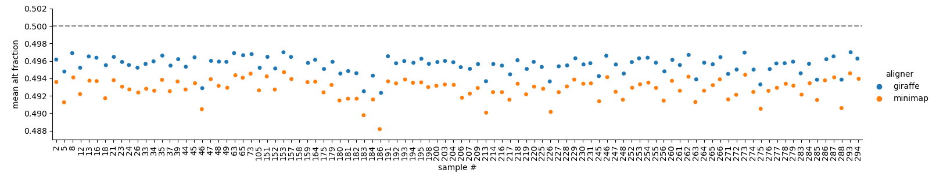
Supplementary Tables (attached separately)

Supplementary Table 1. Additional chickens sequenced with HiFi reads and assembled for inclusion in the minigraph-cactus pangenome.

Supplementary Table 2. Chickens sequenced with short reads and genotyped using pangenome graph alignments.

Supplementary Table 3. Final parameters for PGGB for each chromosome.
Works cited
1. Smith J, Alfieri JM, Anthony N, Arensburger P, Athrey GN, Balacco J, et al. Fourth Report on Chicken Genes and Chromosomes 2022. Cytogenet Genome Res [Internet]. 2023; Available from: http://dx.doi.org/10.1159/000529376
2. Elferink MG, Vallée AAA, Jungerius AP, Crooijmans RPMA, Groenen MAM. Partial duplication of the PRLR and SPEF2 genes at the late feathering locus in chicken. BMC Genomics. 2008;9:391.

