Table 1: Formulation and proximate composition of four experimental diets.

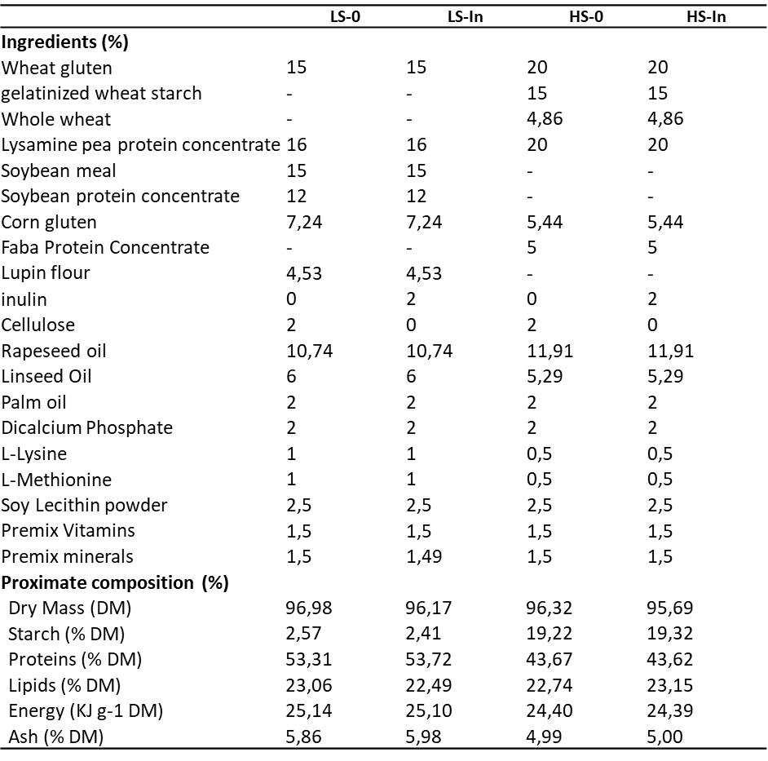

Table 2: Growth performances and feed utilization, in rainbow trout fed the experimental diets

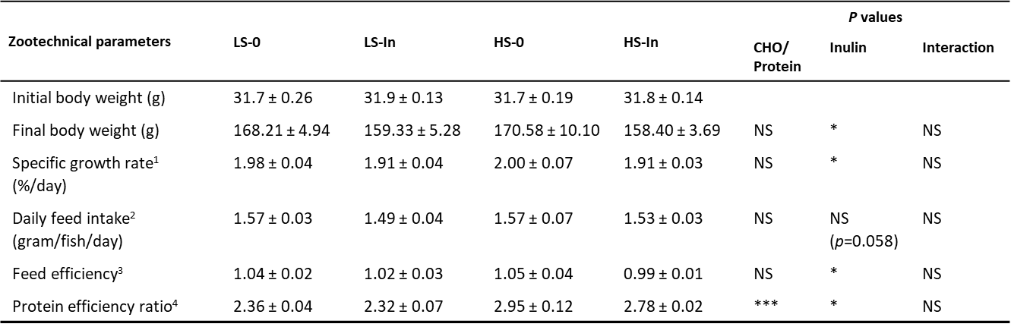

Data are presented as mean ± SD (n=3 tanks). Statistical differences were analyzed with a two-way ANOVA test and were considered statistically significant for P<0.05. NS, non-significant.
¹Specific growth rate (%/day) = 100x [Ln (final body weight. g)-Ln (initial body weight. g)]/ Experiment duration (days).
²Daily feed intake (gram/fish/day) = (Total feed consumed. g/Number of fish/Experiment duration (days)).
³Feed efficiency = (Final biomass. g − Initial biomass. g)/Total feed consumed (g DM).
⁴Protein efficiency ratio = (Final biomass − Initial biomass)/ Total protein consumed (g).

Table 3: Plasma metabolites, hepatic glycogen contents, and hepato-somatic index in rainbow trout
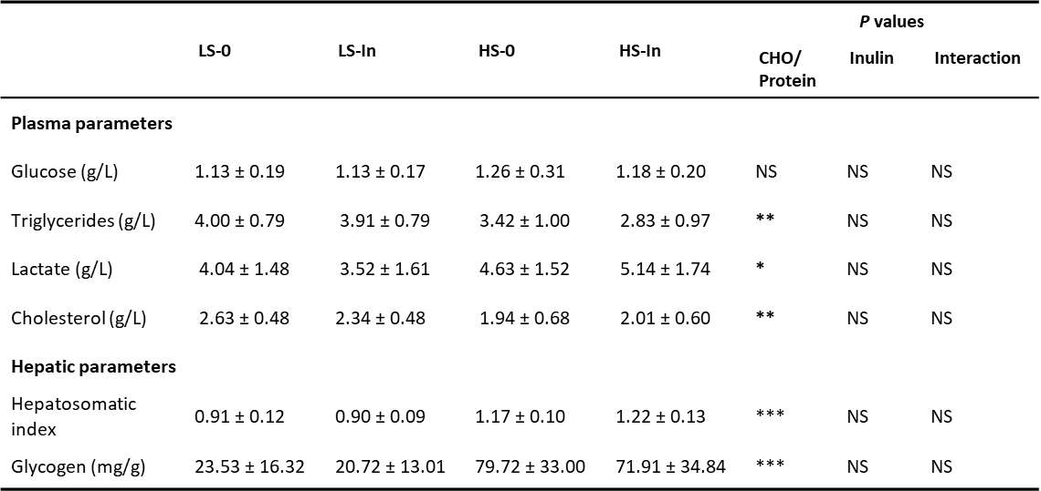
Data are presented as mean ± SD (n=12 fish). Statistical differences were analyzed with a two-way ANOVA test and were considered statistically significant for P<0.05. NS, not significant. P<0.05 *. P<0.01 **. P<0.001 ***.

Table 4: Abundances of different genera significantly affected by experimental diets
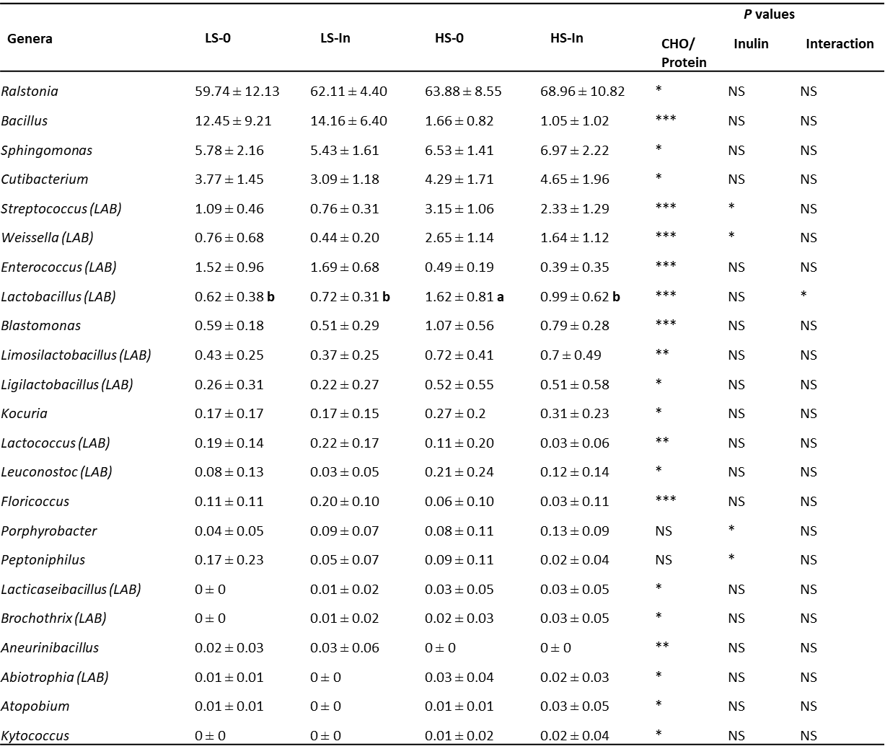
Data are presented as mean ± SD (n=12 fish). Statistical differences were analyzed with a two-way ANOVA test and were considered statistically significant for P<0.05. NS not significant. P<0.05 *. P<0.01 **. P<0.001 ***.

Table 5: mRNA levels of genes involved in different metabolic pathways in liver
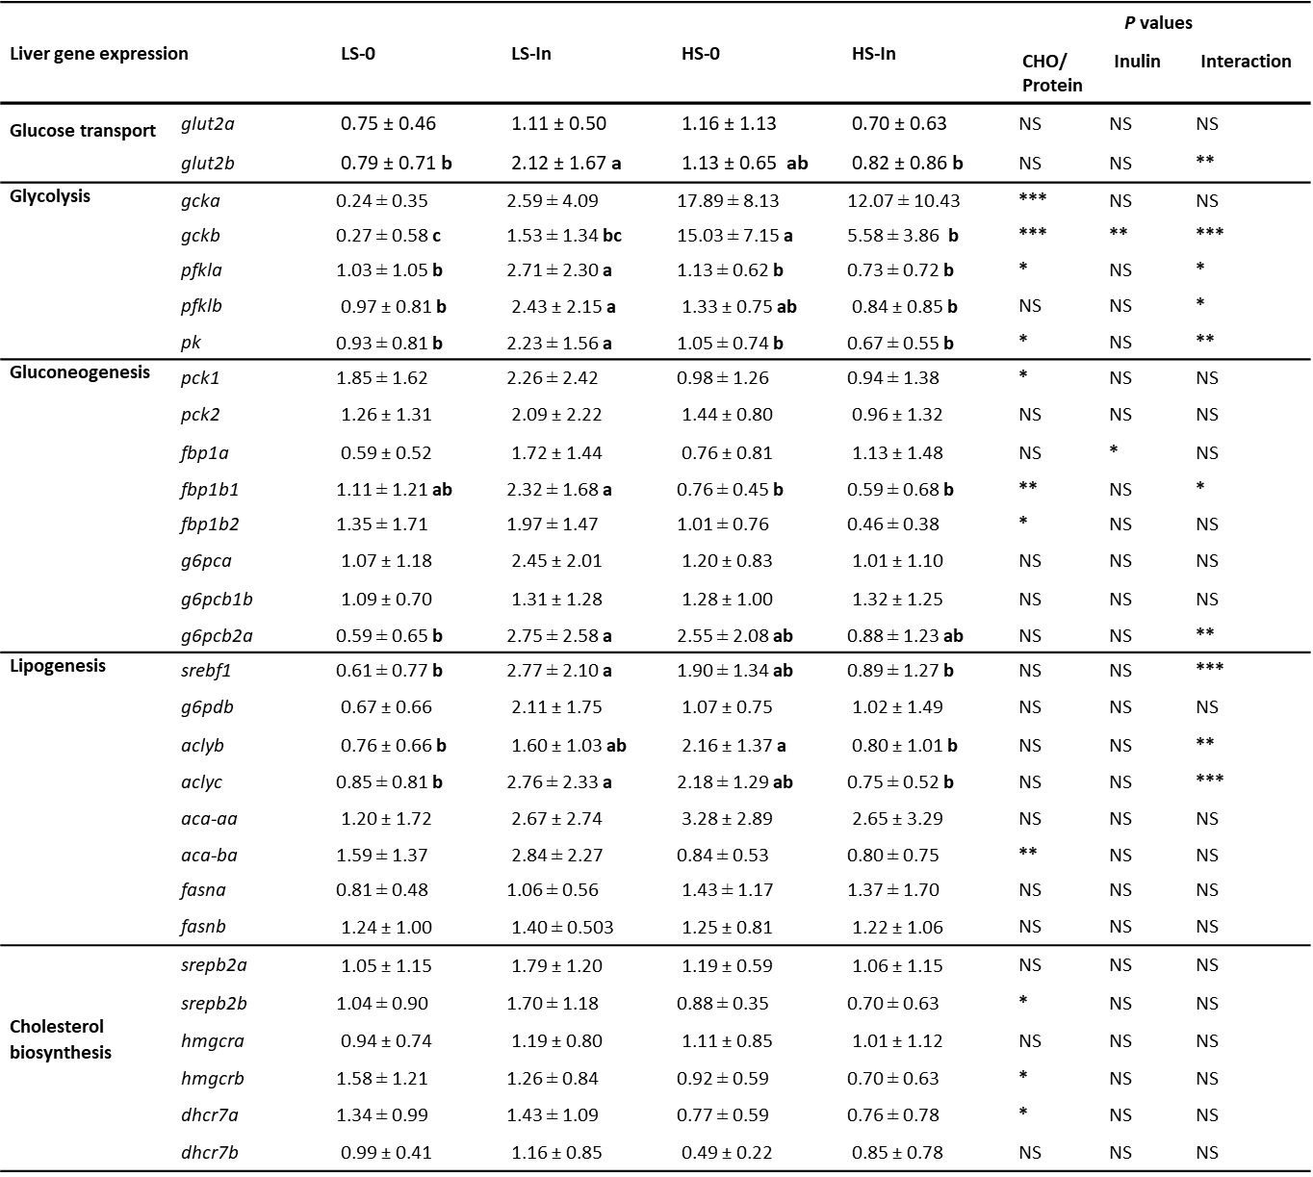

Data are presented as mean ± SD (n=12 fish). Statistical differences were analyzed with a two-way ANOVA test and were considered statistically significant for P<0.05. NS, not significant. P<0.05*. P<0.01 **. P<0.001 ***. glut2a and glut2b: glucose transporter paralogs. gcka and gckb: glucokinase paralogs. pfkla and pfklb: 6-phosphofructokinase paralogues. Pk: pyruvate kinase. pck1 and pck2: phosphoenolpyruvate carboxykinase paralogs. fbp1a, fbp1b1, and fbp1b2: fructose 1.6-bisphosphatase paralogues. g6pca, g6pcb1b, and g6pcb2a: glucose-6-phosphatase paralogs. srebf1: sterol regulatory element binding factor 1. g6pdb: glucose-6-phosphatase dehydrogenase. aclyb, and aclyc: adenosine triphosphate citrate lyase paralogues. aca-aa and aca-ba: acetylcoA carboxylase paralogues. fasna and fasnb: fatty acid synthase paralogs. srebp-2a and srebp-2b: sterol regulatory element-binding protein 2 paralogues. hmgcra, and hmgcrb: hydroxymethylglutaryl-CoA synthase paralogues. dhcr7a, and dhcr7b: 7-dehydrocholesterol reductase paralogues.

Table 6: mRNA levels of free fatty acid receptors (FFAR) in mid-intestine
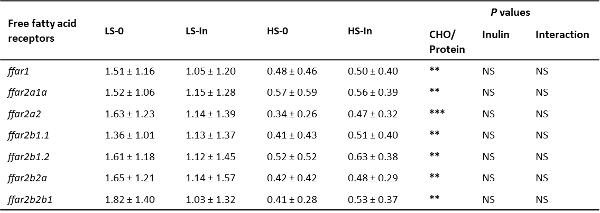
Data are presented as mean ± SD (n=12 fish). Statistical differences were analyzed with a two-way ANOVA test and were considered statistically significant for P<0.05. NS, not significant. P<0.05 *. P<0.01 **. P<0.001 ***.

