A Deep Learning Based Holistic Diagnosis System for Immunohistochemistry Interpretation and Molecular Subtyping

Lin Fan^{1,2,3*}, Jiahe Liu¹, Baoyang Ju¹ and Yushen Tian^{4*}
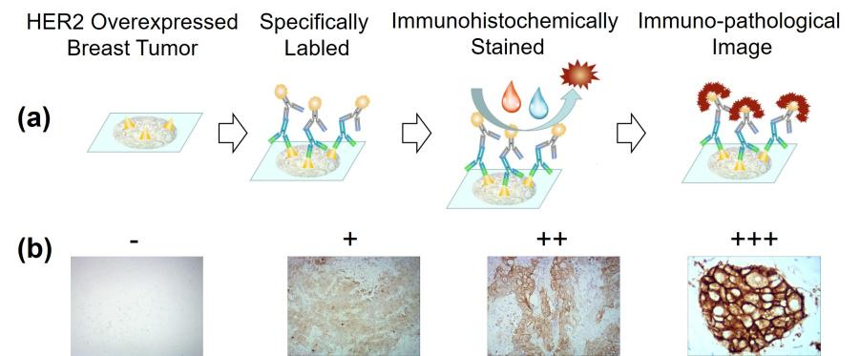
Figure S1. Immunohistochemical methods: (a) Scheme of immunohistochemical detection for HER2 overexpressed breast tumor sections. (b) Microscopic images of breast cancer sections with different expression levels of HER2.

Table.S1 Manually interpreting results of breast tumor sections with HER2 overexpressed ( n=104).
0（n, %) | 1+ (n, %) | 2+ (n, %) | 3+ (n, %)
30, 28.8% | 24, 23.1% | 24, 23.1% | 26, 25.0%

Table S2. Construction of training set and testing set through computer graphics methods.
Positive Degree | - |  | + |  | ++ |  | +++
Set | Training | Testing | Training | Testing | Training | Testing | Training | Testing
Number of Original Images | 60 | 13 | 20 | 4 | 20 | 4 | 20 | 6
Maximum Expansion Multiple | 2.6 | 1.2 | 7.9 | 3.9 | 7.9 | 3.9 | 7.9 | 2.6
Practical Expansion Multiple | 3 | 2 | 10 | 5 | 10 | 5 | 10 | 4
Rotating Step | 120 | 180 | 36 | 72 | 36 | 72 | 36 | 90
Number of Final Subgraphs | 10000 | 1000 | 10000 | 1000 | 10000 | 1000 | 10000 | 1000

Figure S2. Data expansion: (a) Original microscopic images of breast cancer sections with different expression levels of HER2. (b) The images of each positive degree were 360˚ rotated by certain rotating steps respectively and then (c) cut to 100 by 100 pixels. (d) 10000 cases of training data and 1000 cases of testing data were kept for each positive degree, and the subgraphs could not fill up 100 by 100 pixels or were not in accordance with the positive degree of the original images were eliminated.

Table.S3 Statistical results of the CNN based interpretation method for detecting immunohistochemical DAB stained sections of HER2 overexpressed breast tumor ( n=4000).
Subtype |  | Overexpression Level of Tumour Markers |  |  |  | Response to Therapies |  |  | Prognosis
 |  | HER2 | ER | PR | Ki67 | HER2-  Targeted Therapies | Chemotherapy | Homone Therapies | Prognosis
HER2-  related |  | +/++/+++ | - | - |  | High | High | Low | Poor
Luminal A |  | - | +/++/+++ | ++/+++ | + | Low | Low | High | Good
Luminal B | HER2-  negative | - | +/++/+++ | -/+ |  | High | Moderate | High | Moderate
 |  |  |  |  | +/++/+++
Luminal B | HER2-  Positive | +/++/+++ | +/++/+++ |  |  | Low | Moderate | High | Moderate
Basal-like |  | - | - | - | +/++/+++ | Low | High | Low | Poor
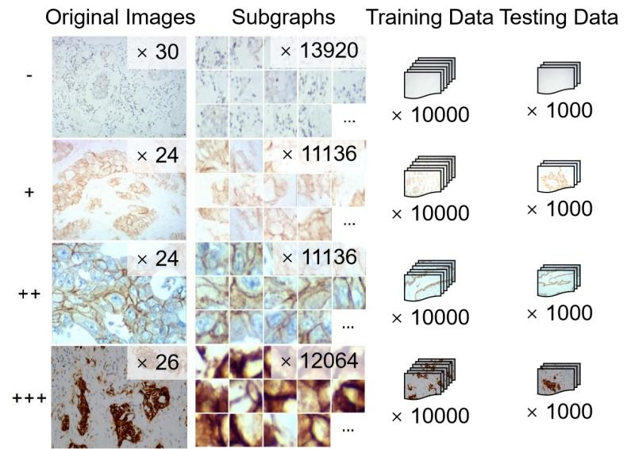
Figure S3. Dataset: The original microscopic images of breast cancer sections with different expression levels of HER2 were expanded by the process in Figure S1. The training data and testing data was expanded to 10000 and 1000 respectively for each positive degree

Table S4. Accuracy of CNN based interpreting model for grading breast cancer sections with HER2 overexpressed ( n=4000).
Positive grade | - | + | ++ | +++ | Total
Number of Concordant Cases | 969 | 955 | 957 | 972 | 3853
Number of Overhigh Cases | 31 | 39 | 6 | 0 | 76
Overhigh Rate | 3.1% | 3.9% | 0.6% | 0 | 1.9%
Number of Overlow Cases | 0 | 6 | 37 | 28 | 71
Overlow Rate | 0 | 0.6% | 3.7% | 2.8% | 1.8%
Number of Total Misinterpreted Cases | 31 | 45 | 43 | 28 | 147
Accuracy (Agreement) | 96.9% | 95.5% | 95.7% | 97.2% | 96.3%

Table.S5 Statistical results of the CNN based interpretation method for detecting immunohistochemical images of HER2 overexpressed breast tumor ( n=4000).
 | HER2 (+) | HER2 (-) | Total
Positive（+） | 2994（a） | 31（b） | 3025（a+b）
Negative（-） | 6（c） | 969（d） | 975（c+d）
Total | 3000（a+c） | 1000（b+d） | 4000（n）

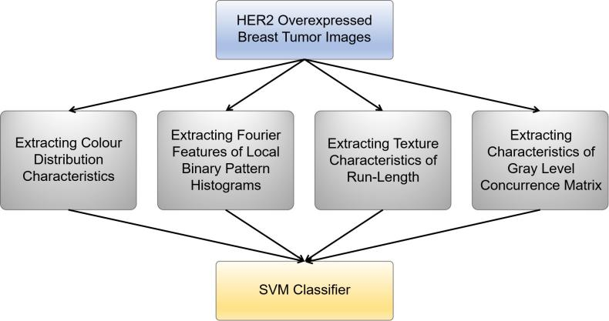
Figure S4. Architecture of PLF based interpreting model for grading immunohistochemical images of HER2-overexpressed breast tumour.

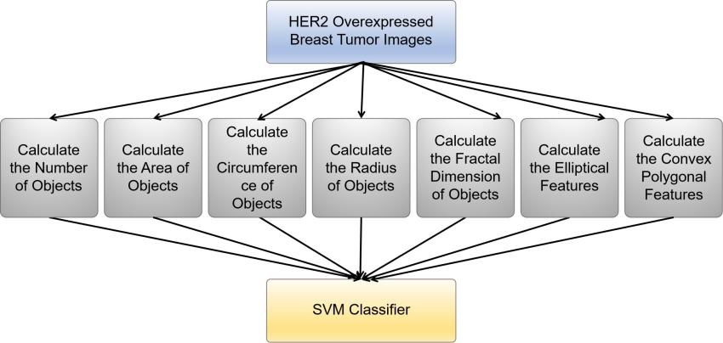
Figure S5. Architecture of OLF based interpreting model for grading immunohistochemical images of HER2-overexpressed breast tumour.

Table S6. Accuracy of CNN based interpreting model for grading breast cancer sections with ER overexpressed ( n=3000).
Positive grade | Neg | Low | High | Total
Number of Concordant Cases | 951 | 897 | 912 | 2760
Number of Misinterpreted Cases | 49 | 103 | 88 | 240
Accuracy (Agreement) | 95.1% | 89.7% | 91.2% | 92.0%

Table S7. Accuracy of CNN based interpreting model for grading breast cancer sections with PR overexpressed ( n=3000).
Positive grade | Neg | Low | High | Total
Number of Concordant Cases | 963 | 934 | 970 | 2867
Number of Misinterpreted Cases | 37 | 66 | 30 | 133
Accuracy (Agreement) | 96.3% | 93.4% | 97.0% | 95.6%

Table S8. Accuracy of CNN based interpreting model for grading breast cancer sections with PR overexpressed ( n=2000).
Positive grade | Low | High | Total
Number of Concordant Cases | 961 | 977 | 1938
Number of Misinterpreted Cases | 39 | 23 | 62
Accuracy (Agreement) | 96.1% | 97.7% | 96.9%

Table.S9 Statistical results of the CNN based interpretation method for detecting immunohistochemical images of ER overexpressed breast tumor ( n=3000).
 | ER（+） | ER（-） | Total
Positive（+） | 1898（a） | 49（b） | 1947（a+b）
Negative（-） | 102（c） | 951（d） | 1053（c+d）
Total | 2000（a+c） | 1000（b+d） | 3000（n）

Table.S10 Statistical results of the CNN based interpretation method for detecting immunohistochemical images of PR overexpressed breast tumor ( n=3000).
 | PR（+） | PR（-） | Total
Positive（+） | 1959（a） | 37（b） | 1996（a+b）
Negative（-） | 41（c） | 963（d） | 1004（c+d）
Total | 2000（a+c） | 1000（b+d） | 3000（n）

Table.S11 Statistical results of the CNN based interpretation method for detecting immunohistochemical images of Ki67 overexpressed breast tumor ( n=2000).
 | Ki67（>14%） | Ki67（<14%） | Total
High | 977（a） | 39（b） | 1016（a+b）
Low | 23（c） | 961（d） | 984（c+d）
Total | 1000（a+c） | 1000（b+d） | 2000（n）

