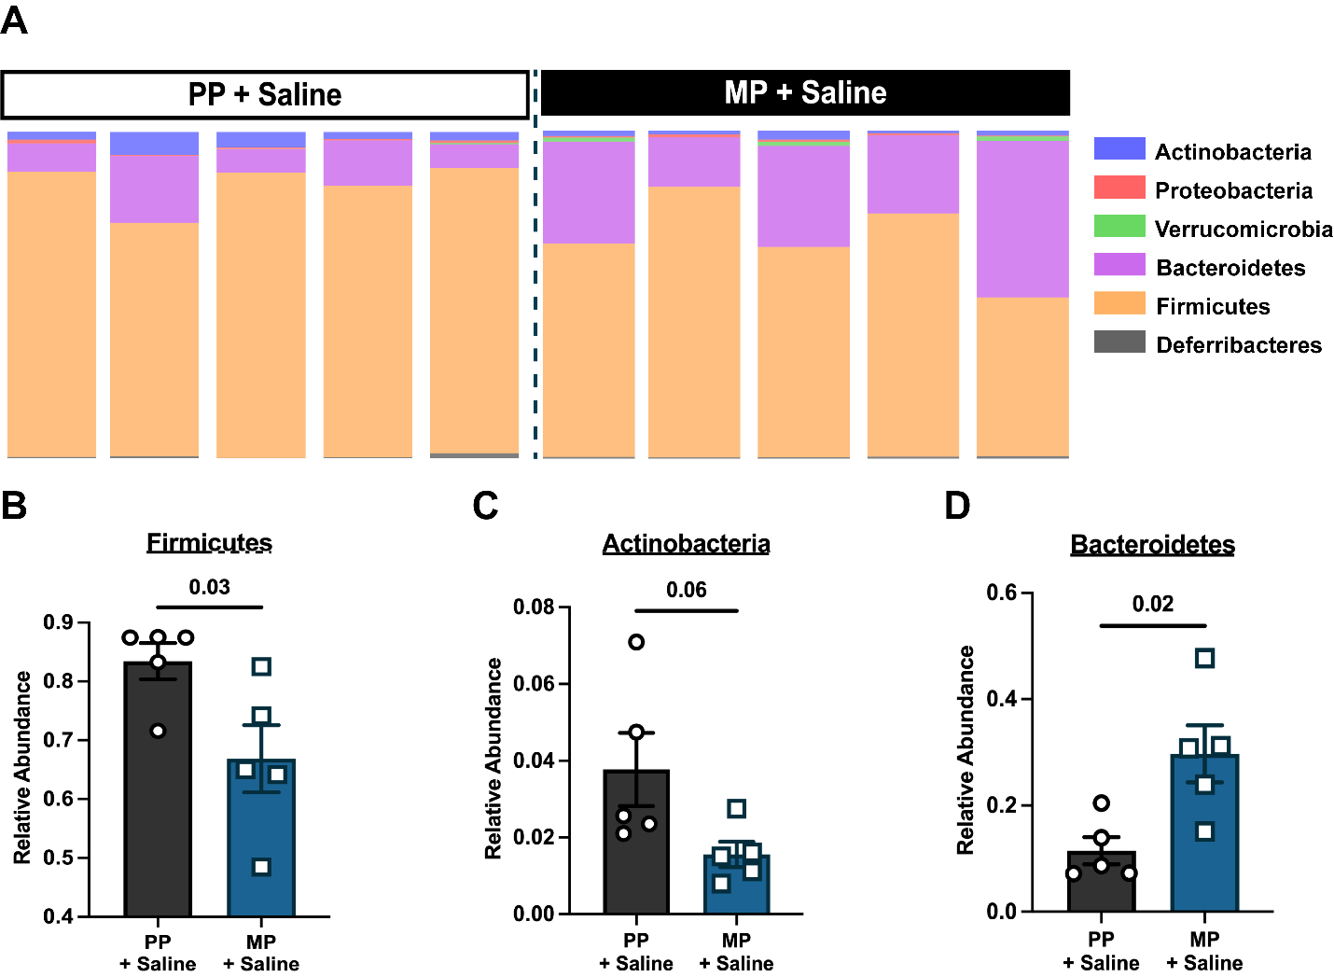

Figure S1. Bacterial phyla in placebo and morphine-pelleted mice. (A) Stack bars depicting the abundance of bacterial phyla in PP and MP mice. Abundance of (B) Firmicutes, (C) Actinobacteria, and (D) Bacteroidetes in PP and MP mice. Data in B, C and D are mean ± SEM, and scatter represents data from individual mice. Sample sizes are 5 mice per group. Data in B, C and D were analyzed by two-tailed unpaired Student’s t-test. P values are indicated.

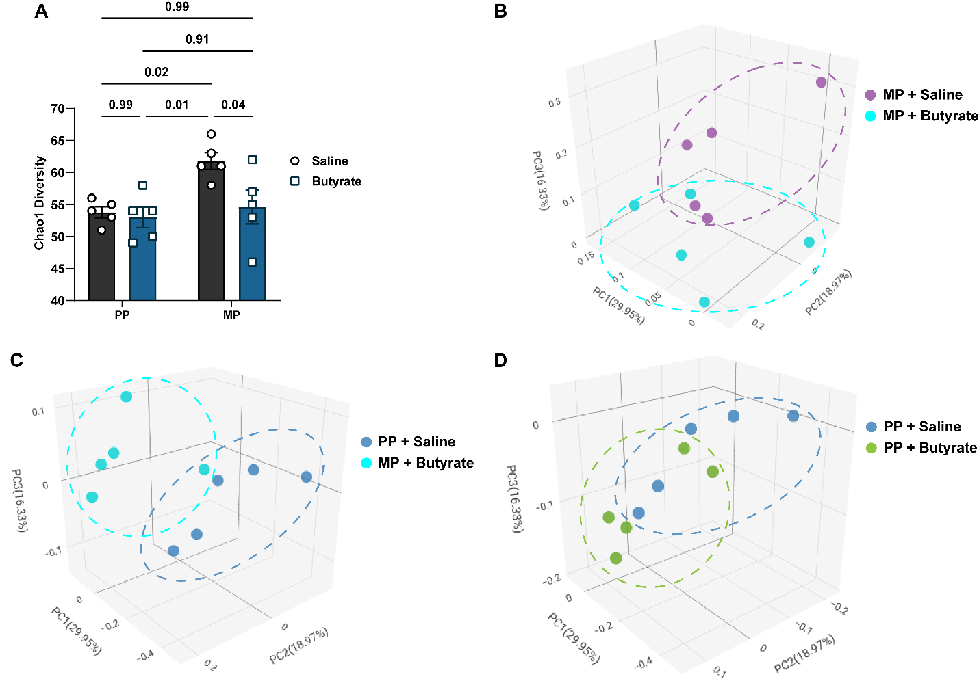

Figure S2. Fecal microbiome analysis in butyrate-treated mice. (A) Alpha diversity was assessed in the fecal samples of saline-treated PP, butyrate-treated PP, saline-treated MP, and butyrate-treated MP mice using the Chao1 index. Principal coordinate analysis (PCoA) of the beta diversity of the fecal bacteria in (B) saline-treated MP and butyrate-treated MP mice, (C) saline-treated PP and butyrate-treated MP mice, and (D) saline-treated PP and butyrate-treated PP mice was measured with the Bray-Curtis Index. Data in A was analyzed by two-way ANOVA and Tukey’s multiple comparisons test was used for post hoc analysis. P values for relevant interactions have been indicated. Data in A are mean ± SEM, and scatter represents data from individual mice. Sample sizes in A and B are 5 mice per group. The data for saline-treated PP and saline-treated MP mice was reused from Figures 1A and 1B.

Table S1. PERMANOVA Analysis of the beta diversity of the fecal bacteria.

Group Comparisons | F-Statistic | P-Value
PP + Saline vs. PP + Butyrate | 2.015 | 0.147
PP + Saline vs. MP + Saline | 3.137 | 0.008
PP + Saline vs. MP + Butyrate | 2.896 | 0.015
PP + Butyrate vs. MP + Saline | 3.454 | 0.012
PP + Butyrate vs. MP + Butyrate | 2.799 | 0.014
MP + Saline vs. MP + Butyrate | 1.966 | 0.022

