SUPPLEMENTARY MATERIALS
for
Validation of the Kidsights Data Measurement Tool

Contents
Removed Items 2
Supplementary Table 1 2
Item-level Information and Statistics 4
Supplementary Table 2 4
Threats to Validity 20
Measurement Non-Invariance 20
Item Misfit 20
Supplemental Figure 1 21
Supplemental Figure 2 22

Removed Items

Supplementary Table 1
Items removed, corresponding domain, and reason for removal
 |  | Domain | Reason Item Removed
R1 | When lying on his/her back, does your child move his/her arms and legs? | Motor/Phys. | Predicted item endorsement > .90 at 0 months.
R2 | Does the child quickly calm down when he/she doesn't get what he/she wants? | Soc. Emot. | Predicted item endorsement > .90 at 0 months.
R3 | When the child is upset, does he/she calm down quickly when you soothe or hold him/her? | Soc. Emot. | Predicted item endorsement > .90 at 0 months.
R4 | Does the child quickly calm down when he/she doesn't get what he/she wants? | Soc. Emot. | Predicted item endorsement > .90 at 0 months.
R5 | Does the child ask you for help using signs or words when he/she cannot do something on his/her own (e.g., to reach an object up high)? | Soc. Emot. | Predicted item endorsement > .90 at 0 months.
R6 | Does the child watch what other children do and try to copy them? | Soc. Emot. | Predicted item endorsement > .90 at 0 months.
R7 | Does the child stop at least briefly when told “no” or “stop that? | Soc. Emot. | Predicted item endorsement > .90 at 0 months.
R8 | Does the child show curiosity to learn new things (e.g., by asking questions or exploring a new area)? | Soc. Emot. | Predicted item endorsement > .90 at 0 months.
R9 | Can the child easily switch back and forth between activities (e.g., go back to a game after being interrupted)? | Soc. Emot. | Predicted item endorsement > .90 at 0 months.
R10 | Does the child sometimes share things (e.g., food, toys) with others without being told? | Soc. Emot. | Predicted item endorsement > .90 at 0 months.
R11 | Does the child show sympathy or look concerned when others are hurt or sad? | Soc. Emot. | Predicted item endorsement > .90 at 0 months.
R12 | Does the child usually put objects or toys back where they belong after using them? | Soc. Emot. | Predicted item endorsement > .90 at 0 months.
R13 | Does your child cry when he/she is hungry, wet, tired, or wants to be held? | Cog./Lang. | Predicted item endorsement > .90 at 0 months.
R14 | Does your child grasp your finger if you touch his/her hand? | Motor/Phys. | Predicted item endorsement > .90 at 0 months.
R15 | Can this child kick a ball? | Motor/Phys. | Predicted item endorsement > .90 at 0 months.
R16 | Does your child hold his/her hands in fists all the time? | Soc. Emot. | Non-positive association with age.
R17 | Does your child look at and focus on objects in front of him/her? | Cog./Lang. | No item variability.
R18 | Does your child make sounds other than crying? | Cog./Lang. | Item location outside of range of person location.
R19 | Does your child bring his/her hand to his/her mouth? | Motor/Phys. | Item location outside of range of person location.

Item-level Information and Statistics

Supplementary Table 2
Item Parameter Table (N = 3,413)
 |  |  |  | DIF Test Statistic |  |  |  |  | Item Parameter Estimates
 |  | Domain | RMSEA | F | df₁ | df₂ | p |  | $$α$$ | $$δ_{1}$$ | $$δ_{2}$$ | $$δ_{3}$$ | $$δ_{4}$$ | $$δ_{5}$$
1 | Does your child stop crying or calm down when you come to the room after being out of sight, or when you pick him or her up? | Soc. Emot. | 0.10 | - | - | - | - |  | 0.671 | -13.348 | - | - | - | -
2 | Does your child turn his/her head towards your voice or some noise? | Cog./Lang. | 0.11 | - | - | - | - |  | 0.876 | -12.895 | - | - | - | -
3 | When your child is on his/her stomach, can he/she turn his/her head to the side? | Motor/Phys. | 0.11 | - | - | - | - |  | 0.781 | -12.82 | - | - | - | -
4 | Does your child sometimes suck his/her thumb or fingers? | Soc. Emot. | 0.06 | - | - | - | - |  | 0.444 | -12.734 | - | - | - | -
5 | Does the child react differently according to the tone of your voice (e.g., smiles when you say something in a happy tone)? | Soc. Emot. | 0.05 | - | - | - | - |  | 0.281 | -12.639 | - | - | - | -
6 | Does your child look at a person when that person starts talking or making noise? | Cog./Lang. | 0.27 | - | - | - | - |  | 1.118 | -12.259 | - | - | - | -
7 | Does your child try to move his/her head (or eyes) to follow an object or person? | Motor/Phys. | 3.13 | - | - | - | - |  | 2.031 | -11.89 | - | - | - | -
8 | When you talk to your child, does he/she smile, make noise, or more arms, legs or trunk in response? | Cog./Lang. | 8.85 | - | - | - | - |  | 2.467 | -11.817 | - | - | - | -
9 | Can your child hold his/her head steady for at least a few seconds, without it flopping to the side? | Motor/Phys. | 0.26 | - | - | - | - |  | 1.13 | -11.78 | - | - | - | -
10 | Does your child look at your face when you speak to him/her? | Soc. Emot. | 0.65 | - | - | - | - |  | 1.422 | -11.713 | - | - | - | -
11 | When your child is on his/her stomach, can he/she hold his/her head up off the ground? | Motor/Phys. | 0.21 | - | - | - | - |  | 1.007 | -11.67 | - | - | - | -
12 | While your child is on his/her back, can he/she bring his/her hands together? | Motor/Phys. | 0.15 | - | - | - | - |  | 0.831 | -11.553 | - | - | - | -
13 | Does your child smile? | Soc. Emot. | 1.14 | - | - | - | - |  | 1.659 | -11.544 | - | - | - | -
14 | Does your child make noise or gesture to get your attention? | Cog./Lang. | 0.20 | - | - | - | - |  | 0.932 | -11.455 | - | - | - | -
15 | Does your child smile when you smile or talk with him/her? | Soc. Emot. | 4.30 | - | - | - | - |  | 2.28 | -10.797 | - | - | - | -
16 | Does your child make sounds when LOOKING at toys or people (not crying)? | Cog./Lang. | 1.92 | - | - | - | - |  | 1.946 | -10.638 | - | - | - | -
17 | When you are about to pick up your child, does he/she act happy or excited? | Soc. Emot. | 0.53 | - | - | - | - |  | 1.391 | -10.535 | - | - | - | -
18 | Does your child grasp onto a small object (e.g., your finger, a spoon) when out in his/her hand? | Motor/Phys. | 0.18 | - | - | - | - |  | 0.842 | -10.5 | - | - | - | -
19 | How often does this child demonstrate an interest in books by choosing a children's book and turning pages? | Cog./Lang. | 0.04 | 7.05 | 16 | 1903.56 | <.001 |  | 0.252 | -10.386 | -3.22 | 1.913 | 7.626 | -
20 | Does your child recognize you or other family members (e.g., smile when they enter a room or move toward them)? | Cog./Lang. | 0.95 | - | - | - | - |  | 1.779 | -9.977 | - | - | - | -
21 | Does your child move excitedly, kick legs, move arms or trunk, or make coo noises when a known person enters the room or speaks to them? | Soc. Emot. | 1.73 | - | - | - | - |  | 2.141 | -9.976 | - | - | - | -
22 | Does the child smile when others smile at him/her? | Soc. Emot. | 0.42 | - | - | - | - |  | 1.649 | -9.973 | - | - | - | -
23 | Does your child smile or become excited when seeing someone familiar? | Soc. Emot. | 7.01 | - | - | - | - |  | 2.913 | -9.925 | - | - | - | -
24 | When he/she is on his/her tummy, can your child hold his/her head straight up, looking around for more than a few seconds? He/she can rest on his/her arms while doing this. | Motor/Phys. | 0.31 | - | - | - | - |  | 1.274 | -9.302 | - | - | - | -
25 | When held in a sitting position, can the child hold his/her head steady and straight? | Motor/Phys. | 0.41 | - | - | - | - |  | 1.525 | -9.201 | - | - | - | -
26 | If you play a game with your child, does he/she respond with interest? For example, if you play peek-a-boo, pat-a-cake, wave bye-bye, etc. does your child smile, widen their eyes, kick or move arms or vocalize? | Soc. Emot. | 0.28 | - | - | - | - |  | 1.24 | -9.191 | - | - | - | -
27 | Does the child often show affection toward others (e.g., hugging parents, brothers, or sisters)? | Soc. Emot. | 0.01 | - | - | - | - |  | 0.36 | -9.057 | - | - | - | -
28 | Does your child laugh? | Cog./Lang. | 0.63 | - | - | - | - |  | 1.831 | -8.951 | - | - | - | -
29 | Child bounces back easily when things do not go his/her way. | Soc. Emot. | 0.01 | 4.93 | 16 | 1894.21 | <.001 |  | 0.286 | -8.869 | 0.427 | 3.242 | 11.735 | -
30 | Is your child interested when he/she sees other children playing? Does she or he watch, smile, or look excited? | Soc. Emot. | 0.08 | - | - | - | - |  | 1.033 | -8.837 | - | - | - | -
31 | Does your child show interest in new objects that are put in front of him/her by reaching out for them? | Cog./Lang. | 0.96 | - | - | - | - |  | 2.253 | -8.675 | - | - | - | -
32 | Can your child reach for AND HOLD an object, at least for a few seconds? | Motor/Phys. | 0.35 | - | - | - | - |  | 1.536 | -8.501 | - | - | - | -
33 | When lying on his/her stomach, can your child hold his/her head and chest off the ground using only his/her hands and arms for support?  ????? | Motor/Phys. | 0.17 | - | - | - | - |  | 1.396 | -8.474 | - | - | - | -
34 | Does your child make single sounds like "buh" or "duh" or "muh"? | Cog./Lang. | 0.17 | - | - | - | - |  | 1.054 | -8.308 | - | - | - | -
35 | Can your child roll from his/her back to stomach or stomach to his/her side? | Motor/Phys. | 0.21 | - | - | - | - |  | 1.304 | -7.96 | - | - | - | -
36 | Can your child sit with support, either leaning against something (furniture or person) or by leaning forward on his or her hands? | Motor/Phys. | 0.14 | - | - | - | - |  | 1.379 | -7.82 | - | - | - | -
37 | Can your child roll from his/her back to stomach, or stomach to back, on his/her own? | Motor/Phys. | 0.19 | - | - | - | - |  | 1.275 | -7.795 | - | - | - | -
38 | Does your child try to reach for objects that are in front of him/her by extending one or both arms? | Motor/Phys. | 0.44 | - | - | - | - |  | 2.338 | -7.675 | - | - | - | -
39 | When lying on his/her back, does the child grab his/her feet? | Motor/Phys. | 0.14 | - | - | - | - |  | 1.528 | -7.505 | - | - | - | -
40 | When necessary, how often does this child listen to adults? | Soc. Emot. | 0.02 | 2.8 | 16 | 1546.24 | <.001 |  | 0.467 | -7.405 | -1.48 | 0.576 | 7.549 | -
41 | Can your child pick up a small object (e.g., a small toy or small stone) using just one hand? | Motor/Phys. | 0.26 | - | - | - | - |  | 2.204 | -7.378 | - | - | - | -
42 | Does your child intentio-lly move or change his/her position to get objects that are out of reach? | Cog./Lang. | 0.12 | - | - | - | - |  | 1.908 | -7.253 | - | - | - | -
43 | Does the child look for an object of interest when it is removed from sight or hidden from him/her (e.g., put under a cover, behind another object)? | Cog./Lang. | 0.07 | - | - | - | - |  | 1.157 | -7.163 | - | - | - | -
44 | Can your child eat food from your fingers or off a spoon you hold? | Soc. Emot. | 0.17 | - | - | - | - |  | 1.931 | -7.026 | - | - | - | -
45 | Does your child play by tapping an object on the ground or a table? | Cog./Lang. | 0.13 | - | - | - | - |  | 2.238 | -6.937 | - | - | - | -
46 | If an object falls to the ground out of view, does your child look for it? | Motor/Phys. | 0.12 | - | - | - | - |  | 1.691 | -6.922 | - | - | - | -
47 | When you put your child on the floor, can she lean on her hands while sitting?  If your child already sits up straight without leaning on her hands, mark 'yes' for this item. | Motor/Phys. | 0.13 | - | - | - | - |  | 1.658 | -6.725 | - | - | - | -
48 | Can your child bang objects together, or bang an object on the table or on the ground? | Motor/Phys. | 0.08 | - | - | - | - |  | 2.246 | -6.585 | - | - | - | -
49 | Can your child pass a small object from one hand to the other? | Motor/Phys. | 0.07 | - | - | - | - |  | 2.158 | -6.457 | - | - | - | -
50 | Does your child make two similar sounds together like baba, mumu, pepe, didi (single conso-nt vowel combi-tions)? | Cog./Lang. | 0.05 | - | - | - | - |  | 1.354 | -6.394 | - | - | - | -
51 | Can your child hold him/herself in a sitting position without help or support for longer than a few seconds? | Motor/Phys. | 0.06 | - | - | - | - |  | 2.739 | -6.15 | - | - | - | -
52 | Can the child sit or play on his/her own for at least 20 minutes? | Soc. Emot. | 0.01 | - | - | - | - |  | 0.344 | -5.907 | - | - | - | -
53 | Even if your child is u-ble to do singing games, does he/she enjoy them and want to be a part of them? | Soc. Emot. | 0.02 | - | - | - | - |  | 0.689 | -5.849 | - | - | - | -
54 | How often does this child play well with others? | Soc. Emot. | 0.02 | 3.39 | 16 | 1523.08 | <.001 |  | 0.547 | -5.84 | -1.749 | -0.245 | 4.322 | -
55 | Can your child maintain a standing position while holding on to a person or object (e.g., wall or furniture)? | Motor/Phys. | 0.02 | - | - | - | - |  | 1.327 | -5.789 | - | - | - | -
56 | Can your child pick up a small object (e.g., a piece of food, small toy or small stone) with just his/her thumb and one finger? | Motor/Phys. | 0.03 | - | - | - | - |  | 1.264 | -5.553 | - | - | - | -
57 | How often does this child show concern when they see others are hurt or unhappy? | Soc. Emot. | 0.02 | 2.75 | 16 | 1559.68 | <.001 |  | 0.43 | -5.527 | -1.071 | 0.466 | 5.256 | -
58 | Does your child stop what he/she is doing when you say “Stop!” even if just for a second? | Cog./Lang. | 0.03 | - | - | - | - |  | 0.954 | -5.52 | - | - | - | -
59 | Can your child pick up small bits of food and feed him/her-self using his/her hand? | Soc. Emot. | 0.00 | - | - | - | - |  | 2.029 | -5.458 | - | - | - | -
60 | When the child is upset, does he/she calm down quickly on his/her own? | Soc. Emot. | 0.03 | 2.28 | 16 | 2248.11 | 0.003 |  | 0.145 | -5.125 | - | - | - | -
61 | Can your child pick up and drop a small object (e.g., a small toy or small stone) into a bucket or bowl while sitting? | Motor/Phys. | 0.00 | - | - | - | - |  | 2.038 | -4.982 | - | - | - | -
62 | Can your child pull themselves up from the floor while holding onto something? For example, can they pull themselves up using a chair, a person, or some other object? | Motor/Phys. | 0.00 | - | - | - | - |  | 4.636 | -4.879 | - | - | - | -
63 | How often does child take turns during games or fun activities? | Soc. Emot. | 0.02 | 2.78 | 16 | 1560.86 | <.001 |  | 0.582 | -4.5 | 0.433 | 2.242 | 7.047 | -
64 | While holding onto furniture, does your child squat with control (without falling or flopping down)? | Motor/Phys. | 0.01 | - | - | - | - |  | 3.74 | -4.373 | - | - | - | -
65 | While holding onto furniture, does your child bend down and pick up a small object from the floor and then return to a standing position? | Motor/Phys. | 0.00 | - | - | - | - |  | 3.536 | -4.31 | - | - | - | -
66 | Can your child walk several steps while holding on to a person or object (e.g., wall or furniture)? | Motor/Phys. | 0.00 | - | - | - | - |  | 2.33 | -4.241 | - | - | - | -
67 | How often does this child keep working at a task when things don’t work out? | Soc. Emot. | 0.02 | 2.98 | 16 | 1850.49 | <.001 |  | 0.511 | -3.986 | 1.383 | 3.701 | 9.062 | -
68 | Does your child share with others (e.g., food)? | Soc. Emot. | 0.01 | - | - | - | - |  | 0.824 | -3.933 | - | - | - | -
69 | Does your child make a gesture to indicate “No” (e.g., shaking head)? | Cog./Lang. | 0.01 | - | - | - | - |  | 1.114 | -3.831 | - | - | - | -
70 | Does the child imitate others' behaviors (e.g., washing hands or dishes)? | Soc. Emot. | 0.03 | 5.99 | 16 | 2279.8 | <.001 |  | 0.36 | -3.802 | - | - | - | -
71 | Can your child stand up without holding onto anything, even if just for a few seconds? | Motor/Phys. | 0.06 | - | - | - | - |  | 2.27 | -3.768 | - | - | - | -
72 | Does the child involve others in play (i.e., play interactive games with other children)? | Soc. Emot. | 0.02 | - | - | - | - |  | 0.544 | -3.761 | - | - | - | -
73 | Can your child make any light marks on paper or in dirt with a crayon or a stick? | Motor/Phys. | 0.03 | - | - | - | - |  | 1.565 | -3.569 | - | - | - | -
74 | Can your child climb onto an object (rock, porch, step, chair, bed, low table, etc.)? | Motor/Phys. | 0.02 | 1.96 | 16 | 513.6 | 0.014 |  | 1.961 | -3.534 | - | - | - | -
75 | How often does this child keep working at a task after setbacks? | Soc. Emot. | 0.01 | 3.32 | 16 | 1847.96 | <.001 |  | 0.614 | -3.521 | 1.129 | 3.025 | 7.895 | -
76 | Can your child follow a simple spoken command or direction without you making a gesture? | Cog./Lang. | 0.02 | - | - | - | - |  | 1.599 | -3.304 | - | - | - | -
77 | Can your child maintain a standing position on his/her own, without holding on or receiving support? | Motor/Phys. | 0.12 | - | - | - | - |  | 2.909 | -3.227 | - | - | - | -
78 | Can your child stack at least two objects on top of each other, such as bottle tops, blocks, stones, etc.? | Motor/Phys. | 0.00 | - | - | - | - |  | 1.386 | -3.216 | - | - | - | -
79 | Can your child make a scribble on paper, or in dirt, in a back and forth manner? For example, can he or she move the pen or pencil or stick back and forth? | Motor/Phys. | 0.01 | - | - | - | - |  | 1.637 | -3.211 | - | - | - | -
80 | Can your child greet people either by giving his/her hand or saying “hello”? | Soc. Emot. | 0.01 | - | - | - | - |  | 1.111 | -3.033 | - | - | - | -
81 | Can your child bend down or squat to pick up an object from the floor and then stand up again, without help from a person or object? | Motor/Phys. | 0.13 | - | - | - | - |  | 3.202 | -3.018 | - | - | - | -
82 | Can your child take several steps (3-5) forward without holding onto any person or object, even if they fall down immediately afterward? | Motor/Phys. | 0.05 | - | - | - | - |  | 2.557 | -2.922 | - | - | - | -
83 | Can your child stand up from sitting by himself and take several steps forward? | Motor/Phys. | 0.01 | - | - | - | - |  | 2.958 | -2.879 | - | - | - | -
84 | Can your child move around by walking, rather than by crawling on his hands and knees? | Motor/Phys. | 0.03 | - | - | - | - |  | 2.475 | -2.842 | - | - | - | -
85 | Can your child break off pieces of food and feed them to him/her-self? | Soc. Emot. | 0.00 | - | - | - | - |  | 1.07 | -2.798 | - | - | - | -
86 | Can your child fetch something when asked? | Cog./Lang. | 0.02 | - | - | - | - |  | 1.461 | -2.74 | - | - | - | -
87 | While standing, can your child purposefully throw the ball and not just drop it? | Motor/Phys. | 0.03 | 2.26 | 16 | 617.55 | 0.003 |  | 1.518 | -2.729 | - | - | - | -
88 | Does your child put his/her hands out to have them washed? | Soc. Emot. | 0.00 | - | - | - | - |  | 1.259 | -2.57 | - | - | - | -
89 | Does the child usually follow rules and obey adults (e.g., go there or don't do that)? | Soc. Emot. | 0.02 | - | - | - | - |  | 0.572 | -2.566 | - | - | - | -
90 | Does your child get along well with other children? | Soc. Emot. | 0.00 | 3.31 | 16 | 1925.07 | <.001 |  | 0.778 | -2.467 | - | - | - | -
91 | Can your child walk well, with coordi-tion, without falling down often? With one foot in front of the other (rather than shifting weight side to side, stiff- legged)? | Motor/Phys. | 0.02 | - | - | - | - |  | 2.056 | -2.371 | - | - | - | -
92 | Can your child kick a ball or other round object forward using his/her foot? | Motor/Phys. | 0.01 | - | - | - | - |  | 1.613 | -2.3 | - | - | - | -
93 | Can your child stack three or more small objects (e.g., blocks, cups, bottle caps) on top of each other? | Motor/Phys. | 0.00 | - | - | - | - |  | 1.975 | -2.101 | - | - | - | -
94 | Can your child say five or more separate words (e.g., -mes like "Mama" or objects like "ball")? | Cog./Lang. | 0.03 | 1.8 | 16 | 829.22 | 0.027 |  | 1.641 | -2.092 | - | - | - | -
95 | While standing, can your child kick a ball by swinging his/her leg forward? | Motor/Phys. | 0.02 | 2.04 | 16 | 589.17 | 0.009 |  | 1.755 | -1.816 | - | - | - | -
96 | Can your child walk on an uneven surface (e.g., a bumpy or steep road) without falling? | Motor/Phys. | 0.01 | 2.26 | 16 | 734.9 | 0.003 |  | 1.453 | -1.8 | - | - | - | -
97 | Can your child run well, without falling or bumping into objects? | Motor/Phys. | 0.01 | - | - | - | - |  | 1.982 | -1.679 | - | - | - | -
98 | Is the child kind to younger children (e.g., speaks to them nicely and touches them gently)? | Soc. Emot. | 0.01 | - | - | - | - |  | 0.919 | -1.656 | - | - | - | -
99 | Does your child show independence (e.g., wants to pick their own clothes, choose their own activities, or tries to go outside alone)? | Soc. Emot. | 0.00 | 2.57 | 16 | 780.82 | <.001 |  | 1.101 | -1.567 | - | - | - | -
100 | Can your child drink from an open cup without help? | Motor/Phys. | 0.02 | - | - | - | - |  | 1.009 | -1.52 | - | - | - | -
101 | Can your child identify at least seven objects?  For example, when you ask 'where is the ball/spoon/cup/cloth/door/plate/bucket etc.' does your child look at or point to (or even -me) the objects? | Cog./Lang. | 0.00 | - | - | - | - |  | 2.399 | -1.509 | - | - | - | -
102 | Can your child correctly -me at least one family member other than mom and dad (e.g., -me of brother, sister, aunt, uncle)? | Cog./Lang. | 0.03 | - | - | - | - |  | 1.69 | -1.5 | - | - | - | -
103 | Can this child open doors by turning a doorknob or handle? | Motor/Phys. | 0.02 | 2.17 | 16 | 1563.12 | 0.005 |  | 1.079 | -1.468 | - | - | - | -
104 | Can your child follow directions with more than one step? For example, "Go to the kitchen and bring me a spoon." | Cog./Lang. | 0.00 | 1.89 | 16 | 516.52 | 0.019 |  | 2.381 | -1.463 | - | - | - | -
105 | Can this child climb stairs with one foot on each stair? | Motor/Phys. | 0.01 | 4 | 16 | 1878.89 | <.001 |  | 0.626 | -1.38 | - | - | - | -
106 | How often can this child explain things they have seen or done so that you understand? | Cog./Lang. | 0.02 | 6.35 | 16 | 1814.47 | <.001 |  | 0.987 | -1.352 | 0.913 | 1.64 | 3.888 | -
107 | Can this child feed self with a spoon with little spilling? | Motor/Phys. | 0.00 | - | - | - | - |  | 1.18 | -1.347 | - | - | - | -
108 | Can the child tell you when he/she is tired or hungry? | Soc. Emot. | 0.02 | - | - | - | - |  | 1.33 | -1.285 | - | - | - | -
109 | Can your child -me at least two body parts (e.g., arm, eye, or nose)? | Cog./Lang. | 0.00 | 1.72 | 16 | 636.18 | 0.039 |  | 2.325 | -1.207 | - | - | - | -
110 | Can your child say ten or more words in addition to "Mama" and "Dada"? | Cog./Lang. | 0.01 | 1.77 | 16 | 832.97 | 0.031 |  | 2.158 | -1.206 | - | - | - | -
111 | Can this child make a tower of three or more blocks? | Motor/Phys. | 0.02 | 2.54 | 16 | 1580.38 | <.001 |  | 0.93 | -1.202 | - | - | - | -
112 | Can your child remove an item of clothing (e.g., take off his/her shirt)? | Motor/Phys. | 0.02 | 2.05 | 16 | 1430.59 | 0.008 |  | 1.211 | -1.178 | - | - | - | -
113 | If you show your child an object he/she knows well (e.g., a cup or animal), can he/she consistently -me it? | Cog./Lang. | 0.02 | - | - | - | - |  | 2.62 | -1.162 | - | - | - | -
114 | Can this child throw a ball overhand? | Motor/Phys. | 0.02 | 4.47 | 16 | 1571.72 | <.001 |  | 0.858 | -1.157 | - | - | - | -
115 | Can your child ask for something (e.g., food, water) by -me when he/she wants it? | Cog./Lang. | 0.02 | - | - | - | - |  | 2.546 | -0.986 | - | - | - | -
116 | Does your child dry hands by herself/himself after you have washed them? | Motor/Phys. | 0.02 | - | - | - | - |  | 1.589 | -0.983 | - | - | - | -
117 | Does your child help out around the house with simple chores, even if he/she doesn't do them well? | Soc. Emot. | 0.02 | 2.15 | 16 | 956.49 | 0.005 |  | 1.072 | -0.898 | - | - | - | -
118 | Does the child listen to someone telling a story with interest? | Soc. Emot. | 0.00 | - | - | - | - |  | 1.225 | -0.891 | - | - | - | -
119 | Can the child sit still when asked to by an adult (e.g., for two minutes)? | Soc. Emot. | 0.00 | - | - | - | - |  | 0.921 | -0.856 | - | - | - | -
120 | Can your child do an activity such as coloring without repeatedly asking for help or giving up too quickly? | Soc. Emot. | 0.05 | 4.3 | 16 | 2237.69 | <.001 |  | 0.745 | -0.792 | - | - | - | -
121 | When looking at pictures, if you say to your child "what is this?", can they say the -me of the object that you point to? | Cog./Lang. | 0.02 | - | - | - | - |  | 3.098 | -0.791 | - | - | - | -
122 | Does your child show respect around elders? | Soc. Emot. | 0.01 | - | - | - | - |  | 1.178 | -0.723 | - | - | - | -
123 | Does your child usually communicate with words what he/she wants in a way that is understandable to others? | Cog./Lang. | 0.05 | - | - | - | - |  | 1.768 | -0.716 | - | - | - | -
124 | Can your child speak using short sentences of two words that go together (e.g., 'Mama go' or 'Dada eat')? | Cog./Lang. | 0.01 | - | - | - | - |  | 2.65 | -0.715 | - | - | - | -
125 | Can this child catch a large ball with both hands? | Motor/Phys. | 0.03 | 3.54 | 16 | 1891.95 | <.001 |  | 0.735 | -0.706 | - | - | - | -
126 | Can your child jump with both feet leaving the ground? | Motor/Phys. | 0.01 | 2.83 | 16 | 1258.53 | <.001 |  | 1.828 | -0.686 | - | - | - | -
127 | Does the child greet neighbors or other people he/she knows without being told (e.g., by saying hello or gesturing hello)? | Soc. Emot. | 0.01 | - | - | - | - |  | 0.972 | -0.667 | - | - | - | -
128 | Can your child say 15 or more separate words (e.g., -mes like "Mama" or objects like "ball")? | Cog./Lang. | 0.02 | 2.38 | 16 | 1240.51 | 0.002 |  | 2.375 | -0.625 | - | - | - | -
129 | Does the child usually finish an activity he/she enjoys (e.g., a game or book)? | Soc. Emot. | 0.00 | - | - | - | - |  | 0.923 | -0.61 | - | - | - | -
130 | If asked to count objects, how high could this child count correctly? | Cog./Lang. | 0.02 | 3.01 | 16 | 1435.67 | <.001 |  | 1.581 | -0.6 | 0.748 | 1.961 | 2.627 | 3.676
131 | Can the child -me at least one color (e.g., red, blue, yellow)? | Cog./Lang. | 0.00 | 1.81 | 16 | 933.09 | 0.025 |  | 2.262 | -0.568 | - | - | - | -
132 | Does this child repeat or sing rhymes? | Cog./Lang. | 0.03 | 2.27 | 16 | 1575.94 | 0.003 |  | 0.961 | -0.542 | - | - | - | -
133 | How high can this child count correctly? | Cog./Lang. | 0.02 | 3.3 | 16 | 1740.35 | <.001 |  | 1.569 | -0.539 | 0.635 | 1.786 | 2.348 | 3.458
134 | When using a pencil, can he or she use fingers to hold it? | Motor/Phys. | 0.02 | 2.34 | 16 | 1903.27 | 0.002 |  | 0.958 | -0.401 | - | - | - | -
135 | Can your child tell you or someone familiar his/her own -me/nick-me when asked to? | Cog./Lang. | 0.00 | - | - | - | - |  | 2.382 | -0.341 | - | - | - | -
136 | Does your child ask about familiar people other than parents when they are not there, for example, “Where is Grandma?” | Soc. Emot. | 0.02 | 2.05 | 16 | 2156.09 | 0.008 |  | 1.773 | -0.314 | - | - | - | -
137 | How often can this child recognize the beginning sound of a word? For example, the word “ball” starts with the “buh” sound? | Cog./Lang. | 0.01 | 2.27 | 16 | 1539.76 | 0.003 |  | 0.996 | -0.311 | 2.2 | 2.92 | 4.724 | -
138 | Can the child concentrate on one task (e.g., playing with friends, eating meal) for 20 minutes? | Soc. Emot. | 0.01 | - | - | - | - |  | 0.887 | -0.283 | - | - | - | -
139 | Can your child sing a short song or repeat parts of a rhyme from memory by him/herself? | Cog./Lang. | 0.02 | 3.5 | 16 | 1202.74 | <.001 |  | 2.147 | -0.279 | - | - | - | -
140 | Can this child jump forward at least six inches? | Motor/Phys. | 0.00 | 1.73 | 16 | 1887.74 | 0.035 |  | 1.011 | -0.225 | - | - | - | -
141 | Can your child tell you when others are happy, angry, or sad? | Soc. Emot. | 0.02 | 2.07 | 16 | 926.74 | 0.008 |  | 1.765 | -0.224 | - | - | - | -
142 | If shown two balls, could this child point to the larger ball? | Cog./Lang. | 0.00 | - | - | - | - |  | 1.832 | -0.199 | - | - | - | -
143 | Is this child able to do the following: Understand “in,” “on,” and “under”? | Cog./Lang. | 0.01 | 2.29 | 16 | 1552.63 | 0.003 |  | 1.212 | -0.171 | - | - | - | -
144 | Can your child tell you when he/she is happy, angry, or sad? | Soc. Emot. | 0.02 | - | - | - | - |  | 1.9 | -0.168 | - | - | - | -
145 | How many letters of the alphabet can this child recognize? | Cog./Lang. | 0.04 | 2.84 | 16 | 1862.39 | <.001 |  | 1.18 | -0.143 | 2.349 | 3.767 | - | -
146 | Can your child stand on one foot WITHOUT any support for at least a few seconds? | Motor/Phys. | 0.00 | - | - | - | - |  | 1.346 | -0.105 | - | - | - | -
147 | Does your child offer to help someone who seems to need help? | Soc. Emot. | 0.01 | - | - | - | - |  | 1.226 | -0.1 | - | - | - | -
148 | If you show your child two objects or people of a different size, can he/she tell you which one is the big one and which is the small one? | Cog./Lang. | 0.00 | 1.75 | 16 | 940.07 | 0.033 |  | 2.549 | -0.081 | - | - | - | -
149 | Can your child put on at least one piece of clothing by himself? | Soc. Emot. | 0.01 | 1.69 | 16 | 1243.61 | 0.043 |  | 1.697 | -0.066 | - | - | - | -
150 | Does your child know the difference between the words "big" and "small"?  For example, if you ask, "Give me the big spoon" can your child understand which one to give if there are two different sizes? | Cog./Lang. | 0.02 | - | - | - | - |  | 2.304 | -0.056 | - | - | - | -
151 | Can this child identify: a circle? | Cog./Lang. | 0.00 | - | - | - | - |  | 2.011 | -0.055 | - | - | - | -
152 | Can this child stand on one foot for at least 5 seconds? | Motor/Phys. | 0.00 | 1.99 | 16 | 1554.85 | 0.011 |  | 0.97 | -0.055 | - | - | - | -
153 | Can your child speak using sentences of three or more words that go together (e.g., "I want water" or "The house is big")? | Cog./Lang. | 0.03 | - | - | - | - |  | 3.343 | -0.052 | - | - | - | -
154 | Does your child pronounce most of his/her words correctly? | Cog./Lang. | 0.01 | - | - | - | - |  | 1.74 | -0.049 | - | - | - | -
155 | Does your child know to keep quiet when the situation requires it? (e.g., at ceremonies, when someone is asleep) | Soc. Emot. | 0.01 | - | - | - | - |  | 0.949 | -0.045 | - | - | - | -
156 | Can your child wash hands by him/herself? | Motor/Phys. | 0.01 | 1.87 | 16 | 880.59 | 0.02 |  | 1.697 | 0.02 | - | - | - | -
157 | Can your child say what he/she likes or dislikes (e.g., "I like sweets")? | Soc. Emot. | 0.04 | - | - | - | - |  | 3.116 | 0.034 | - | - | - | -
158 | Is this child able to do the following: Ask questions that start with, “who,” “what,” “where,” “when”? | Cog./Lang. | 0.01 | - | - | - | - |  | 1.404 | 0.042 | - | - | - | -
159 | Does the child ask about familiar people other than parents when they are not there (e.g., Where is the neighbor?)? | Soc. Emot. | 0.01 | - | - | - | - |  | 1.831 | 0.048 | - | - | - | -
160 | Can this child sort objects by: color? | Cog./Lang. | 0.00 | - | - | - | - |  | 2.015 | 0.055 | - | - | - | -
161 | Can your child unscrew the lid from a bottle or jar? | Motor/Phys. | 0.02 | - | - | - | - |  | 1.096 | 0.124 | - | - | - | -
162 | Can your child count objects up to five (e.g., fingers, people)? | Cog./Lang. | 0.01 | - | - | - | - |  | 2.088 | 0.172 | - | - | - | -
163 | Can your child draw a straight line? | Motor/Phys. | 0.01 | - | - | - | - |  | 1.589 | 0.201 | - | - | - | -
164 | Can the child indicate when he/she needs to go to the toilet? | Soc. Emot. | 0.01 | - | - | - | - |  | 1.43 | 0.222 | - | - | - | -
165 | Can this child recognize and -me emotions in themselves? | Soc. Emot. | 0.02 | 1.68 | 16 | 1567.09 | 0.045 |  | 1.164 | 0.261 | - | - | - | -
166 | Can your child correctly ask questions using any of the words "what," "which," "where," or "who"? | Cog./Lang. | 0.02 | - | - | - | - |  | 2.893 | 0.274 | - | - | - | -
167 | Can this child show you with their fingers how old they are? | Cog./Lang. | 0.00 | - | - | - | - |  | 1.775 | 0.298 | - | - | - | -
168 | If you ask your child to give you three objects (e.g., stones, beans), does the child give you the correct amount? | Cog./Lang. | 0.00 | - | - | - | - |  | 1.757 | 0.305 | - | - | - | -
169 | Can your child explain in words what common objects like a cup or chair are used for? | Cog./Lang. | 0.00 | - | - | - | - |  | 2.611 | 0.307 | - | - | - | -
170 | Can your child correctly use any of the words "I," "you," "she," or "he" (e.g., "I go to store," or "He eats rice")? | Cog./Lang. | 0.00 | - | - | - | - |  | 2.756 | 0.32 | - | - | - | -
171 | Does your child regularly use describing words such as "fast," "short," "hot," "fat," or "beautiful" correctly? | Cog./Lang. | 0.03 | - | - | - | - |  | 1.859 | 0.342 | - | - | - | -
172 | Can this child sort objects by: size? | Cog./Lang. | 0.01 | - | - | - | - |  | 1.996 | 0.397 | - | - | - | -
173 | If you point to an object, can your child correctly use the words "on," "in," or "under" to describe where it is (e.g., "The cup is on the table" instead of "The cup is in the table.")? | Cog./Lang. | 0.00 | - | - | - | - |  | 2.261 | 0.416 | - | - | - | -
174 | Is this child able to do the following: Ask questions that start with “why” and “how”? | Cog./Lang. | 0.02 | - | - | - | - |  | 1.837 | 0.419 | - | - | - | -
175 | Can this child draw a: circle? | Cog./Lang. | 0.02 | - | - | - | - |  | 1.713 | 0.474 | - | - | - | -
176 | Can this child identify: a square? | Cog./Lang. | 0.05 | 1.88 | 16 | 1546.89 | 0.019 |  | 2.023 | 0.485 | - | - | - | -
177 | Can this child sort objects by: shape? | Cog./Lang. | 0.01 | - | - | - | - |  | 1.965 | 0.498 | - | - | - | -
178 | Can this child identify: a triangle? | Cog./Lang. | 0.02 | - | - | - | - |  | 1.801 | 0.541 | - | - | - | -
179 | Does your child ask "why" questions (e.g., "Why are you tall?")? | Cog./Lang. | 0.01 | - | - | - | - |  | 2.591 | 0.555 | - | - | - | -
180 | Can your child say what others like or dislike (e.g., "Mama doesn't like fruit," Papa likes football)? | Soc. Emot. | 0.02 | - | - | - | - |  | 2.996 | 0.603 | - | - | - | -
181 | Can your child recognize at least 5 letters of the alphabet? | Cog./Lang. | 0.00 | 3.04 | 16 | 1903.05 | <.001 |  | 1.348 | 0.668 | - | - | - | -
182 | When you say a word, how often can this child come up with another word that starts with the same sound? | Cog./Lang. | 0.03 | 3.18 | 16 | 1417.59 | <.001 |  | 1.416 | 0.79 | 2.414 | 3.132 | 4.83 | -
183 | Does the child sometimes save things like candy or new toys for the future? | Soc. Emot. | 0.02 | 1.76 | 16 | 423.67 | 0.034 |  | 1.011 | 0.836 | - | - | - | -
184 | Can your child count 10 objects, for example, 10 fingers or blocks, without mistakes? | Cog./Lang. | 0.03 | - | - | - | - |  | 2.013 | 0.888 | - | - | - | -
185 | If you draw a circle can your child do it, just as you did? | Motor/Phys. | 0.02 | 2.64 | 16 | 845.5 | <.001 |  | 1.503 | 0.913 | - | - | - | -
186 | Can your child tell a story? | Cog./Lang. | 0.05 | 3.02 | 16 | 879.79 | <.001 |  | 2.14 | 0.95 | - | - | - | -
187 | Can your child go to the toilet by him/her-self? | Soc. Emot. | 0.00 | 2.2 | 16 | 903.08 | 0.004 |  | 1.592 | 1.047 | - | - | - | -
188 | Can this child sort objects by: length? | Cog./Lang. | 0.04 | 1.7 | 16 | 1814.82 | 0.04 |  | 1.768 | 1.095 | - | - | - | -
189 | If you had four objects, could this child divide them in half so you have two and they have two? | Cog./Lang. | 0.01 | - | - | - | - |  | 0.959 | 1.143 | - | - | - | -
190 | Can this child read one-digit numbers like 4 or 7? | Cog./Lang. | 0.01 | 3.7 | 16 | 1530.44 | <.001 |  | 1.309 | 1.156 | - | - | - | -
191 | Can your child talk about things that will happen in the future using correct language (e.g., "Tomorrow he will attend school" or "Next week we will go to the market")? | Cog./Lang. | 0.02 | - | - | - | - |  | 2.536 | 1.168 | - | - | - | -
192 | If you say the word “cat,” how often can this child tell you a word that rhymes with “cat”? | Cog./Lang. | 0.03 | 3.94 | 16 | 1464.24 | <.001 |  | 1.339 | 1.217 | 2.631 | 3.346 | 4.679 | -
193 | Can your child talk about things that have happened in the past using correct language (e.g., "Yesterday I played with my friend" or "Last week she went to the market")? | Cog./Lang. | 0.02 | - | - | - | - |  | 2.253 | 1.237 | - | - | - | -
194 | Can your child dress him/herself completely (except for shoelaces, buttons and zippers)? | Motor/Phys. | 0.02 | 2.53 | 16 | 948.23 | <.001 |  | 1.393 | 1.451 | - | - | - | -
195 | Can this child draw a face with eyes and mouth? | Motor/Phys. | 0.02 | 2.96 | 16 | 1641.16 | <.001 |  | 1.839 | 1.454 | - | - | - | -
196 | Can this child draw a: square? | Cog./Lang. | 0.03 | 3.51 | 16 | 1654.23 | <.001 |  | 1.746 | 1.649 | - | - | - | -
197 | Can this child draw a: triangle? | Cog./Lang. | 0.02 | 4.31 | 16 | 1711.55 | <.001 |  | 1.468 | 1.746 | - | - | - | -
198 | Can this child draw a person with arms and legs? | Motor/Phys. | 0.03 | 3.51 | 16 | 1716.21 | <.001 |  | 1.675 | 1.802 | - | - | - | -
199 | Can your child fasten and unfasten buttons without help? | Motor/Phys. | 0.00 | 3.52 | 16 | 889.67 | <.001 |  | 1.081 | 1.988 | - | - | - | -
200 | How often can this child correctly add two numbers, like 2 plus 3? | Cog./Lang. | 0.03 | 7.06 | 16 | 1419.81 | <.001 |  | 1.099 | 2.102 | 3.401 | 4.056 | 5.761 | -
201 | Can this child consistently write his or her first -me, even if some of the letters aren't quite right or are backwards? | Cog./Lang. | 0.01 | 4.47 | 16 | 1376.25 | <.001 |  | 1.679 | 2.106 | - | - | - | -
202 | Can your child write his/her own -me? | Cog./Lang. | 0.01 | 4.2 | 16 | 1610.31 | <.001 |  | 1.717 | 2.225 | - | - | - | -
203 | Is your child able to go poo or pee without having accidents (wetting or soiling themselves)? | Soc. Emot. | 0.03 | 2.53 | 16 | 902.06 | <.001 |  | 0.861 | 2.34 | - | - | - | -
204 | How often can this child correctly subtract two numbers, like 5 take away 2? | Cog./Lang. | 0.03 | 9.22 | 16 | 1372.45 | <.001 |  | 0.933 | 2.56 | 3.833 | 4.723 | 6.615 | -

Threats to Validity

Measurement Non-Invariance
do not that conclusions are sensitive to measurement non-invariance. Figure 2 plots the coefficient estimates (and associated 95% confidence intervals) for each criterion variable after having sequentially removed an increasing number of DIF items. From the plots in Figure 2, it is clear that the substantive interpretation of the estimates remains unchanged regardless of the number of items removed. Moreover, the confidence intervals continue to include the point estimate associated with the model fit to all items (i.e., no DIF items removed) regardless of the number of DIF items removed.

Item Misfit

Supplemental Figure 1
Sensitivity of criterion associations to measurement non-invariance caused by differential item functioning (DIF). N = 3,413.
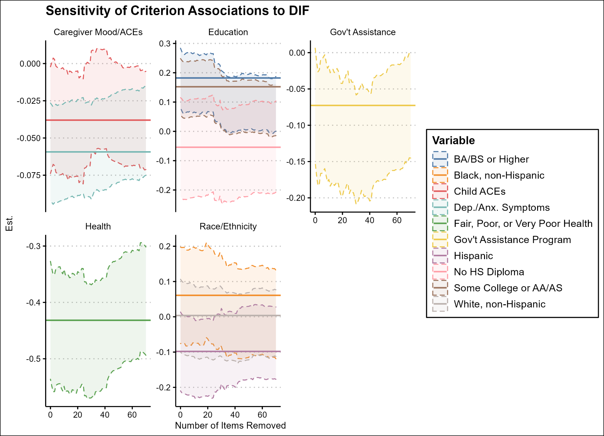

Correlations with Scores
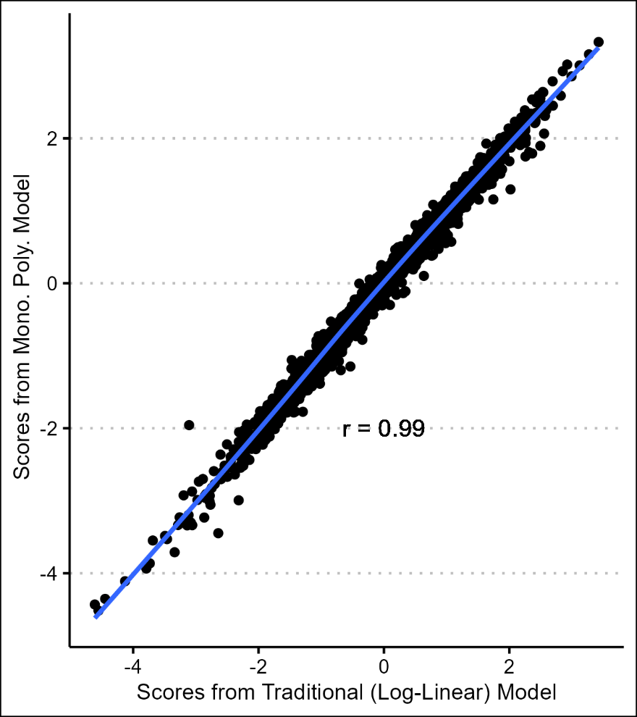

Supplemental Figure 2

